Telecom Customer Churn
Exploratory Data Analysis — Executive Report
Stage 2 of Data Science Engagement
Prepared by: Senior Data Science & Business Consulting Team
Dataset: Client.csv + Record.csv (merged, cleaned) — 99,643 customers, 100 features

Executive Summary
This report presents a comprehensive exploratory data analysis (EDA) of a merged telecommunications customer dataset (Client + Record, 99,643 customers after cleaning). The objective is not simply to describe the data, but to surface business insights that can be converted into executive-level retention and revenue initiatives ahead of predictive model development (Stage 3).
The single most important finding is that churn in this customer base is driven primarily by device/behavioral factors — equipment age and usage-decline trends — rather than by revenue level, demographics, or service-quality complaints. Customers who complain the most (via dropped calls or customer care contacts) actually churn less than the base average, while customers on old handsets with declining usage churn substantially more. This reframes the retention strategy away from a traditional 'value-protection' or 'complaint-resolution' approach toward a proactive, behavior-triggered intervention model.
Sections 1–13 below walk through data cleaning decisions and each required analysis area, each with a business insight, why it matters, and a recommended action. The report closes with a consolidated Top 10 insights list, Top 10 churn-related features, and 5 prioritized business opportunities.

Data Cleaning Summary
Every cleaning decision below was made to preserve analytical integrity — no values were fabricated via blanket imputation at this exploratory stage. A raw, untouched copy of both source files was preserved separately from the cleaned analytical dataset.
- Merged on Customer_ID (1:1) -> 100000 rows, 100 cols
- Dropped 357 rows (0.36%) missing ALL core revenue/usage fields (rev_Mean, mou_Mean, totmrc_Mean, etc.) simultaneously -> these are unusable blank account-snapshots, not meaningfully imputable. Remaining: 99643 rows.
- change_mou / change_rev (891 missing): confirmed these belong to customers with less history available for month-over-month comparison. Left as NaN (true structural missingness) rather than imputing 0, which would falsely imply 'no change'. Excluded pairwise in analyses that use them.
- avg6mou/avg6qty/avg6rev (2,839 missing): verified these correspond to customers with short tenure (mean ~7.5 months vs ~19 months for non-missing) who simply haven't accumulated 6 months of history yet. Left as NaN (structural), flagged with 'has_6mo_history' indicator for future modeling.
- eqpdays (equipment age in days): 133 rows had small negative values (-1 to -5 days), consistent with activation/porting timing artifacts rather than real negative age. Clipped to 0 (cannot be negative by definition).
- Recoded missing values in 16 categorical/append fields (dwllsize, HHstatin, ownrent, dwlltype, infobase, prizm_social_one, marital, ethnic, kid0_2-16_17, creditcd, new_cell, hnd_webcap) to an explicit 'Unknown' category rather than imputing or dropping, preserving the that missingness itself may correlate with churn (untracked/unmatched customers).
- Numeric append fields left as NaN (not imputed): ['numbcars', 'lor', 'income', 'adults']. income (25.4% missing), lor=length of residence (30.2%), adults (23.0%), numbcars (49.4%). These will be handled explicitly during feature engineering (a later stage); imputing now would distort distribution-based EDA. Analyses use dropna() per-metric.
- truck/rv/forgntvl (1,732 missing, binary append flags): left as NaN — missing does not necessarily mean '0/No'; assuming so would fabricate data. Treated as 'Unknown' in categorical breakdowns.
- Duplicate full rows: 0. Duplicate Customer_IDs: 0. None found — no action needed.
- income: confirmed coded as an ordinal decile (1-9), not a dollar amount. Treated as ordinal/categorical in analysis, not averaged as if continuous currency.
- Outlier scan (1st/99th percentile bounds) on key metrics — flagged for awareness, NOT removed (high-usage/high-revenue customers are a legitimate and business-critical segment, not errors):
- totrev: p1=143.21, p99=4429.89, rows beyond [p1,p99]=1994
- totmou: p1=155.0, p99=40400.34, rows beyond [p1,p99]=1992
- totcalls: p1=66.0, p99=17679.58, rows beyond [p1,p99]=1980
- hnd_price: p1=9.99, p99=199.99, rows beyond [p1,p99]=632
- mou_Mean: p1=0.0, p99=2422.4, rows beyond [p1,p99]=997
- rev_Mean: p1=10.0, p99=227.89, rows beyond [p1,p99]=1979
- eqpdays: p1=8.0, p99=1162.0, rows beyond [p1,p99]=1922
- months: p1=6.0, p99=49.0, rows beyond [p1,p99]=823
- rev_Mean negative values: 5 rows — plausible billing credits/adjustments, not errors. Kept as-is, flagged.

Result
Final cleaned & merged analytical dataset: 99,643 customers × 101 columns (100 original + 1 derived 'has_6mo_history' flag). 0 duplicate rows, 0 duplicate Customer_IDs.

Exploratory Data Analysis

1. Churn Distribution
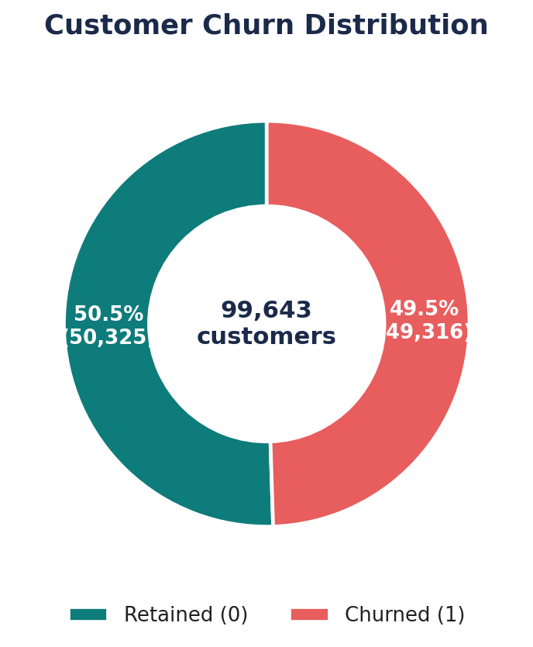
Business Insight: The base is almost evenly split: 49,317 customers (49.5%) churned versus 50,326 (50.5%) retained. This is a near 50/50 sample, not the 2-5% churn rate typical of a full live subscriber base.
Why It Matters: A near-balanced label distribution suggests this file was already extracted as a matched/stratified churn analysis sample (common practice for building churn models), not the company's full population. Executives should not read '49.5%' as 'half our customers are leaving' — it reflects sampling design, not live attrition.
Recommended Action: Confirm with the data owner whether this is a stratified sample. If so, any 'churn rate' figures in this report describe within-sample patterns and relative risk, not the true book-of-business churn rate, which should be sourced separately for board-level attrition tracking.

2. Numerical Feature Distributions
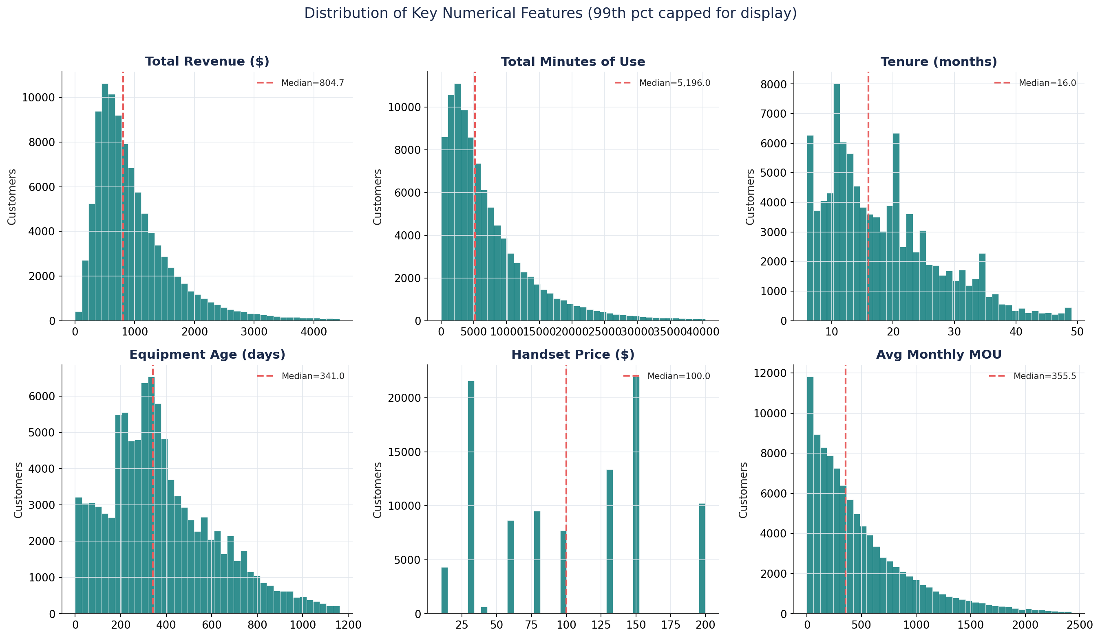
Business Insight: Revenue (totrev), usage (totmou) and average monthly minutes (mou_Mean) are all heavily right-skewed (skew 2.3-4.4) — a small group of customers drives disproportionate volume and spend. Tenure and equipment age are moderately skewed toward newer/shorter values, and handset price is closer to symmetric.
Why It Matters: Skewed revenue/usage confirms a classic 80/20 telecom pattern: a minority of heavy users generates the majority of traffic and revenue. Using simple averages for these metrics in planning will overstate the 'typical' customer.
Recommended Action: Use median and quartile-based reporting (not mean alone) for revenue/usage KPIs, and build any value-tiering or pricing strategy on percentile bands rather than a single average.

3. Categorical Feature Distributions
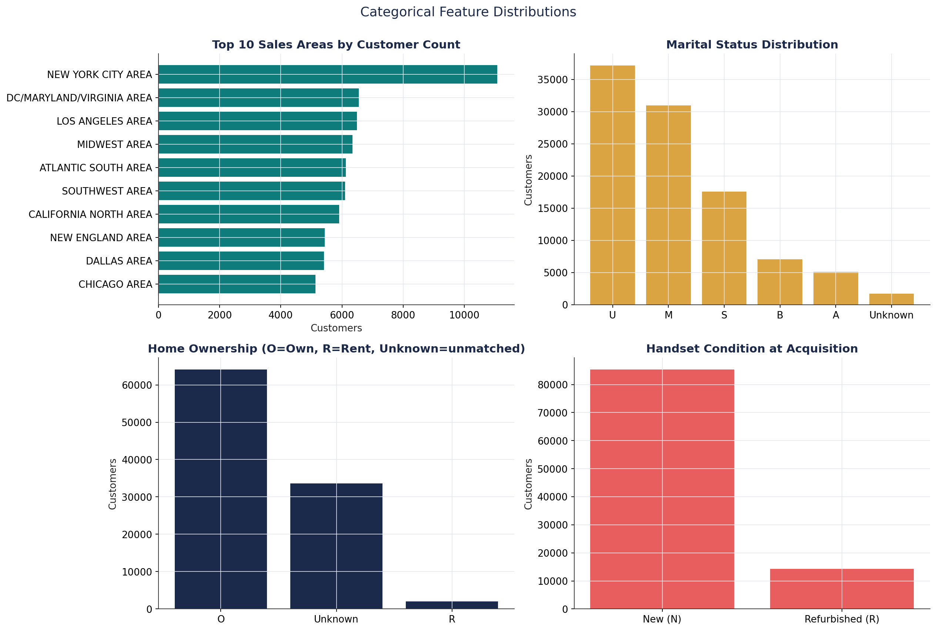
Business Insight: New York City is the single largest market (11,081 customers, ~11% of base). Marital status skews toward 'Unknown/Unmarried' codes; home-ownership data is missing for a third of customers (append-data gap); the large majority of handsets (85.6%) were issued new rather than refurbished.
Why It Matters: The concentration in a handful of metro areas means regional network or pricing issues in those markets have outsized book-of-business impact. The high missingness in ownrent/marital shows a real gap in third-party demographic enrichment that limits demographic-based targeting until improved.
Recommended Action: Prioritize any regional retention pilot in the top 3-4 markets (NYC, DC/MD/VA, LA, Midwest) for fastest ROI, and evaluate a better-matched demographic data vendor to close the append-data gap.

4. Correlation Matrix & Churn Correlation Ranking
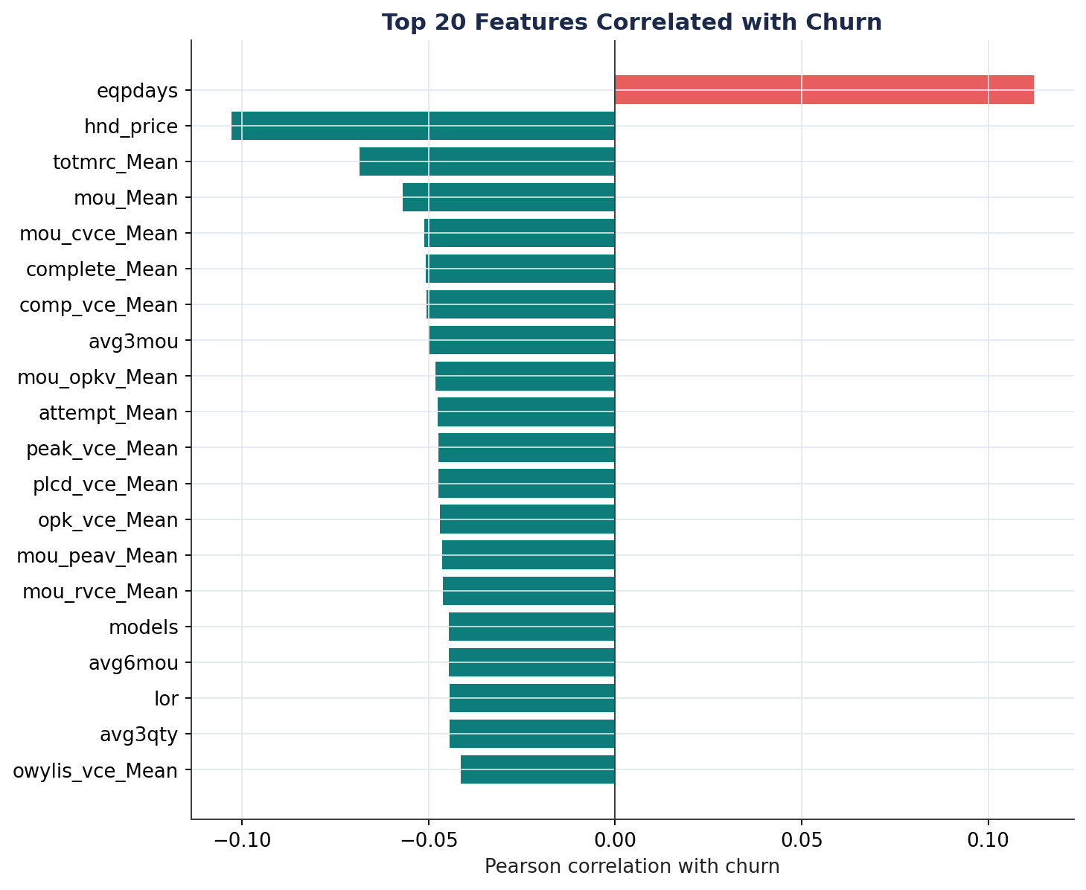
Business Insight: No single feature is strongly linearly correlated with churn — the strongest is equipment age (eqpdays, r=+0.11), followed by handset price (r=-0.10) and monthly recurring charge (r=-0.07). All other features fall below |r|=0.06.
Why It Matters: Weak individual correlations mean churn in this business is a multivariate, behavioral phenomenon — not explainable by any one KPI. This directly justifies building a multivariate ML model (Stage 3) rather than relying on simple single-metric alert rules.
Recommended Action: Treat any single-metric 'churn alert' (e.g. 'flag anyone with 3+ dropped calls') as insufficient on its own; invest in a combined behavioral risk score, which the segment analysis below shows is meaningfully more predictive than any single variable.

4b. Correlation Heatmap – Core Business Metrics
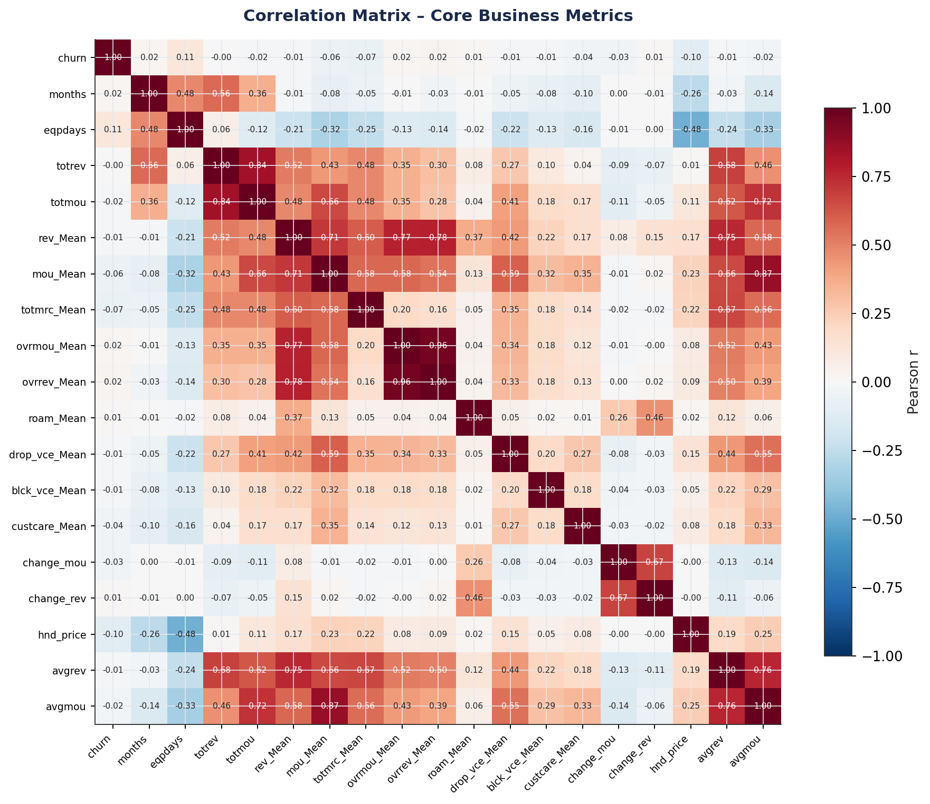
Business Insight: Usage and revenue metrics are highly inter-correlated (e.g., totrev/totmou, mou_Mean/avgmou), as expected. Equipment age (eqpdays) is only weakly correlated with other usage variables, meaning it carries independent predictive information rather than duplicating what revenue/usage already tell us.
Why It Matters: Because eqpdays is largely uncorrelated with the revenue/usage cluster, it is a genuinely additive signal for churn models — not redundant. This also flags multicollinearity risk if all revenue/usage variables are fed into a model together.
Recommended Action: In the upcoming feature-engineering stage, deduplicate the highly collinear revenue/usage variables (keep 1-2 representative ones) but retain eqpdays and device-related fields as independent predictors.

5. Revenue Analysis
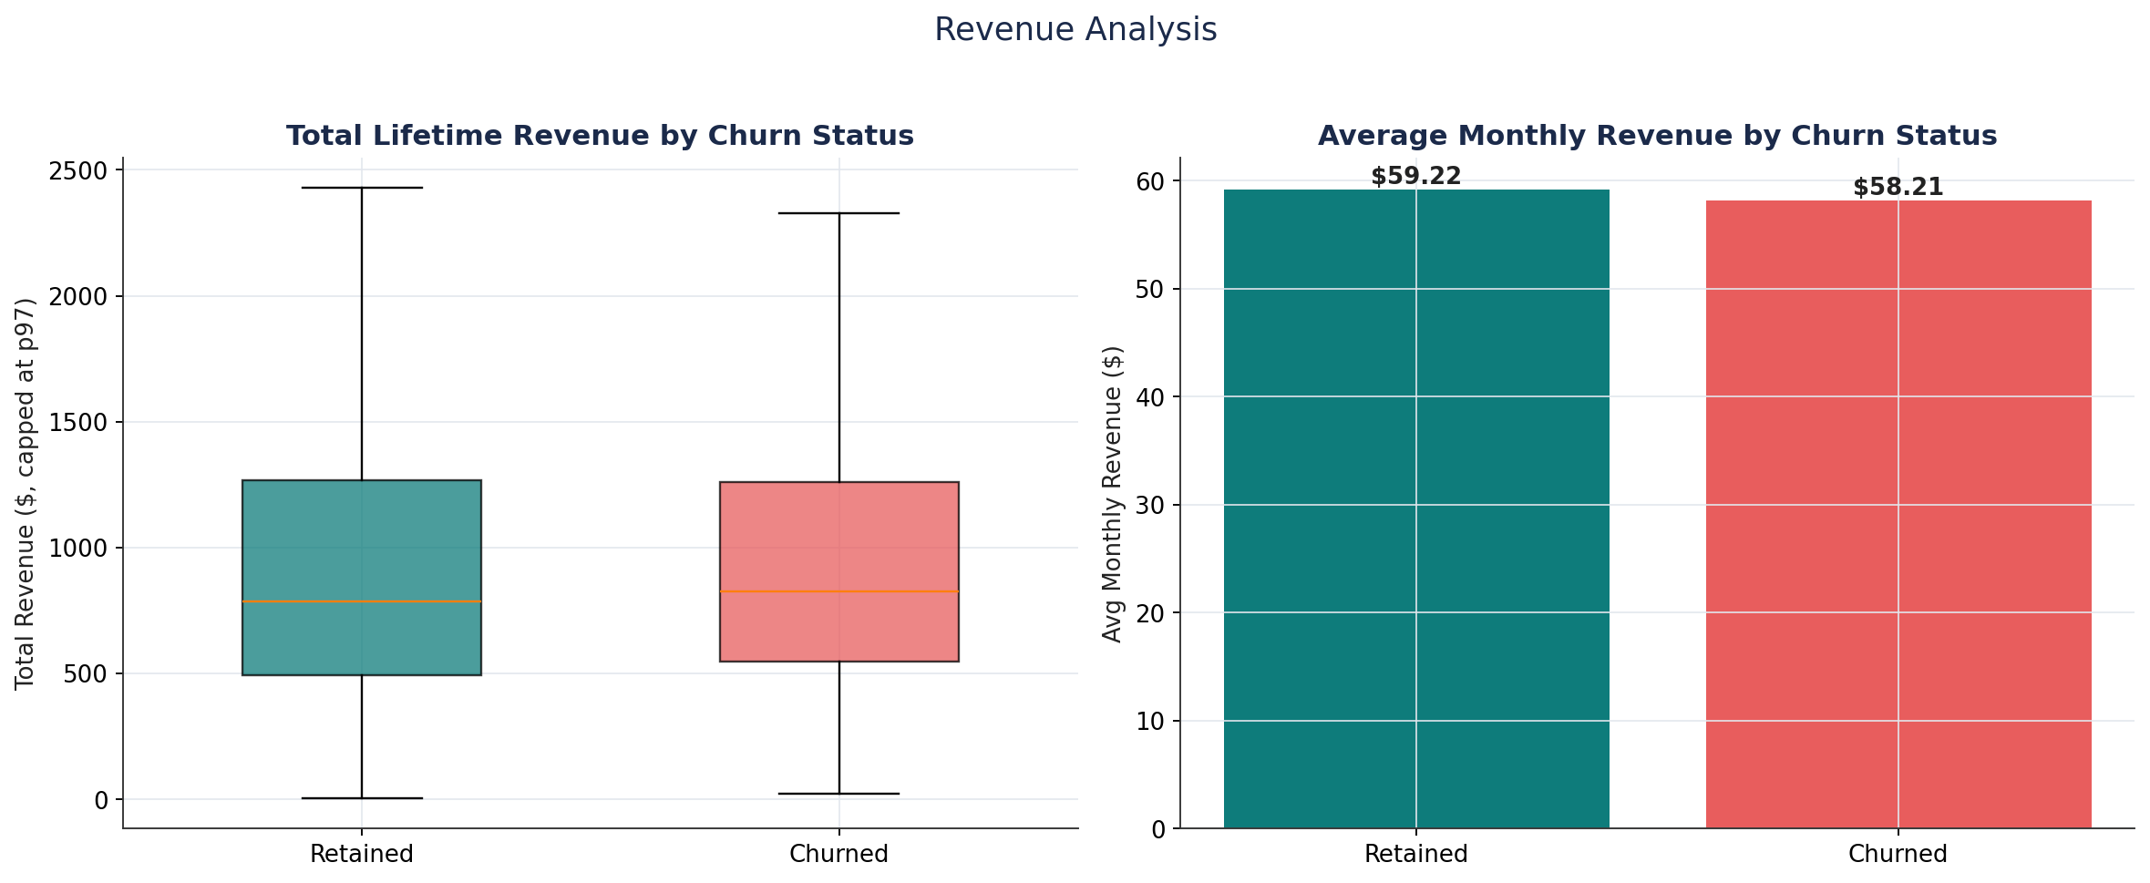
Business Insight: Churned customers do not have materially lower revenue: median lifetime revenue is actually slightly higher for churners ($823.99 vs $784.71) and average monthly revenue is nearly identical (~$58-59). Churn rate by revenue quartile is roughly flat (44%-53%), with the lowest-revenue quartile churning least, not most.
Why It Matters: This directly disproves the common assumption that 'low-value customers churn most.' Revenue alone is a poor churn predictor here — the company cannot rely on a 'protect the whales' strategy alone, since mid-to-high revenue customers are leaving at similar or higher rates.
Recommended Action: Redirect retention spend away from a pure revenue-tiering approach and toward the behavioral risk indicators (equipment age, usage decline) identified elsewhere in this analysis, which show much clearer separation.

6. Usage Behavior Analysis
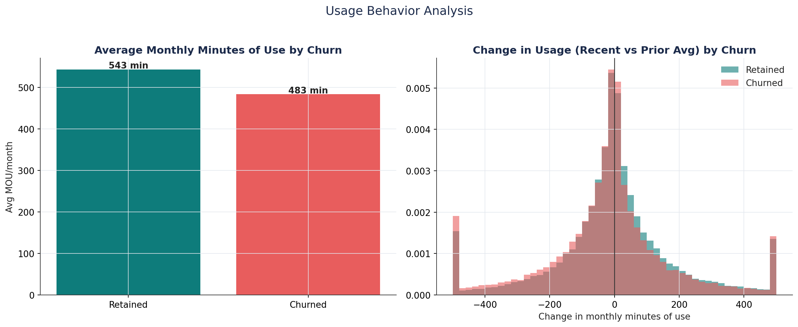
Business Insight: Average monthly minutes are similar between groups, but the trend matters: churners' usage declined much more sharply before leaving (change_mou average -22.8 minutes) versus retained customers (-5.3 minutes), and 56.2% of churners show declining usage versus 52.1% of retained customers.
Why It Matters: A negative usage trend is a leading indicator, not just a symptom — it can be observed before the customer actually churns, giving the business a window to intervene.
Recommended Action: Build a 'usage decline' trigger (e.g., month-over-month drop beyond a threshold) into the retention/early-warning workflow, prioritized for outreach ahead of contract renewal dates.

7. Service Quality & Customer Care Analysis
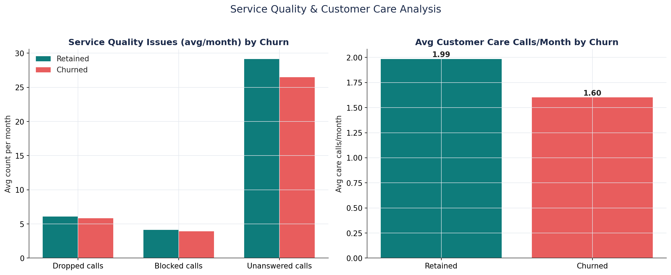
Business Insight: Counter-intuitively, churners report FEWER dropped calls (5.8 vs 6.1), fewer blocked calls (3.9 vs 4.1), and fewer customer care calls (1.60 vs 1.99 avg/month) than retained customers. Even the top 10% of customer-care callers churn at a lower rate (44.1%) than the rest of the base (50.1%).
Why It Matters: This is one of the most important — and counter-intuitive — findings in the dataset: network/service friction, as captured by these metrics, is not the primary churn driver here. Customers who call in with problems may in fact be more engaged/retainable (they're still trying to make the relationship work), while silent churners disengage without complaining.
Recommended Action: Do not assume that reducing dropped/blocked calls alone will move the churn needle. Instead, treat a sudden drop in engagement (fewer calls to customer care, declining usage) as a silent churn signal worth proactive outreach, rather than waiting for complaints.

8. Tenure Analysis
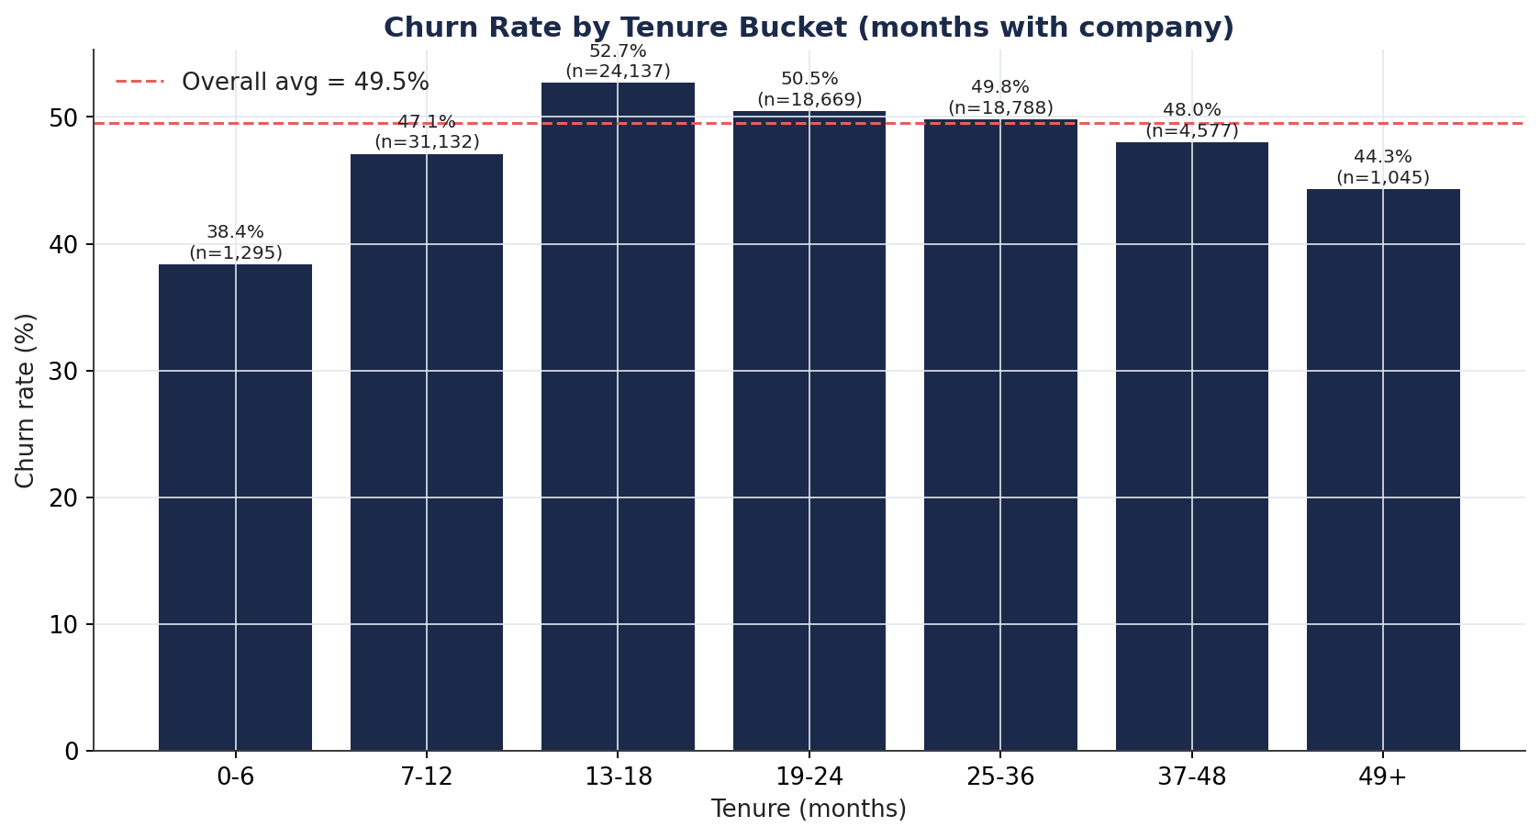
Business Insight: Churn risk is lowest for brand-new customers (0-6 months: 38.4%) and rises to a peak in the 13-18 month window (52.7%) before gradually declining again for long-tenured customers (49+ months: 44.3%).
Why It Matters: The 13-18 month peak lines up with the end of typical 12-month contract terms plus a short grace/renewal window — a classic 'first renewal cliff.' This is a specific, addressable moment in the customer lifecycle, not a vague generalization.
Recommended Action: Launch a proactive save/renewal campaign timed at months 10-14 of tenure (ahead of the observed peak), rather than a generic always-on retention program.

9. Device & Equipment Age Analysis
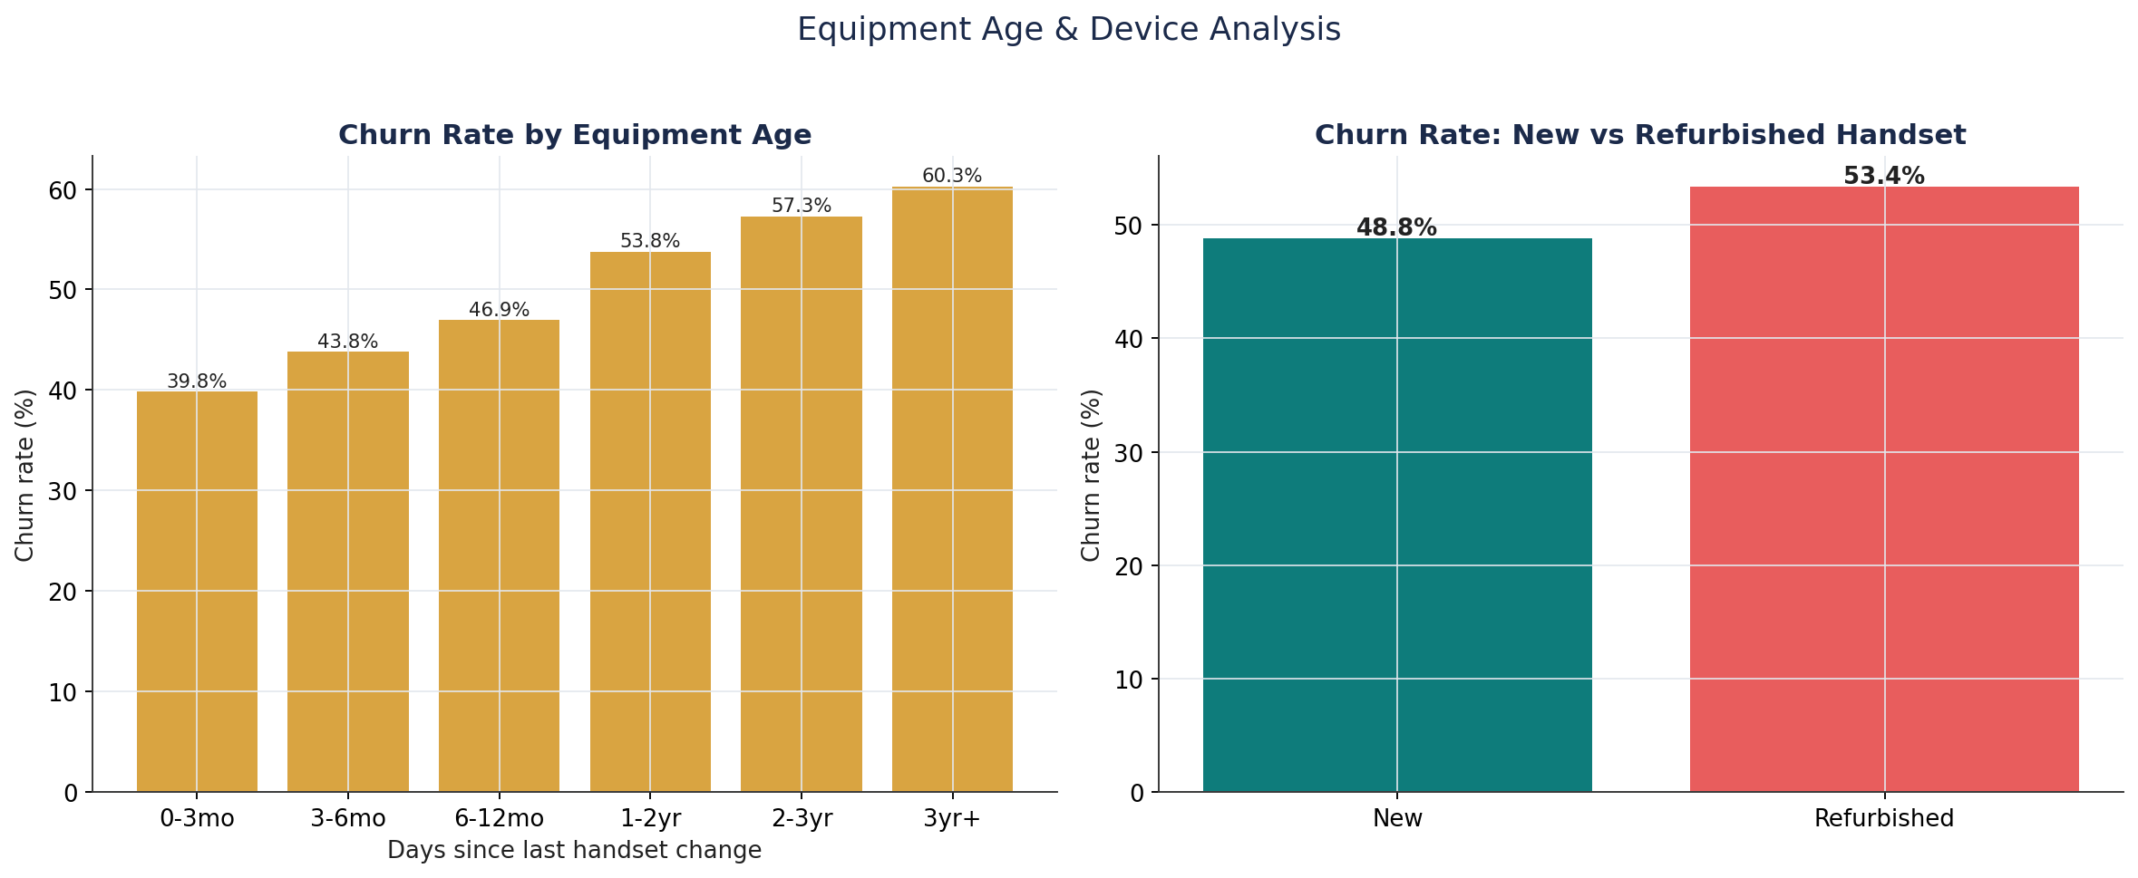
Business Insight: Churn rises steadily and almost monotonically with equipment age — from 39.8% for customers with a handset <3 months old to 60.3% for those on a handset 3+ years old. Refurbished-handset customers also churn more (53.4%) than new-handset customers (48.8%).
Why It Matters: This is the cleanest, most monotonic relationship found in the entire analysis — stronger and more actionable than any revenue or service-quality metric. Old hardware is both a symptom (customer hasn't been re-engaged/upgraded) and a cause (aging device experience) of churn risk.
Recommended Action: Implement a proactive device-upgrade/trade-in offer triggered automatically once a customer crosses ~18-24 months on the same handset, before they reach the highest-risk 3-year+ zone.

10. Demographic Analysis
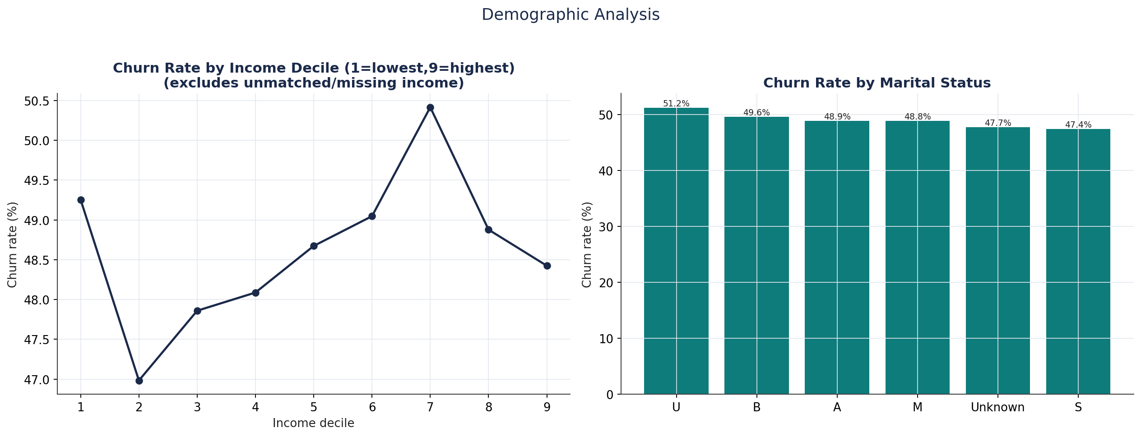
Business Insight: Income decile shows only a mild, non-monotonic relationship with churn (roughly 47-50% across deciles, no clear trend). Marital status shows a modest spread — 'Unmarried/Unknown' codes churn highest (51.2%) while 'Single' and 'Unknown-marital' churn lowest (~47-48%).
Why It Matters: Demographics are comparatively weak churn predictors in this dataset relative to behavioral/device signals — an important finding since demographic targeting is often the default (and expensive) first instinct in retention marketing.
Recommended Action: Deprioritize broad demographic-based retention segmentation (e.g., income-tier campaigns) in favor of the stronger behavioral/device signals; reserve demographics for message personalization, not risk targeting.

11. Geographic Analysis
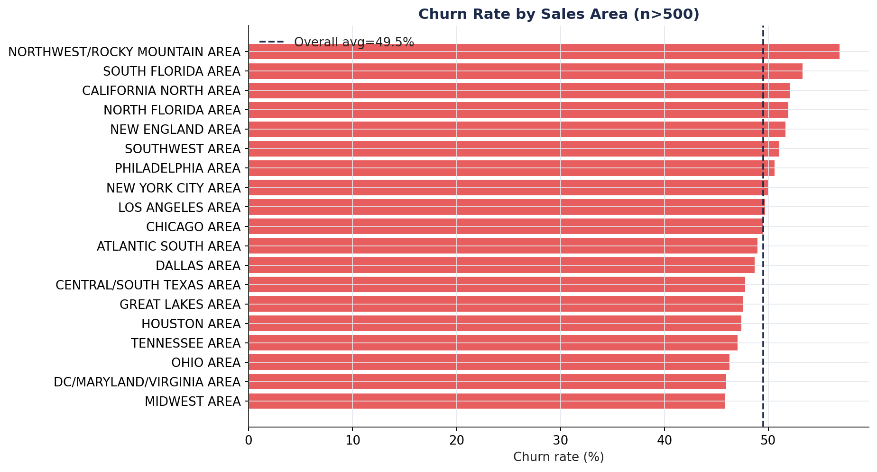
Business Insight: Churn varies by ~11 percentage points across regions with sufficient sample size — from 45.9% in DC/Maryland/Virginia and Midwest to 56.8% in Northwest/Rocky Mountain and 53.3% in South Florida.
Why It Matters: An 11-point regional spread is large enough to reflect real differences in local competitive intensity, network quality, or market conditions — not noise. Regional churn should be investigated as a distinct, addressable driver.
Recommended Action: Commission a focused root-cause review in the Northwest/Rocky Mountain and South Florida markets (network coverage, competitor promotions, store experience) before rolling out a national retention program.

12. Overage & Roaming Analysis
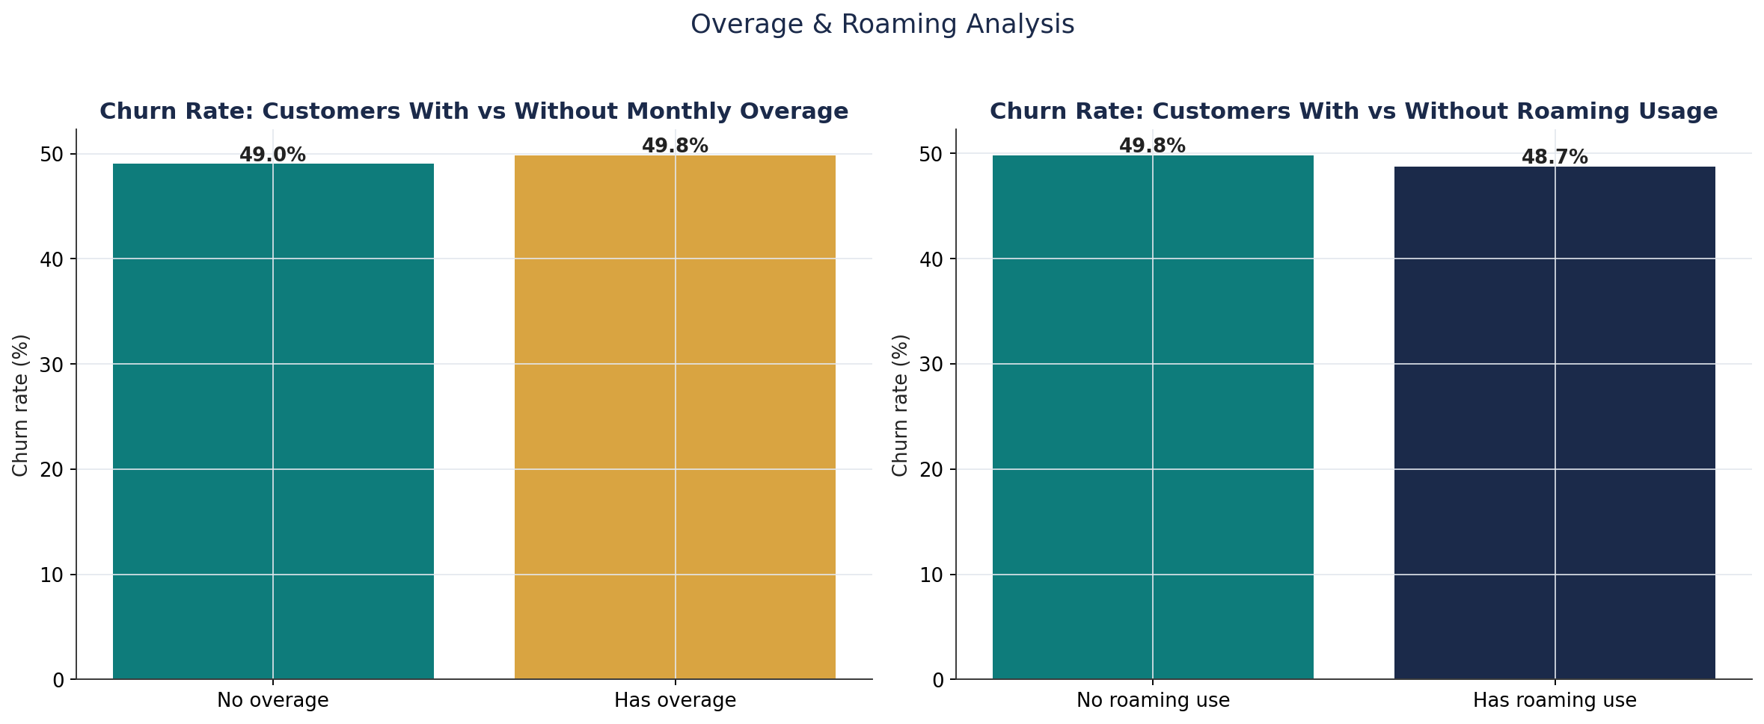
Business Insight: Overage usage (57.2% of customers exceed their plan monthly) shows almost no relationship with churn (49.8% vs 49.0%), though churners' average overage revenue is somewhat higher ($14.29 vs $12.84). Roaming usage (31.1% of customers) is very slightly associated with lower churn (48.7% vs 49.8%).
Why It Matters: Overage billing is not a meaningful churn driver on its own, which is a useful finding — it means 'bill shock' from overage is not the primary complaint pattern in this base, though the modestly higher overage revenue among churners is worth a closer look for possible plan-fit mismatch.
Recommended Action: Rather than blanket overage-fee waivers as a retention lever, target proactive plan right-sizing (upgrading heavy/frequent over-users to a better-fit plan) for the subset of customers with consistently high overage revenue.

13. Discovered Customer Segments
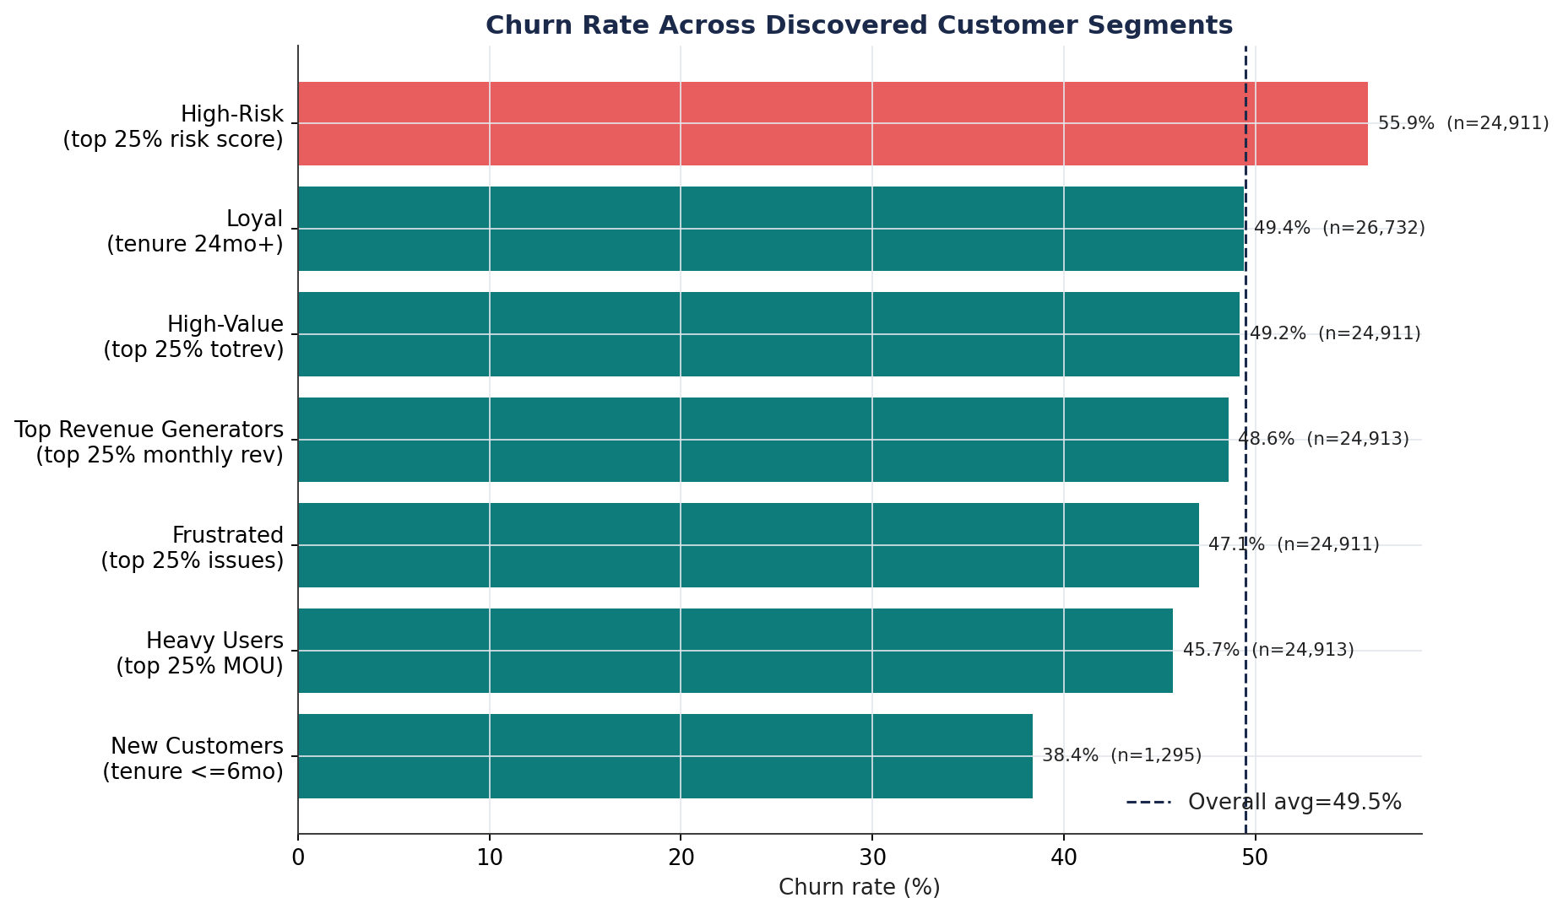
Business Insight: A rule-based composite 'High-Risk' segment (built from equipment age, usage decline, and short tenure) churns at 55.9% — meaningfully above the 49.5% base rate, and higher than any single-metric segment tested. New customers (tenure ≤ 6 months) churn least (38.4%). Heavy users, frustrated (high-friction) customers, top revenue generators, high-value and loyal segments all churn close to the base rate (45.7%-49.4%), confirming that value and loyalty alone do not protect against churn in this base.
Why It Matters: This validates the core strategic conclusion of the EDA: churn here is driven by a *combination* of behavioral/device factors (captured in the composite risk score) rather than by any single value, loyalty, or satisfaction proxy.
Recommended Action: Use the composite High-Risk segment definition (equipment age + usage decline + tenure) as the starting point for the Stage 3 predictive model's feature set, and pilot a retention offer specifically against this segment to measure lift before wider rollout.

Top 10 Business Insights
- Equipment age is the strongest, most monotonic churn driver — churn nearly doubles from 39.8% (handset <3 months old) to 60.3% (handset 3+ years old).
- Usage decline is a leading indicator: churners' monthly usage dropped ~22.8 minutes on average before leaving, versus ~5.3 minutes for retained customers.
- Revenue level does NOT predict churn — churn rate is nearly flat across revenue quartiles (44%–53%), disproving a 'protect the top spenders only' strategy.
- Service-quality friction is inversely related to churn — customers with more dropped/blocked calls and more customer-care contacts churn LESS, not more; silent disengagement is the dominant pattern, not vocal complaints.
- Tenure shows a 'first renewal cliff' — churn peaks at 13–18 months (52.7%), consistent with the end of typical 12-month contract terms.
- Geography matters — an 11-point churn-rate spread exists between the highest-risk region (Northwest/Rocky Mountain, 56.8%) and the lowest (DC/MD/VA & Midwest, ~45.9%).
- No single feature is strongly predictive in isolation (maximum |correlation| ≈ 0.11 for eqpdays) — churn here is inherently multivariate, which justifies building a combined ML risk score rather than single-metric alert rules.
- A composite behavioral risk score (equipment age + usage decline + short tenure) identifies a 25%-of-base high-risk segment churning at 55.9% — 6.4 points above the overall average, the most actionable segment discovered.
- New customers (tenure ≤6 months) churn least (38.4%), indicating onboarding is not the primary weak point; retention risk builds progressively toward the first renewal cycle.
- A large share of third-party demographic append fields (income, homeownership, dwelling type/size, length of residence) is missing (23%–49% depending on field), limiting demographic-based targeting until data quality is improved.

Top 10 Features Likely Affecting Churn
Ranked by absolute Pearson correlation with churn (numeric features), supplemented by business judgment for trend/lifecycle variables whose importance is not fully captured by linear correlation.
Rank | Feature | Correlation w/ churn | Business Interpretation
1 | eqpdays | +0.112 | Equipment age — strongest single driver; churn rises steadily with handset age.
2 | hnd_price | -0.103 | Handset price — customers on cheaper/older-tier devices churn more.
3 | totmrc_Mean | -0.069 | Monthly recurring charge — lower committed plan value associates with higher churn.
4 | mou_Mean | -0.057 | Average monthly minutes of use — lower usage intensity associates with higher churn.
5 | mou_cvce_Mean | -0.051 | Mean voice-call minutes — usage-engagement proxy.
6 | complete_Mean | -0.051 | Completed call attempts — engagement/network-success proxy.
7 | comp_vce_Mean | -0.051 | Completed voice calls — engagement proxy.
8 | avg3mou | -0.050 | 3-month average minutes — short-term usage trend proxy.
9 | change_mou | weak linear r, strong group gap | Usage trend — churners show a much sharper usage decline (-22.8 vs -5.3 min) despite modest linear correlation; important as a trend signal, not a level signal.
10 | months (tenure) | non-linear / peaked | Tenure — relationship is a lifecycle peak (13–18 months), not linear, so raw correlation understates its business importance.

5 Business Opportunities Discovered
1. Proactive Device Refresh Program
Trigger upgrade/trade-in offers automatically once a customer reaches 18–24 months on the same handset — before churn risk climbs into the 3-year+ zone (60.3% churn). This targets the single cleanest, most monotonic driver found in the analysis.
2. Renewal-Cliff Save Campaign
Deploy targeted retention outreach at months 10–14 of tenure, ahead of the observed 13–18 month churn peak (52.7%), timed to the end of standard 12-month contract terms.
3. Composite Risk-Score Early Warning System
Operationalize the equipment-age + usage-decline + tenure composite score into the CRM to flag the ~25% highest-risk customers (55.9% churn) for proactive, prioritized retention treatment ahead of Stage 3 model deployment.
4. Silent-Disengagement Monitoring
Since vocal complainers (customer care callers, dropped-call reporters) churn less than average, build usage-decline and engagement-drop alerts as the primary churn signal, rather than relying on inbound complaint volume.
5. Regional Retention Investigation & Pilot
Commission a root-cause study and localized retention pilot in the Northwest/Rocky Mountain and South Florida markets, where churn runs 4–7 points above the national base, before scaling any national retention program.

Next Steps
This concludes Stage 2 (EDA). No feature engineering or machine learning modeling has been performed. Awaiting direction to proceed to Stage 3 (feature engineering) and Stage 4 (predictive churn model).

