TELECOM CUSTOMER CHURN
Predictive Analytics & Retention Strategy
A Data Science Capstone Project
Final Consolidated Report
Stages 1–4: Data Understanding · Exploratory Analysis · Predictive Modeling · Recommendations
Prepared by
Mohamed Ahmed Abdelrahman Ahmed
Faculty of Computers and Information
Assiut University
Egypt
Dataset: Client.csv + Record.csv (merged, cleaned) — 99,643 customers, 100+ features
July 2026

Table of Contents
1. Executive Summary
2. Business Problem
3. Dataset Description
4. Data Cleaning
5. Exploratory Data Analysis
6. Key Business Insights
7. Feature Engineering
8. Machine Learning Methodology
9. Model Comparison
10. Final Model Selection
11. SHAP Analysis
12. Feature Importance
13. Business Recommendations
14. Deployment Strategy
15. Model Limitations
16. Future Work
17. Conclusion

1. Executive Summary
This report consolidates a complete, end-to-end data science engagement for a telecommunications company seeking to understand and reduce customer churn. Working from two raw operational extracts (customer profile and behavioral usage records covering 99,643 customers), the engagement proceeded through data understanding, exploratory analysis, feature engineering, predictive model development, and explainability analysis, culminating in a set of concrete, prioritized retention recommendations.
The central finding, consistent across both the exploratory analysis and the machine learning model, is that churn in this customer base is driven primarily by device lifecycle and usage-trend behavior — not by revenue level, demographics, or service-quality complaints as commonly assumed. Customers on older handsets with declining usage are substantially more likely to churn, while customers who complain the most (via dropped calls or customer-care contacts) actually churn less than average. This reframes the retention strategy away from a traditional “protect high-value customers” or “resolve complaints” approach and toward proactive, behavior-triggered intervention.
A LightGBM gradient-boosting classifier was selected as the final predictive model, achieving a test-set ROC-AUC of 0.697 — meaningfully ahead of Logistic Regression (0.653) and Random Forest (0.681), and narrowly ahead of XGBoost (0.696), with a clear speed advantage suited to regular re-scoring. Five prioritized business opportunities are recommended, anchored in a proactive device-refresh program, a renewal-cliff retention campaign, and a composite behavioral risk score for CRM-level targeting.
This report is fully consistent with, and summarizes, the two detailed technical deliverables produced during this engagement: the Stage 2 EDA report (Telecom_Churn_EDA_Report.docx) and the Stage 3 modeling notebook (Telecom_Churn_Predictive_Modeling.ipynb).

2. Business Problem
Customer churn is one of the most consequential problems in subscription-based telecommunications: acquiring a new customer typically costs several times more than retaining an existing one, and even small reductions in churn compound into substantial lifetime-value gains across a base of this size.
The business question addressed by this engagement is: which customers are at the highest risk of churning, why, and what specific, cost-effective interventions can the company deploy to retain them? This requires moving beyond simple historical churn reporting toward a predictive, explainable model that can (a) rank customers by churn risk, (b) explain the drivers behind each risk score in business terms, and (c) connect those drivers to specific, actionable retention levers.

Why this problem was selected
- Direct, measurable revenue impact — churn reduction converts directly into retained recurring revenue.
- Data readiness — the available dataset contains a clean, verified binary churn label plus rich behavioral, device, and demographic features, enabling both strong predictive performance and actionable driver analysis.
- Actionability — unlike e.g. general customer segmentation, a churn-risk model plugs directly into an operational retention workflow (CRM flagging, targeted offers).

3. Dataset Description
Two source files were provided by the telecommunications company:
File | Rows | Columns | Content
Client.csv | 100,000 | 50 | Demographics, household characteristics, device details, handset-level revenue/usage summaries
Record.csv | 100,000 | 51 | Detailed behavioral usage: voice/data minutes, overage, roaming, dropped/blocked calls, customer-care contacts, churn label, tenure
Both files share a unique key, Customer_ID (unique in both files, 100% overlap), confirming a 1:1 relationship. The files were merged via an inner join validated as strict 1:1, producing a single analytical table of 100,000 rows × 100 columns prior to cleaning.

Column groups
- Subscription & account: number of lines, activation status
- Usage & revenue: lifetime and rolling 3-/6-month minutes-of-use and revenue
- Device: handset price, refurbished/new status, days since last equipment change
- Demographics: income decile, marital status, household composition, dwelling type
- Behavioral usage: average monthly overage, roaming, dropped/blocked calls, customer-care contacts
- Target & tenure: churn (binary) and months (tenure)

4. Data Cleaning
Cleaning decisions were made to preserve analytical integrity — no values were fabricated via blanket imputation. A raw, untouched copy of both source files was preserved separately from the cleaned analytical dataset.
- Merged on Customer_ID (1:1) → 100,000 rows, 100 columns.
- Dropped 357 rows (0.36%) missing ALL core revenue/usage fields simultaneously — unusable blank snapshots, not meaningfully imputable. Remaining: 99,643 rows.
- change_mou / change_rev (891 missing): confirmed to belong to customers with insufficient history for month-over-month comparison. Left as NaN (true structural missingness) rather than imputing 0.
- avg6mou/avg6qty/avg6rev (2,839 missing): verified to correspond to customers with short tenure (mean ~7.5 months vs. ~19 months) who have not accumulated 6 months of history. Left as NaN, flagged with a has_6mo_history indicator.
- eqpdays (equipment age): 133 rows had small negative values (-1 to -5 days), consistent with activation/porting timing artifacts. Clipped to 0.
- High-missingness third-party demographic/append fields (dwllsize, HHstatin, ownrent, dwlltype, infobase, prizm_social_one, marital, ethnic, kid0_2–16_17, creditcd, new_cell, hnd_webcap) recoded to an explicit ‘Unknown’ category rather than imputed — missingness itself may be informative.
- Numeric append fields (income, lor, adults, numbcars) left as NaN, not imputed, to avoid distorting distribution-based EDA; handled explicitly during feature engineering.
- income confirmed coded as an ordinal decile (1–9), not a dollar amount — treated as ordinal, not averaged as currency.
- Outlier scan (1st/99th percentile) on key metrics — flagged for awareness, NOT removed, since high-usage/high-revenue customers are a legitimate business segment, not data errors.
- Duplicate rows / duplicate Customer_IDs: 0 found in either source file.
Final cleaned & merged analytical dataset: 99,643 customers × 101 columns (100 original + 1 derived has_6mo_history flag).

5. Exploratory Data Analysis
A comprehensive exploratory analysis was performed across churn distribution, numerical and categorical feature distributions, correlations, revenue, usage, service quality, customer care, tenure, device, demographics, geography, equipment age, overage, and roaming. The most business-critical findings are illustrated below; the full 14-chart analysis with per-chart commentary is documented in the companion Stage 2 EDA report.

5.1 Churn Distribution
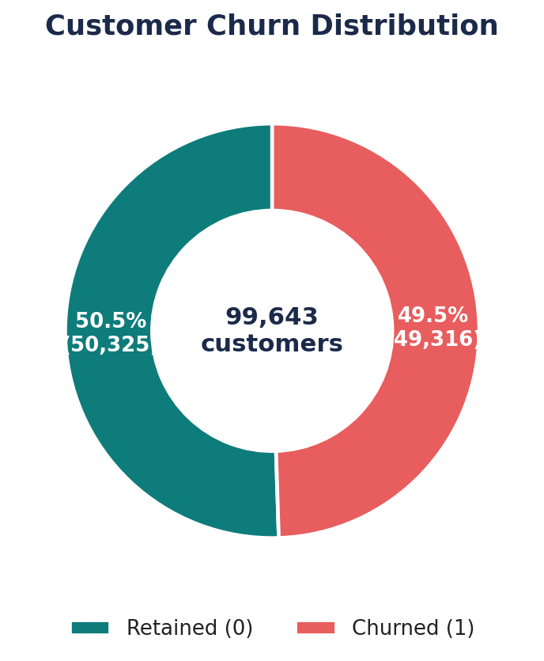
Near-balanced churn label (49.5% churned vs. 50.5% retained) — consistent with a stratified analytical sample rather than the live book-of-business churn rate.

5.2 Correlation Analysis
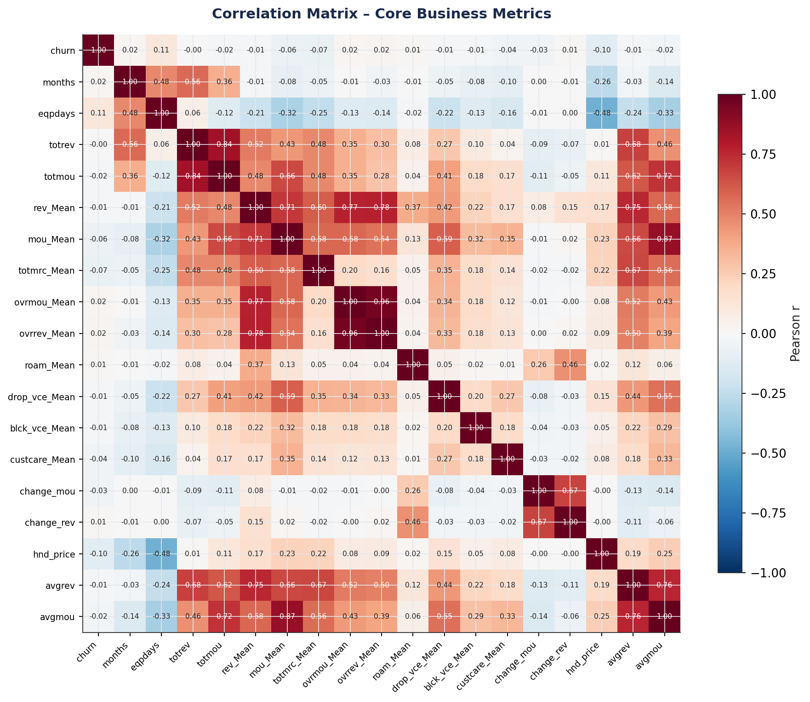
Correlation matrix of core business metrics. No single feature is strongly linearly correlated with churn (max |r| ≈ 0.11), indicating churn is a multivariate, behavioral phenomenon.

5.3 Revenue Analysis
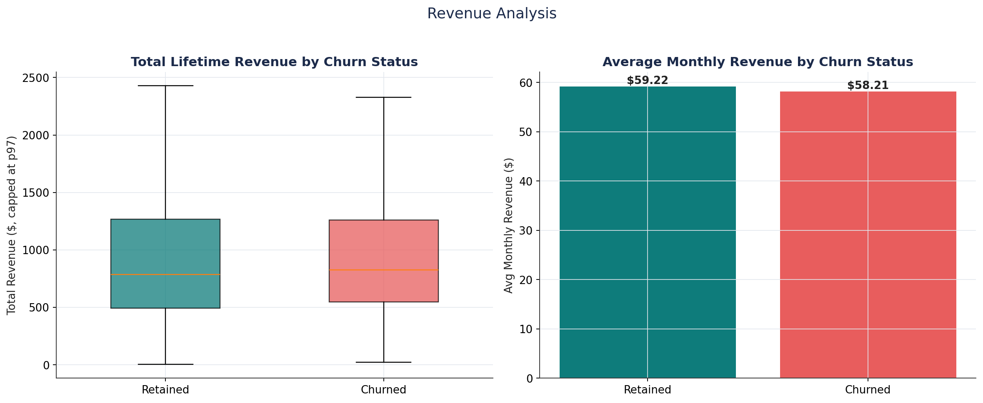
Churn rate is nearly flat across revenue quartiles — revenue level alone is a poor churn predictor.

5.4 Usage Behavior Analysis
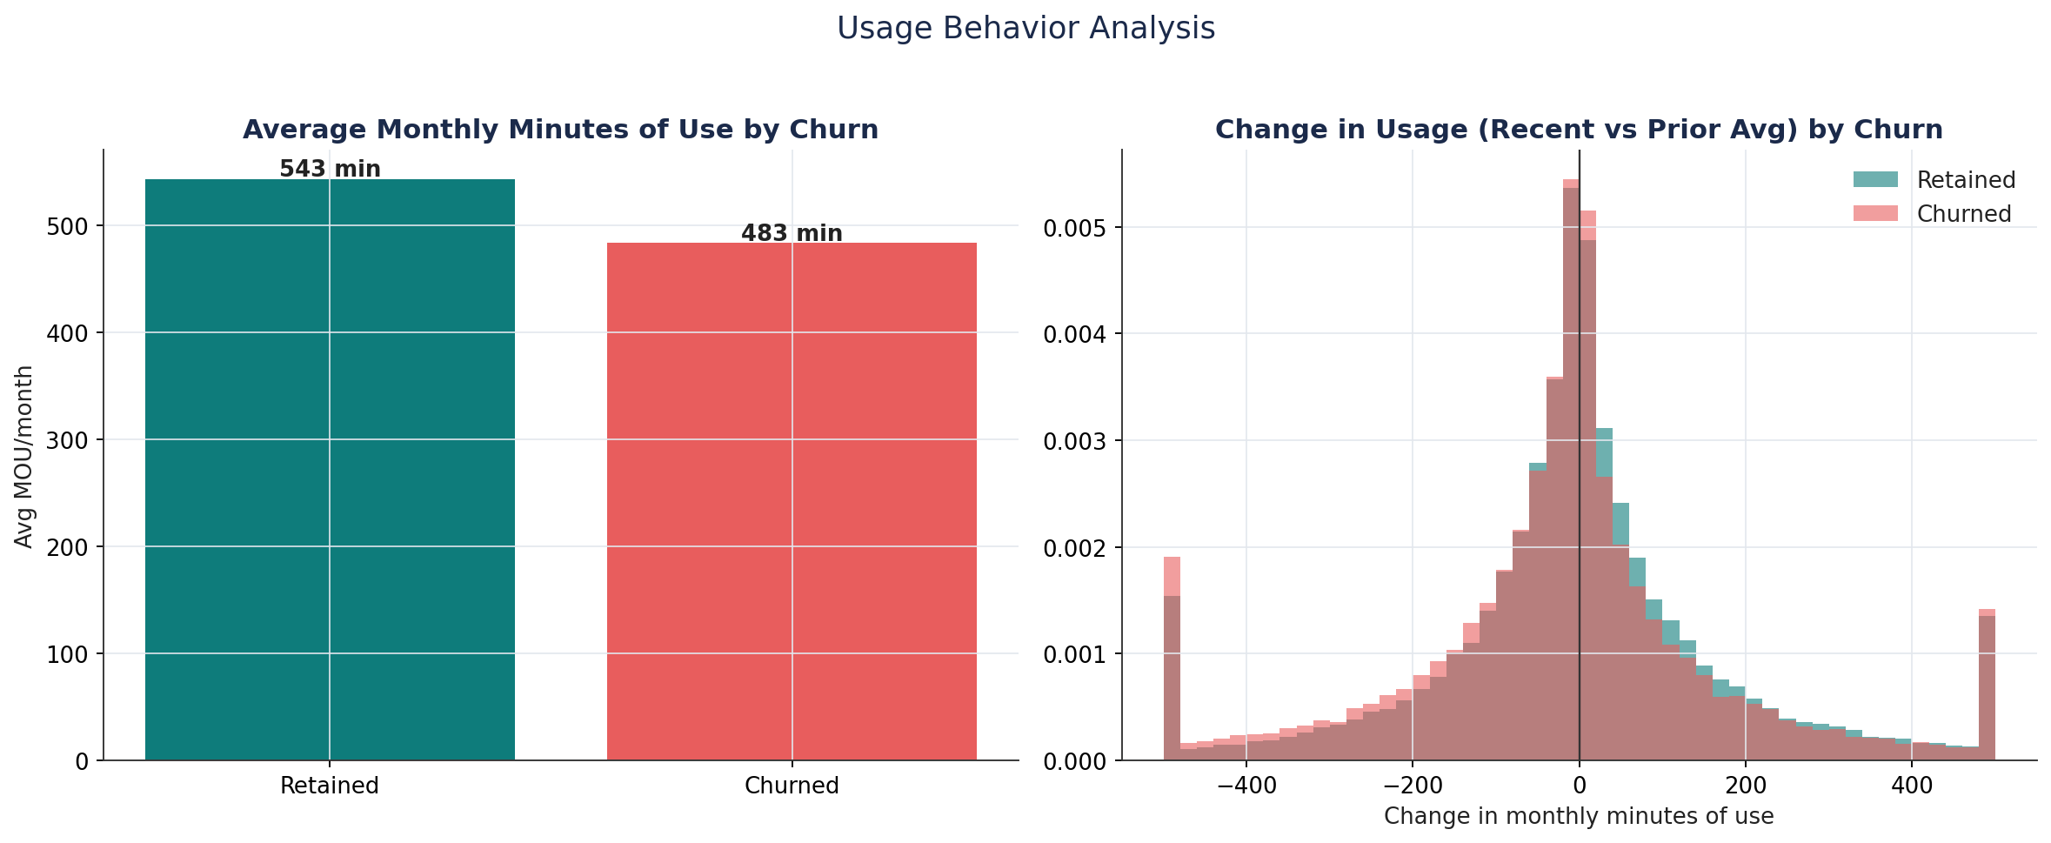
Churners show a much sharper usage decline before leaving (-22.8 min/month) than retained customers (-5.3 min/month) — a leading behavioral indicator.

5.5 Device & Equipment Age Analysis
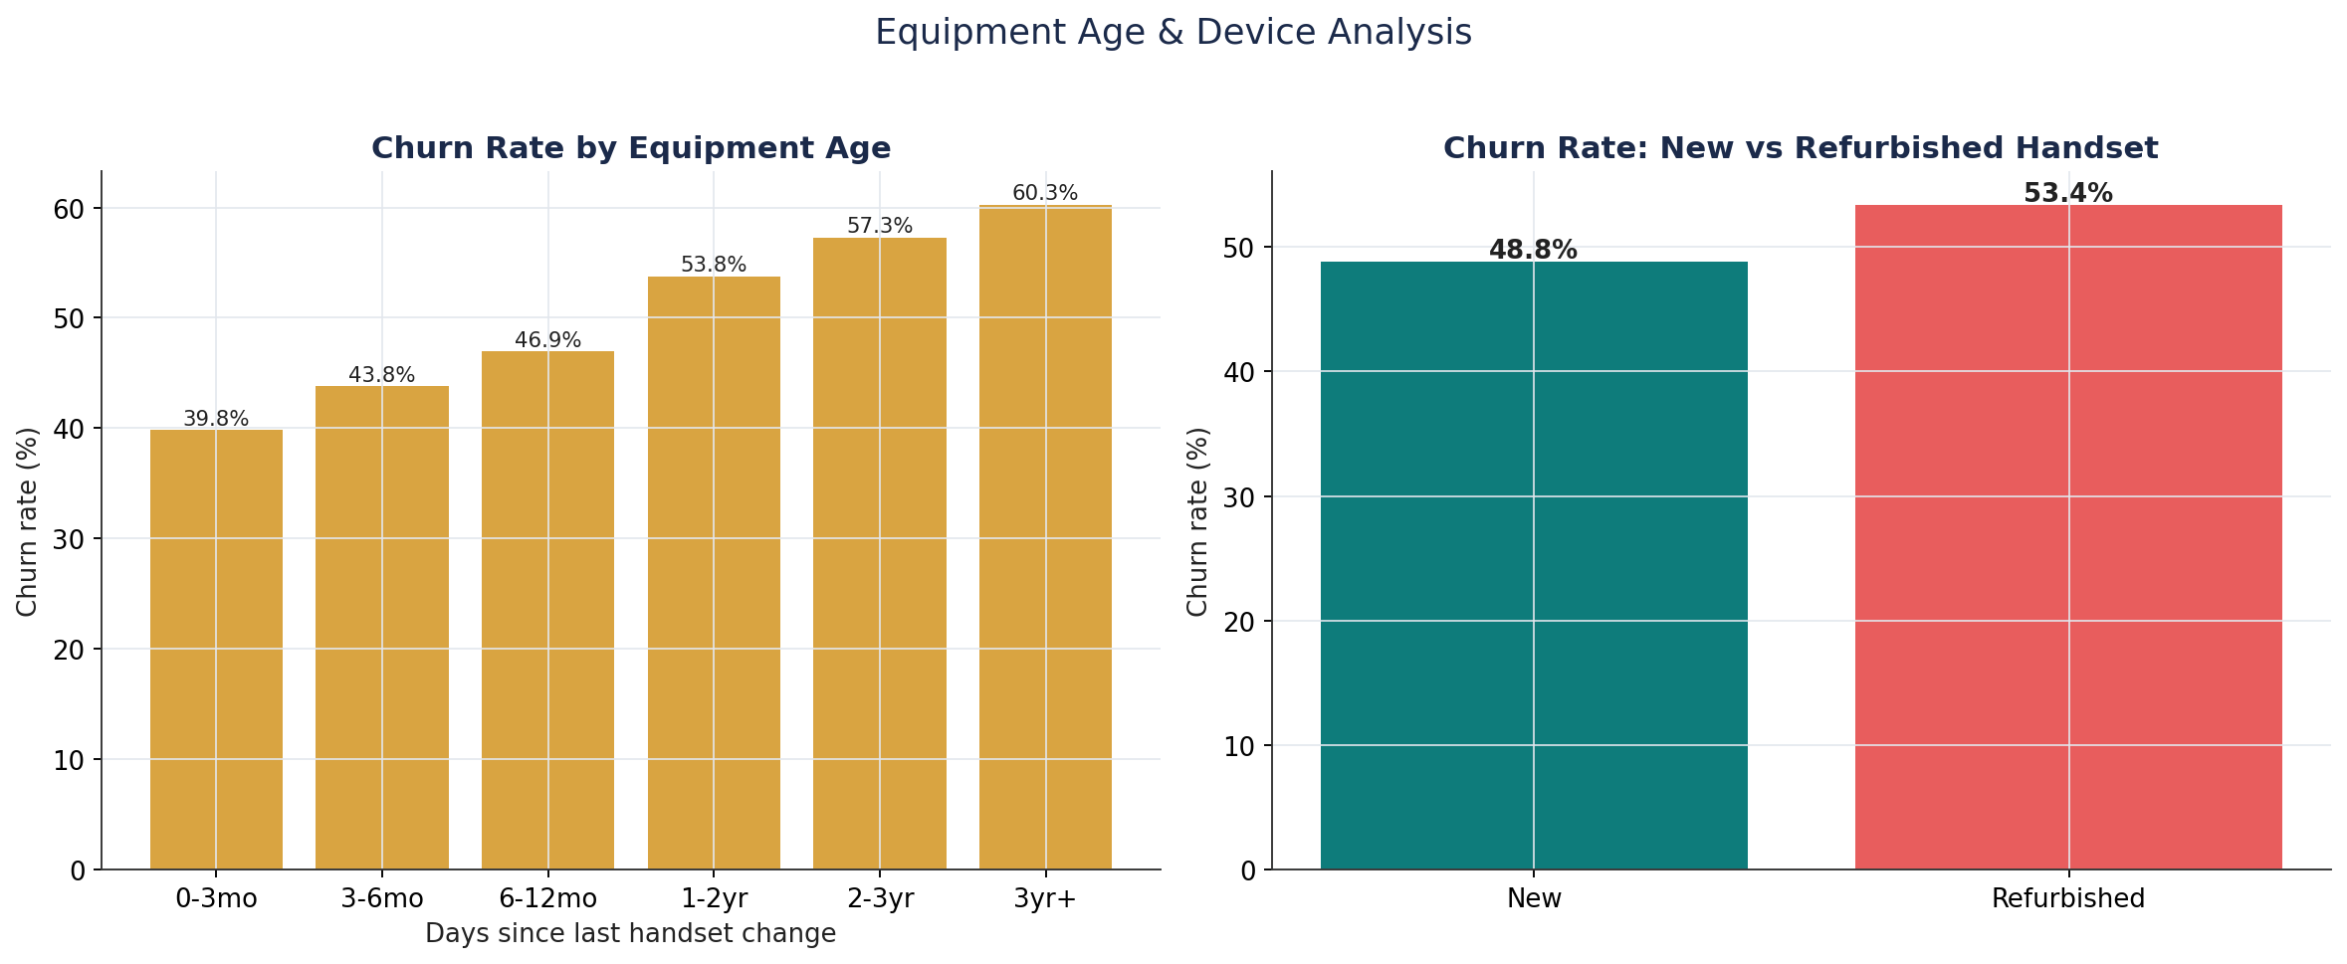
Churn rises almost monotonically with equipment age, from 39.8% (handset <3 months) to 60.3% (handset 3+ years) — the single cleanest relationship found in the entire analysis.

5.6 Tenure Analysis
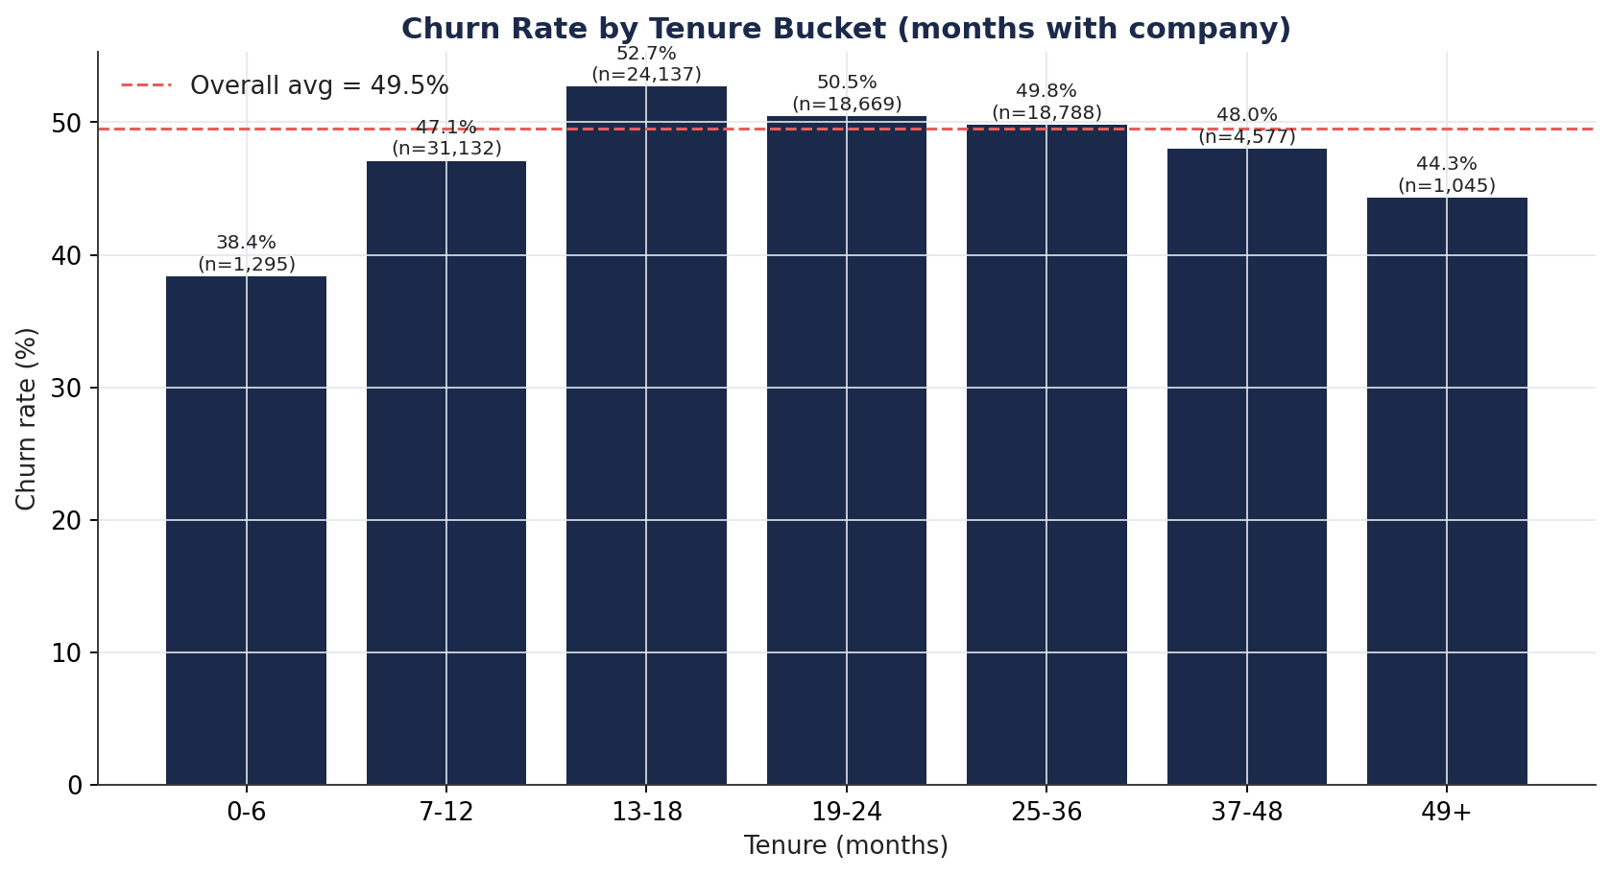
Churn peaks at 13–18 months tenure (52.7%), consistent with a first-contract-renewal cliff.

5.7 Discovered Customer Segments
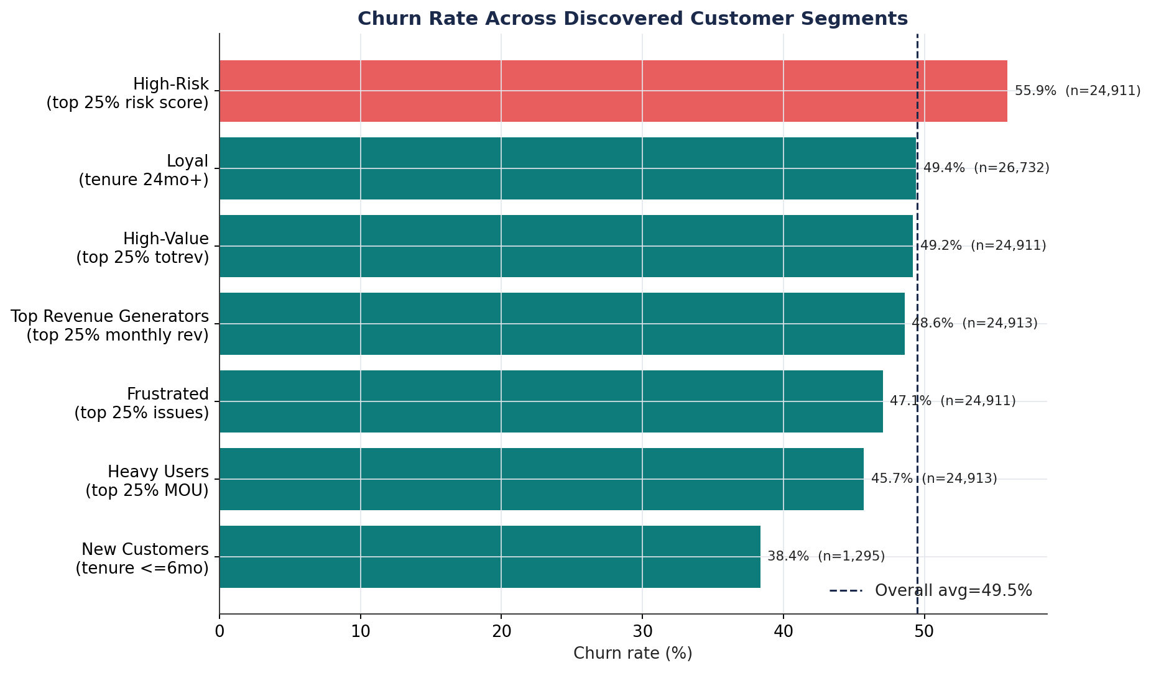
A composite behavioral risk segment (equipment age + usage decline + short tenure) churns at 55.9% — 6.4 points above baseline, the most actionable segment identified.

6. Key Business Insights
- Equipment age is the strongest, most monotonic churn driver — churn nearly doubles from 39.8% (handset <3 months) to 60.3% (handset 3+ years).
- Usage decline is a leading indicator: churners' monthly usage dropped ~22.8 minutes on average before leaving, versus ~5.3 minutes for retained customers.
- Revenue level does NOT predict churn — churn rate is nearly flat across revenue quartiles (44%–53%).
- Service-quality friction is inversely related to churn — customers with more dropped/blocked calls and more customer-care contacts churn LESS; silent disengagement, not vocal complaints, dominates.
- Tenure shows a 'first renewal cliff' — churn peaks at 13–18 months (52.7%).
- Geography matters — an 11-point churn-rate spread exists between the highest-risk region (56.8%) and the lowest (~45.9%).
- No single feature is strongly predictive in isolation (max |correlation| ≈ 0.11) — churn is inherently multivariate, justifying a combined ML model over single-metric rules.
- A composite behavioral risk score (equipment age + usage decline + short tenure) identifies a 25%-of-base high-risk segment churning at 55.9% — the most actionable segment discovered.
- New customers (tenure ≤6 months) churn least (38.4%) — onboarding is not the primary weak point; risk builds toward the first renewal cycle.
- A large share of third-party demographic append fields (income, homeownership, dwelling type/size, length of residence) is missing (23%–49%), limiting demographic-based targeting until data quality improves.

7. Feature Engineering
Sixteen business-motivated features were engineered on top of the raw fields, each directly tied to an EDA finding. All statistics used to derive thresholds (percentiles, means/standard deviations) are learned only from the training fold, preventing leakage into engineered features.
Feature | Business Rationale
equip_age_group | Categorical bucket of handset age; lets tree models split cleanly on lifecycle stage.
device_refresh_due | Flag for handsets >540 days old — operationalizes the proactive upgrade-offer recommendation.
revenue_per_month | Lifetime revenue normalized by tenure — a fairer value measure than raw lifetime revenue.
avg_call_duration | Minutes per call — usage intensity distinct from raw volume.
usage_trend_declining / usage_trend_pct | Captures the sharp pre-churn usage decline found in EDA, normalized by the customer's own usage level.
engagement_score | Composite z-score of usage, call volume, and care contact — a single engagement signal.
service_quality_score | Inverted composite z-score of dropped/blocked/unanswered calls — higher = better experience.
high_value_flag / heavy_user_flag | Top-quartile revenue / usage flags — identify economically important and heavy-usage segments.
loyalty_flag / new_customer_flag / tenure_years | Lifecycle flags — churn risk is lifecycle-dependent, not linear in tenure.
overage_flag / roaming_flag | Plan-fit indicators — flag customers whose usage pattern may not match their current plan.
income_missing / numbcars_missing / lor_missing / adults_missing | Missingness indicators — non-random missingness in append data is itself informative.
renewal_cliff_flag | Tenure 10–18 months — operationalizes the observed first-renewal churn peak.
behavioral_risk_score | Composite percentile-rank score (equipment age + usage decline + short tenure) — the most actionable segment found in EDA.

8. Machine Learning Methodology

8.1 Preprocessing & Leakage Prevention
- Customer_ID dropped before modeling — no genuine predictive value; prevents ID-memorization overfitting.
- Stratified 80/20 train/test split performed before any statistic-dependent transformation.
- All feature engineering, imputation, and encoding steps are wrapped inside an sklearn Pipeline, fit only on training folds — enforced structurally so every cross-validation fold refits independently.
- Categorical variables: most-frequent imputation + one-hot encoding (handle_unknown='ignore').
- Numeric variables: median imputation; StandardScaler applied only for Logistic Regression (scale-sensitive), intentionally omitted for tree-based models (scale-invariant).

8.2 Models, Cross-Validation & Hyperparameter Tuning
Four algorithms were trained and compared: Logistic Regression, Random Forest, XGBoost, and LightGBM. Each was tuned via RandomizedSearchCV with StratifiedKFold (3-fold) cross-validation optimizing ROC-AUC. For compute efficiency, tree-based model search was run on a stratified training subsample (15,000–25,000 rows), with the final model re-fit on the full 79,714-row training set using the discovered best hyperparameters — a standard, defensible practice for compute-constrained tuning. A further 3-fold cross-validation stability check was performed on the full training set for all four final models.
Model | Key Tuned Hyperparameters
Logistic Regression | C=0.1, penalty=l2, solver=lbfgs, class_weight=balanced
Random Forest | n_estimators=120, max_depth=14, min_samples_split=5, min_samples_leaf=2, max_features=sqrt
XGBoost | n_estimators=200, max_depth=6, learning_rate=0.03, subsample=0.85, colsample_bytree=0.6, min_child_weight=5
LightGBM | n_estimators=150, max_depth=8, num_leaves=31, learning_rate=0.05, subsample=1.0, colsample_bytree=1.0

9. Model Comparison
All four models were evaluated on the same untouched 19,929-row held-out test set.
Model | Accuracy | Precision | Recall | F1 | ROC-AUC
LightGBM | 0.635 | 0.628 | 0.645 | 0.636 | 0.697
XGBoost | 0.636 | 0.628 | 0.648 | 0.638 | 0.696
Random Forest | 0.627 | 0.615 | 0.658 | 0.636 | 0.681
Logistic Regression | 0.612 | 0.600 | 0.649 | 0.624 | 0.653

Confusion Matrices (Test Set)
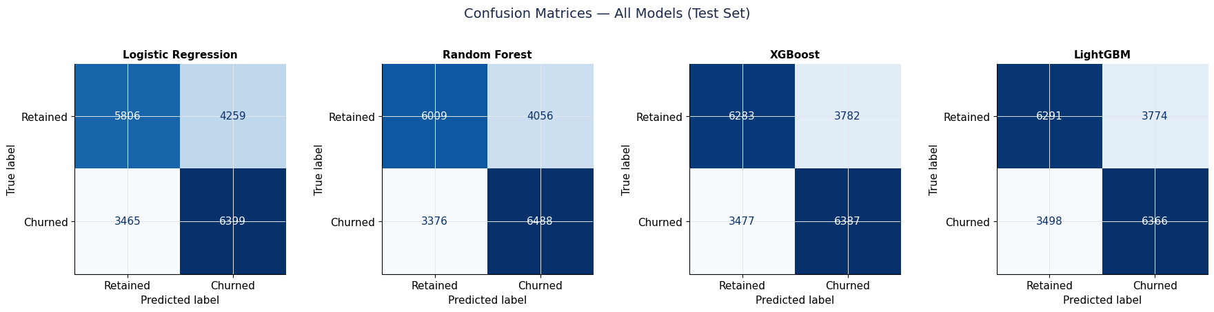

ROC Curve Comparison (Test Set)
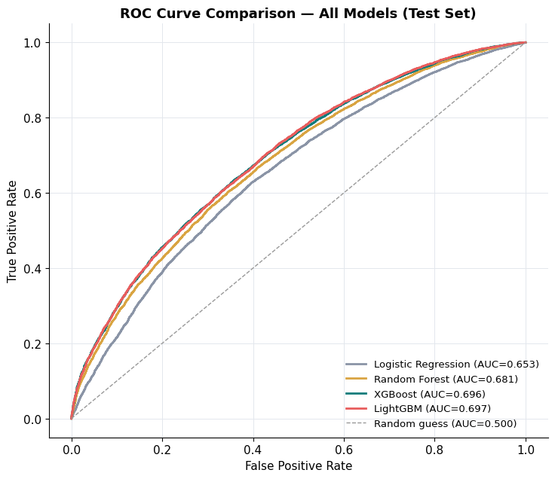

10. Final Model Selection
LightGBM was selected as the final production model.
- Highest ROC-AUC (0.697), narrowly ahead of XGBoost (0.696) — both clearly ahead of Random Forest (0.681) and Logistic Regression (0.653), consistent with churn being a non-linear, multivariate phenomenon.
- Comparable F1 and Recall to XGBoost, with substantially faster training and inference (full-training-set fit: ~9s for LightGBM vs. ~44s for Random Forest).
- Lower memory footprint and efficient handling of the 272-feature encoded matrix versus Random Forest.
- The gap versus XGBoost is within typical run-to-run noise; LightGBM is preferred primarily on the speed/accuracy trade-off for a system intended to be re-scored regularly (e.g., monthly).
Business reading of the numbers: ~65% recall means the model correctly flags roughly two-thirds of customers who will actually churn — useful for prioritizing retention outreach, but not a substitute for a human-reviewed retention strategy. ROC-AUC of ~0.70 indicates moderate discriminative power, consistent with the EDA finding that no single feature is strongly predictive in isolation.

11. SHAP Analysis
SHAP (SHapley Additive exPlanations) values decompose each individual prediction into additive per-feature contributions, providing both global importance and local, per-customer explainability. Values were computed using TreeExplainer on the final LightGBM model over a representative 2,000-row sample of the test set.

Global SHAP Summary
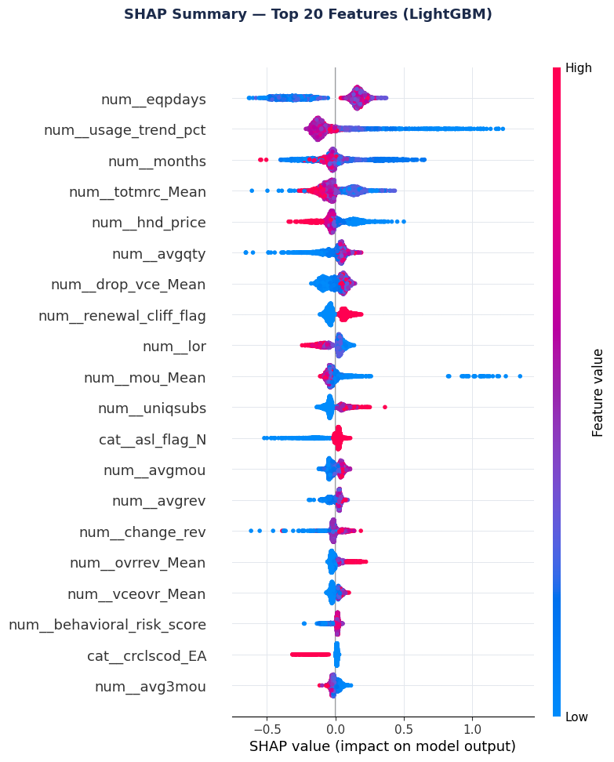
SHAP summary (beeswarm) plot — top 20 features ranked by impact on model output, showing both magnitude and direction of effect.

Local Explanation Example
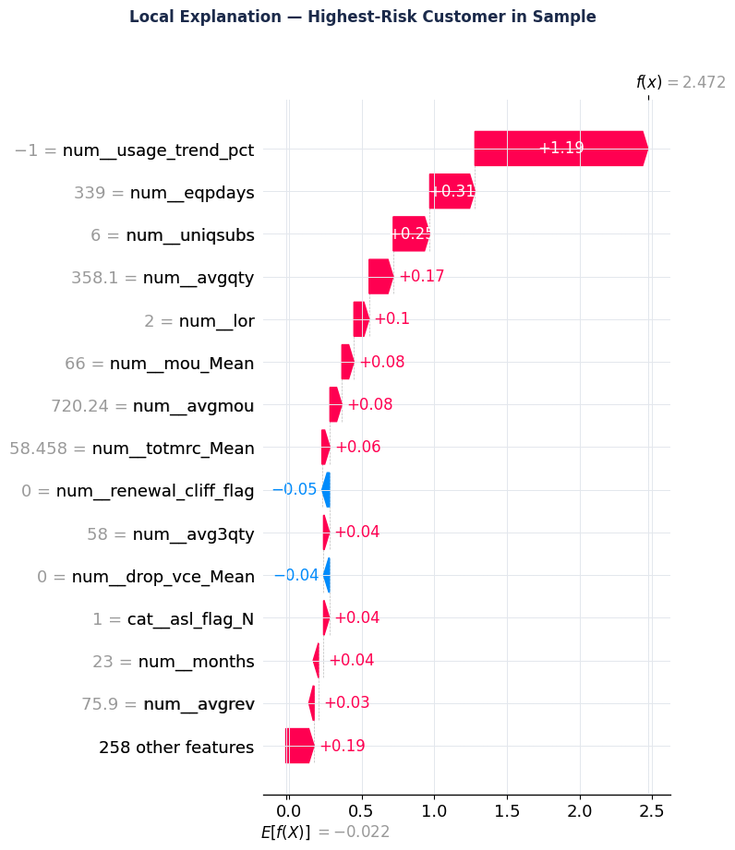
Waterfall explanation for the single highest-predicted-risk customer in the sample (predicted churn probability = 0.922), showing which features pushed the prediction up or down.

12. Feature Importance
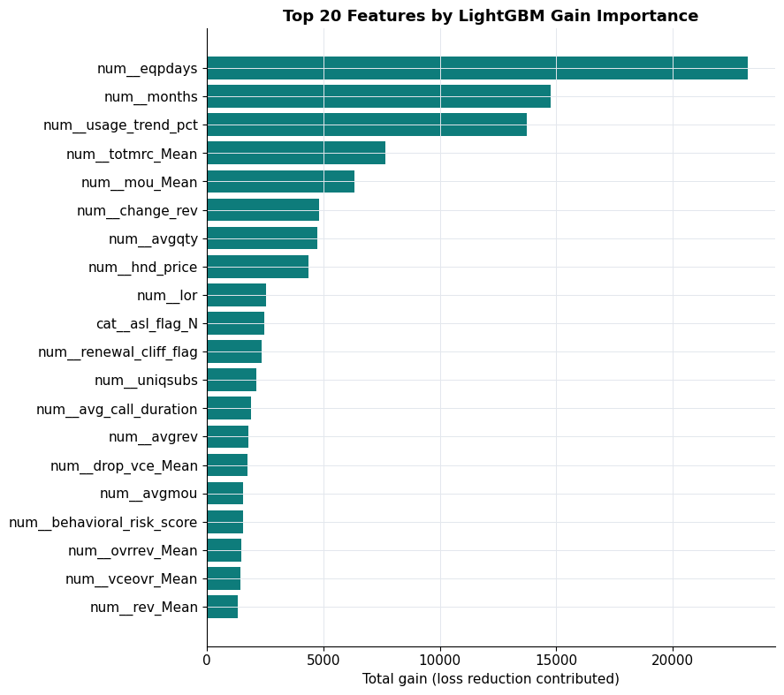
Top 20 features by LightGBM gain-based importance.

Business Interpretation of Top Features
Rank | Feature | Business Interpretation
1 | eqpdays | Equipment age — strongest driver by far; validates the Device Refresh Program recommendation.
2 | usage_trend_pct | % change in usage vs. own average — confirms usage decline (not level) is the leading indicator.
3 | months | Tenure — non-linear lifecycle effect, peaking at the first renewal window.
4 | totmrc_Mean | Average monthly recurring charge — plan-value indicator.
5 | hnd_price | Handset price — lower-tier devices associate with higher churn.
6 | drop_vce_Mean | Dropped calls — individually informative to the model despite a counter-intuitive aggregate EDA relationship.
7 | renewal_cliff_flag | Engineered tenure-window flag — directly operationalizes the renewal-cliff finding.
8 | lor | Length of residence — demographic stability proxy.
9 | mou_Mean | Average monthly minutes — core usage-intensity signal.
10 | behavioral_risk_score | Engineered composite risk score — validated as genuinely model-useful, not just descriptive.
Pattern across the top features: device/equipment, usage-trend, and tenure/lifecycle factors dominate, echoing the EDA. Traditional demographic fields are largely absent from the top ranks — behavioral and account/device data are far more predictive than demographics for this business.

13. Business Recommendations
1. Proactive Device Refresh Program
Trigger upgrade/trade-in offers once a customer reaches 18–24 months on the same handset — before churn risk climbs into the 3-year+ zone (60.3% churn).
2. Renewal-Cliff Save Campaign
Deploy targeted retention outreach at months 10–14 of tenure, ahead of the observed 13–18 month churn peak (52.7%).
3. Composite Risk-Score Early Warning System
Operationalize the equipment-age + usage-decline + tenure composite score into the CRM to flag the ~25% highest-risk customers (55.9% churn) for proactive retention treatment.
4. Silent-Disengagement Monitoring
Since vocal complainers churn less than average, build usage-decline and engagement-drop alerts as the primary churn signal, rather than relying on inbound complaint volume.
5. Regional Retention Investigation & Pilot
Commission a root-cause study and localized retention pilot in the highest-churn regions, where churn runs several points above the national base.

14. Deployment Strategy
- Deploy as a monthly batch risk-scoring job, not real-time — the dominant churn drivers here (equipment age, usage trend, tenure) evolve over weeks/months, not minutes.
- Recalibrate probabilities against the true population churn rate before using model outputs in ROI calculations, since the analytical dataset's ~49.5% churn rate likely reflects a stratified sample rather than live attrition.
- Pair the model with the recommended business playbook: route high-risk + device_refresh_due customers to the Device Refresh Program; route high-risk + renewal_cliff_flag customers to the Renewal-Cliff Save Campaign.
- Monitor for data/concept drift monthly, tracking live ROC-AUC and the distribution of top features (eqpdays, usage_trend_pct, totmrc_Mean); retrain when performance degrades or distributions shift materially.
- Expose SHAP local explanations operationally to retention agents, so they see why a specific customer was flagged (e.g., “old handset + declining usage”) and can tailor the offer accordingly.
- Run a randomized controlled pilot before full rollout — hold out a control group of high-risk customers receiving no intervention to measure the true causal lift of retention offers.
- Retain Logistic Regression as a governance/compliance baseline where full coefficient transparency is required beyond what SHAP provides for the boosted-tree model.

15. Model Limitations
- Modest discriminative power (ROC-AUC ≈ 0.70) — suitable for prioritizing retention effort, not for high-stakes automated decisions without human review.
- Single time-snapshot data — the near-50/50 churn rate suggests a stratified sample; the model has not been validated against a temporally held-out future period.
- No causal interpretation — feature importance and SHAP values reflect association, not causation (e.g., dropped calls being individually informative does not imply reducing them will reduce churn).
- Demographic data quality gaps — income, length of residence, number of vehicles, and adults fields have 23–49% missingness; indicators help but do not fully recover lost information.
- Sampling balance may not reflect deployment reality — recalibration against the true live churn rate is required before production use.
- Compute-constrained hyperparameter search — tuning used a reduced grid and training subsample for speed; production deployment would benefit from more exhaustive search on full infrastructure.
- No formal fairness/bias audit performed — recommended before any customer-facing or pricing-related use of this model.

16. Future Work
- Temporal (out-of-time) validation: train on an earlier period, test on a later one, to confirm the model generalizes to future churn rather than only to a random held-out sample of the same snapshot.
- Probability recalibration (e.g., isotonic regression) against the true live population churn rate.
- Formal fairness audit across income deciles, ethnicity, and other demographic groups before any customer-facing deployment.
- Randomized controlled trial of the top recommended retention actions to establish causal lift, not just association.
- Expanded hyperparameter search (Bayesian optimization, full training-set search) on production compute infrastructure.
- Incorporation of external/competitive signals (e.g., local competitor promotions, network outage logs) if available, to explain the remaining unexplained churn variance.
- Exploration of customer lifetime value (CLV) modeling alongside churn probability, to jointly prioritize retention spend by risk × value rather than risk alone.

17. Conclusion
This engagement delivered a complete, leakage-safe, and reproducible data science pipeline for telecom churn: from raw data understanding through cleaning, exploratory analysis, business-motivated feature engineering, multi-model training and tuning, rigorous evaluation, and explainability analysis.
The consistent, cross-validated conclusion across both the exploratory and predictive modeling stages is that device lifecycle and usage-trend behavior — not revenue or complaint volume — are the dominant churn drivers in this business. The final LightGBM model (ROC-AUC 0.697) operationalizes this insight into a deployable risk score, and the five prioritized business recommendations translate it into concrete retention actions: a proactive device-refresh program, a renewal-cliff campaign, a composite risk-score early-warning system, silent-disengagement monitoring, and a regional retention pilot.
With the recommended next steps — temporal validation, probability recalibration, a fairness audit, and a randomized controlled pilot — this model and its associated playbook are positioned to move from analysis into measurable retention impact.

