Book Tracker Project Documentation

1. Project Overview Document
Project Name: Shelf
Objective: A full-stack web application that allows users to discover books, manage personal reading lists, create custom collections, review books, and monitor reading activity.
Scope: The system includes user authentication, dashboards for users and administrators, profile management, search and filtering, book management operations, reviews, and collection management.
Target Users: General readers and administrators.
Entities and Roles:
- User: Registers, logs in, manages profile, tracks books and collections.
- Admin: Manages book catalog and administrative dashboards.
- Book: Represents books available in the system.
- Collection: Custom book groups created by users.
- Review: Ratings and comments on books.
- UserBook: Tracks reading status and favorites.
- Activity: Stores user activity history.

2. Functional Requirements Document (FRD)
User Authentication: Users register and log in securely using email and password. The system returns a JWT token for authenticated sessions.
Dashboard Access: Authenticated users can view personalized statistics and quick actions.
Profile Management: Users can view and edit their personal information and profile image.
Book Catalog Management: Users can browse books and administrators can add and delete books.
Book Details: Users can view detailed information, ratings, and reviews for each book.
Collection Management: Users can create and delete custom collections and add or remove books.
Review System: Users can submit ratings and add or remove comments for books.
Reading Tracker: Users can mark books as reading, completed, or want-to-read, and set favorites.
Activity Tracking: The system stores significant user actions.
Administrative Functions: Administrators access protected routes for catalog and dashboard management.

3. Technical Requirements Document (TRD)
Architecture: MERN-style application (React frontend, Node.js/Express backend, MongoDB database).
Frontend: React, Vite, React Router, Formik, Bootstrap.
Backend: Node.js, Express, JWT, bcrypt, dotenv, Mongoose.
Database: MongoDB using Mongoose ODM.
Authentication: JWT tokens with protected middleware.
Infrastructure: Node.js runtime, MongoDB database server, environment variables (PORT, MONGO_URI, JWT_SECRET).
System Architecture Diagram:
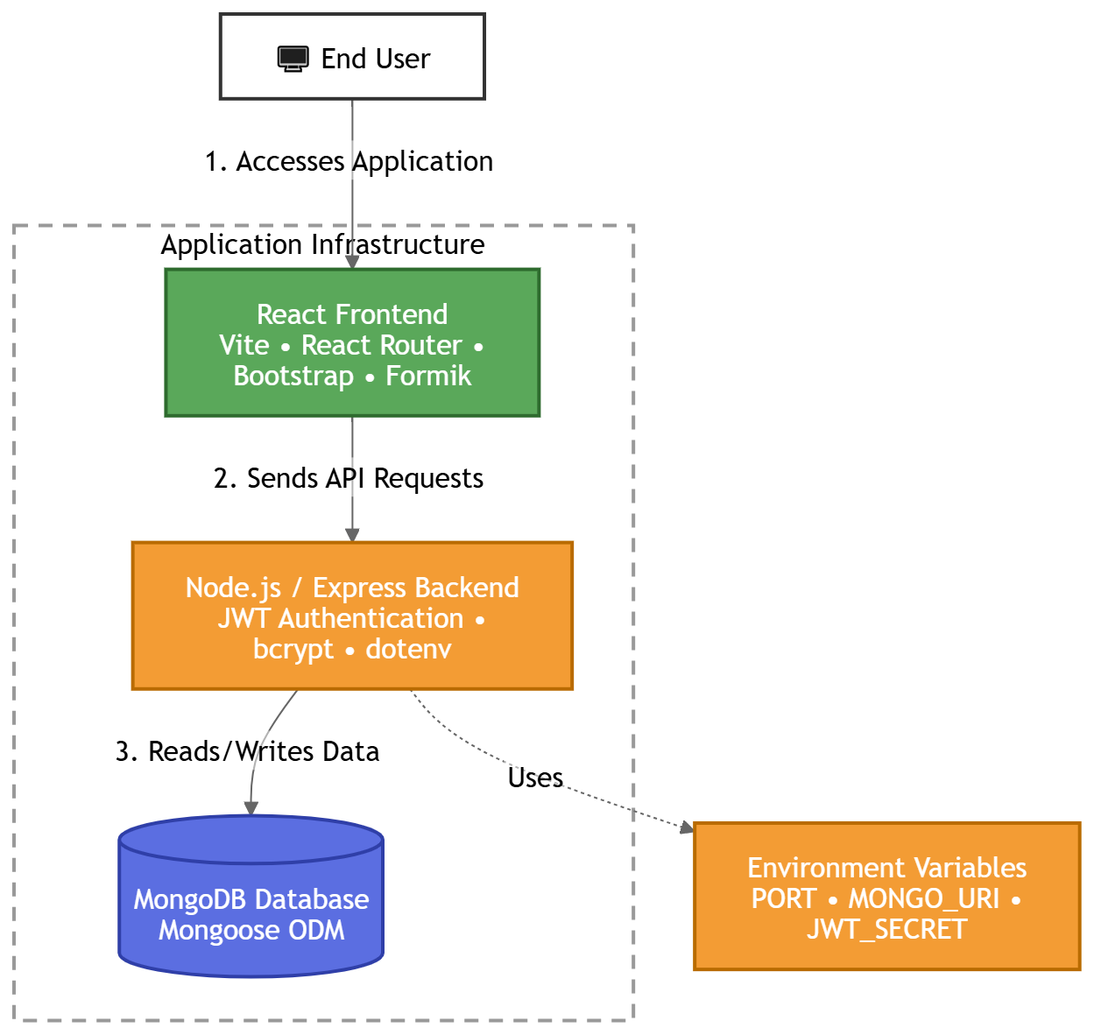

4. Database Schema Documentation
User: Stores first_name, second_name, email, password, profile_image, gender, is_admin, and timestamps.
Book: Stores title, author, cover_image, published_year, language, description, categories, pages, rating, total_reviews, total_reads, and timestamps.
Review: References userId and bookId, and stores rate, comments, and timestamps.
Collection: References userId and stores name, description, an array of books, and timestamps.
UserBook: References userId and bookId, and stores status, isFavourite, and timestamps.
Activity: Stores type, user, book, and timestamps.
Relationships:
- One User can create many Collections.
- One User can have many UserBook records.
- One User can create many Reviews.
- One User can create many Activities
- One Collection contains many Books.
- One Book can appear in many Collections, UserBook records and Reviews.
- One Activity can reference one Book
- One User can track many Books through UserBook records.
- One Book can be tracked by many Users through UserBook records.

5. API Documentation

