Parser Project



# Team members:

1. Mohamed Ali Ahmed Bakr 1801534
2. Mohamed Emad El Dien Mahmoud 1806046
3. Mohamed Elsayed Hassan Selim 1804989
4. Mohamed Ahmed Mahmoud Asran 1808040
5. Mo’men Wlaeed Mamdouh 1802418

# Screen Shots:

## Main Window:

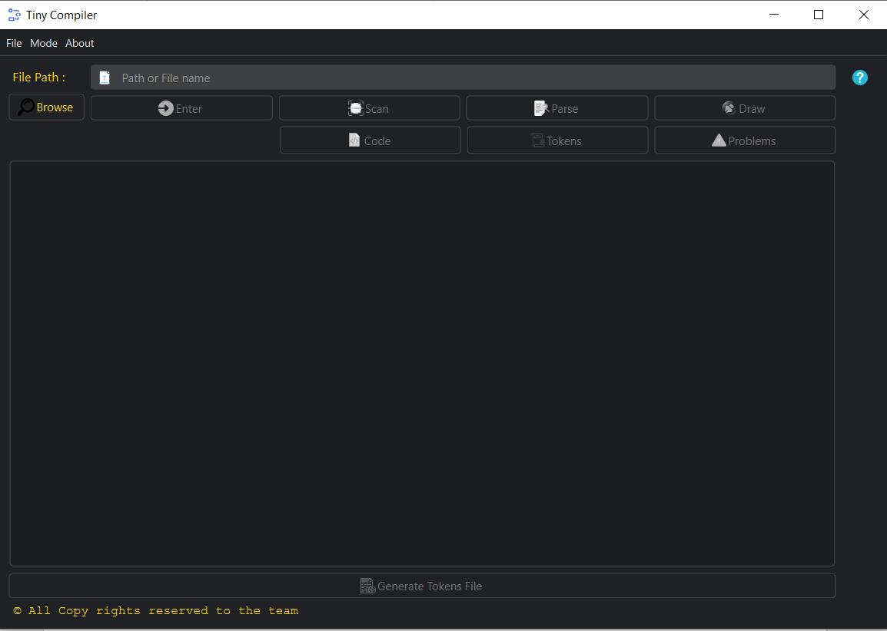

File Path : To put the tiny code path or filename If it was in the same directory with the app.

Browse button : Let you choose a file from the computer.

Enter button : check for the availability of the file and the type of it and the path syntax.

Scan button : to do scan on the tiny code and generate Tokens

Parse button : to do parsing on the tokens and to check syntax error

Draw button: if parser succeed the AST (Abstract Syntax tree) is available to draw.

Code Button: to show the tiny code.

Tokens button: to show the tokens generated from the scanner.

Problems button : to show the problems generated from scanner or parser.

Generate Tokens file: to generate tokens file .

## Browsing:

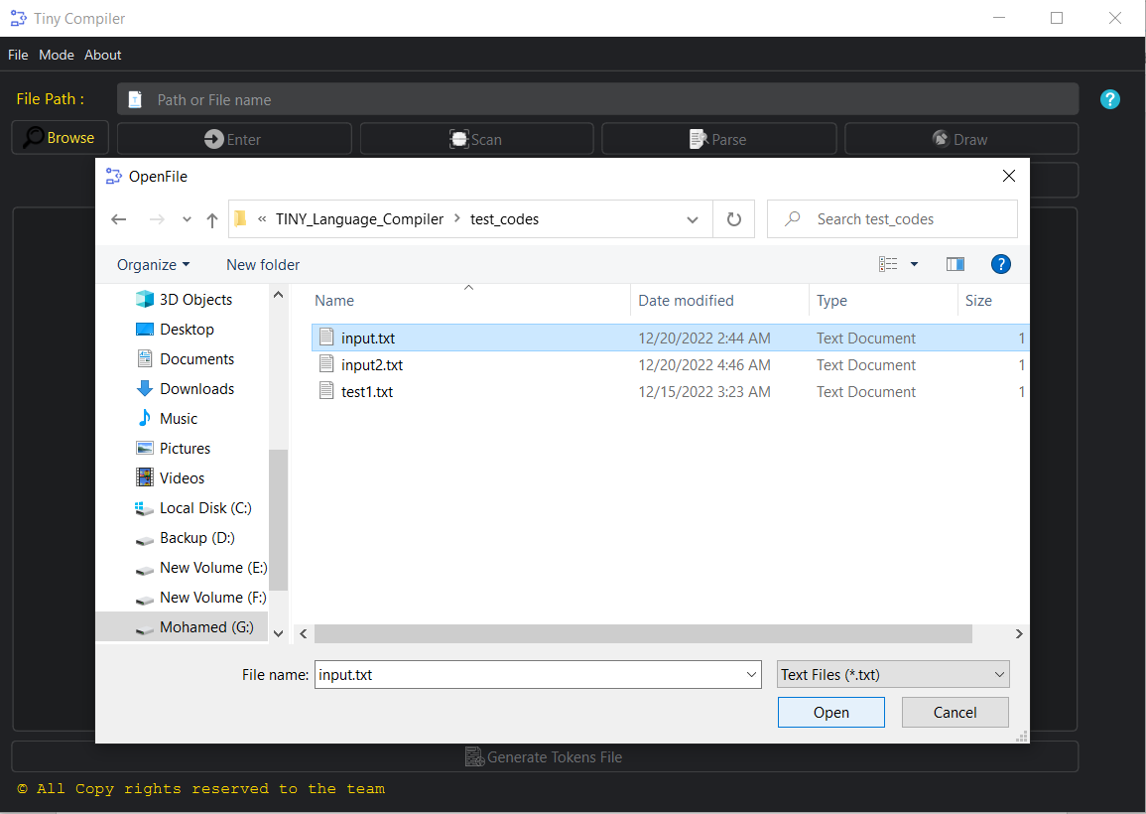

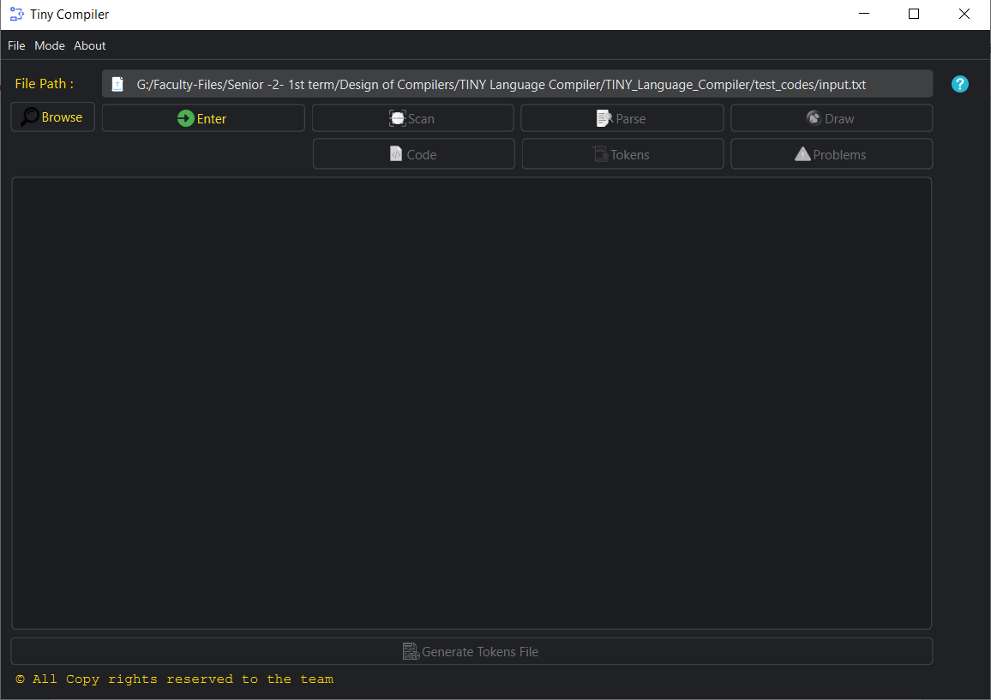 After clicking open enter button is now available to press and the path is filled.

After pressing enter button **Scan** and **code** buttons is now available.

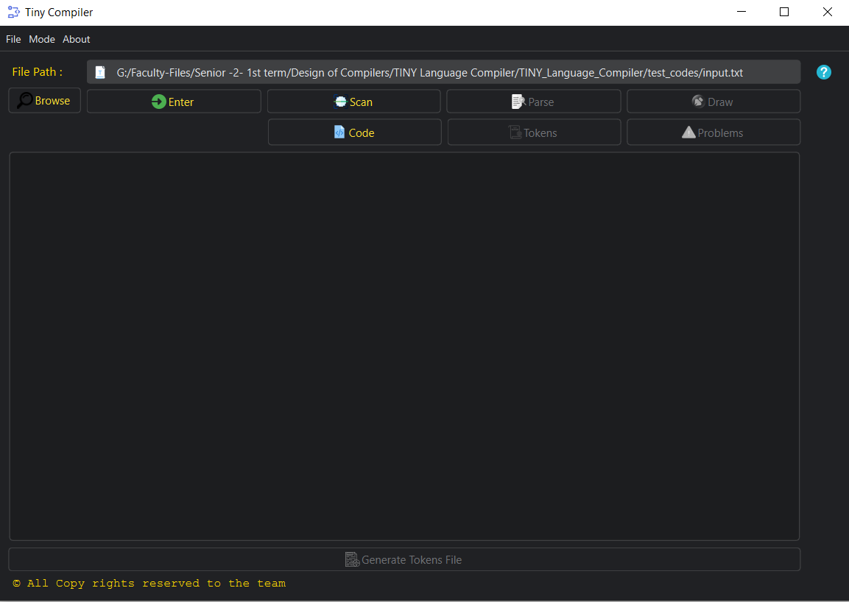

## Scanning:

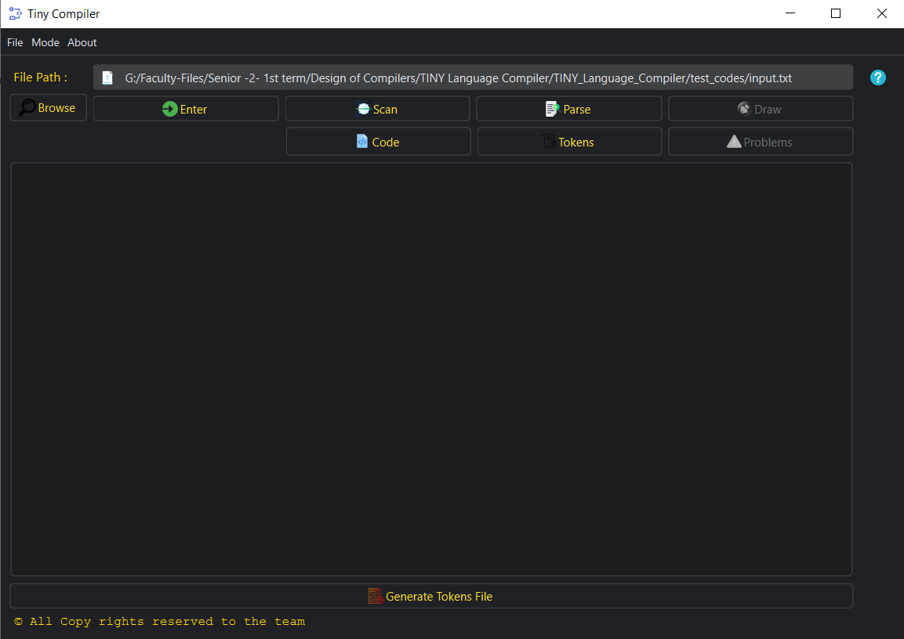

Now after press **scan** button **parse** and **tokens** button is now available.

After pressing **tokens** button tokens are showed in **text** area.

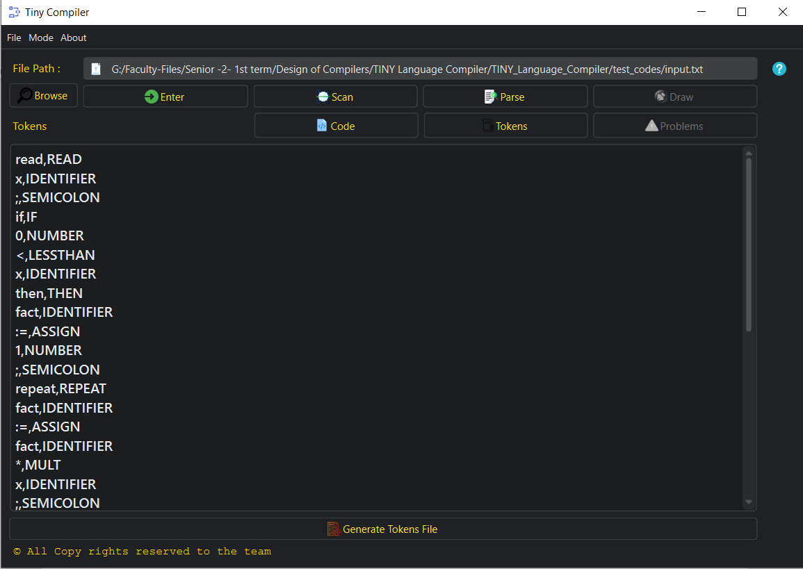

## Parsing:

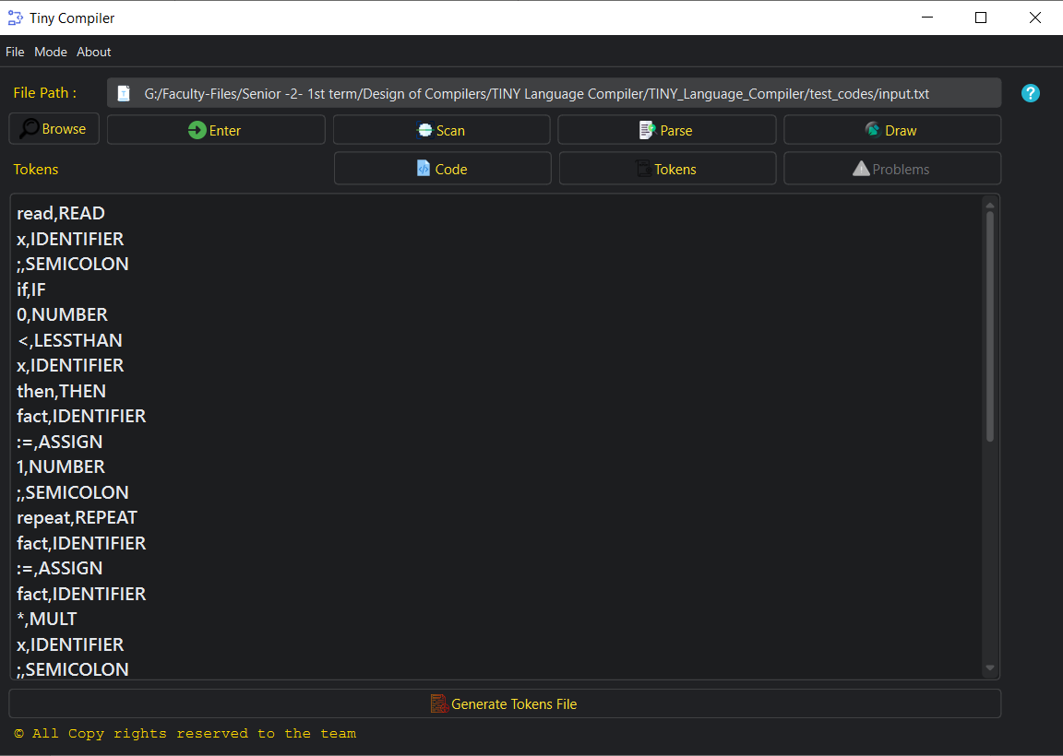After pressing parse button draw button is available with no errors.

## Drawing:

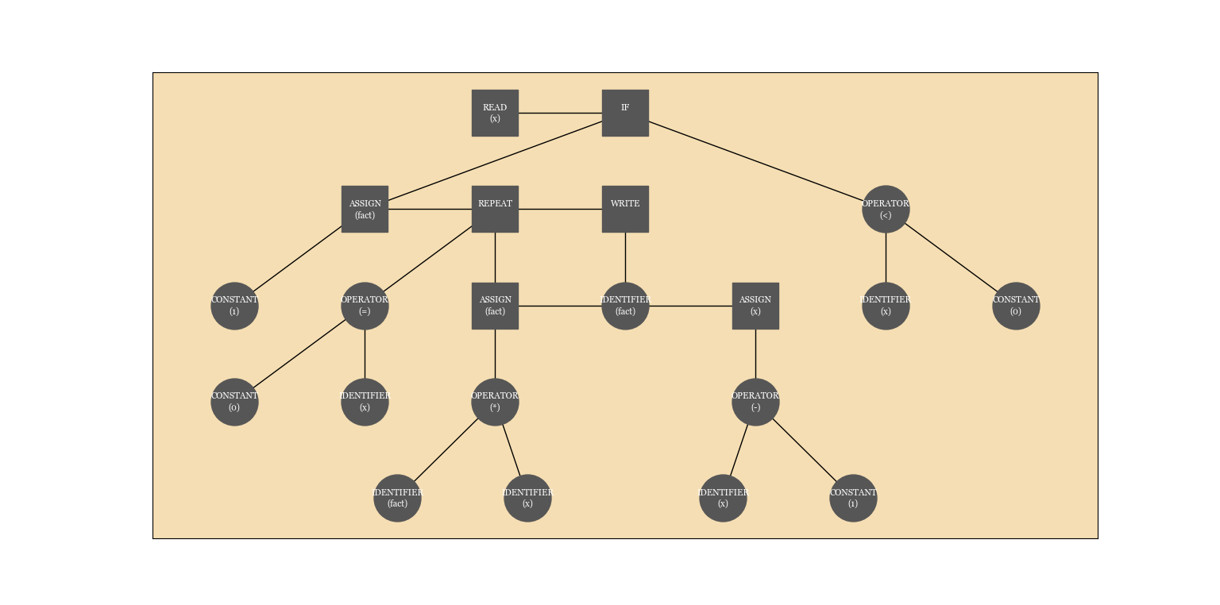After pressing **draw** button this image is generated.

## Here after editing in the code and butting scanner error. No $ symbol in the language. if 0 $ x then.

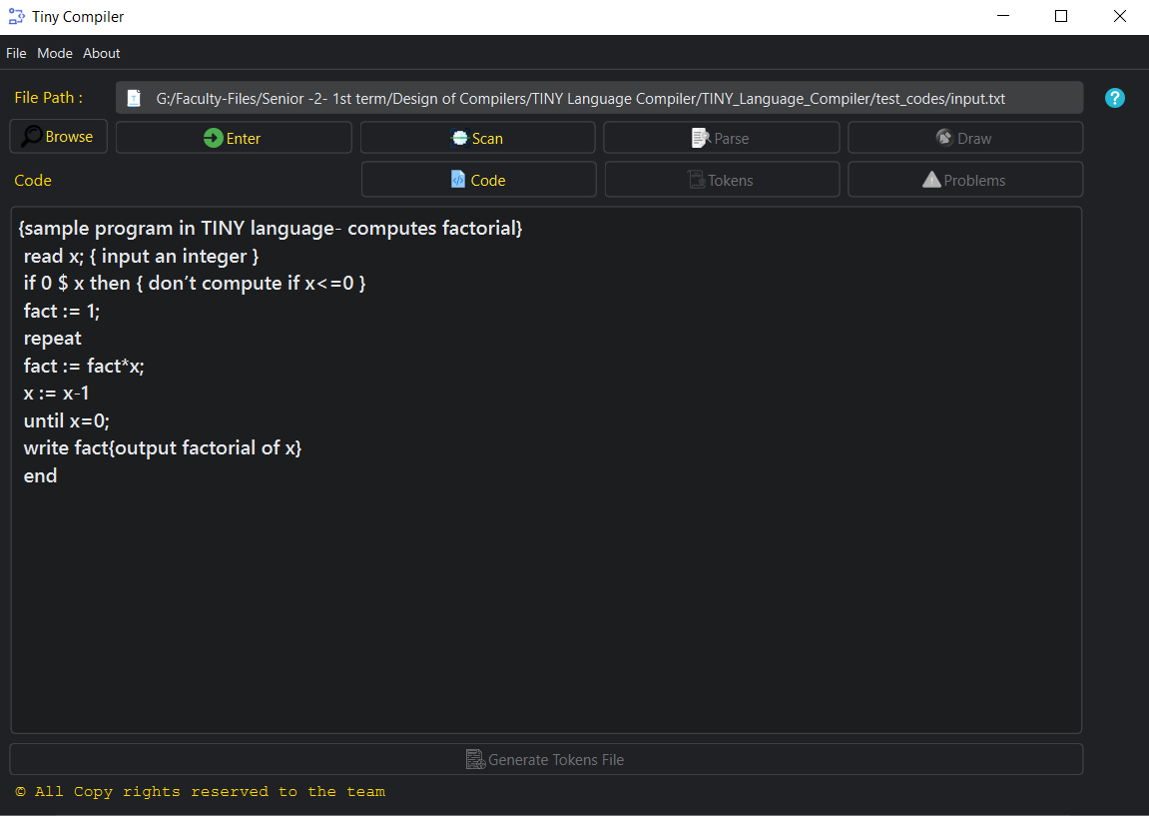

After pressing scan error message pop and problems button is available and **parse and draw** buttons is disabled.

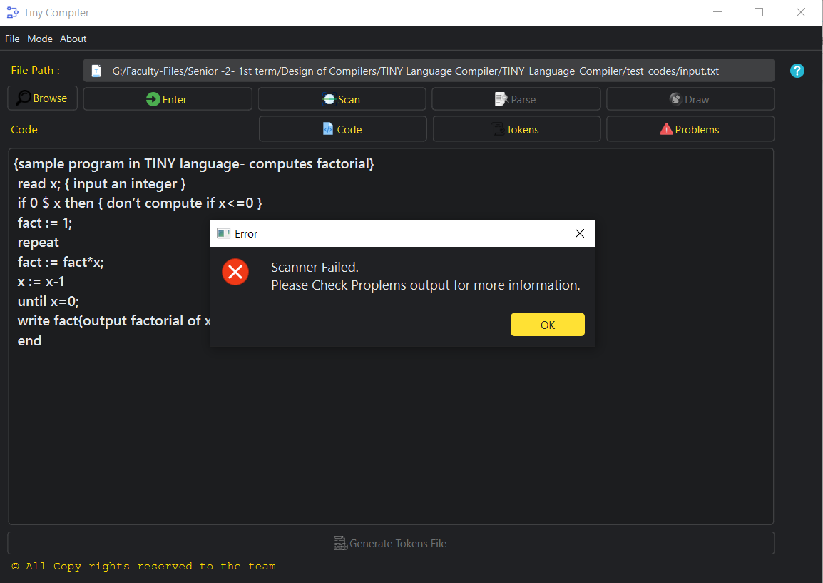

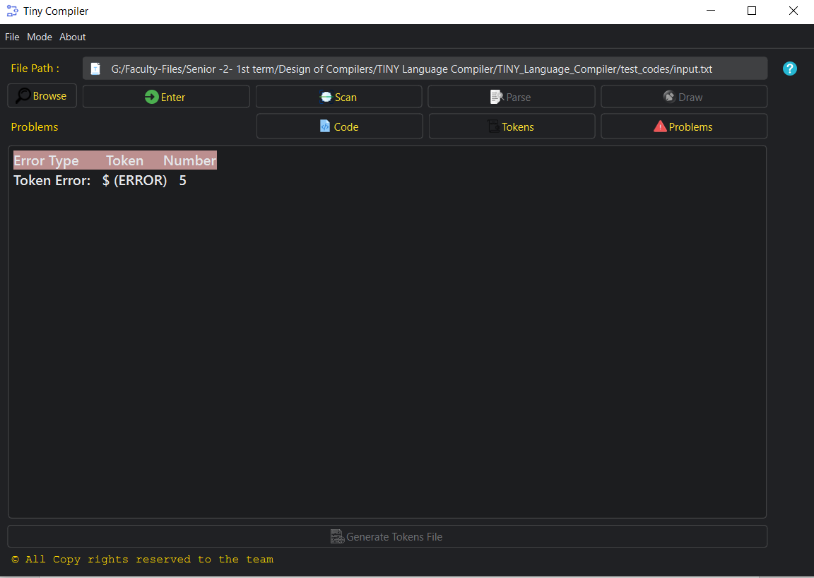After pressing **problems** button.

## Parser error:



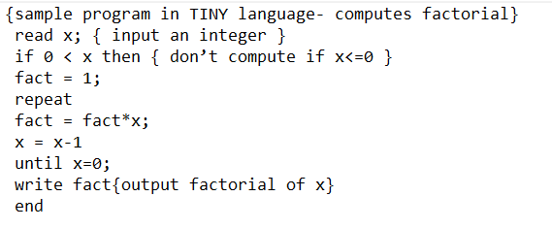

**Here are 3 syntax error .**

After scan and parse the code.

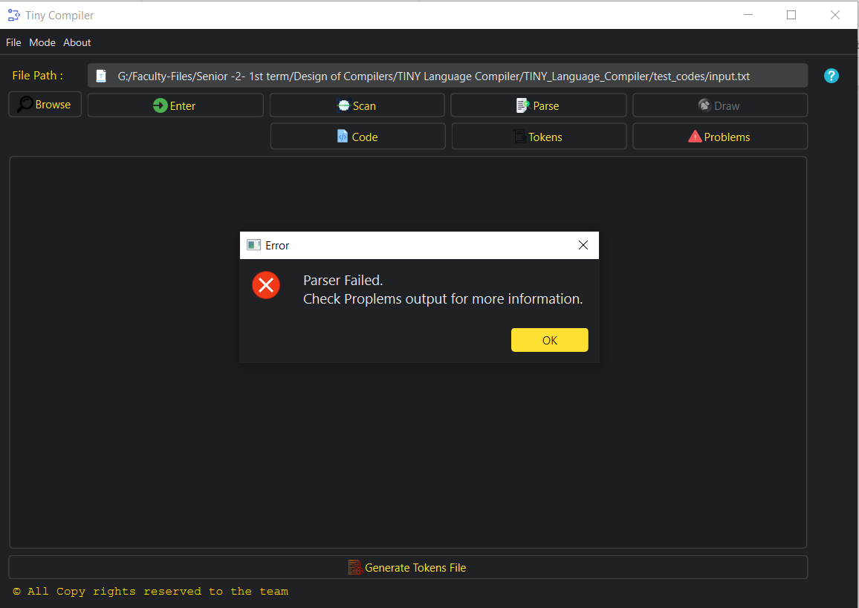

Error message is popped.

After pressing problems button:

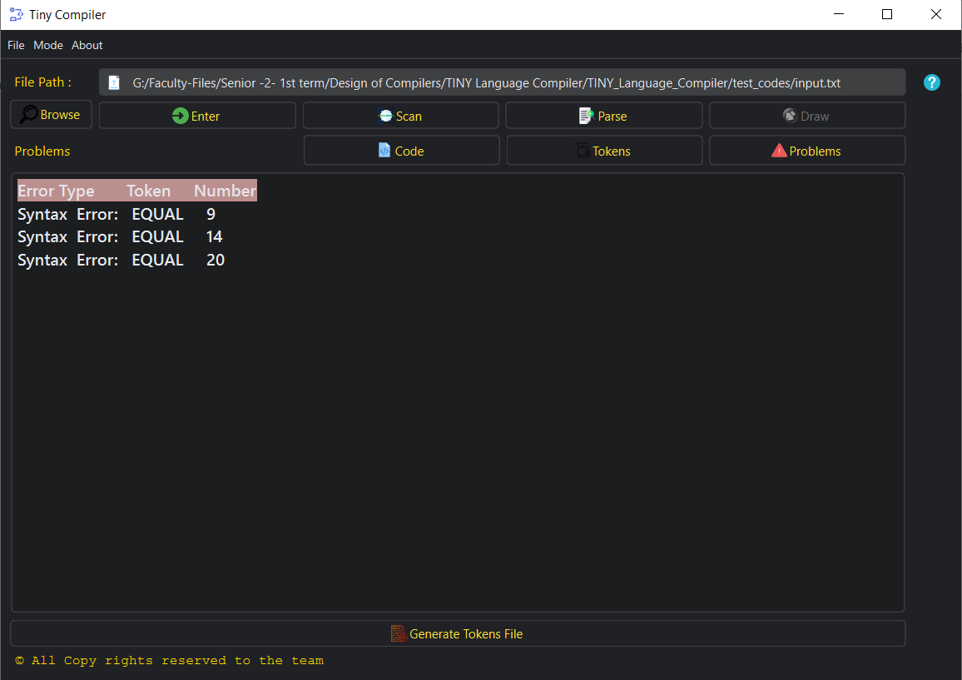

## There is also light mode available in the app could be chosen by CRTL+L or from mode menu bar.