TASK 10
Name: Mario Milad Helmy
ID: 2200540
- Introduction
The purpose of this project is to implement a solution for a coin removal puzzle using a greedy algorithm. The solution aims to clear all the coins from the raw by following specific flipping rules. This report details the logic, the implementation, and complexity of the provided c++ solution.
- Problem Description
The puzzle involves a line of n coins which can be Head (H) or Teal (T) the objective is t remove all coins based on the following rules:
- Only a head up (H) coin can be removed in any move.
- When a (H) coin is removed its neighbors must be flipped.
- Coins are only considered neighbors if they were adjacent in the original line if they are separated by space then they are no longer neighbors.

- Greedy Algorithm strategy and design
The implemented solution follows a greedy algorithm approach the core greedy choice is to always process the first available head (H) from the left of the string (line).
  - Core logic
The algorithm iterates through the string as soon as it finds (H) it
- Remove the coin and replace its position by (_ ).
- Identifies valid neighbors based on the current state and flip them.
- Resets the index to start the search from the beginning of the string again to ensure no newly flipped (H) is missed there.

  - Neighbor handling
The code checks for boundaries and previous removal to ensure only valid original neighbors are flipped if the neighbor has already been removed it is ignored.
- Success and Failure Analysis
- Success Condition: the algorithm is successful when the total number of Heads in the line is odd this allows the flip operations to eventually reach a state of zero coins
- Failure Condition: the algorithm fails when the number of Heads is even. Example of this failure can be because the problem rule can make gaps between coins and if a Tail coin becomes isolated it is impossible to flip or remove it because the gaps break the adjacency required for a flip.
- Algorithm Advantages and Disadvantages
- Advantages:
- the restart i=-1 will provides to the greedy algorithm the ability of going back to the start of the line and check again If there are left behind.
- It effectively simulates a recursive search without the memory overhead of deep recursion stack.
- Disadvantages:
- High time complexity O(n²)
- It failed in some cases of even number of heads

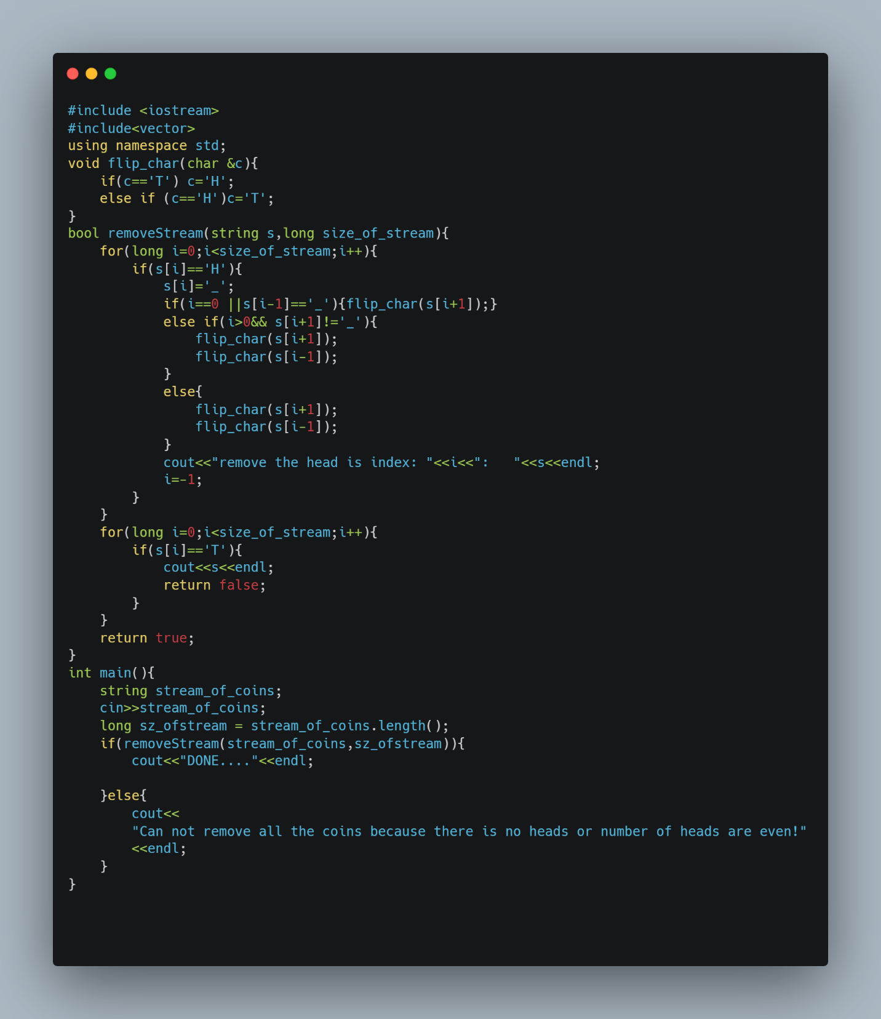
- Code snapshot:

- Pseudo code
Algorithm: removeCoins (stream_of_coins, n)
//input is a string of length n contains T,H
//output sequence of each move until it success of removing all coins or display fail message return true or false
for i $←$ 0 to n do
if stream_of_coins[i] = ‘H’ do
stream_of_coins[i] $←$ ‘_’
if i=0 or stream_of_coins[i-1]=’_’
flip(stream_of_coins[i+1]
else if i>0 and stream_of_coins[i+1] !=’_’
flip(stream_of_coins[i+1]
flip(stream_of_coins[i-1]
else
flip(stream_of_coins[i+1]
flip(stream_of_coins[i-1]
print message remove the head of what index followed by the stream
i $←$ -1
for j $←$ 0 to n do
if stream_of_coins[i]=’ T’
return false
return true

- Complexity Analysis
  - Time Complexity
The time complexity of this greedy algorithm is O(n²) in the worst case because we iterate through the string every time a removal occurs the index is reset since there are at most (n) removals each search takes O(n).
  - Space Complexity
The space complexity is O(n) because we need only string of length n so store the stream on it.
- Another Algorithms can be used:
- Brute force (backtracking) algorithm based on concept try and error so the idea of this algorithm explores a choice and if it hits an end it rewinds to the previous state to try a different head.
But this algorithm has big disadvantage which is high time complexity and also failed to solve the even number of heads up problem because the problem in this case is unsolvable.
Its Pseudo code:
ALGORITHM SolveRecursive(current_string)
if current_string contains only '_' then
return true
for i $←$ 0 to length(current_string) - 1:
if current_string[i] is 'H':
next_state $←$ Copy(current_string)
next_state[i] $←$ '_'
if i > 0 and next_state[i-1] is not '_':
Flip(next_state[i-1])
if i < Length - 1 and next_state[i+1] is not '_':
Flip(next_state[i+1])
if SolveRecursive(next_state) is true:
print "Removed index " + i
return true
return false
end ALGORITHM

- Dynamic Programming algorithm this algorithm based on concept of memorization
Instead of resolving a specific coin configuration many timr Dynamic Programming saves the result of every unique configuration in a table if the algorithm encounters a pattern it has seen before it knows if that pattern is solvable or unsolvable
But this algorithms also does not solve the even number of heads up problem
Its Pseudo code:
INITIALIZE MemoTable as empty Map (String -> Boolean)
ALGORITHM SolveDP(current_string)
if current_string exists in MemoTable:
return MemoTable[current_string]
if current_string contains only '_' then
return true
for i<- 0 to Length(current_string) - 1:
if current_string[i] is 'H':
next_state = ApplyMove(current_string, i)
if SolveDP(next_state) is true:
MemoTable[current_string] <- True
return True
MemoTable[current_string] <- false
return false
end ALGORITHM

- Comparison:
Algorithm name | Time complexity | Space complexity
Greedy algorithm | O(n²) | O(n)
Brute force(backtracking) | O(n!.n) | O(n²)
DP(dynamic programming) | O(n.2^{n}) | O(n.2^{n})

- Algorithm Enhancements
As we mentioned above about comparison between the 3 algorithms we found that our greedy solution is better in time and space complexity
But we can enhance the performance from O(n²) to O(n) by use queue data structure to store the indices of all head coins so instead of restarting the loop using i=-1 we can remove the index from the queue then flip its neighbors and if its neighbor became head we push its index to the queue
- Conclusion
The greedy approach provides an effective way to solve these coins flipping puzzle by consistently removing the leftmost (H) the algorithm maximizes the chances of converting (T) coins into (H) coins.
- Figures
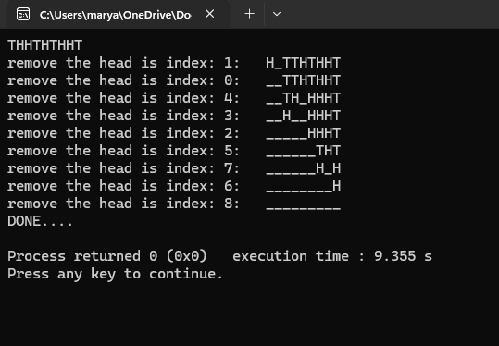
  - Output sequence if the stream is valid
Figure 1: Output sequence of valid stream

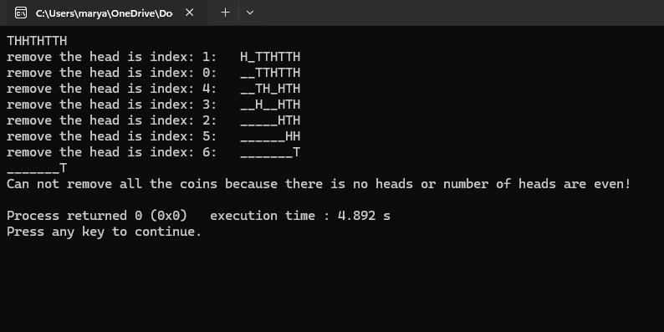
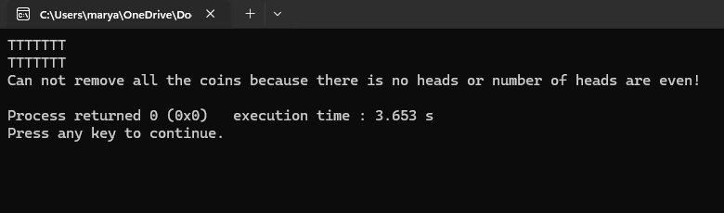
  - Output if the stream is invalid or can not be solved
Figure 3 :Output if the number of Head even
Figure 2:Output sequence if all the stream are T

- Reference
https://puzzling.stackexchange.com/questions/74208/coin-removal-problem

