Task:
Clustering Points with K clusters

Name:
Omar Mohsen Mohamed Amin

ID:
2200418

1. Problem Definition
The Cluster Points problem is a vital component of spatial data processing and unsupervised machine learning. Given an unstructured set of N points in a D-dimensional space, the objective is to partition these points into K in coherent groups such that the variance within each group is minimized. This is mathematically framed as the minimization of the Squared Error, where each point's contribution to the total cost is the square of its distance to its assigned cluster centroid.
The complexity of this problem arises from the vast number of possible partitions. For K clusters and N points, the search space grows exponentially, necessitating the use of approximation algorithms for practical datasets. In this report, we analyze the implementation and performance of three distinct algorithmic approaches: Brute Force, Iterative Improvement (K-Means++), and Divide and Conquer (Hierarchical).

Real-World Applications
• Autonomous Robotics: Path planning and obstacle identification from sensor point clouds.
• Digital Marketing: Segmenting user bases for personalized product recommendations.
• Bio-informatics: Clustering protein sequences to identify structural similarities.
• Image Compression: Reducing the color palette of an image while preserving visual fidelity.
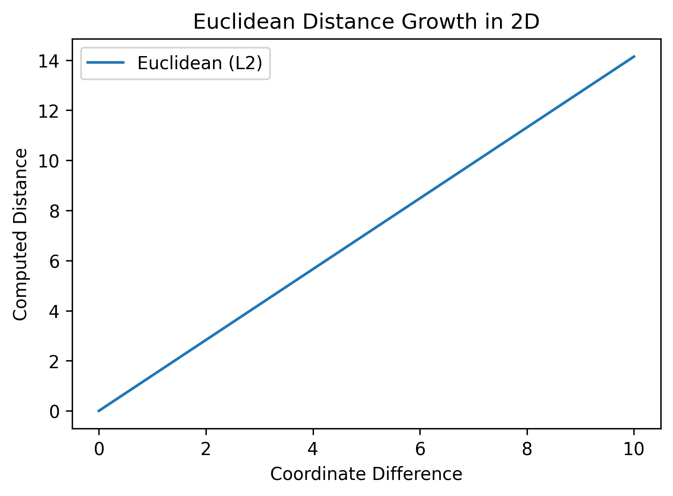
Figure 1: Euclidean distance visualization for 2D clustering.

2. Algorithm Descriptions

2.1 Common Utilities
Input: Point p1, Point p2
Output: Euclidean Distance
----------------------------------------
1: FUNCTION calculateDistance(p1, p2):
2: RETURN sqrt((p1.x - p2.x)^2 + (p1.y - p2.y)^2 + (p1.z - p2.z)^2)

Input: Points, Labels, k
Output: Updated Centroids
----------------------------------------
1: FUNCTION calculateCentroids(Points, labels, centroids, k):
2: count = array of size k initialized to 0
3: FOR EACH centroid in centroids DO: set x, y, z to 0
4: FOR i = 0 TO Points.size - 1 DO
5: c_idx = labels[i]
6: centroids[c_idx].x += Points[i].x
7: centroids[c_idx].y += Points[i].y
8: centroids[c_idx].z += Points[i].z
9: count[c_idx]++
10: END FOR
11: FOR i = 0 TO k - 1 DO
12: IF count[i] != 0 THEN
13: centroids[i].x /= count[i]
14: centroids[i].y /= count[i]
15: centroids[i].z /= count[i]
16: END IF
17: END FOR

2.2 Brute Force Clustering
The Brute Force strategy is an exhaustive enumeration method. It ensures a global optimum by checking every possible label combination for the points. This algorithm is useful for generating ground-truth results to verify the accuracy of more complex heuristics on small datasets.

Input: Points, Labels, Centroids
Output: SSD Cost
----------------------------------------
1: FUNCTION computeCostBruteForce(Points, labels, centroids, k):
2: cost = 0
3: FOR i = 0 TO Points.size - 1 DO
4: cluster_idx = labels[i]
5: cost += calculateDistance(Points[i], centroids[cluster_idx])
6: END FOR
7: RETURN cost

Input: idx, N, K, Points
Output: Best Labels
----------------------------------------
1: FUNCTION computeBruteForceLabels(idx, n, k, Points, labels, best_labels, min_cost):
2: IF idx == n THEN
3: centroids = calculateCentroids(Points, labels, k)
4: current_cost = computeCostBruteForce(Points, labels, centroids, k)
5: IF current_cost < min_cost THEN
6: min_cost = current_cost
7: best_labels = labels
8: END IF
9: RETURN
10: END IF
11: FOR i = 0 TO k-1 DO
12: labels[idx] = i
13: computeBruteForceLabels(idx + 1, n, k, Points, labels, best_labels, min_cost)
14: END FOR

Metric | Value
Time Complexity | O(K^N * N)
Space Complexity | O(N)
Optimality | Global Optimum

2.3 Iterative Improvement (K-Means++)
Our implementation of Iterative Improvement utilizes the K-Means++ initialization algorithm. Traditional K-Means is highly sensitive to the initial placement of centroids, often falling into poor local minima. K-Means++ addresses this by selecting the first centroid at random and picking subsequent centroids with a probability proportional to their squared distance from the existing centroids. This ensures a well-distributed initial state.
Input: Points, K
Output: ClusterResult
----------------------------------------
1: FUNCTION run(Points, k):
2: centers[0] = random point from Points
3: WHILE centers.size < k DO
4: sum = 0
5: FOR EACH point j DO
6: minDist = distance to nearest existing center
7: sum += minDist^2
8: END FOR
9: threshold = random(0, sum)
10: FOR EACH point j DO
11: cumulative += minDist^2
12: IF cumulative >= threshold THEN
13: centers.add(Points[j]); BREAK
14: END IF
15: END FOR
16: END WHILE
17: DO
18: finished = TRUE
19: FOR EACH point i DO
20: best_id = index of closest center
21: IF labels[i] != best_id THEN
22: labels[i] = best_id; finished = FALSE
23: END IF
24: END FOR
25: calculateCentroids(Points, labels, centers, k)
26: WHILE NOT finished
27: RETURN {labels, centers}

Metric | Value
Time Complexity | O(I * K * N)
Space Complexity | O(K + N)
Optimality | Robust Local Optimum

2.4 Divide and Conquer (Hierarchical)
This algorithm uses a bottom-up hierarchical approach. It starts with every point in its own cluster and merges the closest pairs until K clusters remain. The 'closest pair' search is optimized using a Divide and Conquer spatial algorithm, reducing the search time from O(N^2) to O(N log N).

Input: P, left, right
Output: ClosestPair Struct
----------------------------------------
1: FUNCTION closestPairUtil(P, left, right):
2: IF (right - left) <= 3 THEN
3: RETURN bruteForceClosestPair(P[left...right])
4: END IF
5: mid = (left + right) / 2
6: dl = closestPairUtil(P, left, mid)
7: dr = closestPairUtil(P, mid + 1, right)
8: d = min_dist(dl, dr)
9: strip = points in P within d of P[mid].x
10: sort(strip, by_y)
11: FOR i = 0 TO strip.size - 1 DO
12: FOR j = i + 1 TO next 7 points DO
13: IF distance(strip[i], strip[j]) < d THEN
14: d = distance(strip[i], strip[j])
15: END IF
16: END FOR
17: END FOR
18: RETURN d

Metric | Value
Time Complexity | O(N^2 log N)
Space Complexity | O(N)
Optimality | Stable/Deterministic

3. Step-by-Step Execution on Real Data
To provide a clear mathematical demonstration of the execution flow, we utilize a fixed dataset of four points: P1(1,1), P2(2,1), P3(5,4), and P4(6,5). We seek to divide these into K=2 clusters.

3.1 Brute Force Mathematical Walkthrough
The algorithm enumerates all 2^4 = 16 combinations. It calculates the centroid and cost for each.
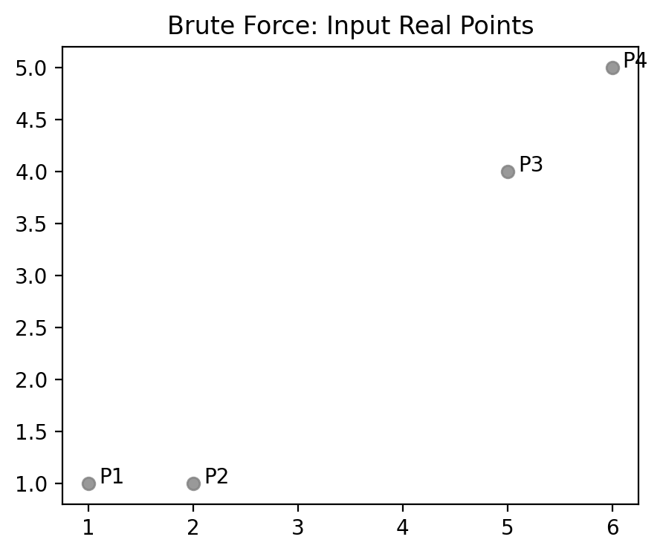
Figure 2: Input points P1-P4 are identified in coordinate space.
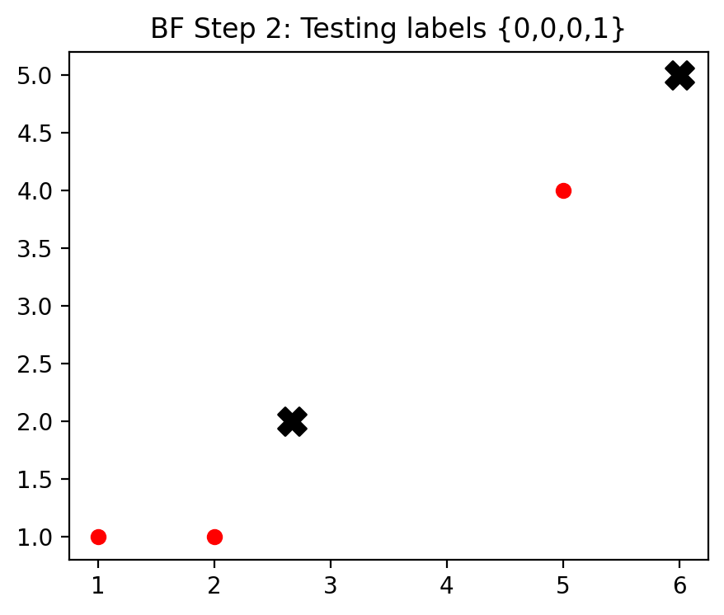
Figure 3: Testing labels {0,0,0,1}. Centroid 0 is (2.6, 2.0). Centroid 1 is (6, 5). Resulting cost is high (approx 18.3).
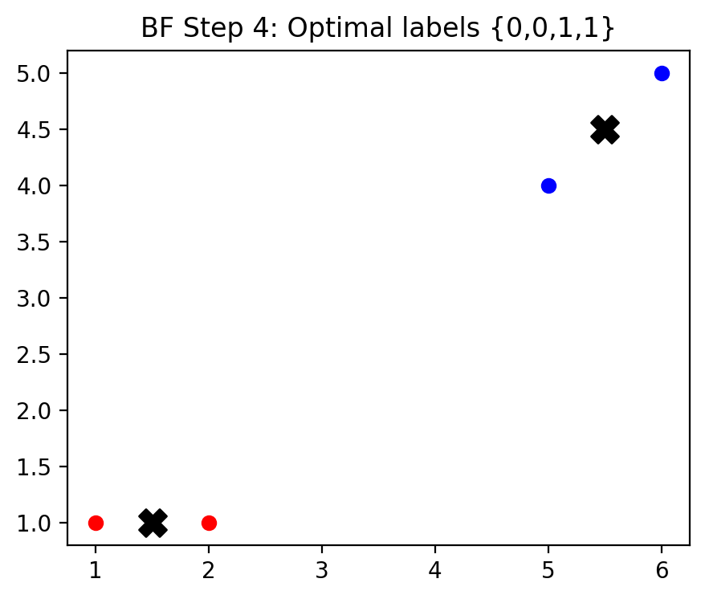
Figure 4: Optimal labels {0,0,1,1} found. Centroid 0 is (1.5, 1.0). Centroid 1 is (5.5, 4.5). Total SSD cost = 2.0.

3.2 Iterative Improvement (K-Means++) Walkthrough
The algorithm uses the K-Means++ seeding logic. First, P1(1,1) is chosen randomly. The next center is chosen with probability proportional to its squared distance from P1. This likely picks P3 or P4 due to their distance, resulting in an optimal initial spread.
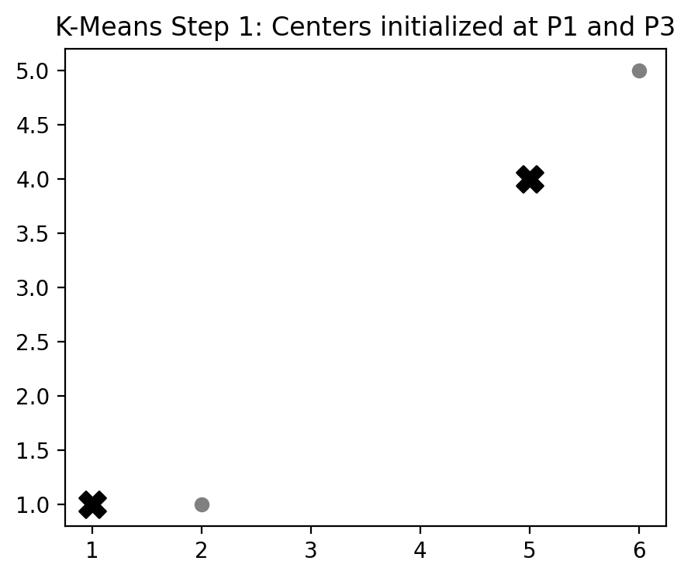
Figure 5: K-Means++ Seeding. Centers chosen at (1,1) and (5,4) using probability distribution.
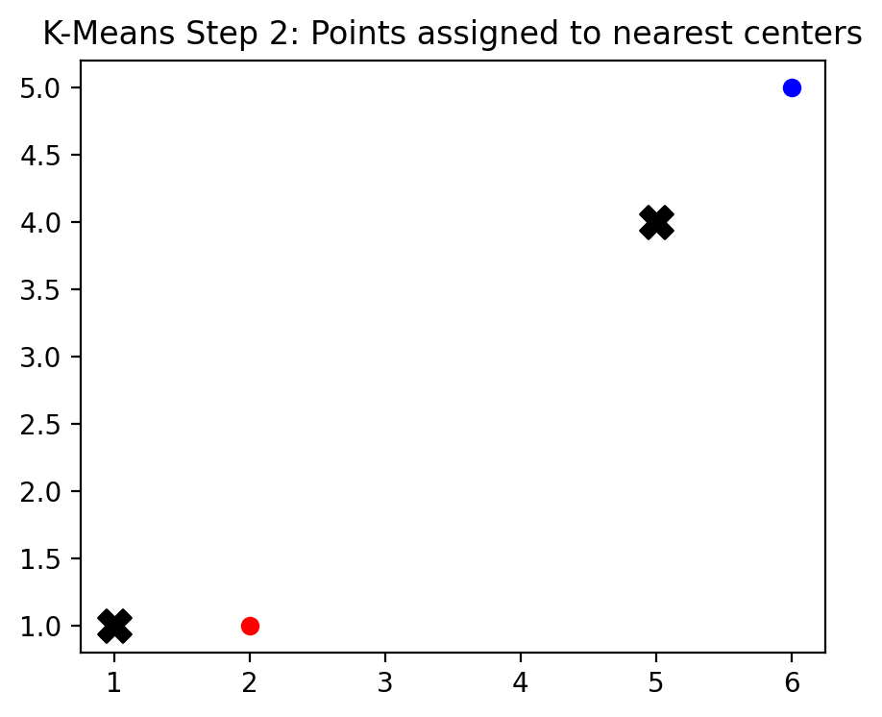
Figure 6: Assignment Step. P1/P2 assigned to C1. P3/P4 assigned to C2.
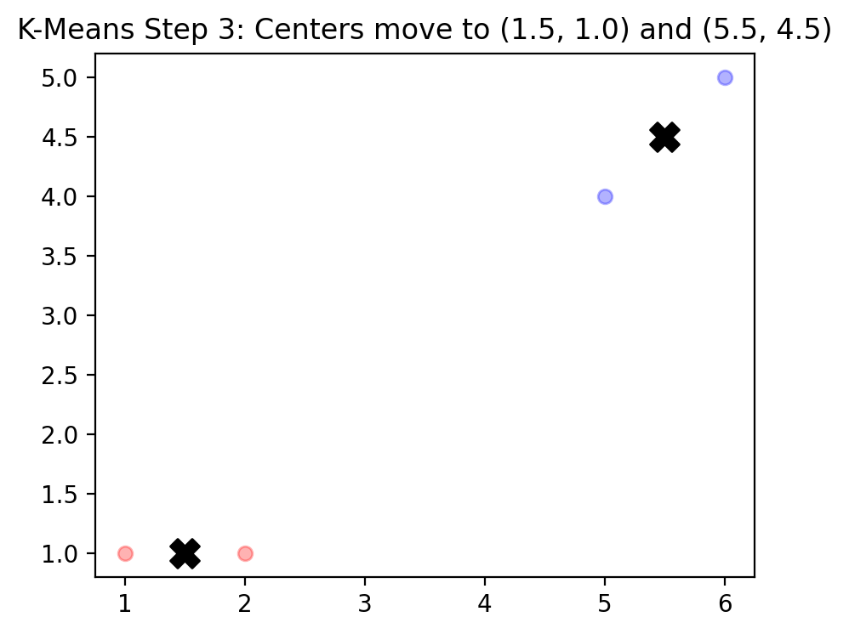
Figure 7: Update Step. Centers recalculate to (1.5, 1.0) and (5.5, 4.5).

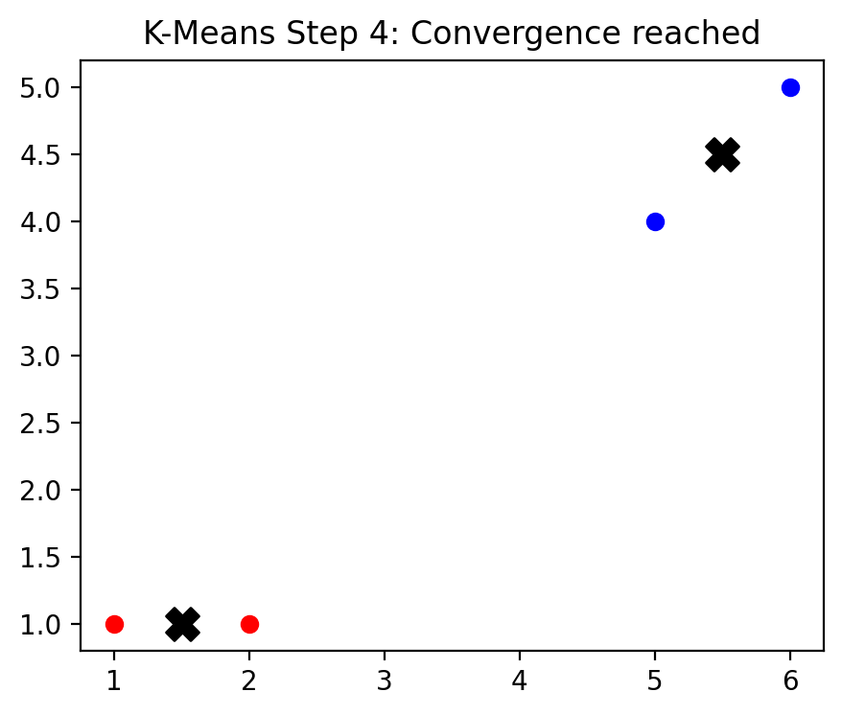
Figure 8: Convergence. Stable centroids reached in minimum iterations thanks to K-Means++ seeding.

3.3 Divide and Conquer (Hierarchical) Walkthrough
The algorithm performs agglomerative merging by identifying the globally closest pair of clusters.
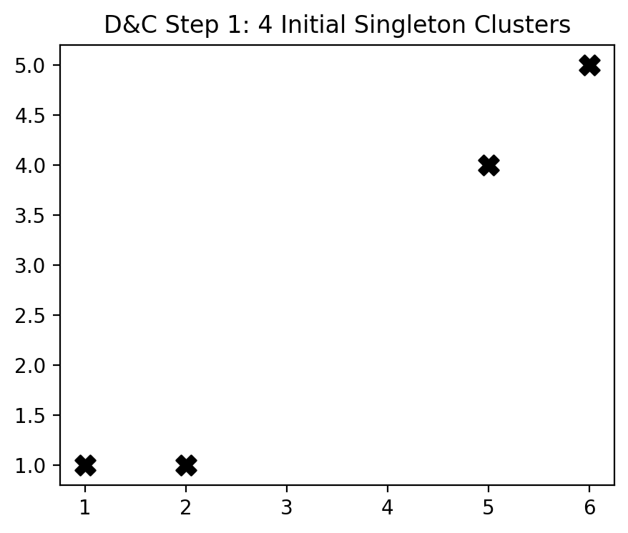
Figure 9: Start with 4 singleton clusters at each point's coordinates.
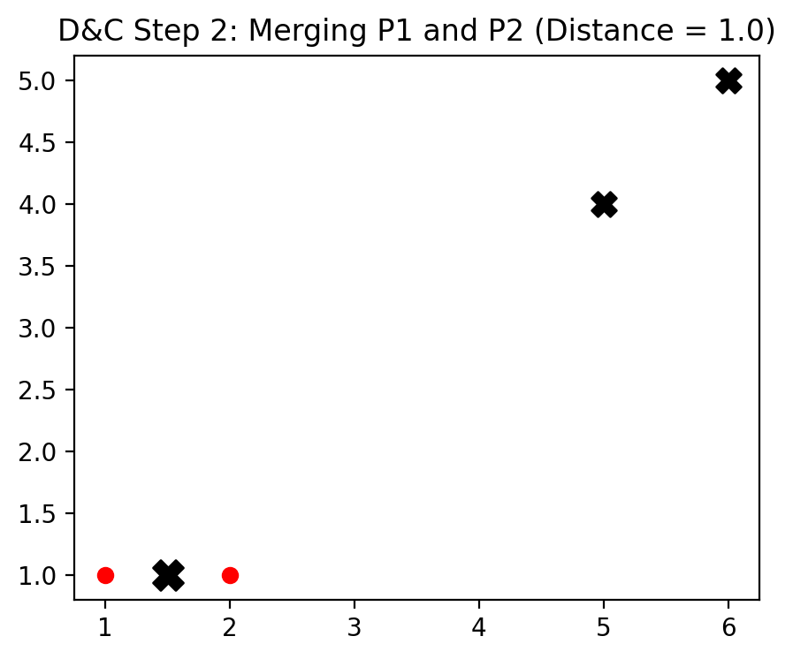
Figure 10: D&C identifies P1 and P2 as the closest (dist=1.0) and merges them into cluster (1.5, 1.0).

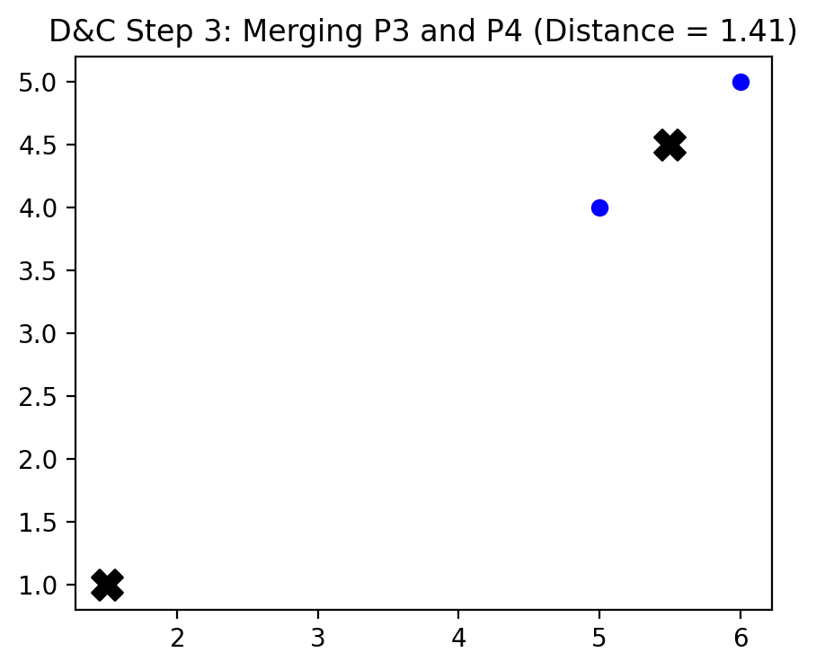
Figure 11: Next closest pair is P3 and P4 (dist=1.41). They are merged into cluster (5.5, 4.5).

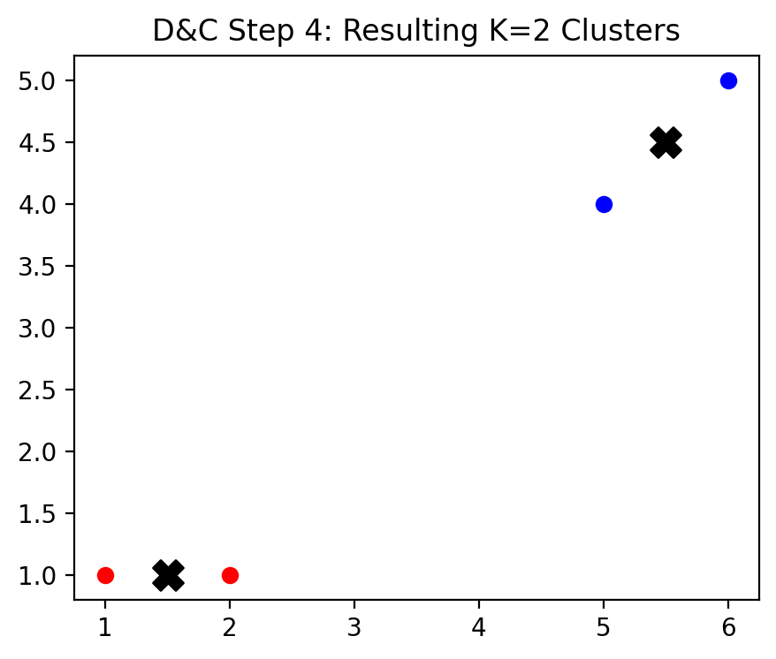
Figure 12: K=2 clusters remain. The algorithm terminates and assigns points to these final centers.
Figure 13: Output of those points for each algorithm

4. Code Implementation Walkthrough
The implementation in C++ follows a robust design pattern, utilizing custom structures to manage point data and clustering results efficiently.

Implementation Architecture
• Point Structure: Standardized for 2D and 3D support. The 'z' coordinate is used for volumetric datasets.
• Common Namespace: Centralizes the core mathematics. 'calculateCentroids' is a shared utility that calculates the geometric mean of point sets based on an index label.
• K-Means++ Logic: Explicitly implemented in IterativeImprovement::run using a while loop for probabilistic centroid selection, ensuring robust start states.
• D&C closest Pair: Implements the O(N log N) recursive spatial split. It sorts points by X, recursively finds the minimum distance in each half, and merges the result using a spatial strip to check.
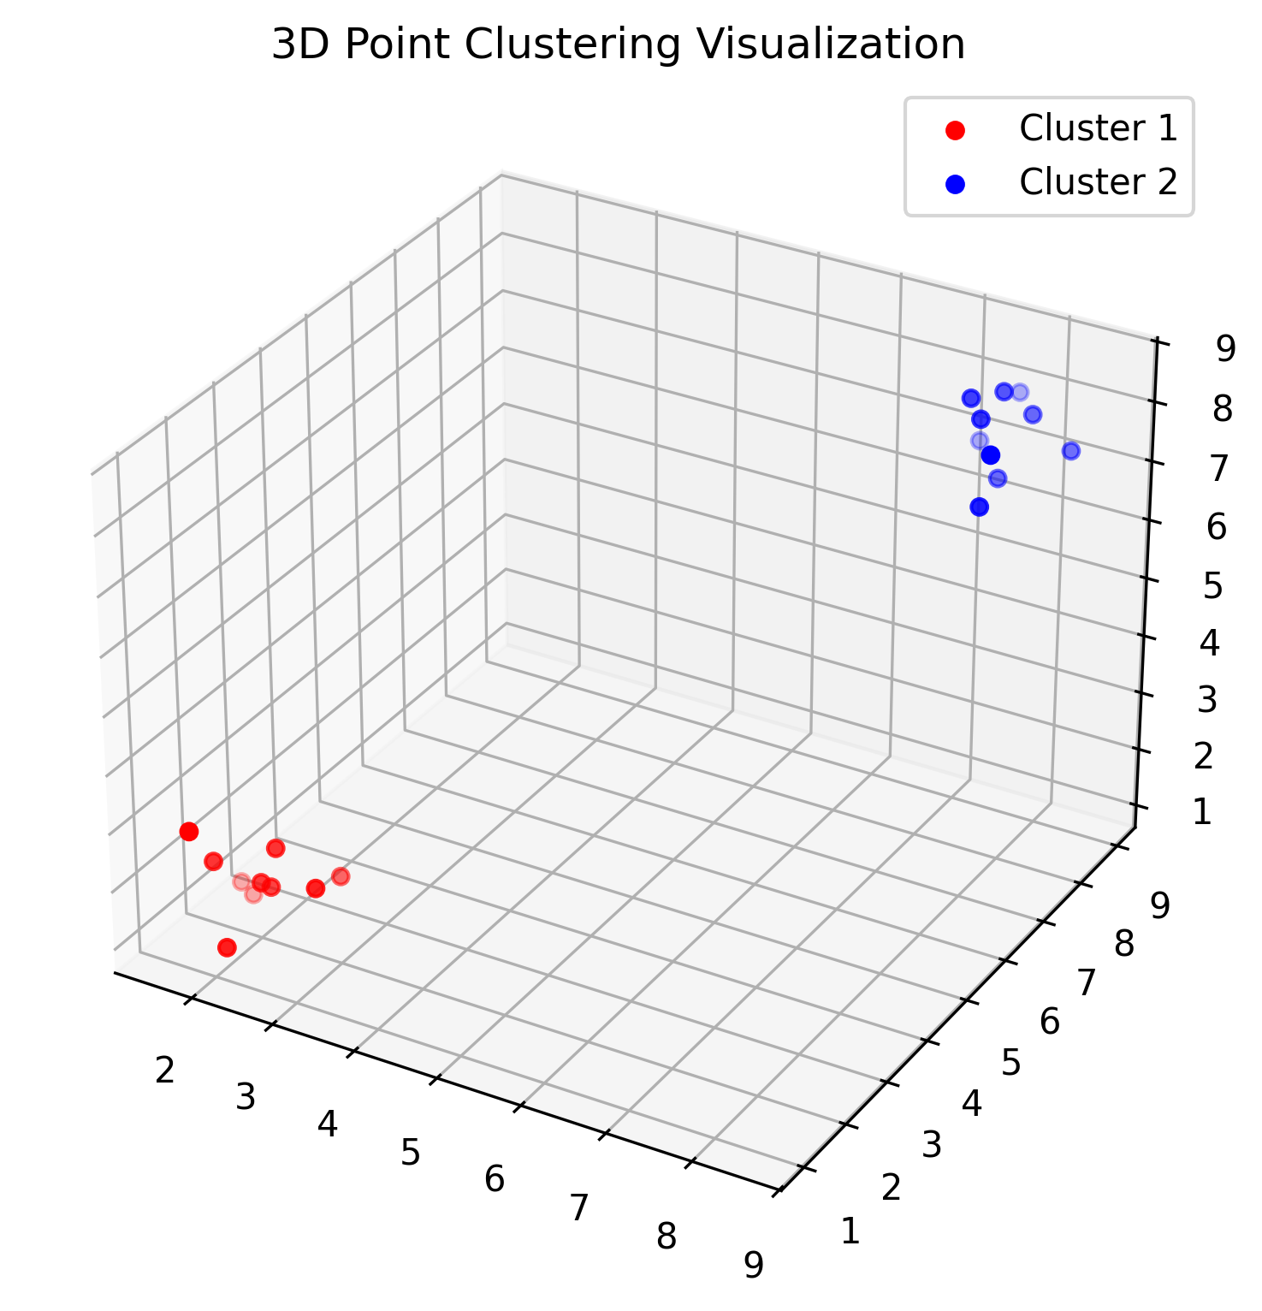
Figure 10: Demonstration of successful clustering on a 3D point cloud.

5. Detailed Comparison Table
Criterion | Brute Force | K-Means++ | Divide & Conquer
Strategy | Exhaustive | Greedy + Probabilistic | Hierarchical Merge
Complexity | O(K^N * N) | O(I * K * N) | O(N^2 log N)
Accuracy | Absolute | High | Very High
Determinism | Deterministic | Non-Deterministic | Deterministic
Initialization | None | K-Means++ Required | None
Scalability | Low (N<20) | High (N>10k) | Moderate
Robustness | High | Very High (Seeding) | Moderate
3D Support | Yes | Yes | Yes
Advantages | Global Min | Superior Seeding | Reproducibility
Disadvantages | Incomputable | Local Trap (Rare) | Memory Usage

6. Summary of Strengths and Weaknesses
This section summarizes the key pros, cons, and ideal use cases for each algorithm in a comparative format to assist in selecting the optimal strategy for a given data profile.
Algorithm | Strengths (Pros) | Weaknesses (Cons) | Best Use Case
Brute Force | Guarantees the global minimum cost. Perfect for verifying correctness on small sets. | Exponential time complexity O(K^N). Completely unscalable for N > 25. | Ground-truth validation and academic verification.
Iterative Improvement (K-Means++) | Superior seeding prevents poor local optimum. Extremely fast and linear scaling. | Still iterative in nature. Requires multiple runs for perfect confidence. | Large-scale commercial data mining where performance is critical.
Divide and Conquer (Hierarchical) | Deterministic and highly stable results. No random initialization bias. | Agglomerative merging is O(N^2). Irreversible merging mistakes. | Scientific research where deterministic reproducibility is critical.

7. Conclusion
In conclusion, the analysis of clustering algorithms reveals a clear spectrum of trade-offs between computational cost and solution quality. For the highest precision on small datasets, Brute Force is the only method that eliminates all approximation errors. However, the sheer volume of modern data makes the Iterative Improvement (K-Means++) algorithm the most valuable tool for general applications, specifically because its advanced probabilistic seeding addresses the convergence issues of traditional methods.
The Divide and Conquer approach offer an excellent deterministic alternative for cases where reproducibility is more important than raw speed. This study highlights that selecting the right algorithm depends entirely on the dataset's scale and characteristics.

8. References
The meaning of Clustering
K means Clustering – Introduction
Divide-and-Conquer in Closest Pair of Points
Minimum Distance between Two Points

