Task: 1

Name: Mohamed Ali Mohamed Elwan

ID: 2200942

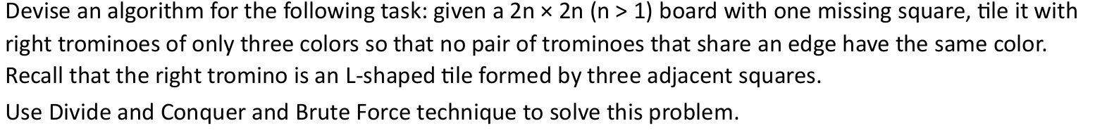
First lets talk about techniques:
- Brute Force
- Divide and conquer

Brute Force :
Brute force is one of the simplest and most direct problem-solving strategies in computing. It systematically tries all possible solutions until the correct one is found. While it is computationally expensive, its simplicity makes it a good starting point for understanding and solving problems.

Steps :
- Checking all possibilities
- Testing every case
- Guaranteed to find answer if one exists

- Time Complexity: Ranges from O(n) to O(n²) or worse, depending on the problem.
- Space Complexity: Often O(1), as brute force solutions typically don’t require additional memory.

Now let's try to apply brute force to our problem, But we should know that:


Which means : Brute Force algorithm is not smart

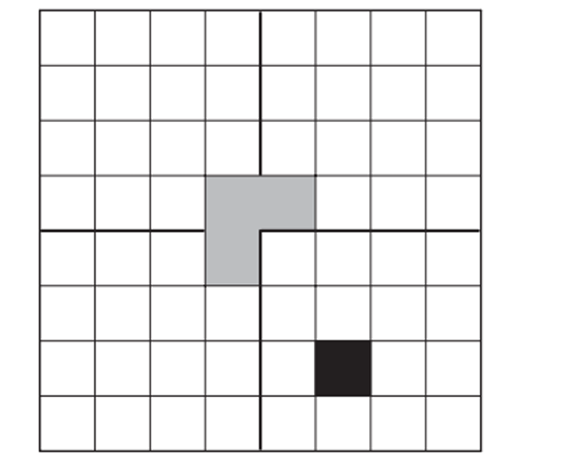
That’s our problem :

Lets think about it , How to apply brute force ?
The answer is to apply all possible ways to tile trominos .
But there are two problems:
1- Massive number of ways
2- Missing variable is Not constant (Remember that brute force is not smart)
Which means there is no memory or CPU can withstand these calculations and possibilities ,
Which lead to Brute force is impossible for our problem

Divide and conquer

Divide and Conquer algorithm is a problem-solving paradigm that breaks a complex problem into smaller, more manageable sub-problems, solves each sub-problem independently, and then combines their solutions to address the original problem. This recursive approach is particularly effective for problems that exhibit overlapping sub-problems and optimal substructure properties.
The process typically involves three main steps:
- Divide: Split the problem into smaller sub-problems.
- Conquer: Solve each sub-problem recursively.
- Combine: Merge the solutions of the sub-problems to form the solution to the original problem.

The most important property :

-- Sub-probelms have same properties of Main problem—

Now let's try to apply Divide and conquer to our problem:


That’s our problem :

There is a missing in one quarter in board ,
But there are many possibilities , lets make
Problem more small and divide it


That is the base case we have , 4 cells and one of the is missing
, now the problem is more easy , we have (L shape tromino),
Just know the missing cell and put the tromino ,so the Sub-problem
Become more much easy , now think about the main problem
, to solve it using divide and conquer we must apply the most
Important property (Sub-probelms have same properties of Main problem)
We can assume the other quarters have missing cell.

Now we have an idea to fill board , but what about condition( no pair of tromino shares the same colour)
To solve it : we have three colours when we fill each tromino we will add check for the neighbours' colour before choosing colour

Pseudo Code :

ALGORITHM :TilingBoard(x, y, size, missingX, missingY)
//Input: top-left corner (x,y), quadrant size, missing cell (missingX, missingY)
//Output: board filled with tromino IDs and colours; no adjacent trominoes share a colour
solveDivideConquer(x, y, size, missingX, missingY)
if size == 2
cells ← 3 non-missing cells of this 2×2 quadrant into cells
placeTromino(cells) ← base case: stamp one L-tromino
return

else
mid ← size / 2
centerX ← x + mid − 1 ;
centerY ← y + mid – 1;
determine missingQuadrant (1=TL, 2=TR, 3=BL, 4=BR)
build cells = { centre corners NOT in missingQuadrant }
placeTromino(cells) ← fill the centre L-tromino// treat the centre corner as the artificial "missing" cell for three sub-quadrants
solveDivideConquer(x, y, mid, TL-missing or centerX, TL-missing or centerY);
solveDivideConquer(x, y+mid, mid, TR-missing or centerX, TR-missing or centerY+1);
solveDivideConquer(x+mid, y, mid, BL-missing or centerX+1, BL-missing or centerY);
solveDivideConquer(x+mid, y+mid, mid, BR-missing or centerX+1, BR-missing or centerY+1);

chooseColor(cells)
used[1..3] ← false
for each cell in cells
for each neighbour of cell (4 directions)
if neighbour is inside board and already
colouredused[ colour[neighbour] ] ← true
for c ← 1 to 3if not used[c] → return creturn −1 // fallback (should not occur on valid boards)

placeTromino(cells)
c ← chooseColor(cells)
for each cell in cells
grid[ cell ] ← currentID // assign tromino ID
colour[ cell ] ← ccurrentID ← currentID + 1

Time Complexity
solveDivideConquer()
The recurrence is T(n) = 4·T(n/2) + O(1), where n = size of the board side. By the Master Theorem (case 1), this gives T(n) = O(n²), which makes sense — every cell is visited exactly once.
chooseColor()
For each tromino (3 cells), it checks up to 4 neighbours per cell → O(1) constant work.

placeTromino()
Stamps 3 cells → O(1).
Overall: O(n²)
- Space Complexity:
grid and color boards: O(n²)

Recursion call stack depth: O(log n)

Overall: O(n²)

Code :
// Board.h

#ifndef BOARD_H
#define BOARD_H
#include <vector>
#include <iostream>
using namespace std;

// Divide and Conquer
void solveDivideConquer(int x, int y, int size, int missingX, int missingY);
void placeTromino(vector<pair<int, int>> &cells);
bool isSafeColor(int x, int y, int c);
void printIDs();
void printColors();

class Board
{
private:
int size;
vector<vector<int>> grid;
vector<vector<int>> color;
int currentID;

public:
Board(int size)
{
this->size = size;
grid.resize(size, vector<int>(size, -1));
color.resize(size, vector<int>(size, -1));
currentID = 1;
}

// Divide and Conquer
void solveDivideConquer(int x, int y, int size, int missingX, int missingY)
{
if (size == 2)
{
vector<pair<int, int>> cells;
for (int i = 0; i < 2; i++)
{
for (int j = 0; j < 2; j++)
{
if (x + i != missingX || y + j != missingY)
{
cells.push_back({x + i, y + j});
}
}
}
placeTromino(cells);
return;
}

int mid = size / 2;
int centerX = x + mid - 1;
int centerY = y + mid - 1;
int missingQuadrant = 0;
if (missingX < x + mid && missingY < y + mid)
{
missingQuadrant = 1;
}
else if (missingX < x + mid && missingY >= y + mid)
{
missingQuadrant = 2;
}
else if (missingX >= x + mid && missingY < y + mid)
{
missingQuadrant = 3;
}
else
{
missingQuadrant = 4;
}

vector<pair<int, int>> cells;
if (missingQuadrant != 1)
cells.push_back({centerX, centerY});
if (missingQuadrant != 2)
cells.push_back({centerX, centerY + 1});
if (missingQuadrant != 3)
cells.push_back({centerX + 1, centerY});
if (missingQuadrant != 4)
cells.push_back({centerX + 1, centerY + 1});
placeTromino(cells);
solveDivideConquer(x, y, mid, missingQuadrant == 1 ? missingX : centerX, missingQuadrant == 1 ? missingY : centerY);
solveDivideConquer(x, y + mid, mid, missingQuadrant == 2 ? missingX : centerX, missingQuadrant == 2 ? missingY : centerY + 1);
solveDivideConquer(x + mid, y, mid, missingQuadrant == 3 ? missingX : centerX + 1, missingQuadrant == 3 ? missingY : centerY);
solveDivideConquer(x + mid, y + mid, mid, missingQuadrant == 4 ? missingX : centerX + 1, missingQuadrant == 4 ? missingY : centerY + 1);
};

int chooseColor(vector<pair<int, int>> &cells)
{
// track which colors (1=R, 2=G, 3=B) are already used by neighbors
bool used[4] = {false, false, false, false}; // index 0 ignored, use 1,2,3

// check all 4 directions (right, left, down, up) for each cell
int dx[] = {0, 0, 1, -1};
int dy[] = {1, -1, 0, 0};

for (auto cell : cells)
{
for (int d = 0; d < 4; d++)
{
int neighbor_row = cell.first + dx[d];
int neighbor_col = cell.second + dy[d];

// if neighbor is inside the board and already colored,

bool insideBoard = neighbor_row >= 0 && neighbor_row < size
&& neighbor_col >= 0 && neighbor_col < size;

if (insideBoard && color[neighbor_row][neighbor_col] != -1)
used[ color[neighbor_row][neighbor_col] ] = true;
}
}

int T_color = -1;
for (int c = 1; c <= 3; c++){
if(!used[c])
return c;

}

return T_color;

}

void placeTromino(vector<pair<int, int>> &cells)
{
int color2 = chooseColor(cells);
for (auto cell : cells)
{
grid[cell.first][cell.second] = currentID;
color[cell.first][cell.second] = color2;
}

currentID = currentID+1;
};

void printIDs()
{

for (int i = 0; i < size; i++)
{
for (int j = 0; j < size; j++)
{
if (grid[i][j] == -1)
{
cout << "X ";
}
else
{
cout << grid[i][j] << " ";
}
}
cout << endl;
}
};

void printColors()
{
for (int i = 0; i < size; i++)
{
for (int j = 0; j < size; j++)
{
if (color[i][j] == -1) cout << "X ";
else if (color[i][j] == 1) cout << "R ";
else if (color[i][j] == 2) cout << "G ";
else if (color[i][j] == 3) cout << "B ";
}
cout << endl;
}
}

};

#endif

// Main

#include <iostream>
#include "Board.h"

using namespace std;

int main() {
int n;
cout << "Enter n (board will be 2^n x 2^n): ";
cin >> n;

int size = 1 << n; // 2^n

int missingX, missingY;
cout << "Enter missing cell (row col): ";
cin >> missingX >> missingY;

// Create board
Board board(size);

// Solve
board.solveDivideConquer(0, 0, size, missingX, missingY);

// Print result
cout << "\nTromino ID Board:\n";
board.printIDs();

cout << "\nColor Board:\n";
board.printColors();
return 0;
}

Are there any algorithms beside divide and conquer can solve this problem ?

Can Dynamic Programming Solve This?
Short answer: No — DP is the wrong tool here.
DP works when a problem has overlapping subproblems — meaning the same subproblem is solved multiple times and you can cache the result. In tromino tiling, every subproblem is a unique quadrant with a unique missing cell position. No two recursive calls ever work on the same region of the board, so there is nothing to cache. Every call does fresh, non-repeated work. DP would add memory overhead with zero benefit.

Can an Iterative Approach Solve This?
Technically yes, but it's unnatural and buys you nothing.
You could simulate the recursion iteratively using an explicit stack — pushing quadrants onto it instead of making recursive calls. The logic would be identical: pop a quadrant, find which sub-quadrant contains the missing cell, place the centre tromino, push four smaller quadrants. But you are just manually doing what the call stack already does automatically. The time and space complexity stay exactly the same: O(n²) time, O(log n) stack depth.

Conclusion :
The Tromino Tiling problem clearly demonstrates how choosing the correct algorithmic paradigm is critical for solving complex computational problems efficiently.
At first glance, a brute force approach may appear possible because it guarantees finding a solution by testing all configurations. However, the number of possible tromino placements grows exponentially as the board size increases, especially since the missing cell can exist in any position. This makes brute force computationally impractical and impossible to execute efficiently for large boards.
On the other hand, the Divide and Conquer technique provides an elegant and highly efficient solution. By recursively dividing the board into four smaller quadrants and reducing each quadrant into a smaller version of the original problem, the algorithm exploits the self-similar structure of the board. The recursive process continues until reaching the simple 2×2 base case, where the tromino placement becomes trivial. This property makes Divide and Conquer the most natural and optimal strategy for the problem.
In addition, the coloring constraint was successfully handled by introducing a neighbour-checking mechanism before assigning colors to trominoes. Using only three colors guarantees that no two adjacent trominoes share the same color while preserving correctness and efficiency.
The final algorithm achieves:
- Time Complexity: O(n²)
- Space Complexity: O(n²)
which is optimal because every board cell must eventually be processed.
Other techniques such as Dynamic Programming or Iterative simulation are theoretically possible but do not provide any real advantage. Dynamic Programming fails because the problem does not contain overlapping subproblems, while the iterative version simply imitates recursion using a manual stack without improving performance.
Therefore, this project shows that Divide and Conquer is not only capable of solving the Tromino Tiling problem, but is also the most efficient, scalable, and mathematically suitable approach for it.

References:
Brute Force:
- https://www.scribd.com/presentation/88429089/Brute-Force-Algorithm
- https://dev.to/craftedwithintent/demystifying-algorithms-brute-force-1pgi

Divide and conquer:
- https://medium.com/@kshitijvaze/divide-and-conquer-algorithms-a-deep-dive-3f70cc476c52
- https://www.geeksforgeeks.org/dsa/introduction-to-divide-and-conquer-algorithm/

