Task 4:
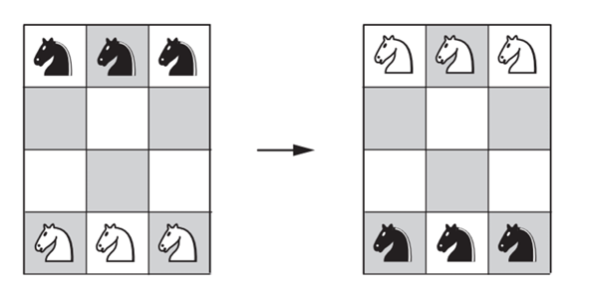
1. Problem description
There are six knights on a 3 × 4 chessboard: the three white knights are at the bottom row, and the three black knights are at the top row. Design an iterative improvement algorithm to exchange the knights to get the position shown on the right of the figure in the minimum number of knights moves, not allowing more than one knight on a square at any time.
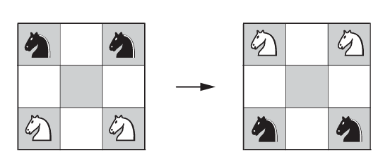
2. History of the problem
The "Knight Swap" originates from Guarini's Problem, first proposed in 1512. In the 3 * 3 version, two white knights and two black knights are placed on the four corners. The goal is to swap their positions using standard knight moves.
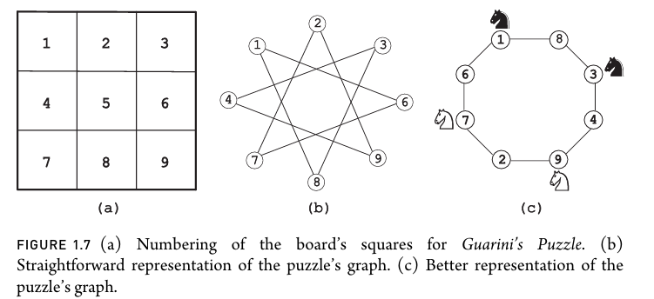
The solution for this problem is found by representing it as a graph, where each square is a node and each legal knight move is an edge. When the 3 * 3 board is "unrolled" in this manner, the graph reveals a single Hamiltonian cycle of eight squares, with the center square remaining isolated as it is unreachable from any other position in a single move. This linearizes the problem: swapping the knights is reduced to moving them sequentially along a fixed track.

However, the 3 * 4 Knight Swap extension introduces a significant jump in complexity for the following reason.
Increased Degree of Freedom: Unlike the 3 * 3 board, where moves are largely forced, the 3 * 4 board offers squares with varying connectivity (some nodes have two edges, while others have four). This introduces the element of "choice" and branching paths.
When we draw the same graph, it looks like the following:
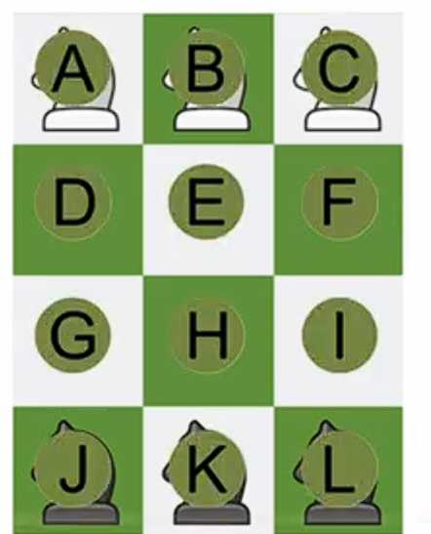
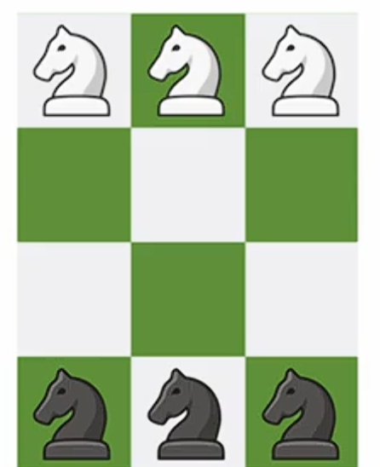
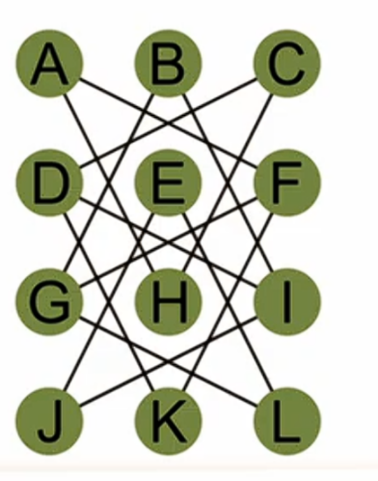

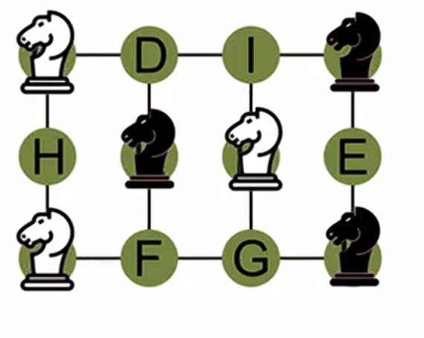

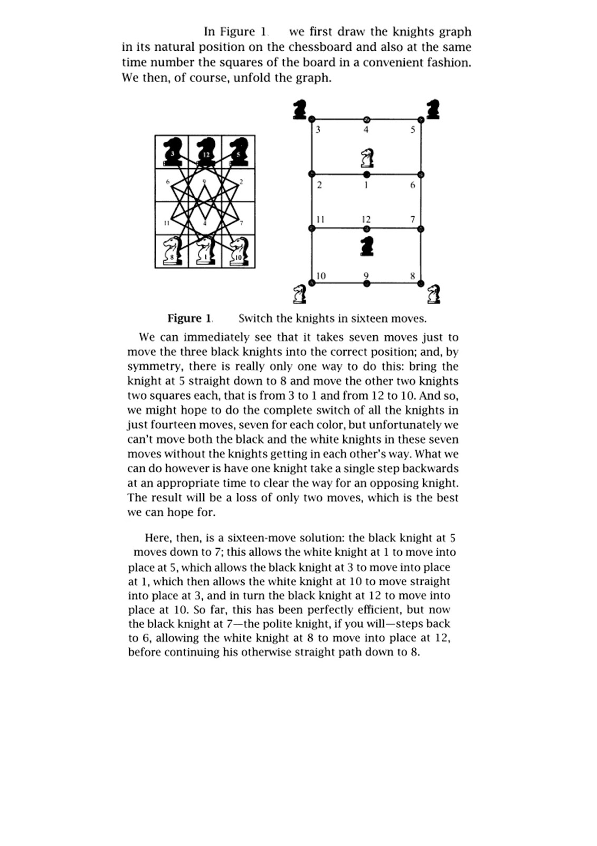
To solve the 3 * 4 Knight Swap optimally, we need 16 moves. This is because each side theoretically needs 7 moves to reach their goal (7 + 7 = 14), but the physical overlap of the pieces on the graph requires a 2-move detour (the "polite move") to resolve the traffic jam.
The following picture[src: Mathematics of chessboard: Guarini's puzzle | Math Nomad] explain the solution in detail:

Next, we transition from manual puzzle-solving to algorithmic solutions.

3. Algorithmic Techniques
3.1 Iterative improvement (simulated annealing):
While search algorithms like BFS explore every possible path, Iterative Improvement treats the Knight Swap as an optimization problem. We use Simulated Annealing to find the solution (not necessary the optimal) by moving through different "states" (board configurations) based on a cost function.(note: it may get the 16-move solution)
How the Algorithm Works:
- The State: A specific arrangement of the 6 knights on the 3 * 4 board.
- The Neighbor: A new state reached by making one legal knight move.
- The Cost Function (h): We calculate how "far" we are from the goal. This is usually the sum of the distances between each knight and its target square.
  - Lower cost = Knights are closer to their target.
  - Higher cost = Knights have moved away from their target.
Handling the "Traffic Jam"
The biggest challenge in the 3 * 4 swap is that knights must sometimes move away from their goal to let others pass (the "polite move"). A simple greedy algorithm would fail here because it refuses to accept a move that increases the cost.
Simulated Annealing solves this by using Probability:
- Accepting Good Moves: If a move lowers the cost, the algorithm always takes it.
- Accepting "Bad" Moves: If a move increases the cost (like a knight stepping into a bypass square), the algorithm might still accept it based on the current Temperature.
- Cooling Down: As the temperature drops, the algorithm becomes stricter, eventually settling on the most efficient 16-move path.

Pseudocode for Simulated Annealing Knight Swap
ALGORITHM SimulatedAnnealing_KnightSwap()
//Swaps 3 white knights (row 0) with 3 black knights (row 3)
//on a 3x4 board using Simulated Annealing
//Input: Board with W at row 0, B at row 3, empty elsewhere
//Output: Board with B at row 0, W at row 3 (swapped)

ALGORITHM Precompute(knightMoves[0..N-1])
//Precomputes all legal knight moves for each square
//Input: Empty move table for N=12 squares
//Output: knightMoves[i] = list of squares reachable from i
for i <- 0 to N-1 do
r <- i / COLS
c <- i % COLS
for each (dr, dc) in {(-2,-1),(-2,1),(-1,-2),(-1,2),
( 1,-2),( 1, 2),( 2,-1),( 2,1)} do
nr <- r + dr
nc <- c + dc
if nr >= 0 and nr < ROWS and nc >= 0 and nc < COLS
knightMoves[i].append(nr * COLS + nc)

ALGORITHM Heuristic(board[0..N-1])
//Estimates distance from current state to goal state
//Input: board[i] in {W, B, .} for each square i
//Output: total row distance of all pieces from target rows
cost <- 0
for i <- 0 to N-1 do
r <- i / COLS
if board[i] = 'W' then cost <- cost + |r - 3| //W wants row 3
if board[i] = 'B' then cost <- cost + |r - 0| //B wants row 0
return cost

ALGORITHM GetLegalMoves(board[0..N-1])
//Returns all legal (from, to) move pairs
//Input: Current board state
//Output: List of (from, to) index pairs where piece can move
moves <- empty list
for i <- 0 to N-1 do
if board[i] ≠ '.' then
for each j in knightMoves[i] do
if board[j] = '.' then
moves.append((i, j))
return moves

ALGORITHM SA_Solve()
//Main simulated annealing loop
//Input: Initial board (W at row 0, B at row 3)
//Output: Sequence of moves that reaches goal state

T_start <- 2.0
T_end <- 0.005
alpha <- 0.999 //cooling rate
maxSteps <- 300000
maxAttempts <- 30

for attempt <- 1 to maxAttempts do

current <- MakeInitial()
best <- current
curCost <- Heuristic(current)
bestCost <- curCost
T <- T_start
path <- empty list
bestPath <- empty list
visited <- {current}
noImprovCount <- 0

for step <- 1 to maxSteps do
if T < T_end then break

legal <- GetLegalMoves(current)
if legal is empty then break

Shuffle(legal) //remove positional bias
moved <- false

for each (from, to) in legal do
next <- ApplyMove(current, from, to)
nextCost <- Heuristic(next)
delta <- nextCost - curCost

if next in visited and next ≠ goal //skip visited
continue

//Acceptance decision
if delta <= 0 then
accept <- true //always accept improvement
else
P <- e^(-delta / T)
r <- Random(0, 1)
accept <- (r < P) //accept worse with prob P

if accept then
path.append((from, to, current[from]))
visited.insert(next)
current <- next
curCost <- nextCost
moved <- true

if curCost < bestCost then
bestCost <- curCost
best <- current
bestPath <- path
noImprovCount <- 0
else
noImprovCount <- noImprovCount + 1

if current = goal then
return path //SOLVED

break //move made, next step

//Stuck: no move made or no improvement for too long
if not moved or noImprovCount > 2000 then
current <- best //restart from best
curCost <- bestCost
path <- bestPath
noImprovCount <- 0
T <- T_start * 0.4 //partial reheat
visited <- RebuildVisited(path) //reset visited

T <- T * alpha //cool down

return FAILURE

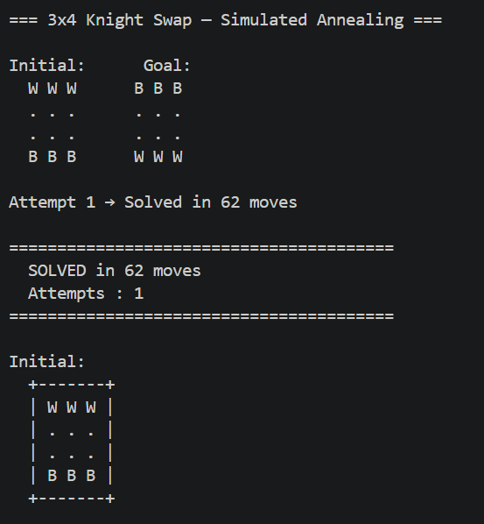
Output:
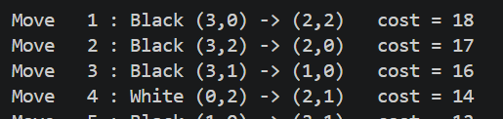
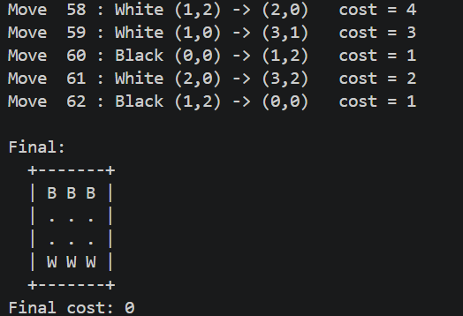

Note: on other runs, it gives me different results(optimal solution isn’t guarenteed)
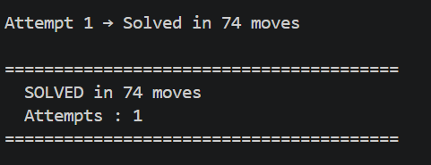
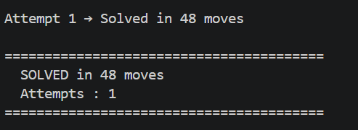

Complexity Analysis
- Time Complexity: O(A × M × N)
Where A = 30 attempts, M = 300,000 max steps, and N = 12 (board size). Each step generates legal moves and computes the heuristic, both linear in N. In practice, the algorithm solves much faster than this worst-case bound.
- Space Complexity: O(V + L)
Where V is the visited states set and L is the path length vector. For the fixed 3×4 board, V is bounded by 18,480 total valid configurations, requiring only a few megabytes. However, for a larger board of size N, the number of valid states grows combinatorially as O(C(N, W) × C(N−W, B)), where W and B are the number of white and black knights respectively. This means memory usage grows exponentially with board size, making the visited set the dominant space cost for any non-trivial scaling.

3.2 BFS(Breadth First Search):
BFS explores all possible board states level by level, where each level represents one knight move. Starting from the initial configuration, it generates all reachable states, guaranteeing the first time it reaches the goal state, it has found the minimum number of moves.
Pseudocode for BFS
ALGORITHM BFS_KnightSwap(initial, goal)
//Solves the 3x4 knight swap problem using Breadth-First Search
//Input: initial — starting board configuration
// goal — target board configuration
//Output: Shortest sequence of moves transforming initial into goal

create empty queue Q
create empty map parent(state -> (parentState, move))
enqueue initial into Q
set parent[initial] <- null

while Q is not empty do
current <- dequeue from Q

if current == goal then
return ReconstructPath(parent, goal)

for each knight position i in current do
for each legal knight move j from i do
if current[j] == empty then
next <- applyMove(current, i, j)
if next not in parent then
parent[next] <- (current, (i, j))
enqueue next into Q

return failure //goal not reachable

ALGORITHM ReconstructPath(parent, goal)
//Traces back moves from goal to initial
//Input: parent map, goal state
//Output: sequence of moves

path <- empty list
state <- goal
while parent[state] != null do
(prevState, move) <- parent[state]
prepend move to path
state <- prevState
return path

Complexity Analysis
- Time Complexity: O(S × N)
Where S is the total number of valid board states (18,480 for the 3×4 board) and N = 12 is the board size. Each state is dequeued once, and for each state all N squares are checked for legal knight moves. Therefore the algorithm visits every reachable state at most once.
- Space Complexity: O(S × N)
The queue and parent map together store up to S states, each represented as a string of length N. For the fixed 3×4 board this is strictly bounded at 18,480 × 12 characters. For a larger board of size N with W white and B black knights, the number of states grows as O(C(N,W) × C(N−W,B)), causing both time and space to grow combinatorially, making BFS infeasible for large boards.

3.3 A* Search:
A* improves on BFS by using a heuristic function to prioritize which states to explore first. Each state is assigned a cost f(n) = g(n) + h(n), where g(n) is the number of moves made so far and h(n) is the estimated cost to reach the goal (heuristic). This guides the search toward the goal faster than BFS while still guaranteeing the minimum number of moves, as long as the heuristic never overestimates the true cost (admissible).
Heuristic used: Sum of row distances of each knight from its goal row.

Pseudocode for A* Search
ALGORITHM AStar_KnightSwap(initial, goal)
//Solves the 3x4 knight swap problem using A* Search
//Input: initial — starting board configuration
// goal — target board configuration
//Output: Shortest sequence of moves transforming initial into goal

create empty priority queue (min-heap) OPEN ordered by f = g + h
create empty map parent(state -> (parentState, move))
create empty map g_cost(state -> integer)

g_cost[initial] <- 0
f_initial <- g_cost[initial] + heuristic(initial)
enqueue (f_initial, initial) into OPEN
set parent[initial] <- null

while OPEN is not empty do
current <- dequeue state with lowest f from OPEN

if current == goal then
return ReconstructPath(parent, goal)

for each knight position i in current do
for each legal knight move j from i do
if current[j] == empty then
next <- applyMove(current, i, j)
new_g <- g_cost[current] + 1

if next not in g_cost OR new_g < g_cost[next] then
g_cost[next] <- new_g
f_next <- new_g + heuristic(next)
parent[next] <- (current, (i, j))
enqueue (f_next, next) into OPEN

return failure //goal not reachable

ALGORITHM heuristic(state)
//Estimates remaining cost from current state to goal
//Input: state — current board configuration
//Output: admissible heuristic value h(n)

cost <- 0
for each position i in state do
if state[i] == White then cost <- cost + |row(i) - 3|
if state[i] == Black then cost <- cost + |row(i) - 0|
return cost

ALGORITHM ReconstructPath(parent, goal)
//Traces back moves from goal to initial
//Input: parent map, goal state
//Output: sequence of moves

path <- empty list
state <- goal
while parent[state] != null do
(prevState, move) <- parent[state]
prepend move to path
state <- prevState
return path

Complexity Analysis
- Time Complexity: O(S × N × log S)
Where S is the total number of valid board states (18,480 for the 3×4 board) and N = 12 is the board size. Each state is processed at most once. For each state, N squares are checked for legal moves, and each insertion into the priority queue costs O(log S). In practice A* explores significantly fewer states than BFS because the heuristic prunes unpromising paths early.
- Space Complexity: O(S × N)
The priority queue, parent map, and g_cost map together store up to S states, each as a string of length N. For the fixed 3×4 board this is strictly bounded at 18,480 × 12 characters. For a larger board of size N with W white and B black knights, the state space grows as O(C(N,W) × C(N−W,B)), making both time and space grow combinatorially. However, A* is more practical than BFS on larger boards since the heuristic drastically reduces the number of states actually explored.

4. Comparison
Algorithm | Time  Complexity | Space  Complexity | Optimal? | Complete? | Scalable? | Difficulty | When to use
BFS | O(S × N) S = 18,480 states N = 12 board size | O(S × N) Stores all visited  states + parent map | Yes | Yes | Poor | Easy | -Small fixed state spaces -Optimal solution needed
A* | O(S × N × log S) Priority  queue adds log S per step; fewer states explored in practice | O(S × N) Priority  queue + parent map  + g_cost  map | Yes | Yes | Moderate | Medium | Optimal solution needed with heuristic to cut exploration cost
Simulated Annealing | O(A × M ×  N) A = 30 attempts, M =  300,000  steps, N =  12 | O(V + L)  V ≤ 18,480 visited states; L = path vector length | No | Likely | Good | Hard | Large or complex spaces  where  optimality is not required

Note:
The reason we say A* is "better" is because the Effective S (the number of states actually visited) is usually much, much smaller for A*.
- In BFS: You are guaranteed to visit every state at distance d=1, 2, 3,… until you hit the goal.
- In A*: If you have a good heuristic (like Manhattan distance), you might only visit 1% of the total states.
Even though each step in A* is slightly "slower" due to the O(log S) sorting, the fact that it performs thousands of fewer steps makes it faster in real-world time.

5. Conclusion
For this specific 3×4 knight swap problem, A* is the best choice — it guarantees the minimum number of moves like BFS but does so significantly faster by using the row-distance heuristic to focus the search. Simulated Annealing is a valid iterative improvement approach, but sacrifices optimality for flexibility and scalability.

