|  |  |
| --- | --- |
| **Name** | محمد خالد محمد السيد |
| **B.N** | 700 |
| **Date** | 29-5-2020 |
| **Topic** | Artificial Intelligence |
| **Github link** |  |
| **Github page** |  |

Application brief

The programming languages are not very different to the languages spoken. Learning any language requires a comprehension of the building blocks and the grammar that governs making statements in that language. This unit will serve as an introduction to programming languages which will take you through the programming languages history. We will also learn about the different universal properties of all programming languages and identify distinct programming language design features. By the end of this unit, you'll gain a deeper understanding of what a programming language is and the ability to recognize programming language properties.[1]

Screenshots

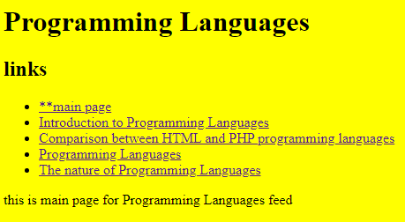

**1**

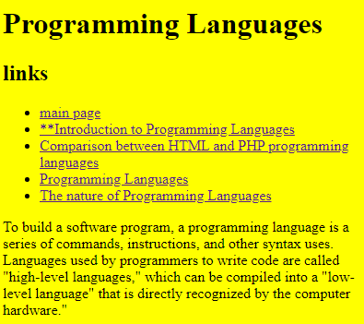

**2**

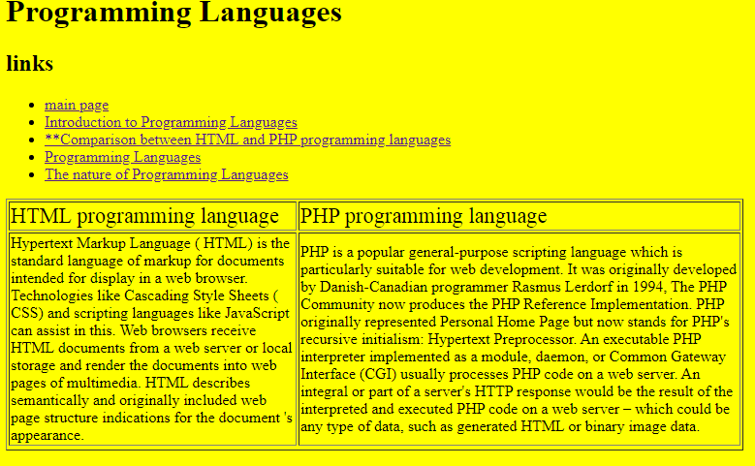

**3**

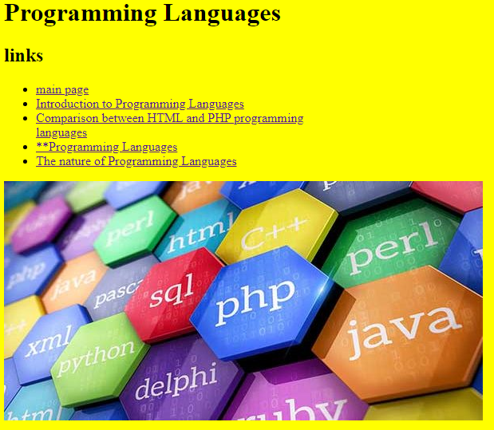

**4**

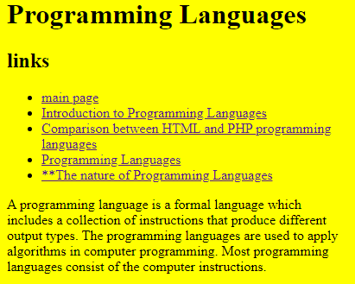

**5**

Source code

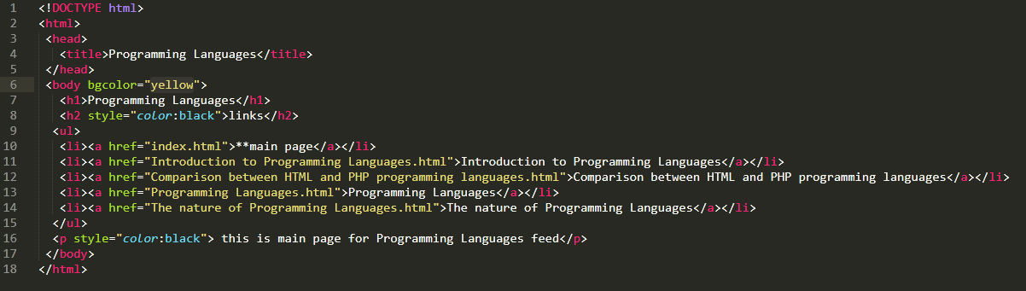

**Code of 1**

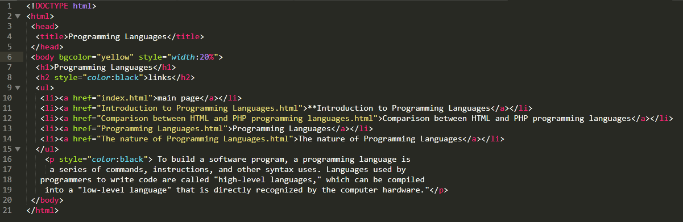

**Code of 2**

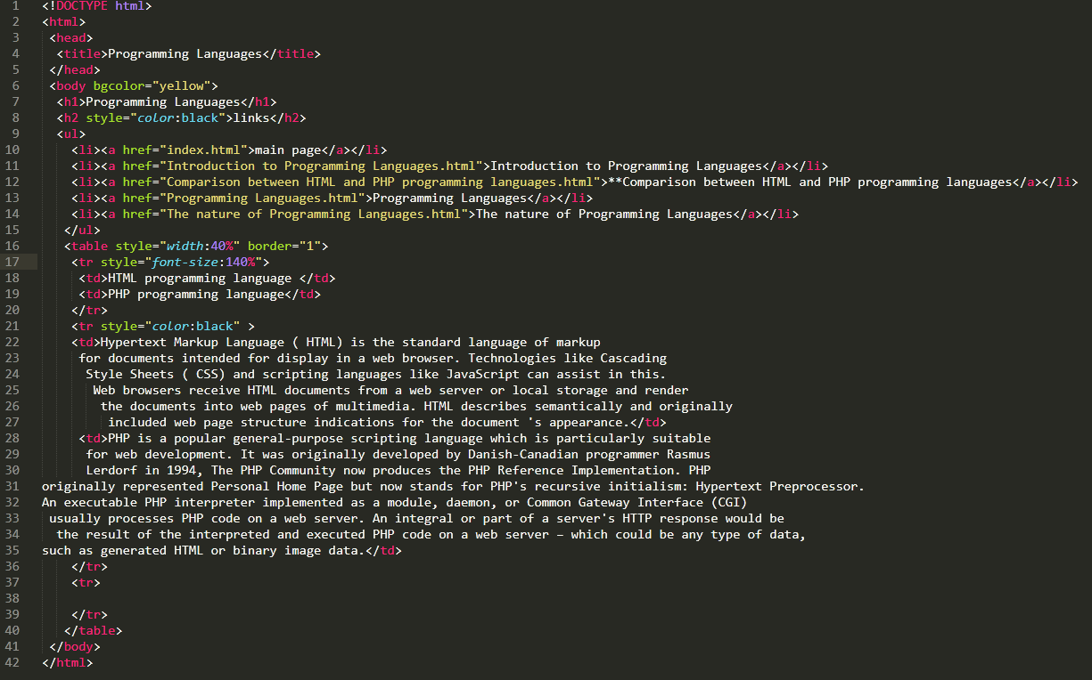

**Code of 3**

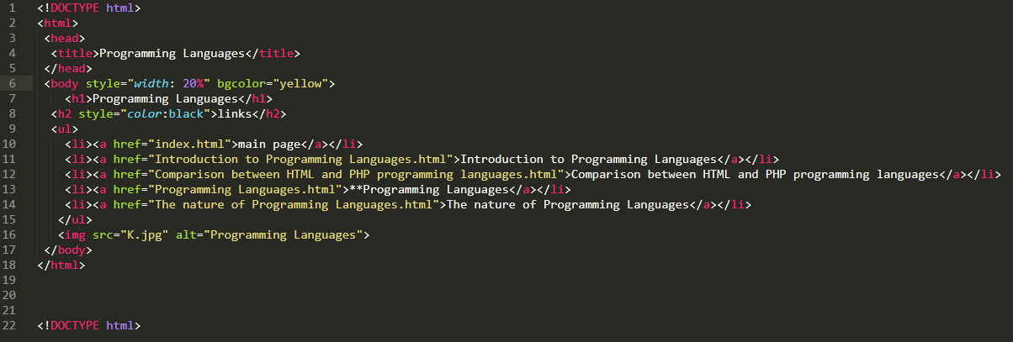

**Code of 4**

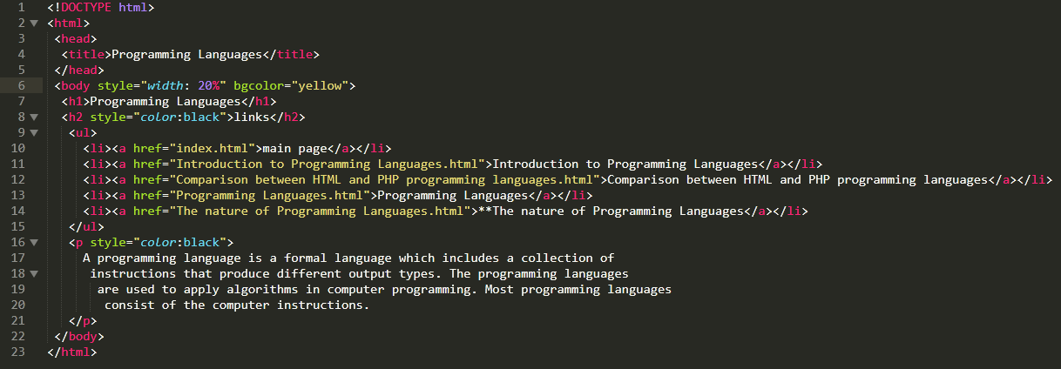

**Code of 5**

1. <https://learn.saylor.org/course/view.php?id=79&sectionid=780>