Digital Watch Project PO2_DGW‏

Table 1 status table

|  |  |  |  |  |
| --- | --- | --- | --- | --- |
| Document | Author | Version | Update Date | Status |
| HSI | SAHER | 1.2 | 11/3/2023 | Released |

Table 2 Document history

|  |  |  |  |  |
| --- | --- | --- | --- | --- |
| Version | Description of Change | Author | Date of last update | Status |
| 1.0 | - Initial creation of the document. | SAHER | 11/2/2023 | Draft |
| 1.1 | - update HSI according to review | SAHER | 15/2/2023 | Released |

Contents

1. INTRODUCTION 4

1.1 Purpose **Error! Bookmark not defined.**

1.2 Hardware components **Error! Bookmark not defined.**

1.3 System block diagrams **Error! Bookmark not defined.**

1.4 Hardware components block diagrams **Error! Bookmark not defined.**

2. Pins Description **Error! Bookmark not defined.**

3. Hardware software interface requirements **Error! Bookmark not defined.**

Table of tables

Table 1 HSI requirements 2

Table 2 Reference document 2

Table 3 Reference table 7

Table of figures

Figure 1 General block diagram 4

Figure 2 Microcontroller Pins configuration 5

Figure 3 LMB161A LCD schematic 5

Figure 4 RTC Pins 5

# INTRODUCTION

## Purpose

This document identifies all the Hardware Software Interface (HSI) data that reference a digital watch described in PO3_DGW_Digital watch (CRS) document.

## 1.2 Hardware components

**1. AVR 8-bit Microcontroller with 32 Kbytes In-System Programmable Flash.**

**2. LMB161A Character LCD.**

**3. Tactical buttons.**

**4. Buzzer.**

**5. Lithium battery 5v.**

**6. Real Time Clock Module (RTC)**

## 1.3 System block diagrams

**Microcontroller**

**Liquid crystal display**

**Button.1**

**Button.2**

**Buzzer**

Buzzer

**Button.3**

**RTC**

**Figure 1** General block diagram.

## 1.4 Hardware components block diagrams

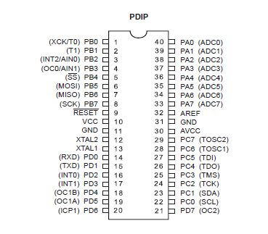

**Figure 2** Microcontroller Pins configuration.

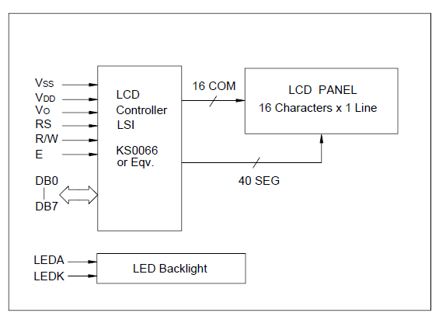

**Figure 3** LMB161ALCD schematic.

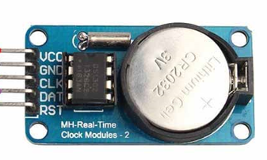

**Figure 4** RTC Module.

1. **Pins & Ports of ATMEGA32 Connection:**

|  |  |  |  |
| --- | --- | --- | --- |
| ***Pin No.*** | ***Symbol*** | ***Configuration*** | ***Function*** |
| ***1*** | ***PB0*** | ***Output*** | ***This pin shall be connected to LCD_RS.*** |
| ***2*** | ***PB1*** | ***Output*** | ***This pin shall be connected to LCD_RW.*** |
| ***3*** | ***PB2*** | ***Output*** | ***This pin shall be connected to LCD_E.*** |
| ***4*** | ***PB3*** | ***Output*** | ***Not used*** |
| ***5*** | ***PB4*** | ***Output*** | ***Not used*** |
| ***6*** | ***PB5*** | ***Output*** | ***Not used*** |
| ***7*** | ***PB6*** | ***Output*** | ***Not used*** |
| ***8*** | ***PB7*** | ***Output*** | ***Not used*** |
| ***9*** | ***RESET*** | ***RESET*** | ***Not used*** |
| ***10*** | ***VCC*** | ***Digital supply voltage*** | ***This pin shall be connected to supply voltage.*** |
| ***11*** | ***GND*** | ***Ground*** | ***Ground*** |
| ***12*** | ***XTAL2*** | ***XTAL2*** | ***Not used*** |
| ***13*** | ***XTAL1*** | ***XTAL2*** | ***Not used*** |
| ***14*** | ***PD0*** | ***Output*** | ***Not used*** |
| ***15*** | ***PD1*** | ***Output*** | ***Not used*** |
| ***16*** | ***PD2*** | ***Output*** | ***Not used*** |
| ***17*** | ***PD3*** | ***Output*** | ***This pin shall be connected to buzzer.*** |
| ***18*** | ***PD4*** | ***Input & Pullup*** | ***This pin shall be connected to button 1.*** |
| ***19*** | ***PD5*** | ***Input & Pullup*** | ***This pin shall be connected to button 2.*** |
| ***20*** | ***PD6*** | ***Input & Pullup*** | ***This pin shall be connected to button 3.*** |
| ***21*** | ***PD7*** | ***Output*** | ***Not used*** |
| ***22*** | ***PC0*** | ***Output*** | ***SCL pin from RTC Module*** |
| ***23*** | ***PC1*** | ***Output*** | ***SDA pin from RTC Module*** |
| ***24*** | ***PC2*** | ***Output*** | ***Not used*** |
| ***25*** | ***PC3*** | ***Output*** | ***Not used*** |
| ***26*** | ***PC4*** | ***Output*** | ***Not used*** |
| ***27*** | ***PC5*** | ***Output*** | ***Not used*** |
| ***28*** | ***PC6*** | ***Output*** | ***Not used*** |
| ***29*** | ***PC7*** | ***Output*** | ***Not used*** |
| ***30*** | ***AVCC*** | ***AVCC*** | ***Not used*** |
| ***31*** | ***GND*** | ***Ground*** | ***Not used*** |
| ***32*** | ***AREF*** | ***AREF*** | ***Not used*** |
| ***33*** | ***PA0*** | ***Output*** | ***This pin shall be connected to LCD_D0.*** |
| ***34*** | ***PA1*** | ***Output*** | ***This pin shall be connected to LCD_D1.*** |
| ***35*** | ***PA2*** | ***Output*** | ***This pin shall be connected to LCD_D2.*** |
| ***36*** | ***PA3*** | ***Output*** | ***This pin shall be connected to LCD_D3.*** |
| ***37*** | ***PA4*** | ***Output*** | ***This pin shall be connected to LCD_D4.*** |
| ***38*** | ***PA5*** | ***Output*** | ***This pin shall be connected to LCD_D5.*** |
| ***39*** | ***PA6*** | ***Output*** | ***This pin shall be connected to LCD_D6.*** |
| ***40*** | ***PA7*** | ***Output*** | ***This pin shall be connected to LCD_D7.*** |

## Hardware software interface requirements

Table 3 HSI requirements

|  |  |
| --- | --- |
| HSI requirement | Requirement description |
| **Req_PO3_DGW_HSI_01_V01.1** | The tactical switches shall be used to switch between the three modes of the digital watch as follows.  Button 1 shall be used to select clock mode. |
| **Req_PO3_DGW_HSI_02_V01** | Button 2 shall be used to select alarm mode, and when selected it shall be used to set alarm time. |
| **Req_PO3_DGW_HSI_03_V01** | Button 3 shall be used to select stopwatch mode, and when selected it shall be used to stop and reset counting respectively. |
| **Req_PO3_DGW_ HSI_04_V01** | The active buzzer shall be used to notify the user when the alarm’s time hit. |
| **Req_PO3_DGW_ HSI_05_V01** | The LCD displayer shall be used to display the chosen mode interface according to the user’s choice. |

Table 4 Reference document

|  |  |  |
| --- | --- | --- |
| Reference document | version | status |
| PO3_DGW_Digital watch_CRS | 1.1 | Released |