***\*SQL CODES ON THE WORKSPACE :***

1. To check if my city is in the list and fortunately I found it (Alexandria,Egypt)

SELECT *

FROM city_list

ORDER BY country

1. To extract only my local data (for Alexandria,Egypt)

SELECT *

FROM city_data

WHERE city LIKE '%Alexandria%' AND country LIKE '%Egypt%'

ORDER BY year DESC

1. To extract global data

SELECT *

FROM global_data

ORDER BY year DESC

***\*Then it’s time to working on data using Excel spreadsheet program:***

First of all I calculated the moving average for the last 5 years towards the end of the data for both local and global data , as we did in the last quiz

=AVERAGE(B2:B6) “for global data”

=AVERAGE(D4:D8) “for local data”

Note: local data started from 2013 not 2015 like global data

Then I make a chart using both data for local and global average temperature using legends on the chart with the axis names.

***Screen Shots :***

1. ***Local data only***

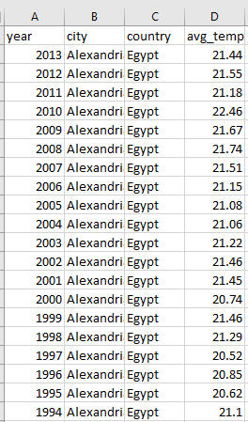

1. ***All the data together in one table:***

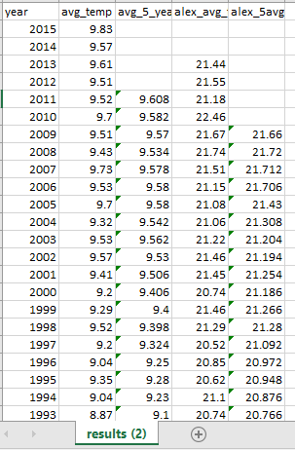

1. ***The Chart Comparison between Global & Local (Alexandria,Egypt) data***

***\*Observations***:

1- My city (Alexandria,Egypt) is hotter (warmer) than the global average temperature

2- the difference is approximately consistent between them for about 12 ‘C

3- both the local and global average temperature increases and decreases with each other , which indicates that they are massively correlated with each other

4- the overall trend in the last 5 years indicates a continuous rise in the average temperature , which gives an indication of the global warming Alert !!

5-In the second chart it shows us that Both trends have positive correlation coefficient (0.69 for local trend) and (0.71 for global trend).