Imen Abdelkader & Mohamed Amine Dammak
1- Elasticsearch Cluster Setup Playbook ( 1 master 3 data nodes) with ansible
Playbook.yml
---
- name: Install and configure Elasticsearch cluster (no security)
hosts: elasticsearch
become: true
vars:
es_cluster_name: "my-cluster"
elasticsearch_host: '["http://10.110.190.189:9200"]' # MasterES IP, HTTP (no security)
dis_seed: ["10.110.190.189", "10.110.190.196", "10.110.190.192", "10.110.190.190"] # All node IPs
init_master: ["MasterES"] # Only MasterES as initial master
server_host: "10.110.190.189" # Kibana on MasterES
elasticsearch_version: "8.17.0" # Latest version per document
tasks:
# Install Prerequisites
- name: Update apt cache
apt:
update_cache: yes
state: present
- name: Install Java
apt:
name: openjdk-17-jdk
state: present
- name: Install OpenSSH server
apt:
name: openssh-server
state: present
# Install Elasticsearch
- name: Create elastic directory
file:
path: /etc/elastic
state: directory
mode: "0755"
- name: Create download directory for Elasticsearch tar file
file:
path: "/home/user"
state: directory
mode: "0755"
owner: user
group: user
run_once: true
- name: Download Elasticsearch tar file
get_url:
url: "https://artifacts.elastic.co/downloads/elasticsearch/elasticsearch-{{ elasticsearch_version }}-linux-x86_64.tar.gz"
dest: "/home/user/elasticsearch-{{ elasticsearch_version }}-linux-x86_64.tar.gz"
mode: "0644"
run_once: true

- name: Extract Elasticsearch tar file
unarchive:
src: "/home/user/elasticsearch-{{ elasticsearch_version }}-linux-x86_64.tar.gz"
dest: /etc/elastic
remote_src: yes
mode: "0755"
creates: "/etc/elastic/elasticsearch-{{ elasticsearch_version }}"
# Configure Elasticsearch (no security)
- name: Configure Elasticsearch
lineinfile:
path: "/etc/elastic/elasticsearch-{{ elasticsearch_version }}/config/elasticsearch.yml"
line: "{{ item }}"
state: present
with_items:
- "cluster.name: {{ es_cluster_name }}"
- "node.name: {{ inventory_hostname }}"
- "network.host: {{ ansible_host }}"
- "http.port: 9200"
- "discovery.seed_hosts: {{ dis_seed }}"
- "cluster.initial_master_nodes: {{ init_master }}"
- "xpack.security.enabled: false"
- "xpack.ml.enabled: false"
- "path.repo: /mnt/snapshots"
- "node.master: {{ 'true' if inventory_hostname == 'MasterES' else 'false' }}"
- "node.data: {{ 'false' if inventory_hostname == 'MasterES' else 'true' }}"
# Set JVM options
- name: Set Elasticsearch heap size
lineinfile:
path: "/etc/elastic/elasticsearch-{{ elasticsearch_version }}/config/jvm.options"
regexp: "{{ item.regexp }}"
line: "{{ item.line }}"
with_items:
- { regexp: "^-Xms.*$", line: "-Xms1g" }
- { regexp: "^-Xmx.*$", line: "-Xmx1g" }
# System settings
- name: Set vm.max_map_count
sysctl:
name: vm.max_map_count
value: "262144"
state: present
sysctl_set: yes
reload: yes
# Manage user and permissions
- name: Add elasticsearch user
user:
name: elasticsearch
create_home: no
shell: /bin/false
system: yes
run_once: true
- name: Set ownership and permissions for Elasticsearch
file:
path: "/etc/elastic/elasticsearch-{{ elasticsearch_version }}"
owner: elasticsearch
group: elasticsearch
recurse: yes
mode: "0755"
hosts.ini
[elasticsearch]
MasterES ansible_host=10.110.190.189
DataNode1 ansible_host=10.110.190.196
DataNode2 ansible_host=10.110.190.192
DataNode3 ansible_host=10.110.190.190
Command To execute the playbook :
ansible-playbook playbook.yml -i hosts.ini --become --become-method=sudo --become-user=root --ask-become-pass

2- Setting Up and Managing Elasticsearch with systemd
This guide provides the steps to configure Elasticsearch to run as a systemd service on all nodes in your cluster (MasterES, DataNode1, DataNode2, DataNode3). This ensures Elasticsearch runs in the background, starts on boot, and automatically restarts if it crashes.

Prerequisites
- Elasticsearch 8.17.0 is installed on all nodes at /etc/elastic/elasticsearch-8.17.0.
- Nodes in the cluster:
  - MasterES: 10.110.190.189
  - DataNode1: 10.110.190.196
  - DataNode2: 10.110.190.192
  - DataNode3: 10.110.190.190
- SSH access to all nodes with the username user.
- Kibana is installed and running on MasterES (or another node), accessible at http://10.110.190.189:5601.
- Security (TLS/SSL) is enabled in Elasticsearch, as indicated by the use of https and credentials (elastic:dfMOIMT6hvJXeBFGzjTY).

Step 1: Stop Any Running Elasticsearch Processes
Before setting up the systemd service, ensure no Elasticsearch processes are running manually.

On Each Node:
- SSH into the node:
- ssh user@<node-ip>
- Replace <node-ip> with:
  - 10.110.190.189 (MasterES)
  - 10.110.190.196 (DataNode1)
  - 10.110.190.192 (DataNode2)
  - 10.110.190.190 (DataNode3)
- Check for running Elasticsearch processes:
- ps aux | grep elasticsearch
- If you see any processes, note the PID (e.g., 71265) and stop them:
- sudo kill -9 71265
- Repeat for all nodes.

Step 2: Create the systemd Service File for Elasticsearch
You need to create a systemd service file on each node to manage Elasticsearch.

On Each Node:
- SSH into the node:
- ssh user@<node-ip>
- Create the systemd service file:
- sudo nano /etc/systemd/system/elasticsearch.service
- Add the following content to the elasticsearch.service file:
- [Unit]
Description=Elasticsearch
Documentation=https://www.elastic.co
Wants=network-online.target
After=network-online.target
[Service]
Type=forking
User=elasticsearch
Group=elasticsearch
ExecStart=/etc/elastic/elasticsearch-8.17.0/bin/elasticsearch -d
ExecStop=/bin/kill -TERM $MAINPID
Restart=always
LimitNOFILE=65535
LimitNPROC=4096
LimitAS=infinity
LimitFSIZE=infinity
TimeoutStopSec=0
KillMode=process
SuccessExitStatus=143
[Install]
WantedBy=multi-user.target
- Save and exit the file (Ctrl+O, Enter, Ctrl+X in nano).
- Repeat for all nodes (MasterES, DataNode1, DataNode2, DataNode3).

Step 3: Reload systemd and Enable the Service
Reload the systemd daemon to recognize the new service and enable it to start on boot.

On Each Node:
- Reload the systemd daemon:
- sudo systemctl daemon-reload
- Enable the Elasticsearch service to start on boot:
- sudo systemctl enable elasticsearch.service
- Expected output:
- Created symlink /etc/systemd/system/multi-user.target.wants/elasticsearch.service → /etc/systemd/system/elasticsearch.service.
- Repeat for all nodes.

Step 4: Start Elasticsearch Using systemd
Start Elasticsearch on all nodes using the systemd service.

On Each Node:
- Start the Elasticsearch service:
- sudo systemctl start elasticsearch
- Check the status to ensure it’s running:
- sudo systemctl status elasticsearch
- Expected output:
- ● elasticsearch.service - Elasticsearch
Loaded: loaded (/etc/systemd/system/elasticsearch.service; enabled; vendor preset: enabled)
Active: active (running) since [timestamp]
- Repeat for all nodes.

Step 5: Verify Elasticsearch is Running
Verify that Elasticsearch is running on all nodes and the cluster is healthy.

On MasterES:
- Test connectivity to MasterES:
- curl --cacert /etc/elastic/elasticsearch-8.17.0/config/elastic-stack-ca.pem -u elastic:dfMOIMT6hvJXeBFGzjTY "https://10.110.190.189:9200"
- Expected output:
- {
"name": "MasterES",
"cluster_name": "my-cluster",
"cluster_uuid": "...",
"version": {
"number": "8.17.0",
...
},
...
}
- Check cluster health:
- curl --cacert /etc/elastic/elasticsearch-8.17.0/config/elastic-stack-ca.pem -u elastic:dfMOIMT6hvJXeBFGzjTY "https://10.110.190.189:9200/_cluster/health?pretty"
- Expected output:
- {
"cluster_name": "my-cluster",
"status": "green",
"number_of_nodes": 4,
"number_of_data_nodes": 3,
...
}

3- Elasticsearch Security Setup Cookbook

Step 1: Set Up the Master Node (MasterES)

1.1 Generate Certificates
Certificates are required to enable TLS for node-to-node and HTTP communication.
- Create the CA Certificate: On the master node, generate a Certificate Authority (CA) certificate using elasticsearch-certutil:
- sudo -u elasticsearch /etc/elastic/elasticsearch-8.17.0/bin/elasticsearch-certutil ca --out /etc/elastic/elasticsearch-8.17.0/config/elastic-stack-ca.p12
  - Prompt: Press Enter to skip setting a password for the CA.
- Generate a Node Certificate with SANs: Generate a certificate for all nodes, including Subject Alternative Names (SANs) for their IP addresses:
- sudo -u elasticsearch /etc/elastic/elasticsearch-8.17.0/bin/elasticsearch-certutil cert \
--ca /etc/elastic/elasticsearch-8.17.0/config/elastic-stack-ca.p12 \
--out /etc/elastic/elasticsearch-8.17.0/config/elastic-certificates.p12 \
--ip 10.110.190.189,10.110.190.196,10.110.190.192,10.110.190.190 \
--name elasticsearch-cluster
  - Prompts:
    - CA password: Press Enter (none).
    - Output file password: Press Enter twice (none).
- Move Certificates to the Correct Directory: Ensure the certificates are in the Elasticsearch configuration directory:
- sudo mv /etc/elasticsearch/certs/elastic-stack-ca.p12 /etc/elastic/elasticsearch-8.17.0/config/
sudo mv /etc/elasticsearch/certs/elastic-certificates.p12 /etc/elastic/elasticsearch-8.17.0/config/
- Set Permissions: Restrict access to the certificate files to the elasticsearch user:
- sudo chown elasticsearch:elasticsearch /etc/elastic/elasticsearch-8.17.0/config/elastic-stack-ca.p12
sudo chown elasticsearch:elasticsearch /etc/elastic/elasticsearch-8.17.0/config/elastic-certificates.p12
sudo chmod 660 /etc/elastic/elasticsearch-8.17.0/config/elastic-stack-ca.p12
sudo chmod 660 /etc/elastic/elasticsearch-8.17.0/config/elastic-certificates.p12

1.2 Configure elasticsearch.yml on the Master Node
Edit the Elasticsearch configuration file to enable security and TLS:
sudo nano /etc/elastic/elasticsearch-8.17.0/config/elasticsearch.yml
- Add the following configuration:
cluster.name: my-cluster
node.name: MasterES
node.roles: [master, remote_cluster_client]
network.host: 10.110.190.189
http.port: 9200
discovery.seed_hosts: ["10.110.190.189", "10.110.190.196", "10.110.190.192", "10.110.190.190"]
cluster.initial_master_nodes: ["MasterES"]
xpack.security.enabled: true
xpack.security.transport.ssl.enabled: true
xpack.security.http.ssl.enabled: true
xpack.security.transport.ssl.keystore.path: /etc/elastic/elasticsearch-8.17.0/config/elastic-certificates.p12
xpack.security.transport.ssl.truststore.path: /etc/elastic/elasticsearch-8.17.0/config/elastic-certificates.p12
xpack.security.http.ssl.keystore.path: /etc/elastic/elasticsearch-8.17.0/config/elastic-certificates.p12
xpack.security.http.ssl.truststore.path: /etc/elastic/elasticsearch-8.17.0/config/elastic-certificates.p12
xpack.ml.enabled: false
xpack.monitoring.collection.enabled: true
path.repo: /mnt/snapshots

1.3 Restart Elasticsearch on the Master Node
Apply the changes by restarting Elasticsearch:
sudo systemctl restart elasticsearch
- Check the logs to ensure the master node starts without errors:
- sudo tail -f /etc/elastic/elasticsearch-8.17.0/logs/my-cluster.log

Step 2: Distribute Certificates to Data Nodes

2.1 Copy Certificates to Data Nodes
Distribute the CA and node certificates to each data node (DataNode1, DataNode2, DataNode3).
- Temporarily Adjust Directory Permissions: On each data node, temporarily make the target directory writable:
- sudo chmod 777 /etc/elastic/elasticsearch-8.17.0/config/
- Copy the Certificates: From the master node, use scp to copy the certificates to each data node:
- sudo scp /etc/elastic/elasticsearch-8.17.0/config/elastic-stack-ca.p12 /etc/elastic/elasticsearch-8.17.0/config/elastic-certificates.p12 user@10.110.190.196:/etc/elastic/elasticsearch-8.17.0/config/
- sudo scp /etc/elastic/elasticsearch-8.17.0/config/elastic-stack-ca.p12 /etc/elastic/elasticsearch-8.17.0/config/elastic-certificates.p12 user@10.110.190.192:/etc/elastic/elasticsearch-8.17.0/config/
- sudo scp /etc/elastic/elasticsearch-8.17.0/config/elastic-stack-ca.p12 /etc/elastic/elasticsearch-8.17.0/config/elastic-certificates.p12 user@10.110.190.190:/etc/elastic/elasticsearch-8.17.0/config/

2.2 Set Permissions on Data Nodes
On each data node, set the correct ownership and permissions for the certificate files:
sudo chown elasticsearch:elasticsearch /etc/elastic/elasticsearch-8.17.0/config/elastic-stack-ca.p12
sudo chown elasticsearch:elasticsearch /etc/elastic/elasticsearch-8.17.0/config/elastic-certificates.p12
sudo chmod 777 /etc/elastic/elasticsearch-8.17.0/config/elastic-stack-ca.p12
sudo chmod 777 /etc/elastic/elasticsearch-8.17.0/config/elastic-certificates.p12
sudo chmod 755 /etc/elastic/elasticsearch-8.17.0/config/
- Note: The permissions 777 on the certificate files are overly permissive and should be tightened in production (e.g., 660).

Step 3: Configure Data Nodes

3.1 Update elasticsearch.yml on Each Data Node
Edit the elasticsearch.yml file on each data node to enable security and TLS.
- On DataNode1 (10.110.190.196):
- sudo nano /etc/elastic/elasticsearch-8.17.0/config/elasticsearch.yml
cluster.name: my-cluster
node.name: DataNode1
network.host: 10.110.190.196
http.port: 9200
discovery.seed_hosts: ["10.110.190.189", "10.110.190.196", "10.110.190.192", "10.110.190.190"]
cluster.initial_master_nodes: ["MasterES"]
xpack.security.enabled: true
xpack.security.transport.ssl.enabled: true
xpack.ml.enabled: false
path.repo: /mnt/snapshots
node.roles: [data]
xpack.security.http.ssl.enabled: true
xpack.security.transport.ssl.keystore.path: /etc/elastic/elasticsearch-8.17.0/config/elastic-certificates.p12
xpack.security.transport.ssl.truststore.path: /etc/elastic/elasticsearch-8.17.0/config/elastic-certificates.p12
xpack.security.http.ssl.keystore.path: /etc/elastic/elasticsearch-8.17.0/config/elastic-certificates.p12
xpack.security.http.ssl.truststore.path: /etc/elastic/elasticsearch-8.17.0/config/elastic-certificates.p12
- On DataNode2 (10.110.190.192): Same as above, but update:
node.name: DataNode2
network.host: 10.110.190.192
- On DataNode3 (10.110.190.190): Same as above, but update:
node.name: DataNode3
network.host: 10.110.190.190

3.2 Restart Elasticsearch on Data Nodes
Restart Elasticsearch on each data node to apply the changes:
sudo systemctl restart elasticsearch

- Check the logs on each node:
- sudo tail -f /etc/elastic/elasticsearch-8.17.0/logs/my-cluster.log

Step 4: Set Up Authentication
Enable authentication by setting passwords for built-in users.

4.1 Generate Passwords
On the master node, run the elasticsearch-setup-passwords command:
sudo -u elasticsearch /etc/elastic/elasticsearch-8.17.0/bin/elasticsearch-setup-passwords auto
- Output:
Changed password for user apm_system
PASSWORD apm_system = gEe5IIq4hHjDnRx3ygjD
Changed password for user kibana_system
PASSWORD kibana_system = 7530zyCaYTsit5M5QJzA
Changed password for user kibana
PASSWORD kibana = 7530zyCaYTsit5M5QJzA
Changed password for user logstash_system
PASSWORD logstash_system = UDcocC44Vr4sWqqZkmYr
Changed password for user beats_system
PASSWORD beats_system = RC0EYOraNIuwfPFFHQ9y
Changed password for user remote_monitoring_user
PASSWORD remote_monitoring_user = VnxEsbgA7vcgcE01Vcmw
Changed password for user elastic
PASSWORD elastic = dfM0IMt6hvJxEbfGjZtY
- Save these passwords securely, especially elastic and kibana_system.

Step 5: Set Up Kibana

5.1 Convert CA Certificate to PEM Format (if the format is not PEM)
Kibana requires the CA certificate in PEM format for SSL verification.
- Convert the File:
- sudo openssl pkcs12 -in /etc/elastic/elasticsearch-8.17.0/config/elastic-stack-ca.p12 -out /etc/elastic/elasticsearch-8.17.0/config/elastic-stack-ca.pem -nodes -nokeys
  - Prompt: Press Enter to skip the password.

- Set Permissions:
- sudo chown kibana:kibana /etc/elastic/elasticsearch-8.17.0/config/elastic-stack-ca.pem
sudo chmod 644 /etc/elastic/elasticsearch-8.17.0/config/elastic-stack-ca.pem

5.2 Configure kibana.yml
Edit the Kibana configuration file:
sudo nano /etc/kibana/kibana.yml
Add the following:
server.port: 5601
server.host: "0.0.0.0"
server.publicBaseUrl: "https://10.110.190.189:5601"
elasticsearch.hosts: ["https://10.110.190.189:9200"]
elasticsearch.username: "kibana_system"
elasticsearch.password: "7530zyCaYTsit5M5QJzA"
elasticsearch.ssl.certificateAuthorities: ["/etc/elastic/elasticsearch-8.17.0/config/elastic-stack-ca.pem"]

5.3 Restart Kibana
sudo systemctl restart kibana
- Check Kibana logs:
- sudo tail -f /var/log/kibana/kibana.log

Step 6: Access Kibana Login
Kibana is now accessible with authentication.
- Open Kibana:
  - URL: https://10.110.190.189:5601
  - Use a web browser to navigate to this URL.
- Log In:
  - Username: elastic
  - Password: dfM0IMt6hvJxEbfGjZtY
  - Click Log in.
- Verify Access:
  - You should see the Kibana dashboard. Navigate to Stack Monitoring to confirm all nodes are visible (MasterES, DataNode1, DataNode2, DataNode3).

Step 7: Use the Elasticsearch API
You can interact with the Elasticsearch cluster using the API, secured with TLS and authentication.

7.1 Check Cluster Health
Use curl to check the cluster health:
curl --cacert /etc/elastic/elasticsearch-8.17.0/config/elastic-stack-ca.pem -u elastic:dfM0IMt6hvJxEbfGjZtY "https://10.110.190.189:9200/_cluster/health?pretty"
- Expected Output:
- {
"cluster_name" : "my-cluster",
"status" : "green",
"timed_out" : false,
"number_of_nodes" : 4,
"number_of_data_nodes" : 3,
"active_primary_shards" : 0,
"active_shards" : 0,
"relocating_shards" : 0,
"initializing_shards" : 0,
"unassigned_shards" : 0,
"delayed_unassigned_shards" : 0,
"number_of_pending_tasks" : 0,
"number_of_in_flight_fetch" : 0,
"task_max_waiting_in_queue_millis" : 0,
"active_shards_percent_as_number" : 100.0
}

7.2 List Nodes
Check the nodes in the cluster:
curl --cacert /etc/elastic/elasticsearch-8.17.0/config/elastic-stack-ca.pem -u elastic:dfM0IMt6hvJxEbfGjZtY "https://10.110.190.189:9200/_cat/nodes?v"
- Expected Output:
- ip heap.percent ram.percent cpu load_1m load_5m load_15m node.role master name
10.110.190.189 15 90 5 0.01 0.03 0.05 mr * MasterES
10.110.190.196 12 88 3 0.02 0.04 0.06 d - DataNode1
10.110.190.192 14 87 4 0.01 0.02 0.04 d - DataNode2
10.110.190.190 13 89 3 0.03 0.05 0.07 d - DataNode3
4- Installation Kibana :
sudo apt install kibana=8.17.0
sudo sudo systemctl enable kibana
sudo sudo systemctl start kibana

Kibana HTTPS Setup

Step 1: Generate Certificates on MasterES

1.1 SSH into MasterES
- Command:
- ssh user@10.110.190.189
- Description: Logged into the MasterES VM to perform certificate generation.

1.2 Generate Certificate in PKCS#12 Format (Initial Attempt)
- Command:
- sudo /etc/elastic/elasticsearch-8.17.0/bin/elasticsearch-certutil cert \
--ca /etc/elastic/elasticsearch-8.17.0/config/elastic-stack-ca.p12 \
--name kibana \
--dns ansible-kibana \
--ip 10.110.190.200 \
--out /etc/kibana/kibana-cert.p12
- Description: Generated a certificate for Kibana in PKCS#12 format, signed by the CA (elastic-stack-ca.p12). The certificate includes the DNS name ansible-kibana and IP 10.110.190.200. This step was an initial attempt, but we later switched to PEM format.

1.3 Generate Certificate in PEM Format
- Command:
- sudo /etc/elastic/elasticsearch-8.17.0/bin/elasticsearch-certutil cert \
--ca /etc/elastic/elasticsearch-8.17.0/config/elastic-stack-ca.p12 \
--name kibana \
--dns ansible-kibana \
--ip 10.110.190.200 \
--pem \
--out /etc/kibana/kibana-cert.zip
- Description: Generated a certificate for Kibana in PEM format, signed by the same CA. The --pem flag ensures the output is in PEM format, and the result is a ZIP file (kibana-cert.zip) containing kibana/kibana_cert.pem and kibana/kibana_key.pem.

1.4 Extract the PEM Files
- Command:
- sudo unzip /etc/kibana/kibana-cert.zip -d /etc/kibana/
- Description: Extracted the contents of kibana-cert.zip into /etc/kibana/, creating the directory /etc/kibana/kibana/ with the files kibana_cert.pem and kibana_key.pem. However, the files were initially named kibana.crt and kibana.key (likely due to a previous step or manual renaming).

Step 2: Rename and Move Certificate Files on MasterES

2.1 Rename kibana.crt to kibana_cert.pem
- Command:
- sudo mv /etc/kibana/kibana/kibana.crt /etc/kibana/kibana/kibana_cert.pem
- Description: Renamed kibana.crt to kibana_cert.pem to align with the expected naming convention for PEM-formatted certificates.

2.2 Rename kibana.key to kibana_key.pem
- Command:
- sudo mv /etc/kibana/kibana/kibana.key /etc/kibana/kibana/kibana_key.pem
- Description: Renamed kibana.key to kibana_key.pem to align with the expected naming convention for PEM-formatted private keys.

2.3 Move kibana_cert.pem to /etc/kibana/cert.pem
- Command:
- sudo mv /etc/kibana/kibana/kibana_cert.pem /etc/kibana/cert.pem
- Description: Moved kibana_cert.pem from /etc/kibana/kibana/ to /etc/kibana/ and renamed it to cert.pem for simplicity in the Kibana configuration.

2.4 Move kibana_key.pem to /etc/kibana/key.pem
- Command:
- sudo mv /etc/kibana/kibana/kibana_key.pem /etc/kibana/key.pem
- Description: Moved kibana_key.pem from /etc/kibana/kibana/ to /etc/kibana/ and renamed it to key.pem for simplicity in the Kibana configuration.

2.5 Verify the Files in /etc/kibana/
- Command:
- ls
- Description: Listed the files in /etc/kibana/ to confirm the presence of cert.pem and key.pem.

2.6 Navigate Up and Remove the kibana Directory
- Commands:
- cd ..
ls
sudo rm -r kibana
ls
- Description: Navigated up to /etc/kibana/, listed the files, removed the now-empty /etc/kibana/kibana/ directory, and verified its removal.

2.7 Set Permissions for cert.pem and key.pem
- Commands:
- sudo chown user:user /etc/kibana/cert.pem /etc/kibana/key.pem
sudo chmod 644 /etc/kibana/cert.pem /etc/kibana/key.pem
- Description: Changed the ownership of cert.pem and key.pem to the user user and group, and set the permissions to 644 to ensure they are readable by the Kibana process.

2.8 Verify the Files with Permissions
- Command:
- ls -l
- Description: Listed the files in /etc/kibana/ with detailed permissions to confirm the changes.

Step 3: Transfer Files from MasterES to ansible-kibana

3.1 Transfer cert.pem to ansible-kibana
- Command:
- sudo scp /etc/kibana/cert.pem user@10.110.190.194:/etc/kibana/
- Description: Transferred cert.pem from /etc/kibana/ on MasterES to /etc/kibana/ on ansible-kibana (IP: 10.110.190.194) using scp.

3.2 Transfer key.pem to ansible-kibana
- Command:
- sudo scp /etc/kibana/key.pem user@10.110.190.194:/etc/kibana/
- Description: Transferred key.pem from /etc/kibana/ on MasterES to /etc/kibana/ on ansible-kibana using scp.

3.3 Verify the Files on MasterES
- Command:
- ls
- Description: Listed the files in /etc/kibana/ on MasterES to confirm the presence of cert.pem and key.pem after the transfer.

Step 4: Configure Kibana on ansible-kibana for HTTPS

4.1 Edit kibana.yml on ansible-kibana
- Command:
- sudo nano kibana.yml
- Description: Edited the kibana.yml configuration file on ansible-kibana to enable HTTPS communication with Elasticsearch.
- Updated kibana.yml (Complete):
- # Port Kibana listens on
server.port: 5601
# Host Kibana binds to (use 0.0.0.0 to allow access from any IP, including your local machine)
server.host: "0.0.0.0"
# Public URL for Kibana (used for generating links)
server.publicBaseUrl: "https://10.110.190.194:5601"
# Enable SSL for Kibana
server.ssl.enabled: true
server.ssl.certificate: "/etc/kibana/cert.pem"
server.ssl.key: "/etc/kibana/key.pem"
# Elasticsearch instance to connect to (MasterES)
elasticsearch.hosts: ["https://10.110.190.189:9200"]
elasticsearch.username: "kibana_system"
elasticsearch.password: "7530zyCaYTsit5M5QJzA" # Change it with your kibana_system pass
elasticsearch.ssl.certificateAuthorities: ["/etc/elastic/elasticsearch-8.17.0/config/elastic-stack-ca.pem"]

4.2 Restart Kibana on ansible-kibana
- Command:
- sudo systemctl restart kibana
- Description: Restarted the Kibana service on ansible-kibana to apply the configuration changes, enabling HTTPS communication.

Step 5: Summary of Security Enhancements
- HTTPS Communication: By adding server.ssl.enabled: true, server.ssl.certificate, and server.ssl.key to kibana.yml, HTTPS was enabled for Kibana on ansible-kibana, ensuring secure communication between the Kibana server and clients (e.g., your browser).
- Secure Connection to Elasticsearch: The elasticsearch.hosts setting uses https://10.110.190.189:9200, and the elasticsearch.ssl.certificateAuthorities setting ensures that Kibana verifies the Elasticsearch server’s certificate using the CA (elastic-stack-ca.pem), securing the connection between Kibana and Elasticsearch.
- File Transfer: The certificate and key files (cert.pem and key.pem) were securely transferred from MasterES to ansible-kibana using scp, maintaining the integrity of the files.

Step 6: Next Steps (Not Performed but Recommended)
- Verify Kibana Status:
- sudo systemctl status kibana
  - Ensure Kibana is running without errors.
- Access Kibana Over HTTPS:
  - Open a browser and navigate to:
  - https://10.110.190.194:5601
  - Accept the self-signed certificate warning if prompted.
- Verify Kibana Connection to Elasticsearch:
  - In Kibana’s Dev Tools, run:
  - GET /
  - Confirm the response shows the Elasticsearch cluster details.
- Check Elasticsearch Cluster Health:
  - On MasterES:
  - curl --cacert /etc/elastic/elasticsearch-8.17.0/config/elastic-stack-ca.pem -u elastic:dfMOIMT6hvJXeBFGzjTY "https://10.110.190.189:9200/_cluster/health?pretty"
  - Ensure the cluster status is green.

Configuration d’un Référentiel de Snapshots NFS pour Elasticsearch et Création d’un Snapshot

1. Aperçu du Cluster
- MasterES : 10.110.190.189
  - Utilisateur elasticsearch : UID 997, GID 984
  - Héberge le partage NFS /mnt/snapshots
- Nœuds de Données :
  - DataNode1 : 10.110.190.196
  - DataNode2 : 10.110.190.192
  - DataNode3 : 10.110.190.190
  - Utilisateur elasticsearch sur les nœuds de données : UID 999, GID 988
- Version d’Elasticsearch : 8.17.0
- Partage NFS : /mnt/snapshots (servi par MasterES, monté sur tous les nœuds de données)

2. Configuration de NFS sur MasterES
MasterES sert le répertoire /mnt/snapshots comme un partage NFS, que tous les nœuds utiliseront pour le référentiel de snapshots.

2.1. Installation du Serveur NFS
Installez le paquet serveur NFS sur MasterES :
sudo apt update
sudo apt install nfs-kernel-server

2.2. Création et Définition des Permissions pour /mnt/snapshots
Créez le répertoire et définissez les permissions pour correspondre à l’utilisateur elasticsearch sur MasterES (UID 997, GID 984) :
sudo mkdir -p /mnt/snapshots
sudo chown 997:984 /mnt/snapshots
sudo chmod 770 /mnt/snapshots

2.3. Configuration de l’Exportation NFS
Éditez /etc/exports pour exporter /mnt/snapshots avec les options correctes. L’option all_squash garantit que toutes les requêtes des clients sont mappées à anonuid=997,anongid=984, résolvant les divergences d’UID entre MasterES et les nœuds de données :
sudo nano /etc/exports
Définissez le contenu de /etc/exports comme suit :
/mnt/snapshots 10.110.190.0/24(rw,sync,no_subtree_check,all_squash,anonuid=997,anongid=984)
- rw : Accès en lecture/écriture
- sync : Écritures synchrones pour la cohérence
- no_subtree_check : Améliore les performances en désactivant la vérification des sous-arbres
- all_squash : Mappe tous les UID/GID des clients à anonuid et anongid
- anonuid=997,anongid=984 : Mappe tous les accès à l’UID/GID de l’utilisateur elasticsearch sur MasterES

2.4. Application de l’Exportation
Réexportez le partage pour appliquer les changements :
sudo exportfs -ra

2.5. Démarrage et Activation des Services NFS
Assurez-vous que le serveur NFS et les services de verrouillage sont en cours d’exécution :
sudo systemctl start nfs-kernel-server
sudo systemctl enable nfs-kernel-server

3. Configuration des Nœuds de Données pour Monter le Partage NFS
Chaque nœud de données doit monter le partage NFS depuis MasterES.

3.1. Installation du Client NFS
Installez le paquet client NFS sur tous les nœuds de données (DataNode1, DataNode2, DataNode3) :
sudo apt update
sudo apt install nfs-common

3.2. Création du Point de Montage
Créez le point de montage sur chaque nœud de données :
sudo mkdir -p /mnt/snapshots

3.3. Configuration de /etc/fstab
Éditez /etc/fstab sur chaque nœud de données pour monter le partage NFS :
sudo nano /etc/fstab
Ajoutez la ligne suivante :
10.110.190.189:/mnt/snapshots /mnt/snapshots nfs rw,sync,nfsvers=4 0 0

3.4. Montage du Partage
Montez le partage NFS sur chaque nœud de données :
sudo mount -a

3.5. Vérification du Montage
Confirmez que le montage est actif et que les permissions sont correctes :
df -h /mnt/snapshots
sudo -u elasticsearch stat /mnt/snapshots
La commande stat devrait indiquer un accès en tant que UID 997, GID 984 grâce à all_squash,anonuid=997,anongid=984.

4. Test de l’Accès au Système de Fichiers
Vérifiez que l’utilisateur elasticsearch sur tous les nœuds peut effectuer des opérations sur /mnt/snapshots.

4.1. Test sur MasterES
sudo -u elasticsearch bash -c 'mkdir /mnt/snapshots/test-dir && touch /mnt/snapshots/test-dir/test-file && echo "test" > /mnt/snapshots/test-dir/test-file && cat /mnt/snapshots/test-dir/test-file && rm -rf /mnt/snapshots/test-dir'

4.2. Test sur les Nœuds de Données
Exécutez le même test sur chaque nœud de données :
sudo -u elasticsearch bash -c 'mkdir /mnt/snapshots/test-dir && touch /mnt/snapshots/test-dir/test-file && echo "test" > /mnt/snapshots/test-dir/test-file && cat /mnt/snapshots/test-dir/test-file && rm -rf /mnt/snapshots/test-dir'

5. Création du Référentiel de Snapshots via l’Interface Kibana
Avec NFS configuré, créez le référentiel de snapshots via Kibana.

5.1. Accès à Kibana
Ouvrez Kibana dans votre navigateur (par exemple, http://<kibana_host>:5601). Connectez-vous avec vos identifiants.

5.2. Navigation vers Snapshot et Restauration
Dans la barre latérale de Kibana, allez à Gestion de la Pile > Snapshot et Restauration. Cliquez sur l’onglet Référentiels. Cliquez sur Enregistrer un référentiel.

5.3. Configuration du Référentiel
- Nom : repo (ou un nom de votre choix)
- Type : Système de fichiers partagé
- Paramètres :
  - Emplacement : /mnt/snapshots
  - Compresser : Cochez cette case (recommandé pour l’efficacité)
- Cliquez sur Enregistrer.

5.4. Vérification du Référentiel
Après l’enregistrement, Kibana devrait afficher le référentiel comme “Connecté”.
En cas d’erreur, vérifiez les journaux Elasticsearch sur tous les nœuds :
sudo cat /var/log/elasticsearch/my-cluster.log

6. Création d’un Snapshot via l’Interface Kibana
Maintenant que le référentiel est configuré, créez un snapshot.

6.1. Navigation vers les Snapshots
Dans Snapshot et Restauration, allez à l’onglet Snapshots. Cliquez sur Créer un snapshot.

6.2. Configuration du Snapshot
- Référentiel : Sélectionnez repo
- Nom du snapshot : my-snapshot-2025-04-27 (ou un nom de votre choix)
- Indices : Sélectionnez les indices à inclure dans le snapshot (par exemple, tous les indices ou des indices spécifiques comme my-index-*)
- Inclure l’état global : Cochez cette case si vous souhaitez inclure les métadonnées du cluster (par exemple, modèles, paramètres).
- Cliquez sur Créer.

6.3. Suivi du Snapshot
Le snapshot démarrera, et vous pourrez suivre sa progression dans l’onglet Snapshots. Une fois terminé, il devrait afficher “Succès”.

7. Vérification du Snapshot
Vérifiez le contenu de /mnt/snapshots sur MasterES pour confirmer les fichiers du snapshot :
ls -l /mnt/snapshots
Vous devriez voir des répertoires comme indices, meta-*.dat, et snap-*.dat pour votre snapshot.

Defining Role-Based Access Control (RBAC) Strategies for Elasticsearch and Kibana
This guide outlines how to define and test Role-Based Access Control (RBAC) strategies in an Elasticsearch and Kibana cluster to restrict access to indices and visualizations based on user profiles. The cluster consists of 1 master node (MasterES), 3 data nodes (DataNode1, DataNode2, DataNode3), and a Kibana VM (Ansible-Kibana). We’ll use Kibana’s interface and KQL (Kibana Query Language) for testing, avoiding curl commands and excluding the Superset component.

Cluster Overview
Based on the provided screenshot, the cluster has the following nodes:
- MasterES: Master node, IP 10.110.190.189, Compute offering ProfilUsersDC, Zone FSS-Zone.
- DataNode1: Data node, IP 10.110.190.196, Compute offering Profil-PFE, Zone FSS-Zone.
- DataNode2: Data node, IP 10.110.190.192, Compute offering Profil-PFE, Zone FSS-Zone.
- DataNode3: Data node, IP 10.110.190.190, Compute offering Profil-PFE, Zone FSS-Zone.
- Ansible-Kibana: Kibana VM, IP 10.110.190.194, Compute offering Profil-PFE, Zone FSS-Zone.
All nodes are in the Running state, indicating a healthy cluster.

1. Define RBAC Strategies
We’ll create roles and users to restrict access to indices and visualizations based on user profiles. Let’s define two user profiles:
- Analyst: Can read data from specific indices (e.g., test-index) and view visualizations.
- Manager: Can read and write to specific indices (e.g., test-index) and manage visualizations.

1.1 Create Roles
We’ll define two roles in Kibana: analyst_role and manager_role.
- Access Kibana:
  - Open Kibana in your browser:
  - http://10.110.190.194:5601
  - Log in with the elastic user (or another admin user).
- Create the analyst_role:
  - Go to Stack Management > Roles.
  - Click Create role.
  - Role Name: analyst_role.
  - Cluster Privileges: Leave empty (no cluster-level access needed).
  - Index Privileges:
    - Indices: test-index.
    - Privileges: read, view_index_metadata.
  - Kibana Privileges:
    - Feature: Discover, Visualize, Dashboard.
    - Privilege: Read.
  - Click Create role.

- Create the manager_role:
  - Go to Stack Management > Roles.
  - Click Create role.
  - Role Name: manager_role.
  - Cluster Privileges: Leave empty.
  - Index Privileges:
    - Indices: test-index.
    - Privileges: read, write, view_index_metadata.
  - Kibana Privileges:
    - Feature: Discover, Visualize, Dashboard.
    - Privilege: All.
  - Click Create role.

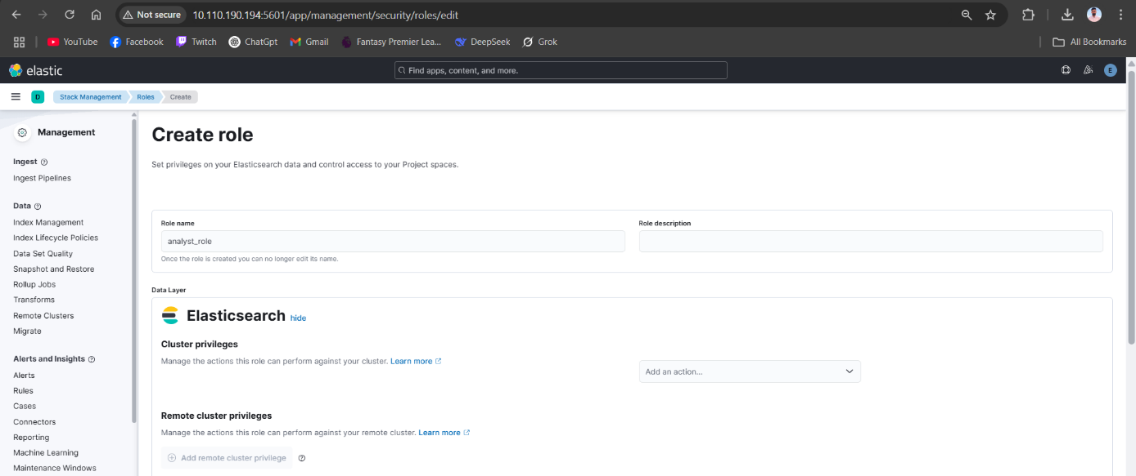

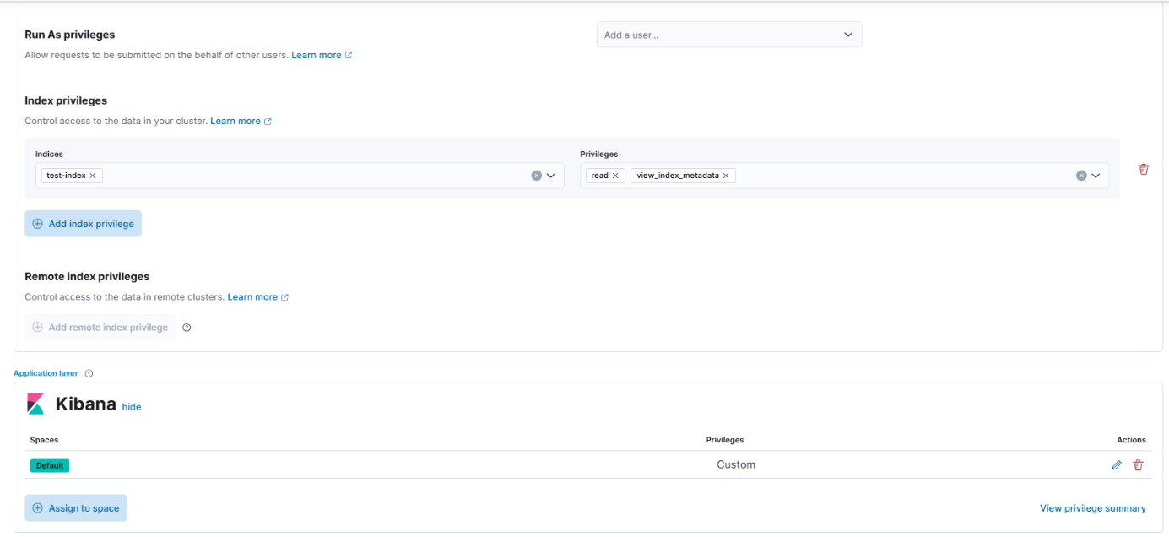

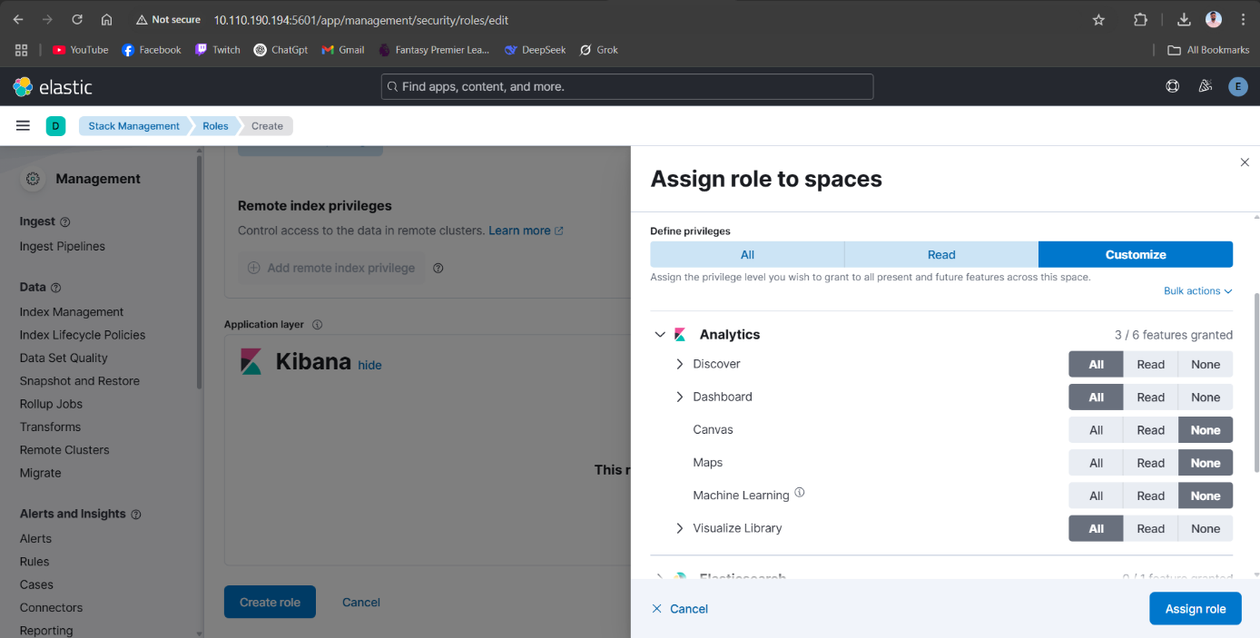
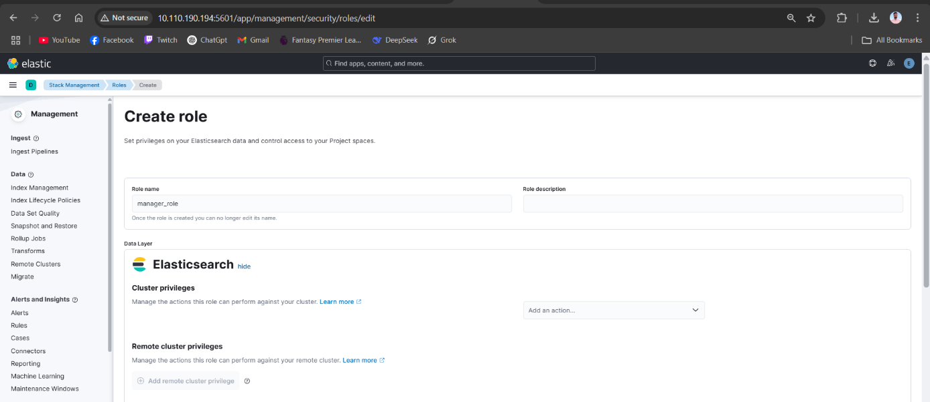

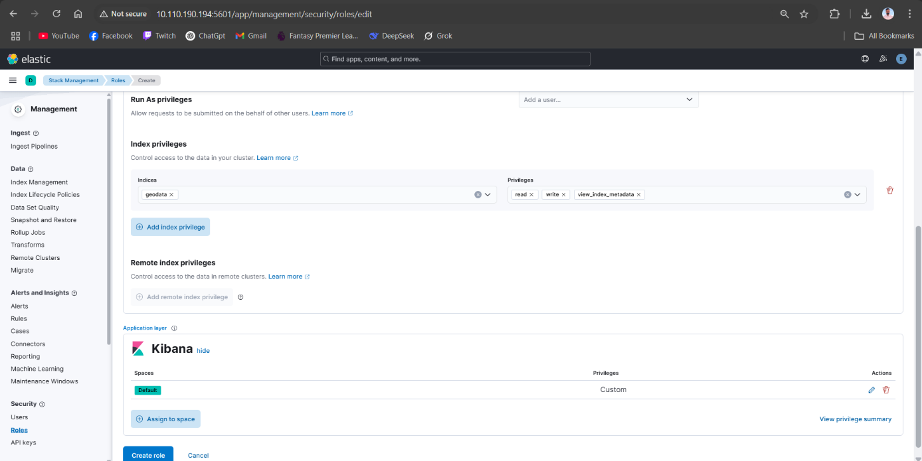
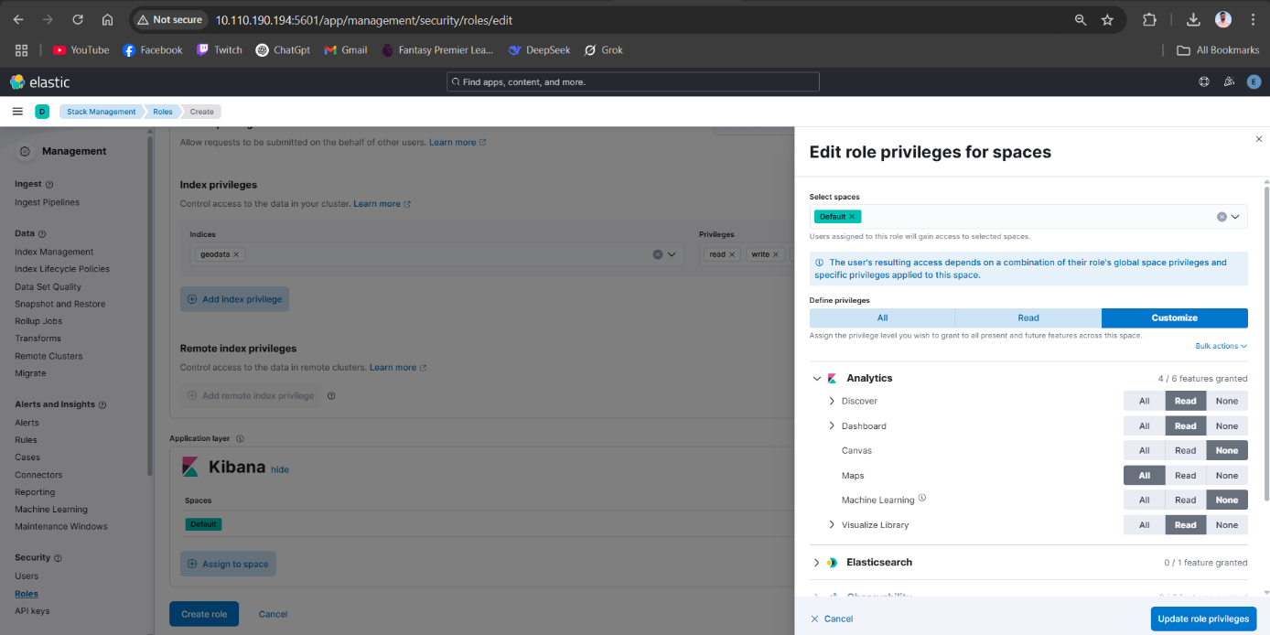

1.2 Create Users
Now, create two users and assign them to the respective roles.
- Create the analyst_user:
  - Go to Stack Management > Users.
  - Click Create user.
  - Username: analyst_user.
  - Password: analystpass123.
  - Full Name: Analyst User.
  - Roles: analyst_role.
  - Click Create user.
- Create the manager_user:
  - Go to Stack Management > Users.
  - Click Create user.
  - Username: manager_user.
  - Password: managerpass123.
  - Full Name: Manager User.
  - Roles: manager_role.
  - Click Create user.

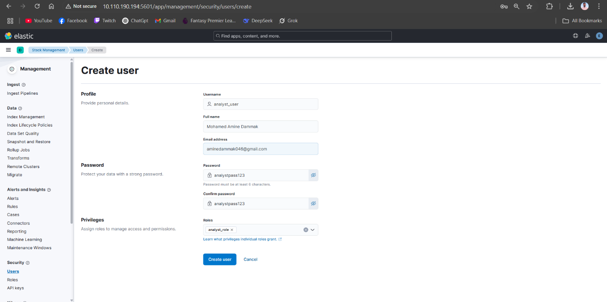

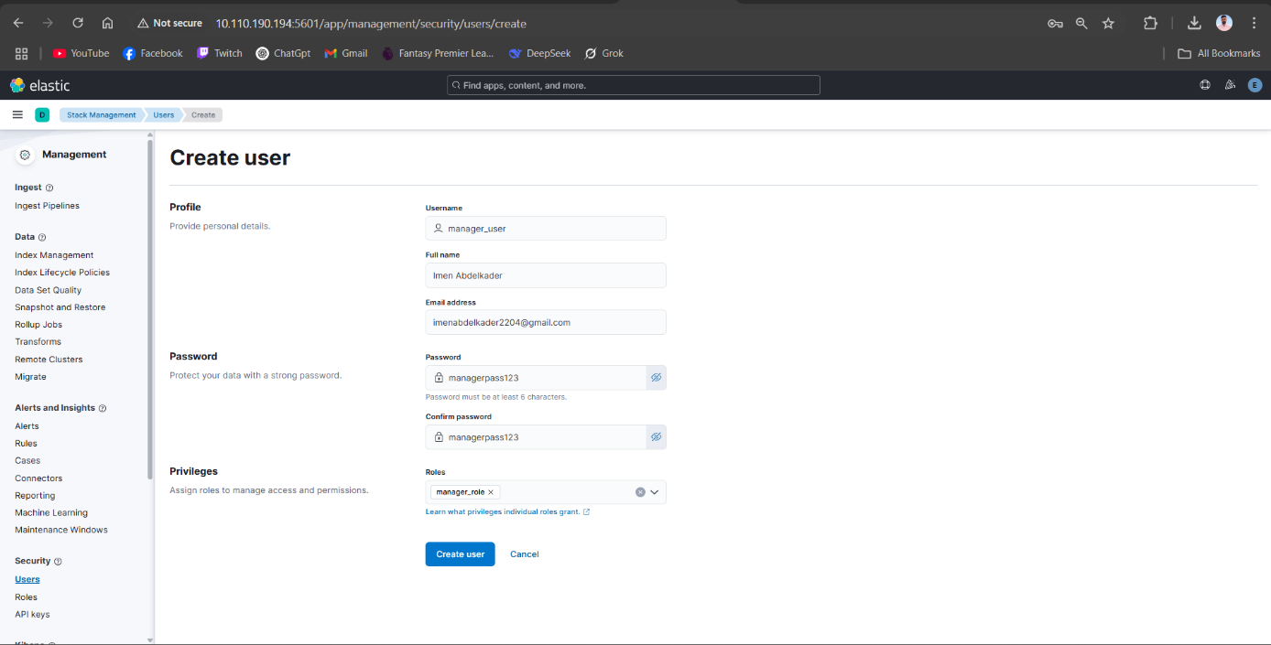

2. Test RBAC with KQL
We’ll test the RBAC setup by logging in as each user, querying the test-index index with KQL, and attempting to access visualizations.

2.1 Prepare Test Data and Visualizations
Ensure the test-index index exists with some data, and create a visualization for testing.
- Verify the test-index Index:
  - Log in as the elastic user.
  - Go to Dev Tools.
  - Run:
  - GET test-index/_mapping
  - If the index doesn’t exist, create it (as shown in your previous steps):
  - PUT test-index
{
"settings": {
"index": {
"number_of_shards": 1,
"number_of_replicas": 0
}
},
"mappings": {
"properties": {
"user_id": { "type": "keyword" },
"name": { "type": "text" },
"age": { "type": "integer" },
"last_updated": { "type": "date" }
}
}
}
- Add Sample Data: In Dev Tools, run:
- POST test-index/_doc/1
{
"user_id": "u1",
"name": "Alice",
"age": 25,
"last_updated": "2025-04-05T06:00:00Z"
}
POST test-index/_doc/2
{
"user_id": "u2",
"name": "Bob",
"age": 30,
"last_updated": "2025-04-05T06:00:00Z"
}
POST test-index/_doc/3
{
"user_id": "u3",
"name": "Charlie",
"age": 35,
"last_updated": "2025-04-05T06:00:00Z"
}
- Create an Index Pattern:
  - Go to Stack Management > Index Patterns.
  - Create an index pattern for test-index (select “I don’t want to use the Time Filter”).
- Create a Visualization:
  - Go to Visualize.
  - Click Create new visualization.
  - Choose Pie chart.
  - Select the test-index index pattern.
  - Buckets: Add a Terms aggregation on the name field.
  - Save the visualization as Test Pie Chart.
- Create a Dashboard:
  - Go to Dashboard.
  - Click Create new dashboard.
  - Add the Test Pie Chart visualization.
  - Save the dashboard as Test Dashboard.

2.2 Test Access as analyst_user
- Log in as analyst_user:
  - Log out of Kibana.
  - Log in with:
    - Username: analyst_user
    - Password: analystpass123
- Test Index Access with KQL:
  - Go to Discover.
  - Select the test-index index pattern.
  - In the KQL search bar, enter:
  - user_id:*
  - Expected Result: You should see all 3 documents (u1, u2, u3) because the analyst_role has read access to test-index.
- Test Write Access:
  - Go to Dev Tools.
  - Try to add a new document:
  - POST test-index/_doc/4
{
"user_id": "u4",
"name": "David",
"age": 28,
"last_updated": "2025-04-05T06:20:00Z"
}
  - Expected Result: This should fail with a 403 Forbidden error because the analyst_role doesn’t have write privileges.
- Test Visualization Access:
  - Go to Visualize.
  - Open the Test Pie Chart.
  - Expected Result: You should be able to view the visualization because the analyst_role has Read access to Visualize.
  - Try to edit the visualization (e.g., change the aggregation).
  - Expected Result: You should not be able to save changes because the analyst_role only has Read access, not All.
- Test Dashboard Access:
  - Go to Dashboard.
  - Open the Test Dashboard.
  - Expected Result: You should be able to view the dashboard because the analyst_role has Read access to Dashboard.

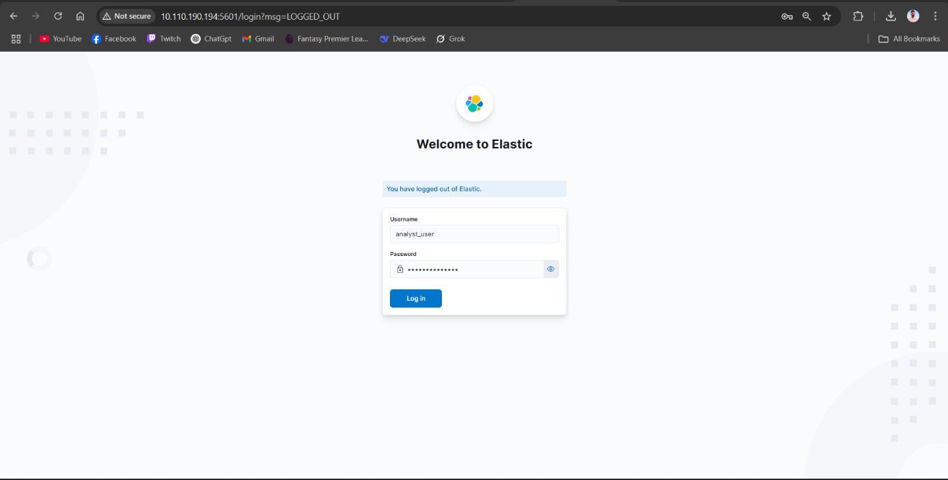

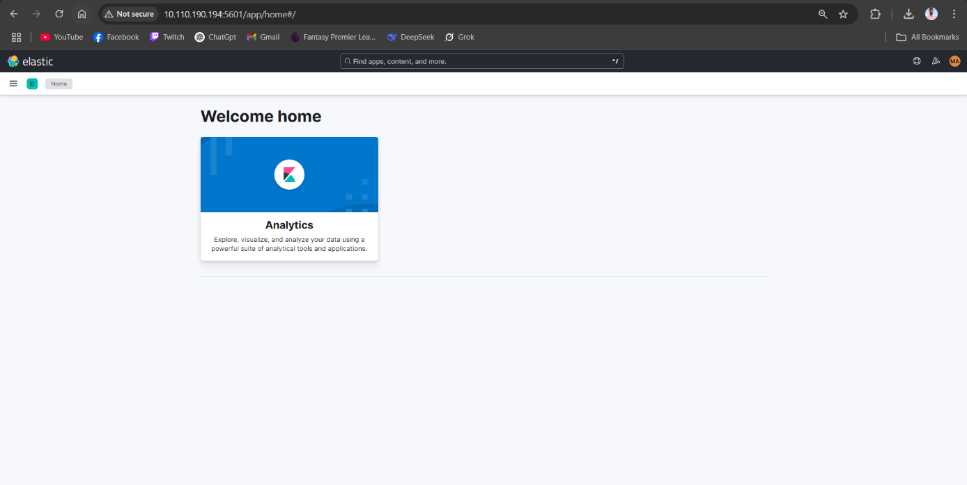
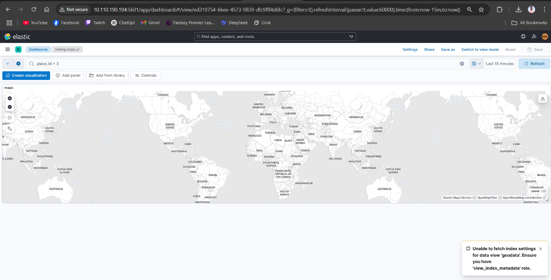

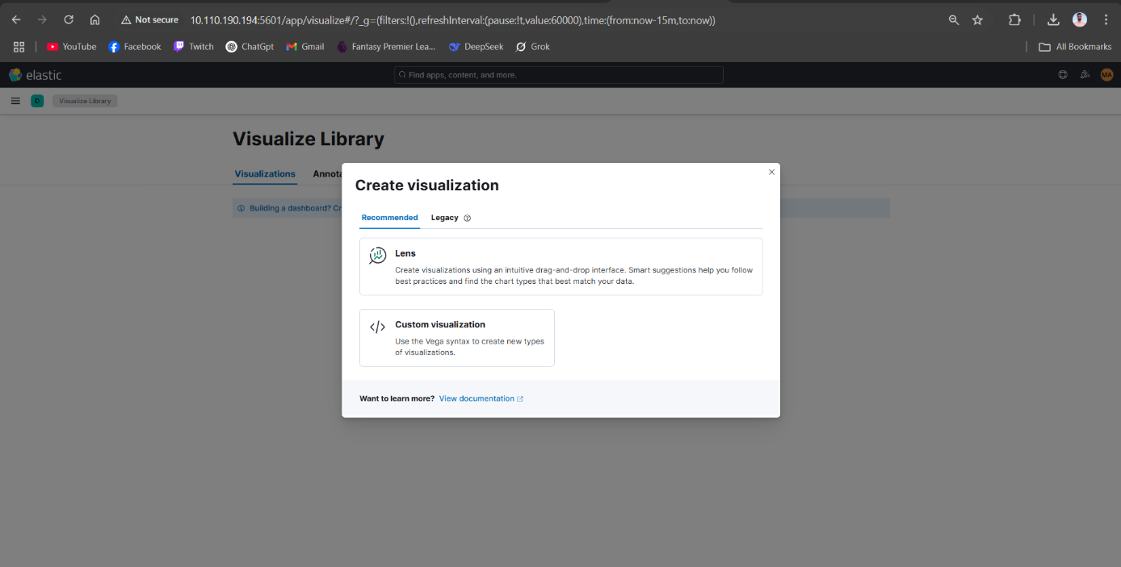

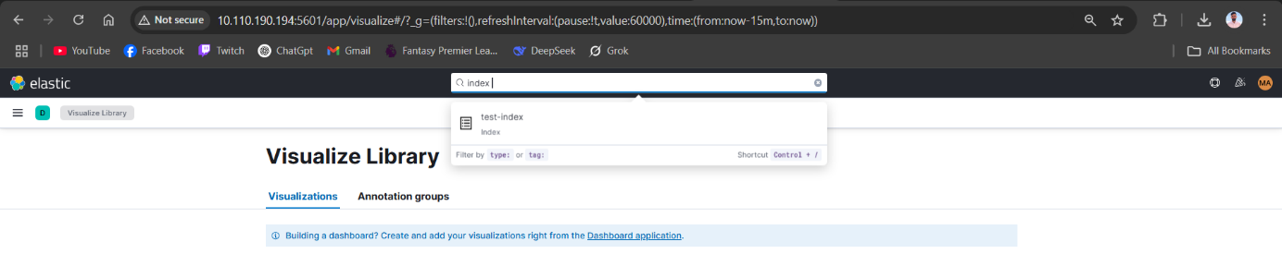

2.3 Test Access as manager_user
- Log in as manager_user:
  - Log out of Kibana.
  - Log in with:
    - Username: manager_user
    - Password: managerpass123
- Test Index Access with KQL:
  - Go to Discover.
  - Select the test-index index pattern.
  - In the KQL search bar, enter:
  - user_id:*
  - Expected Result: You should see all 3 documents (u1, u2, u3) because the manager_role has read access to test-index.
- Test Write Access:
  - Go to Dev Tools.
  - Add a new document:
  - POST test-index/_doc/4
{
"user_id": "u4",
"name": "David",
"age": 28,
"last_updated": "2025-04-05T06:20:00Z"
}
  - Expected Result: This should succeed because the manager_role has write privileges.
  - Go back to Discover and search:
  - user_id:"u4"
  - Expected Result: You should see the new document for David.
- Test Visualization Access:
  - Go to Visualize.
  - Open the Test Pie Chart.
  - Expected Result: You should be able to view and edit the visualization because the manager_role has All access to Visualize.
  - Make a change (e.g., add a new metric) and save it.
- Test Dashboard Access:
  - Go to Dashboard.
  - Open the Test Dashboard.
  - Expected Result: You should be able to view and edit the dashboard because the manager_role has All access to Dashboard.
  - Add a new panel and save the dashboard.
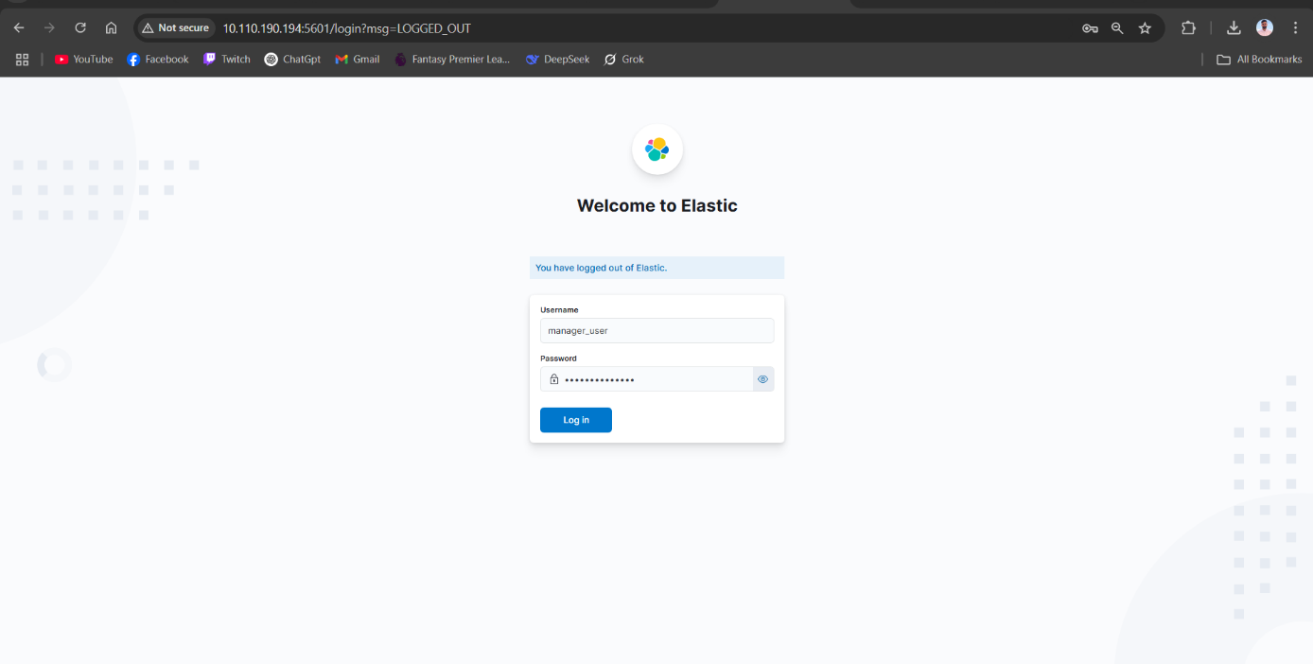

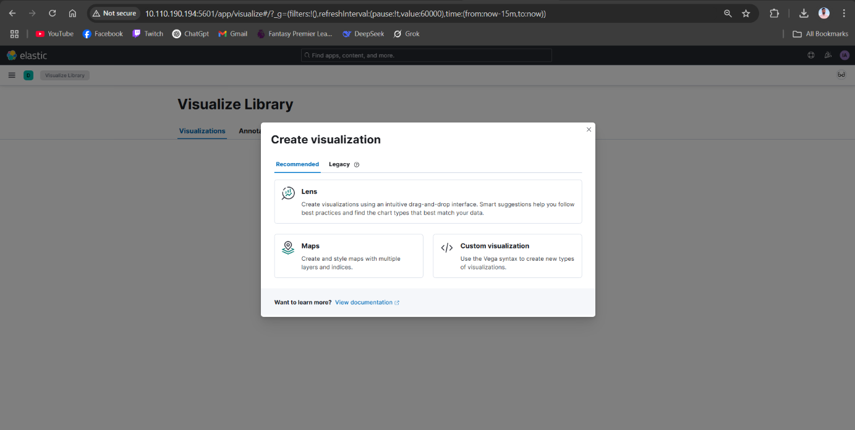
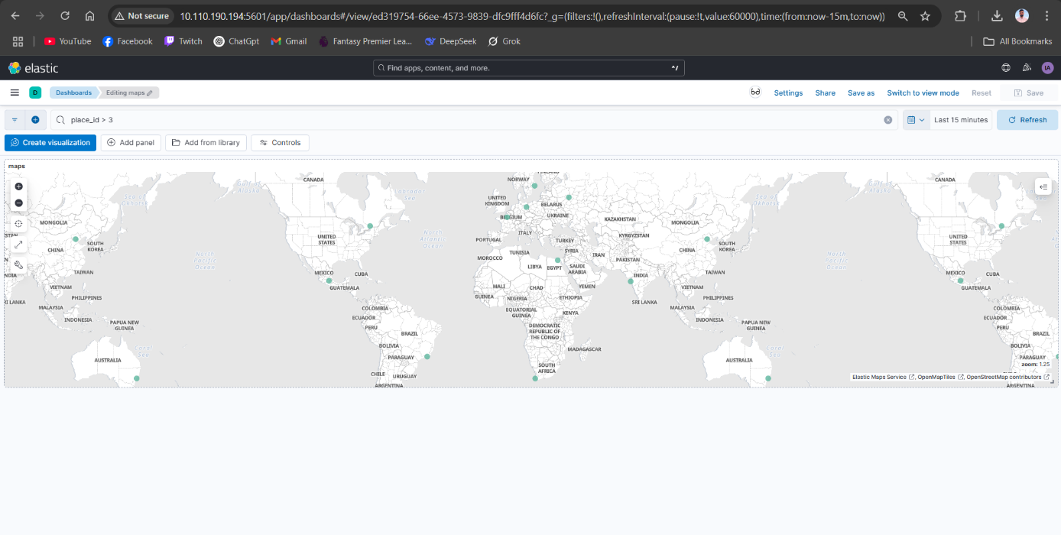

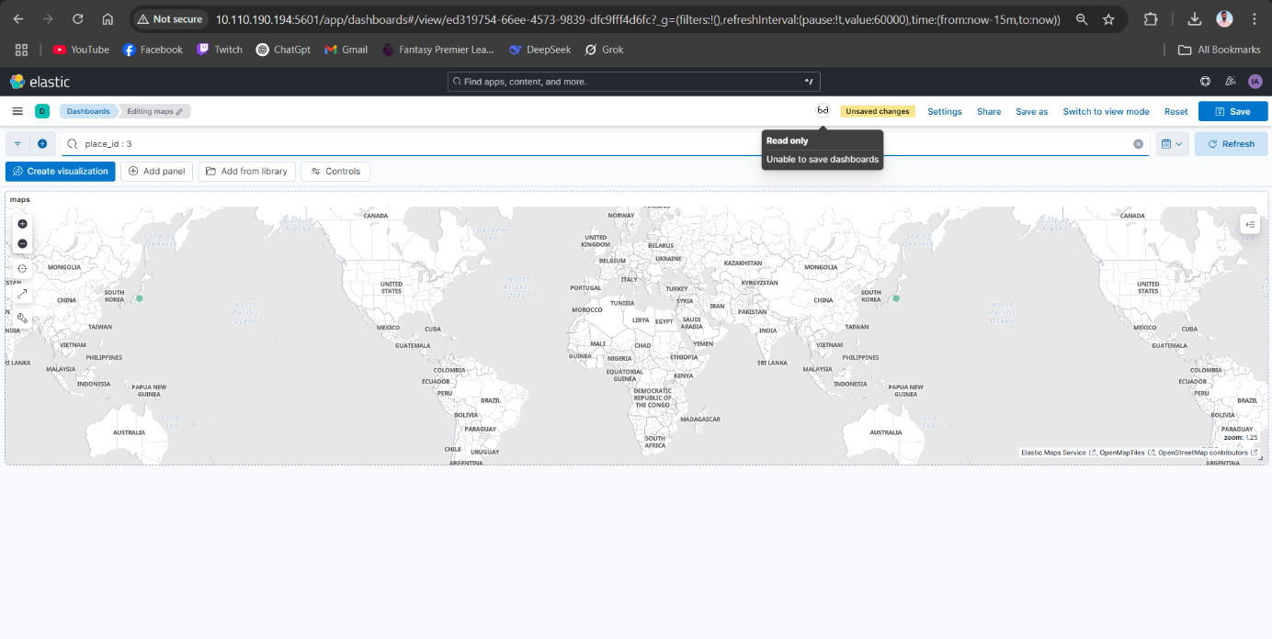

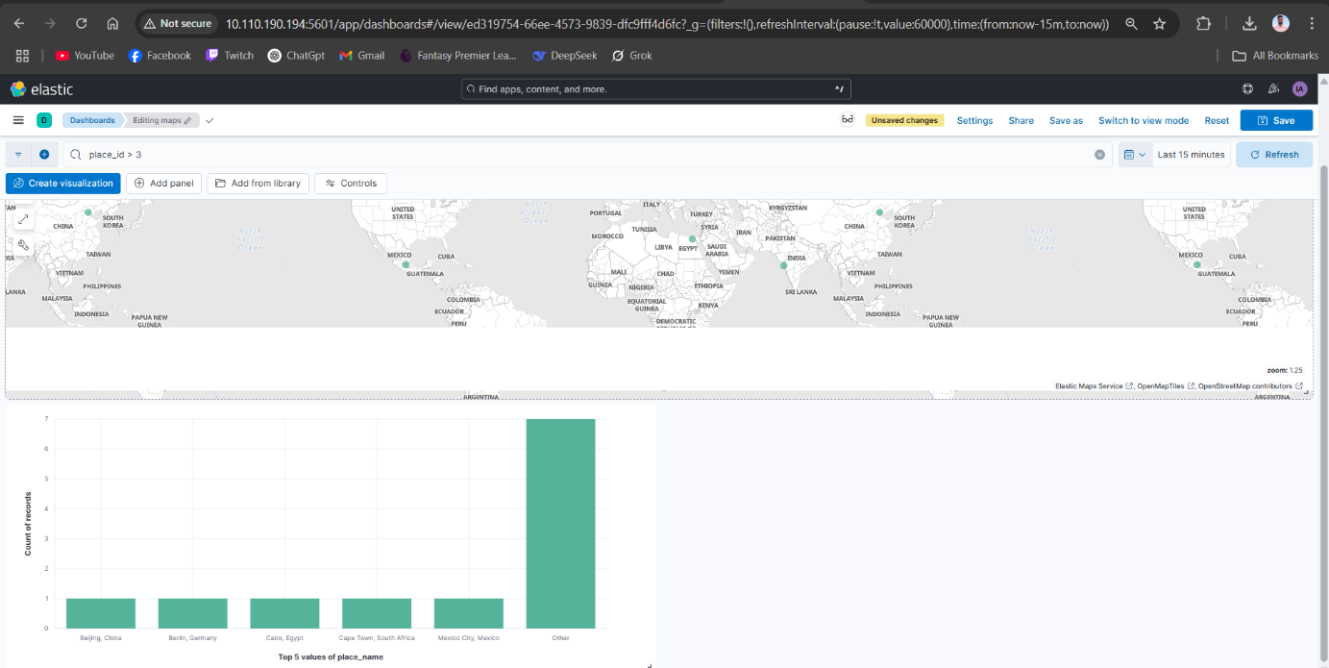

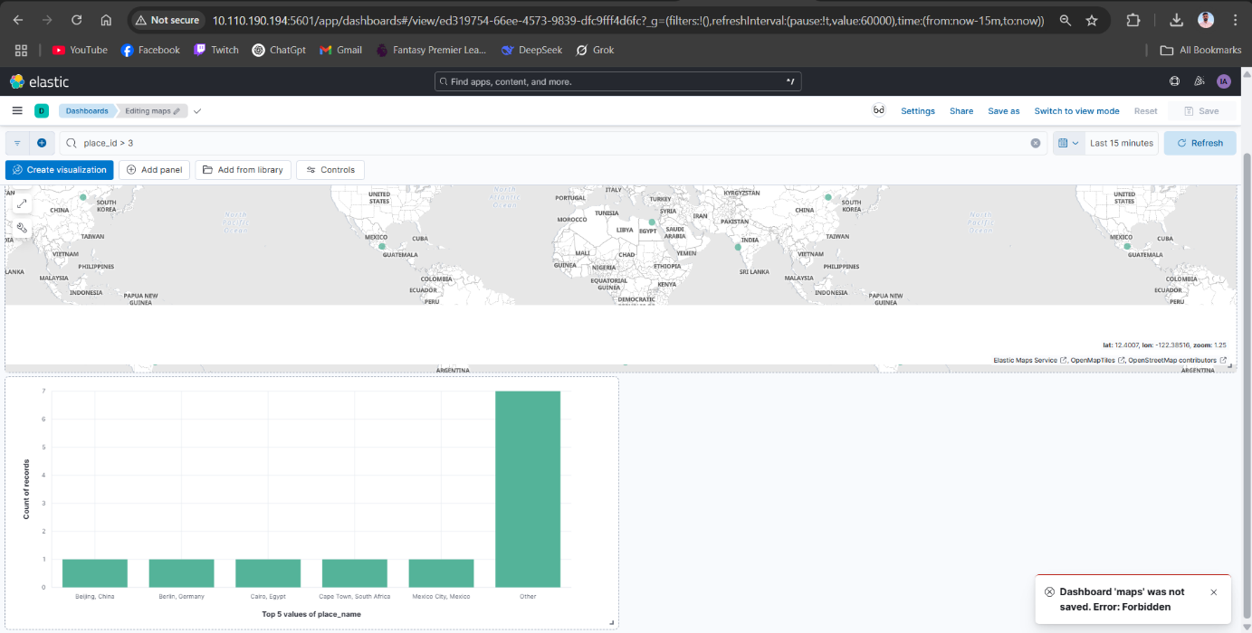

3. Test Access to a Restricted Index
Let’s create another index (restricted-index) and ensure that neither user has access to it.
- Create the restricted-index Index:
  - Log in as the elastic user.
  - In Dev Tools, run:
  - PUT restricted-index
{
"settings": {
"index": {
"number_of_shards": 1,
"number_of_replicas": 0
}
}
}
  - Add a document:
  - POST restricted-index/_doc/1
{
"user_id": "r1",
"name": "Restricted User",
"age": 40,
"last_updated": "2025-04-05T06:30:00Z"
}
- Create an Index Pattern for restricted-index:
  - Go to Stack Management > Index Patterns.
  - Create an index pattern for restricted-index.
- Test Access as analyst_user:
  - Log in as analyst_user.
  - Go to Discover.
  - Try to select the restricted-index index pattern.
  - Expected Result: You should not see restricted-index in the list of available index patterns because the analyst_role doesn’t have access to it.
- Test Access as manager_user:
  - Log in as manager_user.
  - Go to Discover.
  - Try to select the restricted-index index pattern.
  - Expected Result: You should not see restricted-index because the manager_role doesn’t have access to it.

5- Multindex solution to replace nested fields :
Queries to execute dev tools(kibana)
PUT /countries { "mappings": { "properties": { "CountryID": { "type": "keyword" } } } }
PUT /languages { "mappings": { "properties": { "LanguageID": { "type": "keyword" }, "LanguageName": { "type": "keyword" } } } }
PUT /country_names { "mappings": { "properties": { "CountryID": { "type": "keyword" }, "LanguageID": { "type": "keyword" }, "CountryName": { "type": "text" } } } }
PUT /administrative_divisions { "mappings": { "properties": { "AdminDivisionID": { "type": "keyword" }, "CountryID": { "type": "keyword" }, "AdminDivisionLevel": { "type": "integer" }, "ParentDivisionID": { "type": "keyword" } } } }
PUT /admin_division_names { "mappings": { "properties": { "AdminDivisionID": { "type": "keyword" }, "LanguageID": { "type": "keyword" }, "DivisionName": { "type": "text" } } } }
PUT /healthcare_facilities { "mappings": { "properties": { "HealthcareFacilityID": { "type": "keyword" }, "CountryID": { "type": "keyword" }, "DateCreation": { "type": "date" }, "DivisionPath": { "type": "keyword" } } } }
PUT /healthcare_facility_names { "mappings": { "properties": { "HealthcareFacilityID": { "type": "keyword" }, "LanguageID": { "type": "keyword" }, "HFName": { "type": "text" } } } }
PUT /healthcare_facility_divisions { "mappings": { "properties": { "HealthcareFacilityID": { "type": "keyword" }, "Level": { "type": "integer" }, "LanguageID": { "type": "keyword" }, "AdminDivisionID": { "type": "keyword" }, "DivisionName": { "type": "text" } } } }
POST /healthcare_facilities/_doc { "HealthcareFacilityID": "HF-CA-001", "CountryID": "CA", "DateCreation": "2021-03-15", "DivisionPath": "Ontario > Greater Toronto > Downtown Toronto" } POST /healthcare_facility_names/_doc { "HealthcareFacilityID": "HF-CA-001", "LanguageID": "EN", "HFName": "Toronto General Hospital" } POST /healthcare_facility_names/_doc { "HealthcareFacilityID": "HF-CA-001", "LanguageID": "FR", "HFName": "Hôpital Général de Toronto" }
POST /healthcare_facility_names/_doc { "HealthcareFacilityID": "HF-FR-001", "LanguageID": "EN", "HFName": "Timone Hospital" }
POST /healthcare_facility_names/_doc { "HealthcareFacilityID": "HF-FR-001", "LanguageID": "FR", "HFName": "Hôpital de la Timone" } POST /healthcare_facility_divisions/_doc { "HealthcareFacilityID": "HF-CA-001", "Level": 1, "LanguageID": "EN", "AdminDivisionID": "CA-ON", "DivisionName": "Ontario" } POST /healthcare_facility_divisions/_doc { "HealthcareFacilityID": "HF-CA-001", "Level": 2, "LanguageID": "EN", "AdminDivisionID": "CA-ON-GT", "DivisionName": "Greater Toronto" } POST /healthcare_facility_divisions/_doc { "HealthcareFacilityID": "HF-CA-001", "Level": 3, "LanguageID": "EN", "AdminDivisionID": "CA-ON-GT-DT", "DivisionName": "Downtown Toronto" }
POST /healthcare_facilities/_doc { "HealthcareFacilityID": "HF-CA-002", "CountryID": "CA", "DateCreation": "2019-06-22", "DivisionPath": "Ontario > Greater Toronto > Downtown Toronto" }
POST /healthcare_facility_names/_doc { "HealthcareFacilityID": "HF-CA-002", "LanguageID": "EN", "HFName": "Mount Sinai Hospital" }
POST /healthcare_facility_names/_doc { "HealthcareFacilityID": "HF-CA-002", "LanguageID": "FR", "HFName": "Hôpital Mont Sinaï" }
POST /healthcare_facility_divisions/_doc { "HealthcareFacilityID": "HF-CA-002", "Level": 1, "LanguageID": "EN", "AdminDivisionID": "CA-ON", "DivisionName": "Ontario" }
POST /healthcare_facility_divisions/_doc { "HealthcareFacilityID": "HF-CA-002", "Level": 2, "LanguageID": "EN", "AdminDivisionID": "CA-ON-GT", "DivisionName": "Greater Toronto" }
POST /healthcare_facility_divisions/_doc { "HealthcareFacilityID": "HF-CA-002", "Level": 3, "LanguageID": "EN", "AdminDivisionID": "CA-ON-GT-DT", "DivisionName": "Downtown Toronto" }
POST /healthcare_facility_divisions/_doc { "HealthcareFacilityID": "HF-FR-001", "Level": 1, "LanguageID": "EN", "AdminDivisionID": "FR-PACA", "DivisionName": "Provence-Alpes-Côte d’Azur" }
POST /healthcare_facility_divisions/_doc { "HealthcareFacilityID": "HF-FR-001", "Level": 2, "LanguageID": "EN", "AdminDivisionID": "FR-BDR", "DivisionName": "Bouches-du-Rhône" } POST /healthcare_facility_divisions/_doc { "HealthcareFacilityID": "HF-FR-001", "Level": 3, "LanguageID": "EN", "AdminDivisionID": "FR-BDR-MRS", "DivisionName": "Marseille" }
POST /healthcare_facilities/_doc { "HealthcareFacilityID": "HF-CA-003", "CountryID": "CA", "DateCreation": "2020-11-02", "DivisionPath": "Ontario > Greater Toronto > Downtown Toronto" }
POST /healthcare_facility_names/_doc { "HealthcareFacilityID": "HF-CA-003", "LanguageID": "EN", "HFName": "St. Michael’s Hospital" }
POST /healthcare_facility_names/_doc { "HealthcareFacilityID": "HF-CA-003", "LanguageID": "FR", "HFName": "Hôpital Saint-Michel" }
POST /healthcare_facility_divisions/_doc { "HealthcareFacilityID": "HF-CA-003", "Level": 1, "LanguageID": "EN", "AdminDivisionID": "CA-ON", "DivisionName": "Ontario" }
POST /healthcare_facility_divisions/_doc { "HealthcareFacilityID": "HF-CA-003", "Level": 2, "LanguageID": "EN", "AdminDivisionID": "CA-ON-GT", "DivisionName": "Greater Toronto" }
POST /healthcare_facility_divisions/_doc { "HealthcareFacilityID": "HF-CA-003", "Level": 3, "LanguageID": "EN", "AdminDivisionID": "CA-ON-GT-DT", "DivisionName": "Downtown Toronto" }
POST /healthcare_facility_divisions/_doc { "HealthcareFacilityID": "HF-CA-003", "Level": 1, "LanguageID": "FR", "AdminDivisionID": "CA-ON", "DivisionName": "Ontario" }
POST /healthcare_facility_divisions/_doc { "HealthcareFacilityID": "HF-CA-003", "Level": 2, "LanguageID": "FR", "AdminDivisionID": "CA-ON-GT", "DivisionName": "Grand Toronto" }
POST /healthcare_facility_divisions/_doc { "HealthcareFacilityID": "HF-CA-003", "Level": 3, "LanguageID": "FR", "AdminDivisionID": "CA-ON-GT-DT", "DivisionName": "Centre-ville de Toronto" }
POST /healthcare_facilities/_doc { "HealthcareFacilityID": "HF-FR-001", "CountryID": "FR", "DateCreation": "2020-05-10", "DivisionPath": "Provence-Alpes-Côte d’Azur > Bouches-du-Rhône > Marseille" }
POST /administrative_divisions/_doc { "AdminDivisionID": "CA-ON", "CountryID": "CA", "AdminDivisionLevel": 1, "ParentDivisionID": null } POST /admin_division_names/_doc { "AdminDivisionID": "CA-ON", "LanguageID": "EN", "DivisionName": "Ontario" } POST /admin_division_names/_doc { "AdminDivisionID": "CA-ON", "LanguageID": "FR", "DivisionName": "Ontario" }
POST /administrative_divisions/_doc { "AdminDivisionID": "CA-ON-GT", "CountryID": "CA", "AdminDivisionLevel": 2, "ParentDivisionID": "CA-ON" } POST /admin_division_names/_doc { "AdminDivisionID": "CA-ON-GT", "LanguageID": "EN", "DivisionName": "Greater Toronto" } POST /admin_division_names/_doc { "AdminDivisionID": "CA-ON-GT", "LanguageID": "FR", "DivisionName": "Grand Toronto" }
POST /administrative_divisions/_doc { "AdminDivisionID": "FR-PACA", "CountryID": "FR", "AdminDivisionLevel": 1, "ParentDivisionID": null } POST /admin_division_names/_doc { "AdminDivisionID": "FR-PACA", "LanguageID": "EN", "DivisionName": "Provence-Alpes-Côte d’Azur" } POST /admin_division_names/_doc { "AdminDivisionID": "FR-PACA", "LanguageID": "FR", "DivisionName": "Provence-Alpes-Côte d’Azur" }
POST /country_names/_doc { "CountryID": "FR", "LanguageID": "EN", "CountryName": "France" } POST /country_names/_doc { "CountryID": "FR", "LanguageID": "FR", "CountryName": "France" } POST /country_names/_doc { "CountryID": "CA", "LanguageID": "EN", "CountryName": "Canada" } POST /country_names/_doc { "CountryID": "CA", "LanguageID": "FR", "CountryName": "Canada" }
POST /countries/_doc { "CountryID": "FR" }
POST /countries/_doc { "CountryID": "CA" }
POST /languages/_doc { "LanguageID": "EN", "LanguageName": "English" }
POST /languages/_doc { "LanguageID": "FR", "LanguageName": "French" }
GET /healthcare_facility_divisions/_search { "query": { "bool": { "must": [ { "term": { "Level": 3 }}, { "prefix": { "AdminDivisionID": "CA-" }} ] } }, "_source": ["HealthcareFacilityID", "AdminDivisionID", "DivisionName"] }
GET /healthcare_facility_divisions/_search { "query": { "bool": { "must": [ { "term": { "Level": 3 }}, { "wildcard": { "AdminDivisionID": "CA-*" }} ] } }, "_source": ["HealthcareFacilityID", "AdminDivisionID", "DivisionName"] }
GET /healthcare_facility_names/_search { "query": { "bool": { "must": [ { "terms": { "HealthcareFacilityID": [ "HF-CA-001", "HF-CA-002" ] }}, { "term": { "LanguageID": "FR" }} ] } }, "_source": ["HFName"] }
GET /healthcare_facility_divisions/_search { "query": { "term": { "HealthcareFacilityID": "HF-FR-001" } }, "sort": [ { "Level": "asc" } ], "_source": ["Level", "DivisionName", "LanguageID"] }

