**Field Training Management System**

**Youssef Fathi Elwazzan**

**Mohamed Badee**

**Application Description:**  
The Field Training Management System is a comprehensive platform designed to oversee student field training in various companies.  
The system aims to streamline the internship process, facilitate easy management of students and mentors, and ensure effective coordination between academic and external stakeholders. It provides a centralized platform for students, internship coordinators, evaluators, organizations, and administrators to manage and track student registrations, organization profiles, internship details, and evaluation records. The system automates report generation, grade assignment, and student tracking, ensuring a well-documented and organized field training experience for all students.

**ERD:**

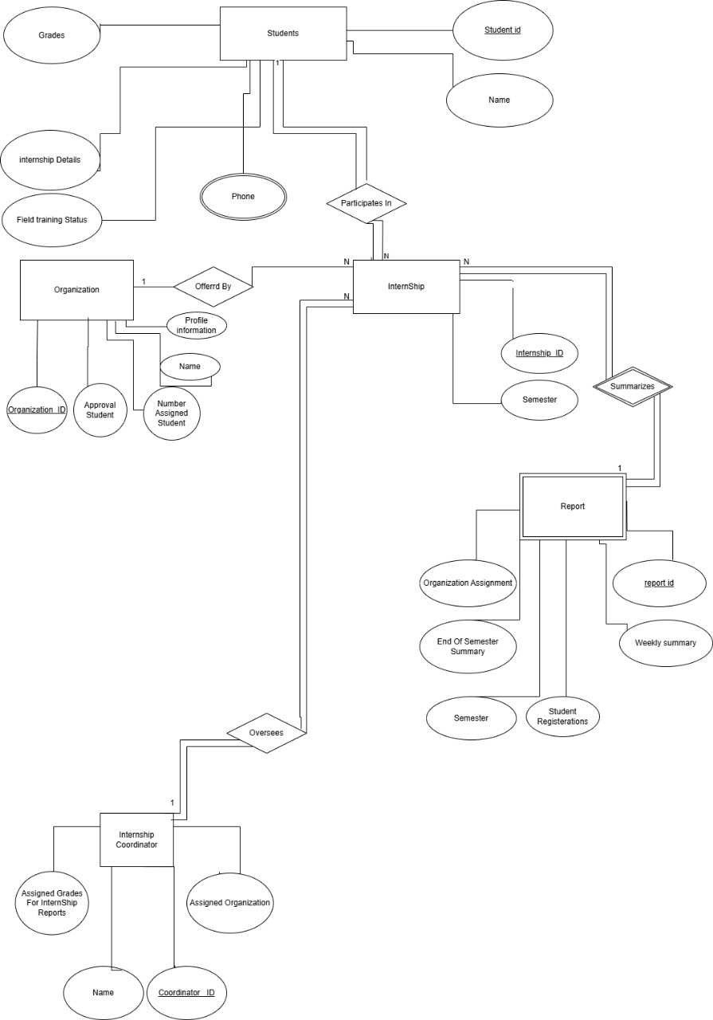

**Business Rules:**

1. **Student Registration Rule:** A student can only register for Field Training.
2. **Organization Approval Rule:** A newly added organization must be approved by the internship coordinator before it can be selected by students for internship purposes.
3. **Grade Assignment Rule:** The internship coordinator can assign grades to students for their final internship report, and internship evaluators can assign grades based on their assessment.
4. **Report Generation Rule:** The system must generate a report at the beginning of each semester, detailing student registrations, organizations involved, and mentor assignments, as well as weekly and end-of-semester reports summarizing internship data.
5. A student will have a name, ID, phone number, grades, internship details and field training status
6. An internship will have an ID and semester
7. An organization will have name, ID, profile information, number of assigned students and approval students
8. A report will have an ID, weekly summary, Student Registrations, Organization Assignment, End Of Semester Summary and Semester
9. An internship coordinator will have a name, ID, Assigned organization, Assigned grades for internship reports

**Relational Mapping:**

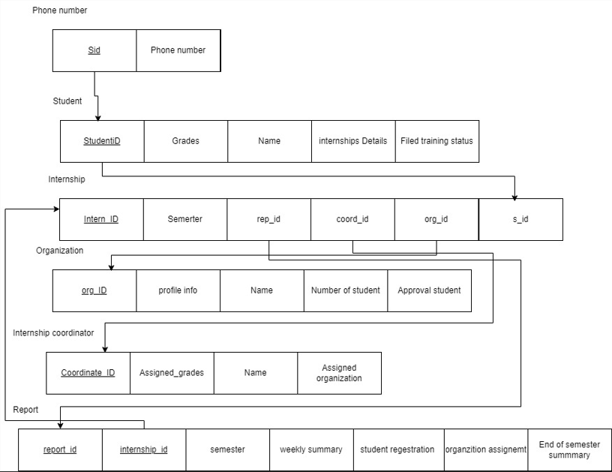

**Testing Queries:**

