
Rashid Petroleum Company (Rashpetco)
Instruments Department
Plant Handover
User Procedure
How to record, find and follow up shift handovers
Developed by: Mohamed Badr

Contents
Before you start 3
Step 1 – Open the app and connect the data folder 3
Step 2 – Sign in 4
Step 3 – Read the dashboard 6
Step 4 – Write a new handover 6
Step 5 – Find handovers 7
Step 6 – Work on a handover 9
Step 7 – Equipment pages and notifications 11
Step 8 – Profile and Administration 12

Plant Handover – User Procedure
Plant Handover is the department's shift log: engineers record what happened on the plant, link it to instrument tags, and the next shift picks it up. It runs in Chrome or Edge with nothing to install: the app files sit on your PC, and every handover is saved in the HandoverData folder on the file share, so everyone sees the same records.

Before you start
Item | Value
App package (.rar) – copy to your PC | ______________________________
Data folder on the file share (choose this once) | ______________________________ \HandoverData
Browser | Google Chrome or Microsoft Edge (Firefox is not supported)
Who signs in | Engineers only. Supervisors and technicians do not need an account.

Step 1 – Open the app and connect the data folder
Do this once on each PC; the browser remembers the folder afterwards.
- Copy the app package (.rar, path above) to your PC and extract it to a folder of your choice.
- Open the extracted folder and double-click index.html. It opens in Chrome or Edge.
- Click Choose folder….
- In the Windows window that opens, paste the data folder path from the table above into the address bar and press Enter. The share path works as it is – no mapped drive is needed. Select the HandoverData folder and click Select Folder.
- When the browser asks to let the site edit files, click Edit files (or Allow). Without this the app can read but not save.
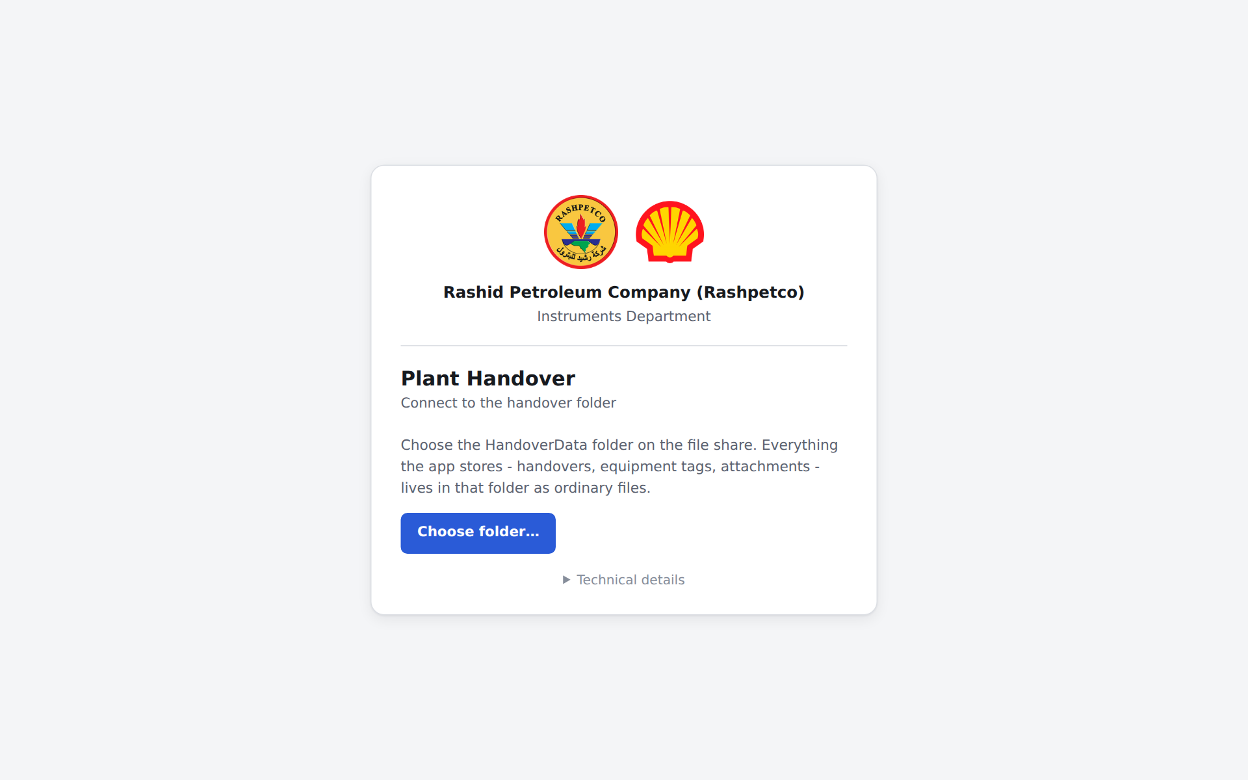
Next time, if the app shows Reconnect, click it and allow access again – no need to pick the folder.
Tip: if Chrome says the folder “contains system files”, you picked the top of the share. Open the share and choose the HandoverData folder inside it.

Step 2 – Sign in
- Pick your name from the list and click Confirm. Only engineers are listed – supervisors and technicians do not sign in; you add them to your handovers under Worked with.
- First time: choose a password (at least 6 characters) and type it twice. After that: type your password.
- Click the eye icon in the password box to see what you typed.
- Click Sign in. You stay signed in until the browser is closed.
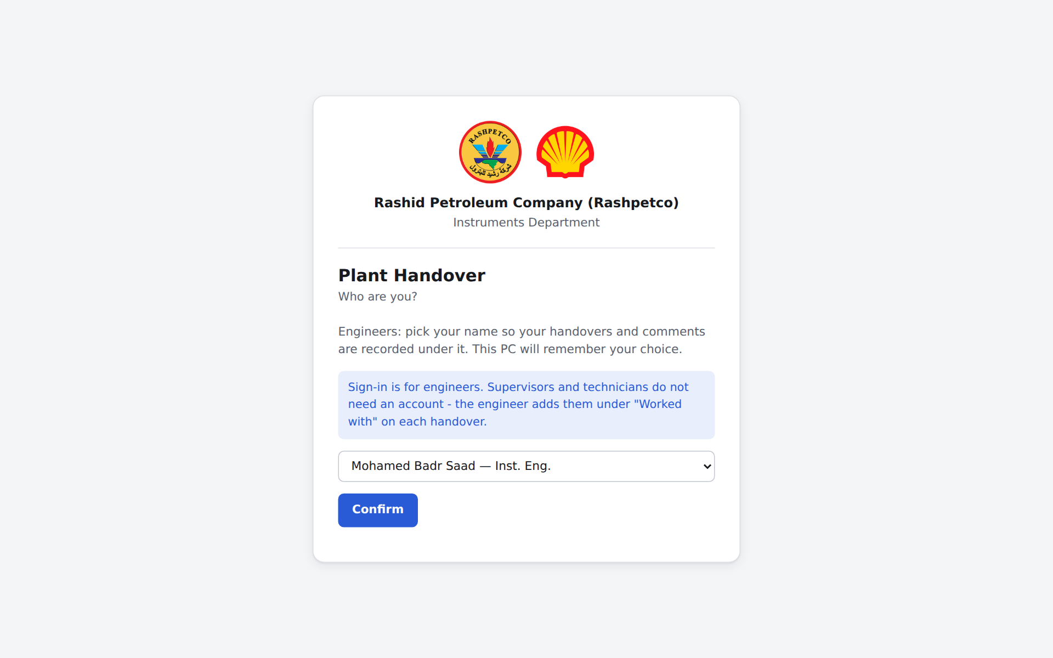
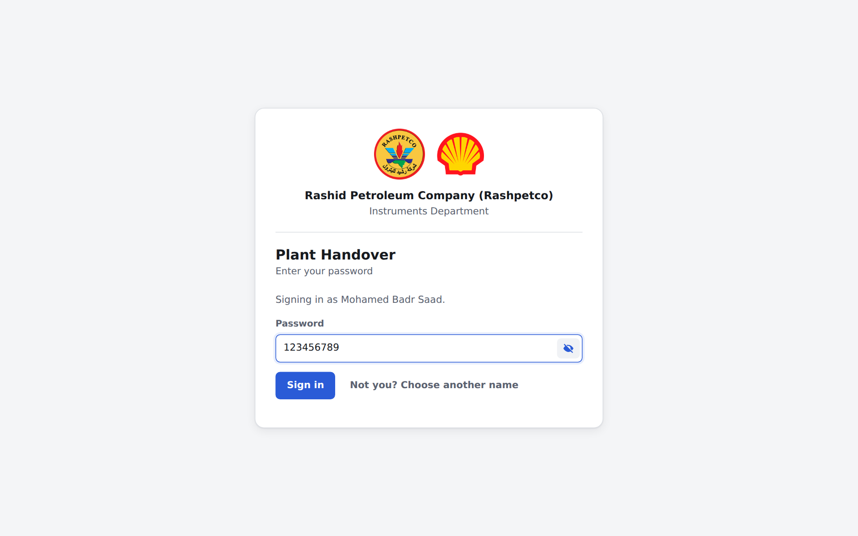
Forgot your password? Ask an administrator to reset it (Step 8); you will set a new one at the next sign-in.

Step 3 – Read the dashboard
The dashboard opens after sign-in. Click any count to open the matching list.
Card | Shows
Submitted today | Handovers submitted today
Submitted in the last 7 days | Handovers from the past week
Info & Follow-up (last 30 days) | Items someone still needs to act on
My submitted handovers | Everything you have written
My drafts | Your handovers not yet submitted
Below the cards: handovers by plant area and by equipment type for the last 30 days, recently updated tags, and the latest handovers.
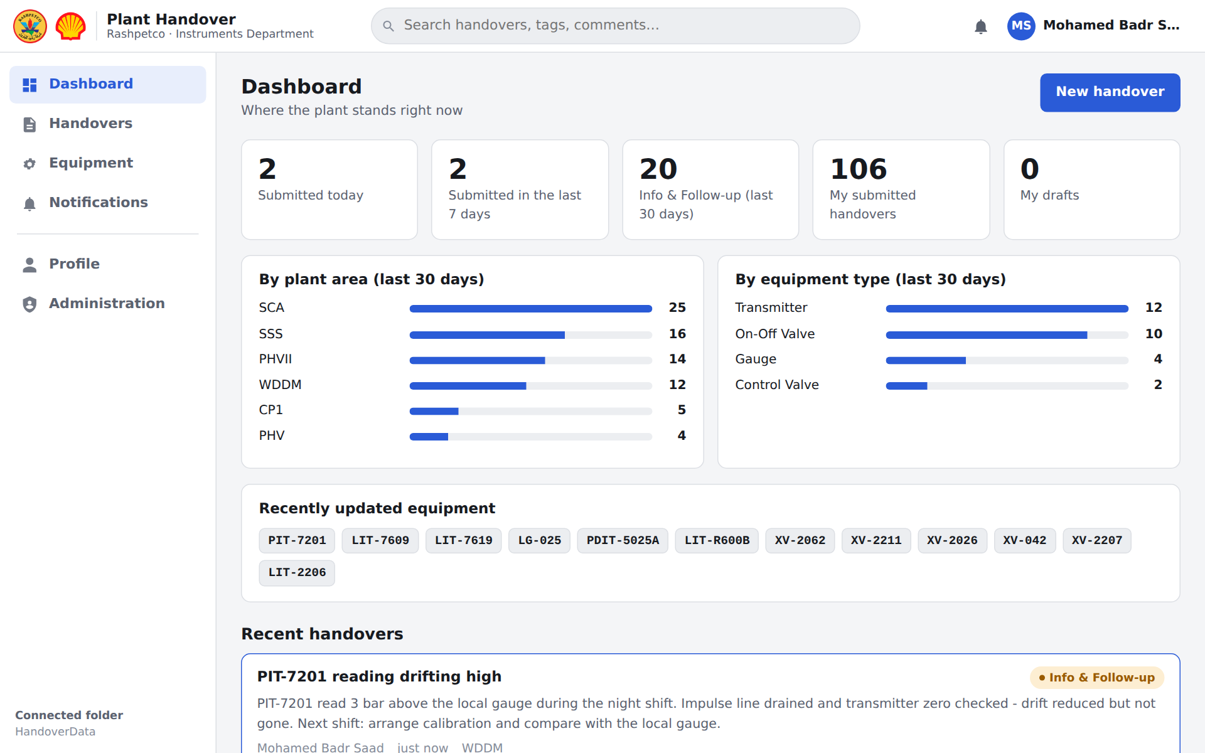

Step 4 – Write a new handover
- Click New handover (top right, or the blue + button).
- Title – a short summary, ideally starting with the tag number.
- Description – what happened, what was done, what the next shift must do.
- Area – pick the plant area; use + to add one that is missing.
- Status – Info (for the record only) or Info & Follow-up (someone needs to act).
- Worked with – tick the engineers and technicians who did the job with you.
- Equipment tags – type a tag number and click it in the suggestions. A tag that is not in the register can be added from the same box.
- Click Submit, or Save as draft to finish later.
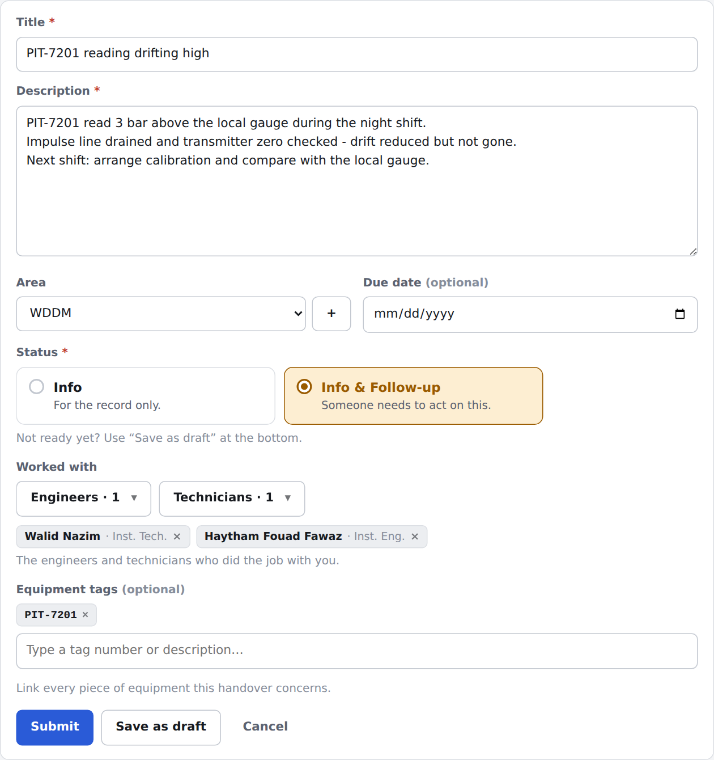
Only the person who wrote a handover can edit or delete it later.

Step 5 – Find handovers
Open Handovers in the left menu. The list holds every handover, including about 16,000 imported from the old Excel sheets (marked Imported).
- Search box – any word from the title, description, tag or author.
- Status – Draft, Info, Info & Follow-up, or all submitted.
- Area, date from / to, Equipment tag.
- Worked on by – a person, grouped as Engineers, Supervisors and Technicians; finds handovers they wrote or worked on.
- All records / New handovers only / Imported only.
- Export CSV – downloads exactly what the filters show, ready for Excel.
- Clear – resets all filters. The list shows 200 at a time; use Show more at the bottom.
The search bar at the top of every page also searches tags, people and comments.
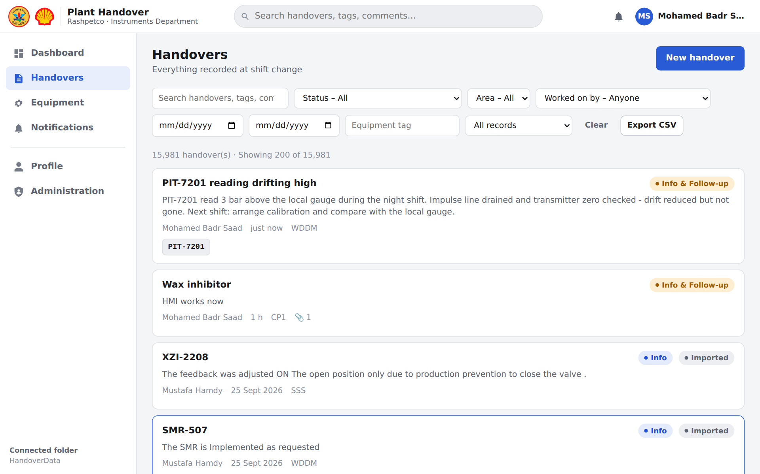
Searching from the top bar finds handovers, equipment and people in one go:
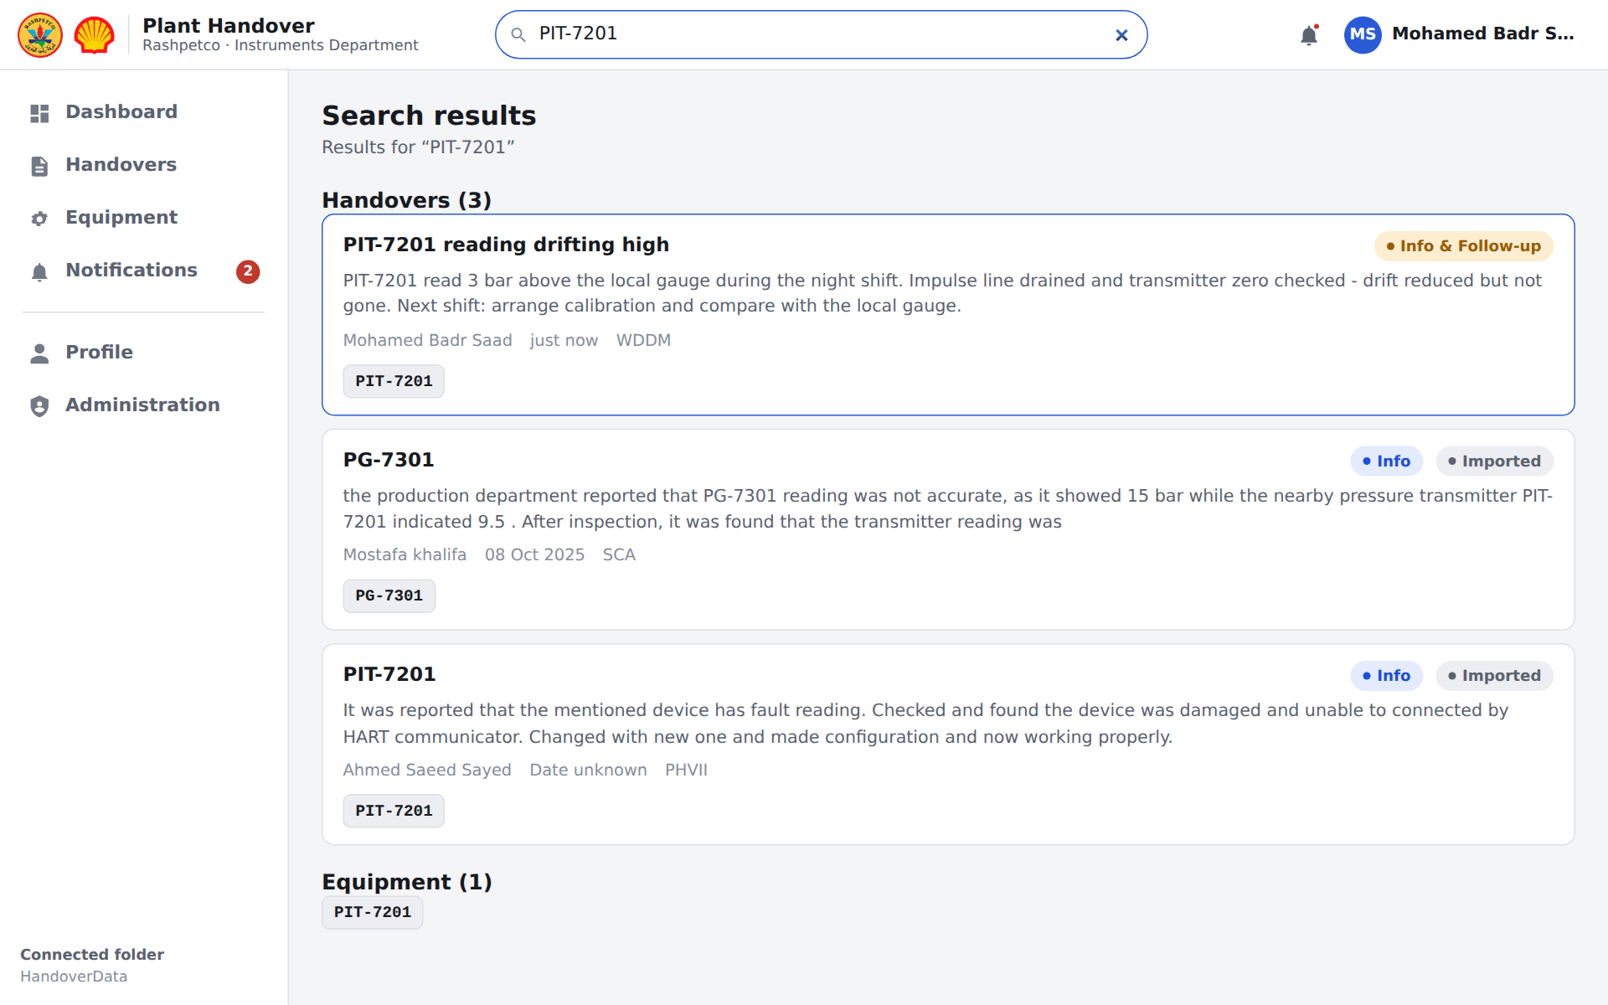

Step 6 – Work on a handover
Click a handover to open it.
Action | Who can do it | How
Add a comment | Everyone | Type in the comment box, click Post comment
Attach files | Everyone | Drop files on the dashed box or click it (images, PDF, Word, Excel, text; up to 20 MB each)
Edit | Author, Administration | Edit button
Change status | Author, Administration | Change status – Draft, Info or Info & Follow-up
Delete | Author, Administration | Delete, then confirm. Administration can restore it.
Imported handovers are read-only: anyone can comment or attach, only Administration can correct them. If someone else has a handover open for editing, the app warns you before you edit it too.
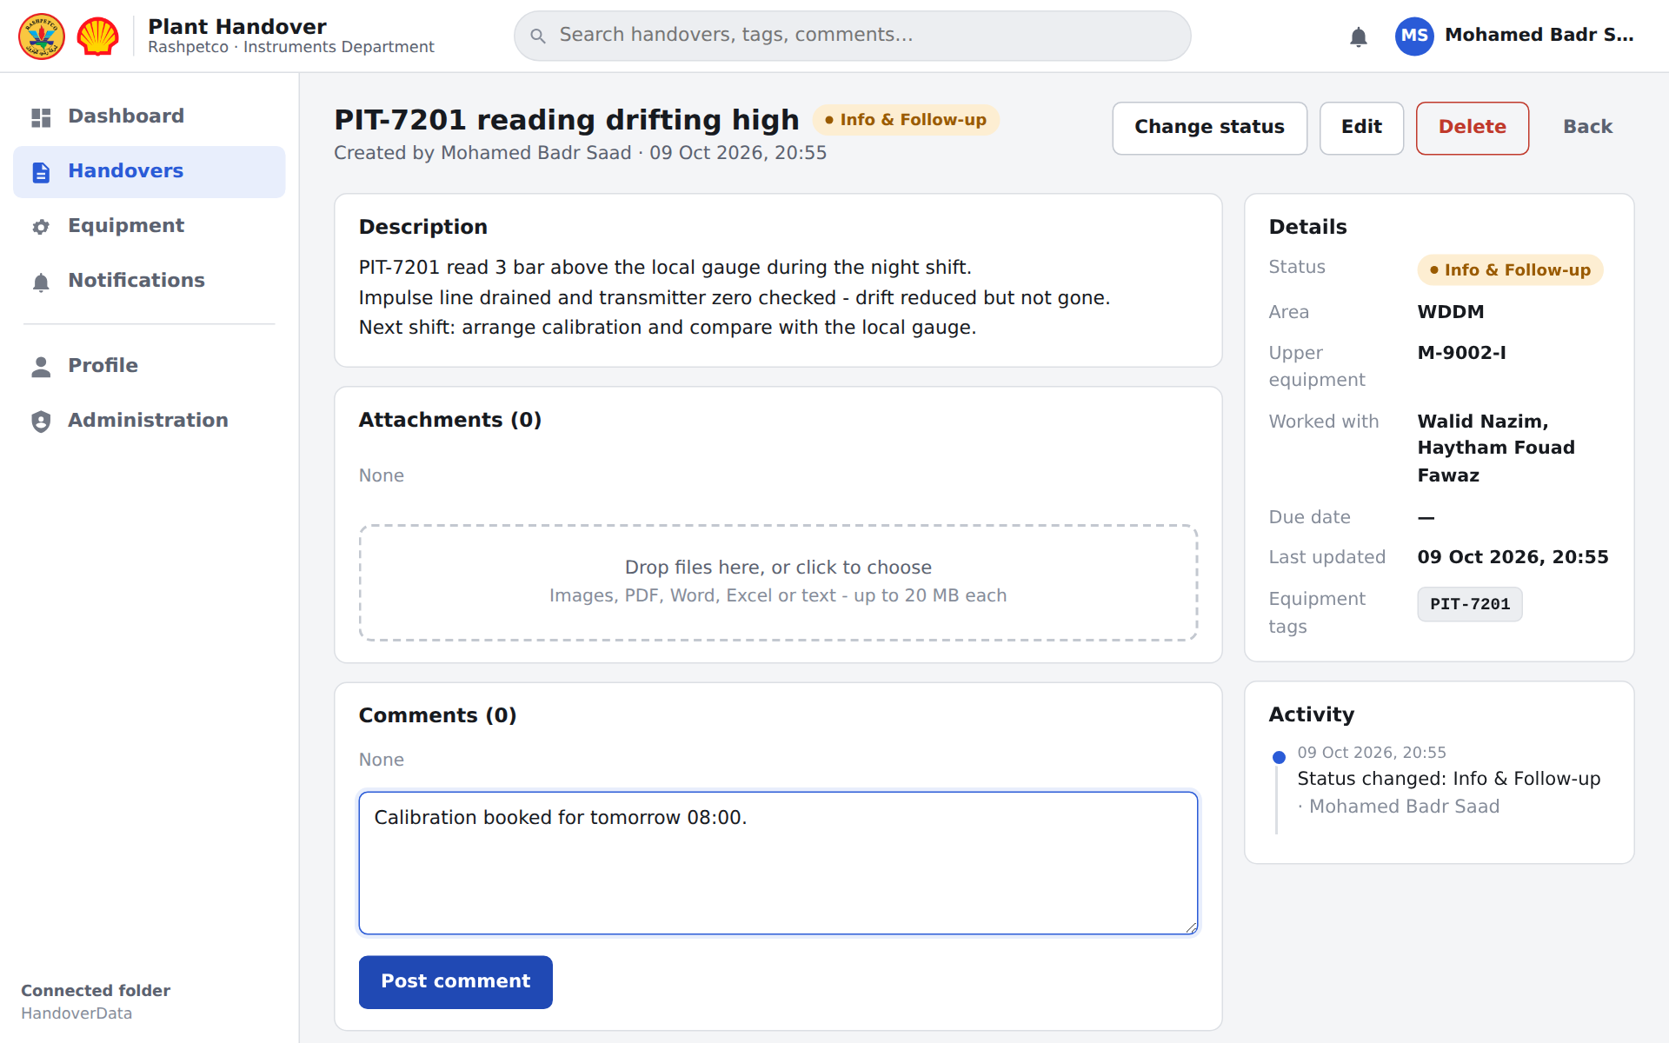
Change status and Delete each open a small window to confirm:
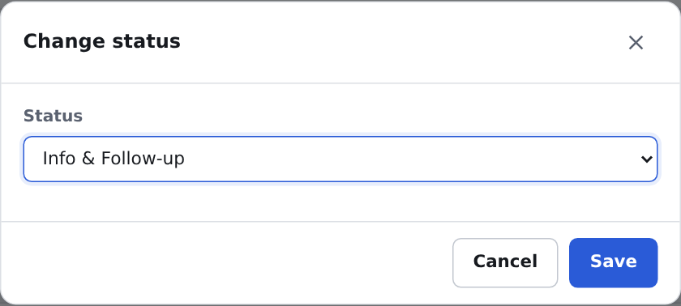
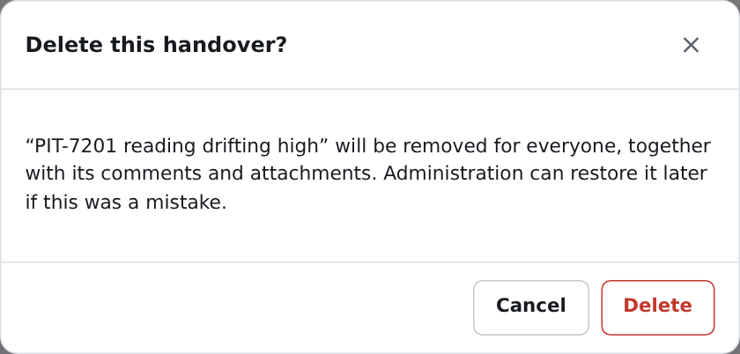

Step 7 – Equipment pages and notifications
Equipment – open Equipment in the menu, or click any tag chip. The tag page shows its type, upper equipment and calibration range, every handover that mentions it (old and new), and a timeline. New handover on this page starts one with the tag already linked.
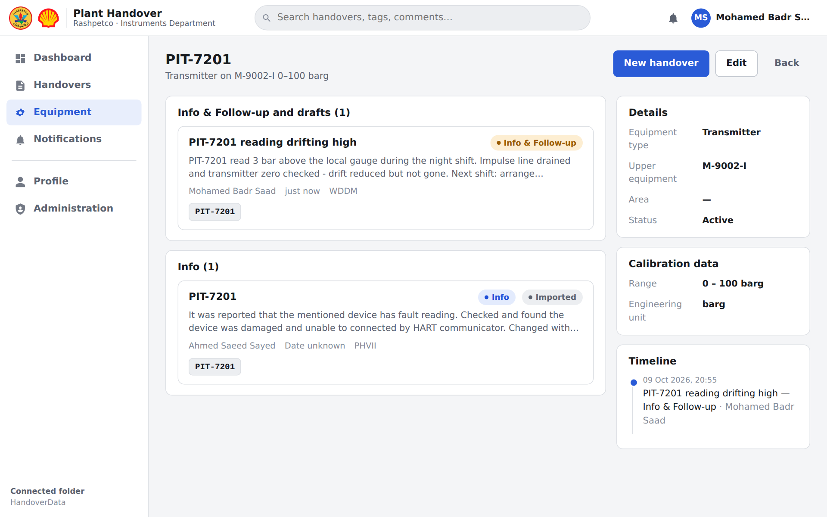
Notifications – the red number on the bell and in the menu counts what is new: handovers, comments, attachments, status changes and deletions by others. Click a notification to open the handover; it is marked read and the count drops. Mark all as read clears the count.
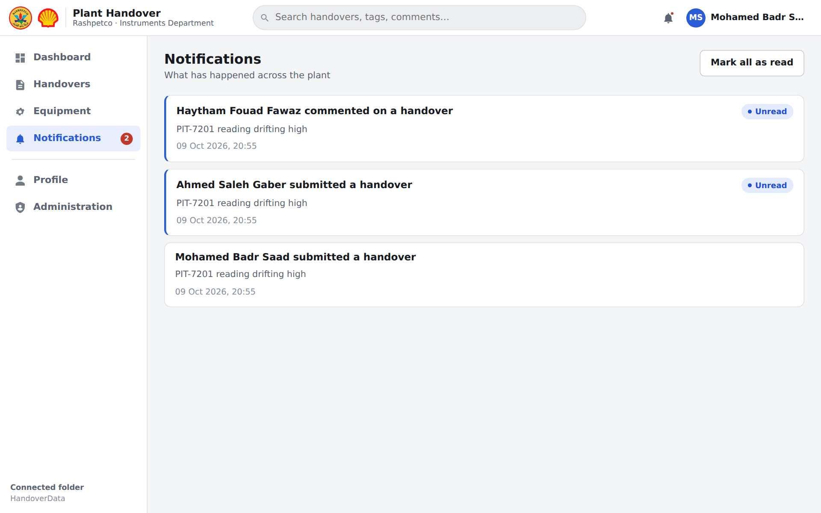

Step 8 – Profile and Administration
Profile (click your name, top right):
- Change my password – current password, new password twice, Save.
- Switch user – hand the PC to a colleague without closing the browser.
- My handovers – everything you wrote.
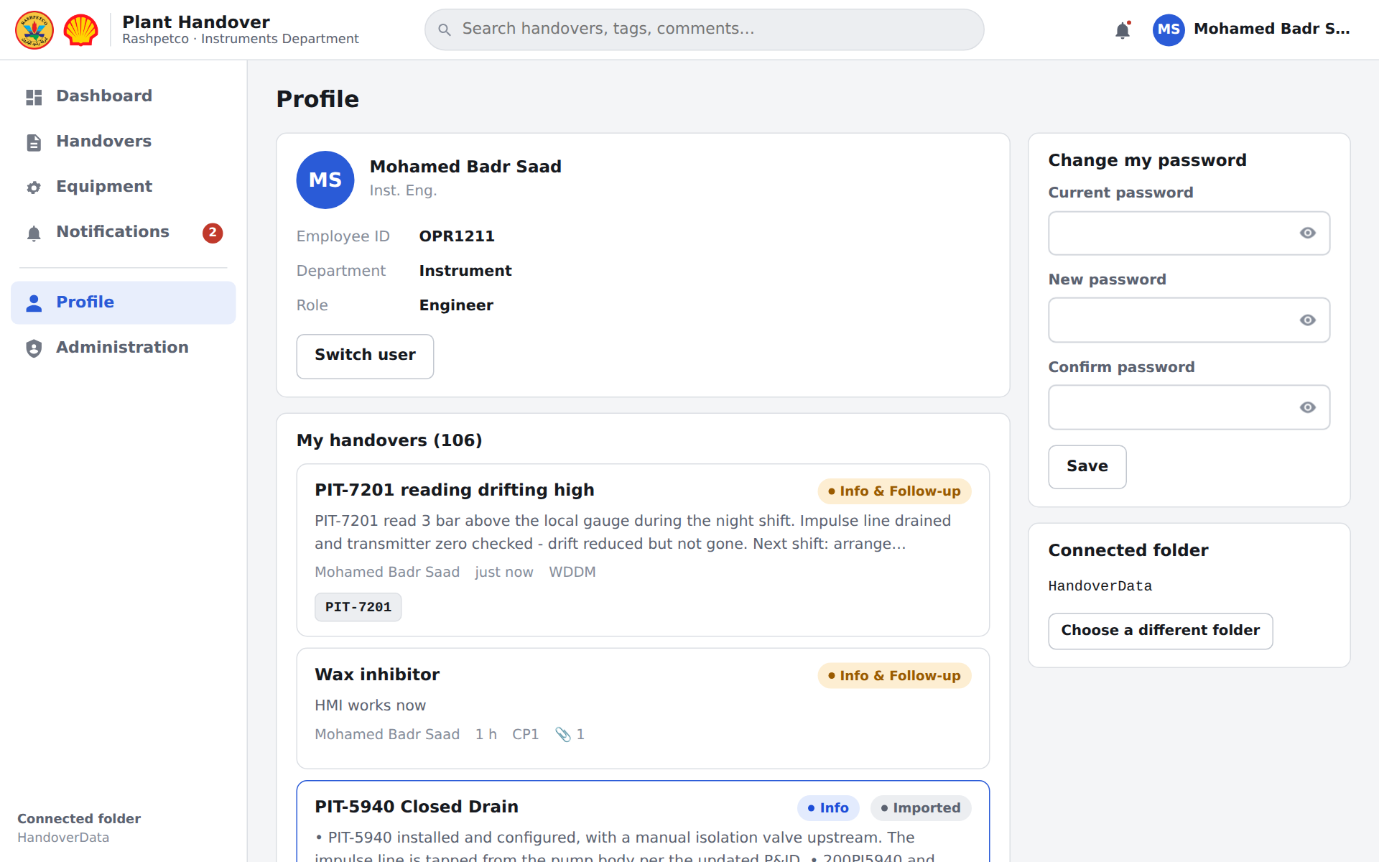
Administration (left menu) asks for the administration password, which the department head keeps. Lock again when you finish. From there an administrator can:
- add or remove plant areas;
- add, edit or deactivate staff and set each person's role (engineer, supervisor, technician) – only engineers can sign in;
- Reset password for someone who forgot theirs;
- add equipment tags, import a tag list, and set the area for many tags at once;
- Restore a deleted handover from Deleted handovers;
- import the old Excel handovers and download a backup.
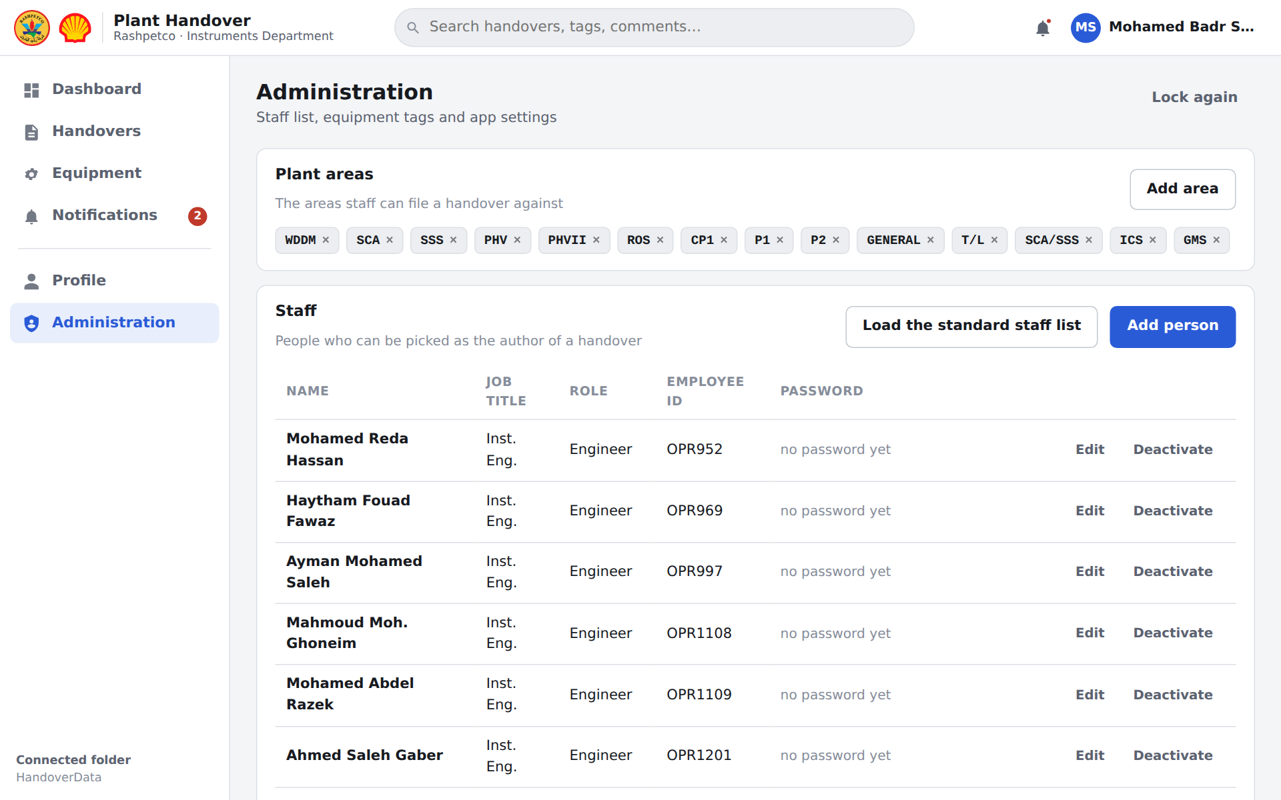
Deleted handovers (in Administration) – click Restore to put a handover back exactly as it was:
