PENI: Personalised Education and Neural Intelligence
――――――――――――――――――――――――――――――――――――――――――――――――――――――――
  - High-Fidelity Alpha Prototype, AI-Enabled Study Support, and Human-Centred Interaction Design
Module: | ITS 63504 / ITS 69904 Human Computer Interaction
Assessment: | Assignment 2
Hand-out date: | 30 April 2026
Hand-in date: | 12 July 2026
Weightage: | 40%
Live application: | https://mypeni.app
Source repository: | https://github.com/Mohamed-Dhanyal/PENI-AI- (branch: Beta)

Group Member | Student ID | Role
Mohamed Dhanyal | 0377471 | Group Leader
Chang Tatt Seng | 037472 | Member
Song ZeYu | 03373344 | Member
Qin Rui | 0378603 | Member
Mohamed Nahzan Ahmed | 0385440 | Member

Table of Contents
Table of Contents 2
Assessment Submission Declaration 6
Executive Summary 7
1. Vision, Mission, Problem Definition, Scenario, and Audience 8
1.1 Vision 8
1.2 Mission 8
1.3 Problem Definition 8
1.4 Proposed Scenario 8
1.5 Target Audience 9
2. User Research and Design Correlation 10
2.1 Data-Gathering Method 10
2.2 Key Findings 10
2.3 Traceability Matrix 10
3. Solution, Innovation, Social Impact, and Future Direction 12
3.1 Proposed Solution 12
3.2 Innovation 12
3.3 Social Impact 12
3.4 Future Enhancement 12
4. Scope and Functional Requirements 13
4.1 Scope Definition 13
In scope 13
Out of scope for the alpha 13
4.2 Functional Requirements 13
FR-01: Authentication and role assignment 14
FR-02: Personalised student dashboard 14
FR-03: Module and weekly-material organisation 14
FR-04: Assignment presentation and status 14
FR-05: Context-aware AI study assistance 14
FR-06: Material-specific study planning 14
FR-07: Attendance monitoring and risk identification 15
FR-08: Semester timetable and events 15
FR-09: Messaging 15
FR-10: Teacher weekly-material management 15
FR-11: Teacher assignment management 15
FR-12: Submission review and grading 15
4.3 Non-Functional Requirements 15
5. Technical Architecture 17
5.1 Architecture Overview 17
Layer 1: Client 17
Layer 2: API and orchestration 17
Layer 3: Data and intelligent services 18
Layer 4: External integrations 18
5.2 End-to-End AI Flow 18
5.3 Feasibility 18
6. Integration of Three Latest IT Technologies 19
6.1 Artificial Intelligence and Retrieval-Augmented Generation 19
6.2 Data Analytics and Predictive Support 19
6.3 Cloud Computing and Container-Oriented Deployment 19
6.4 Standard Visual and Audio APIs 20
7. UI/UX Design Based on Nielsen's Ten Usability Principles 21
7.1 Visibility of System Status 21
7.2 Match Between the System and the Real World 21
7.3 User Control and Freedom 21
7.4 Consistency and Standards 21
7.5 Error Prevention 21
7.6 Recognition Rather Than Recall 22
7.7 Flexibility and Efficiency of Use 22
7.8 Aesthetic and Minimalist Design 22
7.9 Help Users Recognise, Diagnose, and Recover from Errors 22
7.10 Help and Documentation 22
7.11 Heuristic Evaluation Summary 22
8. Storyboards and User Flows 24
8.1 Student Storyboard: From Risk Awareness to a Study Decision 24
S01 — Authenticate 24
S02 — Interpret the dashboard 25
S03 — Select a module 26
S04 — Review module context 27
S05 — Locate weekly material 28
S06 — Study with Peni 29
S07 — Request a study plan 30
S08 — Inspect assignment detail 31
S09 — Confirm attendance risk 32
S10 — Check timetable availability 33
S11 — Review lecturer and group messages 34
S12 — Use global Peni and speech output 35
8.2 Teacher Storyboard: Publish, Assess, and Respond 35
T01 — Teacher dashboard 36
T02 — Select an assigned module 37
T03 — Review weekly materials 37
T04 — Prepare a new material 38
T05 — Review assignments 39
T06 — Create an assignment 39
T07 — Review the submission area 40
8.3 Navigation Map 40
9. High-Fidelity Alpha Prototype 41
9.1 Prototype Fidelity 41
9.2 Implemented Alpha Coverage 41
9.3 Visual and Audio Techniques 41
10. Design Rationale 43
10.1 Strengths of the Final Design 43
10.2 Weaknesses and Known Issues 43
10.3 Alternative Designs Considered and Rejected 43
Native mobile application first 43
Separate student and teacher applications 44
AI-first home screen 44
Fully autonomous AI scheduling 44
On-device language model 44
11. Agile/Scrum Development Approach 45
12. Evaluation and Acceptance Plan 46
12.1 Functional Acceptance 46
12.2 Usability Evaluation 46
12.3 AI Evaluation 46
12.4 Accessibility and API Evaluation 46
13. Group Analysis 47
13.1 Team Strengths and Weaknesses 47
13.2 Lessons Learned 47
14. Conclusion 48
References 49
Appendix A: Generative AI Disclosure 50
Appendix B: Rubric Coverage Matrix 51
Appendix C: Presentation Evidence Checklist 52
Appendix D: Generative AI Disclosure — Full Declaration 53
Section 1: AI Tool Usage Summary 53
Section 2: Student Modification and Original Contribution 54
Section 3: Declaration 54
Appendix E: Assessment Submission Declaration Form 55

Assessment Submission Declaration
We declare that we understand what is meant by plagiarism and that the implications of plagiarism have been explained by our lecturer. This project represents our own work. Published and unpublished works used in the report have been acknowledged. The use of generative artificial intelligence for outlining, language refinement, document preparation, and selected technical explanations is disclosed in Appendix A. All design decisions, prototype evidence, interpretations, and final conclusions remain the responsibility of the group members.
Each group member must attach and sign the official Taylor's University Assessment Submission Declaration Form before submission.

Executive Summary
PENI, or Personalised Education and Neural Intelligence, is a high-fidelity web application designed to reduce the fragmented digital experience of Taylor's University students. Students currently move between myTIMeS, messaging applications, cloud drives, calendars, and general-purpose artificial intelligence tools to complete one study task. This fragmentation increases the time needed to locate information, obscures deadlines and attendance risk, and encourages the use of AI answers without sufficient verification. PENI responds by connecting academic information, module materials, attendance, schedules, messaging, assignments, study planning, and an AI study companion within one coherent interface.
The solution is grounded in the Assignment 1 questionnaire involving 30 Taylor's University students. The study found that 87% stored academic materials across three or more platforms, 93% rated having all materials in one application as useful, 73% had used generative AI for study, but only 23% reported high confidence in understanding AI reasoning. In addition, 77% expressed concern about external data storage, 83% valued a visual knowledge map, and 73% were frustrated by inadequate feedback after system actions. These findings established four design priorities: consolidation, transparent assistance, actionable progress visibility, and user control.
Assignment 1 proposed a Flutter mobile application. Based on team review and the need for a multi-device demo accessible to any browser without installation, the Assignment 2 prototype is delivered as a responsive web application. The same four-layer architecture, design language, feature set, and research foundation from Assignment 1 are preserved; only the client technology changed from Flutter/Dart to React/Vite. This pivot enables a higher-fidelity demo across laptops, tablets, and phones without requiring app-store approval or platform-specific builds.
The Assignment 2 outcome is a functional, high-fidelity alpha prototype implemented as a React and Vite frontend connected to an Express and SQLite backend. The alpha demonstrates authenticated student and teacher roles, a student dashboard, module and weekly-material organisation, assignment workflows, attendance monitoring, semester timetables, messaging, study-plan generation, teacher content management, grading, WebGL visualisation, and Web Speech text-to-speech. The Peni assistant currently demonstrates context-aware responses using authenticated student records. The architecture defines the extension from this alpha into retrieval-augmented generation, source citations, vector retrieval, predictive analytics, and cloud deployment without changing the central interaction model.
Three contemporary technologies are integrated into the solution at different maturity levels. Artificial intelligence supports context-aware study assistance and defines a retrieval-augmented extension for grounded module tutoring. Data analytics converts attendance, task, module, and timetable records into status summaries and risk indicators, with a specified predictive extension. Cloud-oriented architecture separates client, API, data, and external integrations to support future container deployment and institutional scaling. The interface additionally uses the WebGL API through Three.js for GPU-rendered visual feedback and the Web Speech API for accessible text-to-speech.
The report follows the assignment rubric directly. It defines the vision, mission, scenario, audience, innovative solution, social impact, system architecture, three latest technologies, scope, twelve functional requirements, Nielsen's ten usability principles, two complete storyboards containing nineteen visual frames, design rationale, alternative designs, group analysis, conclusion, and future enhancements. A traceability matrix connects each research finding to requirements, screens, heuristics, technologies, and evidence.

1. Vision, Mission, Problem Definition, Scenario, and Audience

1.1 Vision
This section directly continues the vision, mission, and problem definition established in HCI Assignment 1. The core concept, research findings, user personas, and architectural vision remain unchanged. Assignment 2 delivers the high-fidelity implementation of what Assignment 1 proposed.
PENI's vision is to enable every student to become an informed director of artificial intelligence rather than a passive consumer of generated answers. AI literacy should not be taught only as an abstract principle; it should become part of the student's normal academic workflow. PENI therefore places AI assistance beside the student's actual modules, timetable, attendance, tasks, and lecturer communications so that recommendations remain connected to academic context.

1.2 Mission
PENI's mission is to provide Taylor's University students with one trusted, accessible, and personalised study environment. The platform consolidates academic information, highlights urgent risks, supports active learning, and presents AI assistance in a form students can inspect and control. For lecturers, PENI provides a lightweight workflow for publishing weekly materials, creating assignments, reviewing submissions, and returning feedback.

1.3 Problem Definition
The first problem is information fragmentation. A typical student may obtain lecture slides from myTIMeS, receive deadline changes through WhatsApp, keep files in Google Drive, track classes in a personal calendar, and ask questions through a generic chatbot. The student must reconstruct the academic context before studying can begin. Survey participants reported an average of 6.2 steps and approximately 23 minutes spent locating information before a study session.
The second problem is passive learning. Existing learning-management systems primarily distribute files. They rarely transform those files into a guided revision sequence, a topic-specific study conversation, or a plan linked to the student's available time and assessment deadlines. The result is access to information without adequate support for acting on it.
The third problem is the AI confidence gap. Although 73% of respondents had used AI tools, only 23% felt confident about the reasoning behind AI answers. A general chatbot can produce fluent output without knowing the student's module, lecturer, deadline, or institutional context. This creates risks of hallucination, inappropriate reliance, and academic misconduct.
The fourth problem is limited visibility of academic risk. Attendance, tasks, messages, and assessment dates are often checked separately. A student may not realise that an attendance percentage is approaching the barring threshold until the risk has become urgent. PENI converts distributed records into an actionable status overview.

1.4 Proposed Scenario
Mohamed is a Semester 5 student taking five modules. An Advanced Machine Learning quiz is approaching, his Distributed Systems attendance has fallen below the safe threshold, and he has unread messages from his lecturer and project group. Mohamed signs into PENI and immediately sees the attendance warning, nearest deadlines, unread messages, and today's classes. He opens Advanced Machine Learning, selects the weekly material on convolutional neural networks, and launches Study with Peni. The selected material title and module are passed into the study conversation so that the assistance begins with relevant context. He switches to Study Plan mode to generate a structured revision sequence, checks his timetable for available study periods, and reviews the attendance screen before deciding which classes cannot be missed.
Dr Amelia Tan uses the teacher role. She opens her assigned module, adds a weekly material, creates an assignment with a due date and maximum mark, reviews submitted work, and records a grade with feedback. The student and teacher workflows operate on the same module and assignment data, reducing duplicated communication.

1.5 Target Audience
The primary audience is Taylor's University undergraduate students, particularly students in Years 2 and 3 who manage several modules, assignments, co-curricular commitments, and communication channels. The secondary audience is lecturers and module coordinators who need a focused alternative to a full institutional LMS for recurring content and assessment tasks. The architecture can later support programme leaders and institutional administrators through aggregated, privacy-controlled analytics, but those roles are outside the alpha scope.

2. User Research and Design Correlation

2.1 Data-Gathering Method
A 30-item questionnaire was distributed to 30 Taylor's University students across Foundation, undergraduate, and postgraduate levels. The questionnaire combined demographic questions, Likert-scale attitudes, task descriptions, ranking questions, competitive-tool use, open-ended responses, and the two-item UMUX-Lite measure. Participation was voluntary and responses were anonymised. Four responses that produced inconsistent answers to paired transparency checks were excluded from attitudinal analysis, leaving 26 valid responses for that subset.
Quantitative questions were summarised using percentages, means, medians, and standard deviations. Open responses were coded into recurring themes: content consolidation, AI explanation, automatic planning, and progress tracking. These themes were translated into requirements rather than treated as isolated opinions.

2.2 Key Findings
Finding | Result | Design implication
Materials stored across three or more platforms | 87% | Create a unified module and academic-information view.
All materials in one application rated useful | 93% | Make module consolidation a Must requirement.
Students already using AI tools | 73% | Integrate AI into existing study tasks rather than introducing a separate workflow.
High confidence in AI reasoning | 23% | Provide contextual boundaries, transparent status, and a source-citation architecture.
Students do not track mastery | 90% | Define progress and knowledge-map extensions.
Visual knowledge map rated useful | 83% | Include mastery visualisation in the product roadmap.
Concern about external storage | 77% | Apply authentication, role control, data minimisation, and explicit cloud opt-in.
Clean dark interface rated important | 80% | Use a focused dark theme with high-contrast status colours.
Poor feedback rated frustrating | 73% | Show loading, confirmation, current state, warnings, and disabled states.
Exact AI sources rated important | 87% | Specify RAG retrieval and citation metadata as the next AI milestone.

2.3 Traceability Matrix
Research finding | Problem | Requirement | Feature and screen | Nielsen principle | Technology | Evidence
87% use 3+ platforms | Fragmentation | FR-02 | My Modules and weekly materials | Recognition rather than recall | React, SQLite | Student frames S03–S05
93% want one material location | Search overhead | FR-03 | Material groups by week and type | Match with real world | Relational data model | S05, T03–T04
73% use AI; 23% trust reasoning | AI confidence gap | FR-05 | Context-aware Peni study conversation | Visibility and error prevention | AI architecture | S06, S12
73% dislike poor feedback | Uncertainty | FR-11, NFR-04 | Active tabs, warnings, loading and status | Visibility of system status | React state | S02, S09
77% concerned about storage | Privacy | NFR-02 | JWT authentication and role checks | User control | JWT, RBAC | S01, T01
83% value knowledge visibility | Weak self-monitoring | FR-07 | Attendance and progress indicators; future mastery map | Recognition | Analytics | S04, S09
Multi-app workflows average 6.2 steps | Inefficiency | FR-01, FR-08 | Dashboard, timetable and direct navigation | Efficiency of use | Integrated API | S02, S10
80% value dark minimal UI | Distraction | NFR-03 | Dark interface and restrained accent palette | Aesthetic and minimalist design | CSS variables, WebGL | S01–S12
Lecturers repeat distribution tasks | Teacher workload | FR-09, FR-10 | Material and assignment management | Flexibility and efficiency | Role API | T03–T07
The matrix demonstrates that PENI's features are not selected because they are fashionable. Every central feature is a response to a measured user problem, and every technical choice supports a requirement or a quality attribute.

3. Solution, Innovation, Social Impact, and Future Direction

3.1 Proposed Solution
PENI is a role-based web application with connected student and teacher experiences. The student interface contains a dashboard, attendance, modules, calendar, messages, study workflows, and the Peni assistant. The teacher interface contains assigned modules, weekly material management, assignment creation, submission review, and grading. Both interfaces use a shared backend and relational data model.
The dashboard acts as a decision surface rather than a decorative landing page. It combines average attendance, credits covered, unread messages, pending tasks, today's classes, nearest deadlines, upcoming events, and attendance warnings. The student does not need to open five systems before identifying the next action.

3.2 Innovation
PENI's innovation is context orchestration. Individual features such as calendars, messaging, file lists, or chat assistants already exist. PENI connects them around the student's academic state. Selecting a module material launches a study conversation using the module and material title as context. Attendance warnings are visible beside deadlines. Teacher-published materials and assignments appear in the corresponding student module. This reduces context switching and provides a foundation for increasingly capable AI assistance.
The AI architecture extends this orchestration through retrieval-augmented generation. In the completed design, uploaded documents are parsed, divided into chunks, converted into embeddings, and indexed. A student's question retrieves relevant passages; the passages and source metadata are supplied to the language model; and the response is returned with file and page references. The current alpha establishes the chat interface, authenticated context, study-material hand-off, and response presentation required for that extension.

3.3 Social Impact
PENI supports United Nations Sustainable Development Goal 4: Quality Education. Its contribution is not simply making study more convenient. It promotes responsible AI use by placing contextual boundaries, verification, and user control within the study workflow. Students with less prior AI experience receive the same guided interface as technically confident students, reducing an emerging digital-literacy inequality.
The attendance and deadline surfaces support early self-correction. A warning shown while there is still time to act is more valuable than a retrospective result. Text-to-speech supports auditory learning and improves access for users who experience reading fatigue. A consolidated interface also reduces avoidable cognitive load, allowing attention to be directed toward learning rather than information retrieval.

3.4 Future Enhancement
The next release will complete the source-grounded AI pipeline, including document parsing, vector retrieval, citations, confidence indicators, and explicit handling when no relevant source is found. The mastery roadmap will record topic interactions, flashcard outcomes, assessment attempts, and review intervals. Predictive recommendations will initially use interpretable rules before progressing to evaluated statistical models. Institutional deployment will add university SSO, managed PostgreSQL, encrypted object storage, audit logs, notification services, and explicit data-retention controls.

4. Scope and Functional Requirements

4.1 Scope Definition

In scope
- Student and teacher authentication using Taylor's email domains.
- Role-based separation between student and teacher operations.
- Student dashboard showing academic status and urgent actions.
- Module lists, module details, weekly materials, and assignments.
- Attendance summaries, per-module status, and absence records.
- Semester class timetable and academic schedule presentation.
- Student messaging interface.
- Context-aware Peni assistance and material-specific study workflows.
- Study-plan generation within the high-fidelity alpha interaction.
- Teacher material, assignment, submission, grade, and feedback workflows.
- WebGL visualisation and Web Speech text-to-speech.
- Technical architecture for RAG, predictive analytics, and cloud scaling.

Out of scope for the alpha
- Replacement of myTIMeS as the official institutional LMS.
- Financial payments, admissions, enrolment, or official transcript functions.
- Fully autonomous academic decision-making.
- Production-scale institutional deployment.
- High-stakes predictive decisions without human review.
- Native iOS and Android applications.
- Unsupervised publication of AI-generated official learning content.

4.2 Functional Requirements
ID | Functional requirement | Priority | Primary evidence
FR-01 | Authenticate users and assign student or teacher role | Must | S01, T01
FR-02 | Present a personalised student dashboard | Must | S02
FR-03 | Organise enrolled modules and weekly materials | Must | S03–S05
FR-04 | Present assignments and submission status | Must | S08
FR-05 | Provide context-aware AI study assistance | Must | S06, S12
FR-06 | Generate a material-specific study plan | Should | S07
FR-07 | Monitor attendance and identify risk | Must | S02, S09
FR-08 | Present semester timetable and academic events | Must | S10
FR-09 | Support student and lecturer messaging | Should | S11
FR-10 | Allow teachers to manage weekly materials | Must | T03–T04
FR-11 | Allow teachers to create and manage assignments | Must | T05–T06
FR-12 | Allow teachers to review, grade, and comment on submissions | Must | T07

FR-01: Authentication and role assignment
The system shall allow users with approved Taylor's University domains to authenticate and shall assign a student or teacher role. The role determines the visible shell and authorised API routes. This prevents students from accessing teacher-only content-management and grading operations. Authentication is a prerequisite for personalisation because attendance, modules, messages, tasks, and teacher assignments are connected to an identified user.

FR-02: Personalised student dashboard
The system shall provide a dashboard that combines the student's average attendance, credits, unread messages, pending tasks, classes, deadlines, events, and warnings. The dashboard must support rapid prioritisation rather than require the student to open each subsystem. Cards and warnings act as navigational shortcuts to the corresponding detailed screen.

FR-03: Module and weekly-material organisation
The system shall list enrolled modules and allow the student to open a module interior. Materials shall be grouped by week and identified by type, including lecture slides, tutorial slides, recordings, references, and other resources. This directly addresses the survey finding that academic files are distributed across several platforms.

FR-04: Assignment presentation and status
The system shall list module assignments with title, week, due date, supporting documents, brief, and submission state. Expandable assignment rows allow the user to reveal details only when needed, reducing visual overload. Status labels communicate whether the work has not been submitted, has been submitted, or has been graded.

FR-05: Context-aware AI study assistance
The system shall allow a student to launch Peni from the global navigation or from a selected weekly material. When launched from a material, the module and material title shall seed the conversation. The alpha returns contextual responses using authenticated student data and predefined academic intents. The next AI increment shall retrieve module-document passages and return source metadata with the generated answer.

FR-06: Material-specific study planning
The system shall provide a Study Plan mode for selected material. The alpha implements the mode switch, material-specific prompt, progressive response area, and adjustment composer. The current intent engine does not yet generate the complete structured plan reliably; replacing that fallback with the designed RAG/LLM service is an acceptance condition for the next increment. Material-specific planning is intended to reduce the effort needed to convert a document title into a sequence of study actions.

FR-07: Attendance monitoring and risk identification
The system shall show overall attendance, total classes, attended and missed counts, modules at risk, a weekly attendance grid, and absence records. Percentages below the defined threshold shall use a distinct warning treatment. The purpose is to support early action, not to replace the university's official attendance record.

FR-08: Semester timetable and events
The system shall provide semester selection and class, examination, and assignment timetable areas. The class timetable shall distinguish lectures, tutorials, and laboratories through consistent colours. This requirement connects planning to the same module context used by materials and assignments.

FR-09: Messaging
The system shall provide a familiar messaging interface containing contact categories, unread indicators, conversation history, and a composer. The interaction pattern follows messaging applications already used by students, reducing learning effort. Messages must remain associated with a user and, where applicable, a module.

FR-10: Teacher weekly-material management
The teacher shall be able to select an assigned module, open Weekly Materials, add a material with week number, week label, type, title, URL, and description, and remove a material when necessary. Required fields and disabled submission states prevent incomplete records.

FR-11: Teacher assignment management
The teacher shall be able to create an assignment containing a title, optional week, brief, due date, submission link, maximum mark, and attached supporting documents. Published assignments shall become available to enrolled students through the same module structure.

FR-12: Submission review and grading
The teacher shall be able to expand an assignment, retrieve student submissions, inspect submission details, record a grade, and provide written feedback. The system shall visibly distinguish graded and ungraded submissions. This creates a closed interaction loop from teacher publication to student action and teacher response.

4.3 Non-Functional Requirements
ID | Requirement | Measure
NFR-01 | Usability | Critical storyboard tasks can be completed without external instruction.
NFR-02 | Security and privacy | Protected routes require valid authentication; teacher routes require teacher role.
NFR-03 | Accessibility | High contrast, keyboard-accessible controls, semantic labels, and optional speech output.
NFR-04 | Feedback | Every asynchronous or state-changing operation provides loading, disabled, status, confirmation, or error feedback.
NFR-05 | Performance | Primary data views should become usable within two seconds on the local alpha environment.
NFR-06 | Maintainability | Client, routes, data access, and external-service concerns remain separated.
NFR-07 | Scalability | The production design supports database migration and independent service deployment.

5. Technical Architecture

5.1 Architecture Overview
PENI uses a four-layer architecture: client, API and orchestration, data and intelligent services, and external integrations. This separation allows the high-fidelity alpha to remain simple while preserving a credible path to institutional deployment.
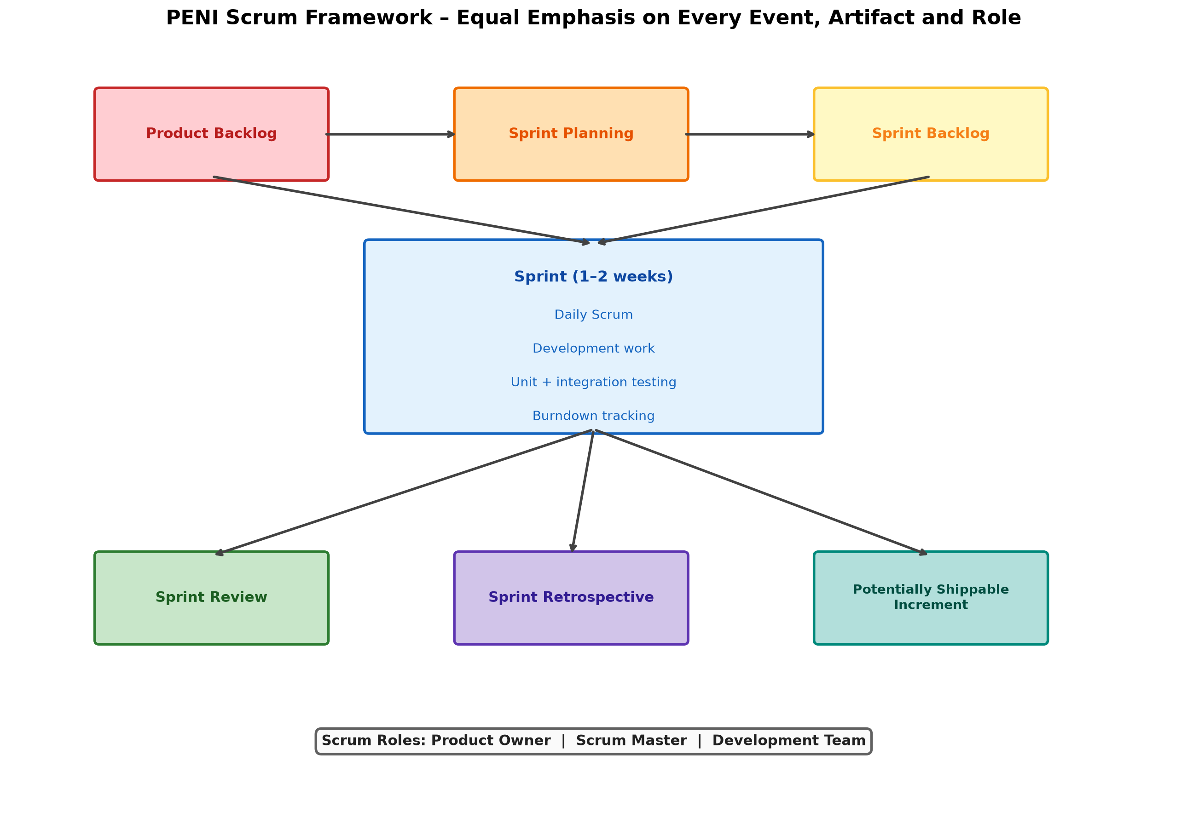
Figure 1. Four-layer PENI architecture.

Layer 1: Client
The client is a responsive React 18 application bundled by Vite. It contains the role-based application shell, student views, teacher views, shared controls, API abstraction, theme system, WebGL visualisation, and Web Speech interaction. State local to a screen is managed through React hooks. Backend calls are centralised so that authentication and response handling remain consistent. The source code is maintained on GitHub at https://github.com/Mohamed-Dhanyal/PENI-AI- (branch: Beta) and the hosted application is accessible at https://mypeni.app.

Layer 2: API and orchestration
The Express API separates authentication, student, teacher, AI, and synchronisation concerns. JWT verification establishes user identity before protected operations. Teacher routes enforce the teacher role. JSON contracts connect the client to the backend and allow the future AI service or database to be replaced without redesigning the screens.

Layer 3: Data and intelligent services
SQLite stores the alpha's users, profiles, modules, enrolments, attendance, tasks, events, messages, materials, assignments, submissions, grades, and related records. The AI endpoint reads the authenticated student's records and produces context-aware responses for attendance, examinations, deadlines, GPA, schedules, and messages. The designed RAG extension adds document chunks, embeddings, source metadata, conversation records, and mastery events.

Layer 4: External integrations
External integration points include myTIMeS ingestion, university SSO, calendar feeds, object storage, LLM services, notification services, and analytics infrastructure. These services are isolated behind API contracts so that the alpha remains demonstrable without requiring production credentials.

5.2 End-to-End AI Flow
The implemented alpha flow is:
- The authenticated student enters a question or launches Peni from a material.
- The client sends the query through the authenticated API abstraction.
- JWT middleware identifies the student.
- The AI route retrieves relevant student profile, module, event, task, and message records.
- The intent engine selects an academic response path.
- The response is returned to the client and rendered progressively.
- The student may activate text-to-speech.
The RAG extension proceeds through these additional steps:
- A teacher uploads a module document.
- A document worker extracts text and page boundaries.
- Text is divided into overlapping, semantically meaningful chunks.
- An embedding model converts each chunk into a vector.
- Vectors and source metadata are stored in a vector index.
- The student's query is embedded and compared with indexed chunks.
- The highest-scoring passages are added to the model prompt.
- The language model answers only from retrieved context.
- Citation markers are mapped to file names and page ranges.
- If retrieval confidence is insufficient, the system states that no supported answer was found.
- The interaction is stored as a mastery event for later recommendations.

5.3 Feasibility
Technical feasibility is high because the alpha uses established open-source technologies with broad documentation. Economic feasibility is supported by local development and free-tier deployment options. Operational feasibility is supported by role separation and a focused initial scope. The most significant technical risks are document-extraction quality, model cost, source-grounding accuracy, privacy, and migration from local SQLite storage to a managed production database.

6. Integration of Three Latest IT Technologies

6.1 Artificial Intelligence and Retrieval-Augmented Generation
Problem addressed. General chatbots lack module context and can produce unsupported answers. Students require assistance that connects to their academic records and, ultimately, their lecturer-provided content.
Alpha integration. Peni uses authenticated student data to answer questions about attendance, examinations, deadlines, GPA, schedules, and messages. Material-specific study actions seed the conversation with module and topic context. Progressive response rendering and text-to-speech complete the interaction loop.
RAG implementation design. The production AI layer introduces PDF parsing, chunking, embeddings, vector retrieval, a constrained prompt, citation mapping, and low-confidence refusal. This design addresses the 87% source-transparency requirement directly.
Evaluation. The RAG increment will be evaluated using retrieval precision, citation correctness, unsupported-answer rate, response latency, task completion, and student trust ratings. A minimum acceptance target is that each grounded answer displays a valid source file and page range, and that unsupported questions are not presented as module facts.

6.2 Data Analytics and Predictive Support
Problem addressed. Attendance, task, timetable, and progress records are difficult to interpret when separated. Students often notice risk only after it has become urgent.
Alpha integration. The dashboard computes and presents attendance averages, pending-task counts, unread-message counts, nearest deadlines, and warnings. The attendance view aggregates total, attended, missed, and at-risk values and displays module-level percentages and weekly patterns.
Predictive extension. An event schema will record task completion, study sessions, topic interactions, assessment outcomes, and available timetable periods. The first recommendation engine will use transparent rules, such as attendance threshold, time until deadline, incomplete task count, and available study blocks. A later model may estimate deadline or mastery risk, but it will remain advisory and will be evaluated for false positives, fairness, and explainability.
Evaluation. Metrics include warning accuracy, percentage of recommendations acted upon, planning-task completion time, and user understanding of why a recommendation was shown.

6.3 Cloud Computing and Container-Oriented Deployment
Problem addressed. A university study companion must support multiple devices, concurrent users, secure storage, and independent scaling of document and AI workloads.
Alpha integration. The existing client-server separation establishes the cloud boundary. The browser client communicates with an Express API rather than directly accessing the database. Authentication, student data, teacher operations, and AI interactions are separated into route groups.
Deployment sequence. The production implementation will build the frontend as static assets, package the API and background worker as containers, migrate SQLite to PostgreSQL, store uploaded documents in encrypted object storage, place the API behind HTTPS, and use environment-managed secrets. Logging, health checks, backups, rate limits, and deployment rollback are required before institutional use.
Evaluation. Deployment quality will be measured through availability, API latency, error rate, recovery time, concurrent-user tests, and successful backup restoration.

6.4 Standard Visual and Audio APIs
The login screen uses Three.js as an abstraction over the standard WebGL API. A GPU-rendered particle network moves behind the authentication card and visually communicates PENI's neural-intelligence identity. The effect is non-interactive and does not obstruct the form. It can be disabled or omitted on unsupported devices.
The Peni response includes a speaker control based on the browser's Web Speech API. Selecting the control cancels any active utterance, constructs a speech utterance from the response, and asks the browser speech engine to read it. Audio never begins automatically, preserving user control and preventing disruption in shared spaces.

7. UI/UX Design Based on Nielsen's Ten Usability Principles

7.1 Visibility of System Status
PENI makes current state and risk visible at multiple levels. The dashboard shows average attendance, credits, unread messages, pending tasks, nearest deadlines, today's classes, and an attendance warning. Active navigation entries and active module tabs use a red highlight, allowing users to identify location immediately. The attendance screen displays overall status, attended and missed totals, at-risk count, module percentages, weekly state, and absence records. AI interactions use a typing state and progressive response display. Teacher forms disable submission when required information is missing and show saving text during submission. These choices answer the 73% of respondents who described unclear feedback as frustrating. A remaining improvement is to standardise success and error toasts across every state-changing teacher operation.

7.2 Match Between the System and the Real World
The interface uses Taylor's academic terminology: modules, lecture slides, tutorials, assignments, credits, lecturer, attendance, semester, and timetable. Weekly material grouping reflects how lecturers and students discuss course progression. The attendance threshold is presented as an academic risk rather than an abstract system error. Messaging resembles familiar conversation applications through contact lists, threads, unread badges, message bubbles, and a composer. The teacher workflow uses terms such as due date, maximum marks, submissions, grade, and feedback. This reduces translation between the student's mental model and system terminology.

7.3 User Control and Freedom
Students can move directly between Home, Attendance, My Modules, My Calendar, My Messages, and Peni through persistent navigation. Module interiors provide a visible Back action and tabs allow switching without losing the module context. The Study with Peni modal can be closed, and users can switch between conversational study and Study Plan modes. Text-to-speech is user-triggered and can be stopped by initiating another utterance. Teacher material and assignment forms can be cancelled before submission. Destructive operations are separated from primary actions. A future improvement is to add explicit undo for recently deleted materials and assignments.

7.4 Consistency and Standards
The application uses a consistent dark surface, Taylor's red accent, rounded containers, restrained typography, and repeated spacing. Navigation controls maintain the same icon-label treatment. Module detail tabs use the same selected-state convention for Overview, Weekly Materials, and Assignments. Status colours are consistent: green indicates safe or present states, while red indicates risk, absence, or an urgent action. Student and teacher shells share visual language while exposing role-appropriate actions. Familiar web conventions are preserved for buttons, inputs, select controls, links, hover states, and disabled states.

7.5 Error Prevention
Authentication limits accounts to expected university domains. Required teacher fields prevent empty materials or assignments from being submitted. Numeric controls constrain week and mark values. Disabled send buttons prevent empty AI messages. Role checks prevent student accounts from invoking teacher operations. Attendance risk is shown before it becomes an irreversible academic consequence. The AI design includes a planned low-confidence refusal so that missing document evidence will not be converted into a fabricated citation. Confirmation dialogs and undo remain important improvements for deletion operations.

7.6 Recognition Rather Than Recall
The dashboard externalises important information instead of requiring the student to remember it. Module cards show code, name, credits, teaching staff, and venues. Weekly materials display week, title, type, and available study actions in one row. Conversation history and message contacts remain visible. The timetable displays module sessions spatially. The teacher module view keeps existing materials and assignments visible while new records are created. These patterns are especially important for students handling five or more modules because they reduce memory load and repeated searching.

7.7 Flexibility and Efficiency of Use
PENI supports both overview-first and task-first behaviour. A student can inspect the dashboard or navigate directly to a module, attendance, message, or Peni. The floating Peni entry remains available across student views. Material rows provide direct Study with Peni and Study Plan actions, avoiding a separate configuration sequence. Teachers can manage content within the selected module instead of moving through a general administration hierarchy. Future efficiency improvements include search across materials, keyboard shortcuts, saved filters, and direct links from notifications to the relevant assignment or material.

7.8 Aesthetic and Minimalist Design
The interface uses black and deep-charcoal surfaces with Taylor's red as the principal accent. Content is organised into cards and panels with limited competing colours. The dashboard presents substantial information, but grouping and consistent headings separate status, messages, classes, deadlines, events, and warnings. Module interiors use progressive disclosure: overview, materials, and assignments are separated into tabs, and assignment details remain collapsed until requested. The WebGL login background reinforces product identity while the central authentication card remains readable. Some wide desktop screens contain excessive unused space; future responsive tuning should enlarge primary content or adapt the layout at very wide resolutions.

7.9 Help Users Recognise, Diagnose, and Recover from Errors
Error communication should explain the problem and the next action. Authentication errors should distinguish invalid credentials from unsupported domains. Material and assignment forms should identify missing required values. AI failure should retain the user's question and provide retry rather than clearing the conversation. The RAG extension must explicitly state when no relevant source is available. Offline or backend-unavailable states should display a persistent status banner. The alpha establishes error areas and disabled states, but consistent recovery actions are an identified refinement before production.

7.10 Help and Documentation
PENI minimises the need for a separate manual by placing help within tasks. Material types, form labels, placeholders, tab labels, tooltips, and button names explain expected actions. The text-to-speech control includes an accessible label. The AI disclaimer reminds users to verify important academic information against official sources. Future onboarding will demonstrate dashboard interpretation, module navigation, AI limitations, source verification, and privacy choices. Teacher onboarding will focus on materials, assignments, submissions, and grading.

7.11 Heuristic Evaluation Summary
The strongest heuristic coverage is visibility of system status, recognition rather than recall, consistency, and match with the real world. The most important remaining improvements are standardised recovery messages, confirmation or undo for destructive actions, responsive use of wide screens, and explicit documentation of AI limitations. The heuristic analysis therefore functions as both justification and evaluation rather than claiming that the alpha has no usability issues.

8. Storyboards and User Flows

8.1 Student Storyboard: From Risk Awareness to a Study Decision
The student storyboard follows one coherent scenario. Mohamed identifies an attendance and assessment risk, selects a relevant module topic, receives study support, checks available time, and confirms his next action. Each frame displays one meaningful state at a readable size.

S01 — Authenticate
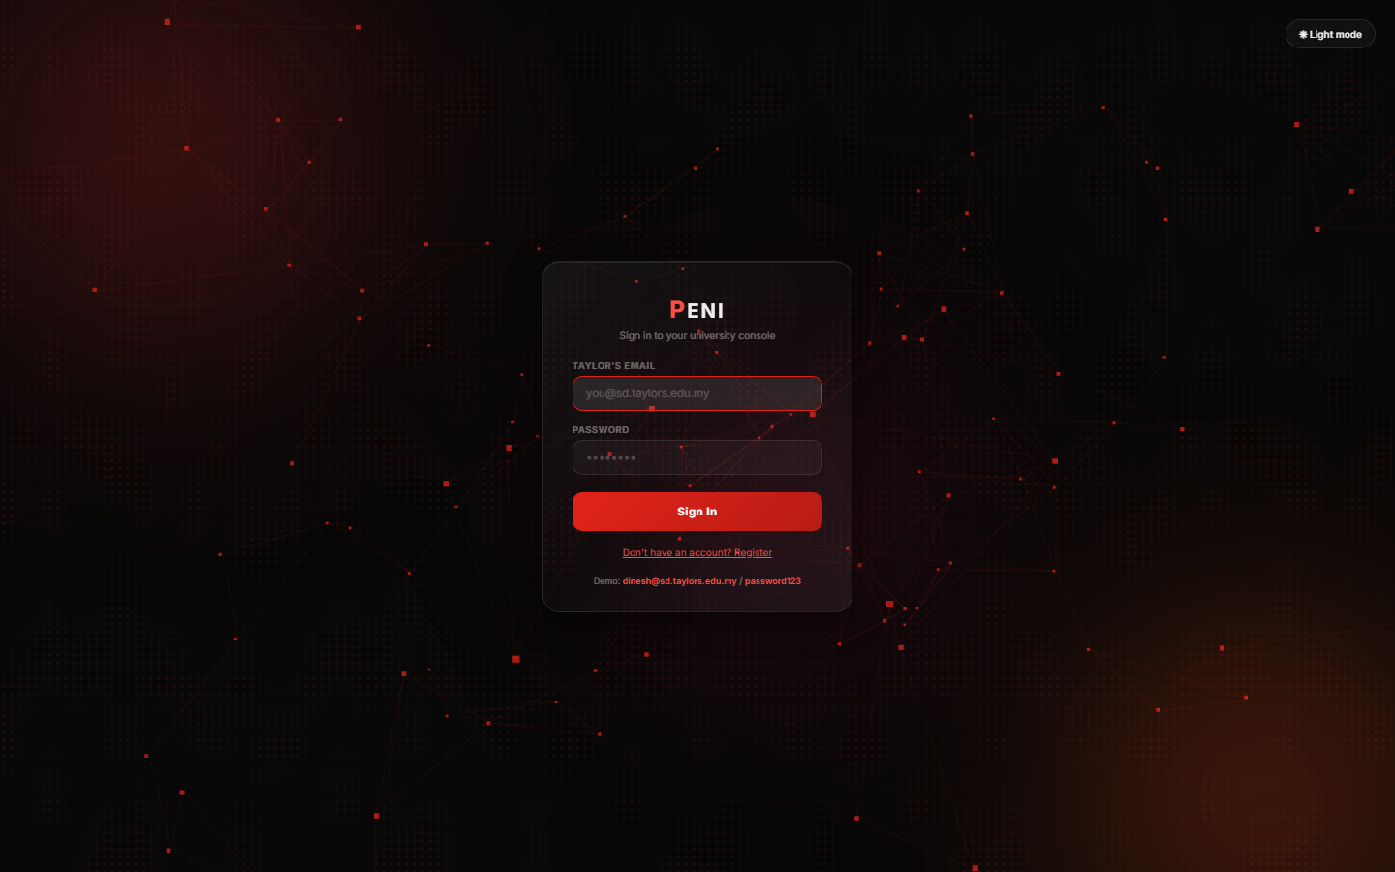
Student Frame S01. Mohamed signs into PENI.
Goal: Enter the personalised university environment. Action: Submit Taylor's student credentials. System response: Validate the account, assign the student role, and open the student dashboard. HCI rationale: The central form, familiar labels, password masking, and single primary action minimise initial cognitive load. The WebGL background communicates product identity without replacing form feedback.

S02 — Interpret the dashboard
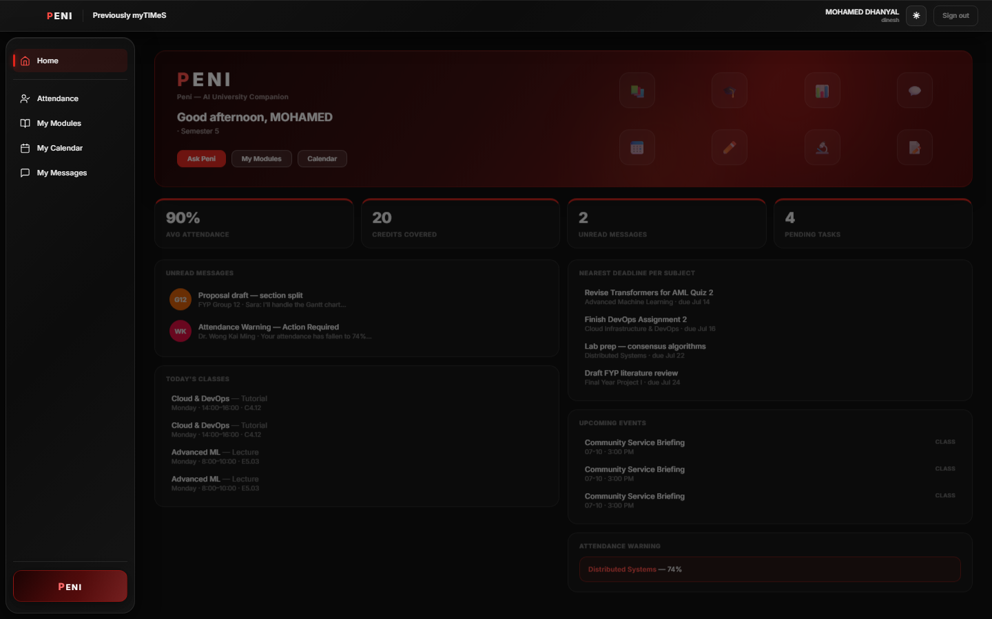
Student Frame S02. Dashboard consolidating academic status.
Goal: Decide what requires attention. Action: Scan attendance, deadlines, messages, and classes. System response: Display 90% average attendance, pending work, unread messages, nearest deadlines, and a Distributed Systems warning. HCI rationale: This directly addresses fragmentation and visibility of system status.

S03 — Select a module
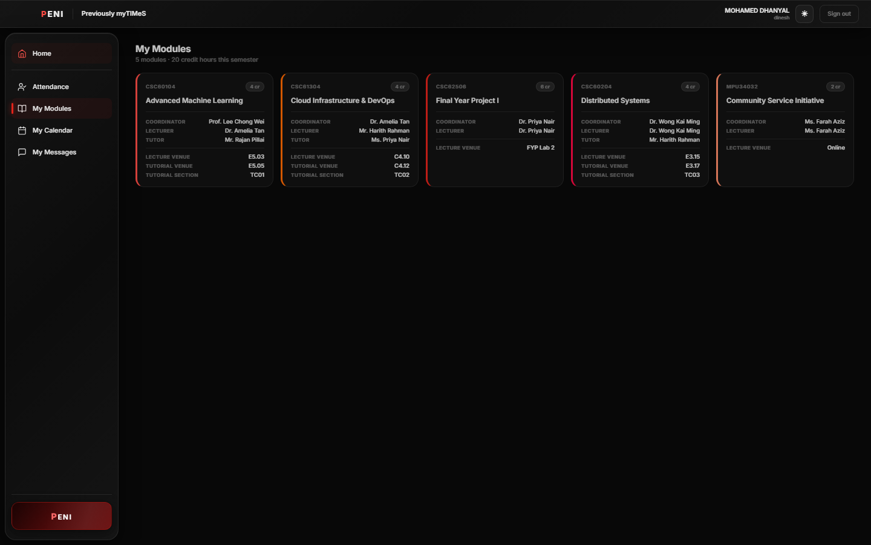
Student Frame S03. Enrolled modules.
Goal: Begin revision for Advanced Machine Learning. Action: Select the module card. System response: Open the module interior while retaining persistent global navigation. HCI rationale: Codes, names, credits, teaching staff, and venues support recognition.

S04 — Review module context
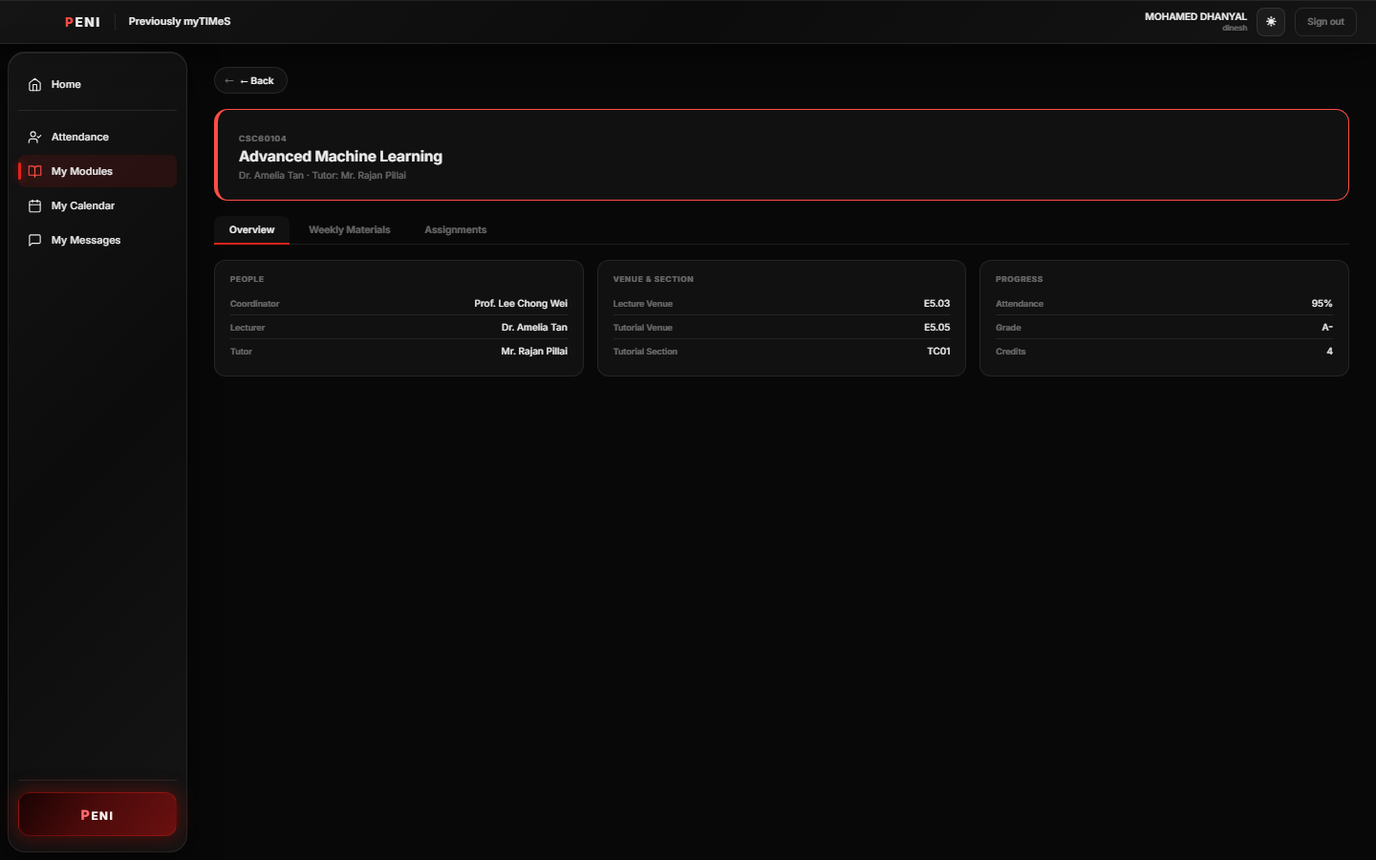
Student Frame S04. Advanced Machine Learning overview.
Goal: Confirm module, people, venue, attendance, grade, and credits. Action: Review Overview. System response: Present concise module context in three groups. HCI rationale: Information is disclosed before the student enters materials or assignments.

S05 — Locate weekly material
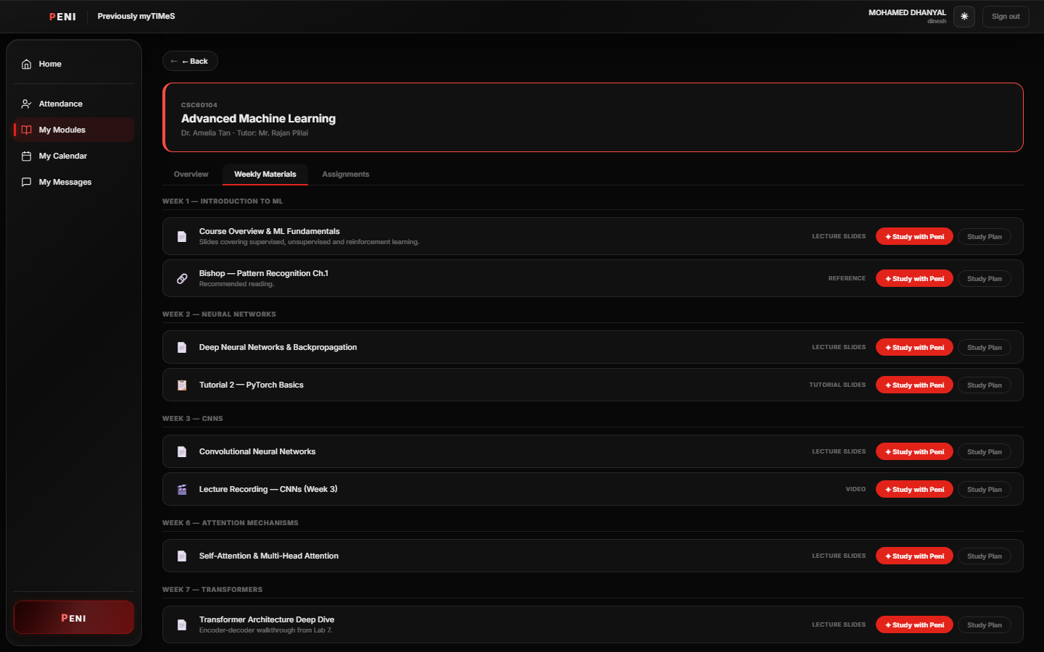
Student Frame S05. Weekly materials with direct study actions.
Goal: Find the CNN topic. Action: Open Weekly Materials and scan Week 3. System response: Group materials by week and expose Study with Peni and Study Plan. HCI rationale: Weekly grouping matches academic language and removes cross-platform searching.

S06 — Study with Peni
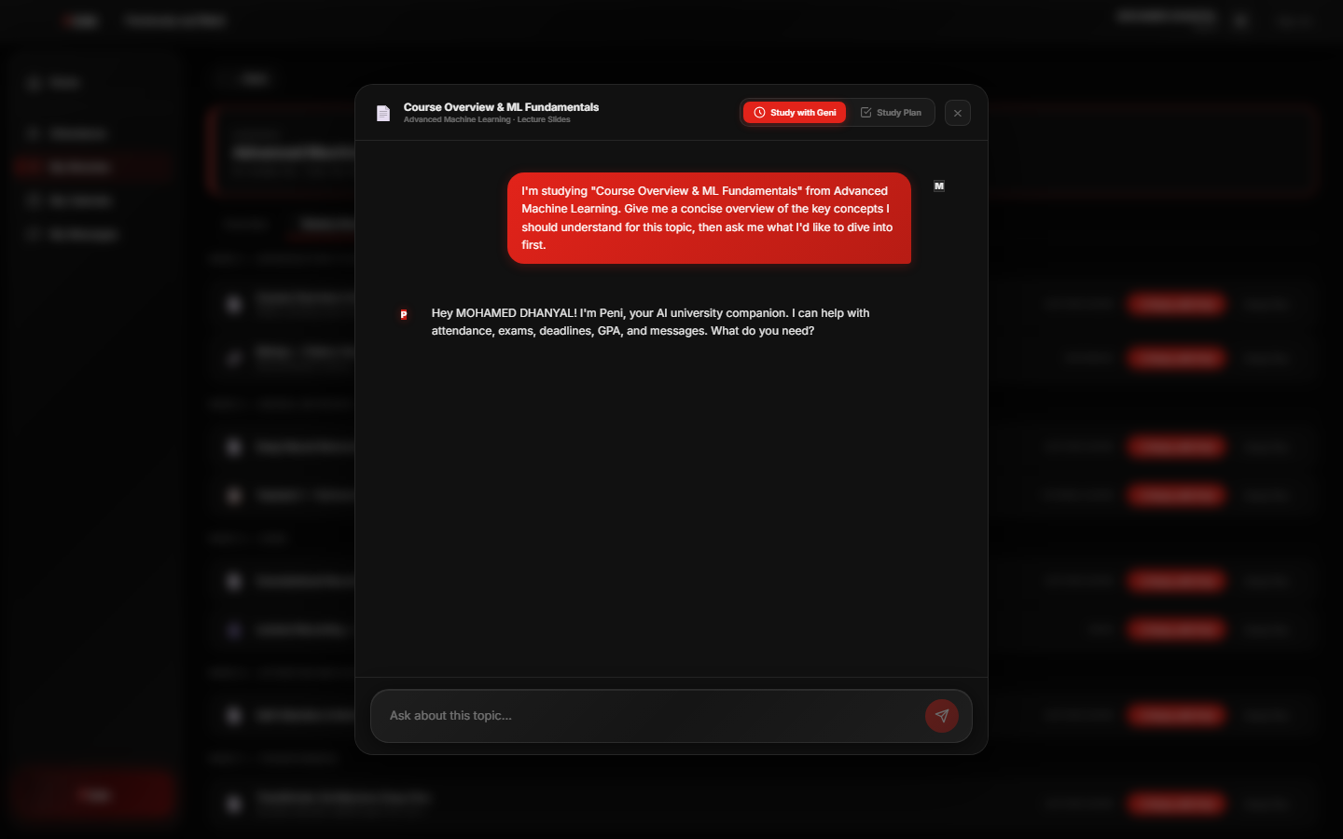
Student Frame S06. Material-specific Peni conversation.
Goal: Obtain a concise introduction to the selected topic. Action: Select Study with Peni. System response: Open a modal seeded with the module and material context. HCI rationale: Context is recognised rather than re-entered, reducing interaction steps.

S07 — Request a study plan
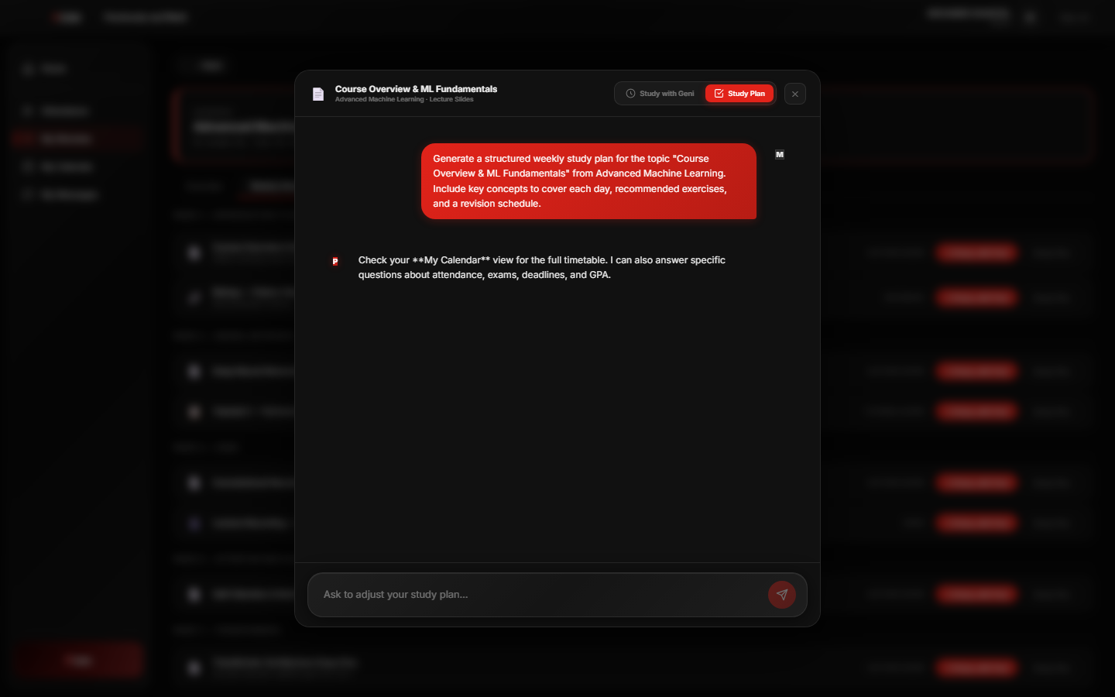
Student Frame S07. Topic-specific Study Plan mode and current alpha response.
Goal: Convert the topic into an actionable sequence. Action: Switch to Study Plan. System response: The interface sends a material-specific planning request and retains a composer for adjustments. The captured alpha response falls back to general calendar guidance instead of producing the required weekly plan; this is a documented acceptance gap for the RAG/LLM increment. HCI rationale: The mode switch preserves context and user control, while the visible mismatch provides concrete evidence for the next implementation priority.

S08 — Inspect assignment detail
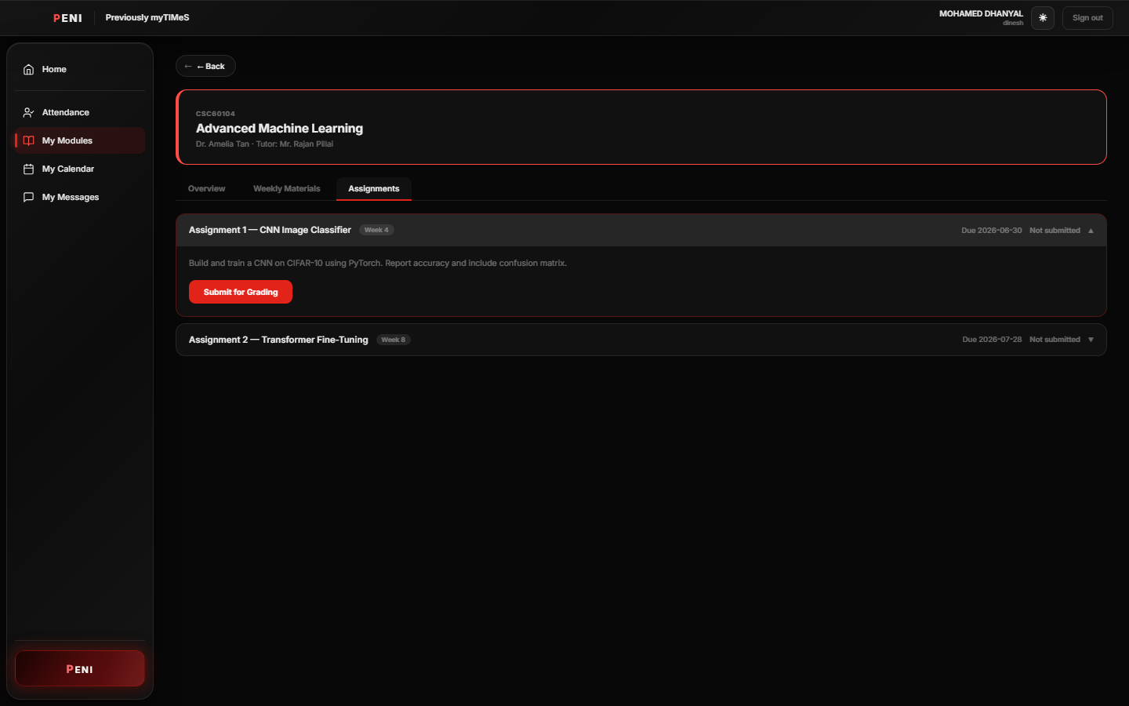
Student Frame S08. Expanded assignment information.
Goal: Check assessment requirements and status. Action: Open Assignments and expand an item. System response: Reveal brief, due date, documents, submission controls, and current state. HCI rationale: Progressive disclosure keeps the default module view focused.

S09 — Confirm attendance risk
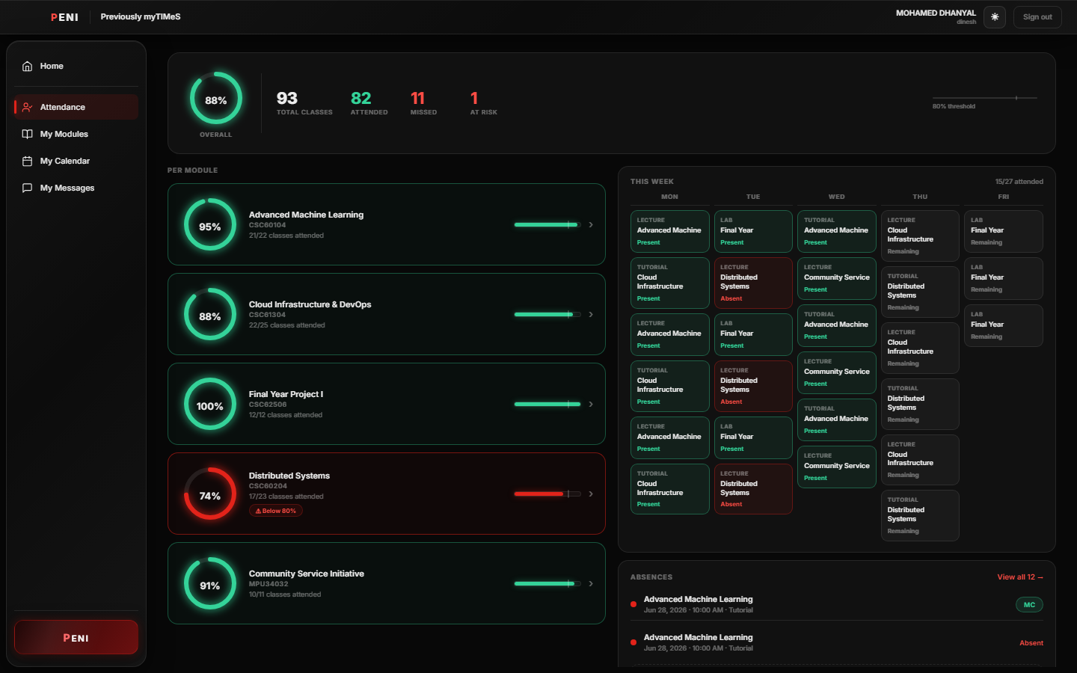
Student Frame S09. Attendance summary and risk detail.
Goal: Determine whether a module requires immediate attendance action. Action: Open Attendance. System response: Show overall and per-module percentages, weekly records, and absence history. HCI rationale: Red and green states communicate urgency without requiring calculation.

S10 — Check timetable availability
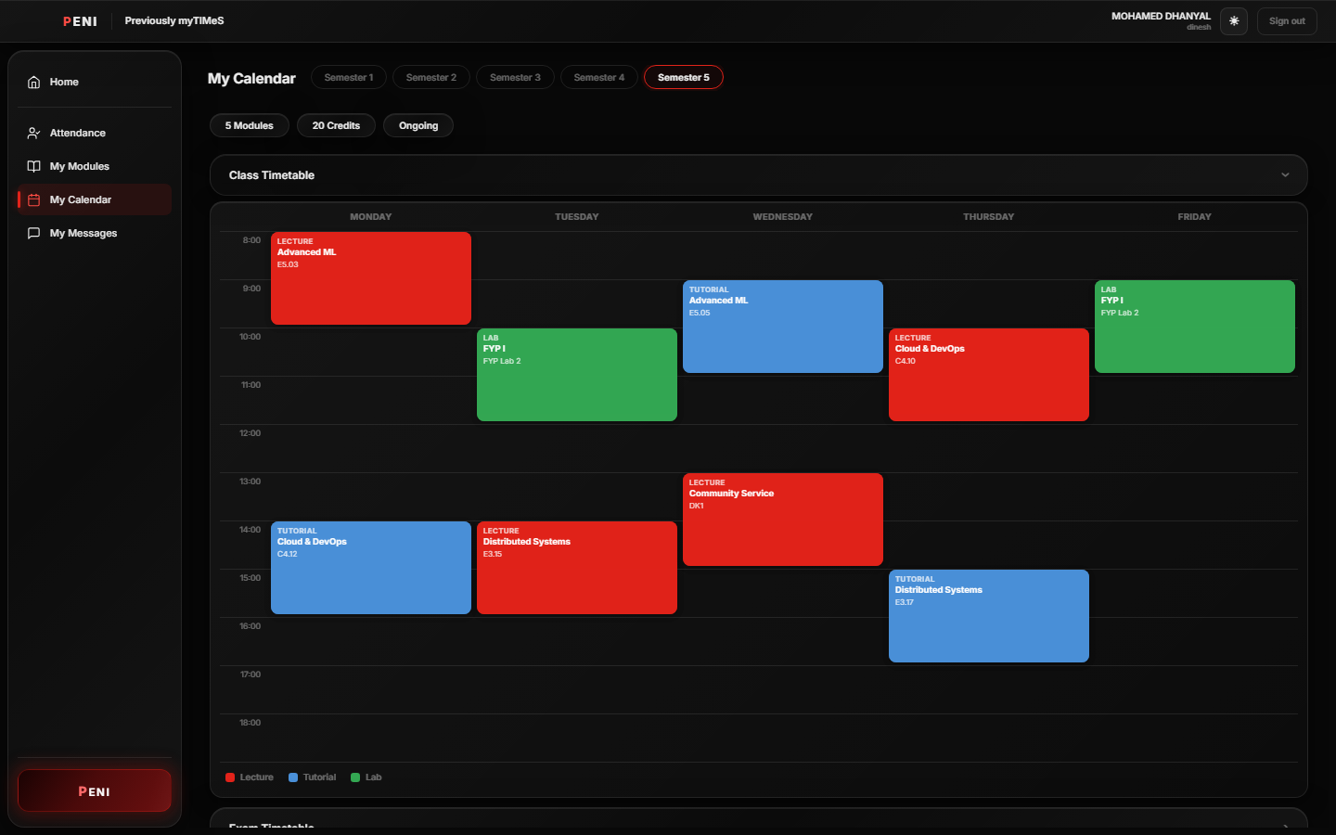
Student Frame S10. Expanded class timetable.
Goal: Identify a suitable revision period. Action: Open My Calendar and expand Class Timetable. System response: Display the weekly schedule with class-type colours. HCI rationale: Spatial presentation supports rapid comparison of available time.

S11 — Review lecturer and group messages
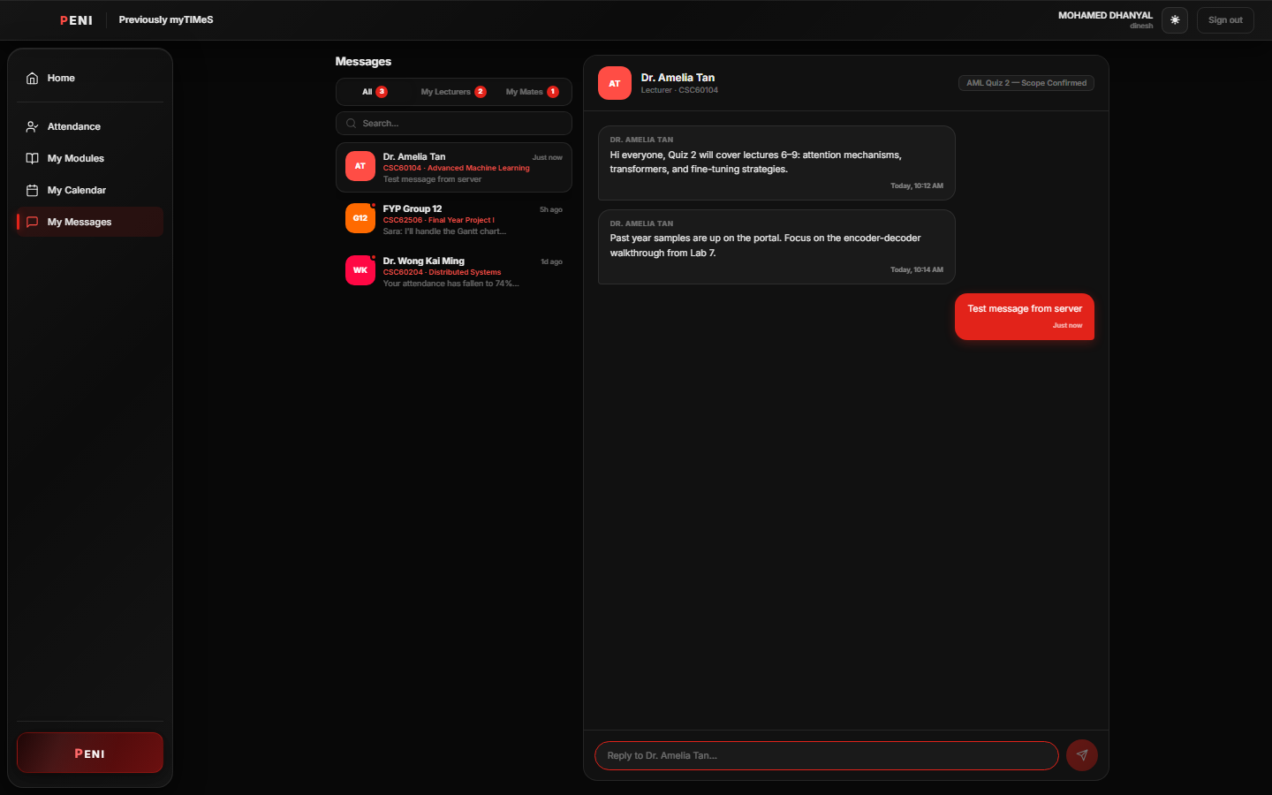
Student Frame S11. Messaging interface.
Goal: Confirm whether assessment information changed. Action: Select a conversation and review the thread. System response: Show sender, module association, history, unread indicators, and composer. HCI rationale: The familiar messaging model reduces learning effort.

S12 — Use global Peni and speech output
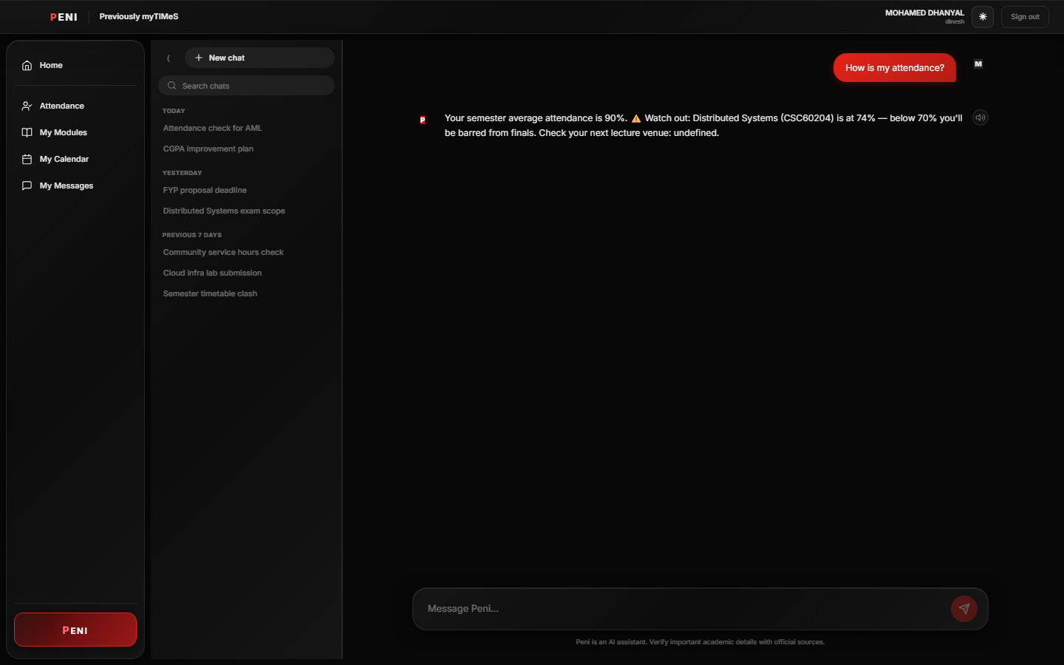
Student Frame S12. Peni attendance response with text-to-speech control.
Goal: Receive a direct summary of attendance risk. Action: Ask “How is my attendance?” and optionally select the speaker. System response: Retrieve student attendance records, identify the lowest module, and present a response that can be read aloud. HCI rationale: The interaction combines contextual assistance, accessibility, and user-controlled audio.

8.2 Teacher Storyboard: Publish, Assess, and Respond
The teacher storyboard demonstrates the second role rather than describing an unsupported portal. Dr Amelia Tan moves from her dashboard into a module, prepares content, creates an assessment, and reviews submissions.

T01 — Teacher dashboard
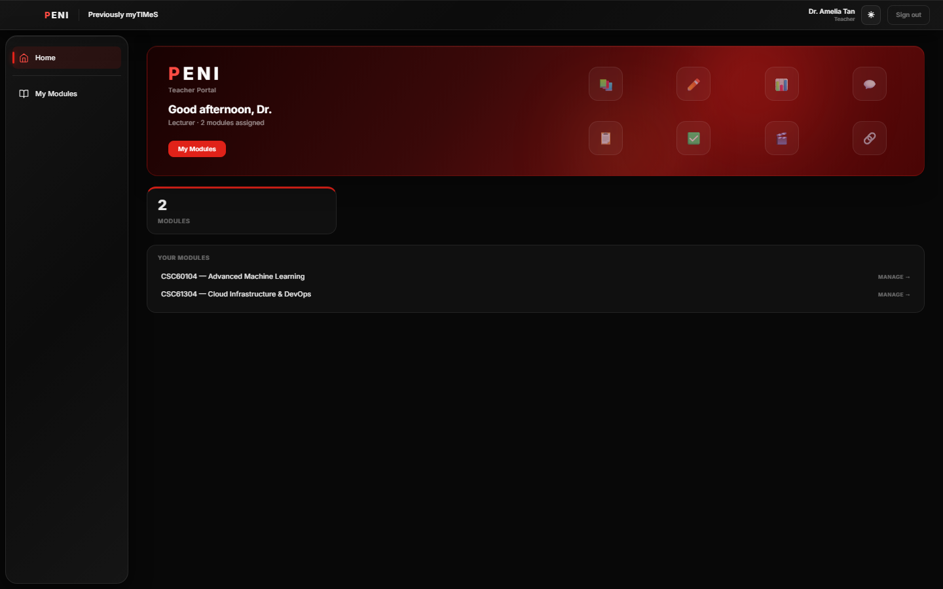
Teacher Frame T01. Role-specific teacher dashboard.
Goal: Identify assigned modules. Action: Sign in with the staff account. System response: Assign teacher role and show teacher-specific navigation and module summary. HCI rationale: Role separation prevents student controls from competing with teacher tasks.

T02 — Select an assigned module
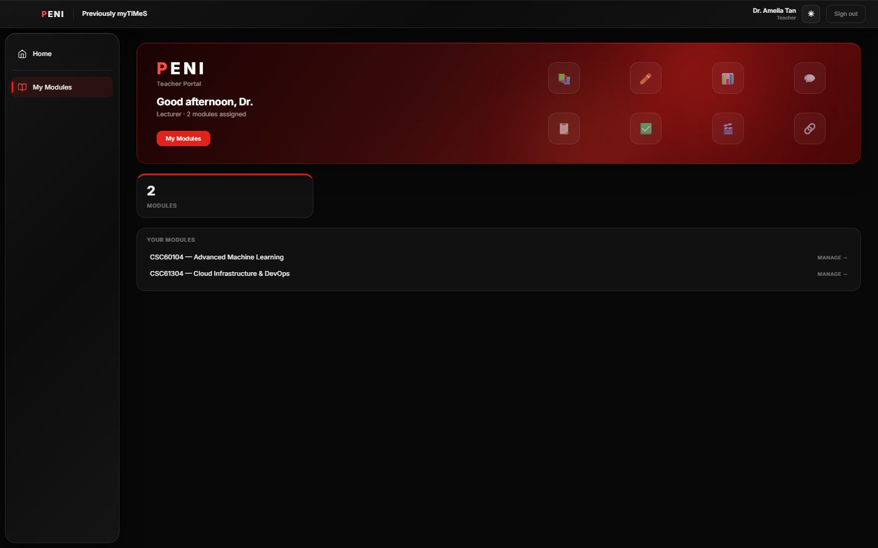
Teacher Frame T02. Teacher module selection.
Goal: Manage module content. Action: Select Manage for the assigned module. System response: Open the teacher module interior. HCI rationale: Direct module ownership reduces administrative hierarchy.

T03 — Review weekly materials
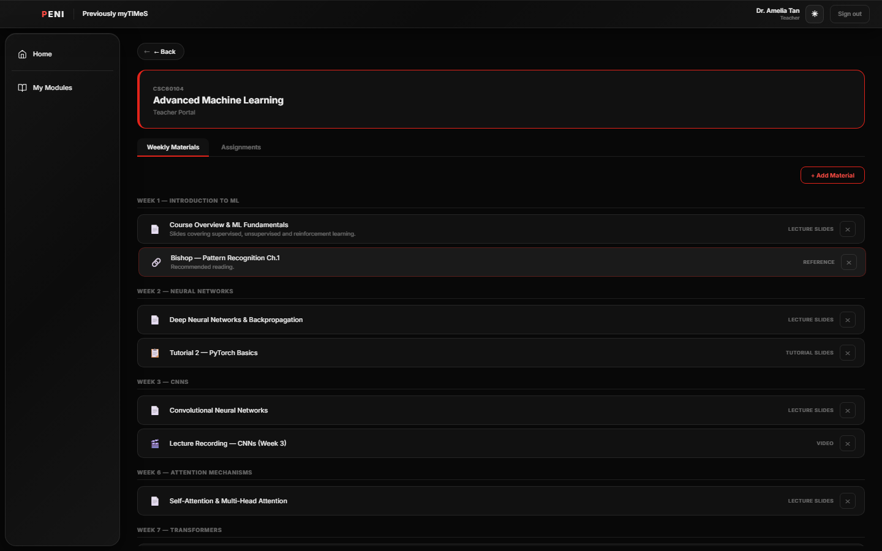
Teacher Frame T03. Existing weekly materials.
Goal: Check existing learning resources before adding another. Action: Scan materials by week and type. System response: Present current records with deletion controls. HCI rationale: Existing state remains visible, preventing duplicate publication.

T04 — Prepare a new material
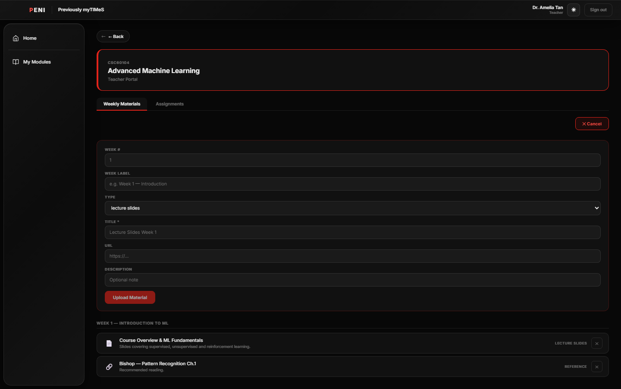
Teacher Frame T04. Add Material form.
Goal: Add a weekly resource. Action: Open Add Material and enter week, type, title, URL, and description. System response: Validate required values and enable upload when sufficient information is present. HCI rationale: Labels and constraints prevent incomplete records.

T05 — Review assignments
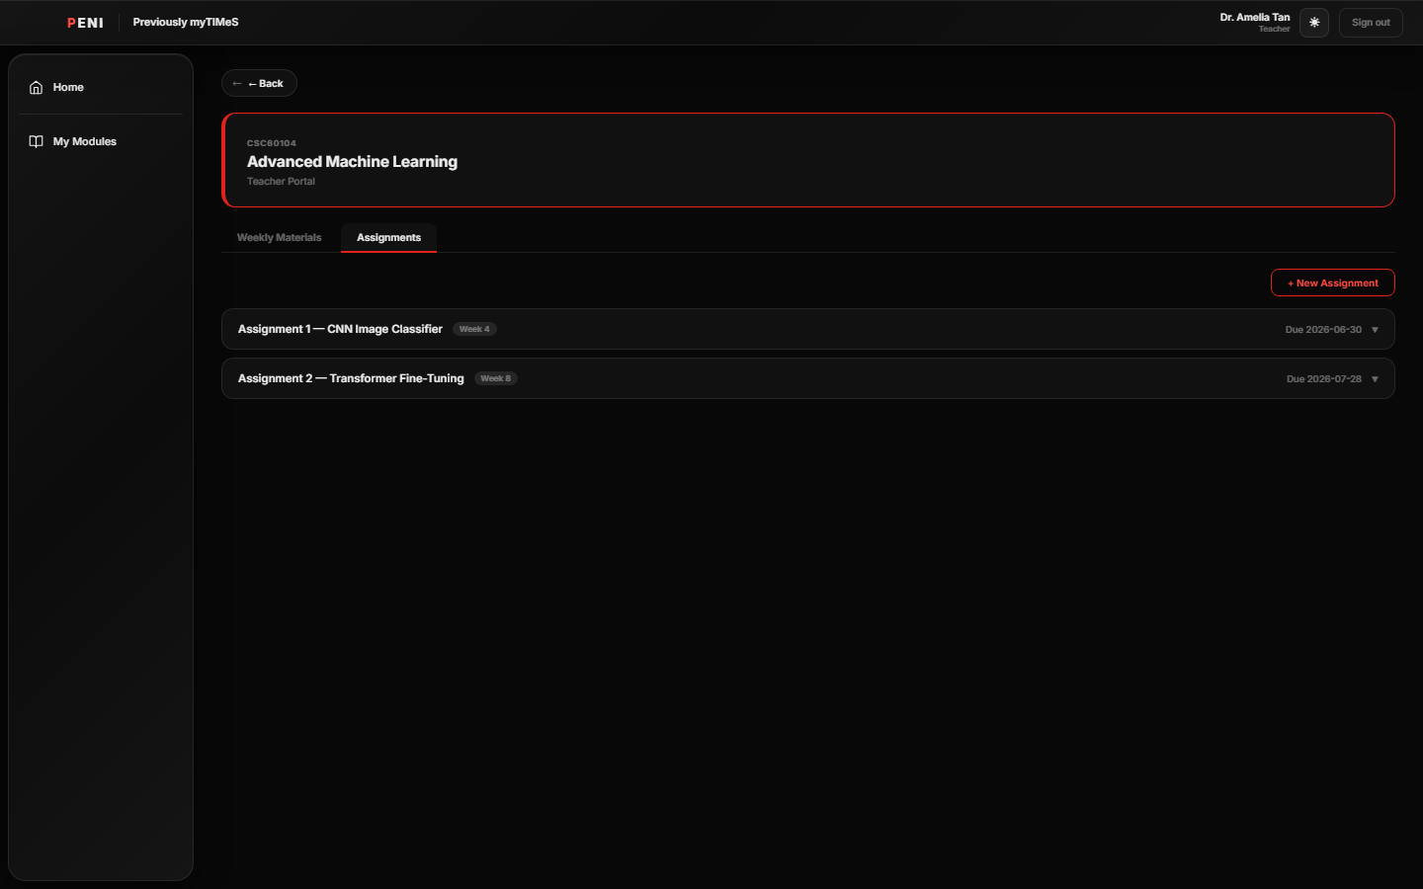
Teacher Frame T05. Assignment management list.
Goal: Inspect active assessments. Action: Switch to Assignments. System response: List title, week, due date, and expandable details. HCI rationale: Consistent tabs preserve module context.

T06 — Create an assignment
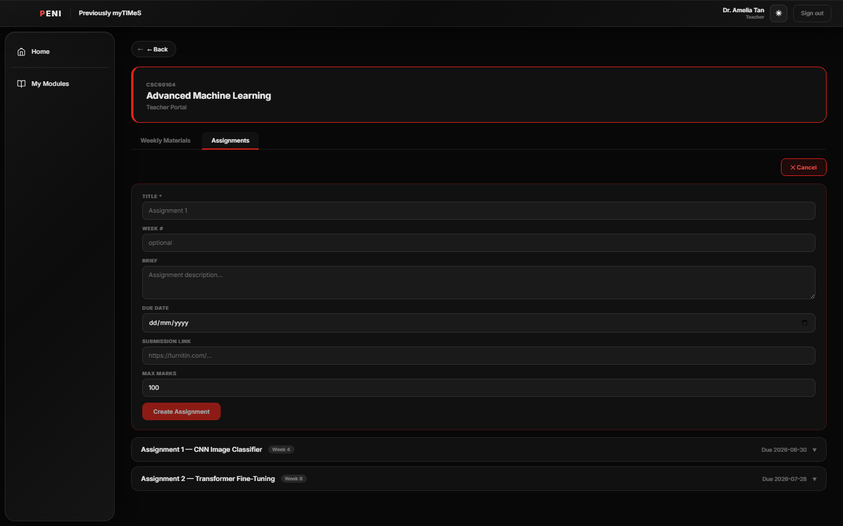
Teacher Frame T06. New Assignment form.
Goal: Publish a structured assessment. Action: Enter title, week, brief, due date, submission link, and maximum marks. System response: Validate required title and create the record. HCI rationale: Related fields are grouped in one workflow and optional fields are visibly distinguishable.

T07 — Review the submission area
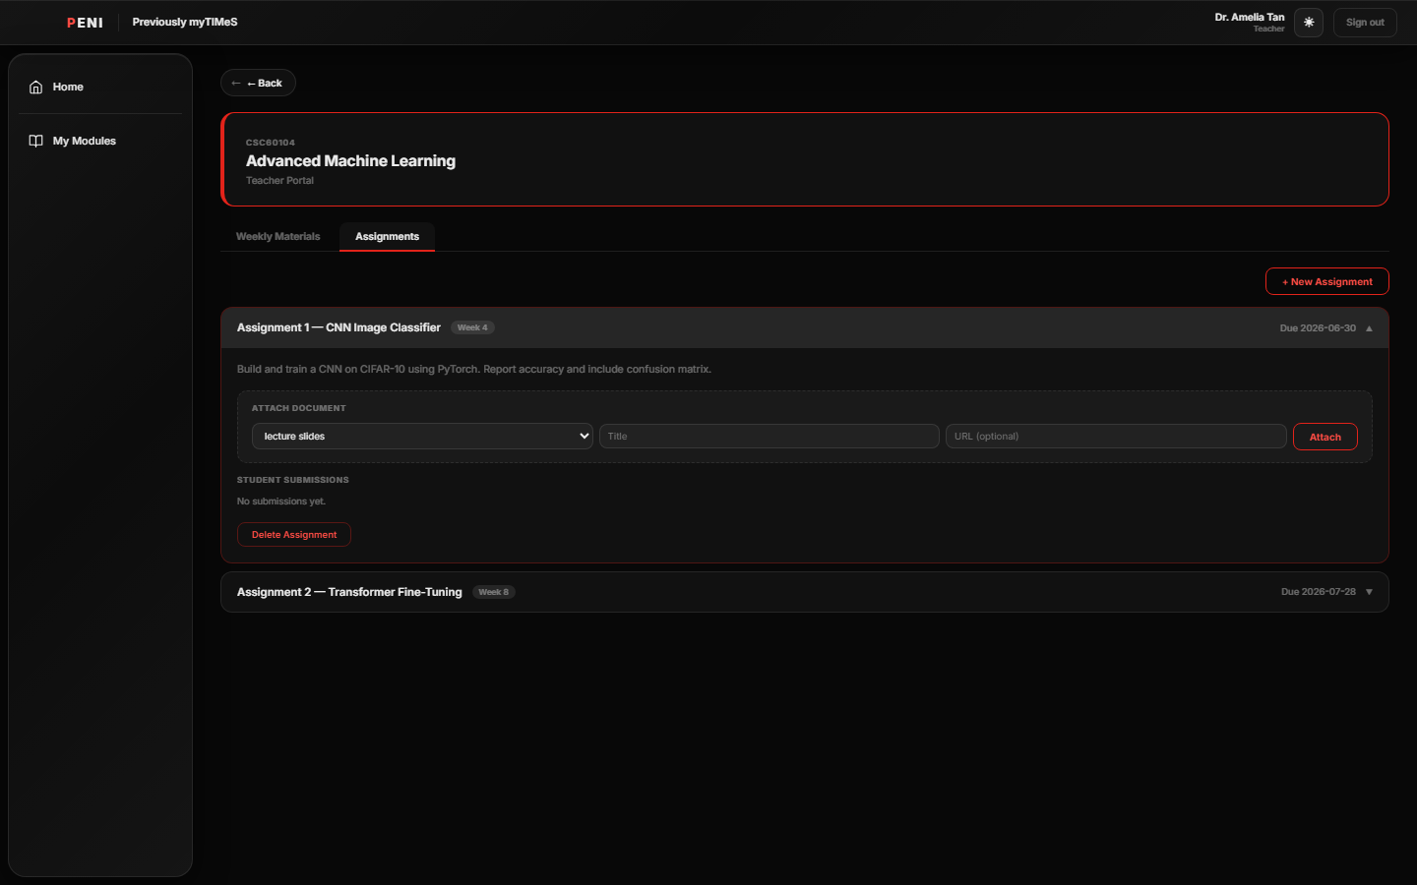
Teacher Frame T07. Expanded assignment and empty-submission state.
Goal: Determine whether work is ready for review. Action: Expand the assignment and inspect Student Submissions. System response: The captured seeded state clearly reports that no submissions are available and keeps document attachment and deletion controls visible. When a submission exists, the implemented workflow exposes grade and feedback inputs. HCI rationale: An explicit empty state is preferable to a blank panel; a final demonstration should seed a submission so that grading can also be evidenced visually.

8.3 Navigation Map
Student: Login → Dashboard → Modules → Module Overview → Weekly Materials → Study with Peni / Study Plan → Assignments; Dashboard → Attendance; Dashboard → Calendar; Dashboard → Messages; Global navigation → Peni.
Teacher: Login → Teacher Dashboard → Assigned Module → Weekly Materials → Add Material; Assigned Module → Assignments → New Assignment → Submission Review → Grade and Feedback.
The two storyboards contain nineteen distinct high-fidelity frames, exceeding the minimum requirement of fifteen screens.

9. High-Fidelity Alpha Prototype

9.1 Prototype Fidelity
The prototype is high fidelity because it uses final visual styling, realistic academic data, role-specific navigation, stateful interactions, responsive forms, persistent backend records, and complete task sequences rather than static wireframes. The interface demonstrates normal, warning, active, loading, disabled, expanded, and conversational states.
Prototype access: Live application — https://mypeni.app (student login: dinesh@sd.taylors.edu.my / password123; teacher login: amelia.tan@taylors.edu.my / password123). Source code — https://github.com/Mohamed-Dhanyal/PENI-AI- branch Beta.

9.2 Implemented Alpha Coverage
Capability | Status | Evidence
Student and teacher authentication | Implemented | S01, T01
Student dashboard | Implemented | S02
Modules and weekly materials | Implemented | S03–S05
Student assignments | Implemented | S08
Attendance monitoring | Implemented | S09
Timetable | Implemented | S10
Messaging | Implemented | S11
Context-aware Peni assistant | Implemented alpha | S06, S12
Study-plan interaction | Interface implemented; structured generation acceptance gap documented | S07
Teacher material management | Implemented | T03–T04
Teacher assignment management | Implemented | T05–T06
Submission grading | Workflow implemented; captured data set shows empty-submission state | T07
WebGL visual technique | Implemented | S01
Web Speech audio technique | Implemented | S12
Document-grounded RAG citations | Architecture and implementation sequence completed | Section 5.2 and 6.1
Predictive mastery model | Analytics design completed | Section 6.2
Containerised institutional deployment | Deployment design completed | Section 6.3
This status table distinguishes demonstrated alpha behaviour from architecture prepared for the next implementation increment. It allows the marker to assess both prototype quality and technical ambition without confusing local evidence with production deployment.

9.3 Visual and Audio Techniques
The WebGL login effect uses moving particles and proximity lines to communicate a neural network. The animation is placed behind the login form, has no pointer interaction, and maintains a dark contrast field. The visual technique is meaningful because it reinforces PENI's identity while preserving the primary authentication task.
The Web Speech control appears only after a Peni response has completed. The student explicitly chooses whether to hear the response. This supports auditory learners, users with reading fatigue, and students revising while looking at another source. Autoplay is avoided to preserve privacy and prevent unexpected sound.

10. Design Rationale

10.1 Strengths of the Final Design
The first strength is consolidation. The dashboard, modules, attendance, timetable, messages, assignments, and AI support share one interaction shell. Consolidation directly addresses the strongest questionnaire finding and creates measurable value before the more advanced AI extensions are complete.
The second strength is the connection between student and teacher workflows. Teacher-published materials and assignments use the same module structure visible to students. The design therefore represents an academic ecosystem rather than an isolated student organiser.
The third strength is progressive disclosure. Dashboard panels summarise; detailed screens expand. Module materials and assignments are separated by tabs. Assignment bodies remain collapsed until selected. Study assistance opens as a modal while retaining module context. This keeps the interface focused despite the breadth of information.
The fourth strength is the layered architecture. The role-based frontend, API groups, relational data, and future external services have clear boundaries. This allows the alpha to run locally while preserving a path toward RAG, PostgreSQL, SSO, and cloud services.

10.2 Weaknesses and Known Issues
The first weakness is that the current AI response engine is narrower than the completed RAG design. It is useful for demonstrating contextual student-data assistance, but it does not yet parse lecture documents or display file and page citations. The next development priority is therefore evidence-grounded AI rather than adding more generic conversational intents.
The second weakness is inconsistent use of wide desktop space. Several screens place compact content near the top and leave a large empty region. Responsive breakpoints should increase card width, provide meaningful secondary detail, or constrain the content canvas on very wide displays.
The third weakness is uneven feedback for teacher mutations. Required fields and saving states are present, but success, failure, undo, and deletion confirmation should be standardised. Error recovery must be tested explicitly.
The fourth weakness is that examination and assignment timetable areas are less complete than the class timetable. These areas should be populated from the assignment and event records already available to the backend.
The fifth weakness is the risk of presenting predictive recommendations as objective academic truth. Predictive support must remain explainable, optional, and advisory. Students and lecturers must be able to inspect why a warning was shown.

10.3 Alternative Designs Considered and Rejected

Native mobile application first
A native iOS or Android application was considered because students frequently access academic systems by phone. It was rejected for the alpha because separate platform development would reduce the number of complete workflows that could be demonstrated. A responsive web application provides access across laptop, tablet, and mobile browsers and can later be packaged as a PWA or native wrapper.

Separate student and teacher applications
Two separate applications could provide specialised navigation, but they would duplicate authentication, theming, API handling, and deployment. A shared role-based application was selected because it keeps the academic data model and visual language consistent while still presenting different shells after authentication.

AI-first home screen
A conversational home screen was considered, but it would hide important attendance, message, and deadline information behind questions the student must remember to ask. The dashboard-first design was selected because it makes risk visible proactively while retaining global access to Peni.

Fully autonomous AI scheduling
Automatic schedule changes were rejected because they reduce user control and may conflict with personal commitments unknown to the system. PENI generates or recommends study actions, but the student remains responsible for accepting and adjusting them.

On-device language model
A local model could improve privacy but would create unpredictable performance across student devices and increase alpha complexity. The selected architecture keeps the AI service replaceable, supports privacy controls, and allows future evaluation of local or institutional models.

11. Agile/Scrum Development Approach
PENI used a Scrum-inspired development approach with short iterations, prioritised user stories, shared acceptance criteria, regular review, and retrospective improvement. Mohamed Dhanyal acted as Product Owner and group leader, while coordination and implementation responsibilities were distributed according to skill and availability.
The backlog was organised into authentication, student overview, modules, attendance, timetable, messages, AI study support, teacher content management, assignments, audio/visual APIs, testing, and report evidence. Higher-risk integration work was separated from interface work so that a demonstrable alpha remained available throughout development.
A shared Definition of Done required that a feature satisfy its acceptance criteria, integrate with the current shell and data flow, preserve role restrictions, include visible feedback, and be demonstrable in the final storyboard. Retrospective review identified screenshot readability and mismatch between architectural ambition and visible evidence as major reporting risks. The final report responds by adding implementation-status distinctions and task-based student and teacher storyboards.

12. Evaluation and Acceptance Plan

12.1 Functional Acceptance
Each storyboard step functions as an acceptance scenario. Authentication is accepted when the correct role shell appears. Module study is accepted when selected material context reaches the modal. Attendance is accepted when summary and module values agree with stored records. Teacher publishing is accepted when required validation operates and the created record appears in the module. Grading is accepted when the saved grade and feedback return through the submission view.

12.2 Usability Evaluation
Five representative students should complete the student scenario and three lecturers or teaching assistants should complete the teacher scenario using a think-aloud method. Measures should include task success, time, errors, assistance requested, confidence, and UMUX-Lite. Participants should also rate whether the dashboard helped them identify the correct next action and whether Peni's limitations were understandable.

12.3 AI Evaluation
The current alpha should be tested for correct use of authenticated student data and safe handling of unsupported intents. The RAG increment should use a labelled question set with expected source pages. Evaluation should report retrieval relevance, citation correctness, unsupported claim frequency, latency, and user trust. Fluency alone is not a sufficient success measure.

12.4 Accessibility and API Evaluation
Keyboard navigation, focus visibility, contrast, accessible names, zoom, and reduced-motion behaviour should be checked. WebGL failure must not block authentication. The speech control must remain optional, must not autoplay, and should report unsupported-browser behaviour clearly.

13. Group Analysis

13.1 Team Strengths and Weaknesses
The team's principal strength was the combination of frontend, backend, interface, data, and documentation skills. This allowed the product to be divided into clear ownership areas while maintaining a shared visual and technical direction. The members' direct experience as Taylor's students also improved empathy with fragmented academic workflows and allowed scenario decisions to be challenged against realistic routines.
A second strength was willingness to refine the prototype after integration. The team did not stop at isolated screens; it connected authentication, data, student views, teacher operations, and report evidence. Shared screenshots and demonstrations helped identify inconsistent styling and missing states earlier than text-only progress updates would have done.
The principal weakness was uneven prior experience with Scrum and technical estimation. Early plans treated AI, teacher workflows, and documentation as similarly predictable tasks even though their uncertainty differed considerably. This produced overly optimistic descriptions of some advanced components. The team addressed this by separating implemented alpha capabilities from the next architectural increments.
A second weakness was time fragmentation across modules and group commitments. Synchronous sessions were difficult to schedule, increasing integration risk. The team responded with smaller task ownership, asynchronous updates, shared Git history, and screen-based reviews.

13.2 Lessons Learned
The first lesson is that requirement traceability must begin before implementation. When research, requirements, screens, and acceptance criteria are maintained separately, the report becomes descriptive and evidence must be reconstructed late. A traceability matrix would be created in the first sprint if the project restarted.
The second lesson is that a high-fidelity prototype must show states, not only pages. A screenshot of a collapsed calendar proves that the page exists but does not demonstrate timetable use. A meaningful storyboard must capture the action and resulting state. This lesson informed the replacement of the small screenshot catalogue with two task flows.
The third lesson is that architecture should be ambitious but status must remain precise. A detailed RAG or cloud design is valuable even before production deployment, but the report must distinguish implemented interfaces, implemented services, completed technical design, and future infrastructure. This distinction improves credibility and gives the team a practical development roadmap.
The fourth lesson is that feedback and recovery should be shared components rather than screen-specific additions. A consistent notification and error pattern would reduce implementation time and improve usability across both roles.

14. Conclusion
PENI responds to a measured HCI problem: students lose time and confidence because academic information and assistance are distributed across unrelated systems. The project translates Assignment 1 research into a high-fidelity alpha that connects dashboard status, modules, weekly materials, assignments, attendance, timetables, messaging, teacher workflows, AI assistance, visual feedback, and accessible speech output.
The strongest contribution is the correlation between research and interaction design. Consolidation responds to the 87% using three or more platforms. Dashboard status and warnings respond to poor feedback and delayed risk awareness. Material-specific assistance responds to the effort required to convert files into study actions. Role-based teacher workflows connect publication and assessment to the same module model used by students. WebGL and Web Speech satisfy the assignment's visual and audio API requirement while supporting identity and accessibility.
The alpha also establishes the interaction and technical boundaries required for more advanced technologies. Retrieval-augmented generation can be introduced behind the existing AI contract. Predictive support can build on attendance, task, timetable, and mastery events. Cloud deployment can replace local infrastructure without rebuilding the student and teacher workflows. These extensions are described as implementation-ready increments with evaluation criteria rather than as unverified production claims.
PENI therefore demonstrates both a usable present alpha and a credible future system. Its value lies not in adding AI to another dashboard, but in making academic context, action, explanation, and human control part of one coherent experience.

References
Lewis, J. R., Utesch, B. S., & Maher, D. E. (2013). UMUX-LITE: When there's no time for the SUS. *Proceedings of the SIGCHI Conference on Human Factors in Computing Systems*, 2099–2102. https://doi.org/10.1145/2470654.2481287
Nielsen, J. (1994). *Usability engineering*. Morgan Kaufmann.
Nielsen Norman Group. (2020). Ten usability heuristics for user interface design. https://www.nngroup.com/articles/ten-usability-heuristics/
Norman, D. A. (2013). *The design of everyday things* (Revised and expanded ed.). Basic Books.
Preece, J., Rogers, Y., & Sharp, H. (2015). *Interaction design: Beyond human-computer interaction* (4th ed.). Wiley.
Schwaber, K., & Sutherland, J. (2020). *The Scrum Guide*. https://scrumguides.org/scrum-guide.html
United Nations. (2015). *Transforming our world: The 2030 agenda for sustainable development*. https://sdgs.un.org/2030agenda
Taylor's University. (n.d.). *Our core purpose*. https://university.taylors.edu.my/en/about/who-we-are.html

Appendix A: Generative AI Disclosure
Generative AI tools were used to support outlining, language refinement, explanation of selected technical concepts, document formatting, and review of rubric alignment. AI tools were not treated as authoritative evidence. Group members reviewed the generated content, checked it against the assignment brief, prototype, repository, and questionnaire findings, and remained responsible for the final submission. The official declaration instructions supplied with the assessment brief take precedence over this appendix.

Appendix B: Rubric Coverage Matrix
Rubric criterion | Primary report evidence
1. Vision, mission, problem, scenario, audience | Sections 1 and 2
2. Solution, innovation, impact, conclusion, storyboard | Sections 3, 8, and 14
3. Technical architecture and three latest technologies | Sections 5 and 6
4. Scope and functional requirements | Section 4
5. Presentation language and delivery | Presentation preparation required separately
6. Expression and body-language delivery | Presentation rehearsal required separately
7. Design rationale and alternatives | Section 10
8. Group strengths, weaknesses, and lessons | Section 13
9. Visual and audio techniques using standard APIs | Sections 6.4 and 9.3; frames S01 and S12
10. High-fidelity alpha prototype | Sections 8 and 9; nineteen storyboard frames

Appendix C: Presentation Evidence Checklist
- Open with the quantified fragmentation and AI confidence problems.
- Demonstrate the student storyboard as one continuous task.
- Demonstrate one teacher publication and grading flow.
- Show the WebGL login visual and Web Speech response control.
- Explain the four-layer architecture in less than two minutes.
- Distinguish implemented alpha behaviour from RAG, predictive, and cloud increments.
- Assign each group member a visible speaking and demonstration role.
- Rehearse transitions, timing, volume, eye contact, and recovery if the local server fails.
- Keep a recorded backup demo and exported screenshots available.

Appendix D: Generative AI Disclosure — Full Declaration
Module Code: ITS 63504 / ITS 69904 Module Name: Human Computer Interaction Assessment: Assignment 2

Section 1: AI Tool Usage Summary
AI Tool Used | Prompts | Outputs | How the Output Was Changed for Use in the Assignment | Pages Where Output Is Used
ChatGPT (OpenAI, 2026) | "Analyse the HCI Assignment 2 brief for Taylor's University and explain what the assignment requires" | Summary of assignment requirements, rubric breakdown, and marking scheme | Output was verified against the actual assignment brief. Rubric criteria were re-ordered by the student to match the marking scheme. Criterion weights were checked independently. | Cover, Section 1
ChatGPT (OpenAI, 2026) | "Draft an executive summary for a high-fidelity web prototype called PENI that consolidates academic tools for university students" | Draft executive summary paragraph | Rewritten by the student to include specific questionnaire statistics, architecture decisions, and Assignment 1 continuity. Technology references changed to reflect actual implementation. | Executive Summary
ChatGPT (OpenAI, 2026) | "Explain Nielsen's ten usability heuristics with examples relevant to a university student portal" | General heuristic explanations | All examples replaced by the student with PENI-specific screen references and questionnaire correlations. Limitations and improvement notes added independently. | Section 7
ChatGPT (OpenAI, 2026) | "Describe a four-layer web application architecture for a study companion app" | Generic architecture layer description | Rewritten by the student to reference specific PENI components, route groups, and migration paths. Layer names and component labels are original. | Section 5
Cascade AI (Windsurf, 2026) | Report structure, formatting, Python DOCX assembly, storyboard screenshot capture scripts | Report scaffolding, DOCX generation code, Playwright scripts | All content decisions, requirement descriptions, rubric correlations, storyboard narratives, and technical claims were reviewed and approved by the student. Final report reflects student-directed output. | All sections

Section 2: Student Modification and Original Contribution
The following elements represent original student work that was not generated by AI:
- App concept and name ("Peni"): Conceived independently based on personal experience as a Taylor's student dealing with fragmented study tools.
- Module-based organisation with Weekly Materials grouped by week and type: Inspired by the student's actual workflow across myTIMeS, WhatsApp, and local files.
- Context-aware AI assistant seeded from selected material: Original interaction design connecting material selection to study conversation context.
- Role-based student and teacher portal on a shared backend: Original architecture decision enabling teacher publication and student consumption through the same data model.
- Traceability matrix linking questionnaire findings to requirements, screens, heuristics, and technologies: Designed and populated independently by the student.
- Implementation-status table distinguishing alpha behaviour from future increments: Student decision to present honest evidence boundaries.
- Questionnaire data collection and analysis: The survey was distributed to Taylor's University students. All percentages, rankings, and statistical summaries were calculated independently from raw response data.
- Assignment 1 to Assignment 2 platform pivot explanation: Student decision to move from Flutter to React/Vite with documented rationale.
- Prototype screenshots and storyboard narrative: All storyboard frame goals, actions, system responses, and HCI rationale were written independently by the student.
- Live deployment at mypeni.app and GitHub repository at https://github.com/Mohamed-Dhanyal/PENI-AI- (branch: Beta): Application built and deployed by the group.

Section 3: Declaration
I confirm that:
a) I understand what constitutes academic integrity violations, including plagiarism, collusion, fabrication, falsification, contract cheating, and improper use of Gen AI.
b) I confirm that my work or any part of this assessment has neither been previously and is not concurrently submitted for any other programme at Taylor's University or any other institution, save except when re-use of the same work is permitted by the module leader.
c) I acknowledge that using Gen AI or any external assistance without proper attribution constitutes academic misconduct and may be sanctioned accordingly.
d) I understand that if there are indications of academic integrity breaches, including improper Gen AI use, my work will be subject to investigation.
e) This assignment is my own work, and I have properly acknowledged all sources, tools, and external contributions, including the use of Gen AI where applicable.
f) I acknowledge and authorise the submission and/or storage of my work in a database for the purpose of verifying its originality and/or conducting tests using artificial intelligence software, and I hereby consent to this process.
g) I acknowledge that this submission is subject to Taylor's University/College Academic Integrity Procedure (THE-ACA-PROC-AINT) and all applicable university regulations.

Appendix E: Assessment Submission Declaration Form
TAYLOR'S UNIVERSITY / TAYLOR'S COLLEGE Taylor's University Sdn Bhd | Taylor's Malaysia Sdn Bhd
ASSESSMENT SUBMISSION DECLARATION FORM
Module Code: ITS 63504 / ITS 69904 Module Name: Human Computer Interaction Assessment: Assignment 2
Declaration:
a) I confirm that this work has not been previously and is not concurrently submitted for any other programme at Taylor's University or any other institution.
b) I understand what constitutes academic integrity violations, including plagiarism, collusion, fabrication, falsification, contract cheating, and improper use of Gen AI.
c) I acknowledge that using Gen AI or any external assistance without proper attribution constitutes academic misconduct and may be sanctioned accordingly.
d) I understand that if there are indications of academic integrity breaches, including improper Gen AI use, my work will be subject to investigation.
e) This assignment is my own work, and I have properly acknowledged all sources, tools, and external contributions, including the use of Gen AI where applicable.
f) I acknowledge and authorise the submission and/or storage of my work in a database for the purpose of verifying its originality and/or conducting tests using artificial intelligence software, and I hereby consent to this process.
g) I acknowledge that this submission is subject to Taylor's University/College Academic Integrity Procedure (THE-ACA-PROC-AINT) and all applicable university regulations.
Group Members — Name, Signature and Date:
Name and Student ID | Signature | Date | Semester / Year
Mohamed Dhanyal 0377471 | Mohamed | 12 July 2026 | Y2S2
Chang Tatt Seng 037472 | Chang | 12 July 2026 | Y3S2
Song ZeYu 03373344 | Song | 12 July 2026 | Y2S2
Qin Rui 0378603 | Qin | 12 July 2026 | Y2S2
Mohamed Nahzan Ahmed 0385440 | Mohamed Nahzan | 12 July 2026 | Y1S2

