HBase Lab
Beginner & Intermediate
Instructor-Led Practice + Student Exercises
Item | Details
Dataset | student table
Column Families | personal, academic
Levels Covered | Beginner → Intermediate

Dataset: Student Table

Column Families
Column Family | Columns
personal | name, city, age
academic | faculty, grade, year

Data
Row Key | Name | City | Age | Faculty | Grade | Year
1 | ali | cairo | 21 | engineering | A | 3
2 | sara | alex | 22 | medicine | B | 4
3 | omar | giza | 20 | engineering | A | 2
4 | nada | cairo | 23 | arts | C | 4
5 | youssef | tanta | 21 | engineering | B | 3

PART 1 — BEGINNER

1.1 Create the Table
Syntax:
create '<table>', '<column_family1>', '<column_family2>'
Instructor Demo:
create 'student', 'personal', 'academic'
Verify the table was created:
list
View table schema:
describe 'student'

1.2 Insert Data — put
Syntax:
put '<table>', '<row_key>', '<family:column>', '<value>'
Instructor Demo — Insert personal data:
put 'student', 1, 'personal:name', 'ali'
put 'student', 2, 'personal:name', 'sara'
put 'student', 3, 'personal:name', 'omar'
put 'student', 4, 'personal:name', 'nada'
put 'student', 5, 'personal:name', 'youssef'

put 'student', 1, 'personal:city', 'cairo'
put 'student', 2, 'personal:city', 'alex'
put 'student', 3, 'personal:city', 'giza'
put 'student', 4, 'personal:city', 'cairo'
put 'student', 5, 'personal:city', 'tanta'

put 'student', 1, 'personal:age', '21'
put 'student', 2, 'personal:age', '22'
put 'student', 3, 'personal:age', '20'
put 'student', 4, 'personal:age', '23'
put 'student', 5, 'personal:age', '21'
Instructor Demo — Insert academic data:
put 'student', 1, 'academic:faculty', 'engineering'
put 'student', 2, 'academic:faculty', 'medicine'
put 'student', 3, 'academic:faculty', 'engineering'
put 'student', 4, 'academic:faculty', 'arts'
put 'student', 5, 'academic:faculty', 'engineering'

put 'student', 1, 'academic:grade', 'A'
put 'student', 2, 'academic:grade', 'B'
put 'student', 3, 'academic:grade', 'A'
put 'student', 4, 'academic:grade', 'C'
put 'student', 5, 'academic:grade', 'B'

put 'student', 1, 'academic:year', '3'
put 'student', 2, 'academic:year', '4'
put 'student', 3, 'academic:year', '2'
put 'student', 4, 'academic:year', '4'
put 'student', 5, 'academic:year', '3'

1.3 Scan Data — scan
Syntax:
scan '<table>'
scan '<table>', { COLUMNS => '<family:col>', LIMIT => N, STARTROW => '<key>' }
Instructor Demo — Full scan:
scan 'student'
Instructor Demo — Scan with options:
scan 'student', {COLUMNS => 'personal:name', LIMIT => 3, STARTROW => '2'}

1.4 Get Data — get
Syntax:
get '<table>', '<row_key>'
get '<table>', '<row_key>', {COLUMN => '<family:col>'}
Instructor Demo — Get all columns of row 1:
get 'student', '1'
Instructor Demo — Get a specific column:
get 'student', '1', {COLUMN => 'academic:grade'}

1.5 Scan with Filter
Instructor Demo — Find students with grade A:
scan 'student', {
COLUMNS => 'academic:grade',
FILTER => "ValueFilter(=,'binary:A')"
}

✏️ Student Exercises — Beginner
Use the student table you just built to answer the following. Write your commands in each answer box.

Q1. How many rows are in the student table?
Hint: There is a command that counts rows directly.
Your answer:

5

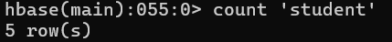

Q2. Get only the personal:city column for student with row key 3.
Your answer:

Giza

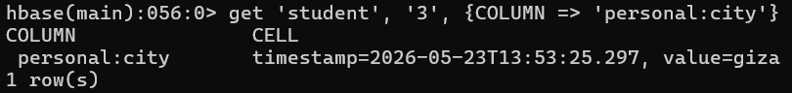

Q3. Scan the table and return only academic:faculty, starting from row 2, with a limit of 3 rows.
Your answer:

medicine, engineering. Arts

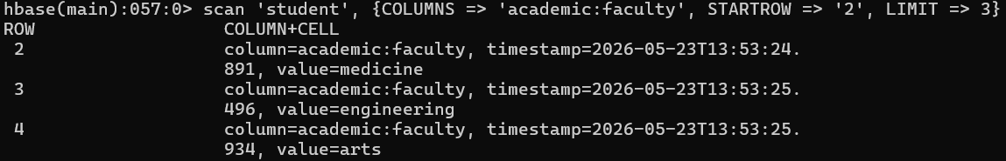

Q4. Student 4 (nada) has moved from cairo to mansoura. Update her city.
Hint: put overwrites an existing value.
Your answer:

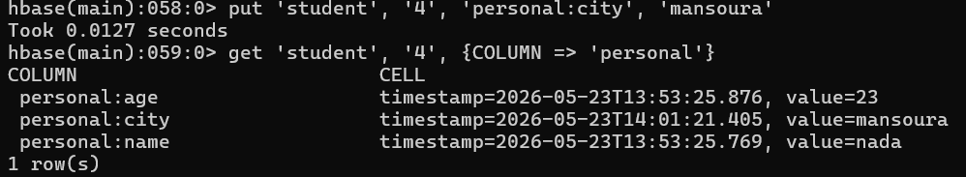

Q5. Delete only the personal:age cell for student 3.
Hint: Look up the delete command.
Your answer:

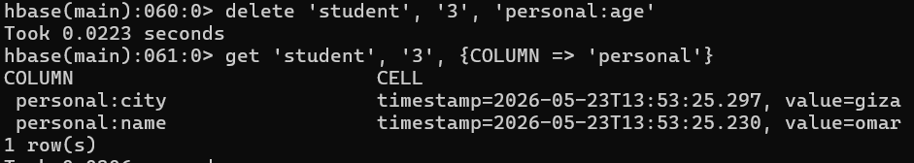

Q6. Confirm the deletion worked by getting all data for row 3.
Your answer:

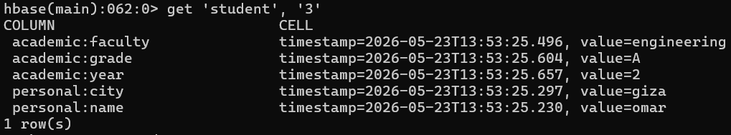

Q7. Delete the entire row for student 5 (youssef).
Hint: Look up deleteall.
Your answer:

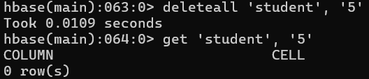

Q8. Verify student 5 no longer exists with a full scan.
Your answer:

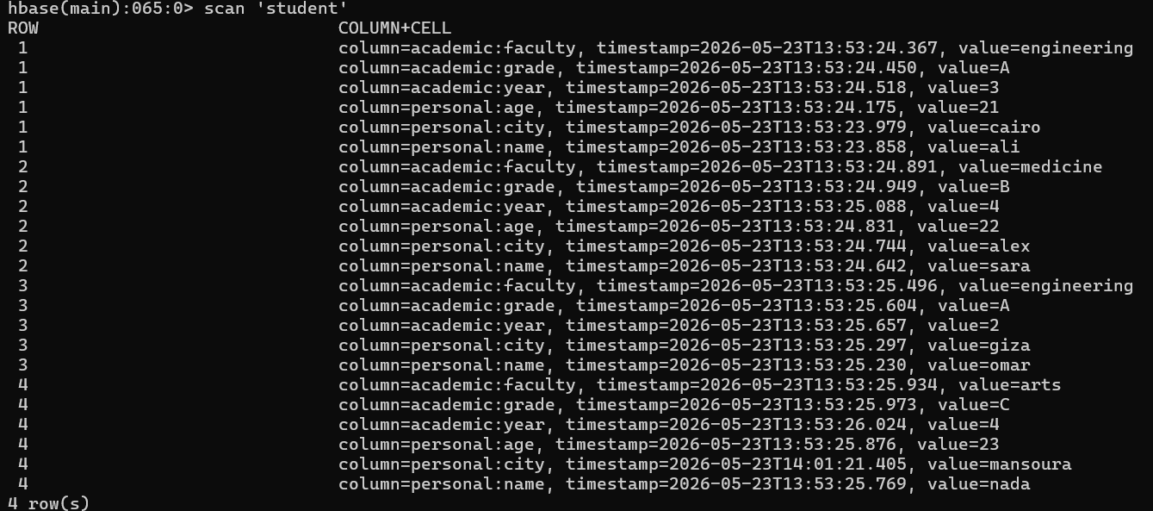

2.1 Versioning
By default, HBase keeps 1 version of each cell. You can increase this to store the full history of changes.
Alter the table to keep 3 versions of the academic column family:
alter 'student', NAME => 'academic', VERSIONS => 3
Instructor Demo — Update a grade multiple times:
put 'student', 1, 'academic:grade', 'B'
put 'student', 1, 'academic:grade', 'A+'
Instructor Demo — Get the latest version (default):
get 'student', '1', {COLUMN => 'academic:grade'}
Instructor Demo — Get all 3 versions:
get 'student', '1', {COLUMN => 'academic:grade', VERSIONS => 3}
💡 Each value is shown with its own timestamp — you can trace the full history of changes.

2.2 Filters
HBase supports powerful server-side filters to query data efficiently.

PrefixFilter — Rows starting with a value
scan 'student', {FILTER => "PrefixFilter('1')"}

RowFilter — Match an exact row key
scan 'student', {FILTER => "RowFilter(=,'binary:2')"}

SingleColumnValueFilter — Filter by column value
Returns the full row where a specific column matches a value.
Instructor Demo — Find all engineering students:
scan 'student', {
FILTER => "SingleColumnValueFilter('academic','faculty',=,'binary:engineering')"
}
Instructor Demo — Find students with grade B:
scan 'student', {
FILTER => "SingleColumnValueFilter('academic','grade',=,'binary:B')"
}

ColumnPrefixFilter — Columns starting with a prefix
scan 'student', {FILTER => "ColumnPrefixFilter('gr')"}

2.3 Alter Table — Add a Column Family
Instructor Demo — Add a new column family contact:
alter 'student', NAME => 'contact'
Add data to the new column family:
put 'student', 1, 'contact:email', 'ali@uni.edu'
put 'student', 2, 'contact:email', 'sara@uni.edu'
Verify the schema changed:
describe 'student'

2.4 Table Lifecycle
disable 'student' # required before dropping
is_disabled 'student' # check status
enable 'student' # re-enable

disable 'student' # drop requires disabled
drop 'student'
list # confirm it's gone
⚠️ You cannot drop a table that is still enabled.

✏️ Student Exercises — Intermediate
Think carefully before running each command. Write your answers in each box.

Q1. Enable versioning on the personal column family — keep up to 5 versions.
Your answer:

Q2. Update personal:city for student 2 (sara) three times: first to cairo, then giza, then back to alex. Then retrieve all versions of that cell.
Hint: Use put three times, then get with VERSIONS => 3.
Your answer:

Q3. Use SingleColumnValueFilter to find all students in year 4.
Your answer:

Q4. Use SingleColumnValueFilter to find all students who live in cairo.
Your answer:

Q5. Add contact:phone for students 1, 3, and 4 with any phone numbers you choose.
Your answer:

Q6. Scan the table and return only the contact column family for all students.
Your answer:

Q7. Add a new column family called enrollment to the student table, then verify it appears in the schema.
Your answer:

Q8. CHALLENGE 🏆 Write a scan that returns only students who are in the engineering faculty AND in year 3.
Hint: Look up FilterList and how to combine filters with MUST_PASS_ALL.
Your answer:

— End of Lab —

