Mohamed Abdelhady Mohamed Elsogher [23101466]

omar mokhtar abd El Fatah tabanga [23101432]

Ahmed Abd ElAleem Ahmed Ahmed [23101547]

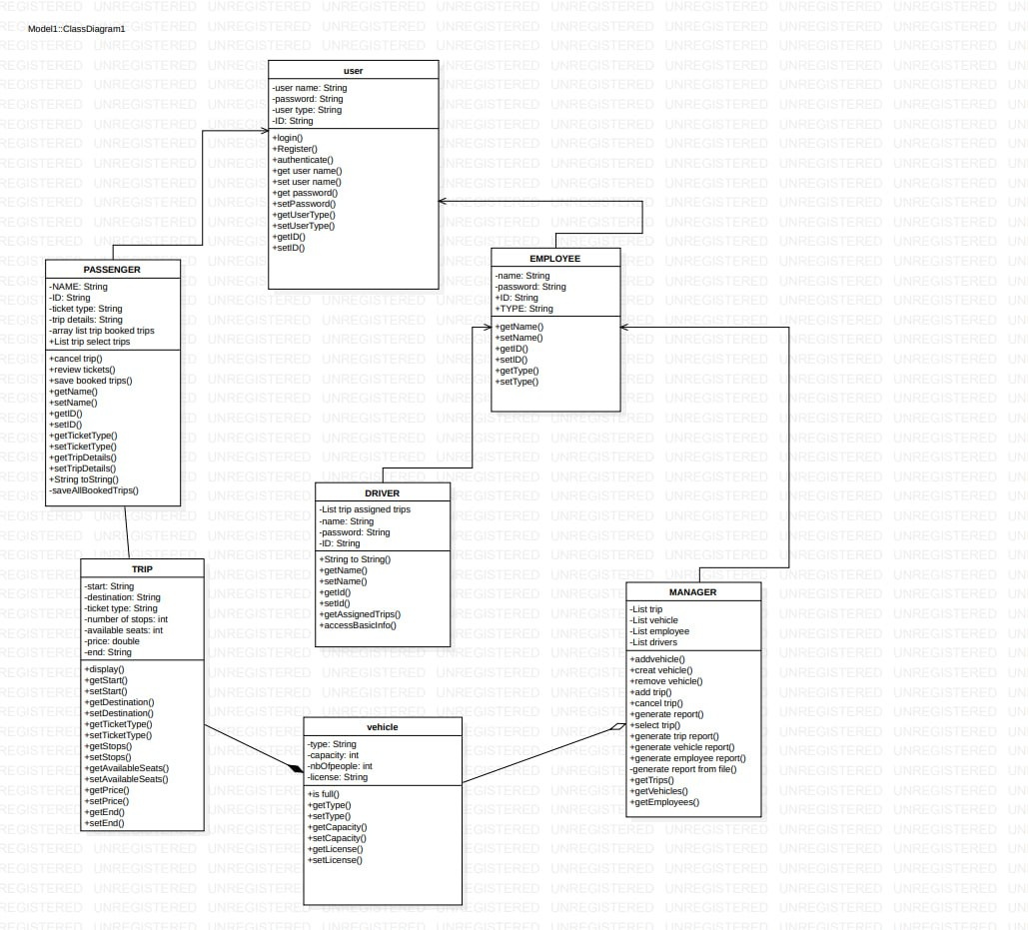

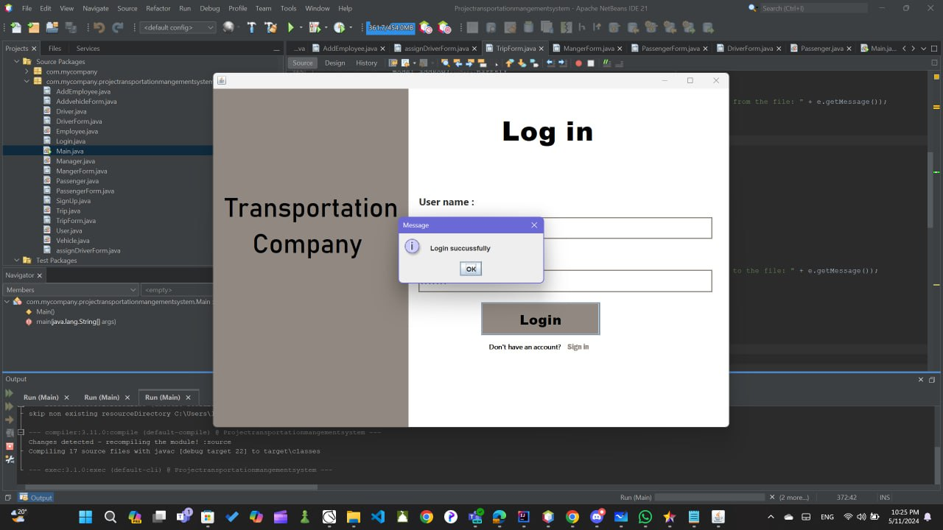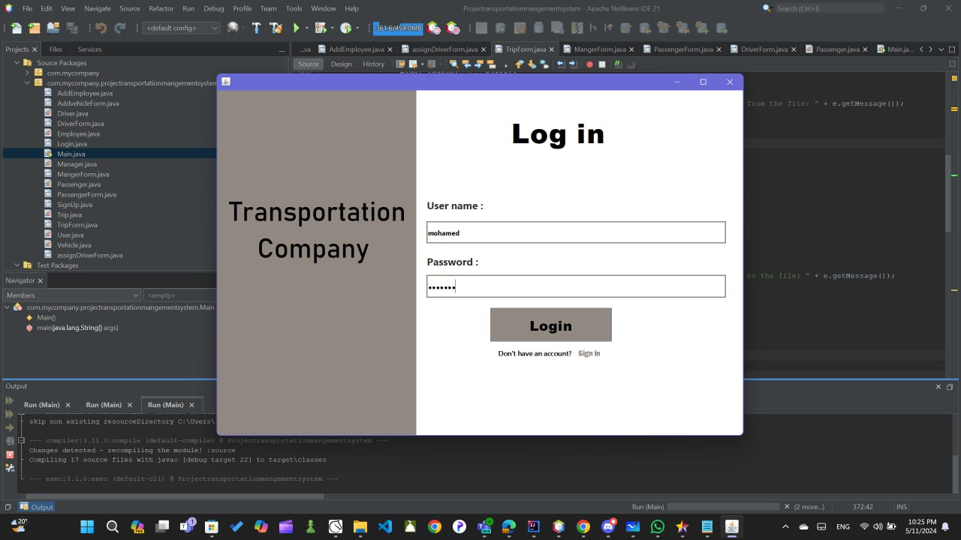When you start the program, will appear log in window. The user can write username and password, if it was true in file data will log in like a type that saved in file data.

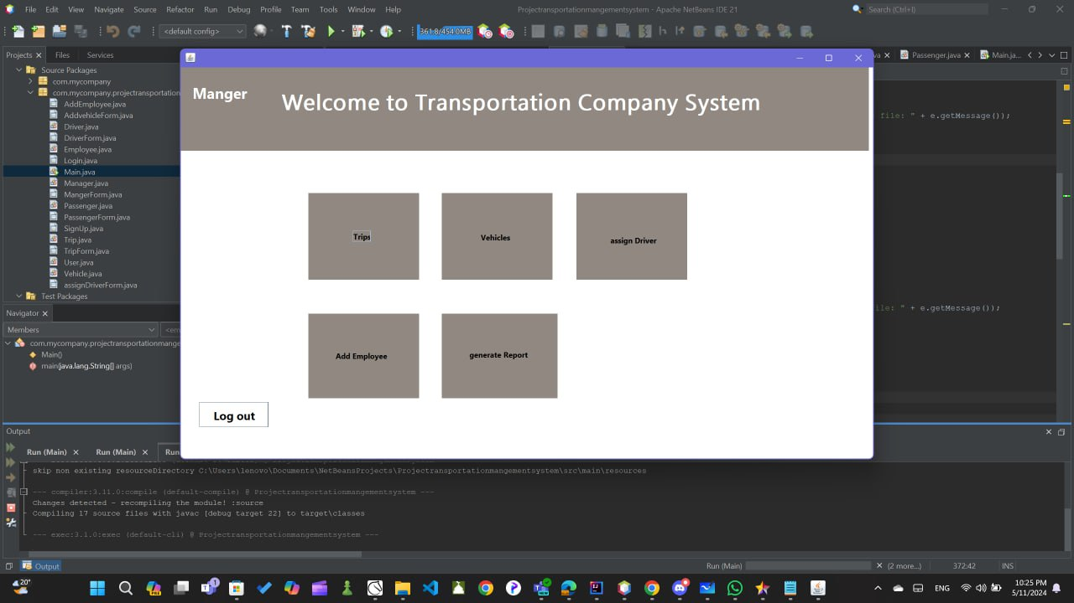If user log in successfully like a manger, will appear this window.

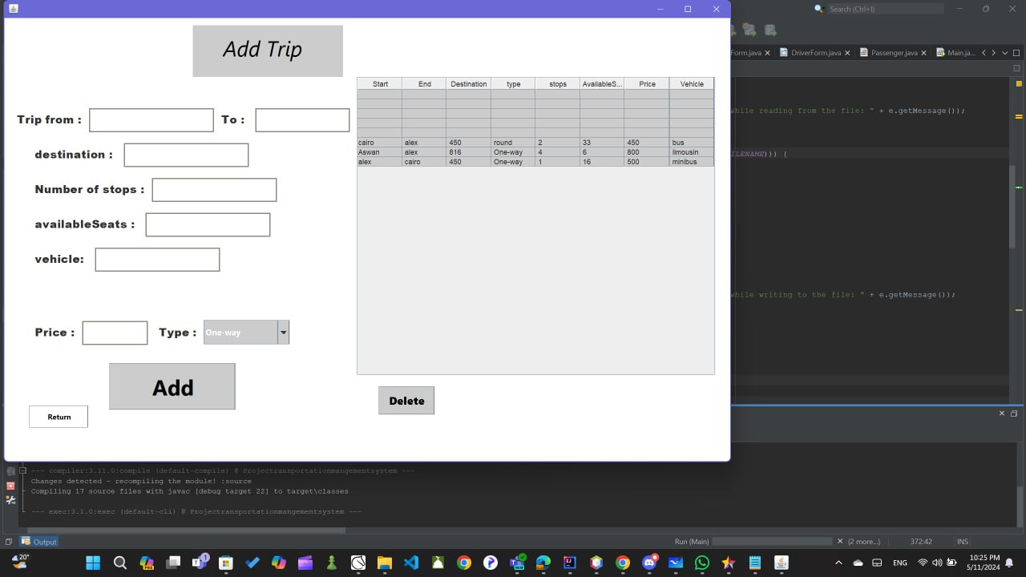If he click in trip, will appear this window that have a table by trips that saved in trips .txt file

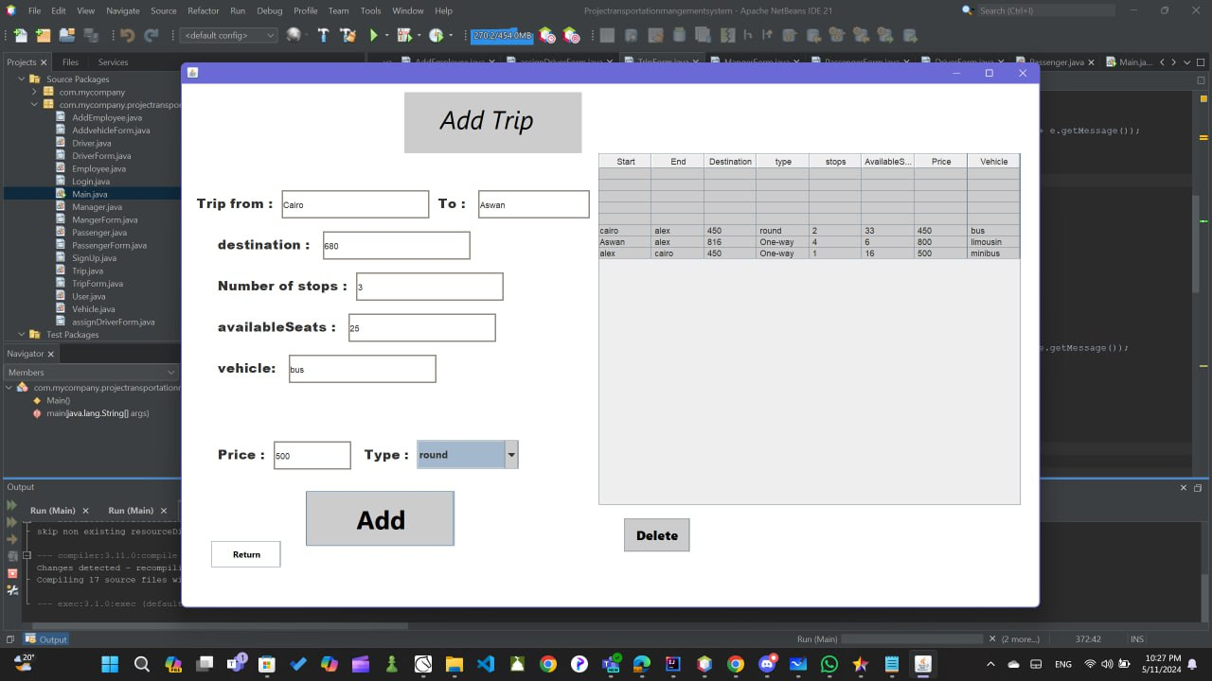Manger can fill information of the trip. If click at will appear this table,

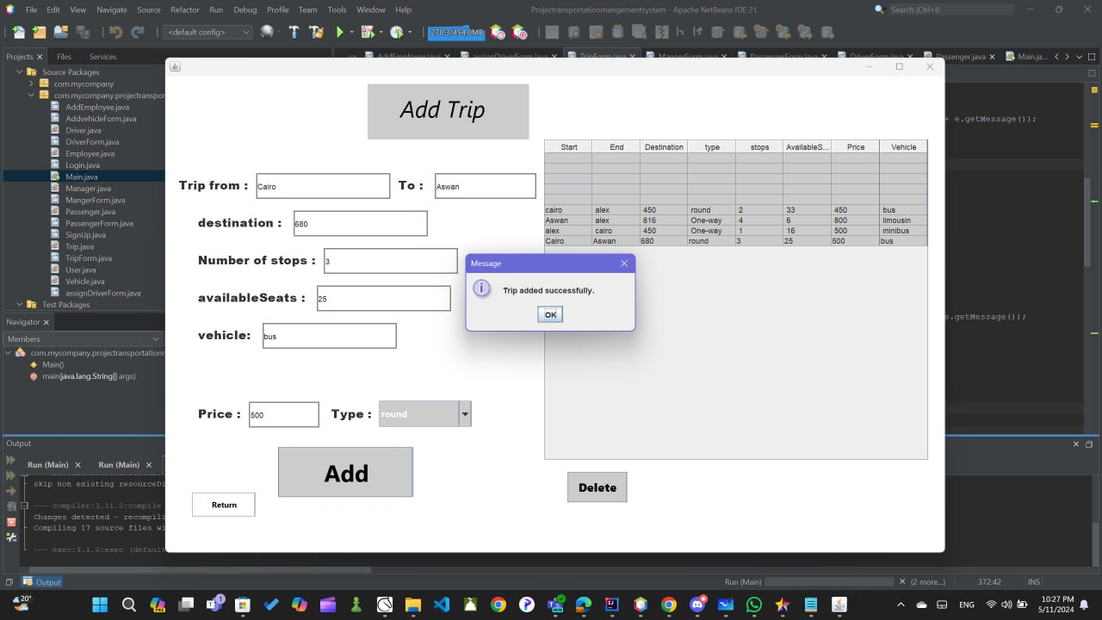

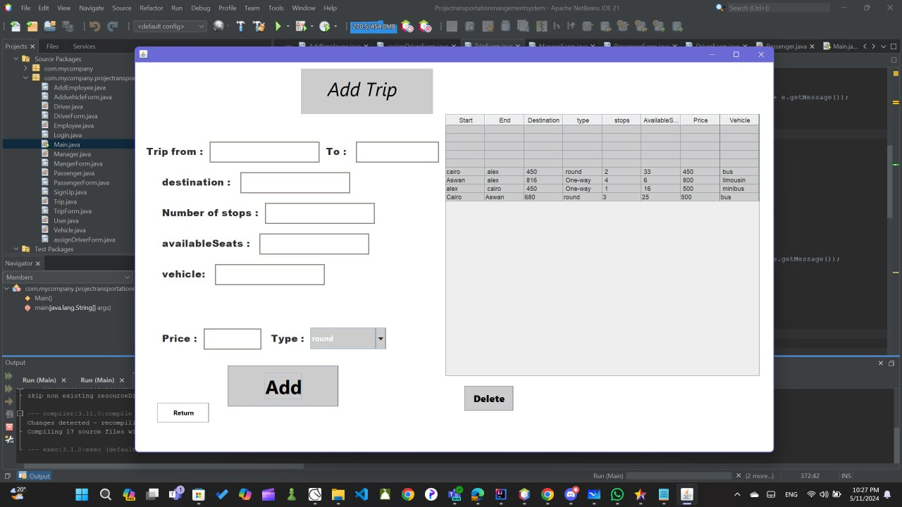

if he select any row and click in delete, trip will delete.

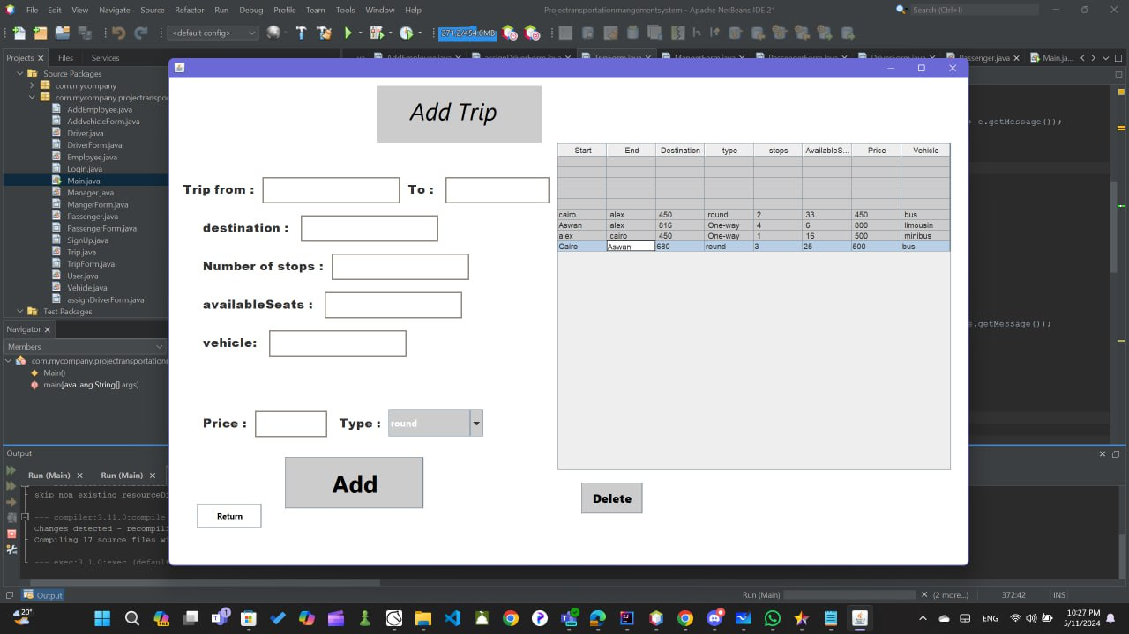

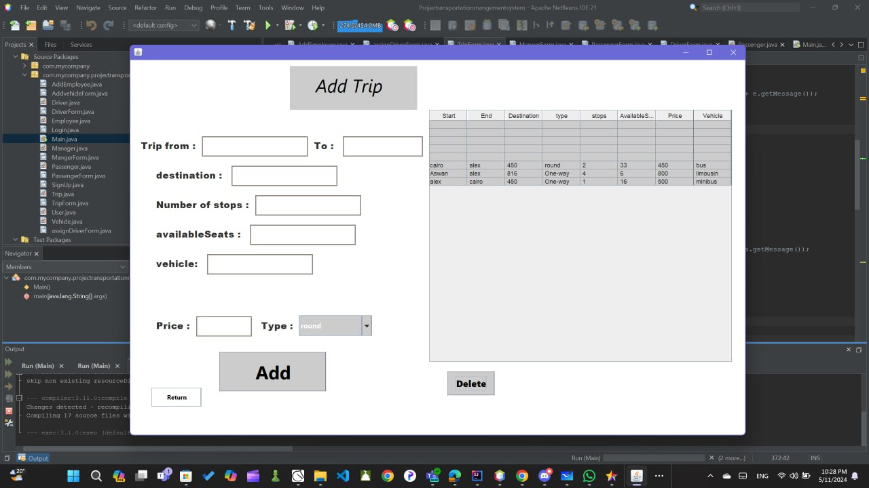

If he click in return button, it will take him to manger window.



If he click in vehicles, will appear its table. And can add or remove any vehicle.

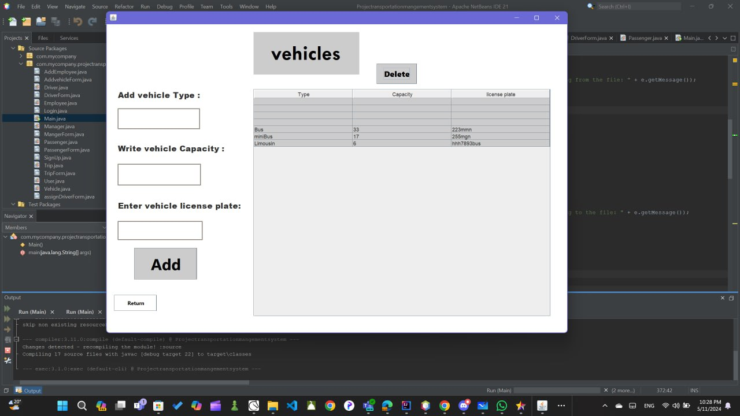

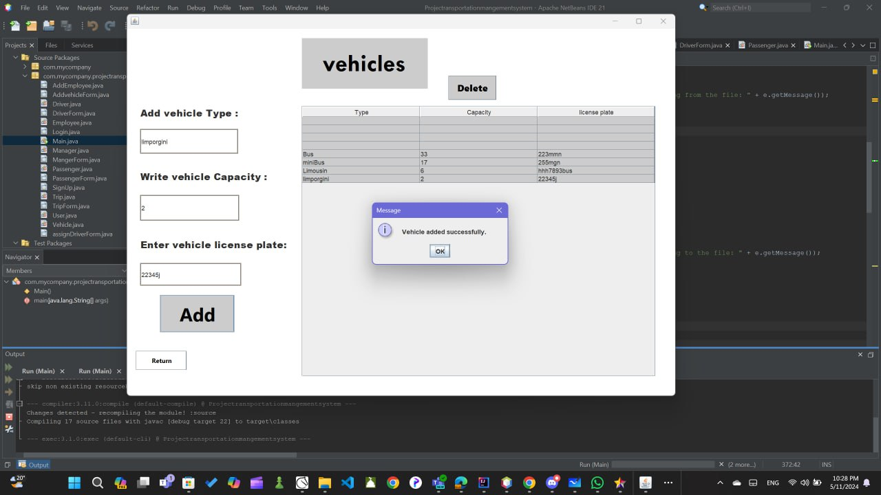

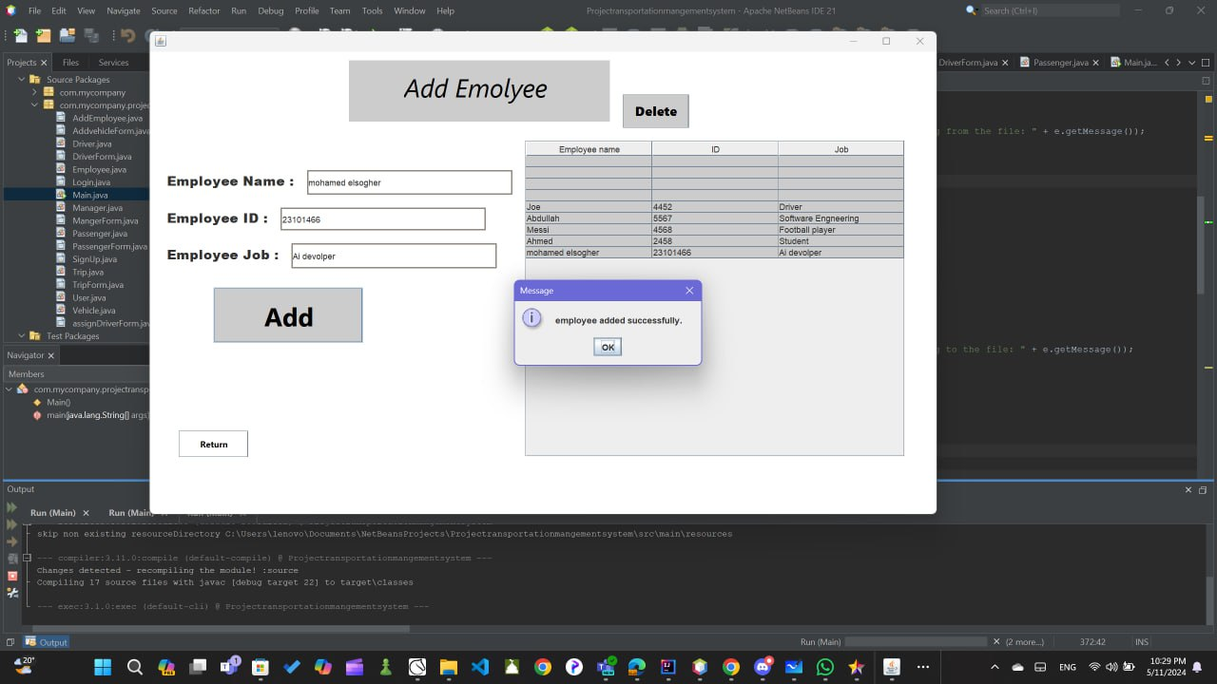If he click in return and back to manger window and click in employee bottom. He cans write information about employee, and click in add it will save in the employee.txt file and he can remove it.

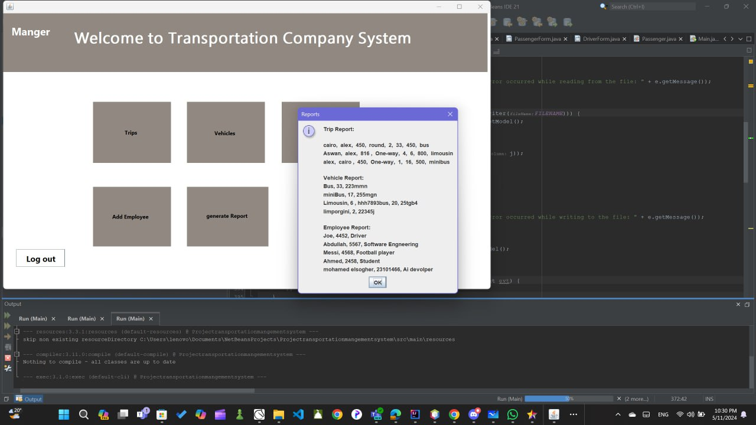If he return to manger window and click to generate report, will appear (trip report, vehicle report, employee report)

In assign driver, he can add any driver with name and ID. If he select any row and click in delete, it will deleted.

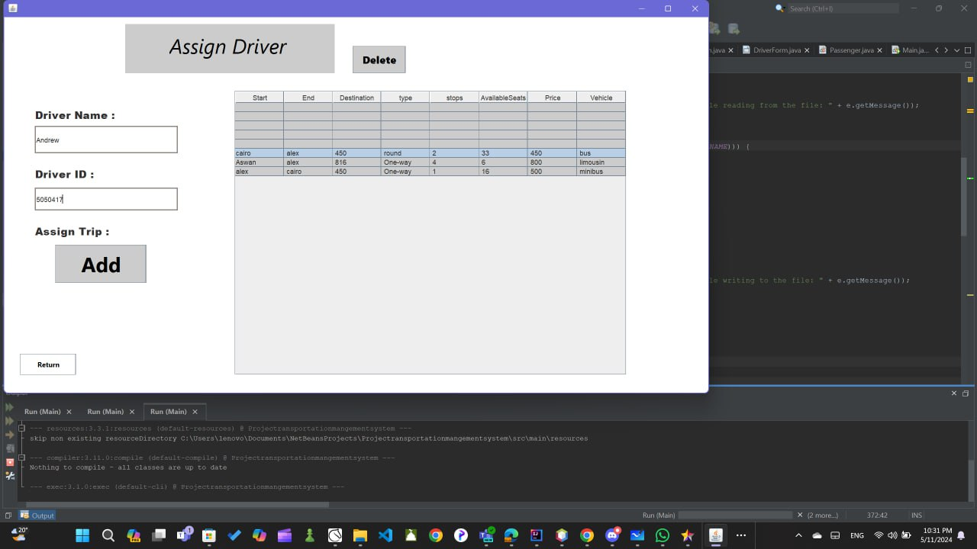

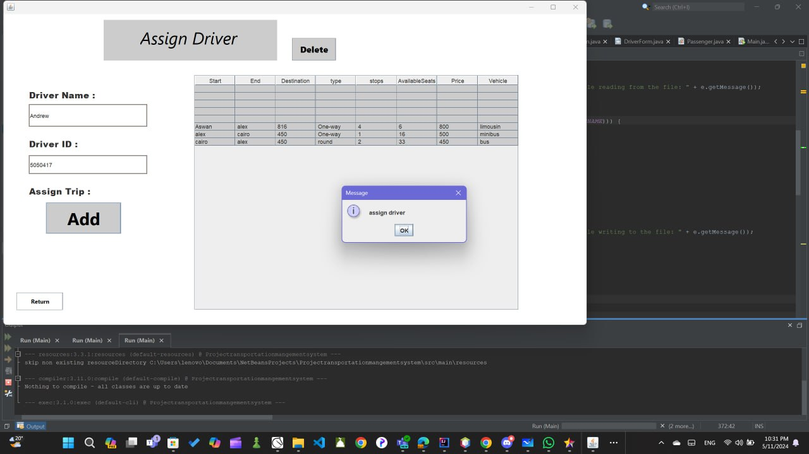

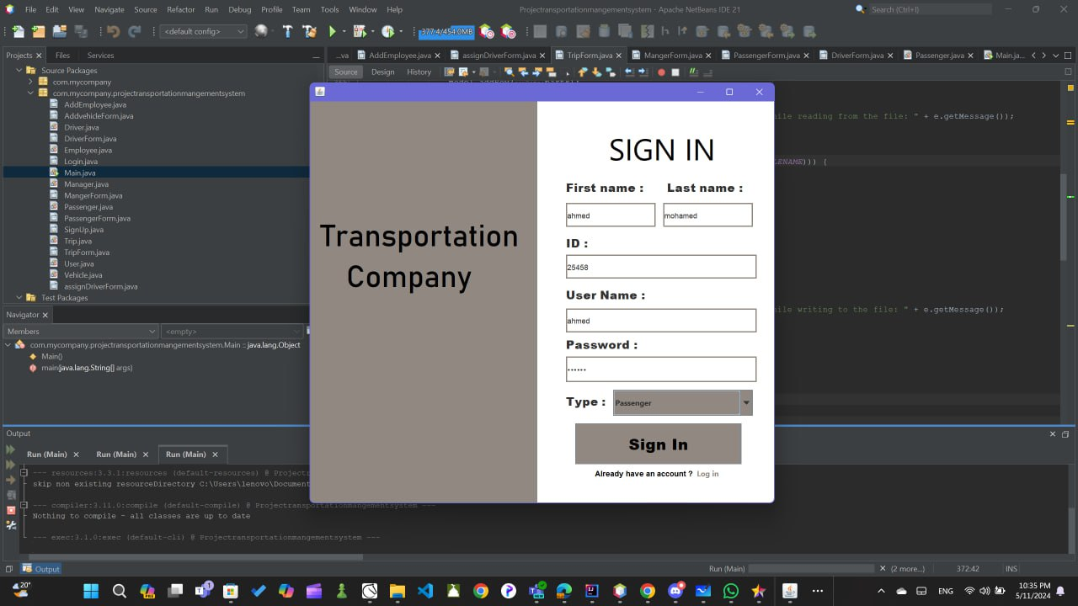If we back to sign in, user can fill his information and sign in like passenger driver and manger.

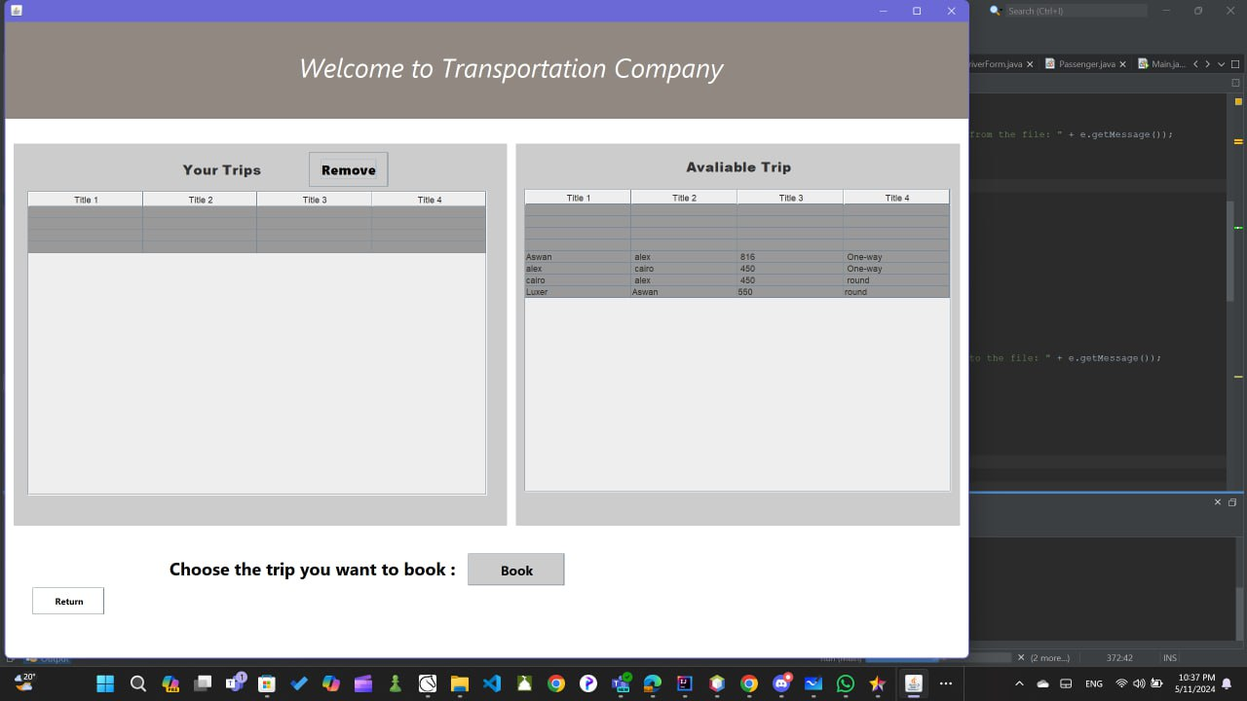If we sign in like a passenger, will appear this window. There are two table: available trips, and booked trips. User can select any row in available trips and click in book then the trip will remove from available trip and appear in booked trip. User can remove book trip from removed bottom.

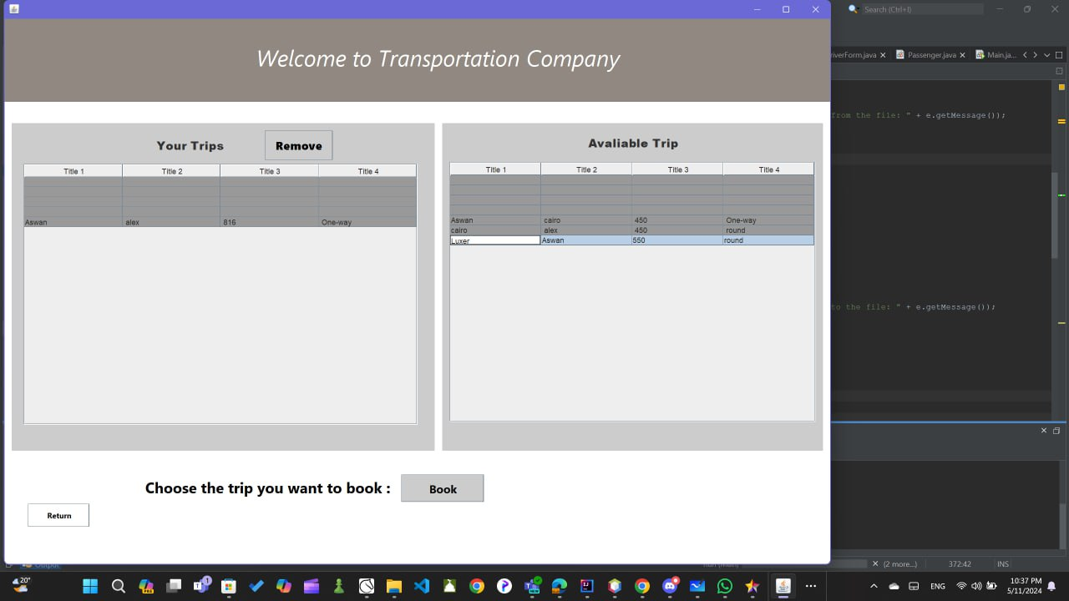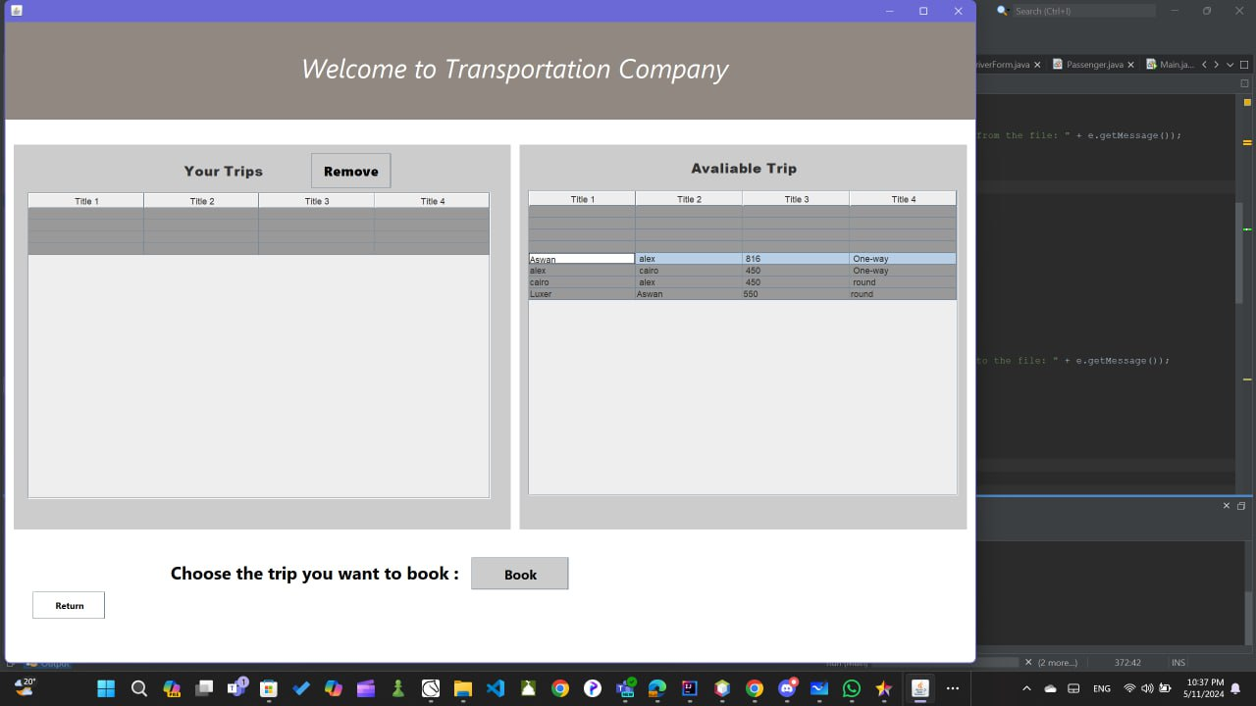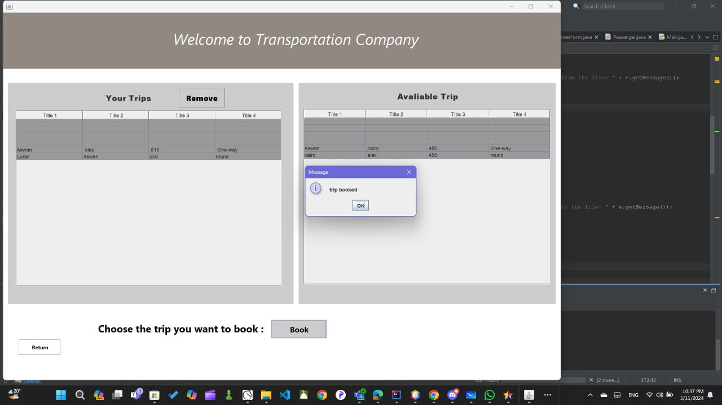

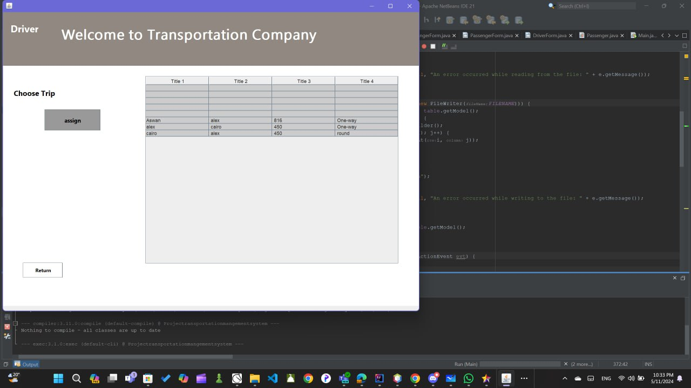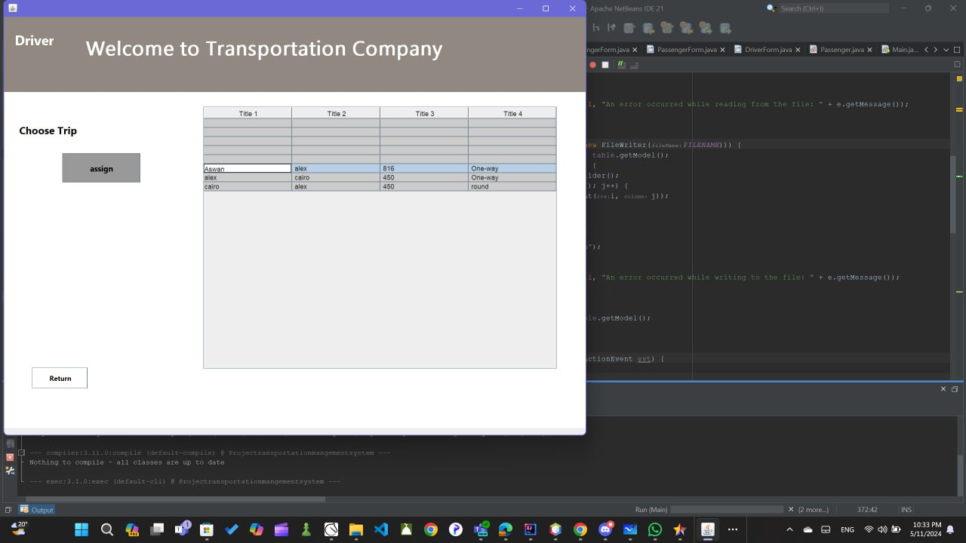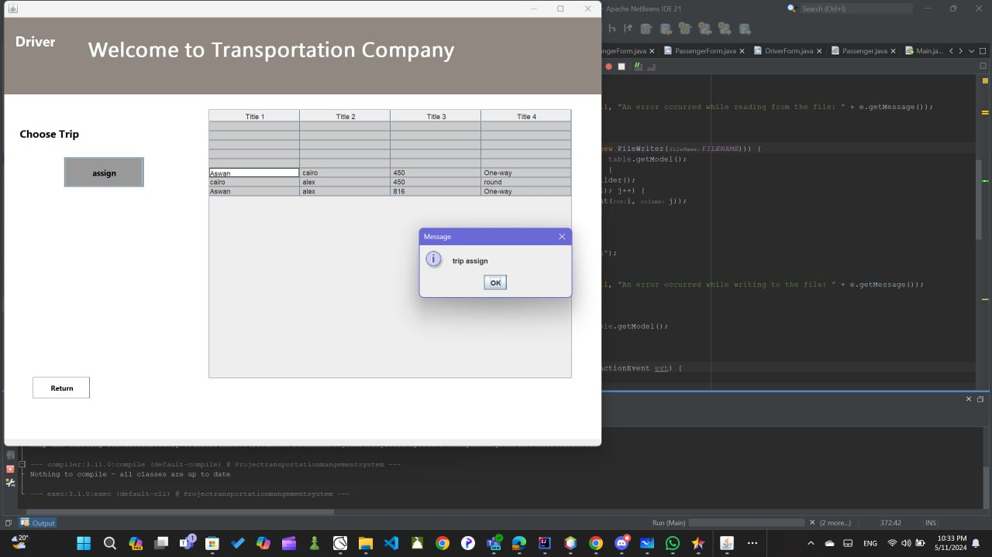If user back and sign in like driver will appear this window. There are table by available trip that was in trip.txt file and driver can choose trip from the row and booked it.

When user log in and user name or password will appear invalid massage and if he sign in or log in and he make anything empty will appear fill all information massage.

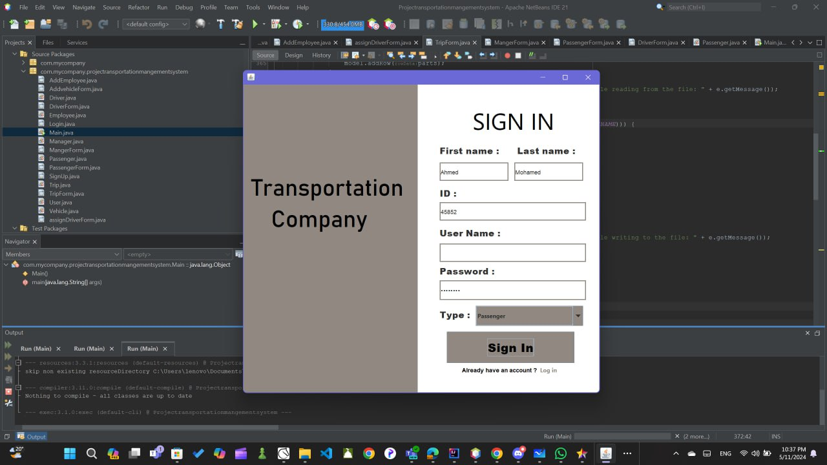

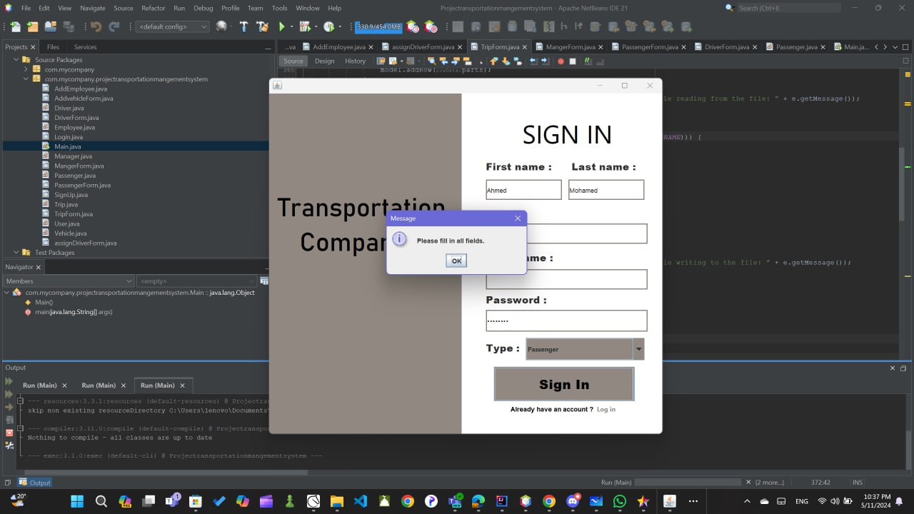

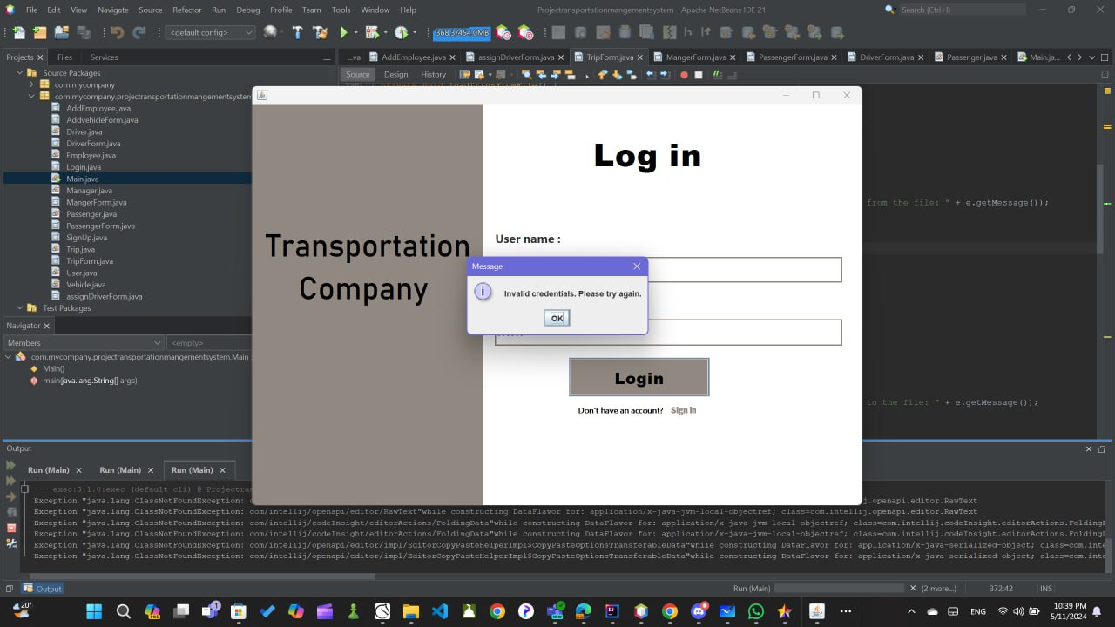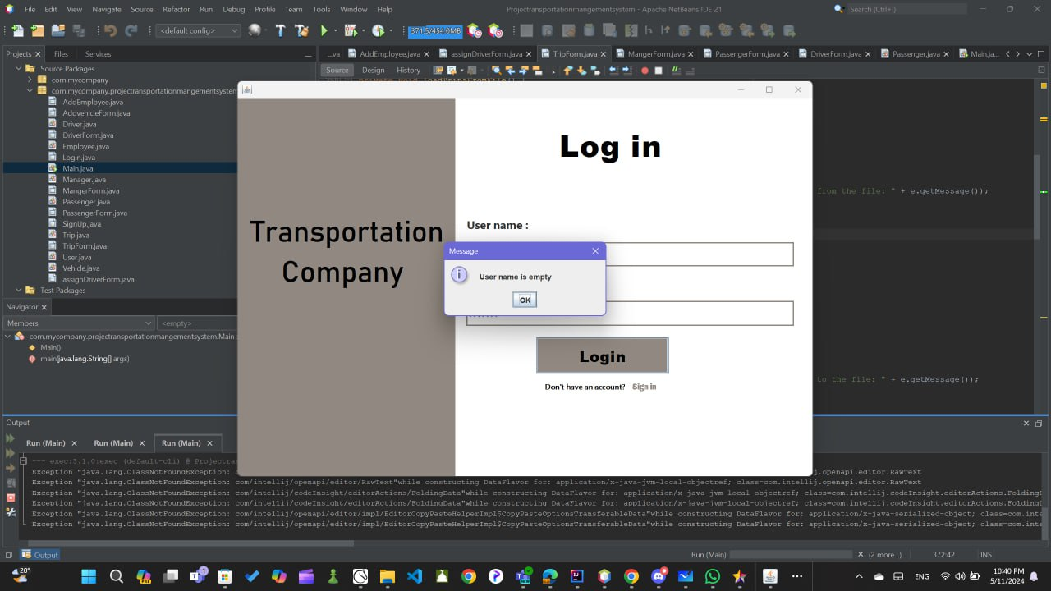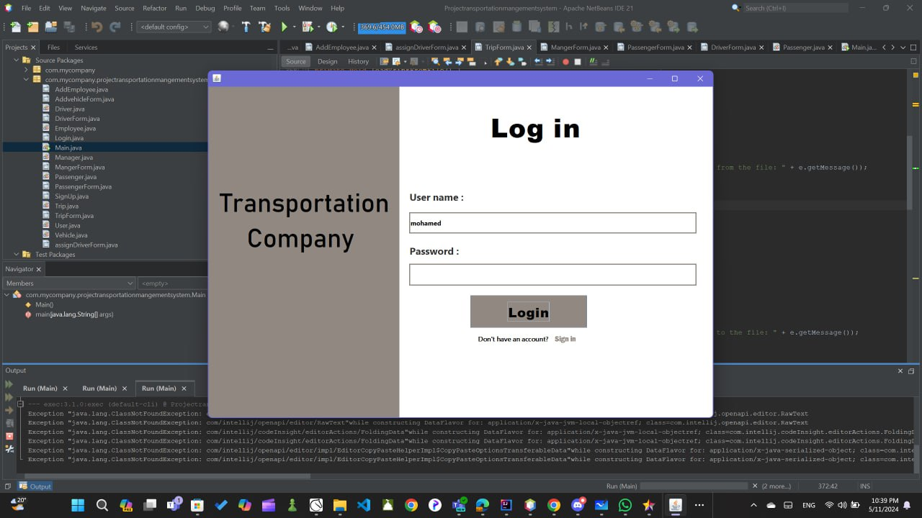

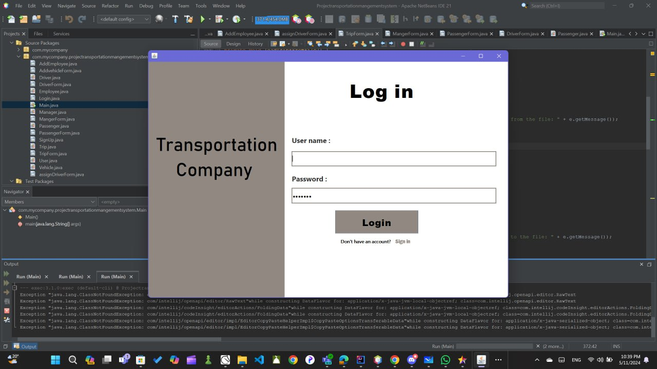

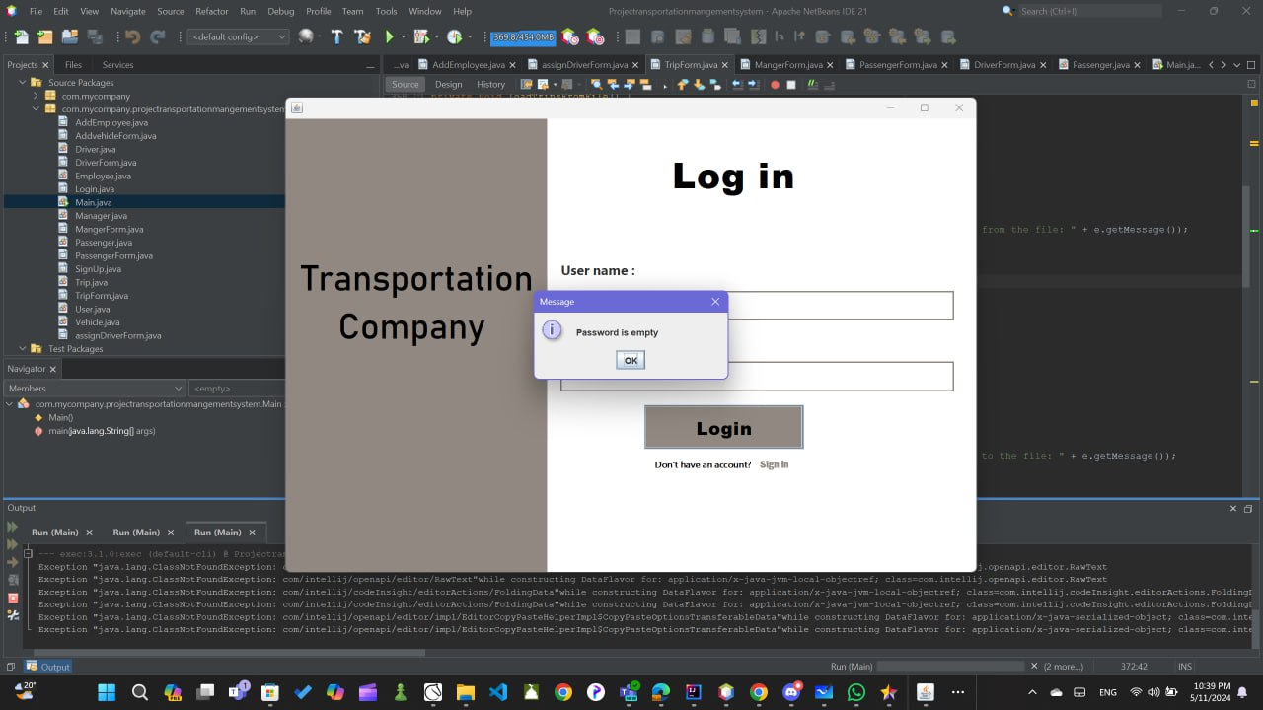

A description about each method :

class user have authenticate method that take boolean and take parameters String user name and password

if user name true and password true it returns true to use this method in Login method we use if rule

, If user name and password true programe will print Login successfully else will print invalid

there are Register that take user name , password , type and Id and will check it in signin class if any

this information empty will show massege to fill all information

Manger class

this class extends to user have an constructor and super take username and password and Id from User class

there are creteVehicle method that make user write type , capacity and license plate and add all this information and return it in new Vehicle to save all this and user addvehicle if there are vehicle with all information to add the same thing with remove you write licensePlate and program will check this license plate and remove it from the system

there are add trip method that take all information of trips and added in new file and when you want to cancel it user will choose the trip and remove it using canceltrip method

there are generateReport This method constructs a report as a String using StringBuilder starts with a Vehicles Report and then iterates over a collection of Vehicle objects, appending each vehicle’s toString() representation to the report. After listing vehicles it adds an Employees Report details of employee (name, ID, and type) and Trips Report show their details (ticket type, start, destination, and price).

The method returns the complete report as a string

selectTrip Method This method is used to select a Trip from a list of available trips

Trip class have getter and setter , constructor and display information of the trip and setDriver that method used to save data of driver in the choosen trip when you use assign driver

vehicle class have an getter and setter and constructor and display information of vehicles

there are isfull method check if the vehicle is full or not

passenger class have bookTrip method that check if there are available seats or not if there are then your trip as passenger will booked else will show you massege that there are not available seats

reviewTickets method that check in book trip what trip you booked and display the all information about that trip