**Online Compiler Link**

[**https://codesandbox.io/p/devbox/agitated-ace-vjf2kd?workspaceId=ws_JQbqGnwrH2NZkuQsobLimv**](https://codesandbox.io/p/devbox/agitated-ace-vjf2kd?workspaceId=ws_JQbqGnwrH2NZkuQsobLimv) **Screenshots**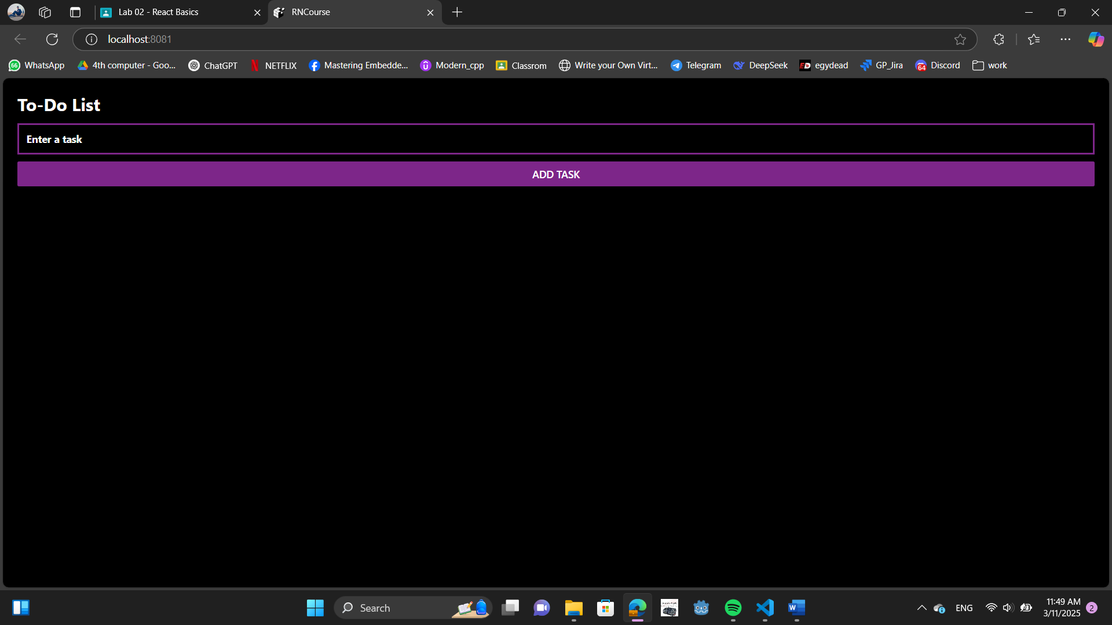

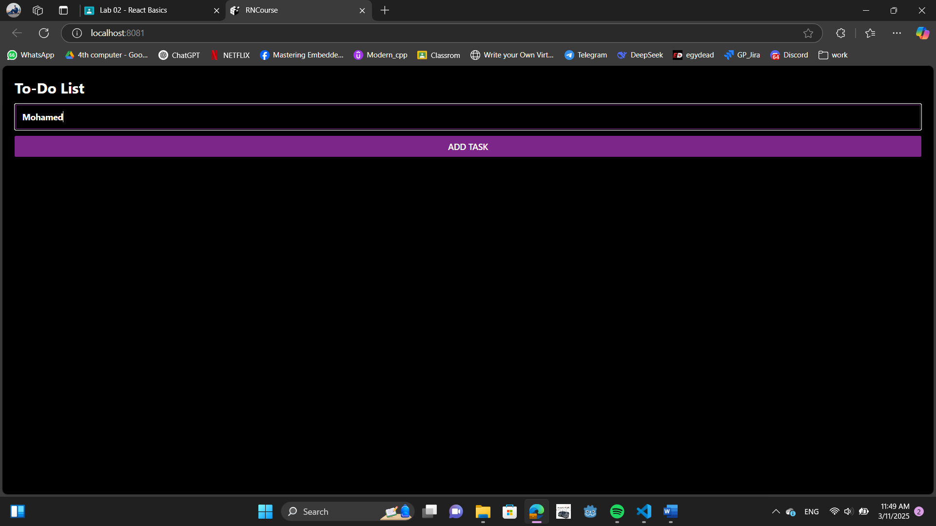

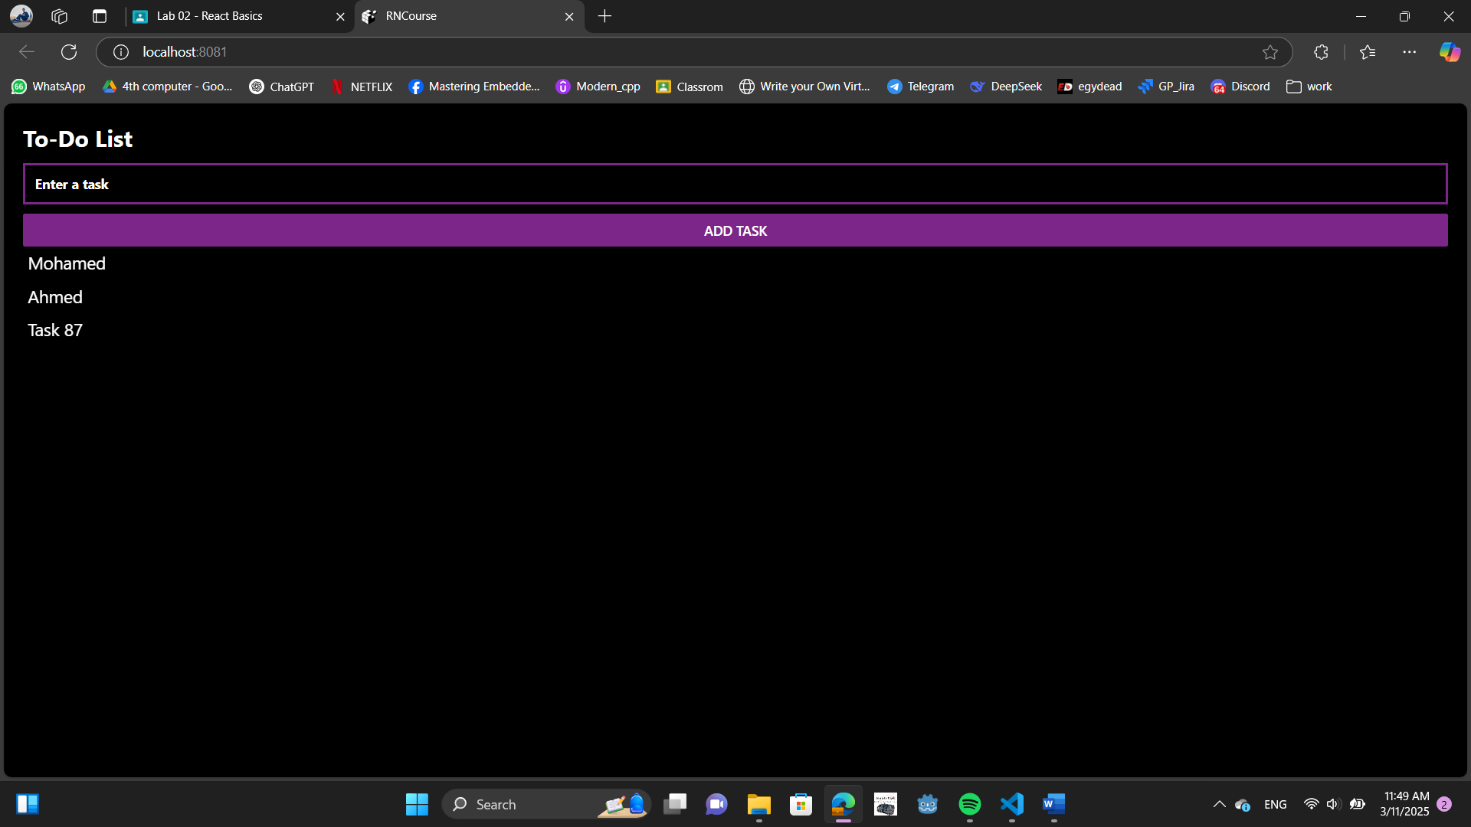

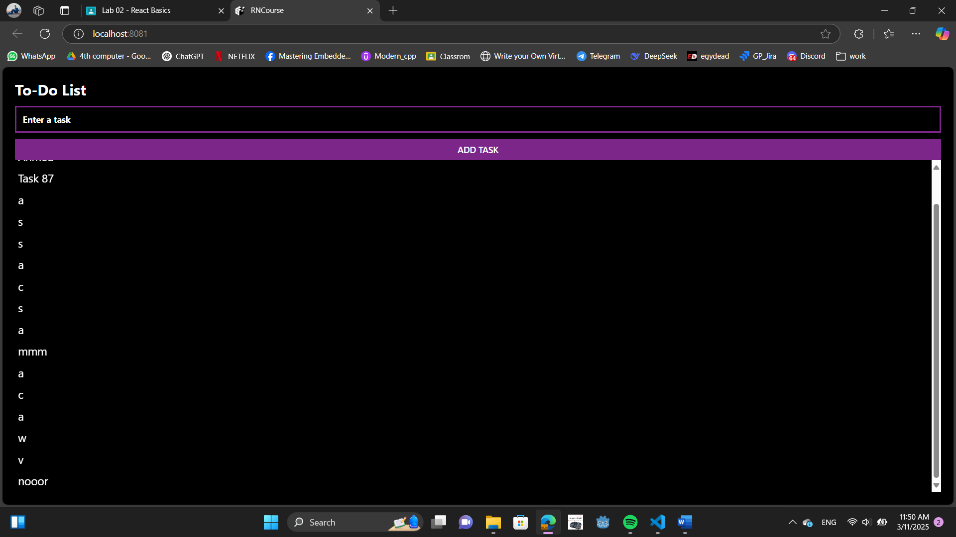

**Code**

import React, { useState } from "react";

import { View, Text, TextInput, Button, FlatList, StyleSheet } from "react-native";

import "react-native";

export default function App() {

  const [task, setTask] = useState(""); // Stores the new task

  const [tasks, setTasks] = useState([]); // Stores the list of tasks

  function addTask() {

    if (task.trim() !== "") { // Avoid empty tasks

      setTasks([...tasks, task]); // Add new task to list

      setTask(""); // Clear input

    }

  }

  return (

    <View style={styles.container}>

      <Text style={styles.title}>To-Do List</Text>

      <TextInput

        style={styles.input}

        placeholder="Enter a task"

        value={task}

        onChangeText={setTask}

      />

      <Button title="Add Task" onPress={addTask} color="#7D2689"/>

      <FlatList

        data={tasks}

        renderItem={({ item }) => <Text style={styles.task}>{item}</Text>}

        keyExtractor={(item, index) => index.toString()}

      />

    </View>

  );

}

const styles = StyleSheet.create({

  container: { flex: 1, padding: 20, justifyContent: "center",backgroundColor:"black" },

  title: { fontSize: 24, fontWeight: "bold", marginBottom: 10,color:"white" },

  input: { borderWidth: 3, padding: 10, marginBottom: 10,borderColor:"#7D2689",color:"white",fontWeight: "bold" },

  task: { fontSize: 18, padding: 5, borderBottomWidth: 1,color:"white" },

});

**Colors & Fonts**

**Colors**

1. violet **#7D2689**

2. white

3. black

**Font:** default