ASSIGNMENT REPORT-2

Submitted by :
Mohamed Fazil [26120142]
Pranav [26120090]

Under the guidance of :
HEMA ARUNACHALAM MURTHY

For The Subject

Pattern Recognition and Machine Learning
(26AI5707)



DEPARTMENT OF COMPUTER SCIENCE & ENGINEERING SHIV NADAR UNIVERSITY
KALAVAKAM

AUGUST 2026
1. INTRODUCTION :
This assignment is about breaking down an image into eigenvalues/eigenvectors and singular values, and then rebuilding it back using only a few of them. The point is to see how much of an image you actually need to keep to still recognise it, and to compare two ways of doing that: Eigenvalue Decomposition (EVD) and Singular Value Decomposition (SVD).
I worked with two images of my cat - one square (512x512) for the EVD + SVD part, and one rectangular (600x450) for the SVD-only part, since EVD only works on square matrices. Both were converted to grayscale first because the decomposition formulas need a single 2D matrix
2. EXPERIMENT STEPS :
Step 1: Load image and convert to grayscale
- Read the image and applied gray = 0.299*R + 0.587*G + 0.114*B.
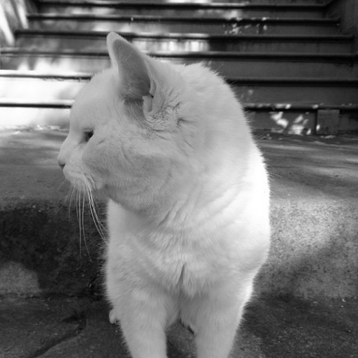
Fig 1: Grayscale square image (512x512) after Step 1
Step 2 — Perform EVD: A = Q Λ Q⁻¹
- Used np.linalg.eig(A) to get the eigenvalues and Q (eigenvectors as columns).
- Took Q_inverse using np.linalg.inv(Q)
- Checked that Q * Lambda * Q_inverse gives back the original A when using all eigenvalues.

Step 3: Choose k, and handle complex eigenvalues
- Picked three k values: 10, 50 and 150
- Since the image matrix is not symmetric, some eigenvalues come out complex, always in conjugate pairs (a+bi and a-bi).
- If only one eigenvalue of a pair is kept, the reconstructed image comes out with leftover imaginary values, which is wrong for a pixel.
- Fixed this by checking: whenever a complex eigenvalue is picked, its exact conjugate partner is pulled in too.
Step 4: Reconstruct with EVD - Ak = Q Lambda_k Q_inverse :
- Set all eigenvalues except the chosen k to zero, then multiplied Q * Lambda_k * Q_inverse.
- Took the real part only, since after keeping full conjugate pairs the imaginary part is just floating point noise.

Step 5: Compute SVD from EVD - A = U Sigma V_transpose :
- Found V from eigenvectors of A_transpose*A, and U from eigenvectors of A*A_transpose.
- Singular values = square root of the eigenvalues of A_transpose*A, clipped at zero first to avoid a negative number under the square root.
- eig() gives eigenvectors with a random sign, so U's sign was fixed to match A*v = sigma*u before using it.

Step 6: Reconstruct with SVD - Ak = U Sigma_k V_transpose :
- Kept only the first k columns of U, first k singular values, first k columns of V, and multiplied them back together.
- No pairing issue here unlike EVD, since singular values are always real and already sorted biggest to smallest.

Step 7: Original, reconstruction and error image :
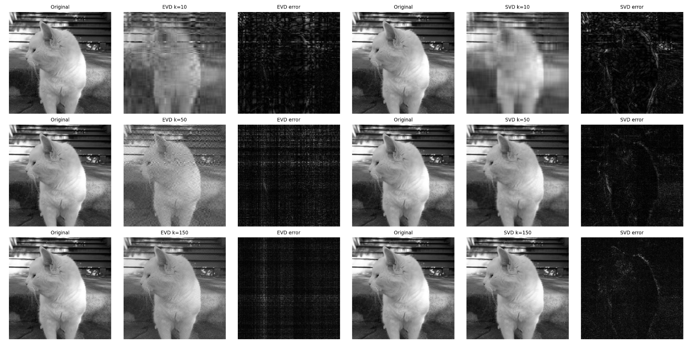
Fig 2: Each row is one k value. Left half is EVD (original, reconstruction, error), right half is SVD (original, reconstruction, error).
- At k=10, EVD reconstruction is barely recognisable and striped. SVD at the same k already shows a rough cat shape.
- At k=150, EVD is closer but still a bit patchy. SVD looks nearly identical to the original.
- EVD's error image still shows a visible grid pattern even at k=150. SVD's error image is close to flat black

Step 8: Frobenius error - E(k) = ||A - Ak||_F
- Computed by subtracting Ak from A, squaring every value, summing them, then taking the square root.
k | EVD E(k) | SVD E(k)
10 | 11649.56 | 6824.41
50 | 8128.10 | 2385.82
150 | 4138.29 | 809.94

Step 9: Error vs k, all k from 1 to 512
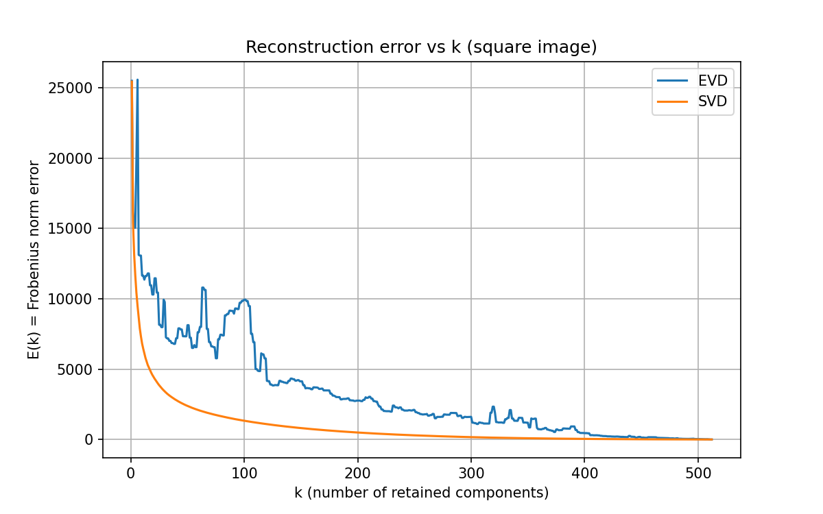
Fig 3: E(k) for every k, EVD (blue) and SVD (orange)
- SVD curve drops off smoothly and flattens near zero well before k=512.
- EVD curve is bumpy - error goes up for a few k values before dropping again, for example around k=60-100. This happens consistently, not just once.
Step 10: Rectangular image - SVD only
- Same Step 1 to Step 6 as above, but only SVD, since EVD does not work on a non-square matrix.
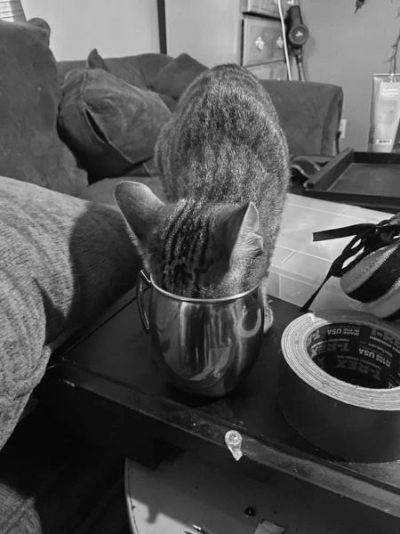
Fig 4: Grayscale rectangular image (600x450)
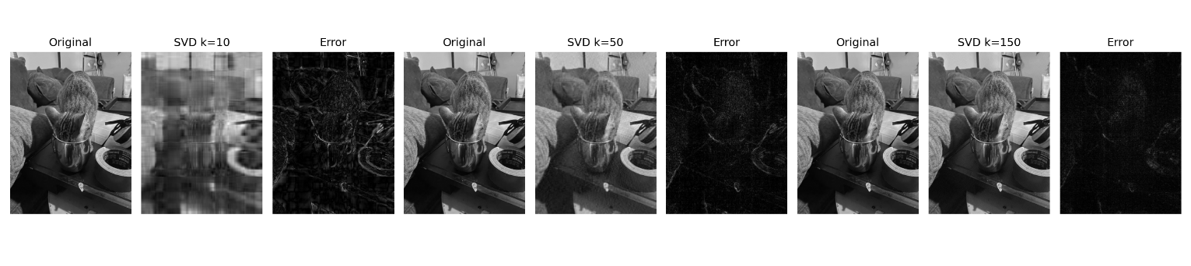Fig 5: SVD reconstruction and error image at k=10, 50, 150
k | SVD E(k)
10 | 10397.45
50 | 4777.32
150 | 1688.02

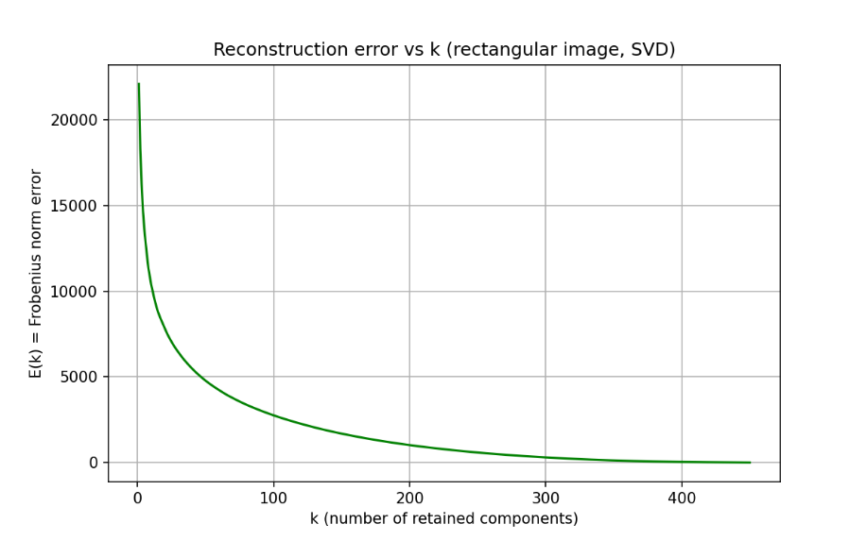
Fig 6: E(k) vs k, rectangular image, k from 1 to 450 (the smaller of the two dimensions)

- Same pattern as the square image - error drops fast at first then flattens, meaning most of the useful information sits in the first few dozen singular values.

3. INFERENCE
3.1 What I learned
- SVD reconstructs better than EVD at the same k.
- Reason: singular values are ranked by actual energy contribution (Eckart-Young theorem says truncated SVD is the best possible rank-k approximation). Eigenvalues of a non-symmetric matrix have no such guarantee.
- Most of an image's information sits in a small number of components. k=150 out of 512 already gets SVD very close to the original.
- The shape of the error curve itself tells you that, SVD's smooth drop is expected for an optimal method. EVD's up-and-down curve shows it is not optimal.
3.2 Edge cases I ran into
- Complex eigenvalues in EVD: the image matrix is not symmetric, so np.linalg.eig can return complex eigenvalues. They always show up in conjugate pairs. Splitting a pair while picking top-k leaves imaginary leftovers in the reconstruction. Fixed by always pulling in the conjugate partner together, even if k ends up one higher than asked.
- Near-zero singular values: a few eigenvalues of A_transpose*A came out as tiny negative numbers from floating point rounding, which breaks sqrt(). Clipped them to zero first.
- k bigger than rank: if k goes past the number of non-zero singular values, reconstruction just equals the original and error stays flat near zero.
4. CONCLUSION
- SVD is the better method for image reconstruction here, both by eye and by the Frobenius numbers.
- This matches the theory - SVD always gives the optimal rank-k approximation, EVD does not.
- Both images only needed a small fraction of their full rank to look close to the original, which is the whole point of low-rank approximation.

