ASSIGNMENT REPORT-4
Submitted by :
Mohamed Fazil [26120142]
Pranav [26120090]
Under the guidance of :
HEMA ARUNACHALAM MURTHY
For The Subject
Pattern Recognition and Machine Learning
(26AI5707)
DEPARTMENT OF COMPUTER SCIENCE & ENGINEERING
SHIV NADAR UNIVERSITY
KALAVAKAM
SEPTEMBER 2026

1. INTRODUCTION :
- The assignment is to generate Gaussian random variables and study the effect of different covariance matrices.
- Gaussian samples were generated using the formula given in Assignment 1.
- The generated data was analysed using mean, covariance, eigenvalues and eigenvectors.
- Constant density curves were plotted to observe the spread and direction of the data.

2. EXPERIMENT STEPS :
A. GAUSSIAN DATA GENERATION :
- Two uniform random values u1 and u2 were generated in the range [-1, 1].
s = u₁² + u₂², 0 < s < 1
k = √(-2 ln(s) / s)
x = u₁k, y = u₂k
- The standard Gaussian values were shifted to the required mean using x' = μ + σx.

B. COVARIANCE TRANSFORMATION :
- The generated two-dimensional data was transformed to obtain the required covariance.
Y = μ + Σ¹ᐟ²(X - μ)
- The square root of covariance was obtained from its eigenvalues and eigenvectors.
Σ¹ᐟ² = QΛ¹ᐟ²Qᵀ

C. MEAN, COVARIANCE AND EIGEN ANALYSIS :
- The sample mean and covariance matrix were calculated from the generated points.
Σ = (1/N)(X - μ)ᵀ(X - μ)
- Eigenvalues give the amount of spread along the principal directions.
- Eigenvectors give the direction of the major and minor axes.

3. PROBLEM 1 – ISOTROPIC COVARIANCE :
- Mean used: μ = [2, 3].
- Covariance used: Σ = [[1, 0], [0, 1]].
- Both variables have equal variance and zero covariance.
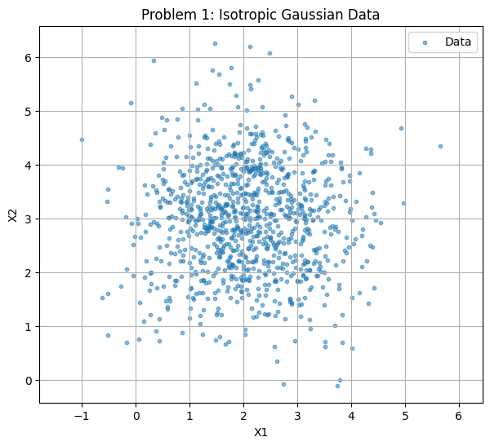
Figure 1 : Isotropic Gaussian Data
- The points are distributed around the mean (2, 3).
- The spread is nearly the same in X1 and X2 directions, giving a circular cloud.
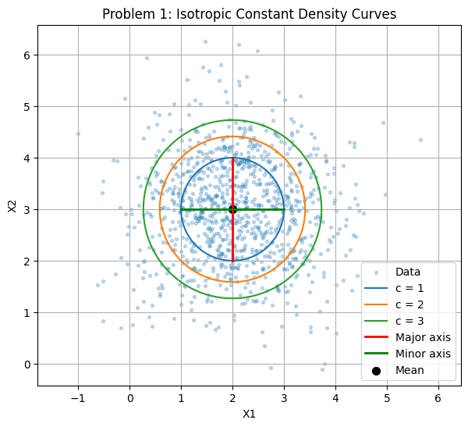
Figure 2 : Isotropic Constant Density Curves
- The density curves for c = 1, 2 and 3 are concentric circles around the mean.
- Both covariance eigenvalues are 1, so the major and minor semi-axis lengths for c = 1 are both 1.
- The equal eigenvalues confirm that there is no preferred direction of spread.
4. PROBLEM 2 – DIAGONAL COVARIANCE :
- Mean used: μ = [2, 3].
- Covariance used: Σ = [[1, 0], [0, 4]].
- The variance along X2 is four times the variance along X1.
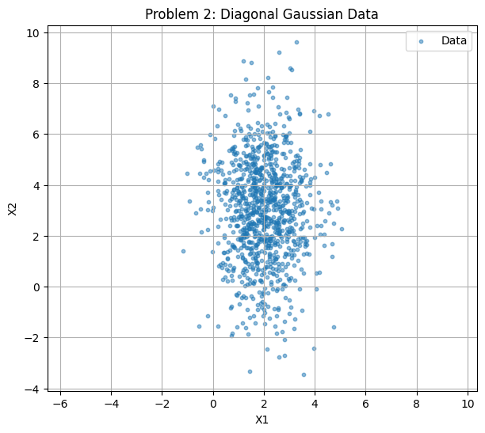
Figure 3 : Diagonal Gaussian Data
- The points remain centered near (2, 3), but the distribution is stretched vertically.
- There is no tilt because the off-diagonal covariance values are zero.
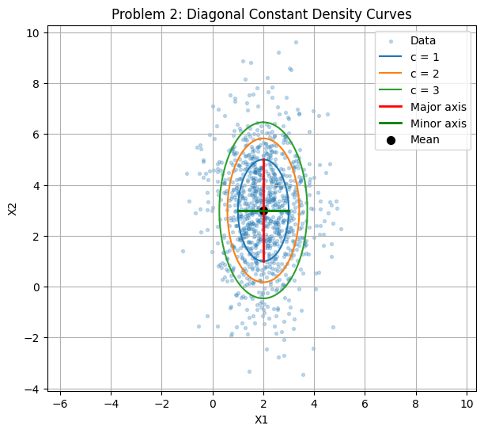
Figure 4 : Diagonal Constant Density Curves
- The constant density curves are vertical ellipses.
- The eigenvalues are 4 and 1, giving semi-axis lengths 2 and 1 for c = 1.
- The larger eigenvalue along X2 explains the larger vertical spread.
5. PROBLEM 3 – FULL COVARIANCE :
- Mean used: μ = [2, 3].
- Covariance used: Σ = [[4, 1.5], [1.5, 1]].
- The non-zero off-diagonal terms introduce correlation between X1 and X2.
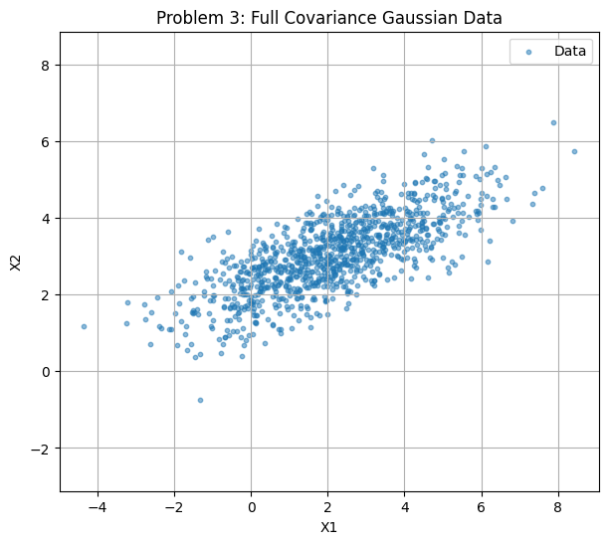
Figure 5 : Full Covariance Gaussian Data
- The data forms a tilted elliptical cloud around the mean.
- As X1 increases, X2 also tends to increase, showing positive correlation.
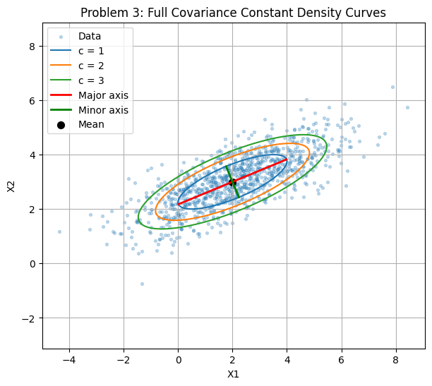
Figure 6 : Full Covariance Constant Density Curves
- The density ellipses are rotated in the direction of the data spread.
- The covariance eigenvalues are approximately 4.62 and 0.38.
- For c = 1, the corresponding semi-axis lengths are approximately 2.15 and 0.62.
- The major eigenvector follows the long direction of the tilted data cloud.
6. PROBLEM 4 – TWO GAUSSIAN CLASSES :
- Two Gaussian classes ω1 and ω2 were generated to observe the effect of changing mean and covariance.
- The class means used in the experiments are μ1 = [0, 0] and μ2 = [5, 5].
A. EXPERIMENT 1 – SAME COVARIANCE :
- Both classes use Σ1 = Σ2 = [[1, 0], [0, 1]].
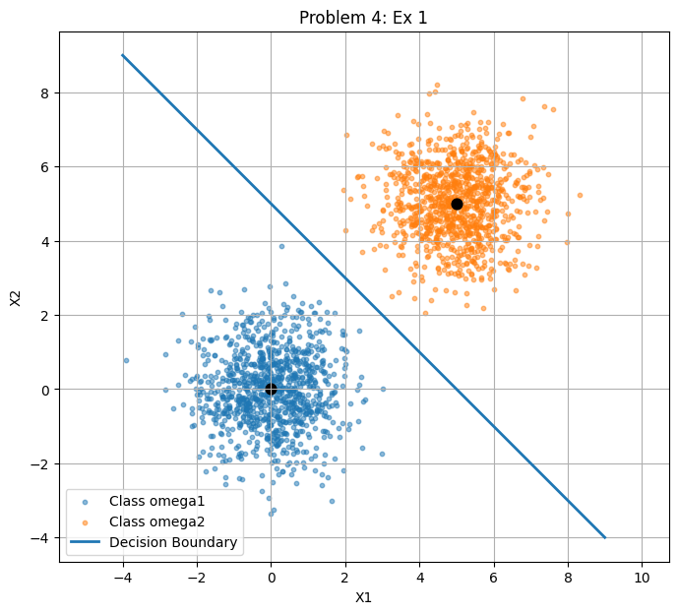
Figure 7 : Two Gaussian Classes with Same Covariance
- Both classes have almost circular and equal spread.
- The class centers are clearly separated at approximately (0, 0) and (5, 5).
- For equal covariance and equal priors, the decision boundary is linear.
- The plotted boundary x1 + x2 = 5 lies between the two class centers.

B. EXPERIMENT 2 – DIFFERENT VARIANCE :
- Class ω1 uses Σ1 = [[1, 0], [0, 1]].
- Class ω2 uses Σ2 = [[4, 0], [0, 1]].
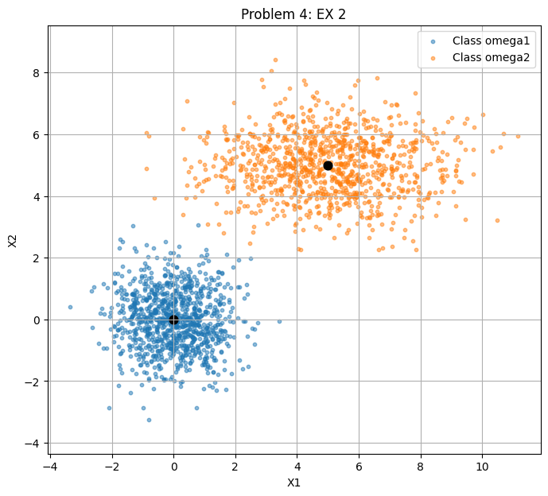
Figure 8 : Two Gaussian Classes with Different Variance
- Class ω1 remains nearly circular around (0, 0).
- Class ω2 is wider along X1 because its X1 variance is 4.
- The unequal covariance matrices give the two classes different shapes.

C. EXPERIMENT 3 – CORRELATED COVARIANCE :
- Class ω1 uses Σ1 = [[2, 1], [1, 2]].
- Class ω2 uses Σ2 = [[2, -1], [-1, 2]].
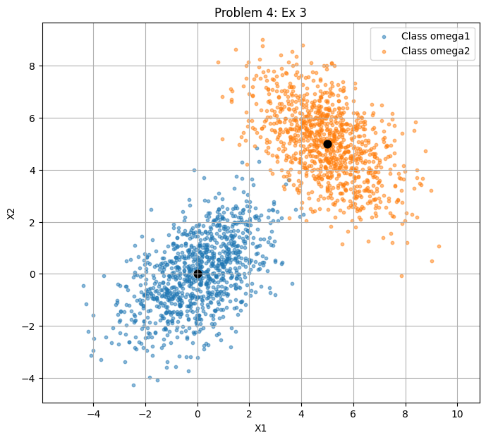
Figure 9 : Two Gaussian Classes with Correlated Covariance
- Class ω1 has positive correlation and tilts upward from left to right.
- Class ω2 has negative correlation and tilts downward from left to right.
- Both covariance matrices have eigenvalues 3 and 1, but their principal directions are different.
- This shows that covariance controls both the spread and orientation of each class.
7. INFERENCE :
- The generated samples follow the required mean and covariance patterns.
- Isotropic covariance gives a circular distribution with equal spread in all directions.
- Diagonal covariance gives an axis-aligned ellipse when the variances are different.
- Full covariance gives a rotated ellipse because the variables are correlated.
- Eigenvalues determine the spread along the principal axes and eigenvectors determine their directions.
- Changing the mean changes the position of a Gaussian class, while changing covariance changes its shape and orientation.
- For two classes with equal covariance, the observed decision boundary is linear; changing the covariance changes the geometry of the class distributions.

