We already have:
- ✅ OpenStack (IaaS)
- ✅ Heat (orchestration of infrastructure)
Now you want:
- 🐳 Docker
- ⚙️ Kubernetes
- 🤖 Ansible
- 🎯 Deploy your application
Let’s design this properly — like an engineer, not a student.
Big Picture Architecture
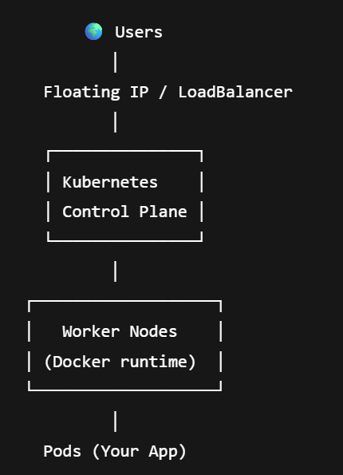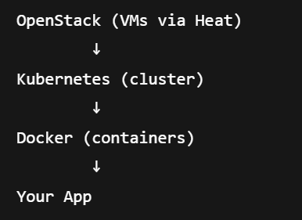
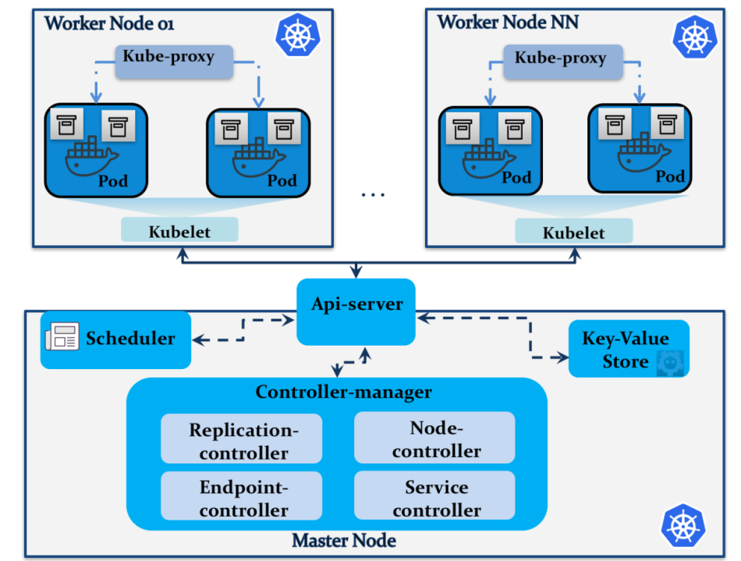
1️⃣ OpenStack (Infrastructure Layer)
- Creates VMs
- Creates networks
- Provides floating IPs
- Provides volumes (Cinder)
You use Heat to automate this.
2️⃣ Ansible (Configuration Layer)
Ansible will:
- Install Docker
- Install Kubernetes (kubeadm)
- Initialize cluster
- Join worker nodes
- Deploy your app
Ansible = automation brain 🧠

3️⃣ Docker (Container Runtime)
- Builds images
- Runs containers
- Used by Kubernetes
Kubernetes does NOT replace Docker — it orchestrates it.
4️⃣ Kubernetes (Orchestration Layer)
- Schedules pods
- Manages scaling
- Handles services
- Handles load balancing
PHASE 1 — Infrastructure (OpenStack + Heat)
Step 1
Create VMs using Heat:
- 1 controller VM (k8s-master)
- 2 worker VMs
Example topology:
VM | Role
k8s-master | Control plane
k8s-worker1 | Worker
k8s-worker2 | Worker
Each VM:
- 2 vCPU
- 4GB RAM (minimum)
- Ubuntu 22.04

PHASE 2 — Configuration (Ansible)
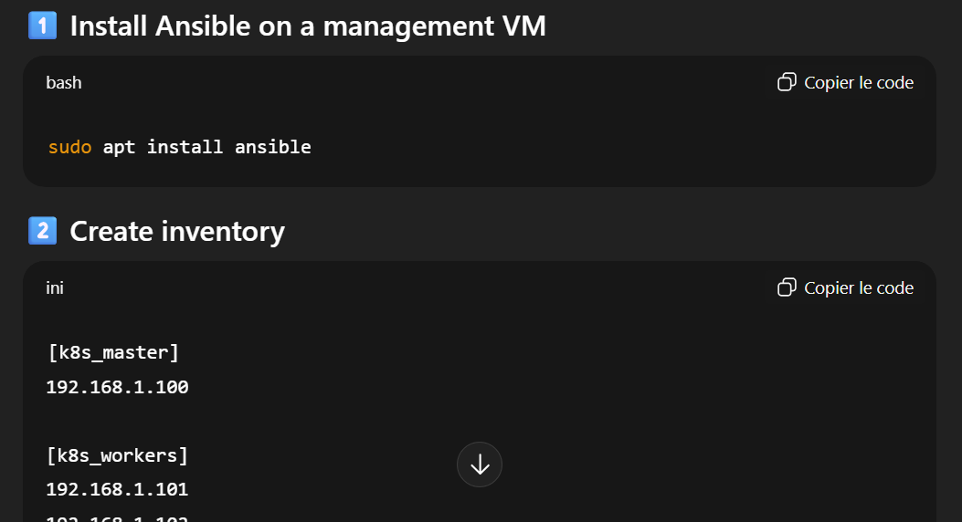

PHASE 3 — Install Docker (via Ansible)
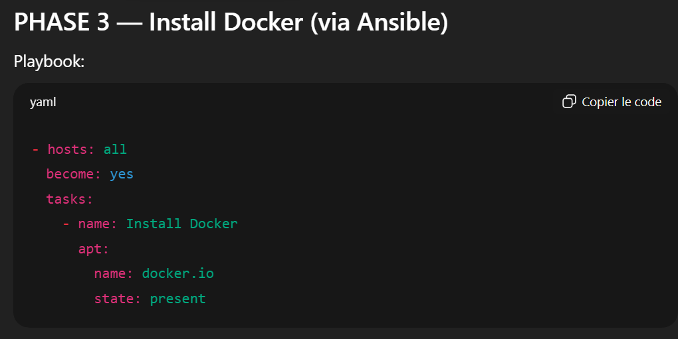
PHASE 4 — Install Kubernetes (kubeadm method)
Kubernetes is a distributed control system that manages containerized workloads across multiple nodes.
🔶 Control Plane (Master Node)
Component | Role
kube-apiserver | Entry point (REST API)
etcd | Cluster database
kube-scheduler | Assigns pods to nodes
kube-controller-manager | Maintains cluster state
🧠 API Server
Central entry point.
All components talk to it.
🧠 etcd
Cluster database.
Stores everything (pods, nodes, configs).
🧠 Scheduler
Chooses which worker runs a pod.
🧠 Controller Manager
Ensures desired state = real state.
Recreates pods if they crash.
🔶 Worker Node
Component | Role
kubelet | Talks to control plane
kube-proxy | Handles networking rules
container runtime | Runs containers (containerd)
Pods | Your workloads

⚙️ kubelet
Agent on each node.
Receives instructions from API server.
Starts containers.
🌐 kube-proxy
Handles networking.
Routes traffic to pods.
🐳 Container Runtime
Runs containers (containerd).
📦 Pod
Smallest deployable unit.
Contains 1+ containers.

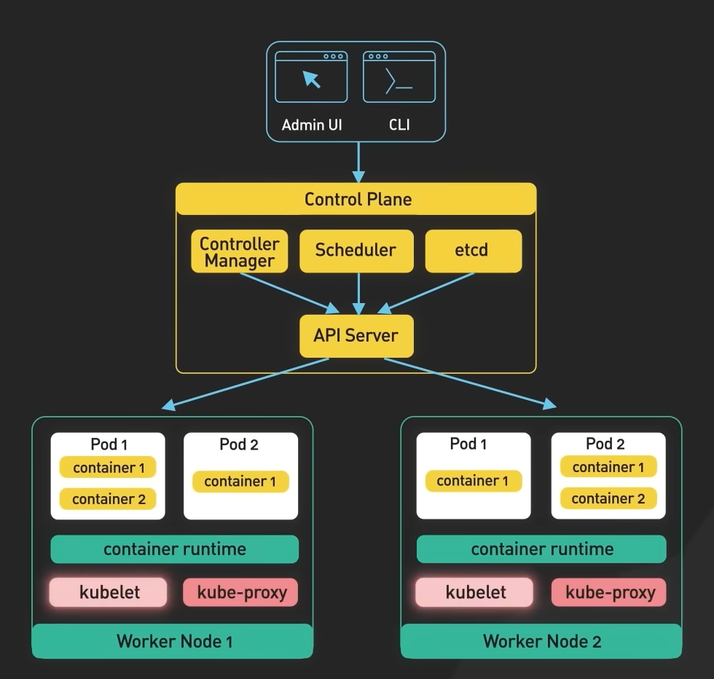
Calico = CNI (Container Network Interface)
It lives in the network layer of the cluster, mainly on worker nodes.
🧠 What Calico does
- Gives IP addresses to pods
- Enables pod-to-pod communication
- Enforces Network Policies
- Handles routing between nodes
Without Calico:
- Pods cannot talk to each other ❌ AND No cluster networking ❌

Where is Helm?

🔑 Helm = Package Manager for Kubernetes
It does NOT run inside the cluster like Calico.
It runs:
- On your admin machine
- Or inside CI/CD
comme apt in UBUNTO

