let's define some specific requirements for the soil moisture thresholds based on a hypothetical scenario:

1. **Type of Plants**: Let's say we're growing tomatoes in a greenhouse.

2. **Soil Type**: The soil in the greenhouse is a loamy soil, which retains moisture well but still allows for good drainage.

3. **Climate Conditions**: The greenhouse is located in a temperate region with moderate sunlight and occasional rainfall.

4. **Irrigation System**: We have a drip irrigation system installed in the greenhouse, which allows for precise control over water delivery.

Based on these requirements, we can suggest some values for the soil moisture thresholds:

1. **Lower Threshold**: We want to trigger irrigation when the soil moisture level drops to a point where the plants may start experiencing water stress but before they reach a critical level. Let's set the lower threshold at 30% soil moisture content. This will ensure that the plants receive water before they experience significant stress.

2. **Upper Threshold**: We want to stop irrigation when the soil moisture level has reached a point where further watering could lead to waterlogging or reduced oxygen availability to the roots. Let's set the upper threshold at 60% soil moisture content. This will allow the soil to dry out slightly between watering cycles and prevent over-saturation.

With these specific requirements, the irrigation system will trigger when the soil moisture falls below 30% and stop when it rises above 60%, ensuring that the tomato plants receive adequate water without being over-watered. Adjustments may be necessary based on actual observations and plant responses over time.

How did I made this system control:

Firstly : I get the moisture through a sensor and check if it is lower than 0.3 then my system will make the pump work.  
And if it exceeds 0.6 the pump will stop.

I will activate a subsystem to make a counter to use this counter Later to subtract it from Irrigation time.

And I take the result and check if it reaches zero the pump will turn off , else the pump will run.

And the way I calculate the Irrigation time is using this look up table:

Difference (Soil Moisture Level) Irrigation Time (secondss)

0 0

0.1 2.5

0.2 5

0.3 7.5

0.4 10

0.5 12.5

0.6 15

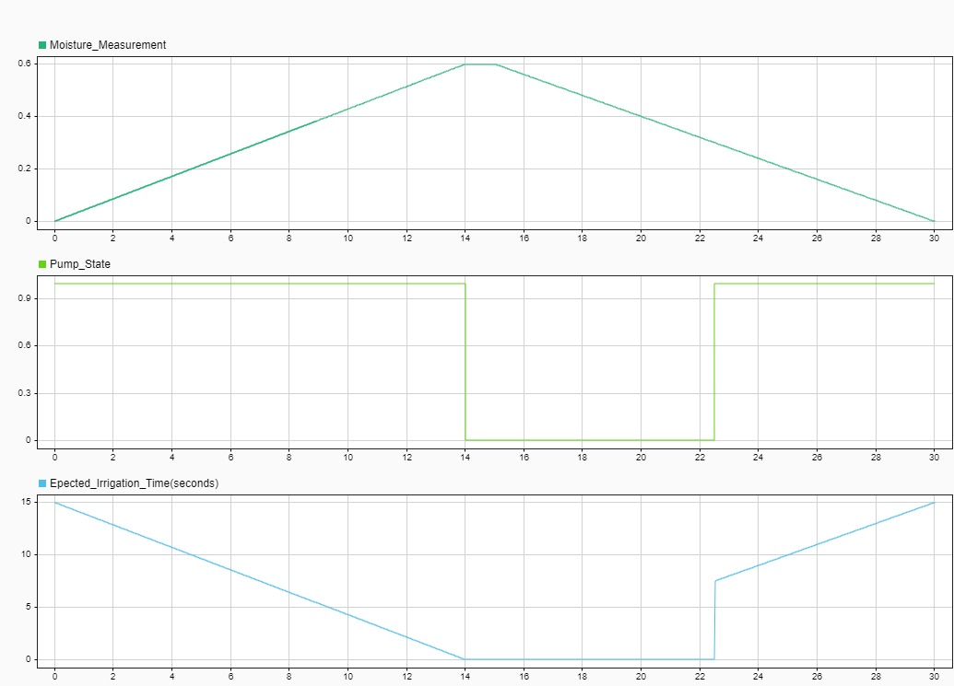If the moisture exceeds 0.6 off course , the system won’t work.  
And I tested my model at begging the moisture is 0 then the system will make the pump till the moisture reaches 0.6 then stop after some seconds ( The irrigation Time).  
I get this result :   
The Difference state is 1 till 1200 seconds as we haven’t reached 0.6 yet and become zero after 1200 seconds so do the pump.

All system :

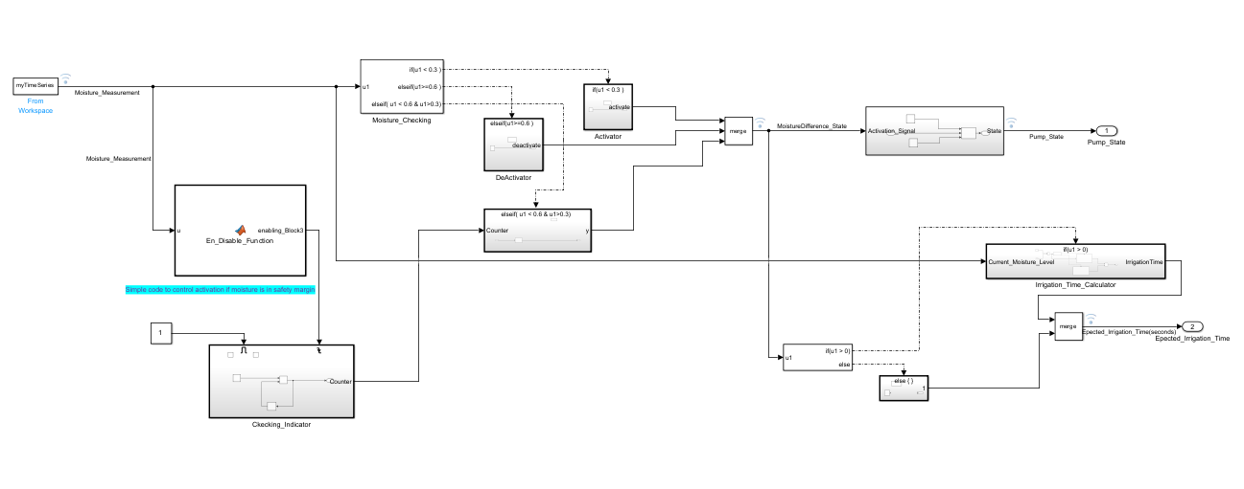  
Irrigation_Time Subsystem :

