**PL/SQL:-**

**Exercise - 1:**

BEGIN

FOR rec IN (

SELECT c.customer_id, l.loan_id

FROM customers c

JOIN loans l ON c.customer_id = l.customer_id

WHERE c.age > 60

) LOOP

UPDATE loans

SET interest_rate = interest_rate - 1

WHERE loan_id = rec.loan_id;

END LOOP;

FOR rec IN (SELECT customer_id FROM customers WHERE balance > 10000) LOOP

UPDATE customers

SET isvip = 'Y'

WHERE customer_id = rec.customer_id;

END LOOP;

FOR rec IN (

SELECT l.loan_id, c.name, l.due_date

FROM loans l

JOIN customers c ON l.customer_id = c.customer_id

WHERE l.due_date BETWEEN SYSDATE AND SYSDATE + 30

) LOOP

DBMS_OUTPUT.PUT_LINE('Reminder: Loan ID ' || rec.loan_id ||

' for customer ' || rec.name ||

' is due on ' || TO_CHAR(rec.due_date, 'DD-Mon-YYYY'));

END LOOP;

COMMIT;

END;

/

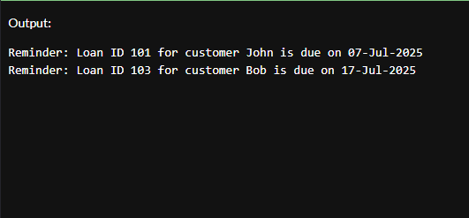

**Exercise - 3**

CREATE OR REPLACE PROCEDURE ProcessMonthlyInterest IS

BEGIN

UPDATE ACCOUNTS

SET Balance = Balance + (Balance * 0.01)

WHERE UPPER(AccountType) = 'SAVINGS';

DBMS_OUTPUT.PUT_LINE(SQL%ROWCOUNT || ' savings accounts updated with interest.');

COMMIT;

END;

/

CREATE OR REPLACE PROCEDURE UpdateEmployeeBonus (

p_Department IN VARCHAR2,

p_BonusPercent IN NUMBER

) IS

BEGIN

UPDATE EMPLOYEES

SET Salary = Salary + (Salary * p_BonusPercent / 100)

WHERE UPPER(Department) = UPPER(p_Department);

DBMS_OUTPUT.PUT_LINE(SQL%ROWCOUNT || ' employees in ' || p_Department || ' got a ' || p_BonusPercent || '% bonus.');

COMMIT;

END;

/

CREATE OR REPLACE PROCEDURE TransferFunds (

p_FromAccountID IN NUMBER,

p_ToAccountID IN NUMBER,

p_Amount IN NUMBER

) IS

v_FromBalance NUMBER;

BEGIN

SELECT Balance INTO v_FromBalance

FROM ACCOUNTS

WHERE AccountID = p_FromAccountID

FOR UPDATE;

IF v_FromBalance < p_Amount THEN

RAISE_APPLICATION_ERROR(-20001, 'Insufficient balance in source account.');

END IF;

UPDATE ACCOUNTS

SET Balance = Balance - p_Amount

WHERE AccountID = p_FromAccountID;

UPDATE ACCOUNTS

SET Balance = Balance + p_Amount

WHERE AccountID = p_ToAccountID;

DBMS_OUTPUT.PUT_LINE('Transferred ' || p_Amount || ' from account ' || p_FromAccountID || ' to account ' || p_ToAccountID);

COMMIT;

END;

/

