# Abstract:

LZ77 Class:

# Compress method:

Decompress:

# Main:

# Test cases:

## Test 1:

for ABAABABAABBBBBBBBBBBBA in main.txt, compressed in c.txt and decompressed in d.txt

c.txt:

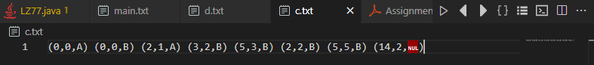

d.txt:



Original size = 22*8 =176 bits

Tag size=4+3+8=15 bits / tag

Compressed size = 15*8 = 120bits

## Test 2:

for DABRADABRAD same process as the first case

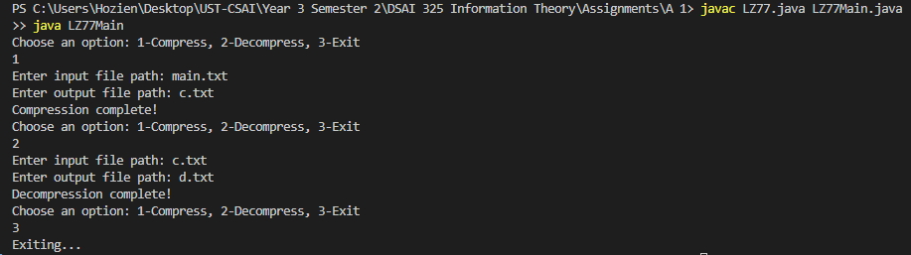

c.txt:

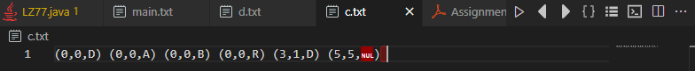

d.txt:



Original size = 8*11 = 88 bits

Tag size = 3 + 3 + 8 = 14 bits / tag

Compressed size = 14 * 6 = 84 bits

# Handling repetitive sequence:

### Testing on AAAAABBBBBAAAAABBBBBAAAAABBBBB





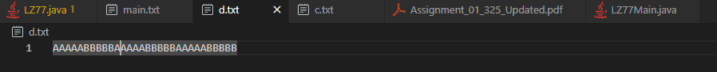

Original size = 30 * 8 = 240 bits

Tag size = 4 + 4 + 8 = 16 bits / tag

Compressed size = 16*7 = 112 bits

So, it can handle repetitive sequence by looking ahead by 15 characters, and I noticed when I increase the lookahead buffer, the tag size increases.