|  |  |
| --- | --- |
| 10 gm | RF Module |
| 12 gm | GPS |
| 7 gm | Arduino nano |
| 15 gm | MPU 6050 |
| 2.49 gm | DHT 11 |
| 0.95 gm | BMB 180 |
| 2 gm | SD Card |
| 44 gm  85 gm | Battery 1:  Battery 2: |

Total Weight in Sensors :  
In case of battery 1 :93.44 gm  
In case of battery 2: 134.44 gm   
  
Total weight with PCB chips :  
  
2 chips:7.6 gm

3 chips: 11.39 gm

|  |  |  |
| --- | --- | --- |
| 3 chips | 2chips | Battery\chips |
| 104.83gm | 101.04gm | Battery1 |
| 145.83gm | 142.34gm | Battery2 |

Battery 1 :

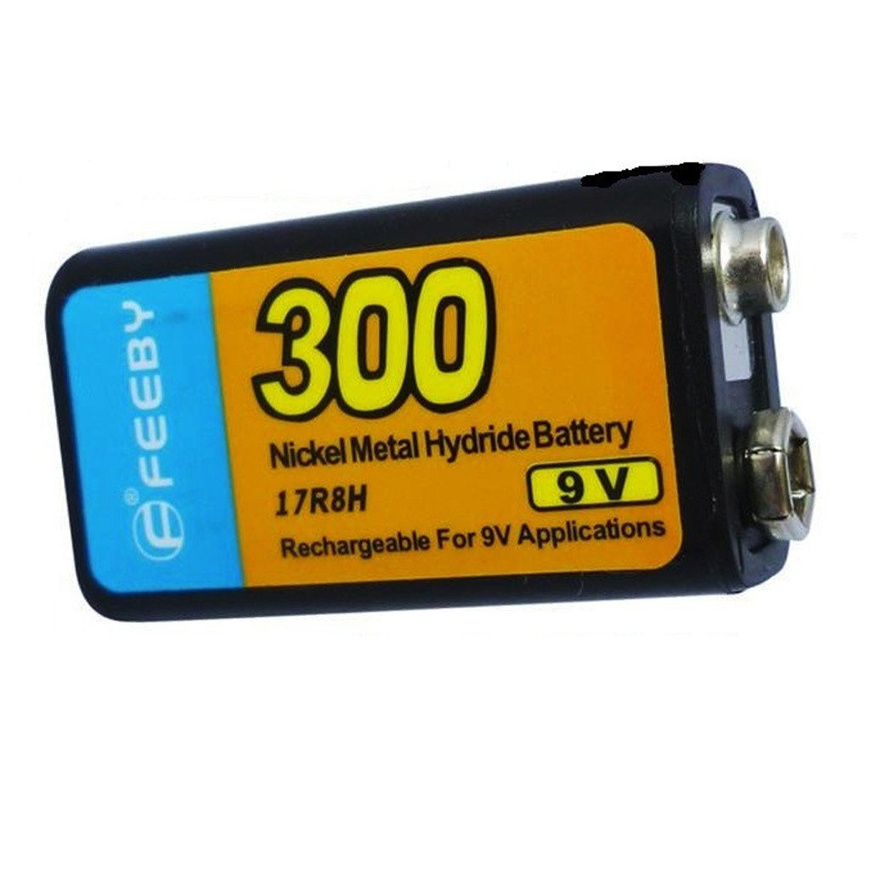

**Specifications**

* Voltage: 9V
* Capacity: 300mAh
* Size: 45*25*15 mm
* Weight: 44g
* Battery 2:  
  7.4V 2-cell pack

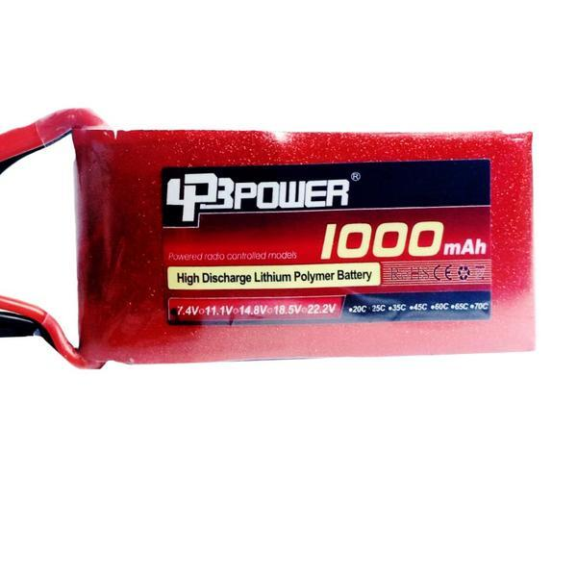

* 1000mAh of charge
* 25C continuous discharge rate
* JST-XH charge plug
* Dean's Connector discharge plug
* Dimensions: 56mm x 28mm x 18mm  
    
  Dimensions increase compared to the first battery :  
  L+20 mm

W+3mm

H+3mm

- Preferable to use battery2 with 2 chips ,Yet this is to be determined by structure team ,They must check if that weight + weight of the structure would be less or equal to 350 gm [Max Weight for Cansat]

-------------------------------------------------------------  
To charge LIPO [Lithium ion polymer battery]:  
We stick to CC/CV which means constant current and constant voltage.  
This can be performed by a power supply :  
<https://www.youtube.com/watch?v=0yhbof6_s64>  
  
Charging with :  
**Constant current** : 1C means 1 * Capacity of battery ,In our case it will equal to   
1000mA (1 ampere)  
**Constant voltage : 4.2V [For safety]**

**We can also use this charger for a better safety :   
https://store.fut-electronics.com/products/imax-b6-balance-charger-lipo-li-ion-ni-mh-nicd-life-50w?_pos=4&_sid=a8344bdee&_ss=r**