

**Faculty of engineering - Shoubra**

**Benha University**

**Research Project**

In fulfillment of the requirements of

|  |  |
| --- | --- |
| **Department** | Engineering Mathematics and Physics |
| **Division** | ---------- |
| **Academic Year** | 2019-2020 Preparatory |
| **Course name** | Computer |
| **Course code** | ECE001 |

Title: -

Build a website on recent computer engineering topics

By:

|  |  |  |  |
| --- | --- | --- | --- |
|  | Name | Edu mail | B.N |
| 1 | Mohamed Ahmed Saad Qurtam | muhammed195717@feng.bu.edu.eg | 645 |

**GitHub-link:**  <https://github.com/Mohamed-Qurtam/ECE001>

**GitHub-page (published-website):** <https://mohamed-qurtam.github.io/ECE001/>

**Approved by:**

|  |  |
| --- | --- |
| Examiners committee | Signature |
| Dr. Ahmed Bayoumi |  |
| Dr. Shady Elmashad |  |
| Dr. Abdelhamid Attaby |  |

**Research objectives**

**Build a simple HTML website about Big Data**

**Literature Review**

**Big Data:**

Big Data is a new term given to a diverse field of data-intensive computer science in which the databases are so broad that they are impossible to work efficiently with. The concept has been used predominantly in two ways, firstly as a technical challenge when dealing with data-intensive domains such as high-energy physics, astronomy or internet search, and secondly as a sociological question when gathering and extracting data about us from companies such as Facebook, Twitter, cell phone companies, retail chains and governments. We look at this second issue from a new viewpoint in this paper, namely how the consumer can gain knowledge of the personally important aspect of Big Data that is publicly accessible on the social network. The amount of user-generated media uploaded to the web is increasingly expanding, and seeing which media impacts our privacy is beyond any human's capacity to sift through all of it. Based on a social media analysis in Flickr, Locr, Facebook and Google+, we discuss the implications of privacy and the potential of the emerging trend of geo-tagged social media. We then present a framework that helps users to remain updated about which aspects of the Big Data social deluge are important to them.[1]

Source code

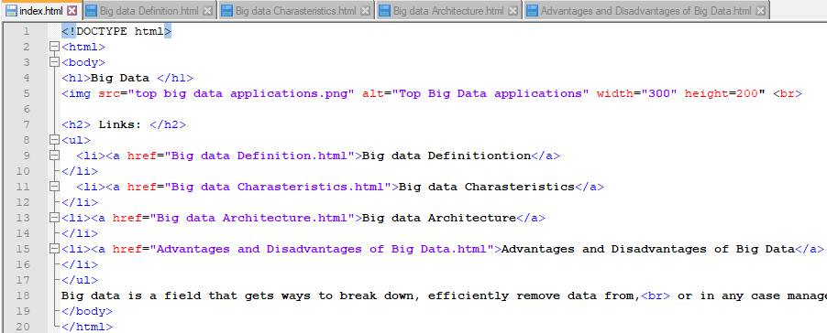

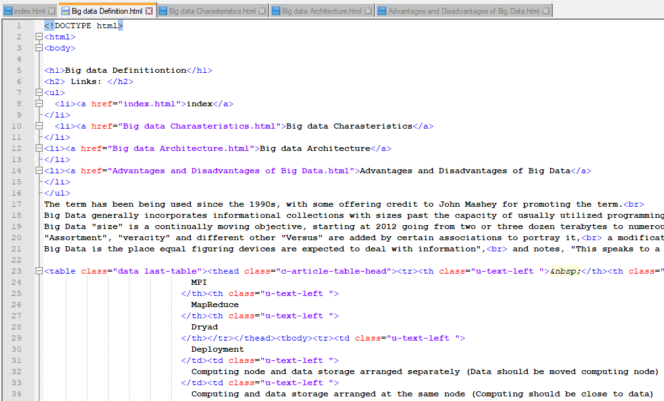

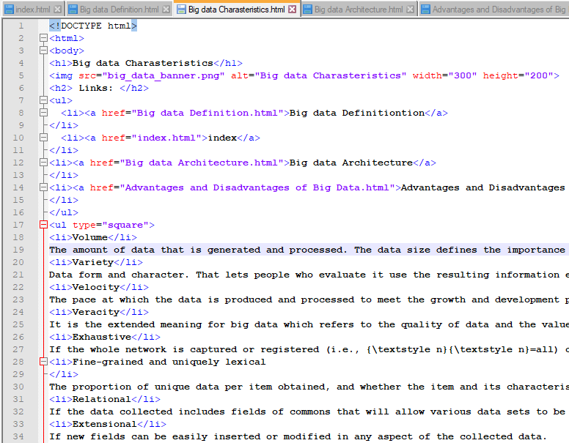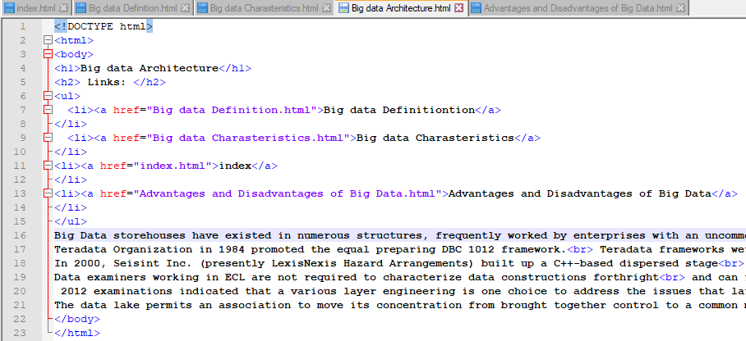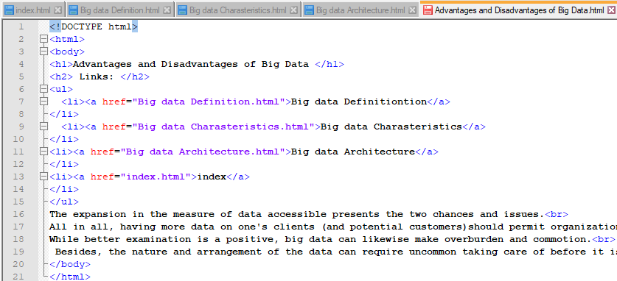

**Screenshots**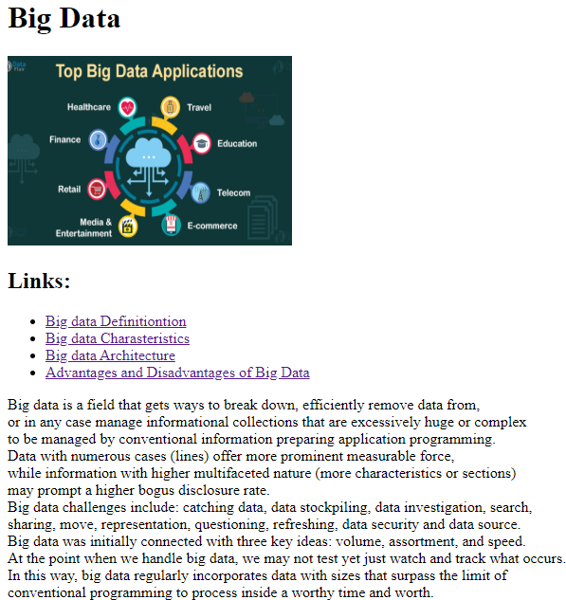

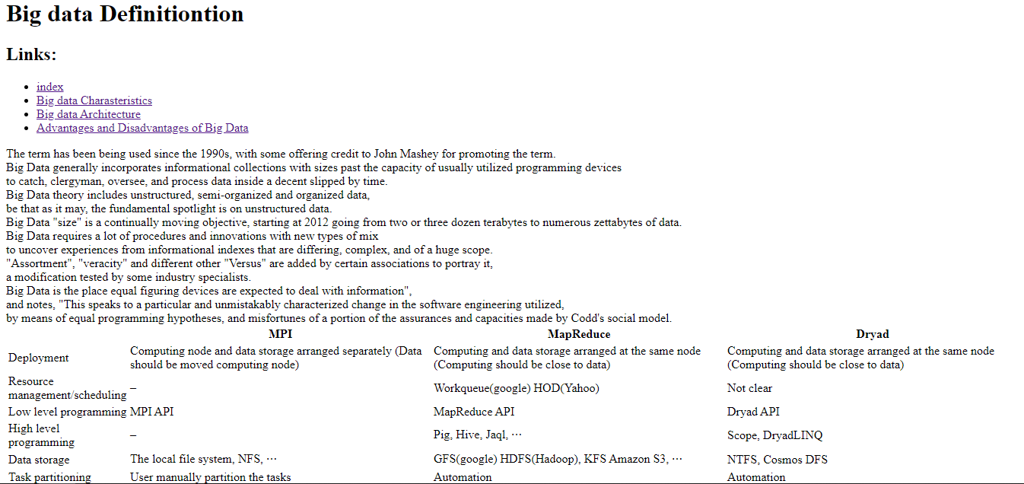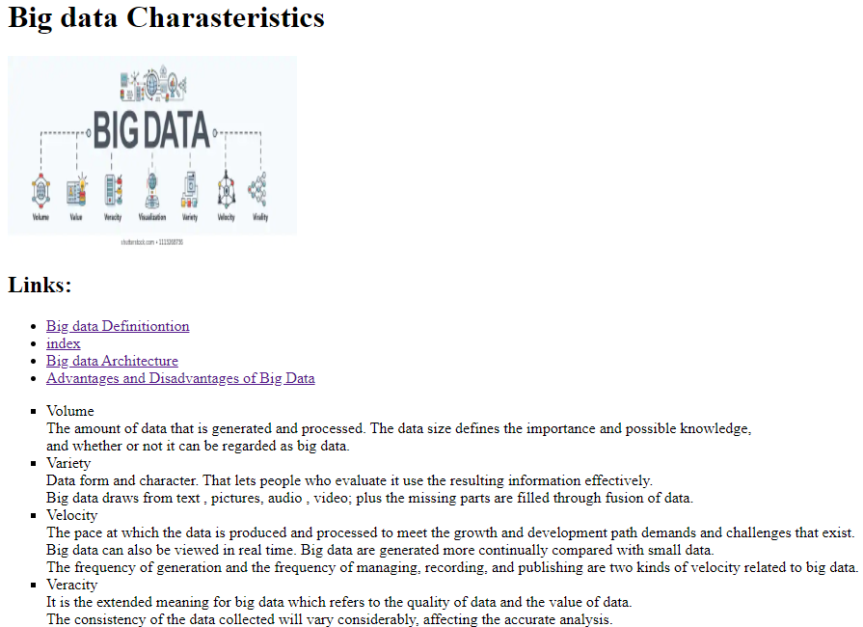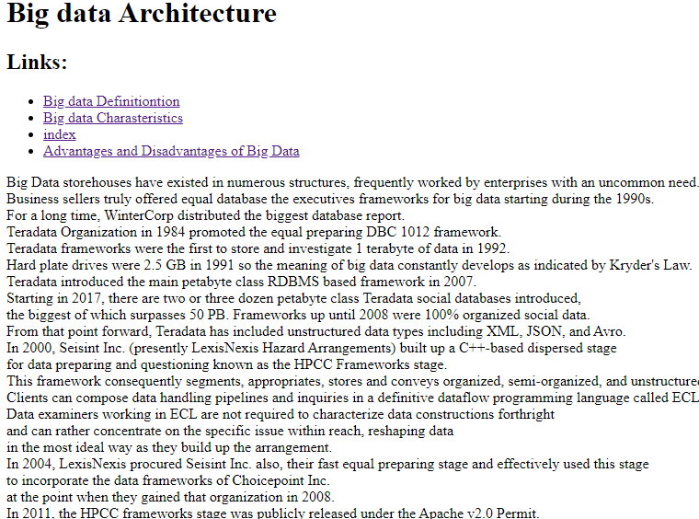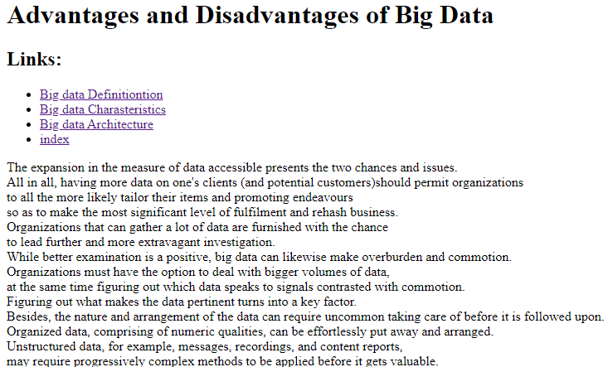

**References**

1. Smith, M., Szongott, C., Henne, B., & Von Voigt, G. (2012, June). Big data privacy issues in public social media. In *2012 6th IEEE International Conference on Digital Ecosystems and Technologies (DEST)* (pp. 1-6). IEEE.

   * Google ([www.google.com](http://www.google.com))
   * The Egyptian knowledge bank (www.ekb.com)

  