Phase 2:
ERD Digram
The relationships:

1) Customer → Orders
One customer places many orders
1-to-Many

2) Store → Orders
One store fulfills many orders
1-to-Many

3) Category → Products
One category groups many products
1-to-Many

4) Orders → Order_Items
One order has many line items
1-to-Many

5) Products → Order_Items
One product appears in many order items
1-to-Many

6) Order_Items → Returns
One order item can have one or more return records
1-to-Many

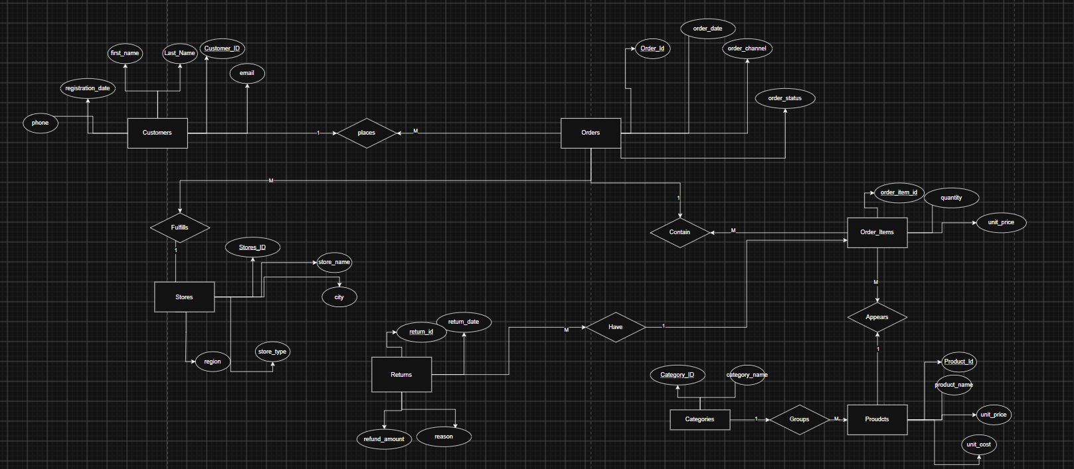

Mapping Schema (Relational Schema)

Customers
---------
PK customer_id
first_name
last_name
email
phone
registration_date

Stores
------
PK store_id
store_name
city
region
store_type

Categories
----------
PK category_id
category_name

Products
--------
PK product_id
product_name
unit_price
unit_cost
FK category_id → Categories(category_id)

Orders
------
PK order_id
order_date
order_channel
order_status
FK customer_id → Customers(customer_id)
FK store_id → Stores(store_id)

Order_Items
-----------
PK order_item_id
quantity
unit_price

FK order_id → Orders(order_id)
FK product_id → Products(product_id)

Returns
-------
PK return_id
return_date
refund_amount
reason
FK order_item_id → Order_Items(order_item_id)

Database Normalization (Third Normal Form - 3NF)
The OLTP database schema is designed to satisfy the Third Normal Form (3NF) to ensure data integrity, minimize redundancy, and prevent update anomalies.
- First Normal Form (1NF): All tables contain atomic attributes, with no repeating groups or multi-valued attributes.
- Second Normal Form (2NF): Every non-key attribute is fully functionally dependent on the entire primary key of its table.
- Third Normal Form (3NF): No transitive dependencies exist. Attributes depend only on the primary key, while descriptive data is stored in separate related tables. For example, category information is stored in the Categories table rather than being duplicated in Products, and customer information is maintained separately from Orders.
This normalized design reduces data redundancy, improves consistency, and provides an efficient transactional database suitable for daily business operations.

