**Project name: virtual reality decor**

**Project sponsor: The Ministry of Investment and the Art and Design Association.**

**Project manager: Eng. Mohamed**

**The purpose of the project: Assisting the user choose the furniture and decoration that he wants.**

**Business case:**

**Virtual Reality Project: It is a project to transform the process of choosing furniture and decoration from a tedious and time-consuming process into a simple and enjoyable process that is completed in the fastest time.**

**Many of us resort to relying on interior designers in the process of choosing furniture and decor, or rely on ourselves, in both cases you need tools to help you in this task. It is the role of the VR-Decor application by scanning the place to be designed and turning it into a 3D image that you can walk around in. Now you can place the furniture and choose the decoration from the information form inside the application. And seeing a sample of the final form that you put in. The designers benefit from this application to get a better and faster result.**

**major deliverables of the project:**

**-The user can scan the site and make it a three-dimensional image, put furniture and decoration in it, and design according to his desire**

**-The user can buy all the furniture and decor of his choice from the application**

**Timeline of project:**

**In the first two months, a project plan is developed and the requirements, cost and risks of the project are determined. After that, the virtual reality team begins to design the information model and assemble most of the products and convert them into a** 3**D view so that the user can try them on the used site. During this period, the software development team works on developing and designing the application. Then the application is tested and errors are fixed. The user is trained to work with the application and ends with the application’s signature on most application stores and the creation of advertisements for it. This is done in a planned period of time and continues from the beginning of determining the requirements to the presence of the application in the market within a year from 1/1/22 to 31/12/22.**

**Project resources:**

**- Servers**

**- Budget: 775.000$**

**- Work crew: A team of VR engineers,** **Team of programmers.**

**- Marketing companies and Internet marketplaces (such as Amazon, Google Play, app store and appgallery (**

**budget:**

775**.000$ (includes servers, project, developers, designers and training)**

**Constraints:**

**-The application is completed within the specified period and is available for use within 12 months.**

**-Use the budget specified for him and that this budget does not exceed 775,000.**

**-Use of high quality servers.**

**Assumptions:**

The quality of all of the equipment or materials is in good working condition throughout the project life-cycle.

All the staff members and workers possess good qualities of the required skills in the project.

Project team members will have access to the tools they need to get their tasks done on time.

The total budget of the project will not exceed the calculated budget.

**High level risk:**

The quality of all of the equipment or materials isn’t in good working condition throughout the project life-cycle.

The project’s material, equipment, and resources costs will remain constant when buying.

Failure of employees and workers to complete their tasks within the specified time

Inefficiency of the virtual reality system

Incompatibility between employees and workers

**SCOPE STATEMENT**

**PROJECT OBJECTIVE:**

**Create an application that is used in design work to facilitate the completion of decoration and furniture tasks so that the specified cost is not traded, which is 775,000 within a year from the start of the project compatible with Windows and Android devices and Apple company operating systems. The application provides the ability to buy furniture and decoration through it.**

**DELIVERABLES:**

**Create an application that uses virtual reality to create a design for a home, office, private or governmental institution. By designing furniture and decoration on virtual reality to obtain a realistic form of design, as well as the possibility of obtaining furniture and decoration used to apply it on the ground**.

**MILESTONES:**

**The project shall be started by defining the requirements and working on them from (1/1/2022) to (2/28).**

**The phase of work on the virtual reality system starts from (3/1) to (6/30).**

**The design of the information model starts from (3/1) to (4/30).**

**Working on the code starts from (3/1) to (6/30).**

**Hardware is tested from (7/1) to (7/31).**

**The software test starts from (7/1) to (8/31).**

**The code is being developed from (9/1) to (10/31).**

**The user is trained from (11/1) to (11/30).**

**Publish the application from (12/1) to the day the project ends (12/31).**

**TECHNICAL REQUIREMENTS:**

**-The application requires a giant comprehensive information model for all available furniture and decor and where to obtain them.**

**-High-performance servers and excellent quality to get the best performance in location analysis.**

**-Good shooting performance in good lighting to get the best treatment and the best result.**

**LIMITS AND EXCLUSIONS:**

**-Availability of a depth camera in the device used to scan the actual location**

**-Use a device with a suitable screen for ease of use**

**-The inability of the user to scan furniture or decor to experience it in virtual reality**

**-Work on the project during all days of the week except for holidays**

**Reviews with customer:**

**Completion of the scope checklist ends with a review with**

**your customer internal or external. The main concern here is the understanding of and agreement to expectations. Is the customer getting what he or she desires in deliverables? Does the project definition identify key accomplishments, budgets, timing, and performance requirements? Are questions of limits and exclusions covered? Clear communication in all these issues is imperative to avoid claims or misunderstanding.**

**(WBS)**

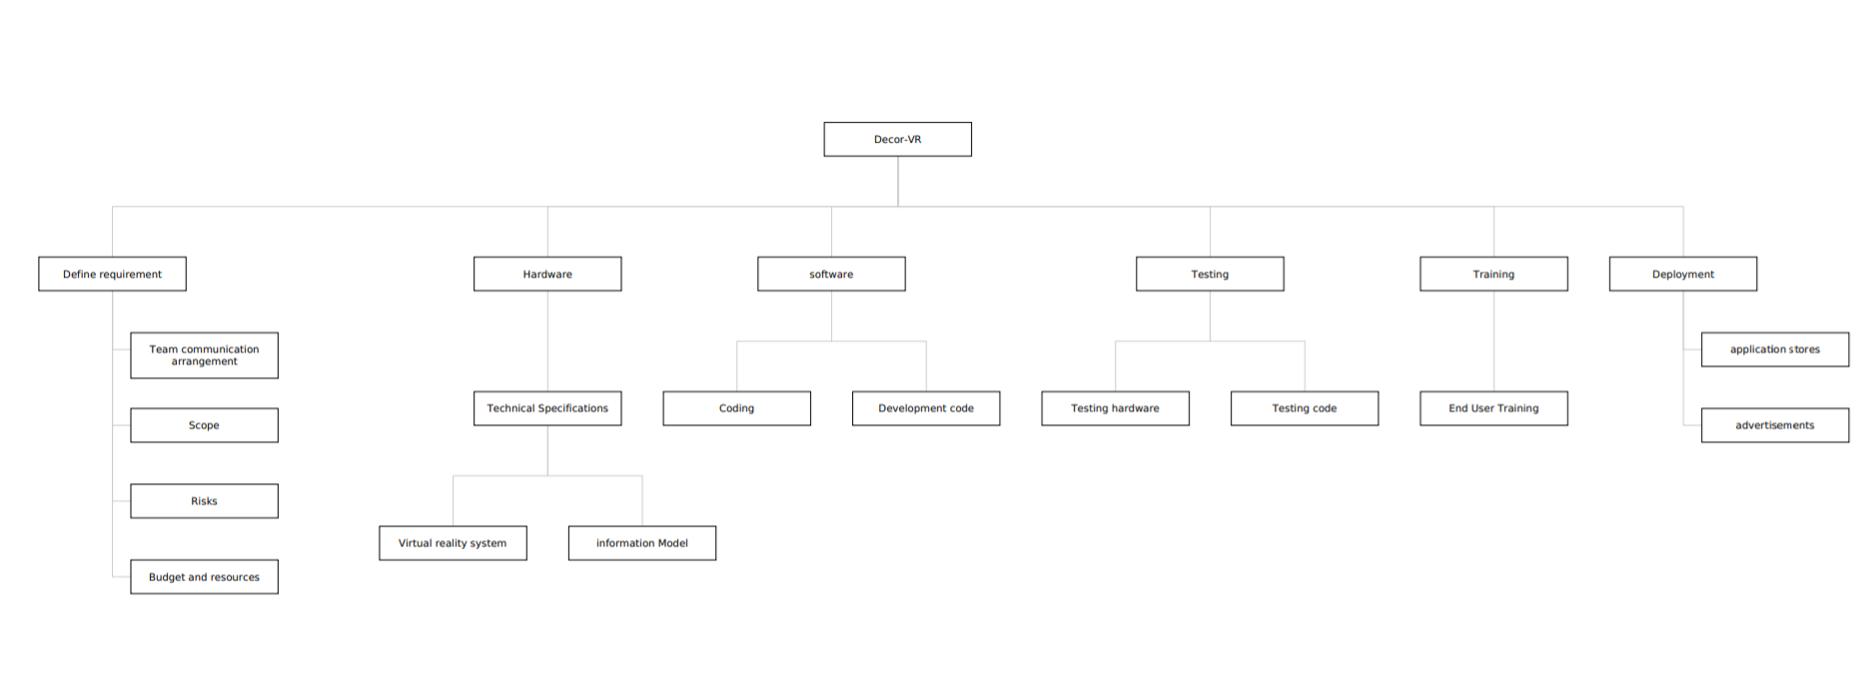

RESPONSIBILITIES MATRIX

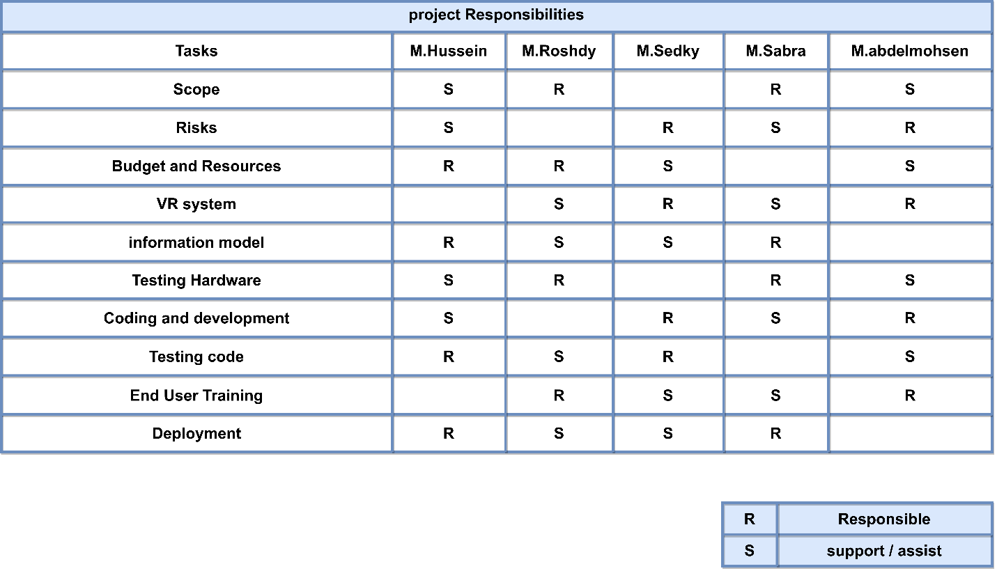

**PROGECT NETWORK**

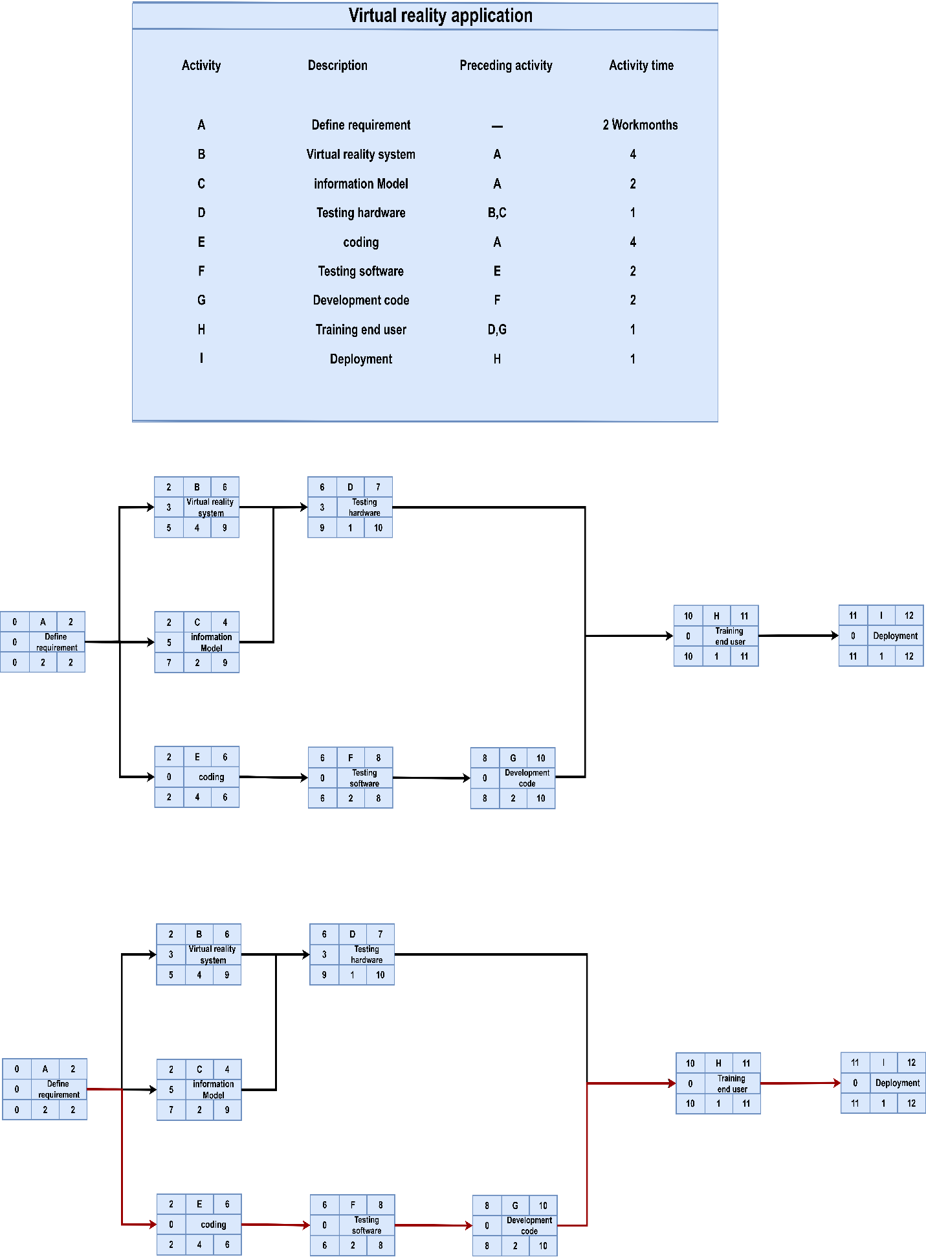

Critical Path

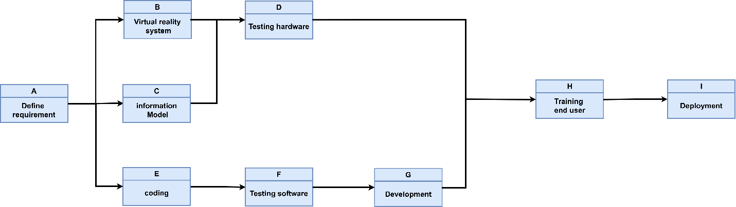

**GHANTT**

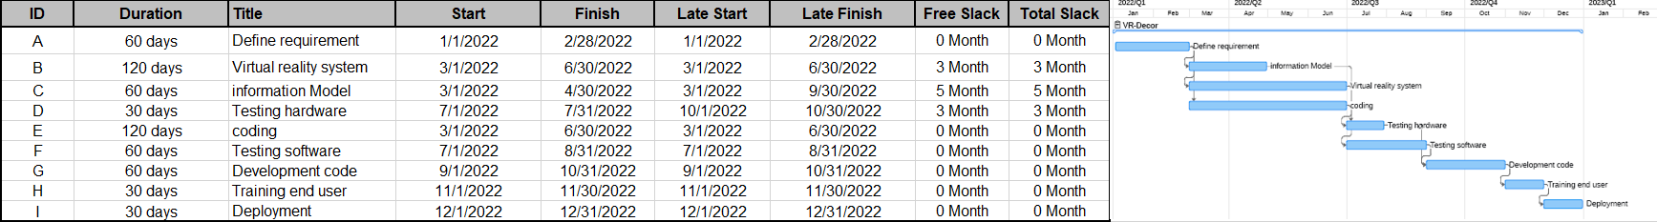

**RESOURCES CONSTRAIND SCHEDUAL**

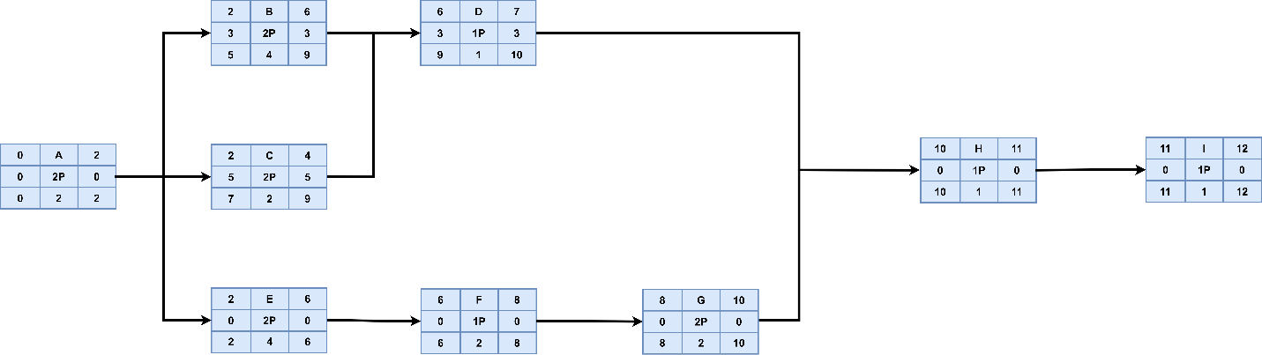

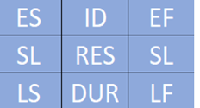

|  |  |  |  |  |  |  |  |  |  |  |  |  |  |  |  |  |  |  |
| --- | --- | --- | --- | --- | --- | --- | --- | --- | --- | --- | --- | --- | --- | --- | --- | --- | --- | --- |
| ID | RES | DUR | ES | LF | SL | 0 1 2 3 4 5 6 7 8 9 10 11 12 | | | | | | | | | | | | |
| A | 2P | 2 | 0 | 2 | 0 | 2P | 2P |  |  |  |  |  |  |  |  |  |  |  |
| B | 2P | 4 | 2 | 9 | 0 |  |  | x | x | x | 2P | 2P | 2P | 2P |  |  |  |  |
| C | 2P | 2 | 2 | 9 | 5 |  |  | 2P | 2P |  |  |  |  |  |  |  |  |  |
| D | 1P | 1 | 6 | 10 | 0 |  |  |  |  |  |  | x | x | x | 1P |  |  |  |
| E | 2P | 4 | 2 | 6 | 0 |  |  | 2P | 2P | 2P | 2P |  |  |  |  |  |  |  |
| F | 1P | 2 | 6 | 8 | 0 |  |  |  |  |  |  | 1P | 1P |  |  |  |  |  |
| G | 2P | 2 | 8 | 10 | 0 |  |  |  |  |  |  |  |  | 2P | 2P |  |  |  |
| H | 1P | 1 | 10 | 11 | 0 |  |  |  |  |  |  |  |  |  |  | 1P |  |  |
| I | 1P | 1 | 11 | 12 | 0 |  |  |  |  |  |  |  |  |  |  |  | 1P |  |
| Total recourse load | | | | | | 2P | 2P | 4P | 4P | 2P | 4P | 3P | 3P | 2P | 3P | 1P | 1P |  |
| Recourse available | | | | | | 4P | 4P | 4P | 4P | 4P | 4P | 4P | 4P | 4P | 4P | 4P | 4P |  |

**TIME PHASED BUDGET BASELINE**

|  |  |  |  |  |  |  |  |  |  |  |  |  |  |  |  |
| --- | --- | --- | --- | --- | --- | --- | --- | --- | --- | --- | --- | --- | --- | --- | --- |
| **ID** | **Dur** | **Task** | **Budget** | **0** | **1** | **2** | **3** | **4** | **5** | **6** | **7** | **8** | **9** | **10** | **11** |
| **A** | **2** | **Define**  **Requirement** | **50,000 $** | **25,000** | **25,000** |  |  |  |  |  |  |  |  |  |  |
| **B** | **4** | **Vitual reality**  **Sestym** | **200,000 $** |  |  |  |  | **50,000** | **50,000** | **50,000** | **50,000** |  |  |  |  |
| **C** | **2** | **Information**  **Model** | **50,000 $** |  |  | **25,000** | **25,000** |  |  |  |  |  |  |  |  |
| **D** | **1** | **Testing**  **Hardware** | **50,000 $** |  |  |  |  |  |  |  |  |  | **50.000** |  |  |
| **E** | **4** | **Coding** | **200,000 $** |  |  | **50,000** | **50,000** | **50,000** | **50,000** |  |  |  |  |  |  |
| **F** | **2** | **Testing**  **Software** | **50,000 $** |  |  |  |  |  |  | **25,000** | **52,000** |  |  |  |  |
| **G** | **2** | **Development**  **Code** | **100,000 $** |  |  |  |  |  |  |  |  | **50,000** | **50,000** |  |  |
| **H** | **1** | **Training end**  **User** | **25,000 $** |  |  |  |  |  |  |  |  |  |  | **25,000** |  |
| **I** | **1** | **Deployment** | **50,000 $** |  |  |  |  |  |  |  |  |  |  |  | **50,000** |
| **Month Total** | | | **775,000 $** | **25,000** | **25,000** | **75,000** | **75,000** | **100,000** | **10,000** | **75,000** | **75,000** | **50,000** | **100,000** | **25,000** | **50,000** |
| **Comulative** | | | | **25,000** | **50,000** | **125,000** | **200,000** | **300,000** | **400,000** | **475,000** | **550,000** | **600,000** | **700,000** | **725,000** | **775,000** |

**RISK MANAGEMENT AND MONITORING**

|  |  |
| --- | --- |
| Risks | Manage the Risks |
| The quality of all of the equipment or materials isn’t in good working condition throughout the project life-cycle. | monitor all of the resources and keep in track of the condition of the resources to ensure that the resources are at the best condition |
| The project’s material, equipment, and resources costs will remain constant when buying. | keep in track with every buying of resources or materials |
| Failure of employees and workers to complete their tasks within the specified time | Monitor the project schedule to track the progress of tasks |
| Inefficiency of the virtual reality system | Choosing the best virtual reality servers and the best skilled programmers, programming in virtual reality |
| Incompatibility between employees and workers | Maintain good communication and follow-up of employees and workers |
| Not all equipment or materials are available when you need them | Provide alternative sources in the event that the main sources are not available |
| Not all resources are in a good condition to be used throughout the project lifecycle | Always monitor all the resources and track the status of the resources to ensure that the resources are in the best condition |
| The inability of the average customer to use the application, other than the interior engineers | Provide a training program for users |
| It is difficult to get a team of programmers dealing with virtual reality technology | Find professional programmers from companies specializing in virtual reality |