📖 HTML and the basics of the Web
Lesson Progress
86% Complete
Origins of HTML
HTML stands for HyperText Markup Language and it's the standard markup language used to create web pages. A markup language is a way to annotate a document in a way that is syntactically distinguishable from the content of said document, which tells the web browser how to display a web page's content for the user.
HTML was born in the late 1980’s after Tim Berners-Lee described an hypertext-system that could work over internet. He, amongst other things, said an encyclopedia could be modelled with it: a series of interconnected documents described with a standard and uniform set of rules.
Understanding HTTP and Client-Server Systems
Now, because HTML is to be served over the internet, we need a way to do so. Cue: the HyperText Transfer Protocol, or HTTP for its friends. HTTP it's the foundation of any data exchange on the web and a protocol used for transmitting hypermedia documents, such as HTML.
HTTP follows a classical client-server model. Basically, a system where a client, in our case a device from an user, sends a request to a remote server and waits for a response to finally deliver it back to the client. Over the duration of our course, we’ll go through every single stage of this process!
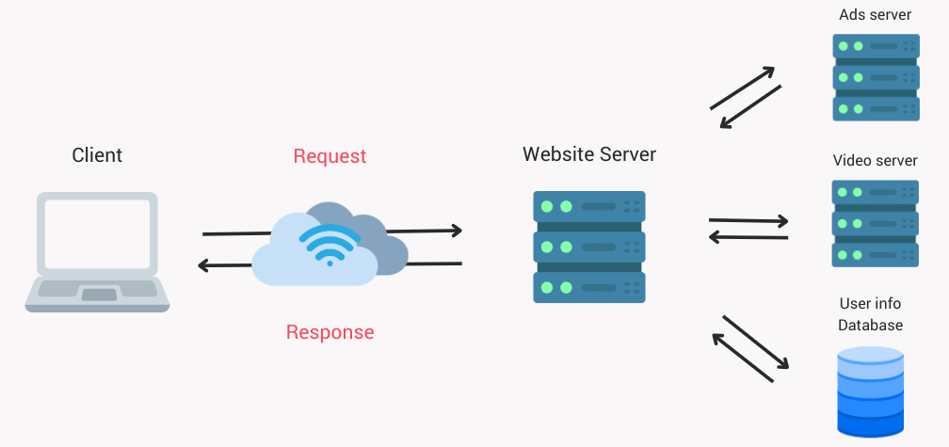
Three-tier architecture
“How?” you asked. Well, this model can be summarised into something known as the Three-tier architecture. A way of conceptualising applications where every single tier owns its infrastructure:
- A presentation tier, the user interface.
- An application tier, the logic tier where all the business rules belong.
- A data tier, the tier where data is accessed, stored and modified.
For us, this will look a little like this!
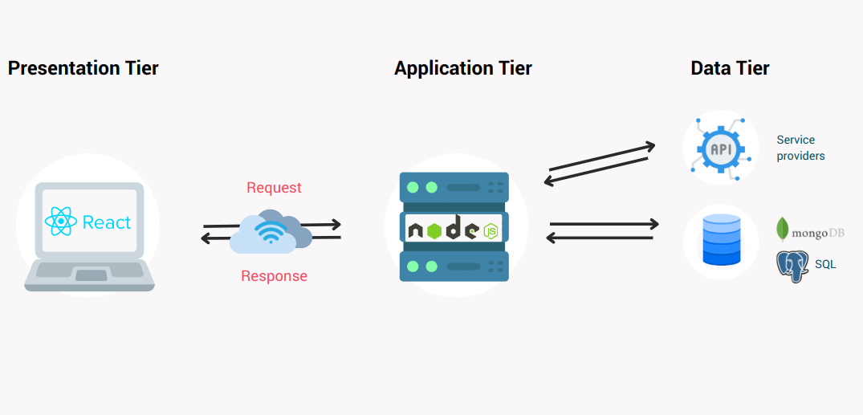
A React application that sends requests to a Node backend, which in turn, interacts with a database to store, access, and modify data. This is what awaits you!
One step at a time!
Hold up! Yes. You will be able to create this amazing applications with all their bells and whistles, but before that, we need to learn some very important things about HTML. For instance, how to create documents with it.
Let’s start exploring some HTML elements and a way to put them together!
Additional resources
- HTTP Overview: https://developer.mozilla.org/en-US/docs/Web/HTTP/Overview
- Three-tier architecture: https://www.ibm.com/topics/three-tier-architecture

📚 Elements, Attributes, Headings and Paragraphs
Lesson Progress
86% Complete
Elements
HTML elements are the basic building blocks of web pages, telling the browser how to display content. Each element is made up of an opening tag, the content, and a closing tag. Some elements have attributes that provide additional information about the element.
Anatomy of an HTML Element:
- Opening Tag: Marks the start of an element (<tagname>).
- Content: The actual information or content.
- Closing Tag: Marks the end of an element (</tagname>).

<!doctype html>
<!-- Declares the document type and version of HTML -->
<html lang="en">
<!-- The root element of the HTML document, specifies language as English -->
<head>
<meta charset="UTF-8" />
<!-- Specifies the character encoding for the document -->
<title>My Sample Page</title>
<!-- Defines the title of the document, shown in browser tab -->
</head>
<body>
<!-- The body tag contains all the content of an HTML document, like text, images, and more -->
<h1>My First Heading</h1>
<!-- h1 to h6 tags are used for headings, h1 is the largest -->
<p>
This is a paragraph. It contains text and can also contain other inline
HTML elements.
</p>
<!-- p tag defines a paragraph -->
<!-- Link to another web page -->
<a href="https://random.dog/" target="_blank">See a cute dog</a>
<!-- a tag defines a hyperlink. href attribute contains the link URL -->
<!-- Display an image -->
<img
src="https://placedog.net/640/480"
alt="Descriptive text for the image"
width="100%"
/>
<!-- img tag embeds an image. src specifies image path, alt provides alternative text -->
<!-- Create an unordered list -->
<ul>
<!-- ul tag defines an unordered list -->
<li>List Item 1</li>
<!-- li tag defines a list item -->
<li>List Item 2</li>
</ul>
<!-- Adding a division or a section -->
<div>
<!-- div tag is used to group block-elements to format them with CSS -->
<p>This is a paragraph inside a division.</p>
</div>
</body>
</html>

Attributes
HTML attributes provide additional information about elements, defining their behavior or appearance. They are always specified in the opening tag of an element and usually come in name/value pairs like name="value". Attributes can control a wide range of element properties, such as the destination of a link, the source of an image, or styling cues.
Common attributes include:
- href: Specifies the URL of a link.
- src: Indicates the source of an image.
- alt: Provides alternative text for an image.
- style: Adds CSS styling directly to an element.
- id: Assigns a unique identifier to an element, which can be targeted with CSS or JavaScript.
- class: Assigns one or more class names to an element, used for styling multiple elements in the same way.
- <!doctype html>
- <html lang="en">
- <head>
- <meta charset="UTF-8" />
- <title>Document with Attributes</title>
- <style>
- .blue-text {
- color: blue;
- }
- </style>
- </head>

- <body>
- <h1 style="color: red;">A Red Heading</h1>
- <!-- The style attribute adds inline CSS -->
- <p id="first-paragraph">This is a paragraph with an ID attribute.</p>
- <!-- The id attribute gives a unique identifier -->
- <a href="https://random.dog/">click here</a>
- <a href="https://random.dog/" target="_blank">click here</a>
- <!-- href defines link URL; target="_blank" opens link in a new tab -->
- <img
- src="https://placedog.net/640/480?r"
- alt="Descriptive text for the image"
- width="100%"
- />
- <!-- src points to the image; alt provides text for screen readers -->
- <div class="blue-text">
- This text is blue because of the class attribute.
- </div>
- <!-- The class attribute applies CSS styles -->
- </body>
- </html>

Headings
Headings in HTML range from <h1> to <h6> and are used to structure content, making it easier for users to navigate and understand. The <h1> represents the most significant heading level, often used for main titles, while <h6> is the least significant.
Proper use of headings is crucial not just for readability and structure but also for SEO and accessibility. Search engines use headings to index the structure and content of web pages, while screen readers use them to provide content navigation.

<!doctype html>
<html lang="en">
<head>
<meta charset="UTF-8" />
<title>HTML Headings Example</title>
</head>
<body>
<h1>Main Title of the Page</h1>
<p>
This paragraph introduces the main topic of the web page, providing a
brief overview of what the reader can expect.
</p>

<h2>Major Section Heading</h2>
<p>
This paragraph goes into more detail about the first major section of the
page. It might introduce a new concept or point of discussion.
</p>

<h3>Subsection Heading</h3>
<p>
Here, we dive deeper into a specific aspect of the major section, offering
further explanations or examples.
</p>

<h4>Topic Heading Within a Subsection</h4>
<p>
This part might break down the subsection's topic even further, getting
into the nitty-gritty details.
</p>

<h5>Special Focus Heading</h5>
<p>
Details on a very specific point or a niche aspect of the discussion could
go here, providing extra insights.
</p>

<h6>Additional Information Heading</h6>
<p>
This might include tangential information, further reading links, or any
other additional details that round off the main content.
</p>
</body>
</html>

Paragraphs
In HTML, the <p> tag is used to define a paragraph. Visually, paragraphs are separated from surrounding text by blank lines and/or first-line indentation, which is handled automatically by browsers.
Paragraphs play a critical role in making content readable and digestible. They can contain inline elements like links, spans, or formatting tags but should not contain block-level elements.
<!doctype html>
<html lang="en">
<head>
<meta charset="UTF-8" />
<title>Paragraphs in HTML</title>
</head>
<body>
<h1>Understanding Paragraphs</h1>
<p>
This is your first paragraph. Notice how it forms a block of text,
separate from this one. Paragraphs help to break down content into
readable chunks.
</p>
<p>
Paragraphs can also contain <strong>bold text</strong>,
<i>italicized text</i>, and <a href="#">links</a> among other things.
</p>
</body>
</html>

Lesson 3, Topic 3
Complete
← Previous Next→
📚 Formatting, Links, Comments and Images
Lesson Progress
86% Complete
Formatting
HTML provides a range of tags for formatting text, allowing authors to indicate emphasis, importance, or mood.
Tags like <em> and <strong> have semantic meaning, indicating emphasis or importance, respectively, and should be used over purely stylistic tags like <i> and <b> when the meaning is relevant.
This distinction is not only important for visual presentation but also for accessibility, as screen readers interpret these tags differently.
Here's a list of some common formatting HTML elements along with short descriptions:
- <b>: Bold text without any extra importance.
- <strong>: Bold text with added importance.
- <i>: Italic text without any extra emphasis.
- <em>: Italic text with added emphasis.
- <mark>: Text highlighted for reference or notation purposes.
- <small>: Smaller text, often used for disclaimers or side comments.
- <del>: Represents text that has been deleted from the document.
- <ins>: Represents text that has been inserted into the document.
- <sub>: Subscript text, appearing half a character below the normal line.
- <sup>: Superscript text, appearing half a character above the normal line.
- <u>: Underlined text.
- <pre>: Preformatted text displayed in a monospace font, preserving spaces and line breaks.
- <blockquote>: A section quoted from another source, typically indented.
- <q>: Inline quotation.
- <abbr>: An abbreviation or acronym; the full expression can be provided in the title attribute.
- <cite>: The title of a creative work, indicating a citation.
- <dfn>: A term being defined within the context of its use.
- <address>: Contact information for the author/owner of a document or article.
Each of these elements serves a specific purpose in HTML document structure and presentation, allowing developers and content creators to produce rich, semantically meaningful web content.

<!doctype html>
<html lang="en">
<head>
<meta charset="UTF-8" />
<title>HTML Formatting Elements Example</title>
</head>
<body>
<p>
<b>Bold text</b> and <strong>strong importance text</strong> are visually
similar, but semantically different.
</p>
<p>
<i>Italic text</i> and <em>emphasized text</em> also share visual styles
but have different meanings.
</p>
<p>
This is a <mark>highlighted section</mark> of text, which might indicate
relevance or focus.
</p>
<p>
<small>This small text can serve as a disclaimer or fine print.</small>
</p>
<p>
Here is an example of <del>deleted text</del> and its
<ins>replacement</ins>.
</p>
<p>
Chemical symbols use <sub>subscripts</sub> for H<sub>2</sub>O, and
<sup>superscripts</sup> for 1st<sup>st</sup> place.
</p>
<pre>
Preformatted text preserves spaces and

line breaks.</pre
>

<blockquote>
Blockquote: "To be, or not to be, that is the question." - Hamlet
</blockquote>

<p>An inline <q>quote</q> can fit within a paragraph.</p>

<p>
The HTML acronym stands for
<abbr title="HyperText Markup Language">HTML</abbr>.
</p>

Comments
Comments in HTML are used to insert notes, explanations, or references in the code that are not displayed in the browser.
This is incredibly useful for documentation, to do notes, or to temporarily disable code. Comments are enclosed in <!-- and --> markers.
They can be placed anywhere in the code and are ignored by the browser, making them invisible to the end-user.
<!DOCTYPE html>
<html>
<head>
<title>HTML Comments</title>
</head>

<body>
<!-- Main header of the document -->
<h1>HTML Commenting</h1>
<p>Comments are not displayed in the browser</p>
<!-- This is a comment spanning multiple lines
It's useful for longer explanations that can't fit in a single line -->
<p>Check the source code to find comments!</p>
</body>
</html>

Links
Links, defined by the <a> tag (anchor), are one of the foundational elements of the web, enabling users to navigate from one web page to another or to a specific part within a page.
The href attribute specifies the URL of the page the link goes to. The target attribute can determine how the linked document is opened, with values like _blank to open the link in a new tab or window.
Links are not limited to navigating to web pages; they can also be used to download files, navigate to sections within a page, or initiate email actions through mailto:.
<!doctype html>
<html lang="en">
<head>
<meta charset="UTF-8" />
<title>HTML Links</title>
</head>

<body>
<h1>Exploring HTML Links</h1>
<p>
Click <a href="https://www.example.com">here</a> to visit Example.com.
</p>
<p>
Open the link in a new tab using
<a href="https://www.example.com" target="_blank">this link</a>.
</p>
<p><a href="#bottom">Skip to the bottom</a> of this document.</p>
<p>Email us by clicking <a href="mailto:someone@example.com">here</a>.</p>

<div id="bottom">
<p>This is the bottom of the document.</p>
</div>
</body>
</html>

Images
Images add visual interest and information to web pages. The <img> tag is used to embed images in an HTML document.
This tag is self-closing and requires the src attribute to specify the image's location.
The alt attribute provides alternative text for the image, crucial for accessibility and SEO, as it describes the image content.
The width and height attributes control the dimensions of the image, which can be specified in pixels or percentages.
<!doctype html>
<html lang="en">
<head>
<meta charset="UTF-8" />
<title>HTML Images</title>
</head>
<body>
<h1>HTML Image Integration</h1>
<p>Here is an example of an image in HTML:</p>
<img
src="https://placedog.net/640/480?random"
alt="A random yet lovely dog"
width="100%"
height="auto"
/>
<!-- we could omit the height attribute since it would be the default -->
<p>Remember to use the <code>alt</code> attribute for accessibility.</p>
</body>
</html>

📚 Lists, Block Level and DIVs
Lesson Progress
86% Complete
Lists
Lists organize information into ordered (numbered) and unordered (bulleted) formats, making content easy to read and understand.
The <ul> tag creates an unordered list, while the <ol> tag creates an ordered list.
Inside these lists, the <li> tag is used to define each list item.
Lists can be nested within each other to create sublists, allowing for complex hierarchical structures of information.
<!doctype html>
<html lang="en">
<head>
<meta charset="UTF-8" />
<title>HTML Lists</title>
</head>

<body>
<h1>Working with Lists in HTML</h1>
<h2>Unordered List</h2>
<ul>
<li>Coffee</li>
<li>Tea</li>
<li>Milk</li>
</ul>
<h2>Ordered List</h2>
<ol>
<li>First</li>
<li>Second</li>
<li>Third</li>
</ol>
<h2>Nested List</h2>
<ol>
<li>
First
<ul>
<li>Kinda cool</li>
</ul>

Block level
Block-level elements in HTML are those that start on a new line and stretch out as wide as their container, creating a "block".
This category includes elements like <div>, <p>, <h1>-<h6>, <ol>, <ul>, and more. In contrast, inline elements, such as <span>, <a>, and <img>, do not start on a new line and only take up as much width as necessary.
If you are curious enough, you may have noticed that even though in the preview we are showing angle brackets, e.g. <h2>, in the source code we have &lt;h2&gt;. This weird looking notation uses HTML Characters Entities, a way of telling the browser we want to use these special characters without actually creating an HTML element.
Understanding the difference between block-level and inline elements is crucial for structuring and styling.
<!doctype html>
<html lang="en">
<head>
<meta charset="UTF-8" />
<title>Block-level vs Inline Elements</title>
<style>
/* Adding some basic styling to differentiate block-level and inline elements */
.block-level {
background-color: lightblue;
margin: 10px 0;
padding: 10px;
}
.inline-element {
background-color: lightcoral;
margin: 0 5px;
padding: 5px;
}
</style>
</head>
<body>
<div class="block-level">
This is a &lt;div&gt; element, a block-level element.
</div>
<p class="block-level">
This is a &lt;p&gt; paragraph, another block-level element.
</p>

DIV
The <div> element is a block-level, generic container for flow content that has no intrinsic semantic meaning.
It's commonly used as a "division" of the page, helpful for styling purposes or to group sections of a document together using CSS or JavaScript.
The <div> tag is one of the most versatile HTML elements because it can hold any other block-level or inline content, making it perfect for building web page layouts.
<h1>WBS Coding School</h1>
<!doctype html>
<html lang="en">
<head>
<meta charset="UTF-8" />
<title>Mastering Divs</title>
</head>
<body>
<div>
<h1>Welcome to Our Website</h1>
</div>
<div>
<p>
This is a generic container without specific styling. It's great for
grouping content.
</p>
</div>
<div>
<p>Contact us at email@example.com.</p>
</div>
</body>
</html>

IFrames
An <iframe> is an HTML document embedded inside another HTML document on a website.
It is a powerful tool for embedding videos, maps, or even interactive content from different sources directly into your web pages.
The <iframe> element creates a nested browsing context, where the embedded content is independent of the parent document's content. Attributes like src, width, height, and style control the appearance and functionality of iframes.
👆That’s actually an iframe, that renders an iframe that renders an iframe.

<h1>WBS Coding School</h1>
<!doctype html>
<html lang="en">
<head>
<meta charset="UTF-8" />
<title>Using Iframes</title>
</head>
<body>
<h2>Embedded Content with Iframes</h2>
<iframe src="https://www.wbscodingschool.com/" width="100%" height="400">
Your browser does not support iframes.
</iframe>
</body>
</html>

Code
The <code> tag is used to display a piece of computer code.
It's an inline element that by default, will render the enclosed text in the browser's default monospace font.
This tag is essential for technical documentation or tutorials where showing code examples is necessary.
It's often combined with the <pre> tag when displaying multi-line code snippets to preserve formatting and whitespace.
Forms
Forms are one of the primary methods of gathering input from users on the web.
Through the use of <form> elements combined with various types of input elements (like <input>, <textarea>, and <button>), developers can create a wide range of forms for submissions, such as login screens, contact forms, and search bars.
The action attribute of the form specifies where the form data should be sent after submission, while the method attribute specifies how (GET or POST).
We'll dive deeper into forms very soon. They are, to this day, one of the best ways of interacting with the web, just think of every time you fill a form to sign in, sign up or submit data!
<!doctype html>
<html lang="en">
<head>
<meta charset="UTF-8" />
<title>HTML Forms</title>
</head>
<body>
<form action="submit-form.php" method="dialog">
<fieldset>
<legend><h2>Contact Form</h2></legend>
<label for="name">Name:</label>
<input type="text" id="name" name="name" /><br /><br />
<label for="email">Email:</label>
<input type="email" id="email" name="email" /><br /><br />
<label for="message">Message:</label>
<textarea id="message" name="message"></textarea><br /><br />
<fieldset>
<legend>Do you agree to the terms?</legend>
<label><input type="radio" name="radio" value="yes" /> Yes</label>
<label><input type="radio" name="radio" value="no" /> No</label>
</fieldset>
<button type="submit">Send</button>
</fieldset>
</form>
</body>
</html>

Media
Media elements like <audio> and <video> allow for the embedding of sound and video content directly into web pages.
These elements support several attributes to control playback, such as controls, autoplay, and loop.
Providing an immersive user experience, these tags support various source files, enabling compatibility across different browsers and devices.
It's essential to include the controls attribute so users can play, pause, or adjust the volume of the media.
<!doctype html>
<html lang="en">
<head>
<meta charset="UTF-8" />
<title>Embedding Media</title>
</head>
<body>
<h2>Audio Example</h2>
<audio controls>
<source
src="https://cdn.pixabay.com/audio/2024/03/21/audio_b20bc53f05.mp3"
type="audio/mp3"
/>
Your browser does not support the audio element.
</audio>
<div>
<a
href="http://whitenoisesleeper.com/"
rel="noopener noreferrer"
target="_blank"
>
Audio by White Noise Sleeper</a
>
</div>
<h2>Video Example</h2>
<video width="320" height="240" controls>
<source

📖 Development Environment
Lesson Progress
86% Complete
Before you dive into the first exercise, there’s a bit of prep work to do 👀
As you learned, an HTML document can be served over HTTP. This happens every time you go to a website because your computer, the client, sends a request to the server, which has access to the HTML document. We need to replicate that flow in our development environment.
You should already have Visual Studio Code installed. We are going to install an extension! 🧩
- Create a new directory and call it something like wbs-exercises and, within it, another directory called html-resume . You can of course use the file explorer in your computer, or give the terminal a shot (?)
- Open Visual Studio Code and open your html-resume directory:
  - You can find the File menu at the top of the window, from there, simply select Open folder
  - You can also use a keyboard shortcut: Ctrl+K Ctrl+O / Cmd+K Cmd+O
  - For more shortcuts, check: https://code.visualstudio.com/docs/getstarted/keybindings#_keyboard-shortcuts-reference
- Open the extension panel:
  - Locate this icon in the side panel on the left and click on it

  - Or press Ctrl+Shift+X / Cmd+Shift+X
  - For additional documentation on the marketplace check: https://code.visualstudio.com/docs/editor/extension-marketplace
- Search for Live Preview. The version may vary but check the verified developer is Microsoft! ⚠️
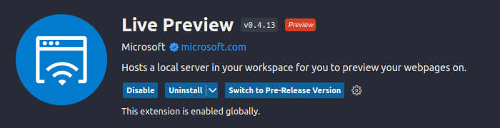
- Install the extension ⌛
- For additional documentation on this extension check: https://marketplace.visualstudio.com/items?itemName=ms-vscode.live-server
- Create a new file called index.html
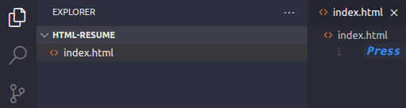
- Now, if you either right click on the file name in the explorer panel or anywhere in the open editor, you will find an option for Live Preview / Show Preview. Click on it!
- And voila! You have a simple development environment! Everything you write into that HTML file will automatically be displayed in your preview window.
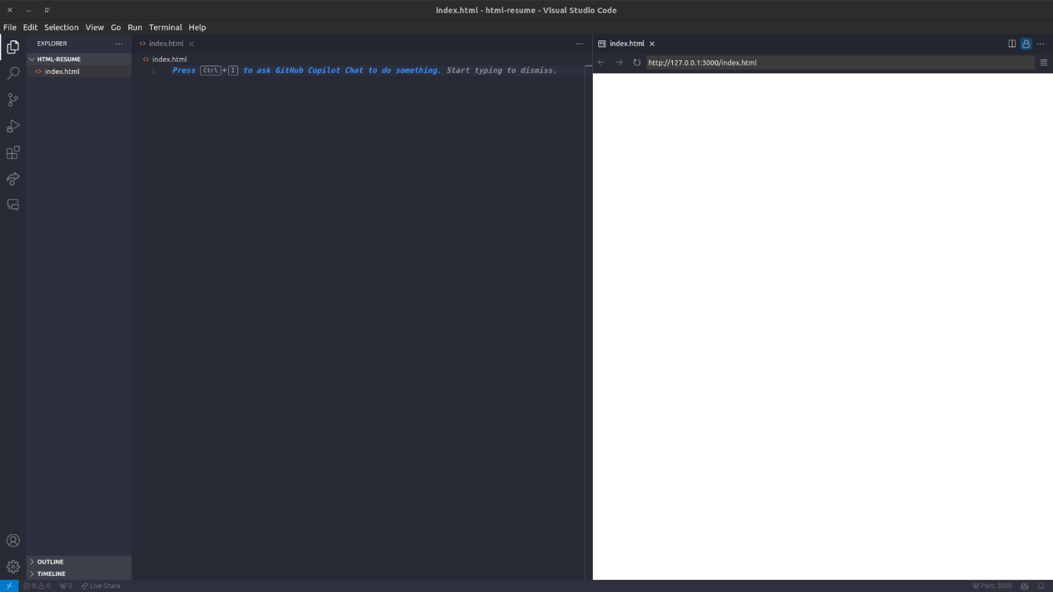
Most of the exercises at this stage will need a similar setup, so please come back to this article if you need a memory refresh!

🧩 HTML Resume
Lesson Progress
86% Complete
Whether this is your first experience with code or you already have some experience, at some point, you’ll need to update your resume so let's create a simple HTML resume that sticks to the basics.
We'll focus on using traditional elements like <div>, <h1> through <h6> for headings, <p> for paragraphs, <ul> and <li> for lists, <a> for links, and of course <img> for images! This exercise will help solidify the understanding of basic HTML structure and tags.
Goal
Create a basic HTML resume document using only traditional HTML elements.
Steps
Set Up the Document
- Begin with the <!DOCTYPE html> declaration to specify the HTML version.
- Open an <html> tag followed by a <head> section. Inside the <head>, include a <title> tag to give your document a title, such as the name of the person the resume belongs to.
- Close the <head> section and open the <body> section where the content of the resume will go.
Create the Header
- Add an <img> tag for your headshot.
  - You can drop the image file on your working directory and simply set the src to the path to that file, e.g. if the file is called mypic.jpg , the src value is /mypic.jpg .
  - You can also use an image that’s publicly available on the internet.
  - Let’s set width and height to 300
  - Don’t forget the alt value. Set it to your name!
- Use an <h1> tag for your name.
- Follow it with an <ul> tag for the contact information (email and phone number).
  - Use <li> tags inside of your <ul> for each one of your contact information
  - You can use fake data of course.
  - You want the actual email and phone number to be <a> tags!
Add an Objective or Summary
- Use an <h2> tag for a section title like "Objective" or "Summary".
- Follow with a <p> tag to write a brief introduction or objective statement.
List Education and Experience
- For each section (Education and Experience), use an <h2> tag for the title.
- Use <ul> for the list container, and <li> for each item. Inside each <li>, you can use <h3> for subheadings like degrees or job titles, and <p> for details like the institution name, dates, and brief descriptions.
Include Skills and Interests
- Again, use an <h2> tag for the section title.
- Use <ul> and <li> tags to list skills and interests.
Close the Document
- Ensure all opened tags are properly closed.
- Close the <body> and then the <html> tags.
Conclusion
This exercise is a great way to practice using basic HTML tags and structuring a document. It helps in understanding how to organize content logically using headings, paragraphs, and lists. Dive in, experiment with the structure, and remember, practice makes perfect! Keep exploring and tweaking your resume as you learn more. Happy coding! 🚀

🧩 Landing Page
Lesson Progress
86% Complete
Creating a basic landing page is a fantastic exercise for practicing HTML skills. This project will involve structuring a simple page with a header, an about section, a features section, and a contact form. We'll use placeholder images from placedog.net to keep it fun 🐶. Remember, we're focusing solely on HTML structure, so no styling will be used, we’ll cover that soon enough!
Goal
Build a basic landing page for a fictional "Dog Adoption Agency" using traditional HTML tags and placeholder images.
Steps
Set Up Your Document
- Start with the <!DOCTYPE html> declaration.
- Open your <html> element, followed by the <head> section. Inside <head>, include a <title> tag for your page title, like "Dog Adoption Agency."
- Close the <head> section and start the <body> section.
Header Section
- Use an <h1> tag for the main title of your page, something catchy like "Find Your Furry Friend!"
- Below the title, use <p> tags to add a short introduction or tagline for your agency.
About Section
- Use an <h2> tag for a subsection titled "About Us."
- Follow it with <p> tags to describe the mission and vision of your adoption agency. Keep it concise and engaging.
Features Section
- Use an <h2> tag for a section titled "Why Adopt From Us?"
- Create a list using <ul> with <li> items to highlight special features or benefits of adopting from your agency, such as "Comprehensive Veterinary Checks," "Behavioral Training for All Dogs," and so on.
Gallery Section
- Use an <h2> tag for a section titled "Meet Our Dogs."
- Below, insert images using <img> tags. Use the source attribute (src) to link to placeholder images from https://placedog.net/. For example, <img src="https://placedog.net/500/280" alt="Dog"/>. Include several images to simulate a gallery of dogs available for adoption.
Contact Form
- Use an <h2> tag for a section titled "Get in Touch."
- Create a simple form using the <form> tag. Include input fields for the user's name, email, and a message. Use <input type="text"> for name and email, and <textarea> for the message. Include a "Submit" button by adding an <button type="submit">Submit</button> tag at the end of the form.
Footer
- Conclude your page with a simple footer. Use a <p> tag to include copyright information, like "© 2024 Dog Adoption Agency."
Close Your Document
- Ensure all tags are properly closed in the correct order.
- Close the <body> and <html> tags.
Conclusion
This exercise offers a practical approach to structuring a basic web page using HTML. It will help you understand how to organize content and use different HTML elements to create a variety of sections on a webpage. Remember, experimentation is key to learning, so feel free to adjust and expand upon this template as you see fit. Dive in and start building your landing page, and most importantly, have fun with it! 🐾

🧩 Multi-page website
Lesson Progress
86% Complete
Alright, let's brew up a simple yet engaging multipage website for a fictional coffee shop, using only HTML! This exercise will help you understand the structure of a basic website, how to link pages using anchor tags, and how to embed images. We'll focus on the mechanics of creating a multipage site without diving into the content or styling. Here's how we're going to do it:
Goal
To create a three-page brochure website for a coffee shop with the following pages:
- Landing Page: This is the home page where visitors land first.
- About Page: A page that tells visitors about the coffee shop.
- Contact Page: Where visitors can find contact information.
Steps
Set Up Your Project
- Create a new folder on your computer named coffee-shop-website.
- Inside this folder, create three HTML files: index.html (Landing Page), about.html (About Page), and contact.html (Contact Page).
- Inside each file, create a basic HTML skeleton. Did you know that Visual Studio Code includes an extension called Emmet? This is relevant because it’s an autocompletion extension with tons of useful shortcuts, for instance, typing ! inside an empty HTML file, will let you create an HTML skeleton 👀
Navigation
- Inside every single one of your files body tag, add your navigation links:
<ul>
<li><a href="index.html">Home</a></li>
<li><a href="about.html">About us</a></li>
<li><a href="contact.html">Contact</a></li>
</ul>
- If this feels repetitive is because it is! We’ll discuss reusability and scalability in the future though.
- You should have something like this:
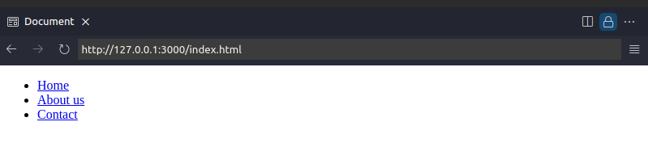
- Clicking on any of the links should take you to that “page”. Anchor tags default behaviour is to navigate to the provided href effectively making a request to the server for that HTML file! 🤓
Create Your Landing Page
- Open index.html in your favorite code editor.
- Inside the <body> tag, but below your navigation links, add an <h1> tag with the name of your coffee shop.
- Add an <img> tag within a div to include a coffee-related image. Pick a favorite from Pexels Coffee Search and use the image URL in the src attribute of the <img> tag. Remember to credit the photographer as a courtesy! You can do this in the alt attribute.
- Let’s set the image width to 100% so it looks tidy
Craft Your About Page
- Open about.html.
- Inside the <body> tag, but below your navigation links, add an <h1> tag with a catchy phrase about the coffee shop.
- Write a few sentences in <p> tags within an enclosing <div> about the coffee shop's history, mission, or what makes it special.
  - There’s a lorem shortcut for Emmet for this kind of boilerplate text btw😀
- Include another <img> inside yet another <div>with a different coffee image from Pexels.
Assemble Your Contact Page
- Open contact.html.
- Inside the <body> tag, but below your navigation links, add an <h1> . Maybe a very straight-forward Contact us is okay here.
- Create a <div> and add any contact like phone and address. Maybe a list?
- Insert one more <img> inside a <div> tag with a coffee image from Pexels.
- Finally, what if the customer want to send feedback or reach out online? Add a form with name, email and message fields. Put this form within a <div>
Conclusion
Congrats! You've brewed your very first multipage website 🎉. Even without styling, you've laid the groundwork for a functional brochure website. This exercise demonstrates the power of HTML in structuring content and linking together different parts of a website. As you become more comfortable with HTML, you'll be able to incorporate CSS for styling and use semantic elements to improve accessibility and SEO. Keep experimenting and learning!

📚 Semantic HTML
Lesson Progress
86% Complete
In the vast and ever-evolving world of web development, the concept of semantic HTML stands as a beacon of clarity and accessibility. Semantic HTML involves using HTML markup to reinforce the semantics, or meaning, of the information in webpages rather than merely defining its presentation or look. This approach is not just about making HTML markup easier to read for developers; it's fundamentally about enhancing accessibility for all users, including those using assistive technologies.
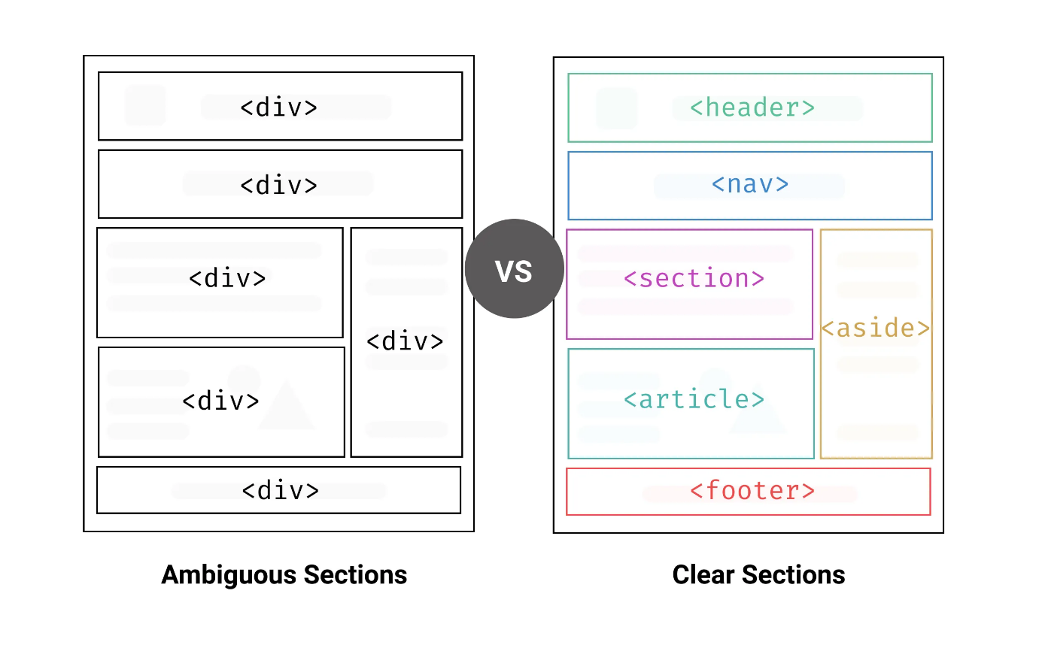
What is Accessibility?
Accessibility, in the context of the web, refers to the practice of making your websites usable by as many people as possible, regardless of disabilities or the devices they are using. This includes individuals who rely on screen readers, keyboard navigation, and other assistive technologies to interact with digital content. Making your web content accessible is not just a good practice; it's a pathway to inclusivity, ensuring that everyone has equal access to information and functionality.
Why Semantic HTML matters?
Semantic HTML plays a crucial role in accessibility. By using elements that describe their meaning in a human- and machine-readable way, developers enable assistive technologies to present content in a more understandable manner. For example, a <nav> element signifies that the enclosed list of links is intended for navigation, helping screen readers announce it as such, rather than just a list of links.
It's essential to understand that semantic elements don't come with any special styling properties by default. Their primary purpose is to describe the structure and meaning of web content. This semantic grouping of information makes it significantly easier for search engines to parse your content and improves SEO too!
Key Semantic Elements in HTML
- <header>: Defines the header of a page or section, typically containing introductory content or navigation links.
- <nav>: Denotes a section of navigation links, guiding users through the website or page sections.
- <main>: Represents the primary content of a document, unique from side content, headers, footers, or navigation links.
- <article>: Indicates a self-contained piece of content that could theoretically stand alone from the rest of the page content, like a blog post.
- <section>: Specifies a section of a document, themed together, which could have its heading.
- <aside>: Marks content indirectly related to the main content, like a sidebar with related links or information.
- <footer>: Defines the footer of a document or section, containing information like copyright notices or related documents.
- <figure> and <figcaption>: Used together to associate an image or illustration (figure) with a caption.
A quick example
Imagine you have the following website. It’s quite easy to understand and read but it could be improved!
<!DOCTYPE html>
<html>
<head>
<title>My Simple Page</title>
</head>
<body>
<div>
<h1>Welcome to My Website</h1>
</div>
<div>
<ul>
<li>Home</li>
<li>About</li>
<li>Contact</li>
</ul>
</div>
<div>
<h2>About Us</h2>
<p>This is a paragraph about our website. We offer various services.</p>
</div>
<div>
<p>Contact us: email@example.com</p>
</div>
</body>
</html>
Now, let’s see how it looks with semantic HTML:
<!DOCTYPE html>
<html>
<head>
<title>My Simple Page</title>
</head>
<body>
<header>
<h1>Welcome to My Website</h1>
</header>
<nav>
<ul>
<li>Home</li>
<li>About</li>
<li>Contact</li>
</ul>
</nav>
<section>
<h2>About Us</h2>
<p>This is a paragraph about our website. We offer various services.</p>
</section>
<footer>
<p>Contact us: email@example.com</p>
</footer>
</body>
</html>
This makes it easier for assistive technologies or search-engines to access your website!
Embracing Semantic HTML
Embracing semantic HTML is about more than adhering to best practices; it's about commitment to inclusivity and ensuring that the web remains an accessible space for everyone. By carefully choosing elements that accurately describe the structure and meaning of your content, you make your sites more navigable and understandable, not just to assistive technologies but to all users.
While the transition to fully semantic HTML can seem daunting, the rewards in terms of accessibility, SEO, and site maintainability are immense. Start small, gradually replacing generic <div> and <span> elements with their semantic counterparts, and witness the positive impact on your user experience and accessibility scores.

🧩 HTML Resume (Semantic HTML)
Lesson Progress
86% Complete
Practice does not make perfect. Practice until you are perfect and you will be perfect only briefly. What's necessary is sustained practice. So…
Repetition. Repetition. Repetition.
Goal
Refactor your HTML resume with Semantic HTML
Steps
This one is easy
- Make a copy of your HTML resume project and rename it appending semantic to the directory
- Open your project in Visual Studio code
- Refactor its contents adding semantic HTML elements!
Conclusion
There’s no only one way! Share your results in class with your instructor and classmates and discuss your approach and reasoning 🚀

🧩 Landing Page (Semantic HTML)
Lesson Progress
86% Complete
Goal
Refactor your Landing Page with Semantic HTML
Steps
This one is easy
- Make a copy of your Landing Page project and rename it appending -semantic to the directory
- Open your project in Visual Studio code
- Refactor its contents adding semantic HTML elements!
Conclusion
There’s no only one way! Share your results in class with your instructor and classmates and discuss your approach and reasoning 🚀

🧩 Multi-page website (Semantic HTML)
Lesson Progress
86% Complete
Goal
Refactor your Multi-page website project with Semantic HTML
Steps
This one is easy (but harder 😀)
- Make a copy of your Multi-page website project and rename it appending -semantic to the directory
- Open your project in Visual Studio code
- Refactor its contents adding semantic HTML elements!
Conclusion
There’s no only one way! Share your results in class with your instructor and classmates and discuss your approach and reasoning 🚀

🧩 Sign up form
Lesson Progress
86% Complete
Goal
Create a signup form for a fictional website that includes various input fields using semantic HTML elements and labels. This form will collect user information such as name, email, password, and a few additional details.
Requirements
This is a sign up form for a Coding School 😅 We need to collect the candidate’s name, email and telephone. Additionally:
- Use semantic HTML elements to structure the form for better accessibility and SEO.
- Use labels for all input fields to ensure the form is accessible.
- Make sure all the fields are required!
- Make sure the input fields are of the correct type for the expected user values
- Add a select element to let the user pick the bootcamp they are interested in.
- Since we are not using CSS just yet, maybe use a fieldset element to wrap your form 😉
Conclusion
Test your form in a browser. Ensure all labels are correctly associated with their respective input fields by clicking on the label text. This should focus the corresponding input field.

