AWS Networking

1. VPC (Virtual Private Cloud)

What is a VPC?
A VPC is your own isolated network in AWS. Think of it as your private data center in the cloud.
┌─────────────────────────────────────────────────────────────────┐
│ AWS CLOUD │
│ ┌───────────────────────────────────────────────────────────┐ │
│ │ YOUR VPC (10.0.0.0/16) │ │
│ │ │ │
│ │ Your isolated network where you launch AWS resources │ │
│ │ │ │
│ │ ┌─────────────┐ ┌─────────────┐ ┌─────────────┐ │ │
│ │ │ Subnet │ │ Subnet │ │ Subnet │ │ │
│ │ │ (Public) │ │ (Private) │ │ (Private) │ │ │
│ │ └─────────────┘ └─────────────┘ └─────────────┘ │ │
│ │ │ │
│ └───────────────────────────────────────────────────────────┘ │
│ │
│ ┌───────────────────────────────────────────────────────────┐ │
│ │ ANOTHER VPC (Different Customer) │ │
│ └───────────────────────────────────────────────────────────┘ │
└─────────────────────────────────────────────────────────────────┘

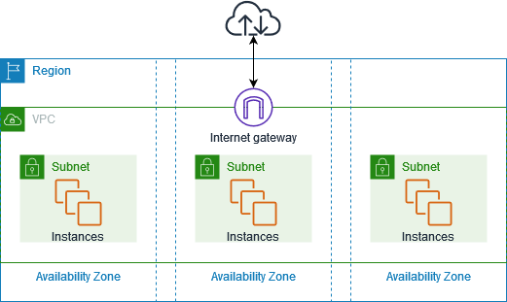

Key VPC Concepts
Concept | Description
CIDR Block | IP address range (e.g., 10.0.0.0/16 = 65,536 IPs)
Region | VPC is region-specific (spans all AZs in region)
Default VPC | AWS creates one per region automatically
Tenancy | Default (shared) or Dedicated (single-tenant hardware)

CIDR Block Explained
10.0.0.0/16
│ │ │ │ │
│ │ │ │ └── /16 = First 16 bits fixed = 65,536 IPs
│ │ │ │ /24 = First 24 bits fixed = 256 IPs
│ │ │ │ /28 = First 28 bits fixed = 16 IPs
│ │ │ │
└──┴─┴─┴───── Network address (10.0.x.x range)

Common CIDR Blocks:
┌──────────────┬───────────────────┬──────────────┐
│ CIDR Block │ IP Range │ # of IPs │
├──────────────┼───────────────────┼──────────────┤
│ 10.0.0.0/16 │ 10.0.0.0-10.0.255.255 │ 65,536 │
│ 10.0.0.0/24 │ 10.0.0.0-10.0.0.255 │ 256 │
│ 10.0.1.0/24 │ 10.0.1.0-10.0.1.255 │ 256 │
│ 172.16.0.0/16│ 172.16.0.0-172.16.255.255│ 65,536│
│ 192.168.0.0/16│192.168.0.0-192.168.255.255│65,536│
└──────────────┴───────────────────┴──────────────┘

Example 1: Create a Basic VPC

Console Method
- Go to VPC Dashboard → Your VPCs → Create VPC
- Click Create VPC

AWS CLI Method
# Create VPC
aws ec2 create-vpc \
--cidr-block 10.0.0.0/16 \
--tag-specifications 'ResourceType=vpc,Tags=[{Key=Name,Value=my-vpc}]'

# Output:
# {
# "Vpc": {
# "VpcId": "vpc-0123456789abcdef0",
# "CidrBlock": "10.0.0.0/16",
# ...
# }
# }

# Enable DNS hostnames (recommended)
aws ec2 modify-vpc-attribute \
--vpc-id vpc-0123456789abcdef0 \
--enable-dns-hostnames '{"Value": true}'

Example 2: Create VPC with VPC Wizard (Full Setup)

Console Method - VPC and More
- Go to VPC Dashboard → Create VPC
- Select VPC and more
- Click Create VPC
This creates:
- 1 VPC
- 2 Public subnets
- 2 Private subnets
- 1 Internet Gateway
- 1-2 NAT Gateways
- Route tables
- S3 endpoint

2. Subnets

What is a Subnet?
A subnet is a segment of your VPC's IP range where you place resources. Each subnet exists in a single Availability Zone.
┌─────────────────────────────────────────────────────────────────┐
│ VPC: 10.0.0.0/16 │
│ │
│ Availability Zone A │ Availability Zone B │
│ ─────────────────────────────│────────────────────────────── │
│ │ │
│ ┌─────────────────────┐ │ ┌─────────────────────┐ │
│ │ PUBLIC SUBNET │ │ │ PUBLIC SUBNET │ │
│ │ 10.0.1.0/24 │ │ │ 10.0.2.0/24 │ │
│ │ │ │ │ │ │
│ │ ┌─────┐ ┌─────┐ │ │ │ ┌─────┐ ┌─────┐ │ │
│ │ │ EC2 │ │ ALB │ │ │ │ │ EC2 │ │ NAT │ │ │
│ │ └─────┘ └─────┘ │ │ │ └─────┘ └─────┘ │ │
│ └─────────────────────┘ │ └─────────────────────┘ │
│ │ │
│ ┌─────────────────────┐ │ ┌─────────────────────┐ │
│ │ PRIVATE SUBNET │ │ │ PRIVATE SUBNET │ │
│ │ 10.0.11.0/24 │ │ │ 10.0.12.0/24 │ │
│ │ │ │ │ │ │
│ │ ┌─────┐ ┌─────┐ │ │ │ ┌─────┐ ┌─────┐ │ │
│ │ │ App │ │ App │ │ │ │ │ App │ │ App │ │ │
│ │ └─────┘ └─────┘ │ │ │ └─────┘ └─────┘ │ │
│ └─────────────────────┘ │ └─────────────────────┘ │
│ │ │
│ ┌─────────────────────┐ │ ┌─────────────────────┐ │
│ │ DATABASE SUBNET │ │ │ DATABASE SUBNET │ │
│ │ 10.0.21.0/24 │ │ │ 10.0.22.0/24 │ │
│ │ │ │ │ │ │
│ │ ┌─────┐ ┌─────┐ │ │ │ ┌─────────────┐ │ │
│ │ │ RDS │ │Redis│ │ │ │ │ RDS Standby │ │ │
│ │ └─────┘ └─────┘ │ │ │ └─────────────┘ │ │
│ └─────────────────────┘ │ └─────────────────────┘ │
│ │ │
└─────────────────────────────────────────────────────────────────┘

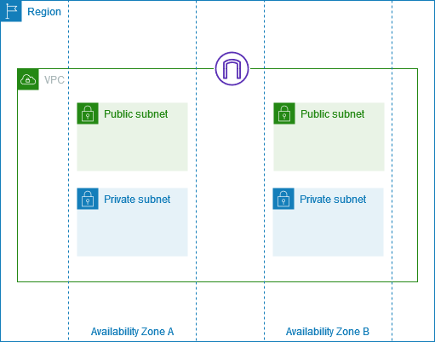

Public vs Private Subnets
Type | Characteristics | Use For
Public | Has route to Internet Gateway | Load balancers, Bastion hosts, NAT Gateways
Private | No direct internet access | App servers, Databases, Internal services

What Makes a Subnet Public or Private?
PUBLIC SUBNET:
Route Table has: 0.0.0.0/0 → Internet Gateway (igw-xxx)
↓
Instances CAN have public IPs
↓
Direct internet access ✅

PRIVATE SUBNET:
Route Table has: 0.0.0.0/0 → NAT Gateway (nat-xxx)
or No 0.0.0.0/0 route at all
↓
Instances have private IPs only
↓
Outbound internet via NAT (or none) ✅

Example 1: Create Public and Private Subnets

Console Method
Create Public Subnet:
- Go to VPC → Subnets → Create subnet
- Click Create subnet
Enable Auto-assign Public IP (for public subnet):
- Select the subnet → Actions → Edit subnet settings
- Check ✅ Enable auto-assign public IPv4 address
- Save
Create Private Subnet:

AWS CLI Method
# Create Public Subnet
aws ec2 create-subnet \
--vpc-id vpc-0123456789abcdef0 \
--cidr-block 10.0.1.0/24 \
--availability-zone us-east-1a \
--tag-specifications 'ResourceType=subnet,Tags=[{Key=Name,Value=public-subnet-1a}]'

# Enable auto-assign public IP
aws ec2 modify-subnet-attribute \
--subnet-id subnet-public123 \
--map-public-ip-on-launch

# Create Private Subnet
aws ec2 create-subnet \
--vpc-id vpc-0123456789abcdef0 \
--cidr-block 10.0.11.0/24 \
--availability-zone us-east-1a \
--tag-specifications 'ResourceType=subnet,Tags=[{Key=Name,Value=private-subnet-1a}]'

# Create subnets in second AZ
aws ec2 create-subnet \
--vpc-id vpc-0123456789abcdef0 \
--cidr-block 10.0.2.0/24 \
--availability-zone us-east-1b \
--tag-specifications 'ResourceType=subnet,Tags=[{Key=Name,Value=public-subnet-1b}]'

aws ec2 create-subnet \
--vpc-id vpc-0123456789abcdef0 \
--cidr-block 10.0.12.0/24 \
--availability-zone us-east-1b \
--tag-specifications 'ResourceType=subnet,Tags=[{Key=Name,Value=private-subnet-1b}]'

3. Route Tables

What is a Route Table?
A route table contains rules (routes) that determine where network traffic is directed.
┌─────────────────────────────────────────────────────────────────┐
│ ROUTE TABLE │
│ │
│ ┌────────────────────────────────────────────────────────────┐ │
│ │ Destination │ Target │ Status │ │
│ ├────────────────────┼──────────────────────┼────────────────┤ │
│ │ 10.0.0.0/16 │ local │ Active │ │
│ │ 0.0.0.0/0 │ igw-xxxxx │ Active │ │
│ │ 172.16.0.0/16 │ pcx-xxxxx │ Active │ │
│ └────────────────────┴──────────────────────┴────────────────┘ │
│ │
│ Routes are evaluated from MOST SPECIFIC to LEAST SPECIFIC │
│ 10.0.0.0/16 (more specific) wins over 0.0.0.0/0 (less specific)│
└─────────────────────────────────────────────────────────────────┘

Route Table Concepts
Concept | Description
Main Route Table | Default for subnets not explicitly associated
Custom Route Table | Created by you, explicitly associated with subnets
Local Route | Auto-created, allows communication within VPC
Destination | Target IP range (CIDR)
Target | Where to send traffic (IGW, NAT, VPC Peering, etc.)

Common Route Targets
┌──────────────────────────────────────────────────────────────┐
│ Target Type │ Format │ Use Case │
├──────────────────────┼─────────────────┼─────────────────────┤
│ Local │ local │ Within VPC │
│ Internet Gateway │ igw-xxxxx │ Internet access │
│ NAT Gateway │ nat-xxxxx │ Private → Internet │
│ VPC Peering │ pcx-xxxxx │ Cross-VPC traffic │
│ Transit Gateway │ tgw-xxxxx │ Hub connectivity │
│ VPN Gateway │ vgw-xxxxx │ VPN connection │
│ Network Interface │ eni-xxxxx │ Specific instance │
│ VPC Endpoint │ vpce-xxxxx │ AWS services │
└──────────────────────────────────────────────────────────────┘

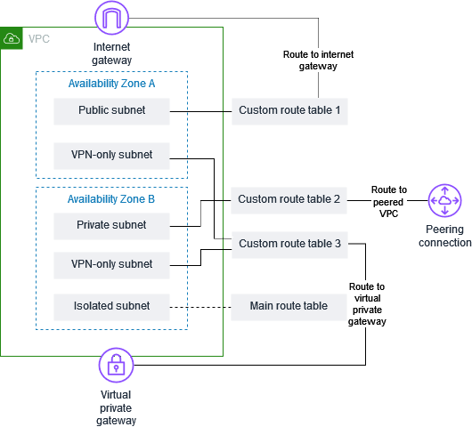

Example 1: Create Public Route Table

Console Method
- Go to VPC → Route Tables → Create route table
- Click Create route table
Add Internet Route:
- Select public-rt → Routes tab → Edit routes
- Save changes
Associate with Public Subnets:
- Subnet associations tab → Edit subnet associations
- Select public subnets → Save

AWS CLI Method
# Create route table
aws ec2 create-route-table \
--vpc-id vpc-0123456789abcdef0 \
--tag-specifications 'ResourceType=route-table,Tags=[{Key=Name,Value=public-rt}]'

# Output: "RouteTableId": "rtb-0123456789abcdef0"

# Add route to Internet Gateway
aws ec2 create-route \
--route-table-id rtb-0123456789abcdef0 \
--destination-cidr-block 0.0.0.0/0 \
--gateway-id igw-0123456789abcdef0

# Associate with subnet
aws ec2 associate-route-table \
--route-table-id rtb-0123456789abcdef0 \
--subnet-id subnet-public123

Example 2: Create Private Route Table with NAT Gateway

Console Method
- Create route table named private-rt
- Associate with private subnets

AWS CLI Method
# Create private route table
aws ec2 create-route-table \
--vpc-id vpc-0123456789abcdef0 \
--tag-specifications 'ResourceType=route-table,Tags=[{Key=Name,Value=private-rt}]'

# Add route to NAT Gateway
aws ec2 create-route \
--route-table-id rtb-private123 \
--destination-cidr-block 0.0.0.0/0 \
--nat-gateway-id nat-0123456789abcdef0

# Associate with private subnets
aws ec2 associate-route-table \
--route-table-id rtb-private123 \
--subnet-id subnet-private123

Example 3: Complete Route Table Setup Diagram
┌─────────────────────────────────────────────────────────────────┐
│ VPC │
│ │
│ PUBLIC ROUTE TABLE (public-rt) │
│ ┌────────────────────────────────────────────────────────┐ │
│ │ Destination │ Target │ │
│ ├──────────────────┼──────────────────────────────────────│ │
│ │ 10.0.0.0/16 │ local │ │
│ │ 0.0.0.0/0 │ igw-xxxxx (Internet Gateway) │ │
│ └────────────────────────────────────────────────────────┘ │
│ │ │
│ ├──────────────► public-subnet-1a │
│ └──────────────► public-subnet-1b │
│ │
│ PRIVATE ROUTE TABLE (private-rt) │
│ ┌────────────────────────────────────────────────────────┐ │
│ │ Destination │ Target │ │
│ ├──────────────────┼──────────────────────────────────────│ │
│ │ 10.0.0.0/16 │ local │ │
│ │ 0.0.0.0/0 │ nat-xxxxx (NAT Gateway) │ │
│ └────────────────────────────────────────────────────────┘ │
│ │ │
│ ├──────────────► private-subnet-1a │
│ └──────────────► private-subnet-1b │
│ │
└─────────────────────────────────────────────────────────────────┘

4. Internet Gateway

What is an Internet Gateway?
An Internet Gateway allows communication between your VPC and the internet.
INTERNET
│
▼
┌─────────────────┐
│ Internet Gateway│
│ (igw-xxx) │
└────────┬────────┘
│
┌─────────────┴─────────────┐
▼ ▼
┌─────────────────┐ ┌─────────────────┐
│ Public Subnet │ │ Public Subnet │
│ (10.0.1.0/24) │ │ (10.0.2.0/24) │
│ │ │ │
│ ┌───────────┐ │ │ ┌───────────┐ │
│ │ EC2 │ │ │ │ EC2 │ │
│ │ Public IP │ │ │ │ Public IP │ │
│ └───────────┘ │ │ └───────────┘ │
└─────────────────┘ └─────────────────┘

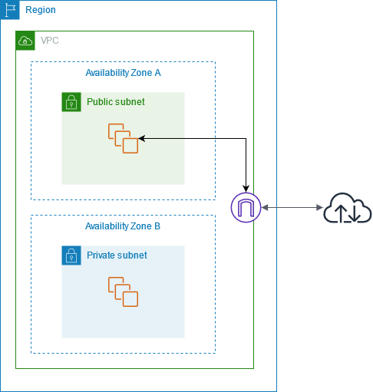

Key Points:
- One IGW per VPC
- Horizontally scaled, redundant, highly available
- No bandwidth constraints
- FREE! (No hourly charge)

Example: Create and Attach Internet Gateway

Console Method
- Go to VPC → Internet Gateways → Create internet gateway
- Name: my-igw
- Click Create internet gateway
- Select the IGW → Actions → Attach to VPC
- Select your VPC → Attach

AWS CLI Method
aws ec2 create-internet-gateway \
--tag-specifications 'ResourceType=internet-gateway,Tags=[{Key=Name,Value=my-igw}]'

# Output: "InternetGatewayId": "igw-0123456789abcdef0"

# Attach to VPC
aws ec2 attach-internet-gateway \
--internet-gateway-id igw-0123456789abcdef0 \
--vpc-id vpc-0123456789abcdef0

# Verify
aws ec2 describe-internet-gateways \
--internet-gateway-ids igw-0123456789abcdef0

5. NAT Gateway

What is a NAT Gateway?
NAT Gateway allows instances in private subnets to access the internet while remaining private (no inbound internet access).
INTERNET
│
▼
┌─────────────────┐
│ Internet Gateway│
└────────┬────────┘
│
▼
┌──────────────────────┐
│ PUBLIC SUBNET │
│ ┌──────────────┐ │
│ │ NAT Gateway │ │
│ │ (nat-xxx) │ │
│ │ Elastic IP │ │
│ └──────┬───────┘ │
└──────────┼───────────┘
│
┌───────────────┴───────────────┐
▼ ▼
┌─────────────────┐ ┌─────────────────┐
│ PRIVATE SUBNET │ │ PRIVATE SUBNET │
│ │ │ │
│ ┌───────────┐ │ │ ┌───────────┐ │
│ │ EC2 │──┼────────────┼──│ EC2 │ │
│ │ No Public │ │ │ │ No Public │ │
│ │ IP │ │ Can reach │ │ IP │ │
│ └───────────┘ │ internet │ └───────────┘ │
│ │ for updates│ │
└─────────────────┘ └─────────────────┘
Internet CANNOT
reach these instances

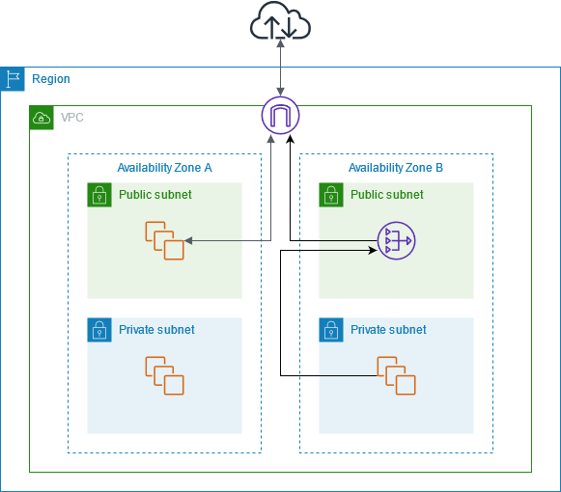

NAT Gateway vs NAT Instance
Feature | NAT Gateway | NAT Instance
Managed by | AWS | You
Availability | Highly available in AZ | Single instance
Bandwidth | Up to 100 Gbps | Depends on instance
Maintenance | None | You patch/update
Cost | ~$0.045/hr + data | Instance cost
Security Groups | Not supported | Supported

Example 1: Create NAT Gateway

Console Method
- Go to VPC → NAT Gateways → Create NAT gateway
- Click Create NAT gateway
- Wait for status to become "Available" (~2-3 minutes)

AWS CLI Method
# First, allocate an Elastic IP
aws ec2 allocate-address --domain vpc
# Output: "AllocationId": "eipalloc-0123456789abcdef0"

# Create NAT Gateway in PUBLIC subnet
aws ec2 create-nat-gateway \
--subnet-id subnet-public123 \
--allocation-id eipalloc-0123456789abcdef0 \
--tag-specifications 'ResourceType=natgateway,Tags=[{Key=Name,Value=nat-gw-1a}]'

# Wait for it to be available
aws ec2 wait nat-gateway-available \
--nat-gateway-ids nat-0123456789abcdef0

# Add route in private route table
aws ec2 create-route \
--route-table-id rtb-private123 \
--destination-cidr-block 0.0.0.0/0 \
--nat-gateway-id nat-0123456789abcdef0

Example 2: High Availability NAT Setup
For production, create a NAT Gateway in each AZ:
┌─────────────────────────────────────────────────────────────────┐
│ VPC │
│ │
│ AZ-a │ AZ-b │
│ ──────────────────────────────│───────────────────────────── │
│ │ │
│ ┌─────────────────┐ │ ┌─────────────────┐ │
│ │ PUBLIC SUBNET │ │ │ PUBLIC SUBNET │ │
│ │ ┌───────────┐ │ │ │ ┌───────────┐ │ │
│ │ │ NAT GW 1 │ │ │ │ │ NAT GW 2 │ │ │
│ │ │(nat-xxx1) │ │ │ │ │(nat-xxx2) │ │ │
│ │ └─────┬─────┘ │ │ │ └─────┬─────┘ │ │
│ └────────┼────────┘ │ └────────┼────────┘ │
│ │ │ │ │
│ ▼ │ ▼ │
│ ┌─────────────────┐ │ ┌─────────────────┐ │
│ │ PRIVATE SUBNET │ │ │ PRIVATE SUBNET │ │
│ │ Route: 0.0.0.0/0│ │ │ Route: 0.0.0.0/0│ │
│ │ → nat-xxx1 │ │ │ → nat-xxx2 │ │
│ └─────────────────┘ │ └─────────────────┘ │
│ │ │
│ Private RT for AZ-a │ Private RT for AZ-b │
│ points to NAT in AZ-a │ points to NAT in AZ-b │
│ │ │
└─────────────────────────────────────────────────────────────────┘

CLI for HA NAT Setup
# Create NAT Gateway in AZ-a
aws ec2 allocate-address --domain vpc # Get eipalloc-1
aws ec2 create-nat-gateway \
--subnet-id subnet-public-1a \
--allocation-id eipalloc-1 \
--tag-specifications 'ResourceType=natgateway,Tags=[{Key=Name,Value=nat-gw-1a}]'

# Create NAT Gateway in AZ-b
aws ec2 allocate-address --domain vpc # Get eipalloc-2
aws ec2 create-nat-gateway \
--subnet-id subnet-public-1b \
--allocation-id eipalloc-2 \
--tag-specifications 'ResourceType=natgateway,Tags=[{Key=Name,Value=nat-gw-1b}]'

# Create separate route tables for each AZ
# RT for AZ-a private subnets → nat-gw-1a
# RT for AZ-b private subnets → nat-gw-1b

6. Security Groups

What is a Security Group?
A Security Group is a virtual firewall for your instances that controls inbound and outbound traffic.
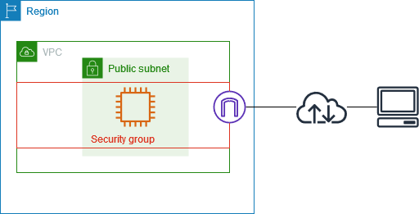
┌───────────────────────────────────────────────────────────────┐
│ SECURITY GROUP │
│ │
│ INBOUND RULES (What can come IN) │
│ ┌─────────────────────────────────────────────────────────┐│
│ │ Type │ Protocol │ Port │ Source │ Status ││
│ ├─────────┼──────────┼───────┼─────────────────┼─────────┤│
│ │ SSH │ TCP │ 22 │ 10.0.0.0/8 │ Allow ││
│ │ HTTP │ TCP │ 80 │ 0.0.0.0/0 │ Allow ││
│ │ HTTPS │ TCP │ 443 │ 0.0.0.0/0 │ Allow ││
│ │ Custom │ TCP │ 8080 │ sg-alb-xxxxx │ Allow ││
│ └─────────────────────────────────────────────────────────┘│
│ │
│ OUTBOUND RULES (What can go OUT) │
│ ┌─────────────────────────────────────────────────────────┐│
│ │ Type │ Protocol │ Port │ Destination │ Status ││
│ ├─────────┼──────────┼───────┼─────────────────┼─────────┤│
│ │ All │ All │ All │ 0.0.0.0/0 │ Allow ││
│ └─────────────────────────────────────────────────────────┘│
│ │
│ ⚠️ NO DENY RULES - Only ALLOW │
│ ⚠️ STATEFUL - Return traffic automatically allowed │
└───────────────────────────────────────────────────────────────┘

Key Security Group Features
Feature | Description
Stateful | Return traffic is automatically allowed
Allow only | No deny rules (implicit deny all)
Instance level | Attached to ENI (network interface)
Multiple SGs | Instance can have multiple security groups
SG as source | Can reference other security groups
Changes immediate | No restart required

Example 1: Web Server Security Group

Console Method
- Go to EC2 → Security Groups → Create security group
- Outbound rules: (keep default - allow all)
- Create

AWS CLI Method
# Create security group
aws ec2 create-security-group \
--group-name web-server-sg \
--description "Security group for web servers" \
--vpc-id vpc-0123456789abcdef0

# Output: "GroupId": "sg-0123456789abcdef0"

# Add inbound rules
# HTTP
aws ec2 authorize-security-group-ingress \
--group-id sg-0123456789abcdef0 \
--protocol tcp \
--port 80 \
--cidr 0.0.0.0/0

# HTTPS
aws ec2 authorize-security-group-ingress \
--group-id sg-0123456789abcdef0 \
--protocol tcp \
--port 443 \
--cidr 0.0.0.0/0

# SSH from internal network only
aws ec2 authorize-security-group-ingress \
--group-id sg-0123456789abcdef0 \
--protocol tcp \
--port 22 \
--cidr 10.0.0.0/8

Example 2: Multi-Tier Security Group Setup
┌─────────────────────────────────────────────────────────────────┐
│ MULTI-TIER SECURITY GROUPS │
│ │
│ INTERNET │
│ │ │
│ ▼ │
│ ┌─────────────────────────────────────────────────────────┐ │
│ │ ALB Security Group │ │
│ │ Inbound: 80, 443 from 0.0.0.0/0 │ │
│ │ Outbound: All │ │
│ └─────────────────────────┬───────────────────────────────┘ │
│ │ │
│ ▼ │
│ ┌─────────────────────────────────────────────────────────┐ │
│ │ App Security Group │ │
│ │ Inbound: 8080 from ALB-SG (sg-alb-xxx) │ │
│ │ Outbound: All │ │
│ └─────────────────────────┬───────────────────────────────┘ │
│ │ │
│ ▼ │
│ ┌─────────────────────────────────────────────────────────┐ │
│ │ DB Security Group │ │
│ │ Inbound: 5432 from App-SG (sg-app-xxx) │ │
│ │ Outbound: All │ │
│ └─────────────────────────────────────────────────────────┘ │
│ │
│ 🔒 Each tier only accepts traffic from the tier above │
└─────────────────────────────────────────────────────────────────┘

7. Network ACLs (NACLs)

What is a NACL?
Network Access Control List is a stateless firewall at the subnet level.
┌─────────────────────────────────────────────────────────────────┐
│ NETWORK ACL (NACL) │
│ │
│ INBOUND RULES │
│ ┌───────────────────────────────────────────────────────────┐ │
│ │ Rule # │ Type │ Protocol │ Port │ Source │ Allow?│ │
│ ├────────┼─────────┼──────────┼────────┼───────────┼───────┤ │
│ │ 100 │ HTTP │ TCP │ 80 │ 0.0.0.0/0 │ ALLOW │ │
│ │ 110 │ HTTPS │ TCP │ 443 │ 0.0.0.0/0 │ ALLOW │ │
│ │ 120 │ SSH │ TCP │ 22 │ 10.0.0.0/8│ ALLOW │ │
│ │ 130 │ Custom │ TCP │ 1024-65535│0.0.0.0/0│ ALLOW │ │
│ │ * │ All │ All │ All │ 0.0.0.0/0 │ DENY │ │
│ └───────────────────────────────────────────────────────────┘ │
│ │
│ OUTBOUND RULES │
│ ┌───────────────────────────────────────────────────────────┐ │
│ │ Rule # │ Type │ Protocol │ Port │ Dest │ Allow?│ │
│ ├────────┼─────────┼──────────┼────────┼───────────┼───────┤ │
│ │ 100 │ HTTP │ TCP │ 80 │ 0.0.0.0/0 │ ALLOW │ │
│ │ 110 │ HTTPS │ TCP │ 443 │ 0.0.0.0/0 │ ALLOW │ │
│ │ 120 │ Custom │ TCP │ 1024-65535│0.0.0.0/0│ ALLOW │ │
│ │ * │ All │ All │ All │ 0.0.0.0/0 │ DENY │ │
│ └───────────────────────────────────────────────────────────┘ │
│ │
│ ⚠️ STATELESS - Must allow return traffic explicitly! │
│ ⚠️ Rules evaluated in ORDER by rule number │
│ ⚠️ First matching rule wins │
└─────────────────────────────────────────────────────────────────┘
Characteristic | Security group | Network ACL
Level of operation | Instance level | Subnet level
Scope | Applies to all instances associated with the security group | Applies to all instances in the associated subnets
Rule type | Allow rules only | Allow and deny rules
Rule evaluation | Evaluates all rules before deciding whether to allow traffic | Evaluates rules in ascending order until a match for the traffic is found
Return traffic | Automatically allowed (stateful) | Must be explicitly allowed (stateless)

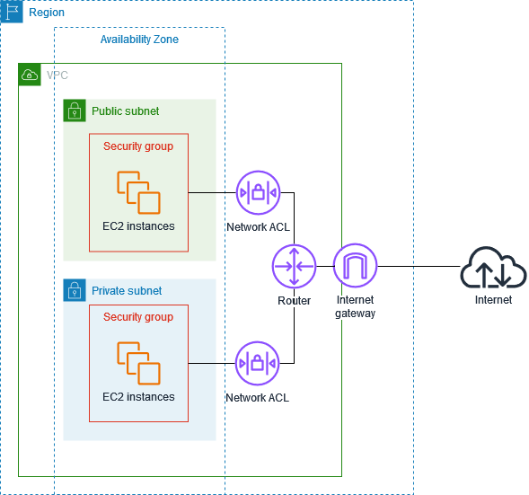

NACL -

Ephemeral port are managed by the OS of the machine.

For mac os ephemeral ports vary from 49152 to 65535
For windows, ports range can be set in the interval 1025 to 65535
For most linux kernel 32768 to 60999.

Example 1: Create NACL for Public Subnet

Console Method
- Go to VPC → Network ACLs → Create network ACL
- Create
Edit Inbound Rules:
Rule # | Type | Protocol | Port Range | Source | Allow/Deny
100 | HTTP | TCP | 80 | 0.0.0.0/0 | Allow
110 | HTTPS | TCP | 443 | 0.0.0.0/0 | Allow
120 | SSH | TCP | 22 | 10.0.0.0/8 | Allow
130 | Ephemeral | TCP | 1024-65535 | 0.0.0.0/0 | Allow
 | All | All | All | 0.0.0.0/0 | Deny
Edit Outbound Rules:
Rule # | Type | Protocol | Port Range | Dest | Allow/Deny
100 | HTTP | TCP | 80 | 0.0.0.0/0 | Allow
110 | HTTPS | TCP | 443 | 0.0.0.0/0 | Allow
120 | Ephemeral | TCP | 1024-65535 | 0.0.0.0/0 | Allow
 | All | All | All | 0.0.0.0/0 | Deny

NACL Diagram with Traffic Flow
INTERNET
│
▼
┌─────────────────────────────┐
│ NACL (Subnet Level) │
│ ┌───────────────────────┐ │
│ │ Rule 50: DENY badIP │ │ ← Checked first
│ │ Rule 100: ALLOW 80 │ │
│ │ Rule 110: ALLOW 443 │ │
│ │ Rule *: DENY all │ │ ← Implicit deny
│ └───────────────────────┘ │
└──────────────┬──────────────┘
│
▼
┌─────────────────────────────┐
│ Security Group (Instance) │
│ ┌───────────────────────┐ │
│ │ ALLOW 80 from ALB-SG │ │
│ │ ALLOW 443 from ALB-SG │ │
│ └───────────────────────┘ │
└──────────────┬──────────────┘
│
▼
┌───────────┐
│ EC2 │
└───────────┘

Traffic must pass BOTH NACL and Security Group!

8. Elastic IPs

What is an Elastic IP?
An Elastic IP is a static, public IPv4 address that you can allocate and associate with AWS resources.
┌─────────────────────────────────────────────────────────────────┐
│ ELASTIC IP │
│ │
│ Normal Public IP (Dynamic) Elastic IP (Static) │
│ ┌─────────────────────────┐ ┌─────────────────────────┐ │
│ │ Assigned at launch │ │ You allocate it │ │
│ │ Changes on stop/start │ │ Never changes │ │
│ │ Released on terminate │ │ You control lifecycle │ │
│ │ FREE │ │ FREE when attached │ │
│ └─────────────────────────┘ │ $0.005/hr when NOT │ │
│ │ attached │ │
│ └─────────────────────────┘ │
│ │
│ Use Cases: │
│ • Failover - quickly remap to standby instance │
│ • Whitelisting - fixed IP for firewall rules │
│ • NAT Gateway - requires Elastic IP │
│ • DNS - stable IP for A records │
└─────────────────────────────────────────────────────────────────┘

Elastic IP Limits & Costs
Aspect | Details
Default Limit | 5 per region (can request more)
Cost (attached) | FREE
Cost (unattached) | $0.005/hour (~$3.60/month)
Cost (additional on running) | $0.005/hour per additional EIP

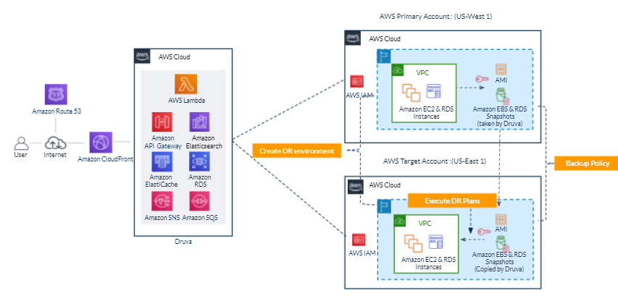

This guide walks you through setting up an EC2 instance with Nginx serving multiple paths, and configuring an Application Load Balancer (ALB) with path-based routing.

Architecture
Internet
│
▼
┌───────────────┐
│ ALB │
│ (Port 80) │
└───────┬───────┘
│
┌───────────────┴───────────────┐
│ │
Path: /* Path: /api/*
│ │
▼ ▼
┌───────────────┐ ┌───────────────┐
│ Target Group │ │ Target Group │
│ (default) │ │ (api) │
└───────┬───────┘ └───────┬───────┘
│ │
└───────────────┬───────────────┘
│
▼
┌───────────────┐
│ EC2 │
│ Nginx │
│ (Port 80) │
└───────────────┘

Prerequisites
- AWS Account with appropriate permissions
- EC2 instance running Ubuntu (or Amazon Linux)
- VPC with public subnets in at least 2 Availability Zones
- Security Groups configured

Part 1: EC2 Instance Setup

Step 1: Install Nginx
# Update packages
sudo apt update

# Install Nginx
sudo apt install nginx -y

# Start and enable Nginx
sudo systemctl start nginx
sudo systemctl enable nginx

# Verify Nginx is running
sudo systemctl status nginx
ss -tulpn | grep 80

Step 2: Create Directory Structure
# Create /api directory
sudo mkdir -p /usr/share/nginx/html/api

# Create default page
echo "<h1>Welcome to Home Page</h1>" | sudo tee /usr/share/nginx/html/index.html

# Create API page
echo "<h1>API Response - /api</h1>" | sudo tee /usr/share/nginx/html/api/index.html

# Set proper permissions
sudo chmod -R 755 /usr/share/nginx/html
sudo chown -R www-data:www-data /usr/share/nginx/html

Step 3: Configure Nginx
Remove default config (if exists):
sudo rm -f /etc/nginx/sites-enabled/default
sudo rm -f /etc/nginx/conf.d/default.conf
Create new configuration:
sudo vi /etc/nginx/conf.d/myapp.conf
Paste the following configuration:
server {
listen 80;
server_name _;

root /usr/share/nginx/html;

# /api path - TRAILING SLASHES ARE IMPORTANT
location /api/ {
alias /usr/share/nginx/html/api/;
index index.html;
}

# Default location
location / {
try_files $uri $uri/ =404;
}
}

Step 4: Test and Reload Nginx
# Test configuration syntax
sudo nginx -t

# Reload Nginx
sudo systemctl reload nginx

# Test locally
curl http://localhost/
curl http://localhost/api/
Expected Output:
<h1>Welcome to Home Page</h1>
<h1>API Response - /api</h1>

Part 2: AWS Security Groups Setup

ALB Security Group
Create a security group for the ALB with these inbound rules:
Type | Port | Source | Description
HTTP | 80 | 0.0.0.0/0 | Allow HTTP from internet

EC2 Security Group
Create/modify EC2 security group with these inbound rules:
Type | Port | Source | Description
SSH | 22 | Your IP | SSH access
HTTP | 80 | ALB Security Group | Allow traffic from ALB
Important: The EC2 must allow port 80 from the ALB's security group for health checks to pass.

Part 3: Create Target Groups

Target Group for Default Path (/)
- Go to EC2 → Target Groups → Create target group
- Configure:
  - Target type: Instances
  - Target group name: tg-default
  - Protocol: HTTP
  - Port: 80
  - VPC: Select your VPC
- Health check settings:
  - Protocol: HTTP
  - Path: /
  - Success codes: 200-399
- Click Next → Register your EC2 instance → Create target group

Target Group for API Path (/api/*)
- Create another target group:
  - Target group name: tg-api
  - Protocol: HTTP
  - Port: 80
- Health check settings:
  - Path: /api/
  - Success codes: 200-399
- Register the same EC2 instance → Create target group

Part 4: Create Application Load Balancer

Step 1: Create ALB
- Go to EC2 → Load Balancers → Create Load Balancer
- Select Application Load Balancer
- Configure:
  - Name: myALB
  - Scheme: Internet-facing
  - IP address type: IPv4
- Network mapping:
  - Select your VPC
  - Select at least 2 public subnets in different AZs
- Security groups:
  - Select the ALB security group (with port 80 open)
- Listeners:
  - Protocol: HTTP, Port: 80
  - Default action: Forward to tg-default
- Click Create load balancer

Step 2: Add Path-Based Routing Rules
- Go to Load Balancers → Select myALB
- Click Listeners tab → Click on HTTP:80
- Click Add rule
- Configure Rule for /api/*:
  - Name: api-routing
  - Priority: 1
IF (Conditions):
  - Add condition → Path
  - Value: /api/*
THEN (Actions):
  - Forward to → tg-api
- Click Save

Final Listener Rules Should Look Like:
Priority | Condition | Action
1 | Path = /api/* | Forward to tg-api
Last (default) | If no other rule applies | Forward to tg-default

Part 5: Verify Setup

Check Target Health
- Go to EC2 → Target Groups
- Select each target group
- Click Targets tab
- Status should show healthy
If unhealthy, check:
- EC2 security group allows port 80 from ALB
- Health check path returns HTTP 200
- Nginx is running

Test ALB Endpoints
Get your ALB DNS name from: Load Balancers → Select ALB → DNS name
# Test default path
curl http://myALB-XXXXXXXXX.us-east-1.elb.amazonaws.com/

# Test API path
curl http://myALB-XXXXXXXXX.us-east-1.elb.amazonaws.com/api/
Expected Output:
<h1>Welcome to Home Page</h1>
<h1>API Response - /api</h1>

Troubleshooting

Issue: Connection Timeout
Cause: Security group blocking traffic
Fix:
- Ensure ALB security group allows inbound port 80 from 0.0.0.0/0
- Ensure EC2 security group allows inbound port 80 from ALB security group

Issue: 503 Service Unavailable
Cause: All targets are unhealthy
Fix:
- Check target group health status
- Verify health check path returns HTTP 200:
- curl -I http://localhost/
curl -I http://localhost/api/
- Ensure EC2 security group allows traffic from ALB

Issue: 404 Not Found on /api/
Cause: Nginx misconfiguration or missing files
Fix:
- Ensure trailing slashes in Nginx config:
- location /api/ {
- alias /usr/share/nginx/html/api/;
}
- Verify file exists:
ls -la /usr/share/nginx/html/api/index.html

Issue: 502 Bad Gateway
Cause: Nginx not running or crashed
Fix:
sudo systemctl status nginx
sudo systemctl start nginx
sudo tail -f /var/log/nginx/error.log

Quick Reference Commands
# Nginx commands
sudo systemctl start nginx
sudo systemctl stop nginx
sudo systemctl reload nginx
sudo systemctl status nginx
sudo nginx -t # Test config

# View logs
sudo tail -f /var/log/nginx/access.log
sudo tail -f /var/log/nginx/error.log

# AWS CLI - Check target health
aws elbv2 describe-target-health --target-group-arn <TG_ARN>

# Test endpoints
curl -I http://localhost/ # Local test
curl http://<ALB-DNS>/ # ALB default
curl http://<ALB-DNS>/api/ # ALB API path

