**Neural Network Report**

**(Task 2)**

|  |  |  |  |
| --- | --- | --- | --- |
| Name | ID | Section | Department |
| 1. محمد سامي عبد الكريم أحمد حسان | 20201700691 | **Section 8** | Computer Science |
| 1. يوسف عبدالحميد فرج الحميد الكمار | 20201701249 | **Section 12** | Computer Science |
| 1. كريم حسين عبده جويلي | 20201700605 | **Section 7** | Computer Science |
| 1. كمال كريم فؤاد رمضان | 20191700897 | **Section 7** | Computer Science |
| 1. ماريا سامح مكرم بولس | 20201700633 | **Section 7** | Computer Science |

Sigmoid Examples

Example (2):

Example (3):

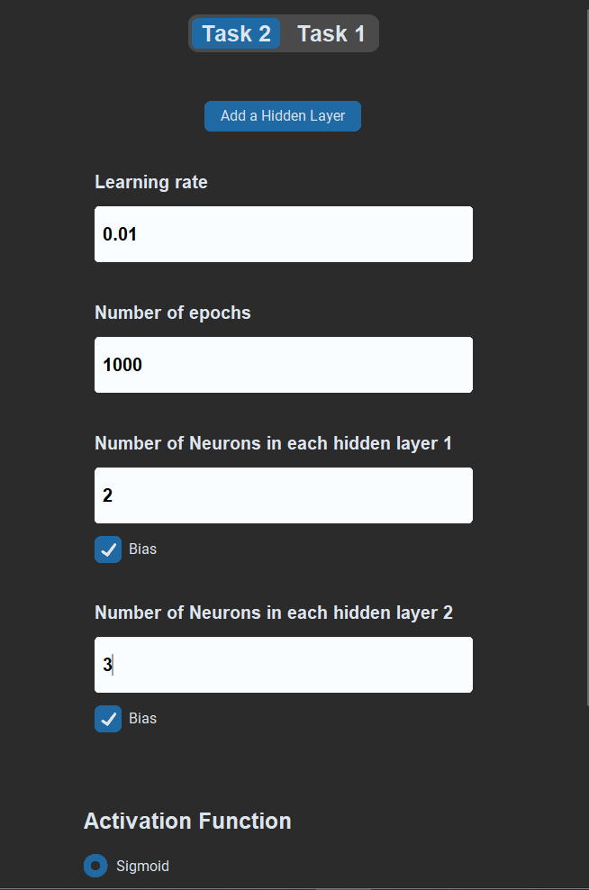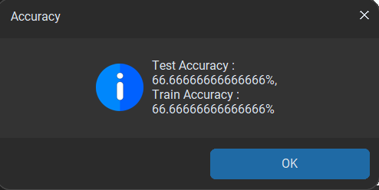

Example (4):

Example (5):

Hyperbolic Examples

Example (1):

Example (2):

Example (3):

Example (4):

Example (5) :

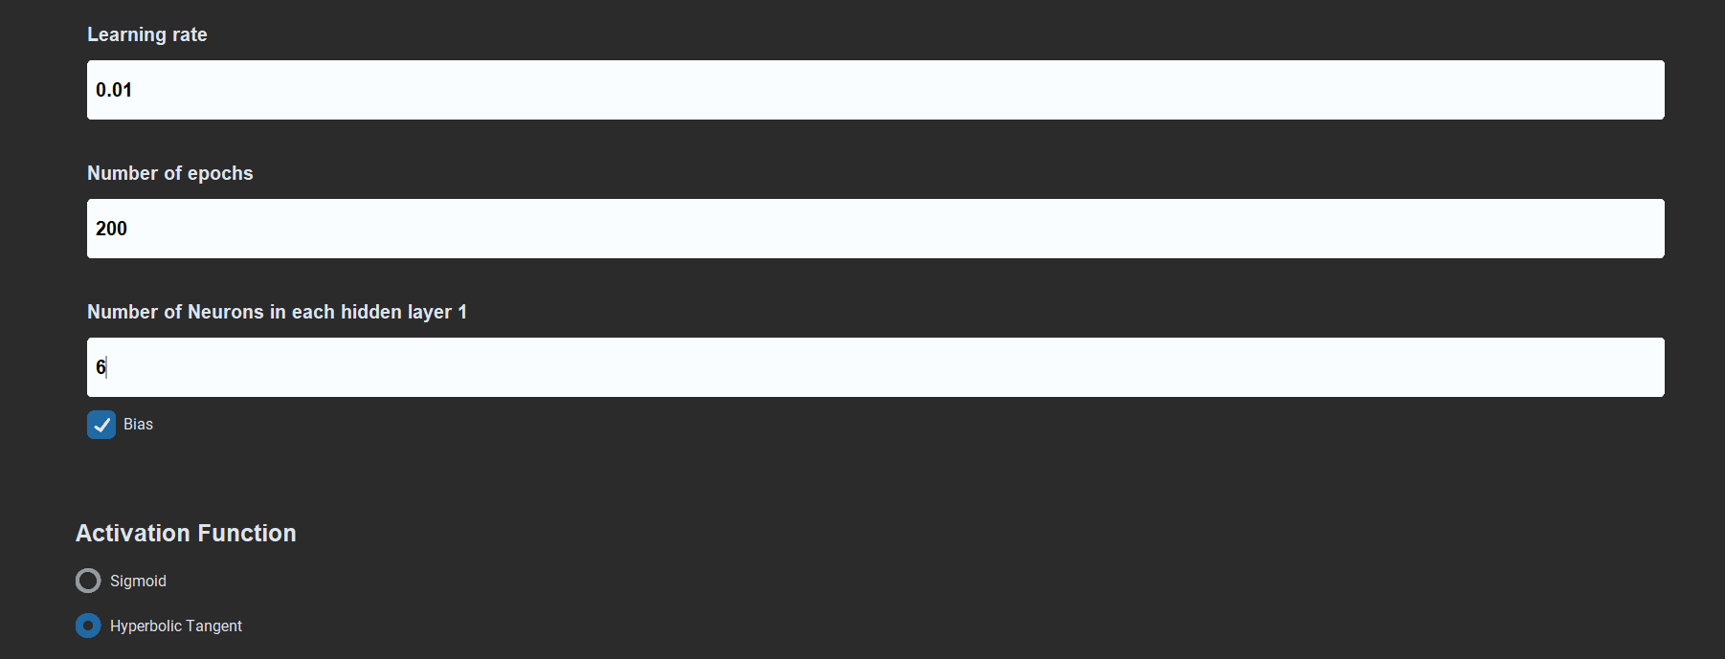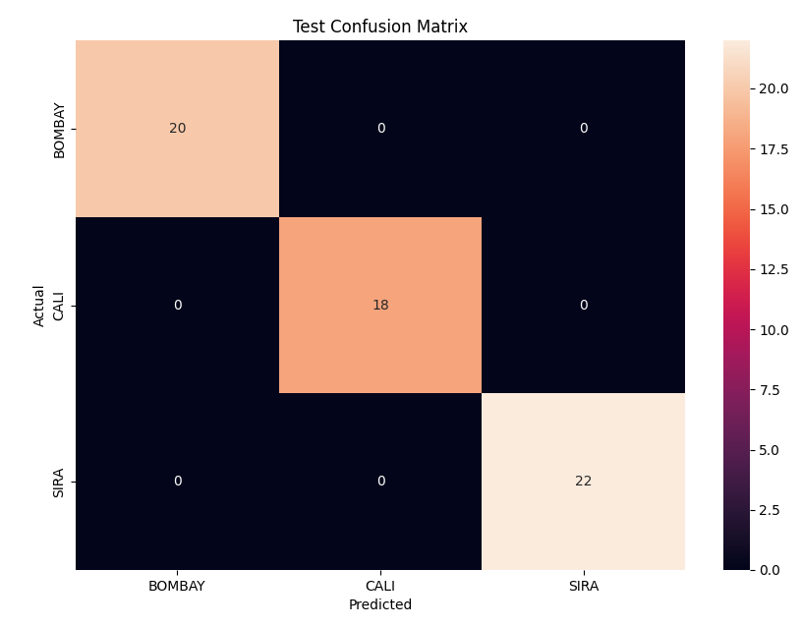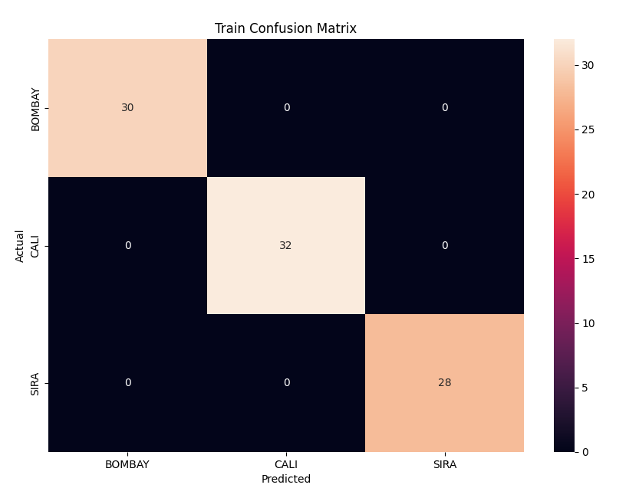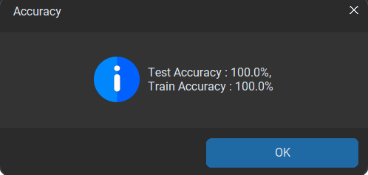

Example (6) :

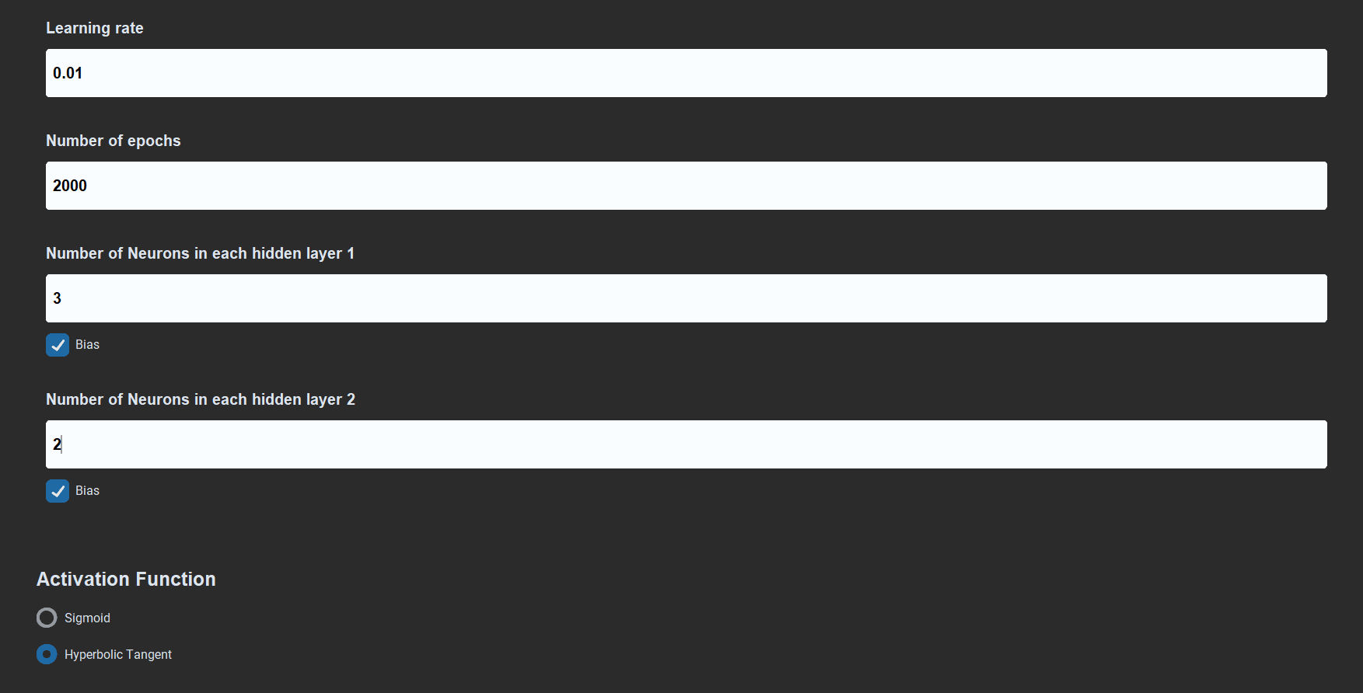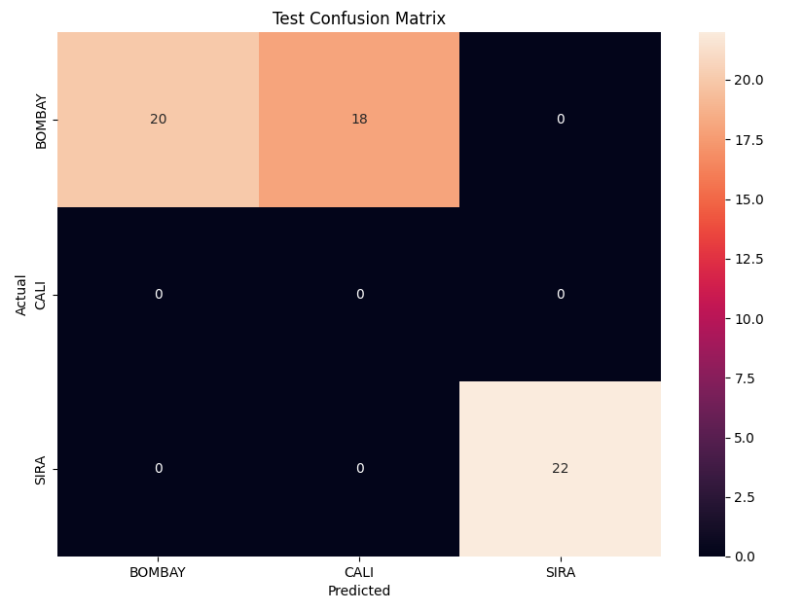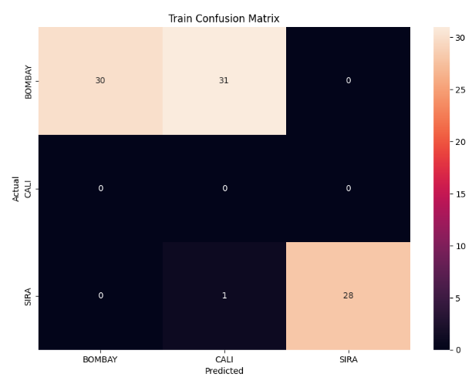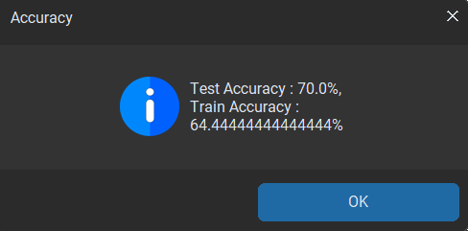

Summary table

|  |  |  |  |  |  |  |
| --- | --- | --- | --- | --- | --- | --- |
| Activation Function | Train Accuracy | Test Accuracy | LR | Epochs | #Layers | #HiddenNodes |
| Sigmoid | 100 | 100 | 0.01 | 1000 | 1 | 4 |
| Sigmoid | 64.4 | 70 | 0.001 | 50 | 2 | 3,4 |
| Sigmoid | 66.6 | 66.6 | 0.01 | 1000 | 2 | 2,3 |
| Sigmoid | 85.5 | 93.3 | 0.001 | 100 | 1 | 5 |
| Sigmoid | 34.4 | 30 | 0.001 | 100 | 3 | 5,4,3 |
| Sigmoid | 66.6 | 66.6 | 0.001 | 5000 | 3 | 5,4,3 |
| Tanh | 95.5 | 100 | 0.01 | 50 | 1 | 4 |
| Tanh | 68.8 | 75 | 0.01 | 2000 | 2 | 4,3 |
| Tanh | 67.7 | 75 | 0.01 | 5000 | 2 | 4,3 |
| Tanh | 67.7 | 73.3 | 0.01 | 5000 | 3 | 4,3,2 |
| Tanh | 100 | 100 | 0.01 | 200 | 1 | 6 |
| Tanh | 64.4 | 70 | 0.01 | 2000 | 2 | 3,2 |

Some observations

* Large # layers need large Epochs and low learning rate to give high Accuracy
* Small Number Of Epochs Need High Learning Rate and Large Number Of Need Low Learning Rate