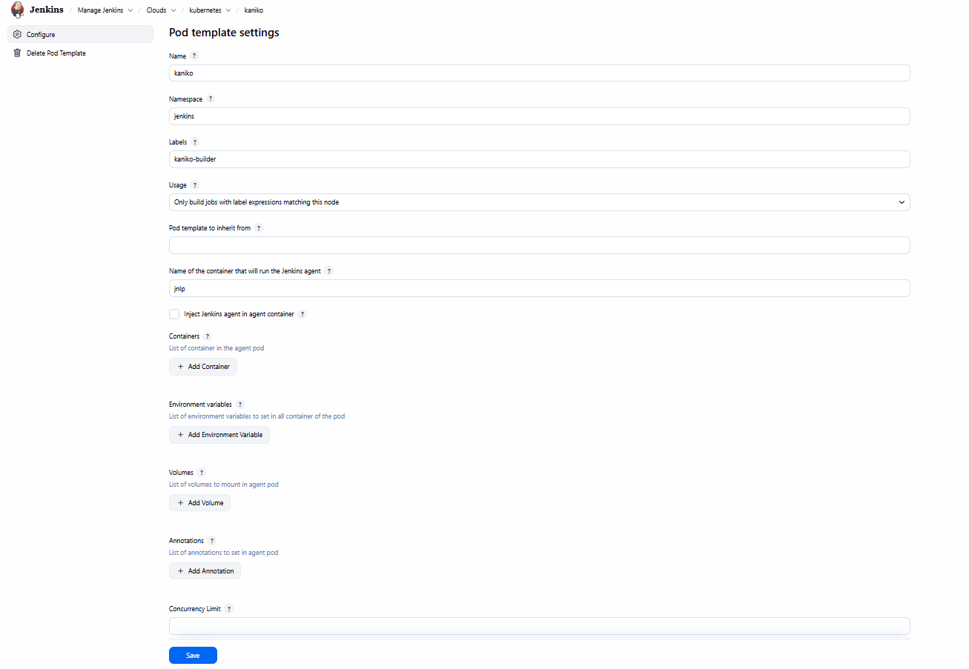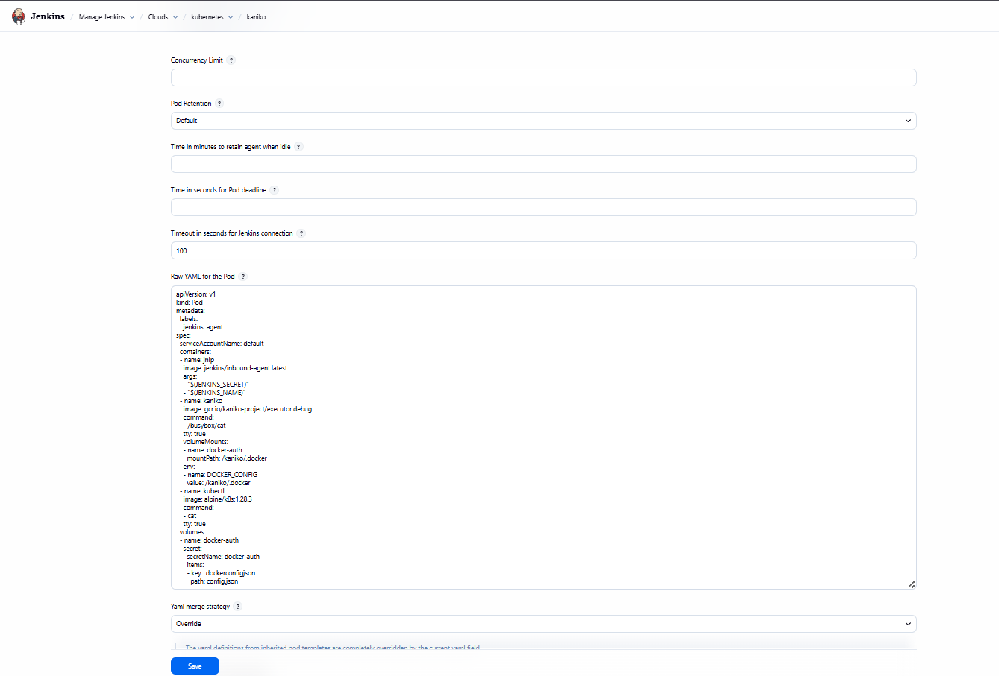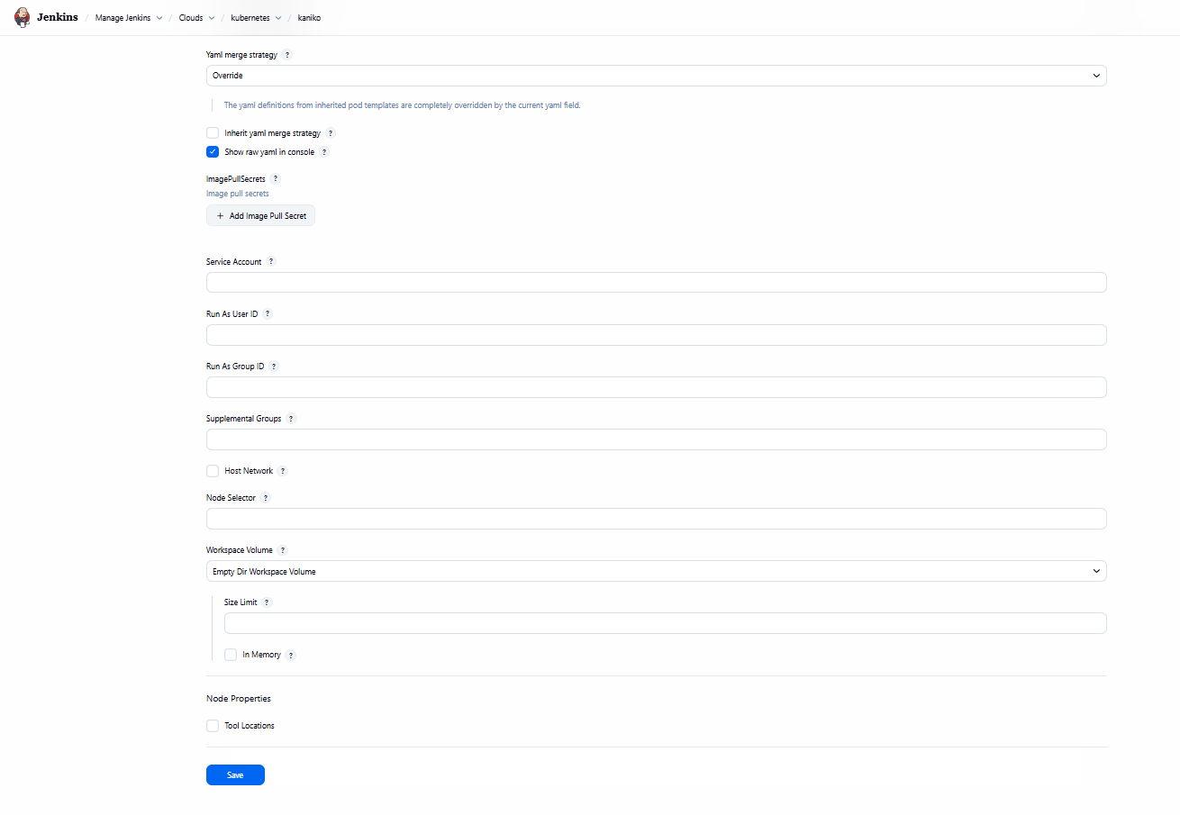

apiVersion: v1
kind: Pod
metadata:
labels:
jenkins: agent
spec:
serviceAccountName: default
containers:
- name: jnlp
image: jenkins/inbound-agent:latest
args:
- "$(JENKINS_SECRET)"
- "$(JENKINS_NAME)"
- name: kaniko
image: gcr.io/kaniko-project/executor:debug
command:
- /busybox/cat
tty: true
volumeMounts:
- name: docker-auth
mountPath: /kaniko/.docker
env:
- name: DOCKER_CONFIG
value: /kaniko/.docker
- name: kubectl
image: alpine/k8s:1.28.3
command:
- cat
tty: true
volumes:
- name: docker-auth
secret:
secretName: docker-auth
items:
- key: .dockerconfigjson
path: config.json
