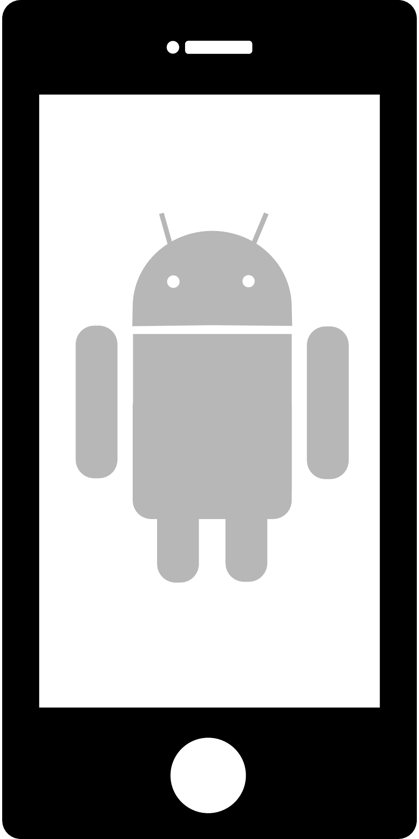
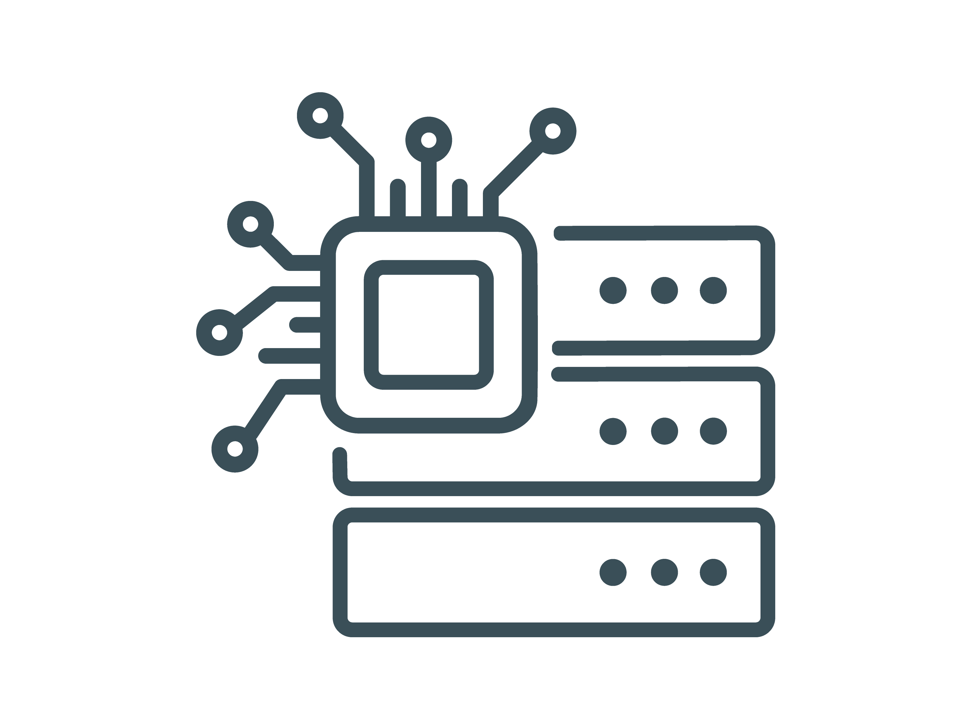
Sending and receiving messages
Web Socket Disconnect
Server
Client
Handshake (HTTP Upgrade)
Web Socket connect

