SMART NURSERY GUARDIAN
An AI-Assisted Embedded Monitoring System for Infant Care

Final Project Report
Team 6

Name | ID | Role
Mohamed Ibrahim | 7131E | Machine Learning / Audio Pipeline / GUI / Telegram
Filopateer Hani | 7129E | Hardware / Serial Integration
Tharaa Mohamed | 7005E | PCB / Firmware

An intelligent crib-side system that listens to infant cries, classifies the cause
using machine learning, and automatically soothes the baby while notifying caregivers.

Table of Contents:

1. Introduction ------------------------------------------------------------------------------------------------ 3

2. Project Objectives --------------------------------------------------------------------------------------- 3

3. System Overview & Architecture -------------------------------------------------------------------- 4

4. Hardware Design ----------------------------------------------------------------------------------------- 4

5. Software Design ------------------------------------------------------------------------------------------ 6
5.1 Streamlit Dashboard (Laptop)
5.2 Arduino Firmware (Microcontroller)
5.3 Serial Communication Protocol

6. Machine Learning Pipeline ----------------------------------------------------------------------------- 8

7. System Workflow (End-to-End) ----------------------------------------------------------------------- 9

8. Implementation Details & Screenshots ------------------------------------------------------------- 9

9. Testing & Results --------------------------------------------------------------------------------------- 11

10. Challenges & Solutions ------------------------------------------------------------------------------- 11

11. Conclusion ----------------------------------------------------------------------------------------------- 12

12. Future Work ----------------------------------------------------------------------------------------------12

13. Resources & References ----------------------------------------------------------------------------- 12

1. Introduction:
At 3 a.m., a baby cries. Is she hungry? Tired? In discomfort? The parent stands in darkness guessing. Crying is the infant’s only language, and most parents cannot read it fluently. Sleep deprivation, anxiety, and delayed responses are common consequences.
Smart Nursery Guardian is an AI-assisted embedded monitoring system that listens to the cry, uses a trained machine-learning model to identify the cause (hungry, tired, or discomfort), and reacts instantly: rocking the crib, displaying a clear message on an LCD and a modern GUI, sounding a buzzer when needed, and sending a Telegram alert to the caregiver’s phone. Nearby sensors continuously monitor motion, light level, air quality, and temperature, controlling lights and cooling automatically.
The system aims to respond as fast and attentively as a caregiver watching the crib — but never sleeps and never misses a signal.

1.1 Why This Project Matters
- Addresses a real, universal problem: sleep loss and stress caused by misinterpreting infant cries.
- Demonstrates a realistic technical stack: signal processing, classical ML, real-time firmware, GUI design, serial IoT communication, and cloud messaging.
- Bridges the gap between academic prototypes and practical home-use systems.

2. Project Objectives:
# | Objective | Success Criterion
1 | Classify infant cries into 3 clinically meaningful classes | Macro-F1 ≥ 0.75 on held-out test set
2 | Provide real-time visual & audible feedback | LCD + Streamlit GUI update < 1 s after prediction
3 | Automatically soothe the baby | Servo rocks continuously while cry is active
4 | Detect dangerous gas / smoke | Buzzer + Telegram alert within 2 s of threshold breach
5 | Maintain comfortable environment | Fan & RGB LED respond to temperature bands
6 | Notify caregiver remotely | Telegram message delivered for every cry & gas event

Cry Class | System Response | Priority
Hungry | Display message on GUI/LCD and play a calming video clip | Normal
Tired | Sound the buzzer immediately and display a warning (urgent pattern) | High
Discomfort | Display message and suggest checking diaper / clothing / position | Normal

3. System Overview & Architecture:
Two programs run on two devices and communicate over a serial (USB) link:
Component | Runs On | Main Responsibilities
Python / Streamlit App | Laptop | Microphone capture, feature extraction, ML inference, GUI dashboard, Telegram alerts, serial command & telemetry
Arduino Firmware | Microcontroller | Read PIR, LDR, thermistor, gas sensor; control servo, buzzer, room LED, RGB status LEDs, cooling fan; send sensor telemetry

3.1 Critical Data Paths
- Audio path (zero latency): Laptop microphone → Python feature extractor → trained model. Audio never crosses the serial link.
- Sensor path: Microcontroller reads sensors and streams values (GAS, TEMP, LIGHT, MOTION) to the laptop every second. Commands (CRY:hungry, RESET …) travel in the opposite direction.

This asymmetry is intentional: cry detection has the lowest possible latency, while environmental sensors can tolerate a short serial delay.

4. Hardware Design:

4.1 Bill of Materials & Pin Mapping
Component | Arduino Pin | Function
PIR Motion Sensor | D2 | Detect baby movement (awake detection)
LDR (Light Sensor) | A0 | Room darkness threshold
Thermistor (Temp) | A1 | Ambient temperature
MQ-series Gas Sensor | A2 | Smoke / gas detection
Room LED (Lamp) | D3 | Night light when dark + awake/cry
RGB LED – Red | D9 | Hot temperature indicator
RGB LED – Green | D10 | Comfortable temperature
RGB LED – Blue | D11 | Cold temperature
Cooling Fan (PWM) | D5 | Speed controlled by temperature
Fan Direction (IN) | D12 | Motor driver enable
Buzzer | D8 | Gas alert or tired-cry continuous tone
Servo Motor | D6 | Crib rocking (0° ↔ 90° ↔ 180°)
LCD 16×2 (I2C) | 0x27 | Local status display

4.2 Key Thresholds & Control Logic
Parameter | Value | Action
Darkness (LDR) | < 900 | Room considered dark
Gas / Smoke | > 400 | Buzzer ON + Telegram + GUI alert
Motion window | 8 seconds | Count PIR edges
Awake threshold | ≥ 4 motions | isBabyAwake = true
Temp < 25 °C | Blue LED | Fan low (PWM 100)
25–30 °C | Green LED | Fan half (PWM 160)
Temp > 30 °C | Red LED | Fan full (PWM 255)

4.3 Custom PCB Design
A custom 2-layer PCB was designed in Altium Designer (dated 5-9-2026, Team 6). The board integrates the microcontroller, sensor connectors, power regulation, servo and fan drivers, and the Smart Nursery Guardian logo.

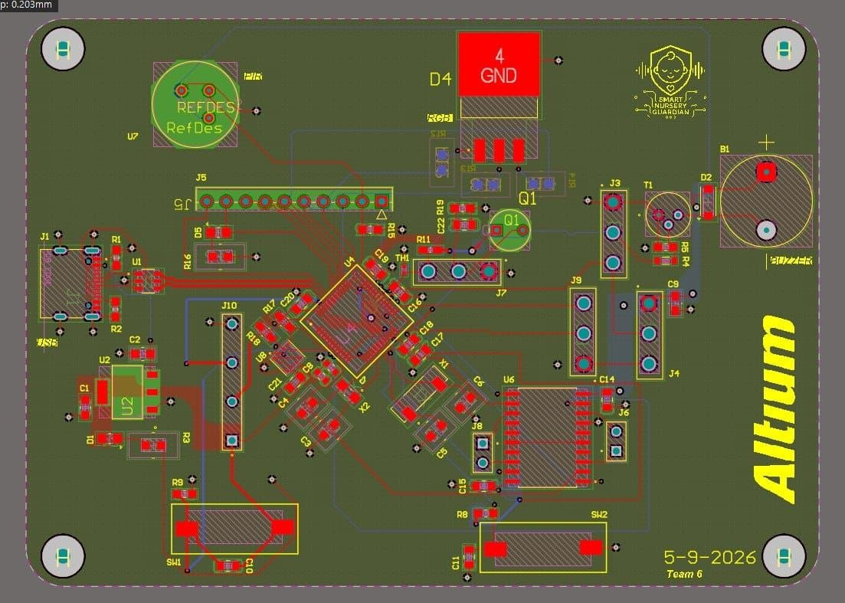
Figure 1 – PCB Layout (Altium Designer)
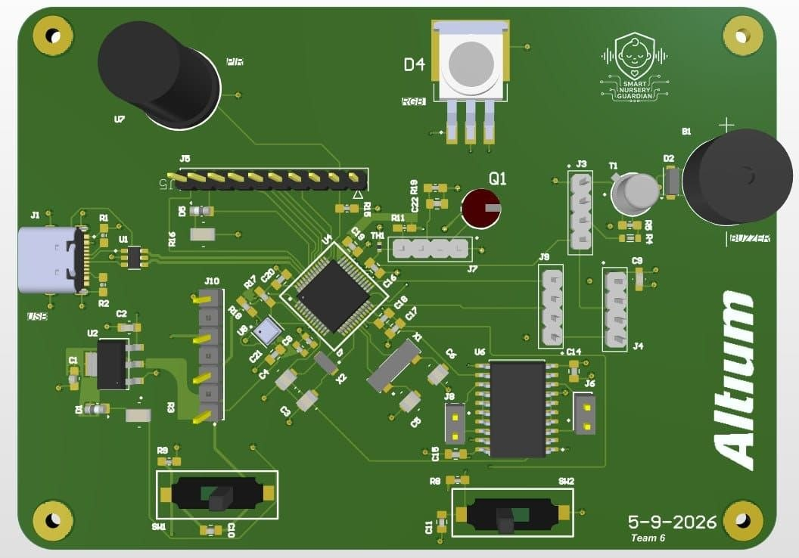
Figure 2 – 3D Render of the Assembled PCB

4.4 Hardware Prototype in Action

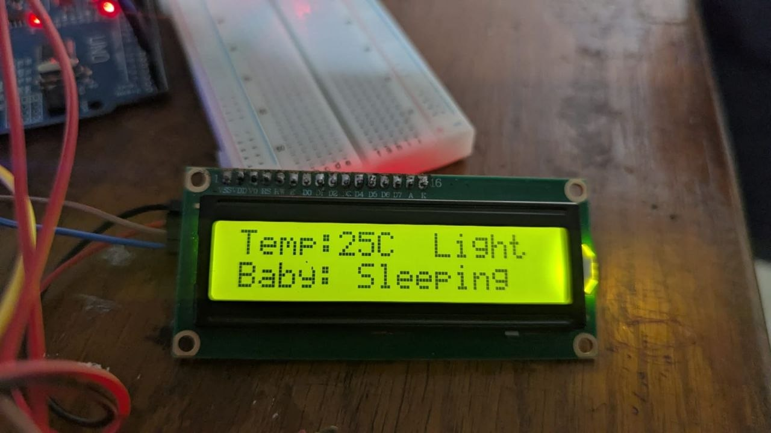
Figure 3 – Live LCD showing “Temp:25C Light / Baby: Sleeping” with surrounding sensors and wiring

5. Software Design:

5.1 Streamlit Dashboard (Laptop Side)
The caregiver interface is a responsive Streamlit web application that runs on the laptop. It provides real-time status cards, a serial log, manual audio upload, mock-test buttons, and automatic microphone monitoring.
Main Features
- Live metrics: Temperature / Fan, Motion (Awake/Calm), Gas level, Room Lamp
- Cry classification results with confidence scores
- Auto-mode continuous microphone loop (optional)
- Manual upload of cry audio files (WAV, MP3, …)
- Telegram notifications for every cry and gas event
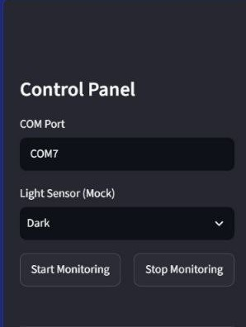
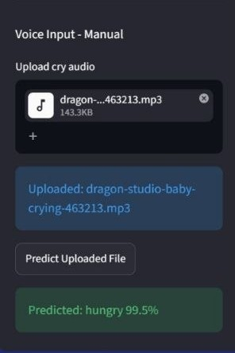

Figure 4 – Control Panel (COM Port & Start/Stop Monitoring) Figure 5 – Manual Voice Upload & Prediction Result (hungry 99.5%)

5.2 Arduino Firmware
The firmware (finalCodeHardware.ino) runs a tight non-blocking loop that:
- Reads serial commands from the laptop (CRY:hungry / tired / discomfort, RESET, …)
- Samples all sensors
- Updates the 8-second motion window and awake state
- Sends periodic telemetry (GAS, TEMP, LIGHT)
- Controls lighting, temperature actuators, buzzer, and servo rocking
- Refreshes the 16×2 LCD every 300 ms

5.3 Serial Communication Protocol
Direction | Message | Meaning
Laptop → MCU | CRY:hungry | Start hungry response (rock + display)
Laptop → MCU | CRY:tired | Start tired response (rock + continuous buzzer)
Laptop → MCU | CRY:discomfort | Start discomfort response
Laptop → MCU | RESET / CRY:END | Clear cry state, stop buzzer, center servo
MCU → Laptop | GAS:<value> | Raw gas sensor reading
MCU → Laptop | TEMP:<value> | Temperature in °C
MCU → Laptop | LIGHT:DARK/BRIGHT | Room light state
MCU → Laptop | MOTION:<n> | Motion count inside current window
MCU → Laptop | AWAKE | Baby declared awake (≥4 motions)
MCU → Laptop | ALERT:GAS_DETECTED | Gas threshold crossed
MCU → Laptop | ACK:… | Command acknowledgement
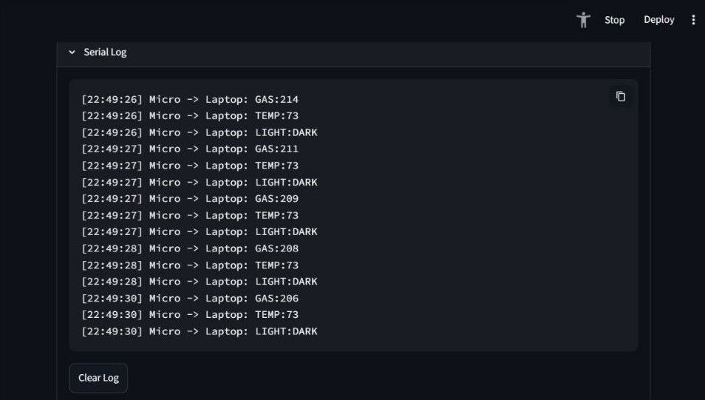

Figure 6 – Live Serial Log showing continuous GAS / TEMP / LIGHT telemetry

6. Machine Learning Pipeline:

6.1 Dataset
We used the publicly available Donate-a-Cry Corpus (457 labeled recordings). A pre-extracted feature version was obtained from Kaggle for rapid prototyping, while a matching feature-extraction routine was also implemented for live inference.
Class | Recordings | Percentage | System Response
Hungry | 382 | ≈ 84 % | Display message + optional calming video
Discomfort | 27 | ≈ 6 % | Display message (check diaper / position)
Tired | 24 | ≈ 5 % | Continuous buzzer + urgent warning

Note: The strong class imbalance is a well-known challenge of this dataset. SMOTE / RandomOverSampler inside the cross-validation pipeline and careful macro-F1 evaluation were used to mitigate it.

6.2 Feature Set (25 acoustic features)
Feature Group | Examples
Amplitude / Energy | Amplitude_Envelope_Mean, RMS_Mean
Temporal | ZCR_Mean
Spectral | STFT_Mean, SC_Mean, SBAN_Mean, SCON_Mean, MelSpec
MFCC | MFCCs13Mean, MFCCs1 … MFCCs13, MFCCs20
Delta MFCC | delMFCCs13, del2MFCCs13

6.3 Training Strategy
- 80 / 20 stratified train-test split (random_state = 42)
- 5-fold Stratified Cross-Validation inside the training set
- Pipeline: Imputer → Scaler → (optional) SMOTE → Classifier
- Models evaluated: Logistic Regression, SVM, Random Forest, Extra Trees, HistGradientBoosting, KNN, VotingClassifier
- Selection criterion: highest CV macro-F1 (balanced performance across the three classes)
- Final artifact saved as a single joblib file containing pipeline, feature names, class names

6.4 Live Inference Path
When a new audio file (or microphone buffer) arrives, the same feature-extraction recipe is applied, the resulting vector is fed to the loaded pipeline, and the predicted label plus confidence are returned. The GUI then issues the corresponding serial command and Telegram notification.

7. System Workflow (End-to-End):

7.1 Cry Detection & Classification
- Laptop microphone (or uploaded file) captures audio.
- Optional spectral noise reduction + voice-activity detection.
- Fixed-length (5 s) feature vector is extracted.
- Trained model returns one of {hungry, tired, discomfort} + confidence.
- Streamlit updates status cards and log.
- Serial command CRY:<label> is sent to the microcontroller.
- Telegram message is dispatched to the caregiver.

7.2 Hardware Reaction
- Servo immediately begins a continuous rocking cycle (0° → 90° → 180°).
- LCD shows “Baby Crying! Reason: <label>”.
- If the label is tired, the buzzer stays on continuously.
- Room lamp turns on if the room is dark.

7.3 Environmental & Safety Loops
- PIR motion window (8 s) decides whether the baby is awake.
- Temperature band drives RGB LED colour and fan PWM.
- Gas sensor continuously compared against threshold 400; on breach the system enters the highest-priority SAFETY ALERT state (buzzer + full-screen GUI + Telegram).

8. Implementation Details & Screenshots

8.1 Gas Safety Alert (Highest Priority)
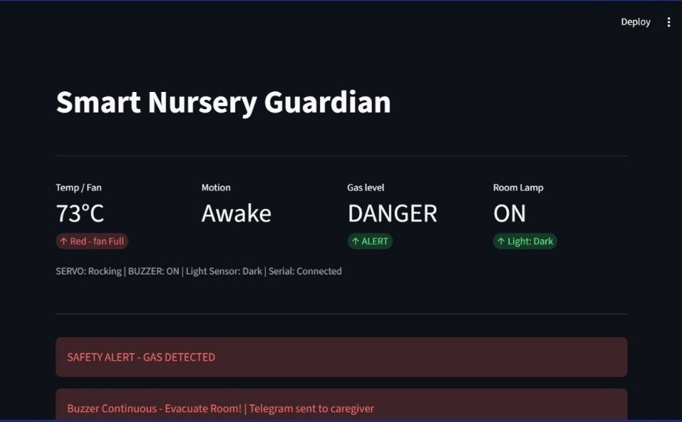
Figure 7 – GUI in SAFETY ALERT state: Gas = DANGER, Servo rocking, Buzzer ON, Telegram sent

8.2 Temperature / Calm State
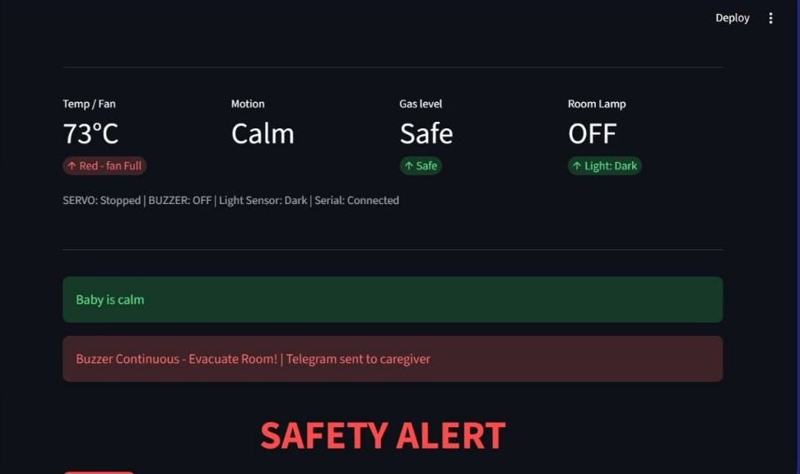
Figure 8 – High temperature (73 °C in test) with Red-fan-Full indicator; baby calm

8.3 Telegram Bot Integration
A dedicated Telegram bot (@SMART_NURSERY_GUARDIAN_bot) receives every cry classification and every gas alert, giving the caregiver immediate mobile visibility even when away from the laptop. When gas is detected (or a cry is classified), the system sends a Telegram message to a pre-configured chat so the caregiver gets a phone alert even from another room. Implementation: a bot created through @BotFather provides the API token; the chat ID is read from the first getUpdates response; alerts are sent with python-telegram-bot — free, serverless, and far more reliable than browser-automation alternatives. Cry alerts are deduplicated per label and gas alerts are rate-limited to one message every 30 seconds to avoid notification spam.
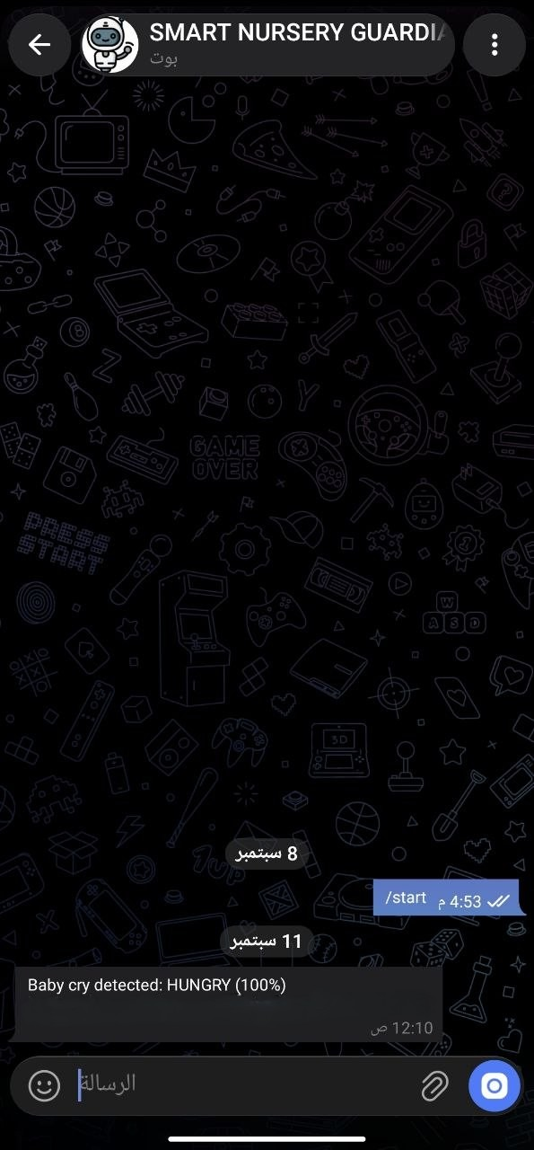
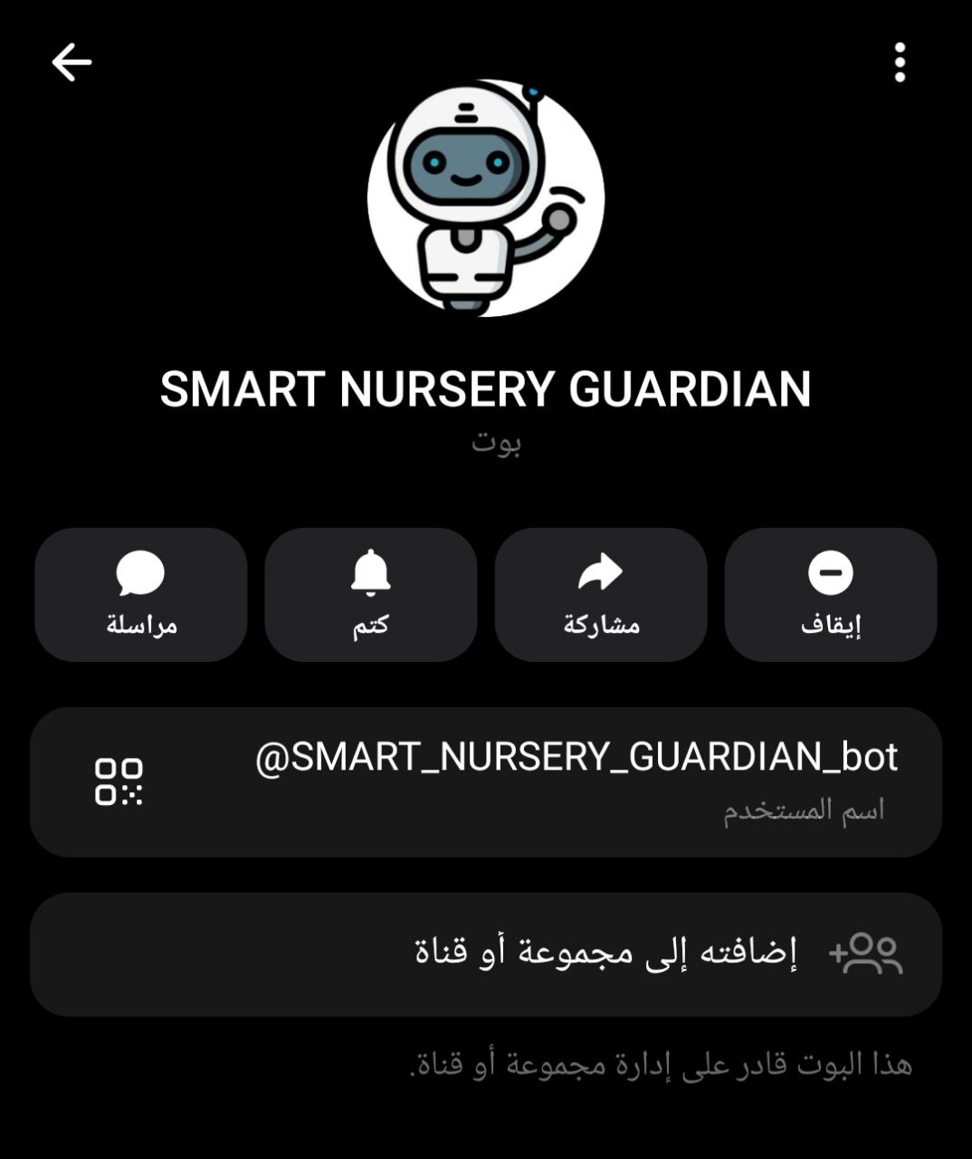

Figure 9 – Telegram bot profile Figure 10 – Real-time cry notification: “Baby cry detected: HUNGRY (100%)”

9. Testing & Results:

9.1 Functional Test Matrix
Test Case | Input / Stimulus | Expected Outcome | Result
Hungry cry (upload) | Audio file labelled hungry | GUI “hungry”, CRY:hungry, Telegram | Pass
Tired cry (mock) | Sidebar “Try Tired” | Continuous buzzer + LCD “Tired” | Pass
Discomfort cry | Sidebar “Try Discomfort” | LCD message + rock, no buzzer | Pass
Gas threshold | Sensor > 400 or mock button | Full SAFETY ALERT + Telegram | Pass
Motion → Awake | ≥ 4 PIR edges in 8 s | isBabyAwake, LCD “Awake” | Pass
Dark + Awake → Lamp | LDR dark + awake/cry | Room LED ON | Pass
Temperature bands | Thermistor readings | Correct RGB + fan PWM | Pass
Reset command | RESET / Clear button | All actuators return to idle | Pass
Serial telemetry | Continuous monitoring | GAS/TEMP/LIGHT every ≈1 s | Pass

9.2 Machine-Learning Evaluation Notes
Because of the severe class imbalance, overall accuracy alone is misleading. The final model was selected on the basis of macro-averaged F1 and balanced accuracy obtained from stratified 5-fold cross-validation. The saved artifact (smart_nursery_guardian_3class_best_model.pkl) contains the complete scikit-learn / imbalanced-learn pipeline and can be loaded once at GUI start-up for all subsequent inferences.

10. Challenges & Solutions:

Challenge | Solution Adopted
Severe class imbalance (hungry ≈ 84 %) | SMOTE / RandomOverSampler inside CV pipeline; selection by macro-F1 instead of accuracy
Feature schema mismatch risk | Strict feature-name validation before prediction; same extraction code used for training & live
Serial flooding / latency | 1-second telemetry throttle; non-blocking Arduino loop
False awake detections | 8-second sliding window + ≥ 4 motion edges required
Telegram spam | Per-label deduplication + 30-second rate limit on gas alerts
Streamlit thread-safety | Best-effort session-state updates from background mic thread; manual upload path remains fully synchronous

11. Conclusion:
Smart Nursery Guardian successfully demonstrates a complete, end-to-end intelligent infant-care system that combines classical machine learning, real-time embedded control, a modern web dashboard, and remote mobile notifications.
The three-class cry classifier, trained on the Donate-a-Cry corpus and carefully regularised against class imbalance, provides actionable guidance (hungry / tired / discomfort). The microcontroller reacts within milliseconds by rocking the crib, illuminating the room when needed, and raising an unmistakable safety alarm when gas is detected. Caregivers receive immediate Telegram messages and can monitor the entire system from a single Streamlit interface.
By splitting responsibilities — high-level AI and GUI on the laptop, low-level sensing and actuation on the microcontroller — the architecture mirrors professional IoT practice and remains maintainable and extensible. The project therefore fulfils both its technical and its human-centred goals: reducing parental uncertainty and improving the safety and comfort of the infant.

12. Future Work:
- Expand the cry taxonomy (pain, burping, environmental noise) with additional labelled data.
- Replace classical models with a lightweight spectrogram CNN or self-supervised audio encoder once more balanced data become available.
- Add on-device (edge) inference using TensorFlow Lite Micro or Edge Impulse for fully offline operation.
- Integrate a camera for visual confirmation of sleep posture and face occlusion.
- Multi-room / multi-crib support via MQTT or a local Wi-Fi mesh.
- Long-term data logging and parental insights dashboard (sleep patterns, cry frequency trends).
- Formal clinical validation study with paediatricians.

13. Resources & References:

13.1 Project Repositories & Media
- GitHub Repository: https://github.com/Mohamed-Teba/Smart-Nursery-Guardian-System

13.2 Datasets
- Infant Cry Audio Corpus – Kaggle: https://www.kaggle.com/datasets/warcoder/infant-cry-audio-corpus
- Pre-extracted Features – Kaggle: https://www.kaggle.com/datasets/bhoomikavalani/donateacrycorpusfeaturesdataset

13.3 Libraries & Frameworks
- Python 3.12, scikit-learn, imbalanced-learn, librosa, joblib
- Streamlit (GUI), pyserial, python-telegram-bot
- Arduino / AVR C++ (LiquidCrystal_I2C, Servo)
- Altium Designer (PCB)

13.4 Academic & Technical References
- G. Veres et al., “Donate-a-Cry Corpus” – public infant cry dataset used for training.
- Published studies on MFCC-based infant cry classification reporting >90 % accuracy after proper balancing and augmentation.
- scikit-learn documentation – Pipeline, StratifiedKFold, metrics.
- librosa documentation – feature extraction (MFCC, spectral, RMS, ZCR).
- Streamlit documentation – session state, caching, file upload.
- Arduino Reference – Servo, analogRead, Serial protocol design patterns.

Team 6 — Mohamed Ibrahim (7131E), Filopateer Hani (7129E), Tharaa Mohamed (7005E)
Smart Nursery Guardian — Final Project Documentation

