**Railway Reservation**

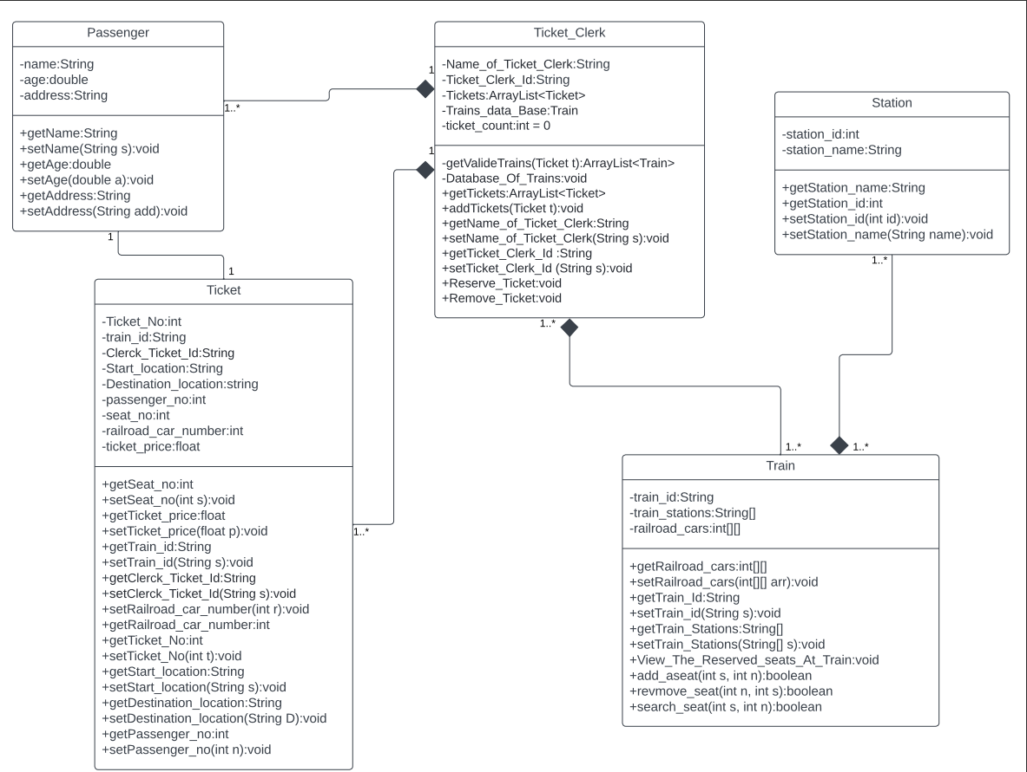**Class Diagram (UML Diagram):**

**Description** :

**-** The main actors in the problem statement are Passenger and Ticket Clerks and those share common attributes and operations that could be build up Tickets to Train That pass on many Stations.

- Each ticket have price depend on number of staions That the Train pass on it.

- Each Passenger has Id that printed in ticket.

- Each Ticket Clerk has Id that printed in ticket.

- Each Train has id printed in ticket also.

- Ticket has many information that explain many things like the position of passenger by two variable car number in the train and seat number in this car , passenger Id , Ticket clerk id, unique ticket id, train id , the start location of passenger, destination location of passenger and ticket price.

- Each train has has path from some stations that pass on it , this stations used to get ticket price and each Station have ID and Name.

- Ticket Clerk class Contains most of operation in the system.

- Train may contains multible Passengers each passenger have one Ticket.

- Ticket clerk may be clerk one or more ticket to one or more passenger each passenger have one ticket.