MODEL DEPLOYMENT ON FLASK

Name: Mohamed Derbeli
Batch Code: LISUM12
Date of submission: 29/08/2022
Submitted to: Data Glacier
Model Deployment steps
Step1: Choosing the data
I have used the data of G2M insight for Cab Investment firm
Step2: Build and save the model

First I have choose the features and target.

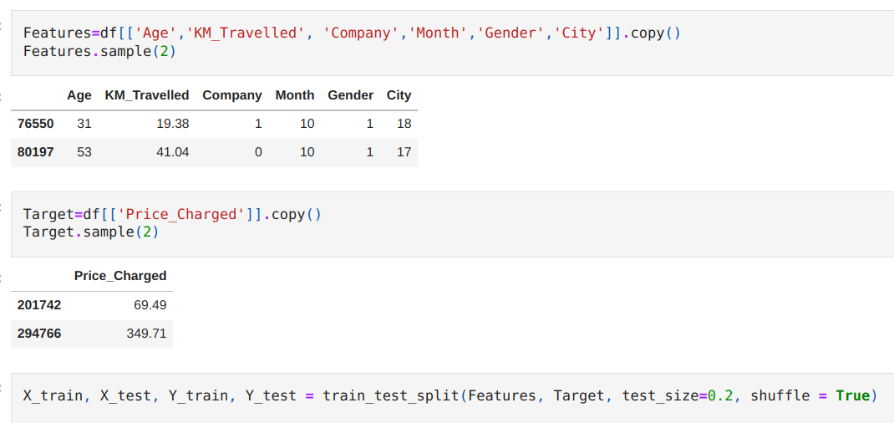
After the data split I have used Random Forest Regressor since it has provided high prediction accuracy.
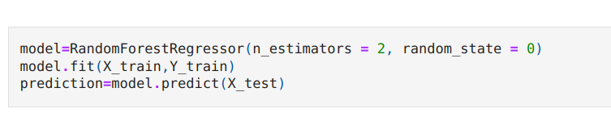

The following figure shows the actual and predicted data.
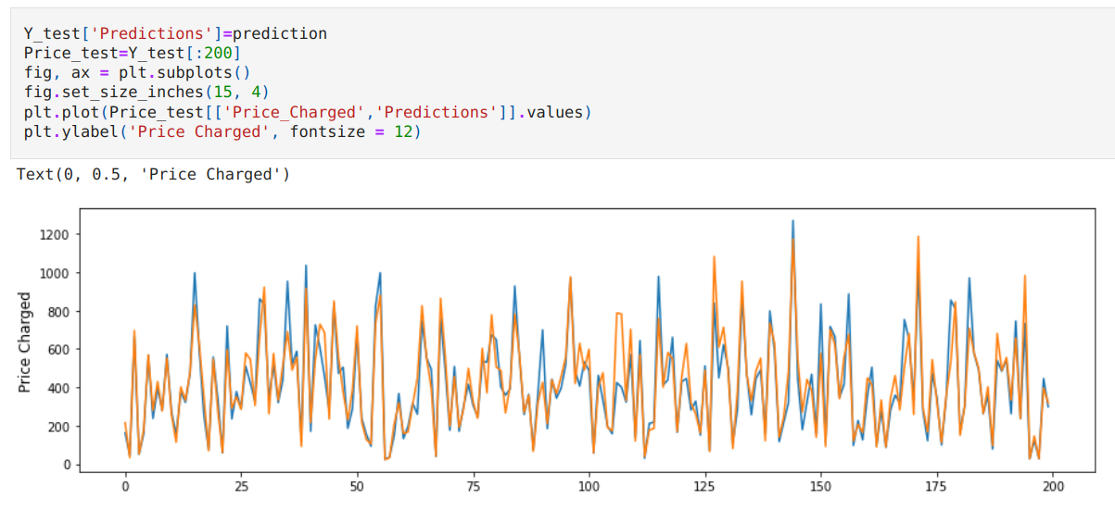
Save the model:

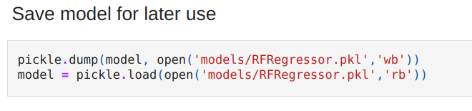
Step3: Deployment using Flask

Firstly, App.py is built, a flask app that used the deserialized model to accept new data and predict a
the price charged.

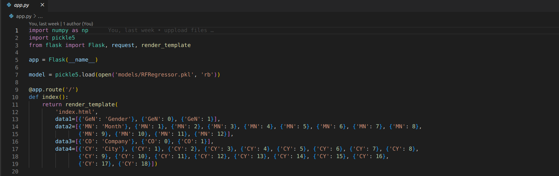

Now the function below accepts the data and return the predicted percentage

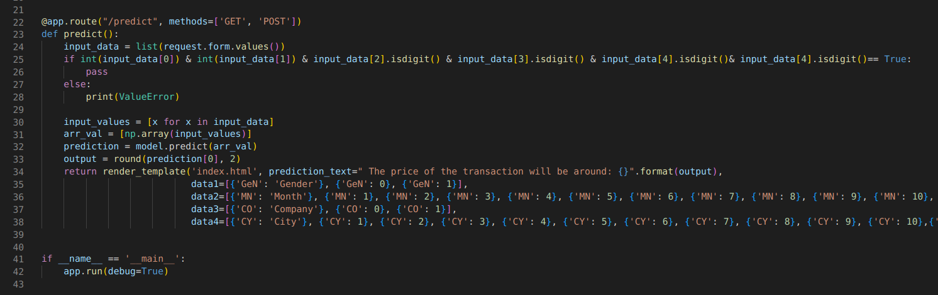

The index.html is a file that contains the structure of the web app design and AppStyle.css is used to
beautify the web design.

Then, create a new app in Heroku and and push the repository to Heroku using the terminal. If everything goes well, a link will generated.

Inside the folder of your project, open terminal and implement the following code:

git init
git add .
git commit -m “first commit”
heroku git:remote -a name_of_app
git push heroku master

Finally, clicking on the link will direct you to the flask web application interface shown below.
