MODEL DEPLOYMENT ON HEROKU

Name: Mohamed Derbeli
Batch Code: LISUM12
Date of submission: 06/09/2022
Submitted to: Data Glacier

Model Deployment steps

Step1: Selecting the model
I have used the data and model that used in the deployment on Flask (Assignment of week 4)

Step2: Build the HTML for the graphic interface

The index.html is a file that contains the structure of the web app design and AppStyle.css is used to
beautify the web design.

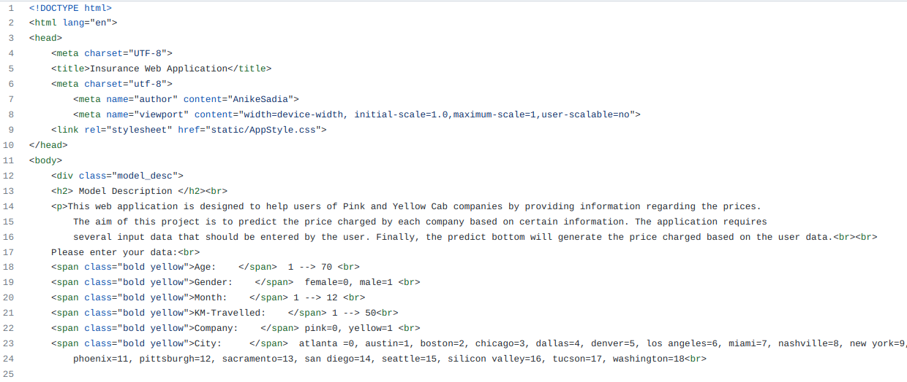

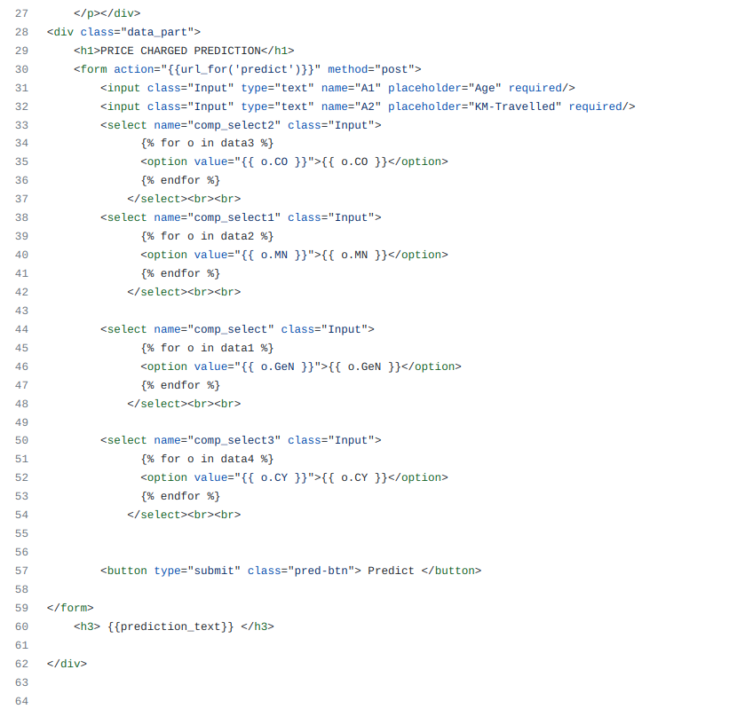

Step3: Build the Flask app

App.py is built, a flask app that used the deserialized model to accept new data and predict a
the price charged.
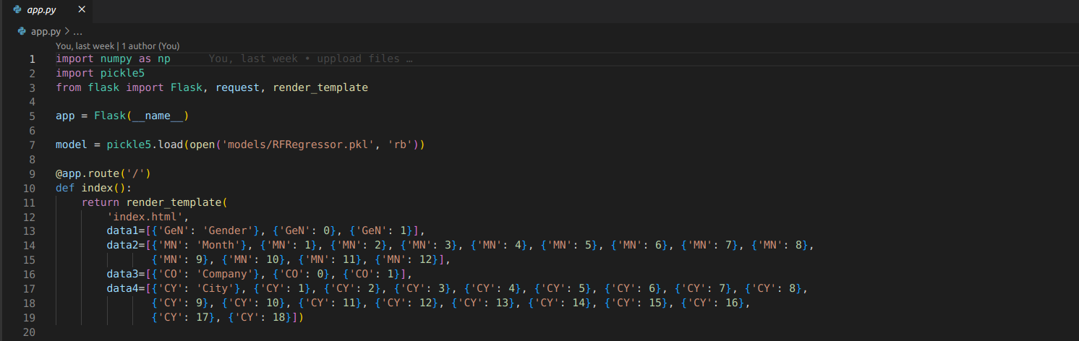
Now the function below accepts the data and return the predicted percentage

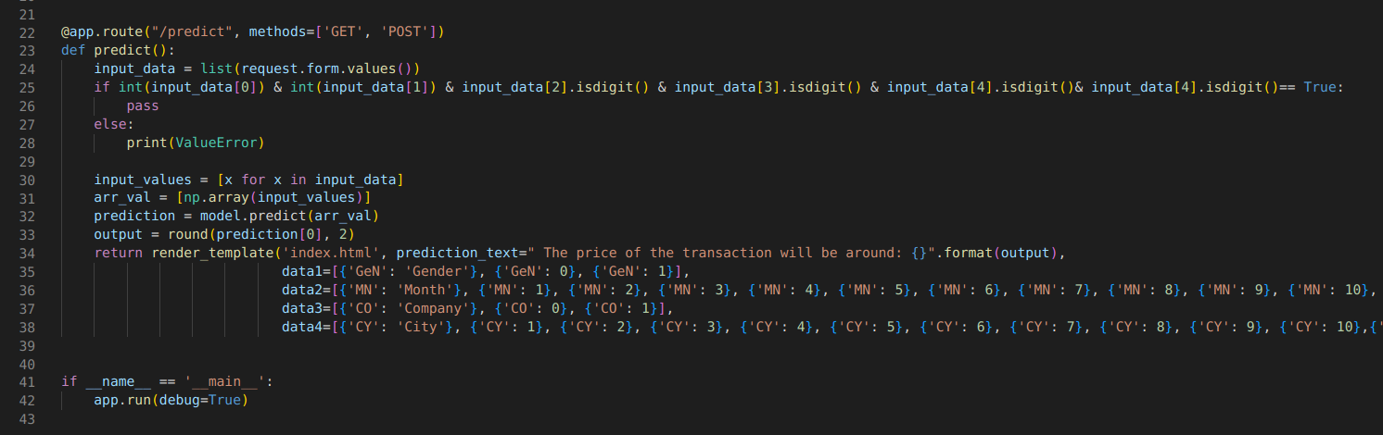

Then, create a new app in Heroku and and push the repository to Heroku using the terminal. If everything goes well, a link will generated.
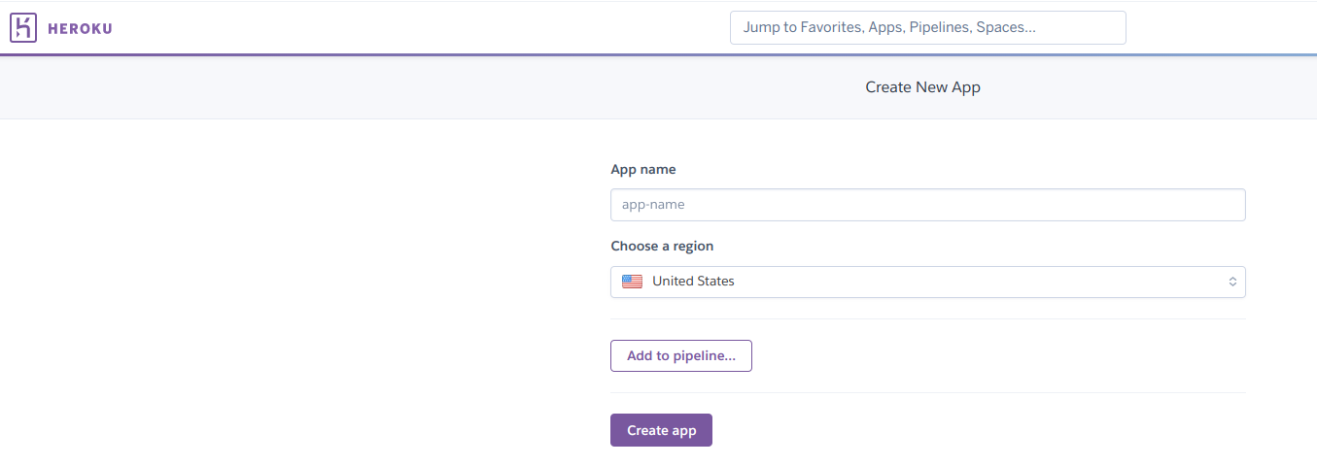

Inside the folder of your project, open terminal and implement the following code:

git init

git add .

git commit -m “first commit”

heroku git:remote -a name_of_app

git push heroku master

Finally, clicking on the link will direct you to the flask web application interface shown below.
