**Name:**

**B.N :**

**Date ;**5/6/2020

**Topic :** Database Systems

**Gihub Link:**

**Github Page :**

* **Data definition** – Creation, modification and removal of definitions that define the organization of the data.
* **Update** – Insertion, modification, and deletion of the actual data.
* **Retrieval** – Providing information in a form directly usable or for further processing by other applications. The retrieved data may be made available in a form basically the same as it is stored in the database or in a new form obtained by altering or combining existing data from the database.
* **Administration** – Registering and monitoring users, enforcing data security, monitoring performance, maintaining data integrity, dealing with concurrency control, and recovering information that has been corrupted by some event such as an unexpected system failure.

**Application**

External interaction with the database will be via an application program that interfaces with the DBMS.[ This can range from a [database tool](https://en.wikipedia.org/wiki/Comparison_of_database_tools) that allows users to execute SQL queries textually or graphically, to a web site that happens to use a database to store and search information.

**Application Program Interface**

A [programmer](https://en.wikipedia.org/wiki/Programmer) will [code](https://en.wikipedia.org/wiki/Computer_programming) interactions to the database (sometimes referred to as a [datasource](https://en.wikipedia.org/wiki/Datasource)) via an [application program interface](https://en.wikipedia.org/wiki/Application_program_interface) (API) or via a [database language](https://en.wikipedia.org/wiki/Database#database_language). The particular API or language chosen will need to be supported by DBMS, possible indirectly via a [pre-processor](https://en.wikipedia.org/wiki/Pre-processor) or a bridging API. Some API's aim to be database independent, [ODBC](https://en.wikipedia.org/wiki/ODBC) being a commonly known example. Other common API's include [JDBC](https://en.wikipedia.org/wiki/JDBC) and [ADO.NET](https://en.wikipedia.org/wiki/ADO.NET).

Screenshot :

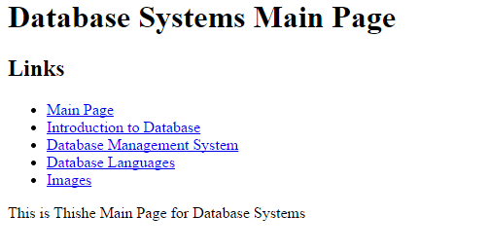

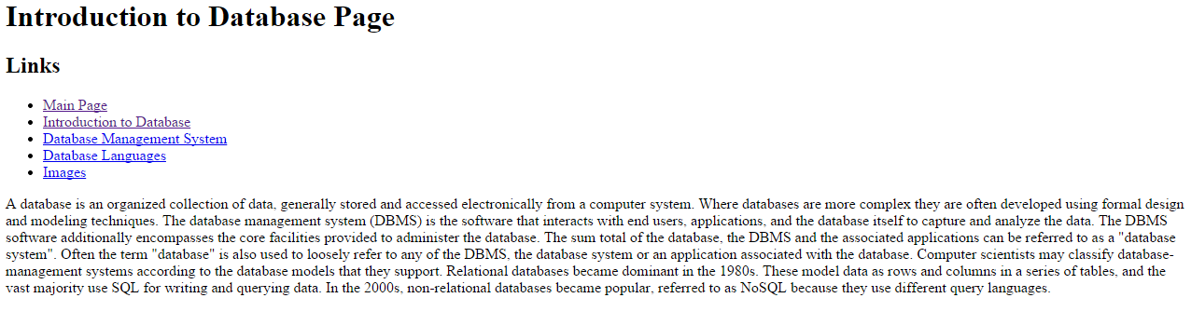

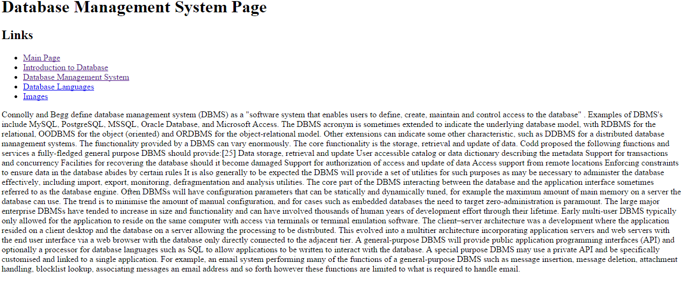

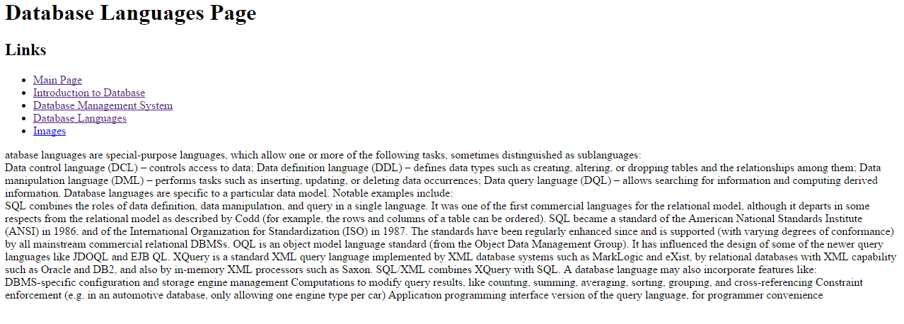

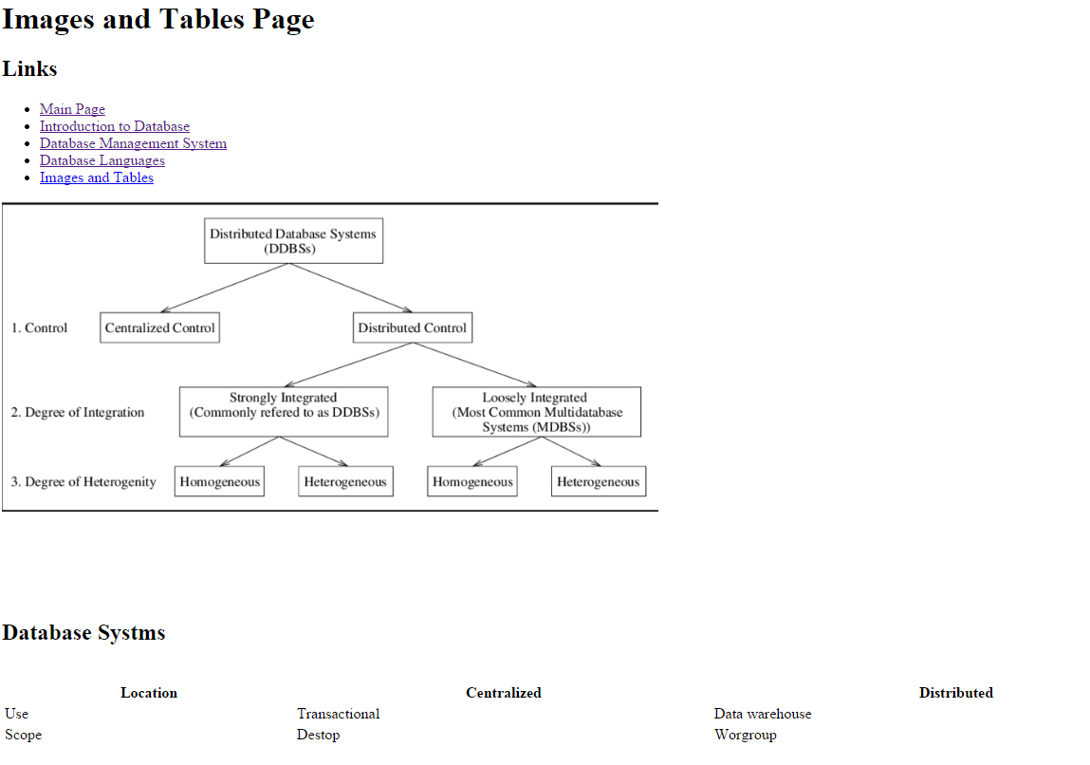

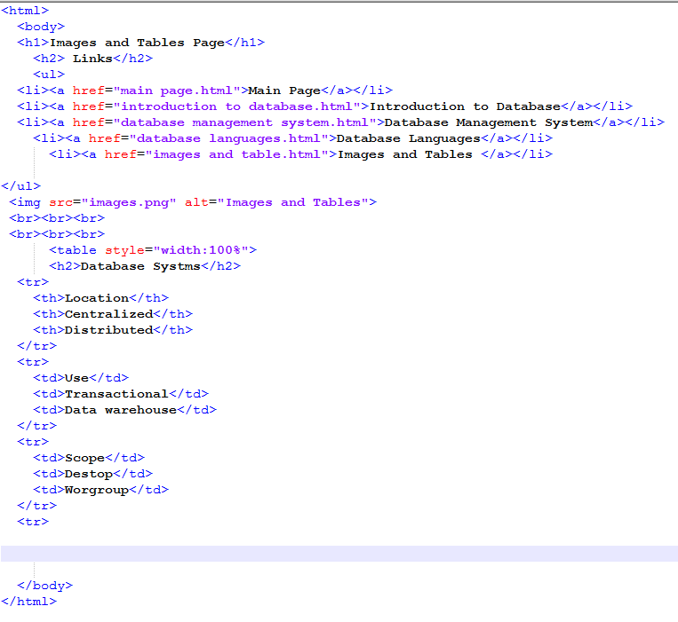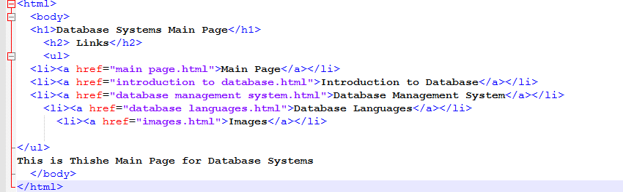

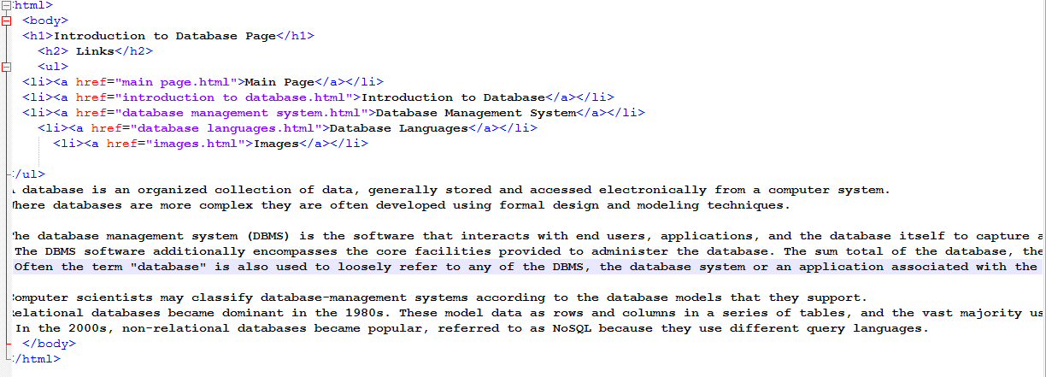

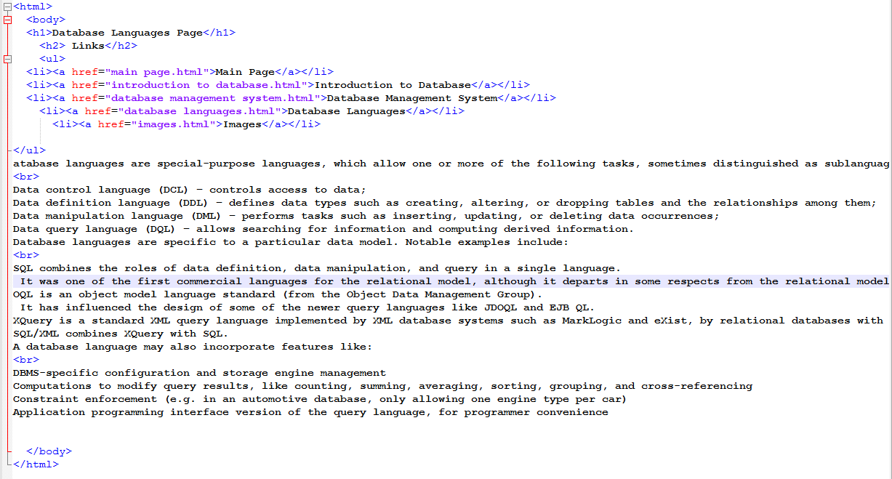

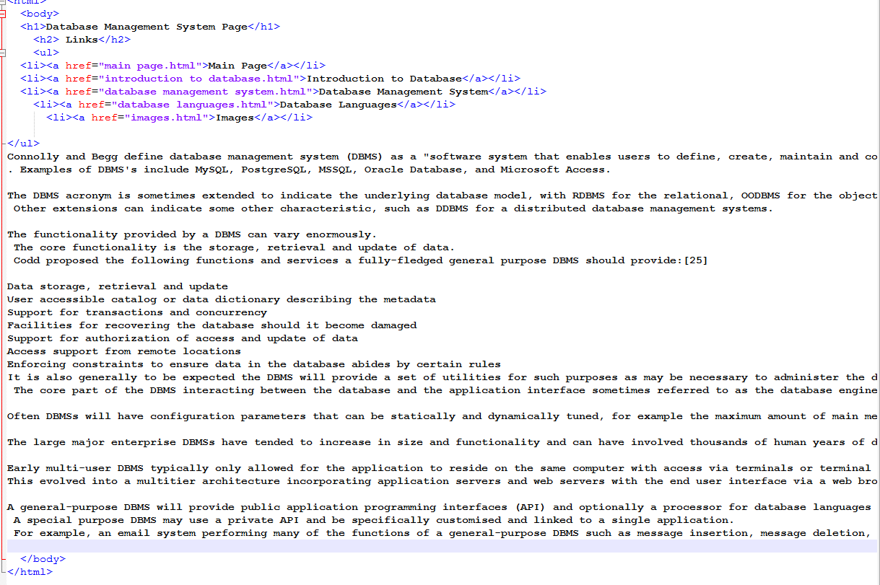

**Referances**

**Silberschatz, A., Korth, H. F., & Sudarshan, S. (1997). Database system concepts (Vol. 5). New York: McGraw-Hill.‏**

**LAMB, Charles, et al. The ObjectStore database system. Communications of the ACM, 1991, 34.10: 50-63.‏**

**Copeland, George, and David Maier. "Making smalltalk a database system." ACM Sigmod Record 14.2 (1984): 316-325.‏**