Please check that new statement generation methods and statements types were created correctly.
- Add new statement generation method:
For Debit Account:

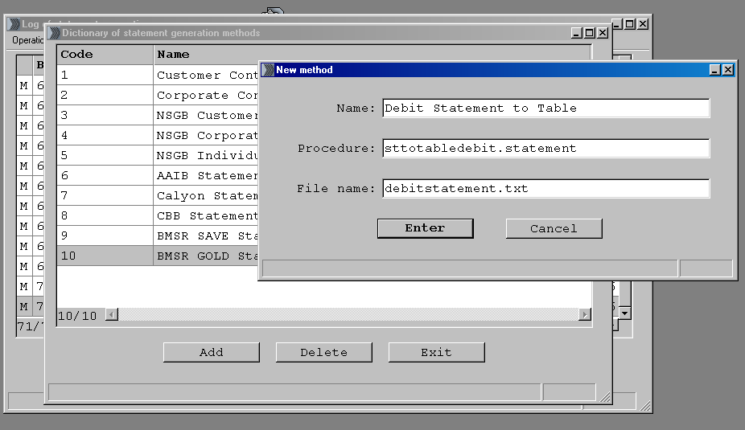

For Private Contract Statement:

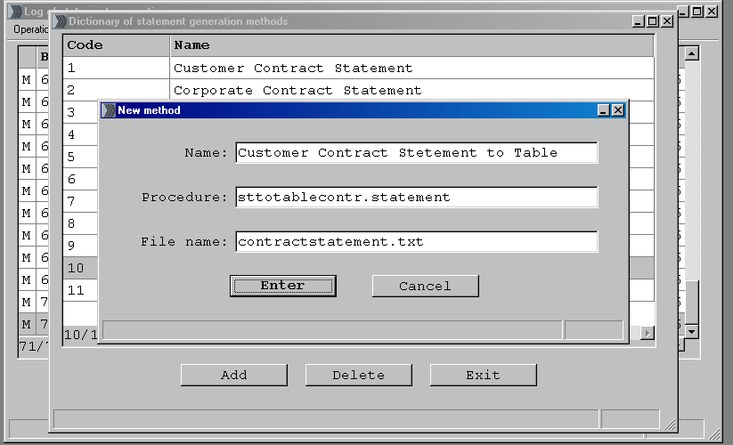

For Corporate Contract Statement:
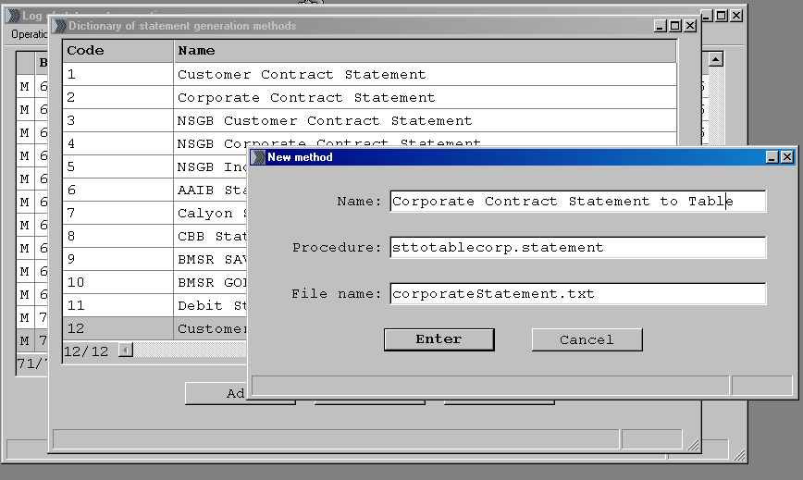

- Add new statement generation type
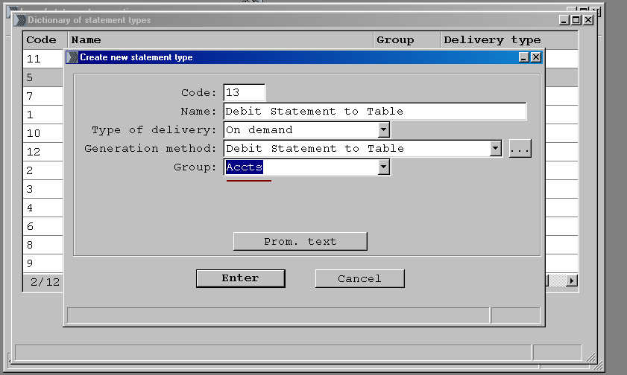

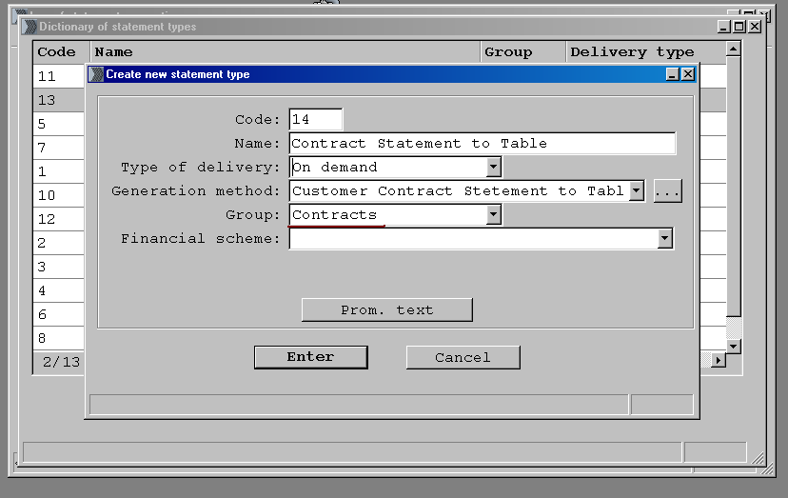

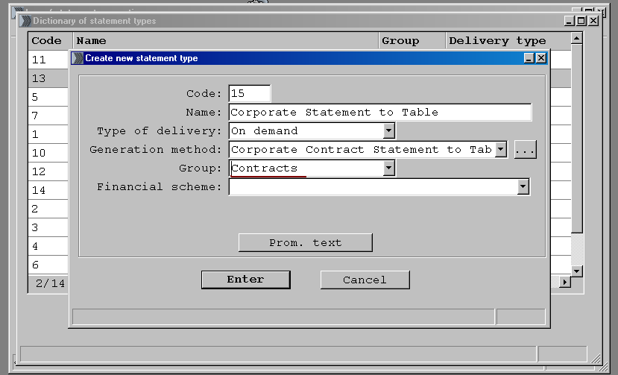On Your Test Server “TW1TST” Branch 1 this statement types was created already

- Create Statement:
a) To Create Debit Statement
Batch Operations\Generate Statement\ Create Batch of statements Manually\ Account\
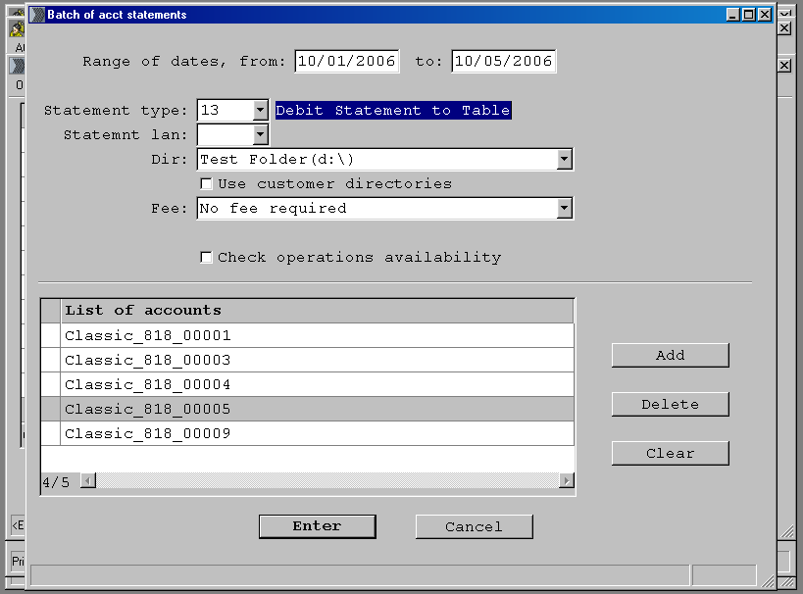

After Batch processing information will be unloaded in statement tables.

b) To Create Customer Contract Statement:
Batch Operations\Generate Statement\ Create Batch of statements Manually\ Contract\
If you want to get Private Contracts Statement then select statement type “Contract Statement To Table”(14)
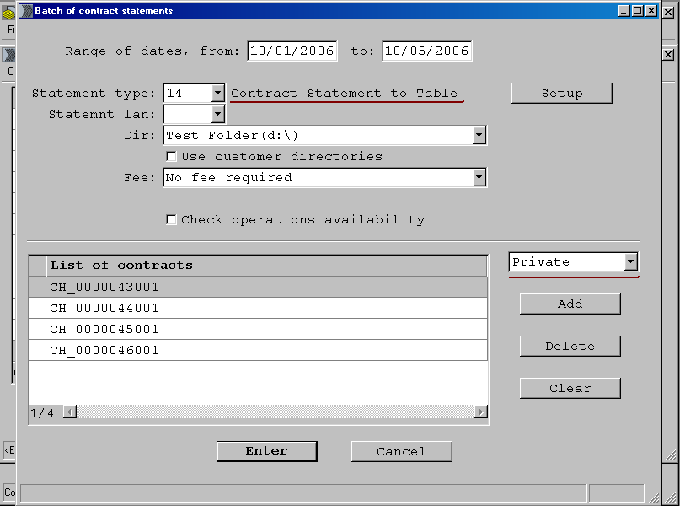

After Batch processing information will be unloaded in statement tables.
If you want to get Corporate Contracts Statement then select statement type “Corporate Statement To Table”(15)

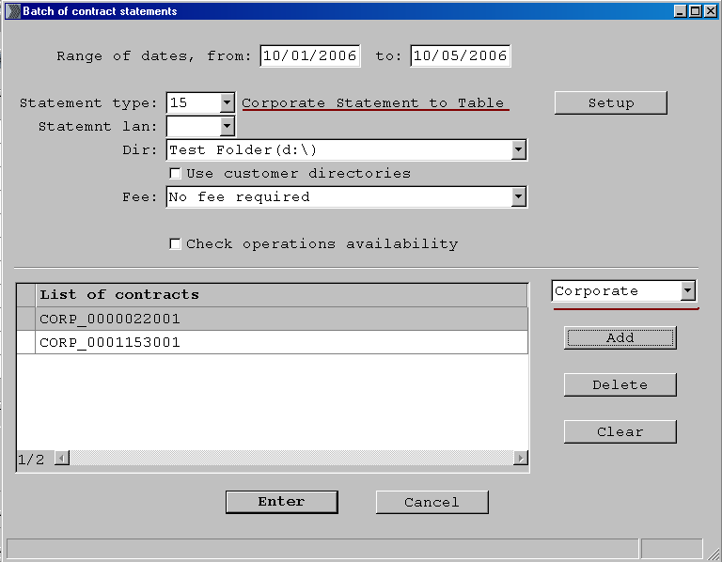

After Batch processing information will be unloaded in statement tables.

Check please that after creation batch was processed.

