Faculty of Engineering
Ain Shams University
Computer & Systems Engineering Department
CSE241 — Object-Oriented Computer Programming
2nd Semester 2025/2026
Hotel Reservation System
Project Report — Milestones 1 and 2
Submitted by:
Mohamed Raouf · Saeb Alrayyes · Omar Abdelrahman · Yousef Sameh · Saja Yousef
April 2026

1. Problem Description
Hotels handle dozens of moving parts every day: guest registrations, room availability, reservations, check-ins and check-outs, payments, and on-site services such as spa or restaurant bookings. When all of this is tracked manually or split across separate paper-based systems, mistakes quickly compound — rooms get double-booked, payments are lost, and staff spend more time chasing information than serving guests. The goal of this project is to replace that chaos with a single, well-organized desktop application that centralizes every part of the hotel's daily operations.
The Hotel Reservation System we built is a Java desktop application targeting three different user roles: guests, receptionists, and administrators. Each role sees a tailored interface: guests can browse rooms, make reservations, manage payments, and chat with reception; receptionists can confirm check-ins, process check-outs, and assist guests over a live chat channel; administrators have full control over the room catalogue, room types, and amenities. Behind the scenes, the application enforces rules that match how a real hotel works — rooms cannot be double-booked, services cannot be scheduled outside operating hours, guests cannot pay with insufficient balance, and the hotel cannot exceed its physical capacity for any one room category.
The system was developed across two milestones. Milestone 1 focused on the object-oriented backend — modeling the domain with proper classes, relationships, encapsulation, and validation. Milestone 2 added a complete JavaFX graphical interface, multi-threading for live updates, and a client-server chat feature implemented with Java Sockets. The result is a working application that demonstrates the full breadth of the CSE241 curriculum.

2. Detailed Analysis and Design

2.1 Functional Requirements
- Guest registration and login with input validation (password strength, age, duplicate usernames).
- Room browsing with multi-criteria filtering by type, price, and required amenities.
- Reservation creation with check-in/check-out date validation and total cost calculation.
- Reservation cancellation with automatic refund to the guest's balance.
- Checkout flow supporting cash, credit card, and online payment methods.
- Hotel service booking (spa, gym, restaurant, room service) with time-slot validation.
- Receptionist functions: view guests/rooms, create reservations on a guest's behalf, check in, check out.
- Administrator functions: full CRUD on rooms, room types, and amenities, with enforced capacity limits per type.
- Real-time chat between guest and receptionist.

2.2 Non-Functional Requirements
- Responsive UI — long-running tasks must not freeze the interface.
- Data integrity — invalid actions must be blocked before they corrupt the in-memory state.
- User feedback — every action must produce an alert, success message, or visible state change.
- Maintainability — controllers must follow the MVC pattern with clear separation between FXML views and Java logic.

2.3 Class Design Overview
The system follows a layered class hierarchy. At the core, three groups of classes form the domain model:

Users
- Guest — independent class with login, reservations list, balance management, and a checkout / pay flow.
- AdminReceptionist — abstract parent class capturing shared staff fields (username, password, role, working hours).
- Admin and Receptionist — concrete subclasses that implement the abstract makeBehaviour() method and add role-specific actions.

Hotel Inventory
- Room — has a room number, availability flag, RoomType, and a list of Amenity objects.
- RoomType — describes a category (Single, Double, Suite, Penthouse, Family) with price, capacity, and a maximum allowed count.
- Amenity — a small data class with id and name (WiFi, TV, mini-bar, etc.).

Bookings
- Reservation — links a Guest, a Room, check-in/check-out dates, and a status (PENDING / CONFIRMED / CANCELLED / COMPLETED).
- Invoice — holds a list of reservations, calculates the total via Java Streams, and processes payment.
- HotelService — represents an extra service booking (spa, gym, restaurant, room service) tied to a Guest.
All entities are stored in a static HotelDatabase class that holds ArrayLists per type. This satisfies the project's requirement for an in-memory database and is pre-populated with sample data on application startup.

2.4 Custom Exceptions
Validation is enforced through a family of custom exception classes, each extending RuntimeException or Exception as appropriate:
- RoomAlreadyBookedException, RoomNotAvailableException, InvalidRoomNumber
- InvalidDateException, InvalidTimeSlotException, InvalidAgeException
- InvalidCardException, InvalidPaymentException, InsufficientBalanceException
- DuplicateUsernameException, EmptyFieldException, GuestNotFoundException
- ServiceUnavailableException, RoomTypeCapacityFullException, CannotFireLastReceptionistException, InsufficientWarningsException
Each exception encodes a precise business rule. Throwing exceptions instead of returning null or boolean flags makes the validation impossible to ignore at the call site, and the controllers catch them individually to display targeted error alerts.

2.5 Encapsulation and Validation
Every domain class follows strict encapsulation: fields are private, exposed only through getters and setters that perform validation. For example, RoomType.setPrice() rejects negative values, Room.setRoomType() rejects null, Guest's constructor rejects passwords shorter than 8 characters or missing a digit, and Reservation's constructor rejects check-out dates that are equal to or before check-in. Combined with the custom exceptions, these guards mean the in-memory state can never enter an invalid configuration, regardless of which controller is calling.

3. Used Techniques and Technologies
Component | Technology / Tool
Programming Language | Java 17
GUI Framework | JavaFX with FXML and CSS
Layout System | BorderPane, VBox, HBox, GridPane
Concurrency | JavaFX Timeline, java.lang.Thread, Platform.runLater()
Networking | java.net.ServerSocket and Socket
Build Tool | Apache Maven
Version Control | Git and GitHub
IDE | IntelliJ IDEA / Apache NetBeans
Database | SQLite via JDBC (org.xerial sqlite-jdbc 3.45.1.0)

3.1 Object-Oriented Principles Applied
- Encapsulation — every class exposes a controlled API; no public mutable fields.
- Inheritance — Admin and Receptionist extend the abstract AdminReceptionist class.
- Polymorphism — both subclasses override makeBehaviour() with role-specific output.
- Abstraction — AdminReceptionist defines the staff contract without prescribing how each role behaves.
- Composition — Reservation has-a Guest and has-a Room; Room has-a RoomType and a list of Amenity.

3.2 Multi-threading
Two areas use threads to keep the UI responsive. First, the room browsing and reservation management screens run a JavaFX Timeline that fires every five seconds, refreshing the visible list without blocking the application. All UI updates from this background work are dispatched through Platform.runLater() to comply with JavaFX's single-threaded UI rule. Second, the chat client (both guest and receptionist sides) opens its own background thread that listens on the socket's input stream — incoming messages are appended to the chat area through Platform.runLater() as soon as they arrive, while the user is free to keep typing.

3.3 Networking — Client/Server Chat
The ChatServer class binds a ServerSocket to port 5000 and accepts two connections per session: the guest first, then the receptionist. For each pair, two background threads are launched. Each thread reads from one socket's input stream and writes to the other socket's output stream, effectively relaying messages between the two clients in real time. The client side (ChatController and ReceptionistChatController) uses a similar pattern: one background thread reading incoming messages and posting them to the chat area through Platform.runLater(), while the send button writes outgoing messages directly to its PrintWriter.

3.4 JavaFX with FXML and CSS
The UI follows the MVC pattern: each screen has a .fxml file describing the layout (managed visually in Scene Builder), a controller class containing the event handlers, and a shared style.css applying consistent typography and the navy/gold color scheme. Layouts use BorderPane (for screens with a header and a sidebar), VBox (for vertical stacks of fields), and HBox (for button rows). All user-facing feedback is delivered through a centralized AlertHelper utility class that wraps JavaFX's Alert dialogs into four convenience methods: info, success, warning, and error.

3.5 Persistent Storage — SQLite Database
As a bonus feature, the system was extended with a persistent SQLite database so that all data survives application restarts. SQLite was chosen because it requires no separate server installation — the entire database lives in a single hotel.db file stored inside the project directory. The JDBC driver (org.xerial sqlite-jdbc 3.45.1.0) was added as a Maven dependency, and a dedicated DatabaseManager class was introduced to handle all database operations.
On application startup, DatabaseManager initializes the schema (creating tables for guests, rooms, room types, amenities, reservations, and hotel services if they do not already exist) and then loads all persisted records into the in-memory HotelDatabase ArrayLists. This hybrid approach means that all existing business logic and controllers required no changes — they continue to read and write through the ArrayLists as before, while DatabaseManager intercepts key state changes (new reservations, cancellations, guest registrations, room updates) and writes them through to the SQLite file using standard JDBC PreparedStatements. The result is full data persistence: guests can log out, close the application, and return to find their reservations exactly as they left them.

4. Detailed Solution

4.1 Application Structure
The project is organized into two Java packages. The main package com.mycompany.uniproject contains all domain classes, the abstract Staff parent, the HotelDatabase, the ChatServer, and the JavaFX entry point Testmain. A nested package com.mycompany.uniproject.controllers contains all 12 FXML controllers plus the AlertHelper utility. Resource files live under src/main/resources/com/mycompany/uniproject/, split into fxml/ for the layouts, images/ for the application icon, and a top-level style.css.

4.2 Application Lifecycle
On startup, Testmain.start() initializes the system in a deterministic order: first it boots the chat server in its own thread, then it pre-populates the in-memory database (room types, amenities, rooms, guests, staff), and finally it loads the login.fxml file and shows the primary stage. From there, the user navigates the application by triggering scene swaps in each controller's event handlers.

4.3 Room Capacity Enforcement
Each RoomType carries a maxCount field that represents the hotel's physical capacity for that category — for example, only one penthouse can ever exist. When the admin tries to add a new room, Admin.createRoom() asks HotelDatabase.getRoomCountOfType() how many rooms of that type already exist. If the answer equals or exceeds the maximum, a RoomTypeCapacityFullException is thrown, and the AdminDashboardController catches it and displays a clear error alert that explains the limit and instructs the admin to wait for an existing room to be unbooked or remove one first.

4.4 Reservation and Payment Flow
When a guest books a room, the Reservation constructor immediately validates the dates and sets the room's availability flag to false. The reservation is created with a PENDING status, which the receptionist can later upgrade to CONFIRMED. At checkout time, Guest.checkout() collects all PENDING and CONFIRMED reservations into a new Invoice, which uses Java Streams to sum the per-night totals. The CheckoutController then walks the user through the chosen payment method — for credit cards, it sequentially prompts for the card number (length validated to 16 digits), expiry date, and CVV (length validated to 3 digits), throwing an InvalidCardException at the first failure. Once payment succeeds, every reservation's status flips to COMPLETED, the guest's balance is reduced, and an invoice receipt is rendered on screen.

4.5 Real-time Chat Sequence
The chat feature is a small but complete client-server application. The server (ChatServer) accepts two clients sequentially, holds a reference to each client's socket, and spins up two relay threads. The guest's chat window opens a single connection to localhost:5000 from the ChatController, and the receptionist does the same from ReceptionistChatController. Each client has one background thread that blocks on the socket's BufferedReader; when a message arrives, it is appended to the on-screen TextArea via Platform.runLater(). Sending a message simply writes to the local PrintWriter and echoes the same line to the user's own chat area for immediate feedback.

4.6 Filtering Logic on Room Browsing
RoomBrowsingController exposes three filter controls: a type ComboBox, a max-price TextField, and a multi-select amenity ListView. The loadRooms() method walks every room in HotelDatabase, skipping any that are unavailable, do not match the selected type, exceed the max price, or are missing any of the selected amenities. The filters compose with AND logic: a room must satisfy all active filters to appear. A Clear button resets every filter and re-runs the load. The same Timeline-based auto-refresh that powers live room availability also re-applies the current filters every five seconds, so a room booked by another user vanishes from the list without manual action.

5. Sample Output
The screenshots below illustrate the main user-facing screens of the Hotel Reservation System.

5.1 Login Screen

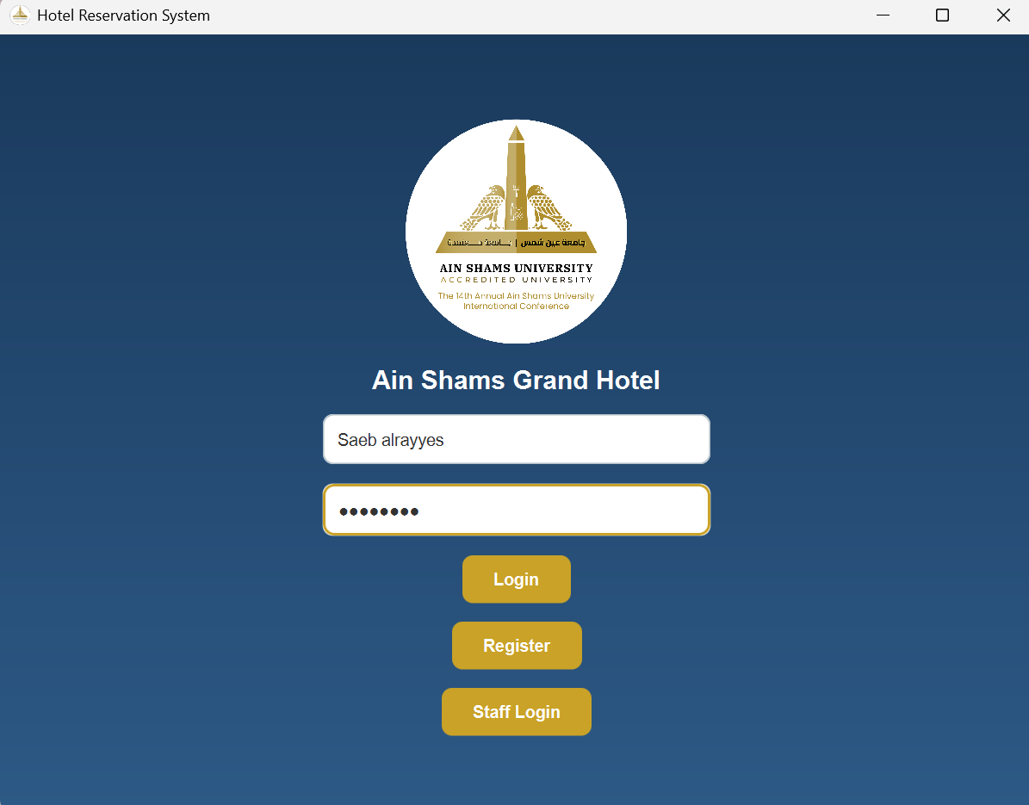5.2 Guest Registration

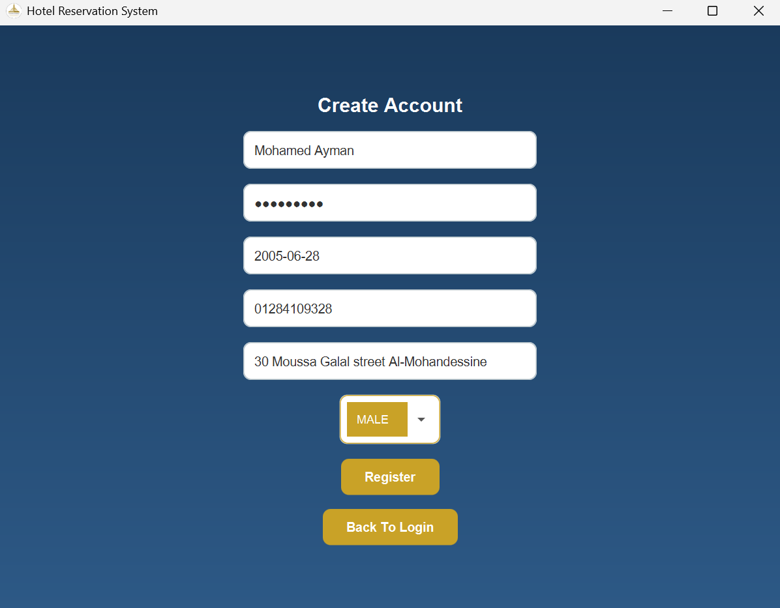5.3 Guest Dashboard with Active Reservations

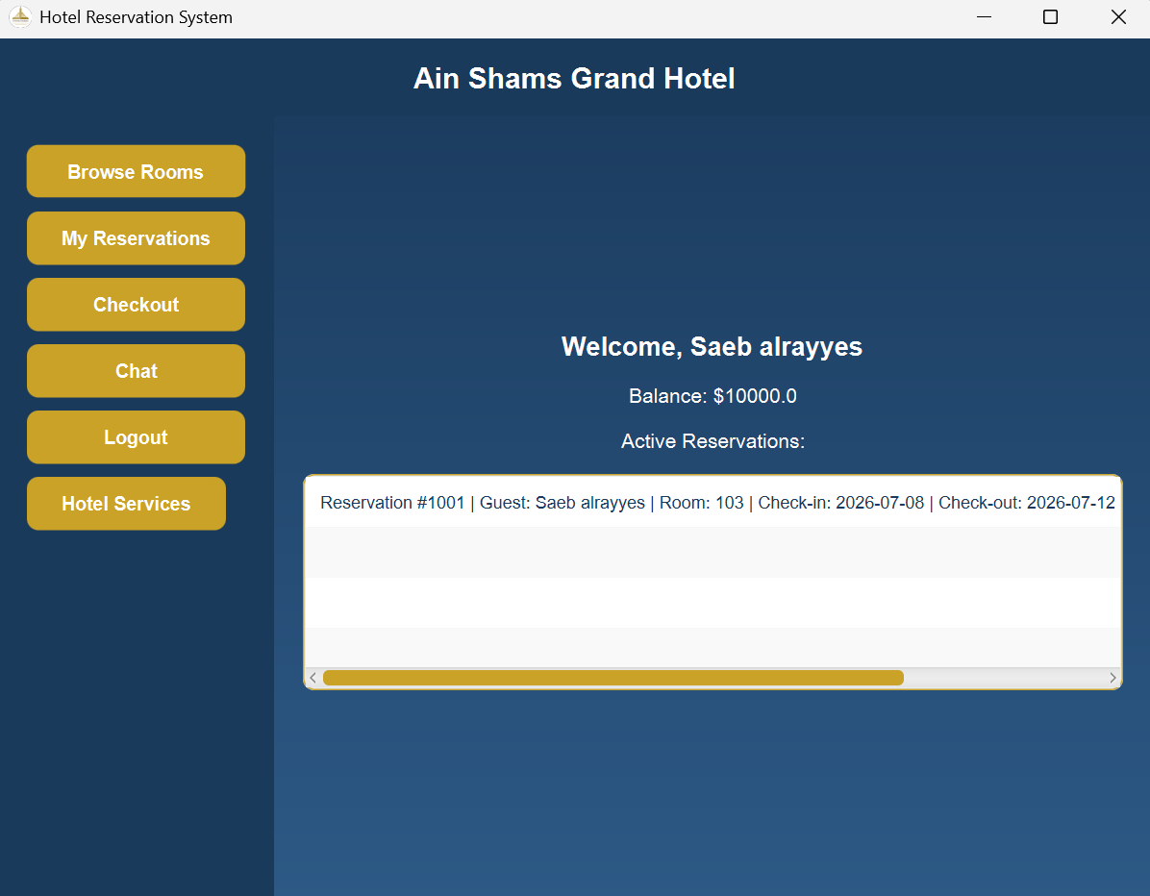5.4 Room Browsing with Filters

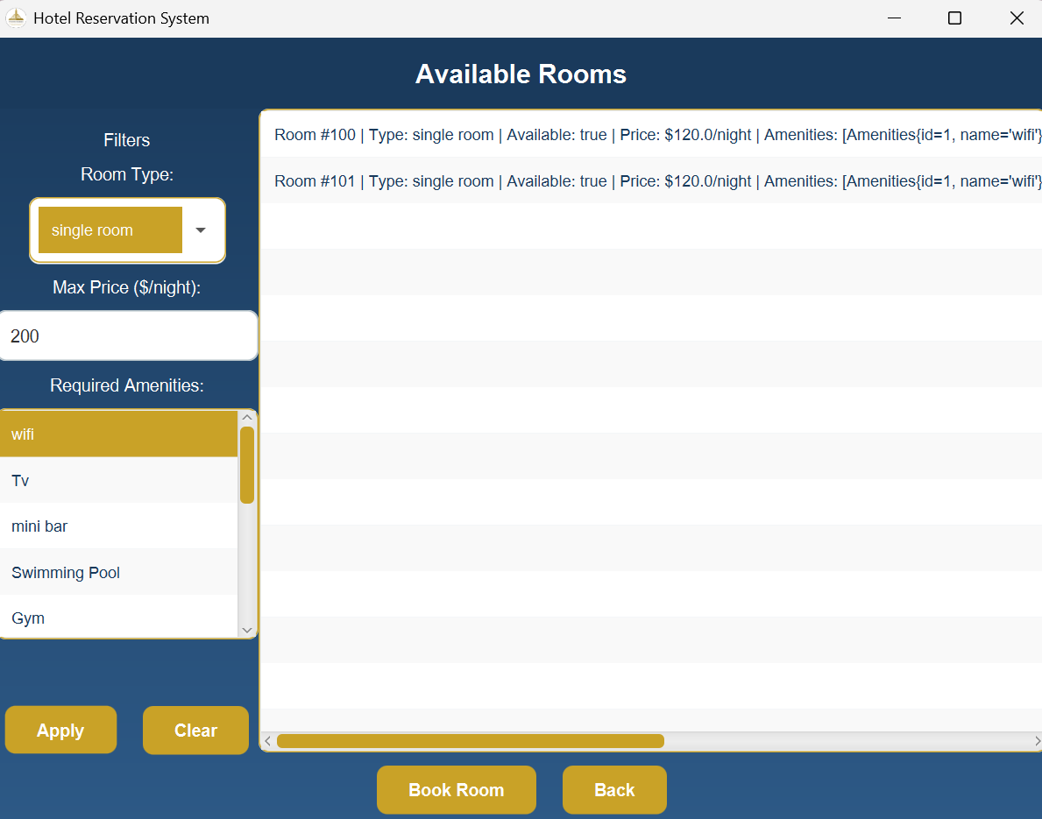5.5 Reservation Confirmation Alert

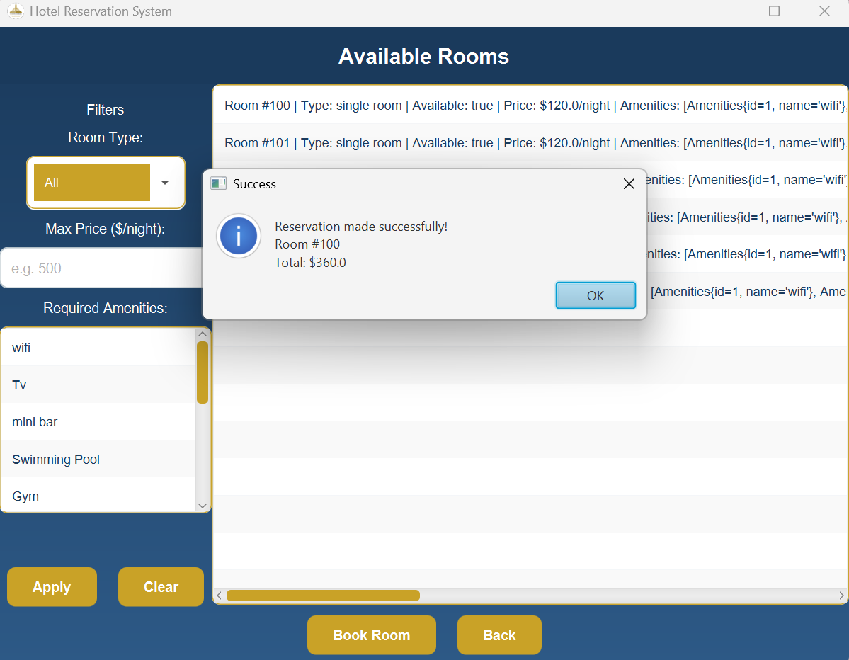5.6 Reservation Management

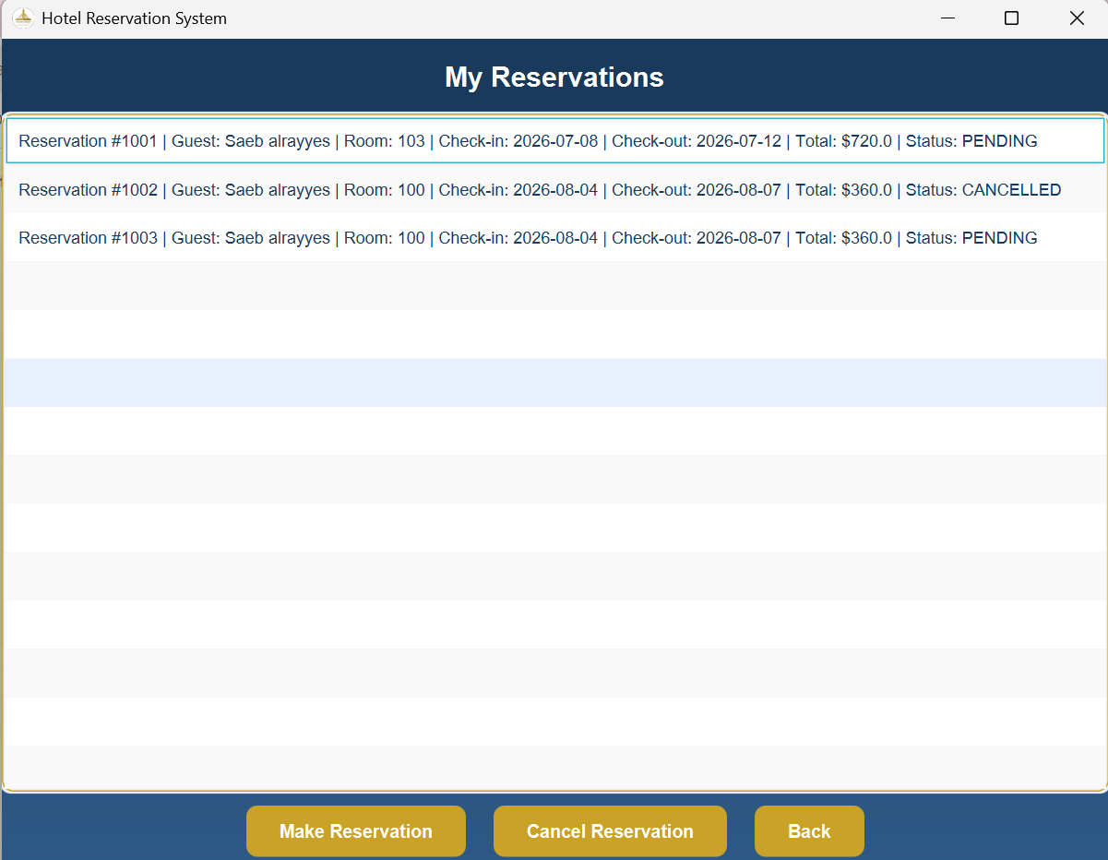5.7 Checkout — Payment Method Selection

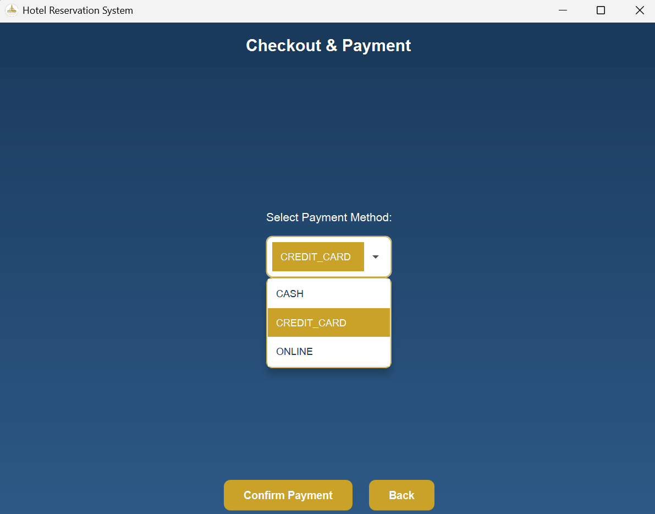5.8 Checkout — Credit Card Dialog

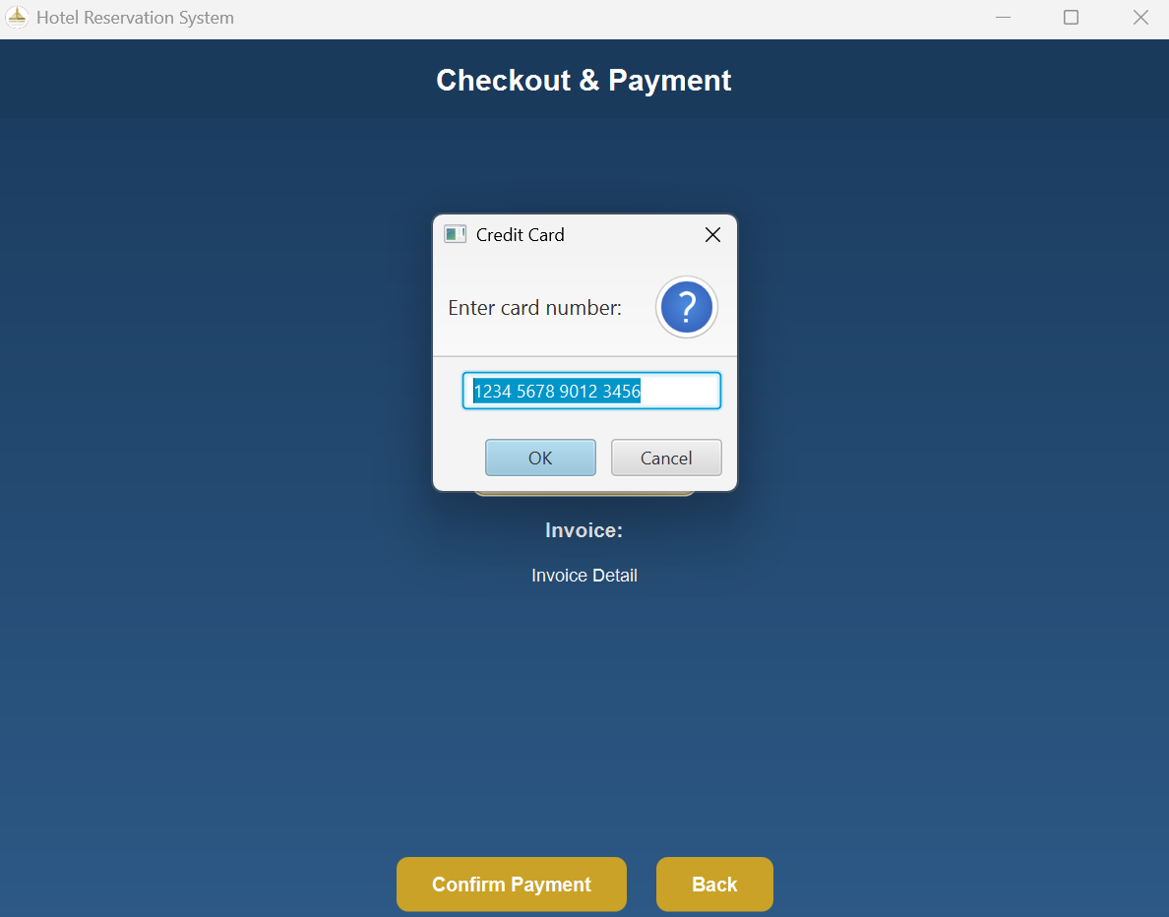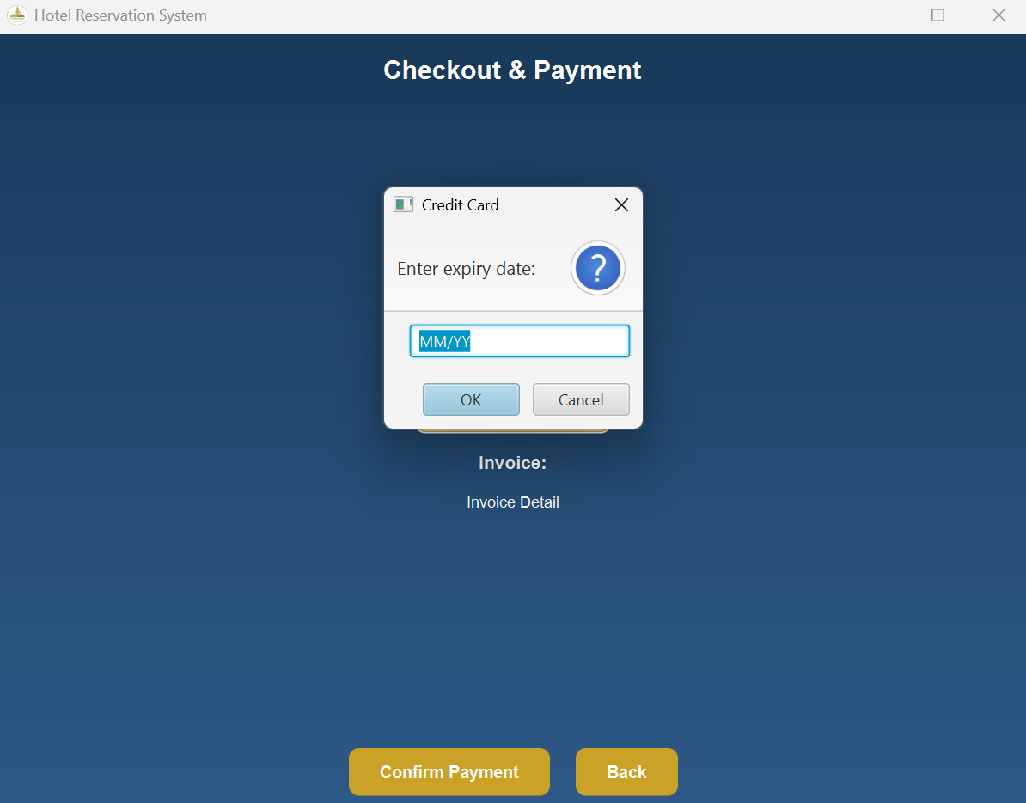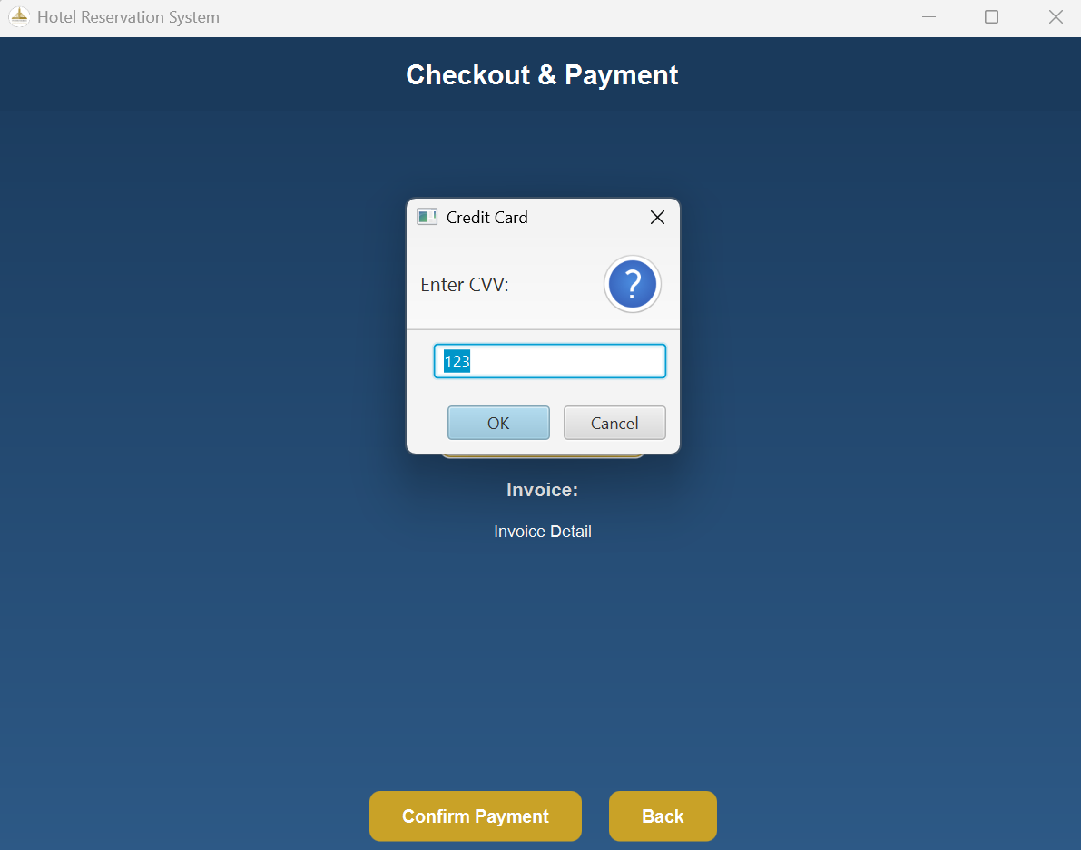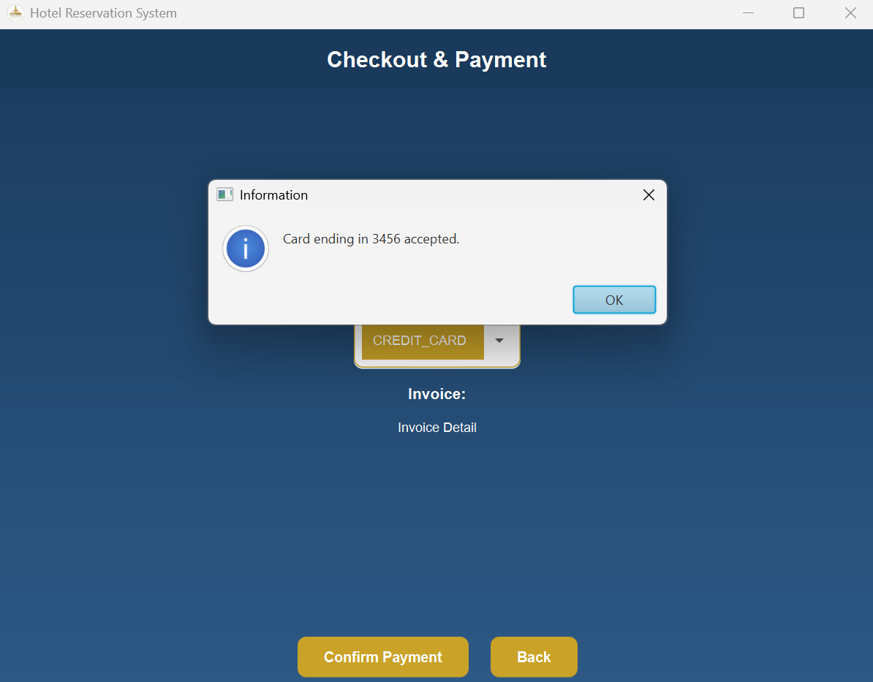5.9 Generated Invoice

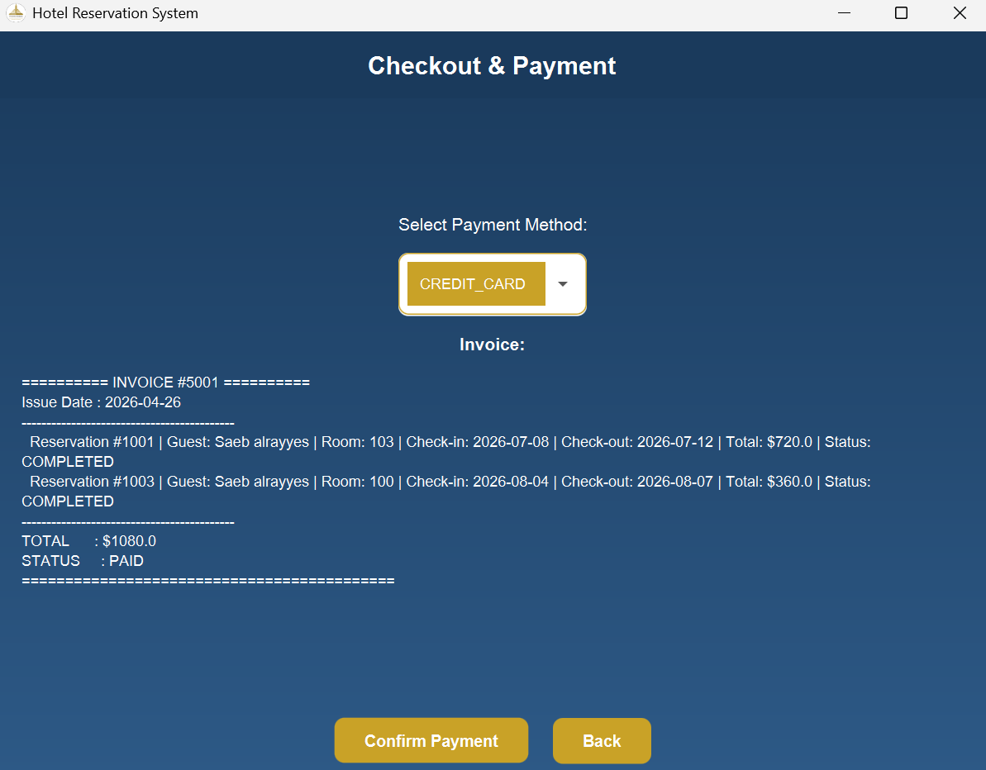5.10 Hotel Services Booking

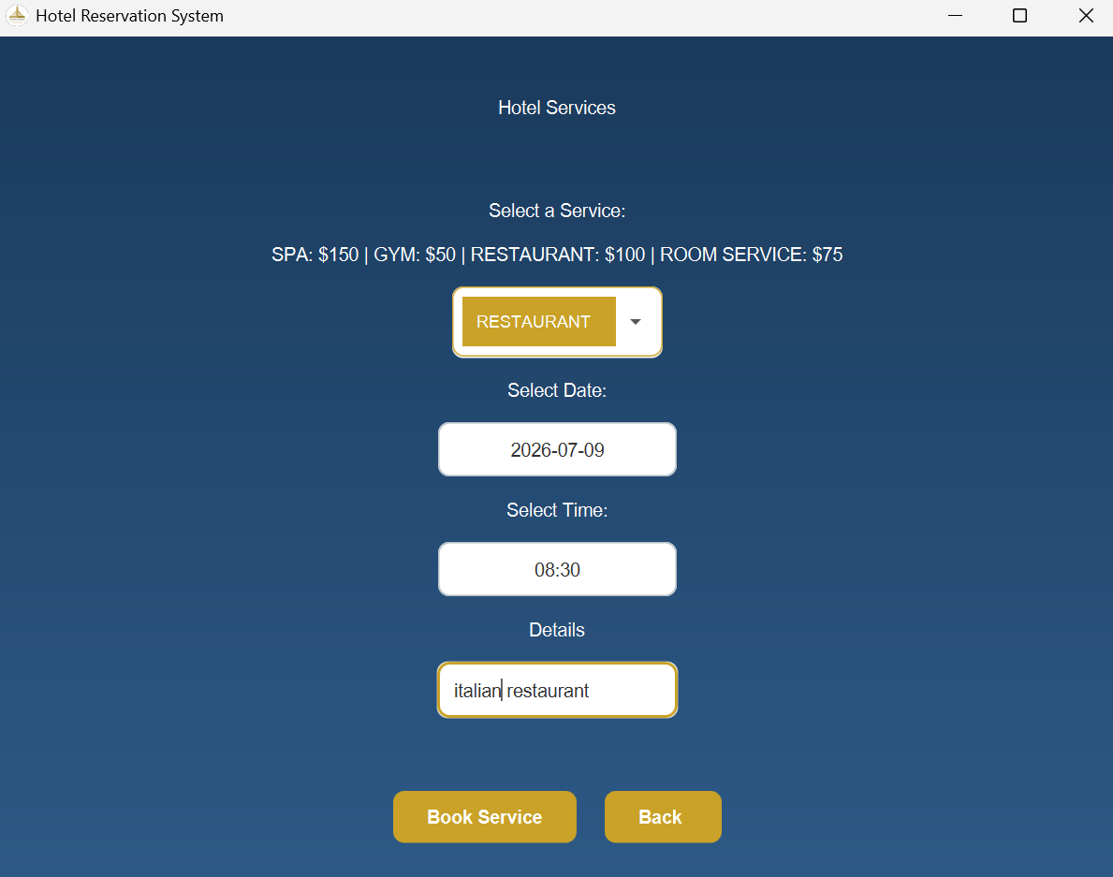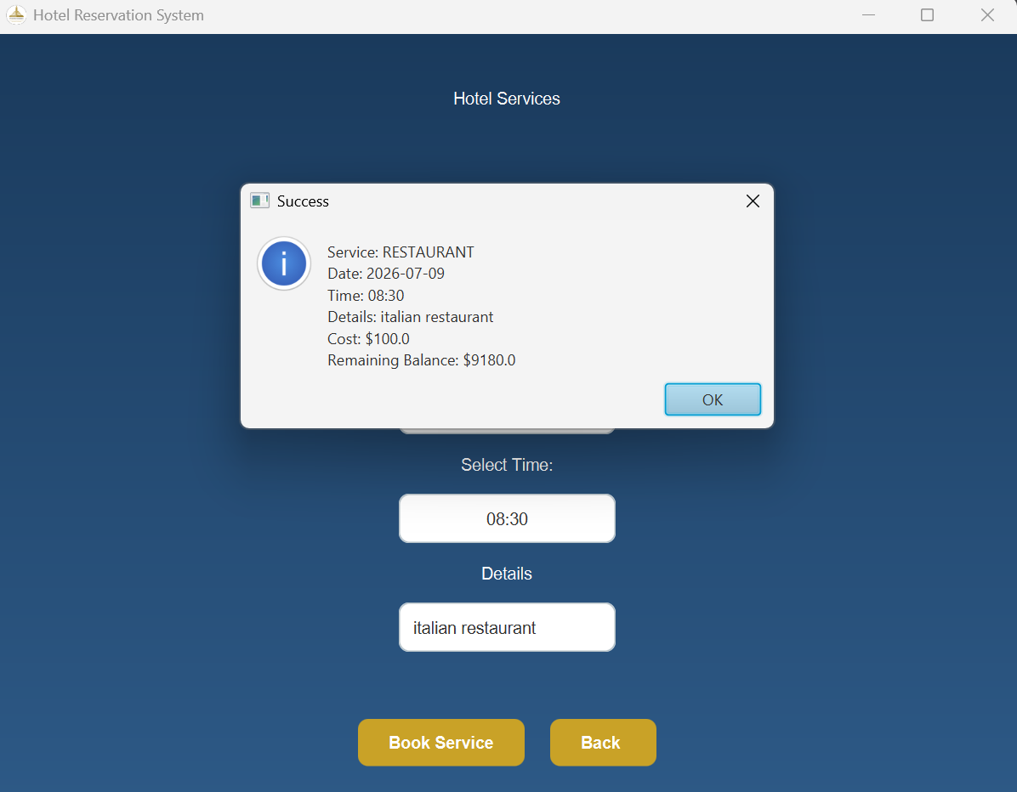5.11 Receptionist Dashboard

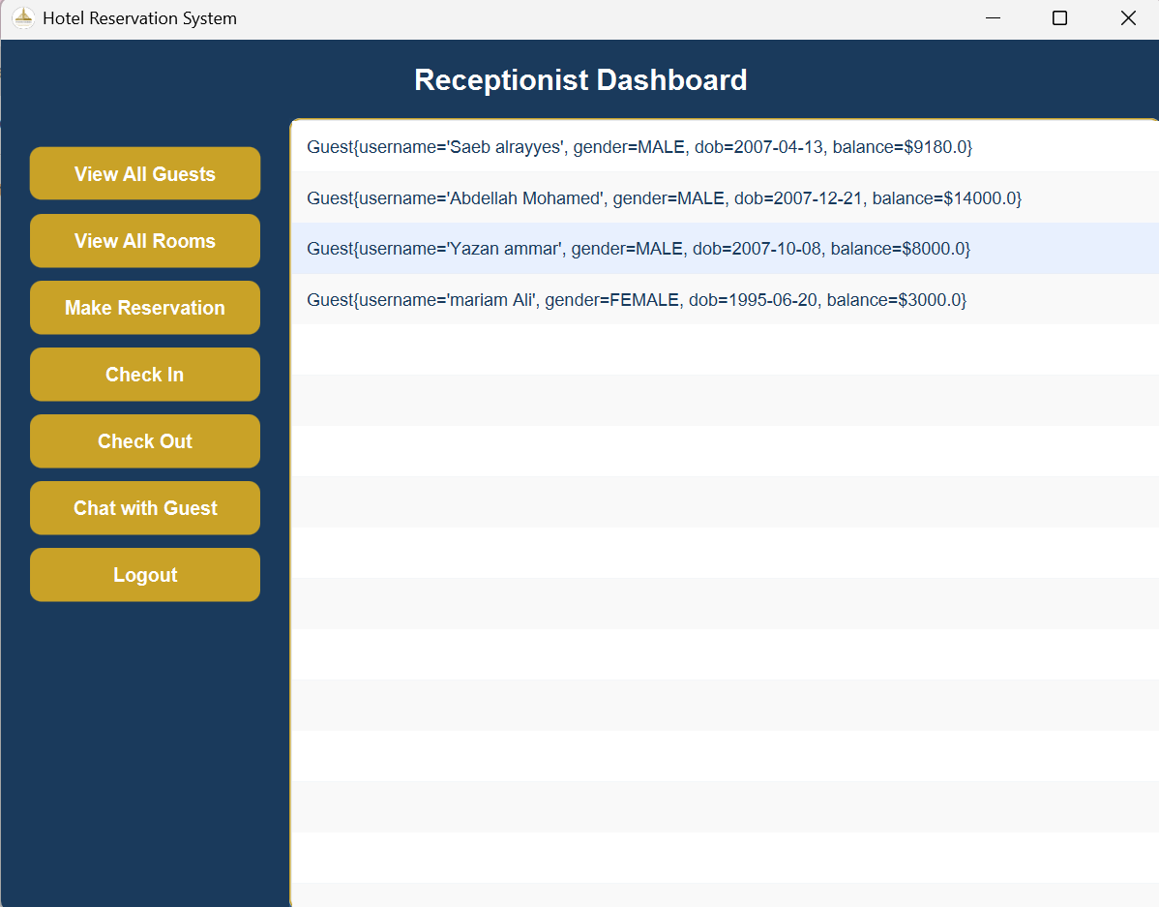5.12 Admin Dashboard — Room Capacity View

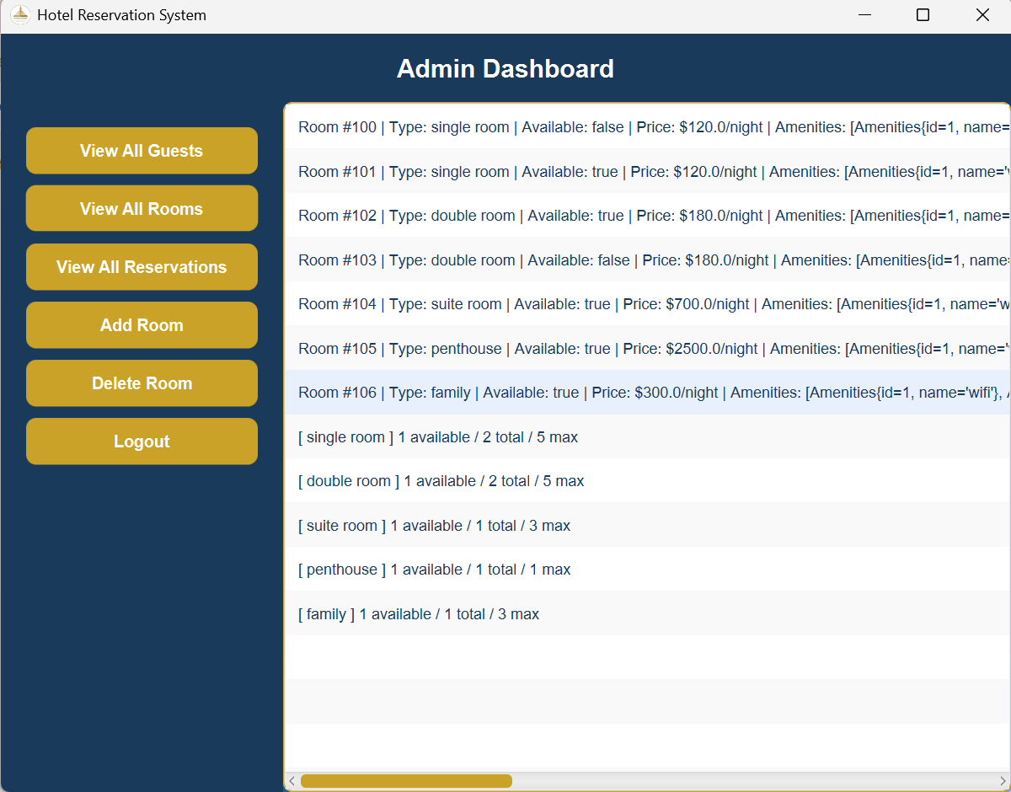5.13 Admin Add Room — Capacity Full Error

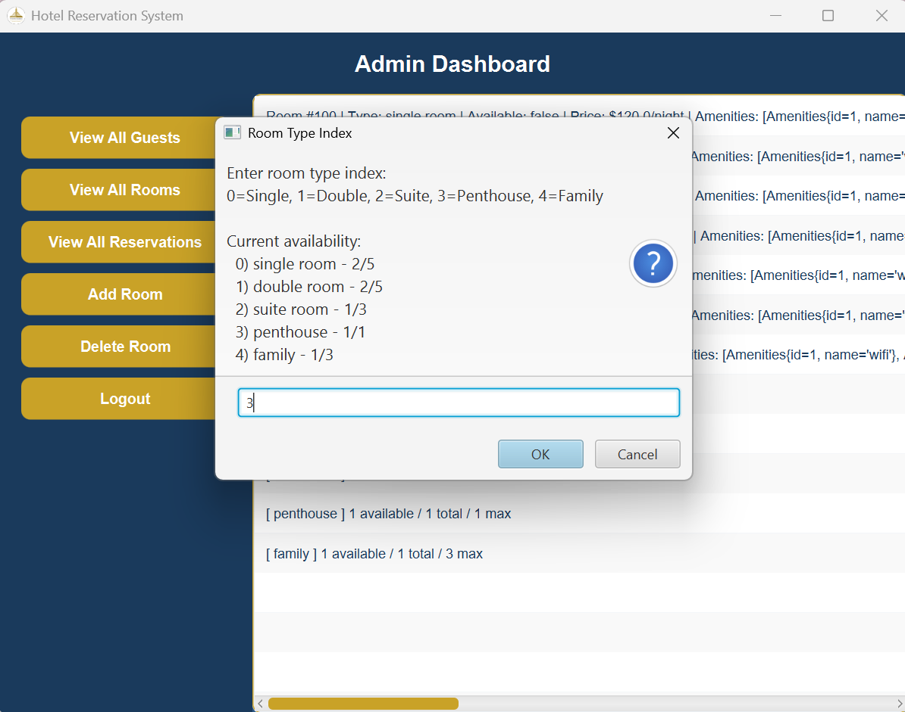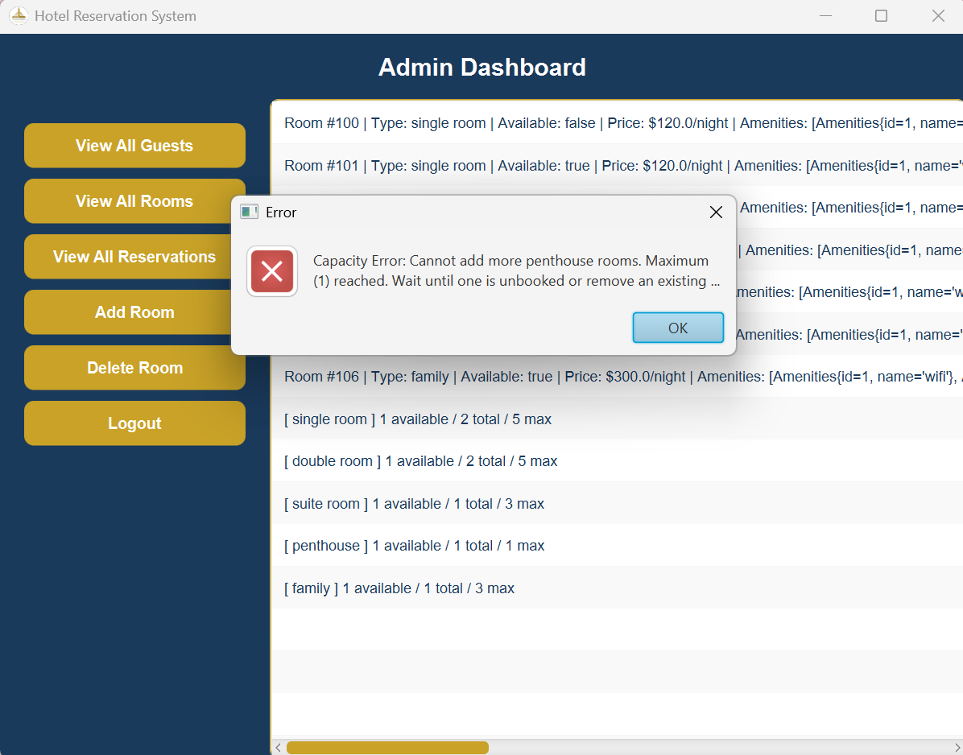5.14 Live Chat — Guest and Receptionist Side by Side

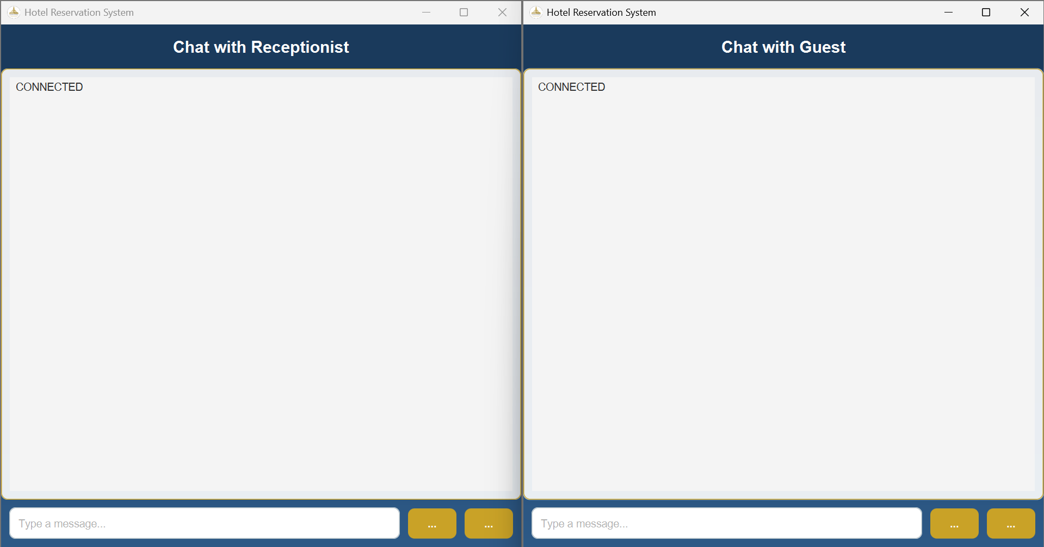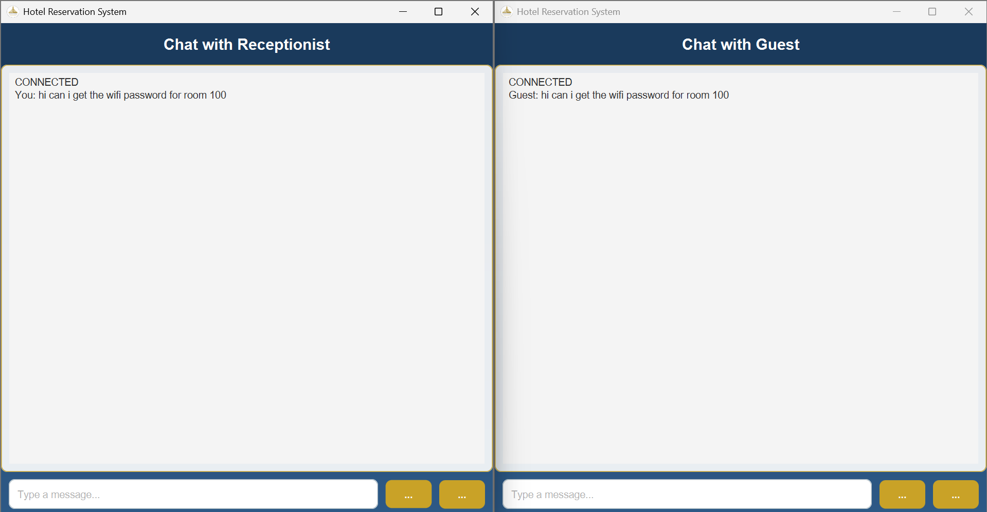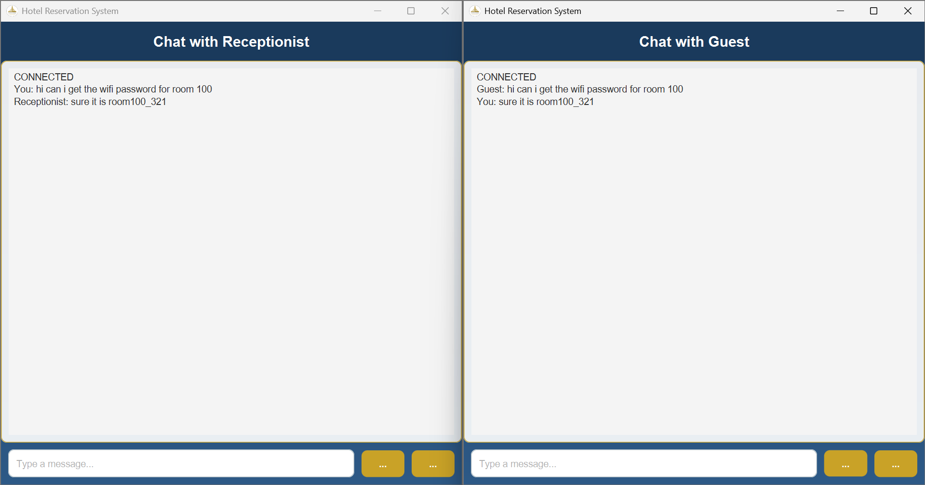6. Testing
The system was tested across all major flows with both valid and invalid inputs. The table below summarizes the twenty test cases that cover the most important behaviors — every test passed in the final build.
ID | Scenario | Input | Expected | Result
T01 | Valid guest login | Username: Saeb alrayyes, Password: SAEB_312 | Dashboard opens | Pass
T02 | Invalid password | Correct username, wrong password | Error alert | Pass
T03 | Empty login fields | Both fields empty | Warning alert | Pass
T04 | Register under-age guest | Date of birth less than 18 years ago | InvalidAgeException alert | Pass
T05 | Register duplicate username | Existing guest's username | DuplicateUsernameException alert | Pass
T06 | Filter rooms by type | Type = Suite | Only suite rooms shown | Pass
T07 | Filter rooms by price | Max price = 200 | Only rooms ≤ $200 shown | Pass
T08 | Combined filters | Type Single + Max 150 + WiFi | Matching rooms only | Pass
T09 | Book past date | Check-in before today | Date error alert | Pass
T10 | Book invalid range | Check-out before check-in | InvalidDateException | Pass
T11 | Book unavailable room | Already booked room | RoomAlreadyBookedException | Pass
T12 | Cancel reservation refund | Cancel a confirmed booking | Status CANCELLED, balance refunded | Pass
T13 | Insufficient balance pay | Invoice total > balance | InsufficientBalanceException | Pass
T14 | Invalid card number | Card with 12 digits | InvalidCardException | Pass
T15 | Add room over max count | Add 2nd penthouse (max=1) | RoomTypeCapacityFullException | Pass
T16 | Service in past | Spa for yesterday | InvalidDateException | Pass
T17 | Service outside hours | Time = 03:00 | InvalidTimeSlotException | Pass
T18 | Real-time chat | Guest sends message | Receptionist receives instantly | Pass
T19 | Auto-refresh rooms | Wait 5 seconds on browse screen | List refreshes without freeze | Pass
T20 | Receptionist check-out | Valid reservation ID | Status COMPLETED, room released | Pass

7. Limitations
The system meets all functional requirements for the course, but a few limitations are worth noting honestly:
- Persistent storage uses SQLite via JDBC. Data is saved to a local hotel.db file and reloaded on startup, so all records survive application restarts.
- Single-host chat. The chat server binds to localhost only. Running on multiple machines would require swapping localhost for the server's actual IP and exposing port 5000 through any local firewall.
- Two participants per chat session. The current ChatServer accepts one guest and one receptionist per pair. Group chats or multiple simultaneous receptionists would require a more elaborate session-management layer.
- No password hashing. Passwords are stored in plaintext inside the in-memory database, which is acceptable for a course project but would be unacceptable in production.
- Hard-coded sample data. The pre-populated guests, rooms, and staff are fixed at startup. There is currently no admin UI for editing room types or amenities through the GUI — the admin can only create rooms; updates to types and amenities are exposed only through the model layer.

8. Team Contributions
Work was divided so that each member owned a logical chunk of the application and could explain their part in detail during the discussion session. The complexity of each role roughly matches the difficulty of the controllers assigned.
Member | Responsibility | Difficulty
Saja Yousef | Login screen and Guest Dashboard navigation. Implemented LoginController and GuestDashboardController including the active reservations preview list. | Intermediate
Yousef Sameh | Staff login flow and guest registration. Implemented StaffLoginController and RegisterController with validation for empty fields, duplicate usernames, and minimum age. | Intermediate
Omar Abdelrahman | Real-time chat feature using Java sockets. Implemented ChatServer, ChatController, and ReceptionistChatController with multi-threaded message forwarding. | Intermediate
Saeb Alrayyes | Hotel services booking, reservation viewing, and room browsing with filters. Implemented HotelServicesController, ReservationManagementController, and RoomBrowsingController with the auto-refresh Timeline. | Intermediate
Mohamed Raouf | Checkout and payment, admin dashboard, and receptionist dashboard. Implemented CheckoutController, AdminDashboardController, and ReceptionistDashboardController. Also handled bug fixes, room capacity logic, and project integration. | Intermediate

In addition to the controller work above, every member contributed to the report and the demo video, and reviewed each other's pull requests on GitHub before merging.

9. References
- Oracle Corporation. Java Platform SE 17 Documentation. https://docs.oracle.com/en/java/javase/17/
- OpenJFX. JavaFX 17 API Reference. https://openjfx.io/javadoc/17/
- Gluon. Scene Builder User Guide. https://gluonhq.com/products/scene-builder/
- Oracle Corporation. The Java Tutorials — Custom Networking. https://docs.oracle.com/javase/tutorial/networking/sockets/
- Oracle Corporation. The Java Tutorials — Concurrency in JavaFX. https://docs.oracle.com/javafx/2/threads/jfxpub-threads.htm
- CSE241 Lecture Notes — Object-Oriented Computer Programming, Ain Shams University, 2025/2026.

10. Appendices

10.1 GitHub Repository
The complete source code, FXML files, CSS, report, and supporting materials are available at:

https://github.com/Mohamed-raouf123/Hotel-Reservation-System/tree/milestone-2

10.2 Demo Video
A walkthrough of the application is available on YouTube (unlisted):
[INSERT YOUTUBE LINK]

10.3 How to Run
1. Clone the GitHub repository to your local machine.
2. Open the project in IntelliJ IDEA or Apache NetBeans as a Maven project.
3. Ensure the JavaFX SDK is configured (Maven will pull dependencies automatically).
4. Run the Testmain class — the login screen will appear and the chat server will boot in the background.
5. Use one of the pre-populated guest accounts to explore guest features, or use the staff login screen with one of the seeded admin or receptionist accounts.

