
ACCRA TECHNICAL UNIVERSITY

NAME: ASENSO RICHMOND

INDEX NUMBER: 01259229B

PROGRAMME: B
ACHELOR OF
TECH
OLOGY

IN COMPUTER
SCIENCE (TOP
-
UP)

COURSE TITLE: INTRODUCTION TO DATA SCIENCE

COURSE CODE: BCS 404

MID
-
SEMESTER PROJECT

JULY, 2026

Table of Contents
Table of Contents 2
1. Introduction 1
2. Dataset Description 1
3. Methodology 2
4. Results 2
4.1 Data Cleaning Results 2
4.2 Data Visualisation Results 2
4.3 Statistical Analysis Results 6
4.4 Machine Learning Results 6
5. Discussion 7
6. Conclusion 7
6.1 Major Findings 7
6.2 Statistical Insights 8
6.3 Machine Learning Results 8
6.4 Limitations 8
6.5 Recommendations 8
References 9
Appendix: Python Code 9

1. Introduction
This report walks through a full data science workflow built around the Titanic passenger dataset, carried out as project work for BCS 404: Introduction to Data Science with Python at Accra Technical University. It sets out to demonstrate hands-on competence across the pipeline, from acquiring and cleaning the data, through exploratory visualisation and statistical analysis, to a first machine learning model, all implemented with the standard Python data-science stack (pandas, NumPy, Matplotlib, Seaborn, and Scikit-Learn).
On 15 April 1912, the RMS Titanic struck an iceberg during its maiden voyage and sank, claiming the lives of a large proportion of the passengers and crew aboard (Eaton & Haas, 1994). The Titanic dataset, distributed through Kaggle's "Titanic: Machine Learning from Disaster" competition, records demographic and travel details for 891 passengers together with an indicator of whether each passenger survived (Kaggle, 2012). Because survival was strongly influenced by identifiable factors such as sex, age, and passenger class, the dataset is a widely used introductory case study for both statistical analysis and binary classification.
The rest of the report follows this structure: Section 2 introduces the dataset; Section 3 sets out the methodology; Section 4 reports results from the cleaning, visualisation, statistical, and machine learning stages; Section 5 discusses what the findings mean; Section 6 closes with conclusions and recommendations; and the Appendix reproduces the Python code behind the analysis.

2. Dataset Description
This project draws on the Titanic dataset made available through Kaggle (https://www.kaggle.com/competitions/titanic/data), comprising 891 passenger records across 12 variables, summarised in Table 1.
Table 1: Description of dataset variables
Column | Type | Description
PassengerId | Integer | Unique identifier for each passenger
Survived | Integer (0/1) | Target variable: 0 = did not survive, 1 = survived
Pclass | Integer (1-3) | Ticket class, a proxy for socio-economic status
Name | Text | Passenger's full name
Sex | Categorical | Passenger's sex (male / female)
Age | Float | Age in years
SibSp | Integer | Number of siblings/spouses aboard
Parch | Integer | Number of parents/children aboard
Ticket | Text | Ticket number
Fare | Float | Passenger fare paid
Cabin | Text | Cabin number (mostly missing)
Embarked | Categorical | Port of embarkation (C, Q, S)

The dataset mixes numerical, categorical, and identifier/free-text fields, and the Age, Cabin, and Embarked columns each carry missing values, a gap that is addressed during cleaning (Section 4.1).

3. Methodology
The project followed a standard data-science pipeline implemented in a Jupyter Notebook using Python 3:
- Data Acquisition: the dataset was loaded into a pandas DataFrame (McKinney, 2010) and inspected for its dimensions, column names, data types, and first observations.
- Data Cleaning: missing values were identified and treated (median imputation for Age, mode imputation for Embarked, and removal of the Cabin column), and the data was checked for duplicate rows.
- Data Visualisation: six visualisations were produced using Matplotlib (Hunter, 2007) and Seaborn (Waskom, 2021) to explore distributions and relationships among key variables.
- Statistical Analysis: descriptive statistics, frequency distributions, and a Pearson correlation analysis were computed to quantify relationships between variables.
- Machine Learning: a Logistic Regression classifier was trained using Scikit-Learn (Pedregosa et al., 2011) on an 80/20 stratified train-test split, using Pclass, Sex, Age, SibSp, Parch, Fare, and Embarked as predictors of Survived, and evaluated using accuracy, a confusion matrix, and a classification report.
All code was developed and executed in a single Jupyter Notebook (Titanic_Data_Science_Project.ipynb), which is included in the submitted GitHub repository and reproduced in the Appendix.

4. Results

4.1 Data Cleaning Results
Missing data affected three columns in the raw dataset: Age (177 records, 19.9%), Cabin (687 records, 77.1%), and Embarked (2 records); no duplicate rows were found. Age was filled in with the median value (28 years), a sensible choice given the right-skewed distribution and the median's resistance to outliers. Embarked was filled with its mode ("S", Southampton), reasonable since only two values needed replacing, while Cabin was dropped altogether given how sparse it was. Once cleaning was complete, all 891 rows remained intact, with no missing values left across the 11 remaining columns.

4.2 Data Visualisation Results
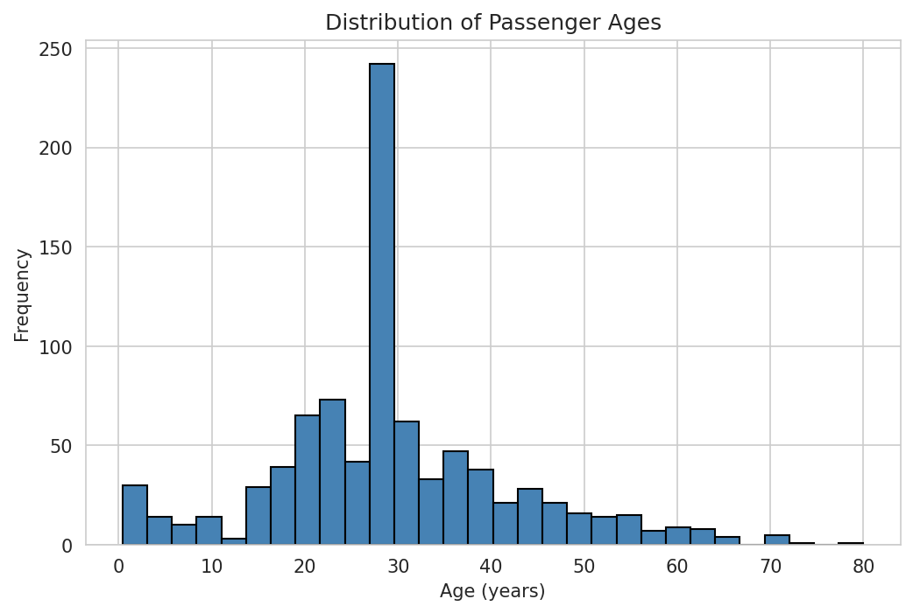
Figure 1: Histogram of passenger ages. The distribution is right-skewed and concentrated between 20 and 40 years, with a spike at the imputed median age.
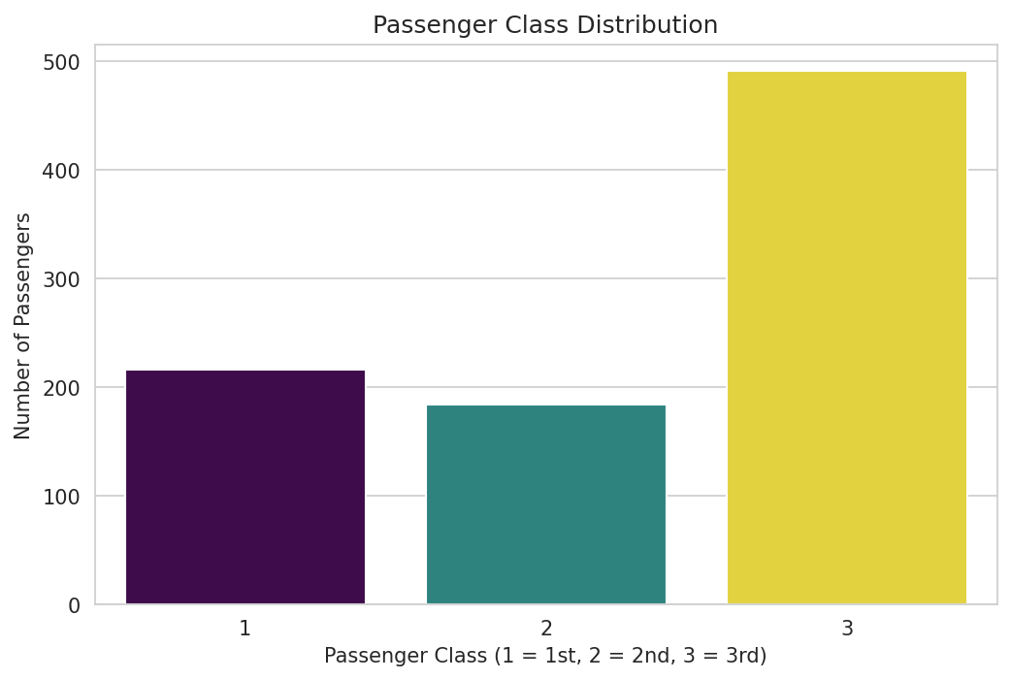
Figure 2: Passenger class distribution. Third-class passengers form the largest group, about 55% of the total.
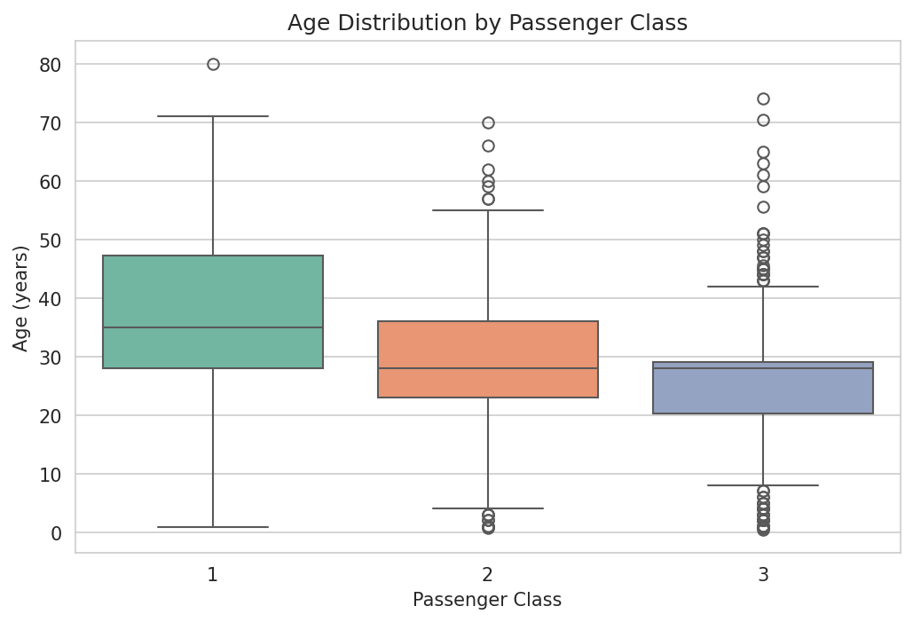
Figure 3: Age distribution by passenger class. Median age decreases from first to third class.
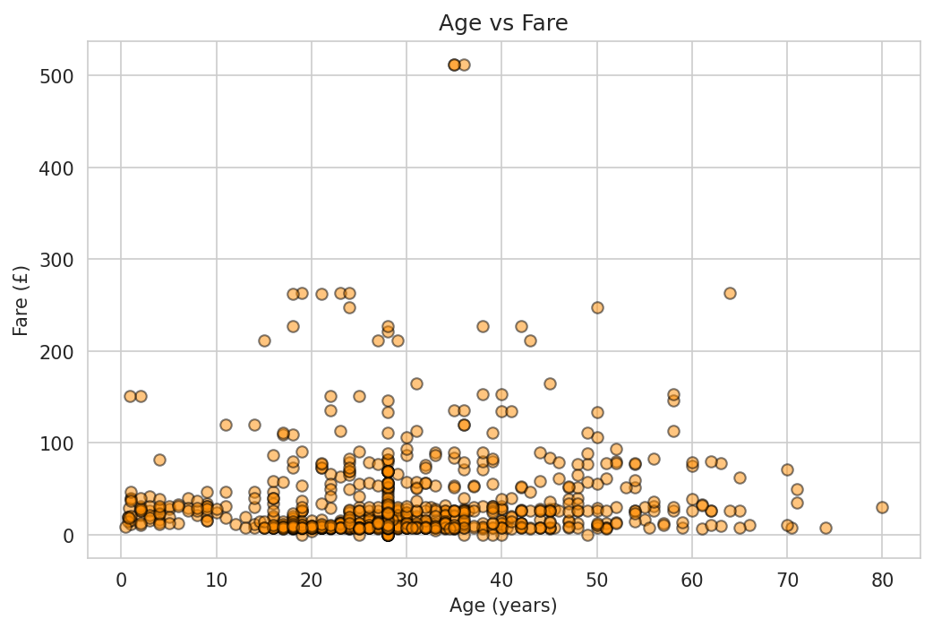
Figure 4: Age versus Fare. No strong linear relationship is visible; high fares occur across a wide age range.
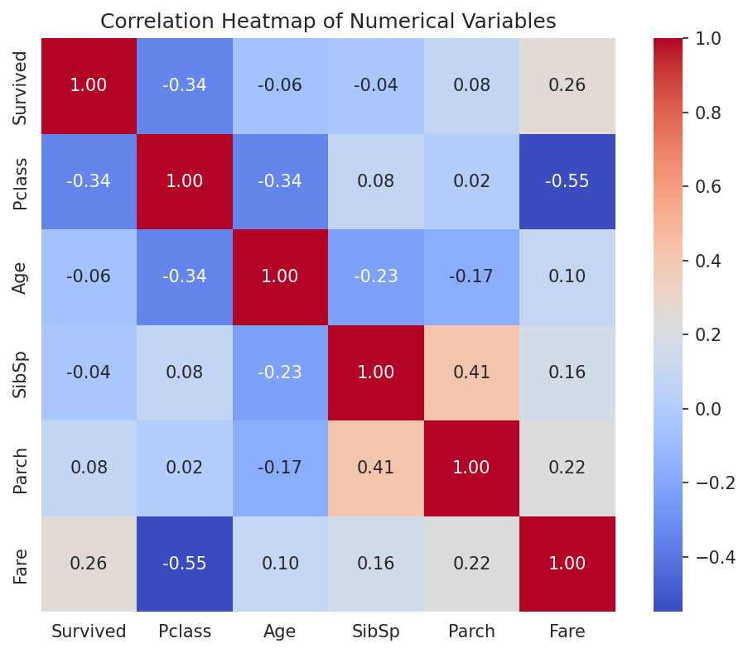
Figure 5: Correlation heatmap of numerical variables. Pclass and Fare show the strongest correlation (-0.55).
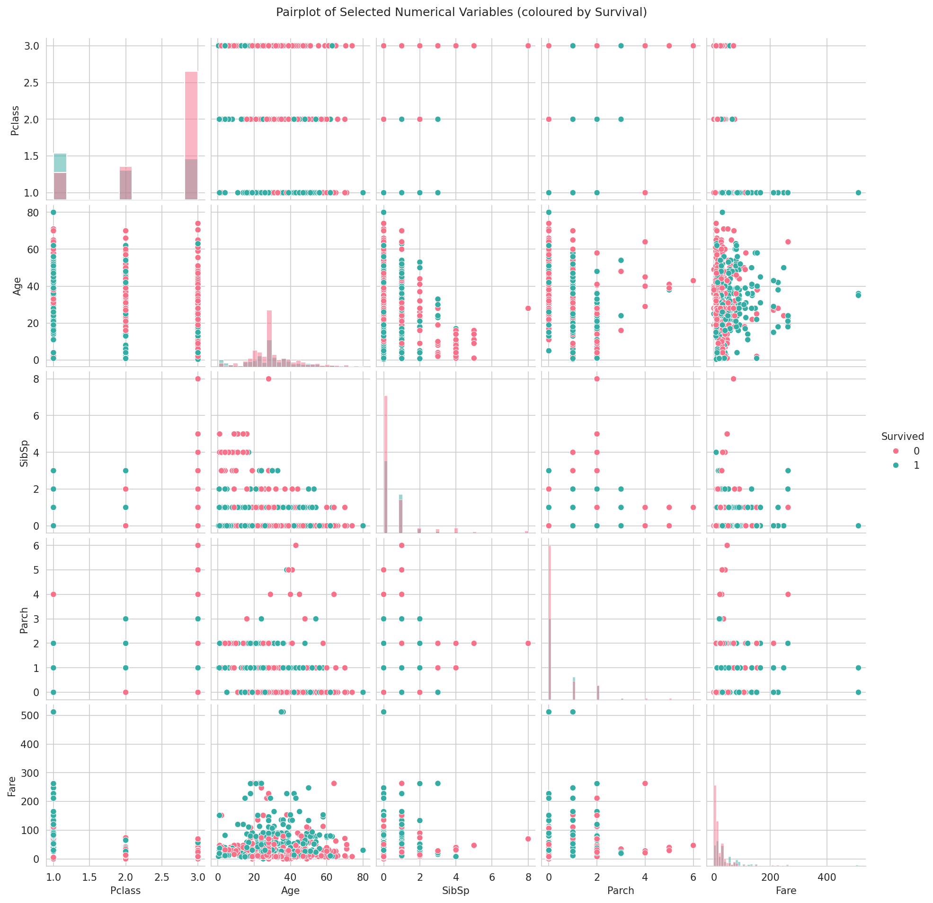
Figure 6: Pairplot of numerical variables coloured by survival status.

4.3 Statistical Analysis Results
Table 2: Descriptive statistics for numerical variables
Statistic | Survived | Pclass | Age | SibSp | Parch | Fare
Mean | 0.384 | 2.309 | 29.36 | 0.523 | 0.382 | 32.20
Std Dev | 0.487 | 0.836 | 13.02 | 1.103 | 0.806 | 49.69
Min | 0 | 1 | 0.42 | 0 | 0 | 0.00
Median | 0 | 3 | 28.00 | 0 | 0 | 14.45
Max | 1 | 3 | 80.00 | 8 | 6 | 512.33

Frequency counts show 549 passengers (61.6%) did not survive versus 342 (38.4%) who did; 577 passengers (64.8%) were male versus 314 (35.2%) female; and 646 (72.5%), 168 (18.9%), and 77 (8.6%) passengers embarked from Southampton, Cherbourg, and Queenstown respectively.
The strongest positive correlation among numerical variables is between SibSp and Parch (r = 0.415), reflecting that passengers travelling with siblings/spouses often also travelled with parents/children (family groups). The strongest negative correlation is between Pclass and Fare (r = -0.549), confirming that lower class numbers (higher class) are strongly associated with higher fares.
Three important statistical findings emerge from this analysis:
- Passenger class and fare, not age, are most strongly associated with survival: Survived correlates at -0.338 with Pclass and +0.257 with Fare, but only -0.065 with Age.
- Family-related variables move together: SibSp and Parch are moderately correlated (0.415), suggesting many passengers travelled in family units rather than alone.
- Fares were highly right-skewed: the mean fare (£32.20) is more than double the median (£14.45), driven by a small number of very expensive first-class tickets (up to £512.33).

4.4 Machine Learning Results
A Logistic Regression classifier was trained on the seven selected predictors using an 80/20 stratified train-test split (712 training observations, 179 testing observations). The model achieved:
- Accuracy: 80.4%
- Confusion Matrix: 98 true negatives, 12 false positives, 23 false negatives, 46 true positives
- Precision / Recall / F1 (Survived class): 0.79 / 0.67 / 0.72
- Precision / Recall / F1 (Did Not Survive class): 0.81 / 0.89 / 0.85
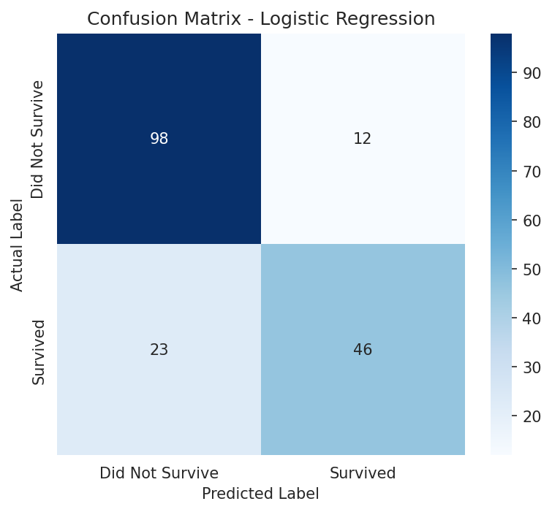
Figure 7: Confusion matrix for the Logistic Regression model on the test set.

5. Discussion
Taken together, the exploratory and statistical findings tell a consistent story: survival aboard the Titanic tracked socio-economic status, captured here through passenger class and fare, far more closely than it tracked age or family size. First-class passengers, who paid noticeably higher fares, enjoyed a clearly better chance of survival than those travelling third class, even though third class made up the largest single group aboard. This pattern lines up with well-documented historical accounts, which describe lifeboat access as often tied to cabin location and class (Encyclopaedia Britannica, 2024).
The Logistic Regression model, trained on class, sex, age, family-size, fare, and embarkation port, was able to predict survival with approximately 80% accuracy. However, its recall for the 'Survived' class (0.67) is noticeably lower than for the 'Did Not Survive' class (0.89), meaning the model misses a larger fraction of actual survivors than of actual non-survivors. This is a common outcome of the underlying class imbalance in the data (more non-survivors than survivors) and of using a simple linear model without additional feature engineering (Chawla et al., 2002).
In short, the statistical and machine learning results point to the same conclusion from two different angles: fare and class, standing in for a passenger's socio-economic standing and likely nearness to the lifeboats, drove survival in this dataset far more than age did.

6. Conclusion

6.1 Major Findings
Across the 891 passenger records examined here, the goal was twofold: uncover what shaped survival and use those factors to build a predictive model. Class and fare stood out as the strongest correlates of who lived, while age contributed only marginally. Third-class travellers, despite making up the majority of everyone aboard, faced a meaningfully lower chance of survival than their first- and second-class counterparts.

6.2 Statistical Insights
Correlation analysis quantified these relationships, with Pclass and Fare showing the strongest overall correlation (-0.549), and Survived correlating more strongly with Pclass (-0.338) and Fare (0.257) than with Age (-0.065). Family-related variables (SibSp, Parch) were moderately correlated with each other (0.415), indicating many passengers travelled in family units.

6.3 Machine Learning Results
The Logistic Regression classifier reached roughly 80% accuracy on unseen test data, doing a better job spotting non-survivors than survivors — a gap that points to room for further refinement of the model.

6.4 Limitations
- Median/mode imputation of Age and Embarked may understate true variability and could weaken observed relationships.
- The Cabin column, despite being 77% missing, may have carried useful information (e.g., deck location) that was lost when dropped.
- Logistic Regression assumes linear relationships between predictors and the log-odds of survival, and cannot capture complex interaction effects without explicit feature engineering.
- No additional feature engineering (e.g., family size, title extraction from Name) was performed in this iteration.
- The test set (179 records) is relatively small, so evaluation metrics may vary across different random splits.

6.5 Recommendations
- Engineer additional features such as total family size, passenger title, and a binary 'has cabin recorded' indicator.
- Compare Logistic Regression against ensemble methods such as Random Forest or Gradient Boosting using cross-validation.
- Address class imbalance through class weighting or resampling to improve recall on the survived class.
- Tune model hyperparameters (e.g., regularisation strength) using grid search with cross-validation.
- Conduct formal hypothesis tests (e.g., chi-square tests) to statistically confirm associations observed visually.

References
Kaggle. (2012). Titanic - Machine Learning from Disaster. https://www.kaggle.com/competitions/titanic/data
McKinney, W. (2010). Data structures for statistical computing in Python. In S. van der Walt & J. Millman (Eds.), Proceedings of the 9th Python in Science Conference (pp. 56–61). https://doi.org/10.25080/Majora-92bf1922-00a
Hunter, J. D. (2007). Matplotlib: A 2D graphics environment. Computing in Science & Engineering, 9(3), 90–95. https://doi.org/10.1109/MCSE.2007.55
Waskom, M. L. (2021). seaborn: Statistical data visualization. Journal of Open Source Software, 6(60), 3021. https://doi.org/10.21105/joss.03021
Pedregosa, F., Varoquaux, G., Gramfort, A., Michel, V., Thirion, B., Grisel, O., Blondel, M., Prettenhofer, P., Weiss, R., Dubourg, V., Vanderplas, J., Passos, A., Cournapeau, D., Brucher, M., Perrot, M., & Duchesnay, E. (2011). Scikit-learn: Machine learning in Python. Journal of Machine Learning Research, 12, 2825–2830.
Harris, C. R., Millman, K. J., van der Walt, S. J., Gommers, R., Virtanen, P., Cournapeau, D., Wieser, E., Taylor, J., Berg, S., Smith, N. J., Kern, R., Picus, M., Hoyer, S., van Kerkwijk, M. H., Brett, M., Haldane, A., del Río, J. F., Wiebe, M., Peterson, P., … Oliphant, T. E. (2020). Array programming with NumPy. Nature, 585, 357–362. https://doi.org/10.1038/s41586-020-2649-2
Encyclopaedia Britannica. (2024). Titanic: Ocean liner. https://www.britannica.com/topic/Titanic
Eaton, J. P., & Haas, C. A. (1994). Titanic: Triumph and tragedy (2nd ed.). W. W. Norton & Company.
Chawla, N. V., Bowyer, K. W., Hall, L. O., & Kegelmeyer, W. P. (2002). SMOTE: Synthetic minority over-sampling technique. Journal of Artificial Intelligence Research, 16, 321–357. https://doi.org/10.1613/jair.953

Appendix: Python Code
The full, executable Python code is provided in the accompanying Jupyter Notebook (Titanic_Data_Science_Project.ipynb) submitted in the GitHub repository. The complete code listing is reproduced below for reference.

import pandas as pd
import numpy as np
import matplotlib.pyplot as plt
import seaborn as sns
from sklearn.model_selection import train_test_split
from sklearn.linear_model import LogisticRegression
from sklearn.metrics import accuracy_score, confusion_matrix, classification_report
from sklearn.preprocessing import LabelEncoder

sns.set_style("whitegrid")
plt.rcParams['figure.figsize'] = (8, 5)

FIG_DIR = "figures"

# ---------------- Task 1: Data Acquisition ----------------
df = pd.read_csv("data/titanic.csv")
print("Shape:", df.shape)
print("Columns:", list(df.columns))
print(df.head())
print(df.dtypes)

# ---------------- Task 2: Data Cleaning ----------------
print("\nMissing values:\n", df.isnull().sum())
print("\nDuplicates:", df.duplicated().sum())

df_clean = df.copy()
df_clean['Age'] = df_clean['Age'].fillna(df_clean['Age'].median())
df_clean['Embarked'] = df_clean['Embarked'].fillna(df_clean['Embarked'].mode()[0])
df_clean.drop(columns=['Cabin'], inplace=True)
df_clean.drop_duplicates(inplace=True)
print("\nAfter cleaning missing values:\n", df_clean.isnull().sum())
print("Cleaned shape:", df_clean.shape)

# ---------------- Task 3: Visualisation ----------------
plt.figure()
plt.hist(df_clean['Age'], bins=30, color='steelblue', edgecolor='black')
plt.title("Distribution of Passenger Ages")
plt.xlabel("Age (years)")
plt.ylabel("Frequency")
plt.savefig(f"{FIG_DIR}/1_age_histogram.png", dpi=150, bbox_inches='tight')
plt.close()

plt.figure()
sns.countplot(x='Pclass', data=df_clean, palette='viridis', hue='Pclass', legend=False)
plt.title("Passenger Class Distribution")
plt.xlabel("Passenger Class")
plt.ylabel("Number of Passengers")
plt.savefig(f"{FIG_DIR}/2_pclass_bar.png", dpi=150, bbox_inches='tight')
plt.close()

plt.figure()
sns.boxplot(x='Pclass', y='Age', data=df_clean, hue='Pclass', palette='Set2', legend=False)
plt.title("Age Distribution by Passenger Class")
plt.xlabel("Passenger Class")
plt.ylabel("Age (years)")
plt.savefig(f"{FIG_DIR}/3_age_by_pclass_box.png", dpi=150, bbox_inches='tight')
plt.close()

plt.figure()
plt.scatter(df_clean['Age'], df_clean['Fare'], alpha=0.5, c='darkorange', edgecolor='k')
plt.title("Age vs Fare")
plt.xlabel("Age (years)")
plt.ylabel("Fare (£)")
plt.savefig(f"{FIG_DIR}/4_age_vs_fare_scatter.png", dpi=150, bbox_inches='tight')
plt.close()

num_cols = ['Survived', 'Pclass', 'Age', 'SibSp', 'Parch', 'Fare']
plt.figure(figsize=(8, 6))
corr = df_clean[num_cols].corr()
sns.heatmap(corr, annot=True, cmap='coolwarm', fmt='.2f', square=True)
plt.title("Correlation Heatmap of Numerical Variables")
plt.savefig(f"{FIG_DIR}/5_correlation_heatmap.png", dpi=150, bbox_inches='tight')
plt.close()

pp = sns.pairplot(df_clean[num_cols], hue='Survived', palette='husl', diag_kind='hist')
pp.fig.suptitle("Pairplot of Selected Numerical Variables", y=1.02)
pp.savefig(f"{FIG_DIR}/6_pairplot.png", dpi=150, bbox_inches='tight')
plt.close()

print("\nCorrelation matrix:\n", corr)

# ---------------- Task 4: Statistical Analysis ----------------
print("\nDescriptive statistics:\n", df_clean[num_cols].describe())
print("\nSurvived counts:\n", df_clean['Survived'].value_counts())
print("\nSex counts:\n", df_clean['Sex'].value_counts())
print("\nEmbarked counts:\n", df_clean['Embarked'].value_counts())

corr_unstack = corr.abs().unstack().sort_values(ascending=False)
corr_pairs = corr_unstack[corr_unstack < 1].drop_duplicates()
print("\nTop correlations by magnitude:\n", corr_pairs.head(10))

signed = corr.unstack()
signed = signed[signed != 1].drop_duplicates()
print("\nStrongest positive:", signed.idxmax(), signed.max())
print("Strongest negative:", signed.idxmin(), signed.min())

# ---------------- Task 5: Machine Learning ----------------
ml_df = df_clean.copy()
le_sex = LabelEncoder()
ml_df['Sex_enc'] = le_sex.fit_transform(ml_df['Sex'])
le_emb = LabelEncoder()
ml_df['Embarked_enc'] = le_emb.fit_transform(ml_df['Embarked'])

features = ['Pclass', 'Sex_enc', 'Age', 'SibSp', 'Parch', 'Fare', 'Embarked_enc']
X = ml_df[features]
y = ml_df['Survived']

X_train, X_test, y_train, y_test = train_test_split(X, y, test_size=0.2, random_state=42, stratify=y)

model = LogisticRegression(max_iter=1000)
model.fit(X_train, y_train)
y_pred = model.predict(X_test)

acc = accuracy_score(y_test, y_pred)
cm = confusion_matrix(y_test, y_pred)
report = classification_report(y_test, y_pred)

print("\nAccuracy:", acc)
print("Confusion Matrix:\n", cm)
print("Classification Report:\n", report)

plt.figure()
sns.heatmap(cm, annot=True, fmt='d', cmap='Blues', xticklabels=['Did Not Survive', 'Survived'], yticklabels=['Did Not Survive', 'Survived'])
plt.title("Confusion Matrix - Logistic Regression")
plt.xlabel("Predicted")
plt.ylabel("Actual")
plt.savefig(f"{FIG_DIR}/7_confusion_matrix.png", dpi=150, bbox_inches='tight')
plt.close()

df_clean.to_csv("data/titanic_clean.csv", index=False)
print("\nDone.")

