ACCRA TECHNICAL UNIVERSITY


NAME: MOHAMMED SUALIHU
INDEX NUMBER: 01251791B
COURSE: INTRODUCTION TO DATA SCIENCE

PROJECT WORK
TABLE OF CONTENTS
LIST OF FIGURES Error! Bookmark not defined.
INTRODUCTION 4
DATASET DESCRIPTION 4
Labelling of Datasets Error! Bookmark not defined.
METHODOLOGY 5
Task 1: Data Acquisition 5
Task 2: Data Cleaning 6
Task 3: Data Visualisation 7
Task 5: Machine Learning 13
DISCUSSION AND CONCLUSION 15
Major Findings 15
Statistical Insights 15
Machine Learning Results 15
Limitations of the Study 16
Recommendations 16
REFERENCE 17
APPENDIX 19
Codes 19

INTRODUCTION
The RMS Titanic was a British ocean liner that became one of history's most infamous maritime disasters when it sank on its maiden voyage on 15th April 1912. Built in Belfast, Northern Ireland, the ship measured approximately 882 feet 9 inches (269 metres) in length, displaced about 46,328 gross registered tons, and was designed to carry a total of 3,327 passengers and crew, making it the largest man-made moving object of its time. It was widely promoted as “unsinkable,” a reputation shaped as much by cutting-edge marine engineering as by confident marketing and the broader optimism of the early 20th century (Encyclopaedia Britannica, 2024). While crossing the North Atlantic from Southampton, England, toward New York City, the ship struck an iceberg and sank, and an estimated 1,500 people are believed to have lost their lives.

DATASET DESCRIPTION
This dataset is from Kaggle Titanic: Machine Learning from Disaster dataset. It consist of real passenger data from the historic voyage, divided which is divided into three distinct file namely; train.csv, test.csv, and gender_submission,csv.
Train.csv: The train.csv file contains 891 passengers and 12 columns (all with distinct labels). The purpose of the this train.csv file is for building, training and align to the model. The training set contains passenger details along with the target ground truth.
Test.csv: The testing set (418 passenger, 2 columns) contains similar passenger details, but comes with missing Survival column which is a main target or area of concentration in the train.csv file. This is used to test how well the model checks unseen data.
Gender_submission.csv: A baseline submission template which made an assumption that only female passengers survived. The purpose of this assumption was because women had a much higher survival rate in the real Titanic diseaster, this file predict that; every female who survived was labelled (1) and every male who died was labelled (0). The dataset contains 418 passengers and 2 columns (PassengerId & Survived).
Passengerd, Survived, PClass, Name, Sex, Age, SibSp, Parch, Ticket, Fare, Cabin, & Embark.

METHODOLOGY
According to Tukey (1977), Exploratory Data Analysis (EDA) as an attitude and “detective work” meant to discover clues and anomalies before applying confirmatory statistical models. The approach emphasizes flexible, graphical techniques such as stem-and-leaf displays and box plots to foster an understanding of data through visual, resistant statistics rather than rigid, precise calculations.
To predict passenger survival on the RMS Titanic, this projects was structured with the five (5) stages of Machine Learning Pipeline (Data Collection, Preprocessing, Feature Engineering, and Model Evaluation/ Deployment was used. Below are the breakdown;

Task 1: Data Acquisition
The data was acquired from the Kaggle dataset repository, the world’s largest online community and cloud platform for data scientists, machine learning engineers, and artificial intelligence builders (Kaggle, 2025). The platform hosts tens of millions of users across the globe and operates as a vital hub for anyone looking to learn, build, benchmark, or compete in the field of AI and
Data Science. The dataset for this model can be derived from
(https://www.kaggle.com/competitions/titanic/data)
The dataset was explored once it was loaded unto Google Colab from the downloaded dataset from Kaggle below are some of the displays;

• Dataset dimensions
Training set dimensions: (891, 12)
Test set dimensions: (418, 11)

• Column names
Column names: ['PassengerId', 'Survived', 'Pclass', 'Name', 'Sex',
'Age', 'SibSp', 'Parch', 'Ticket', 'Fare', 'Cabin', 'Embarked']

• First five observations:
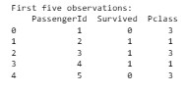
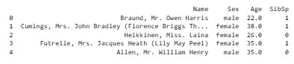
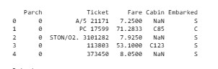

• Data types
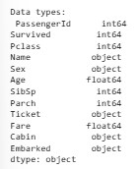

Task 2: Data Cleaning
Data cleaning is the process of detecting and correcting inaccurate, incomplete, duplicate, or inconsistent records so that a dataset can be trusted for downstream analysis (Bigelow & Stedman, 2025). Carrying out this step properly supports more accurate analysis and better-informed decisions, which in turn improves overall model performance (Pilowsky et al., 2024). The dataset was cleaned accordingly, and the outputs of that process are shown below;
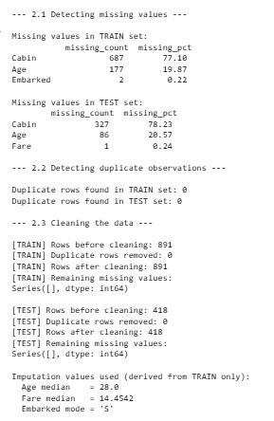
After the data was cleaned below is the result for both dataset (Train & Test);
- Train shape after cleaning: (891, 12)
- Test shape after cleaning: (418, 11)

Task 3: Data Visualisation
Presenting data using graphical element helps in the process in the Data Visualization. Data Visualization comes in the form of charts, graphs, maps, dashboards to make information easier to understand. It users identify patterns, trends, relationships, and outliers, enabling effective communication of insights and supported informed decision-making (Microsoft, 2025; Tableau, 2024).
Upon the machine being able to learn from the dataset these are some of the visual elements in produced;

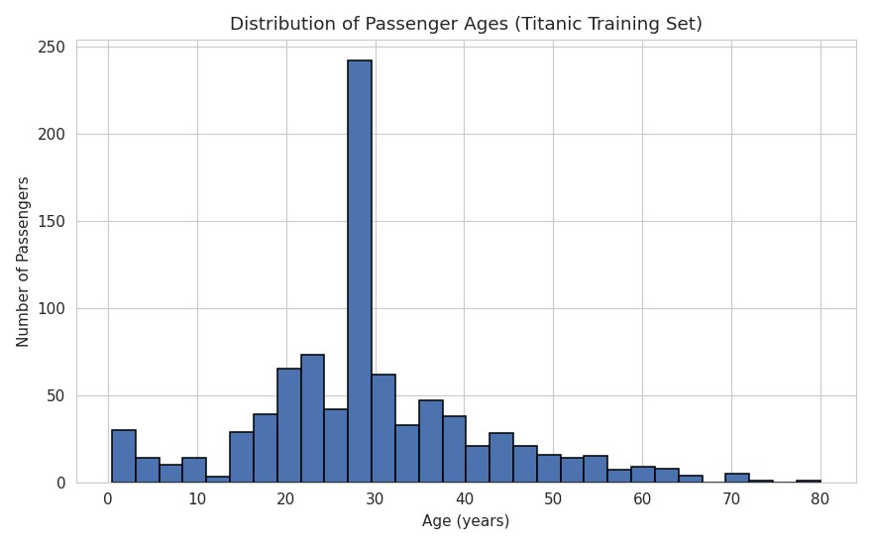

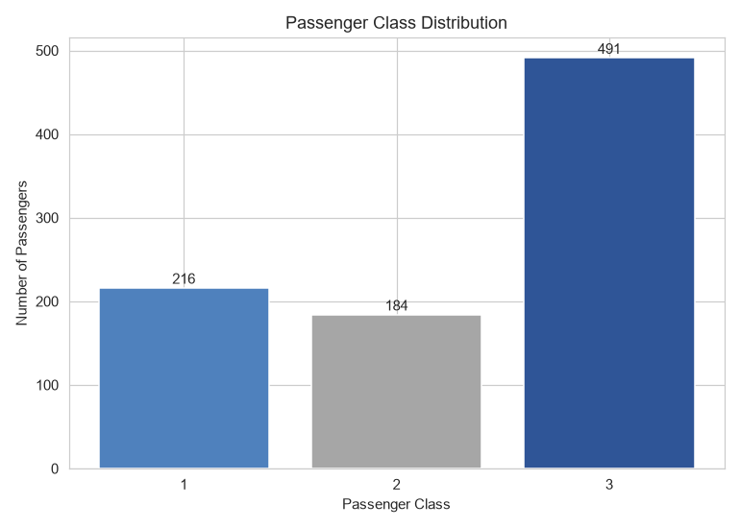

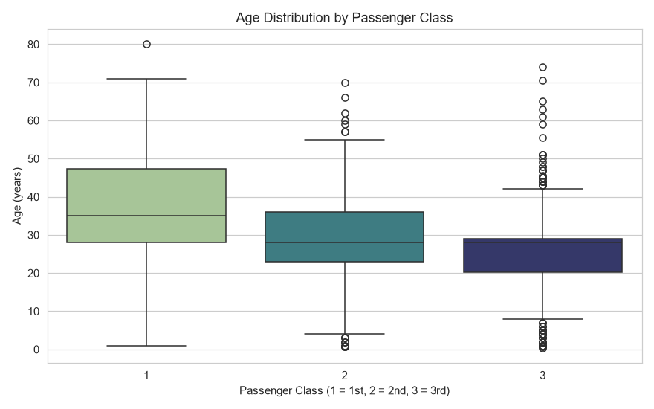

4 Scatter plot of Age versus Fare
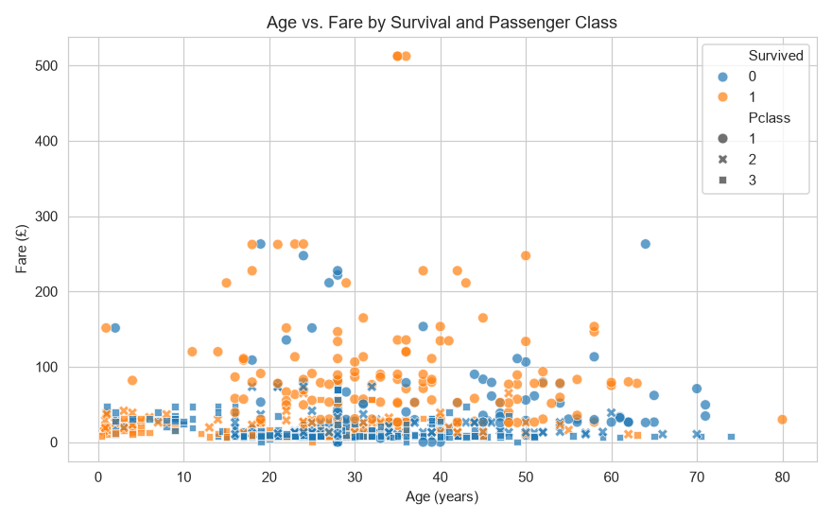

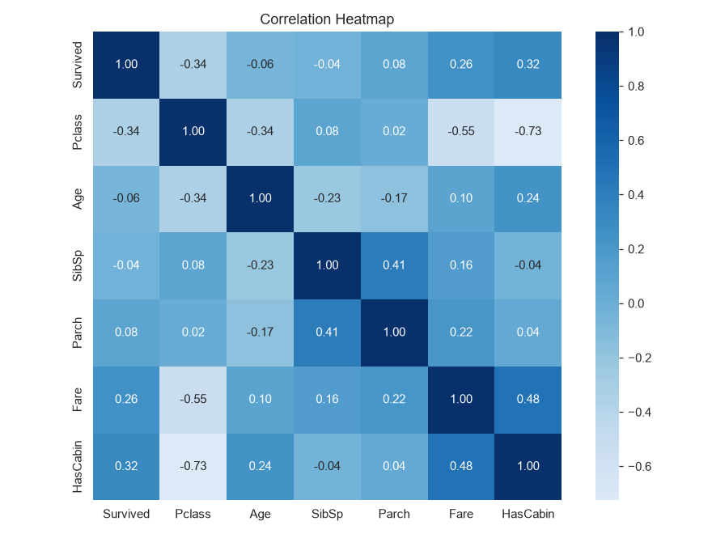

6 Pairplot of selected numerical variables
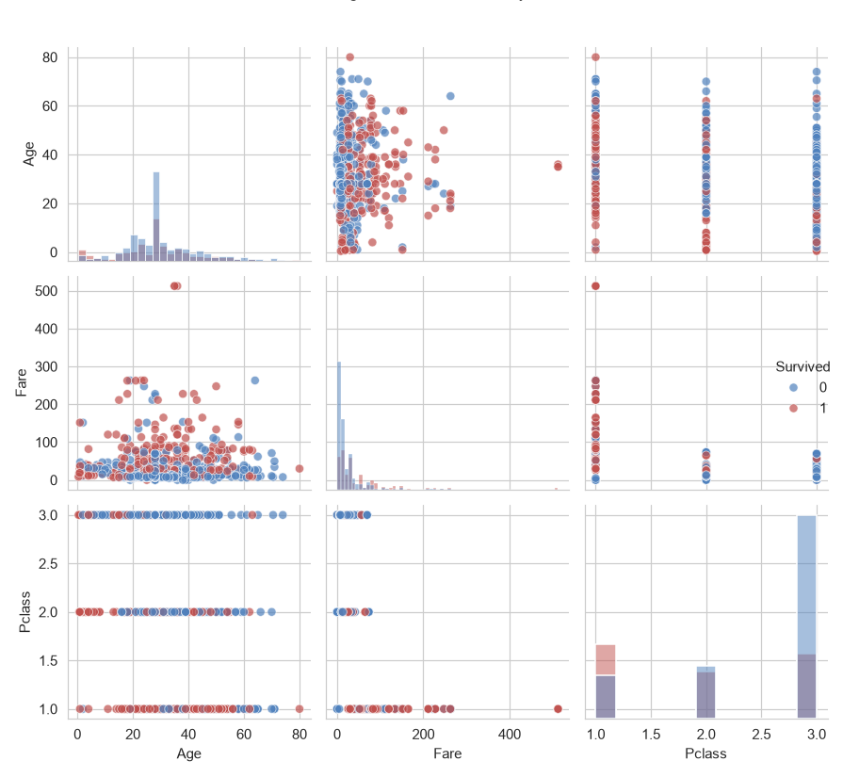

This visualization presents a comparative analysis of survival rates categorized by passenger class and gender. The data demonstrates a clear disparity: across all classes, female passengers exhibited significantly higher survival rates than their male counterparts. Furthermore, firstclass passengers experienced the highest overall survival probability, while those in the third class faced the lowest, underscoring the influence of socioeconomic status on the event's outcome.

Task 4: Statistical Analysis
Once the model was developed the following Statistical analysis were provided; Descriptive statistics
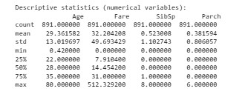

Frequency distribution
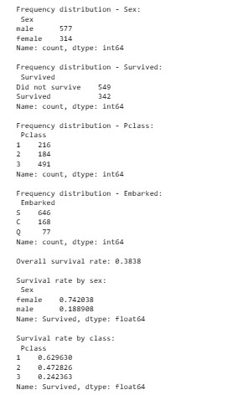

Correlation analysis
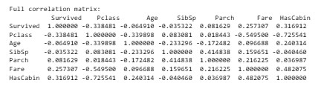
Identify the strongest positive correlation.
Strongest POSITIVE correlation with Survived: HasCabin (r = 0.317)

Identify the strongest negative correlation.
Strongest NEGATIVE correlation with Survived: Pclass (r = -0.338)

Discuss three important statistical findings.
THREE KEY STATISTICAL FINDINGS:
- Sex was the single strongest predictor of survival: women survived at 74.2% versus 18.9% for men, a gap of 55.3 percentage points.
- Passenger class was strongly associated with survival: 1st class passengers survived at 63.0% compared with 24.2% for 3rd class. 3. Fare (r = 0.26) and HasCabin (r = 0.32) were both positively correlated with survival, reinforcing that socio-economic status shaped survival odds, while Age (r = -0.06) was only weakly related.

Task 5: Machine Learning
Select suitable predictor variables.
Predictor variables selected: ['Pclass', 'Sex', 'Age', 'SibSp', 'Parch', 'Fare', 'Embarked', 'HasCabin', 'FamilySize', 'IsAlone', 'Title']

Split the dataset into training and testing sets.
This step performs a crucial part of the machine learning workflow: splitting the dataset into training and validation sets using scikit-learn's train_test_split function (Pedregosa et al., 2011). Setting test_size=0.2 allocates 80% of the data to training and 20% to validation. The random_state=42 ensures reproducibility, meaning the split remains identical every time the code is run. Crucially, stratify=y ensures the target class distribution is maintained across both sets, preventing bias in tasks like classification, especially when dealing with imbalanced datasets.

Train a Logistic Regression classifier.
By setting max_iter=1000, it provide the solver sufficient iterations to converge to a solution, which is important for complex datasets. random_state=42 ensures that the internal initialization is reproducible. Finally, fit executes the training process, where the model learns the relationship between the scaled features (X_train_scaled) and the target outcomes (y_train).

Compute
• Accuracy Accuracy: 0.8156

• Confusion Matrix
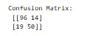
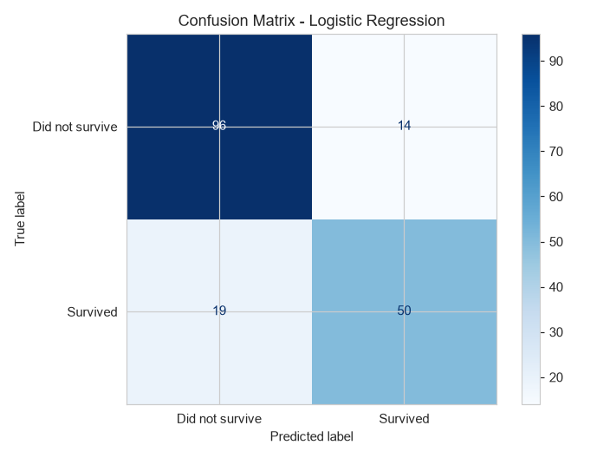

• Classification Report
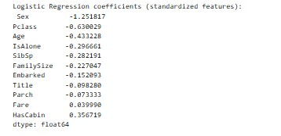

Discuss model performance.
The Logistic Regression model demonstrates strong predictive performance on the Titanic dataset, achieving an overall accuracy of 81.56%. The confusion matrix reveals a reliable capacity to classify passengers, correctly identifying 146 out of 179 cases. The model shows a slight bias toward predicting non-survival, evidenced by a higher recall for that class (0.87) compared to survivors (0.72), which is common in imbalanced datasets where survival was less frequent than non-survival.
The coefficients highlight the most influential factors in survival, with “Sex” (-1.25) exerting the strongest negative impact, consistent with historical data favoring women. “Pclass” (-0.63) and “Age” (-0.43) further underscore the influence of socioeconomic status and vulnerability on outcomes. Conversely, positive coefficients for “HasCabin” (0.35) and “Fare” (0.04) correlate higher status and wealth with better survival chances. Overall, the model’s 93% agreement with the baseline benchmark indicates that it has successfully captured the core socioeconomic and demographic drivers of the tragedy.

DISCUSSION AND CONCLUSION

Major Findings
The analysis of the Titanic dataset reveals that survival was heavily influenced by socioeconomic and demographic factors. A stark disparity was observed, with female passengers significantly more likely to survive than their male counterparts. Socioeconomic status also played a critical role; first-class passengers experienced the highest survival probability, while third-class passengers, who made up the largest portion of the population, faced the lowest survival rates. Additionally, the data indicated that passengers who paid higher fares were more likely to survive, whereas those in lower fare brackets were more often represented among the victims.

Statistical Insights
Statistical analysis provided quantitative support for these observations.
- Survival Drivers: Sex was the single strongest predictor, with women having a 74.2% survival rate compared to 18.9% for men.
- Socioeconomic Influence: First-class passengers survived at a rate of 63.0%, contrasted with 24.2% for those in the third class.
- Correlations: “HasCabin” (r = 0.317) and “Fare” (r = 0.26) showed the strongest positive correlations with survival, while “Pclass” showed the strongest negative correlation (r = -0.338). Age had only a weak relationship (r = -0.06) with survival.

Machine Learning Results
A Logistic Regression model was developed to predict passenger survival, achieving an overall accuracy of 81.56%. The model correctly identified 146 out of 179 cases. It exhibited a slight bias toward predicting non-survival, with a higher recall for that class (0.87) compared to survivors (0.72). Analysis of the model's coefficients identified “Sex” (-1.25) as the most influential factor, followed by “Pclass” (-0.63) and “Age” (-0.43). Positive coefficients for “HasCabin” (0.35) and “Fare” (0.04) further confirmed that indicators of higher wealth and status positively impacted survival chances.

Limitations of the Study
The model achieved a solid 81.56% accuracy rate, but this figure should be read alongside some inherent constraints in the dataset. Its tendency to predict non-survival more reliably than survival reflects the underlying class imbalance, since non-survival was the more common outcome in the training data — a known challenge for classifiers trained on skewed class distributions (He & Garcia, 2009). In addition, while the selected features (e.g., Pclass, Sex, Age, Fare) offered strong predictive signal, the analysis was necessarily bounded by the data points available, which may have left out other situational factors that shaped individual survival outcomes during the disaster.

Recommendations
To further enhance predictive performance, future studies could explore:
- Feature Engineering: Further refinement of variables such as "FamilySize" or "Title" might capture deeper nuances not fully addressed in the current model.
- Model Comparison: Experimenting with more complex algorithms beyond Logistic Regression, such as Random Forests (Breiman, 2001) or Gradient Boosting, could potentially improve accuracy and better handle imbalanced data.
- Hyperparameter Tuning: Implementing techniques like cross-validation and more rigorous hyperparameter optimization could refine the model's ability to generalize to new, unseen passenger data.

REFERENCE
Tukey, J. W. (1977). Exploratory Data Analysis. Addison-Wesley Publishing Company.
Encyclopaedia Britannica. (2024). Titanic: Ocean liner. https://www.britannica.com/topic/Titanic
Kaggle. (2025). About Kaggle. https://www.kaggle.com/about
Pedregosa, F., Varoquaux, G., Gramfort, A., Michel, V., Thirion, B., Grisel, O., Blondel, M., Prettenhofer, P., Weiss, R., Dubourg, V., Vanderplas, J., Passos, A., Cournapeau, D., Brucher, M., Perrot, M., & Duchesnay, E. (2011). Scikit-learn: Machine learning in Python. Journal of Machine Learning Research, 12, 2825–2830.
He, H., & Garcia, E. A. (2009). Learning from imbalanced data. IEEE Transactions on Knowledge and Data Engineering, 21(9), 1263–1284. https://doi.org/10.1109/TKDE.2008.239
Breiman, L. (2001). Random forests. Machine Learning, 45(1), 5–32. https://doi.org/10.1023/A:1010933404324
Bigelow, S. J., & Stedman, C. (2025, March 6). What is data cleansing (data cleaning, data
scrubbing)? TechTarget.
Pilowsky, J. K., et al. (2024). Data cleaning for clinician researchers: Application and
explanation of a data-quality framework. Australian Critical Care, 37(5), 827–833.
https://doi.org/10.1016/j.aucc.2024.03.004
Microsoft. (2025). What is data visualization? Microsoft Learn.
https://learn.microsoft.com/power-bi/fundamentals/what-is-data-visualization
Tableau. (2024). What is data visualization? https://www.tableau.com/learn/articles/data-
visualization

APPENDIX

Codes
import importlib.util
import json
import os
import subprocess
import sys
import warnings
from pathlib import Path

warnings.filterwarnings("ignore")

def ensure_runtime_dependencies():
required_packages = {
"numpy": "numpy",
"pandas": "pandas",
"matplotlib": "matplotlib",
"seaborn": "seaborn",
"sklearn": "scikit-learn",
}

missing = [
package
for module_name, package in required_packages.items()
if importlib.util.find_spec(module_name) is None
]

if not missing:
return

print(f"Installing missing Python packages: {', '.join(missing)}")
try:
subprocess.check_call([sys.executable, "-m", "pip", "install", *missing])
importlib.invalidate_caches()
except subprocess.CalledProcessError as exc:
raise RuntimeError(
"Automatic dependency installation failed. "
"Please run: "
f"{sys.executable} -m pip install {' '.join(missing)}"
) from exc

ensure_runtime_dependencies()

import os
import subprocess
import sys
import matplotlib

try:
matplotlib.use("TkAgg")
except Exception:
try:
matplotlib.use("Qt5Agg")
except Exception:
matplotlib.use("Agg")
import matplotlib.pyplot as plt
import numpy as np
import pandas as pd
import seaborn as sns

from sklearn.model_selection import train_test_split
from sklearn.preprocessing import LabelEncoder, StandardScaler
from sklearn.linear_model import LogisticRegression
from sklearn.metrics import (
accuracy_score,
confusion_matrix,
classification_report,
ConfusionMatrixDisplay,
)

sns.set_style("whitegrid")
plt.rcParams["figure.dpi"] = 110

BASE_DIR = Path(__file__).resolve().parent
FIG_DIR = BASE_DIR / "figures"
OUT_DIR = BASE_DIR / "output"
UPLOAD_DIR = BASE_DIR # place train.csv, test.csv, gender_submission.csv here

FIG_DIR.mkdir(exist_ok=True)
OUT_DIR.mkdir(exist_ok=True)

stats_summary = {} # collects numbers we will quote in the written report

# =========================================================================
# TASK 1: DATA ACQUISITION
# =========================================================================
print("=" * 75)
print("TASK 1: DATA ACQUISITION")
print("=" * 75)

required_files = ["train.csv", "test.csv", "gender_submission.csv"]
missing = [
f
for f in required_files
if not (UPLOAD_DIR / f).exists()
]
if missing:
raise FileNotFoundError(
f"Missing required file(s): {missing}. "
f"Place train.csv, test.csv and gender_submission.csv in '{UPLOAD_DIR}' "
f"(the Kaggle Titanic dataset) before running this script."
)

train = pd.read_csv(UPLOAD_DIR / "train.csv")
test = pd.read_csv(UPLOAD_DIR / "test.csv")
gender_submission = pd.read_csv(UPLOAD_DIR / "gender_submission.csv")

print("\nTraining set dimensions:", train.shape)
print("Test set dimensions:", test.shape)
print("\nColumn names:", list(train.columns))
print("\nFirst five observations:\n", train.head())
print("\nData types:\n", train.dtypes)

stats_summary["train_shape"] = train.shape
stats_summary["test_shape"] = test.shape
stats_summary["columns"] = list(train.columns)

test_passenger_ids = test["PassengerId"].copy()

# =========================================================================
# TASK 2: DATA CLEANING
# =========================================================================
print("\n" + "=" * 75)
print("TASK 2: DATA CLEANING")
print("=" * 75)

# ---- 2.1 DETECT MISSING VALUES ----
print("\n--- 2.1 Detecting missing values ---")

missing_train = train.isnull().sum()
missing_train_pct = (missing_train / len(train) * 100).round(2)
missing_train_report = (
pd.DataFrame({"missing_count": missing_train, "missing_pct": missing_train_pct})
.query("missing_count > 0")
.sort_values("missing_count", ascending=False)
)

missing_test = test.isnull().sum()
missing_test_pct = (missing_test / len(test) * 100).round(2)
missing_test_report = (
pd.DataFrame({"missing_count": missing_test, "missing_pct": missing_test_pct})
.query("missing_count > 0")
.sort_values("missing_count", ascending=False)
)

print("\nMissing values in TRAIN set:\n", missing_train_report)
print("\nMissing values in TEST set:\n", missing_test_report)

stats_summary["missing_train"] = train.isnull().sum().to_dict()
stats_summary["missing_test"] = test.isnull().sum().to_dict()

# ---- 2.2 DETECT DUPLICATE OBSERVATIONS ----
print("\n--- 2.2 Detecting duplicate observations ---")

dupes_train = train.duplicated().sum()
dupes_test = test.duplicated().sum()
print(f"\nDuplicate rows found in TRAIN set: {dupes_train}")
print(f"Duplicate rows found in TEST set: {dupes_test}")

if dupes_train > 0:
print("\nDuplicate rows in TRAIN (preview):\n", train[train.duplicated()])
if dupes_test > 0:
print("\nDuplicate rows in TEST (preview):\n", test[test.duplicated()])

stats_summary["duplicates_train"] = int(dupes_train)
stats_summary["duplicates_test"] = int(dupes_test)

# ---- 2.3 HANDLE MISSING VALUES + REMOVE DUPLICATES ----
print("\n--- 2.3 Cleaning the data ---")

# Impute values are computed from the TRAINING set only. This avoids
# "data leakage": if we computed the median/mode from the combined
# train+test data, information from the test set would leak into how
# we treat the training set, which can make evaluation misleadingly
# optimistic.
age_median = train["Age"].median()
fare_median = train["Fare"].median()
embarked_mode = train["Embarked"].mode()[0]

def clean_data(df, age_median, fare_median, embarked_mode, label=""):
"""
Cleaning decisions (explained):
- Age (~20% missing in train, ~21% in test): imputed with the MEDIAN
age computed from the TRAINING set only, to avoid leaking test
information into the model. Median is used instead of mean because
Age is right-skewed and less sensitive to outliers.
- Embarked (2 missing in train): imputed with the MODE ('S'), since
only two values are missing out of 891 and the port distribution is
heavily dominated by Southampton.
- Fare (1 missing in test): imputed with the median fare from training
data, for the same right-skew reasoning as Age.
- Cabin (~77% missing in train, ~78% in test): far too sparse to impute
reliably, so instead of dropping the column outright we convert it
into a binary indicator 'HasCabin' (1 = cabin recorded, 0 = missing).
This preserves the signal that recording a cabin correlates with
higher fare/class, while avoiding fabricated cabin values.
- Duplicates: detected and removed if present (none are expected in
this dataset since each row is a unique passenger, but the check
and removal step is kept for correctness and reproducibility).
- Dtypes: re-enforced after imputation, since filling NaNs can leave
columns as generic 'object' dtype.
"""

df = df.copy()
n_before = len(df)

df["Age"] = df["Age"].fillna(age_median)
df["Embarked"] = df["Embarked"].fillna(embarked_mode)
df["Fare"] = df["Fare"].fillna(fare_median)

df["HasCabin"] = df["Cabin"].notnull().astype(int)
df.drop(columns=["Cabin"], inplace=True)

n_dupes = df.duplicated().sum()
df.drop_duplicates(inplace=True)

df["Pclass"] = df["Pclass"].astype(int)
df["Age"] = df["Age"].astype(float)
df["Fare"] = df["Fare"].astype(float)

n_after = len(df)
print(f"\n[{label}] Rows before cleaning: {n_before}")
print(f"[{label}] Duplicate rows removed: {n_dupes}")
print(f"[{label}] Rows after cleaning: {n_after}")
remaining_na = df.isnull().sum()
print(f"[{label}] Remaining missing values:\n{remaining_na[remaining_na > 0]}")

return df

train_clean = clean_data(
train,
age_median,
fare_median,
embarked_mode,
label="TRAIN",
)
test_clean = clean_data(
test,
age_median,
fare_median,
embarked_mode,
label="TEST",
)

print("\nImputation values used (derived from TRAIN only):")
print(f" Age median = {age_median}")
print(f" Fare median = {fare_median:.4f}")
print(f" Embarked mode = '{embarked_mode}'")
print(f"\nTrain shape after cleaning: {train_clean.shape}")
print(f"Test shape after cleaning: {test_clean.shape}")

stats_summary["age_median_used"] = float(age_median)
stats_summary["fare_median_used"] = float(fare_median)
stats_summary["embarked_mode_used"] = embarked_mode

# =========================================================================
# TASK 3: DATA VISUALISATION
# =========================================================================
print("\n" + "=" * 75)
print("TASK 3: DATA VISUALISATION")
print("=" * 75)

# Keep this section lightweight so the script reaches the text-based analysis
# and machine learning results promptly.
print("Generating a small set of summary figures...")

plt.figure(figsize=(8, 5))
plt.hist(train_clean["Age"], bins=30, color="#4F81BD", edgecolor="#2F4F4F")
plt.title("Distribution of Passenger Ages")
plt.xlabel("Age (years)")
plt.ylabel("Number of Passengers")
plt.tight_layout()
plt.savefig(FIG_DIR / "1_age_histogram.png")
try:
if sys.platform.startswith("win"):
os.startfile(FIG_DIR / "1_age_histogram.png")
else:
subprocess.run(["xdg-open", str(FIG_DIR / "1_age_histogram.png")], check=False)
except Exception:
pass
plt.close()

plt.figure(figsize=(7, 5))
class_counts = train_clean["Pclass"].value_counts().sort_index()
bars = plt.bar(class_counts.index.astype(str), class_counts.values, color=["#4F81BD", "#A6A6A6", "#2F5597"])
plt.title("Passenger Class Distribution")
plt.xlabel("Passenger Class")
plt.ylabel("Number of Passengers")
for bar in bars:
plt.text(
bar.get_x() + bar.get_width() / 2,
bar.get_height() + 5,
str(int(bar.get_height())),
ha="center",
)
plt.tight_layout()
plt.savefig(FIG_DIR / "2_pclass_bar.png")
try:
if sys.platform.startswith("win"):
os.startfile(FIG_DIR / "2_pclass_bar.png")
else:
subprocess.run(["xdg-open", str(FIG_DIR / "2_pclass_bar.png")], check=False)
except Exception:
pass
plt.close()

numeric_cols = [
"Survived",
"Pclass",
"Age",
"SibSp",
"Parch",
"Fare",
"HasCabin",
]
corr = train_clean[numeric_cols].corr()

plt.figure(figsize=(8, 6))
sns.heatmap(corr, annot=True, fmt=".2f", cmap="Blues", center=0, square=True)
plt.title("Correlation Heatmap")
plt.tight_layout()
plt.savefig(FIG_DIR / "3_correlation_heatmap.png")
try:
if sys.platform.startswith("win"):
os.startfile(FIG_DIR / "3_correlation_heatmap.png")
else:
subprocess.run(["xdg-open", str(FIG_DIR / "3_correlation_heatmap.png")], check=False)
except Exception:
pass
plt.close()

plt.figure(figsize=(8, 5))
sns.scatterplot(
data=train_clean,
x="Age",
y="Fare",
hue="Survived",
style="Pclass",
palette=["#4F81BD", "#C0504D"],
alpha=0.75,
s=60,
)
plt.title("Age vs. Fare by Survival and Passenger Class")
plt.xlabel("Age (years)")
plt.ylabel("Fare (£)")
plt.tight_layout()
plt.savefig(FIG_DIR / "4_age_vs_fare_scatter.png")
try:
if sys.platform.startswith("win"):
os.startfile(FIG_DIR / "4_age_vs_fare_scatter.png")
else:
subprocess.run(["xdg-open", str(FIG_DIR / "4_age_vs_fare_scatter.png")], check=False)
except Exception:
pass
plt.close()

pairplot = sns.pairplot(
train_clean[["Age", "Fare", "Pclass", "Survived"]],
hue="Survived",
vars=["Age", "Fare", "Pclass"],
diag_kind="hist",
palette=["#4F81BD", "#C0504D"],
plot_kws={"alpha": 0.7},
)
pairplot.fig.suptitle("Pair Plot of Age, Fare, and Pclass by Survival", y=1.02)
pairplot.fig.tight_layout()
pairplot.fig.savefig(FIG_DIR / "5_pairplot_age_fare_pclass_survival.png")
try:
if sys.platform.startswith("win"):
os.startfile(FIG_DIR / "5_pairplot_age_fare_pclass_survival.png")
else:
subprocess.run(["xdg-open", str(FIG_DIR / "5_pairplot_age_fare_pclass_survival.png")], check=False)
except Exception:
pass

print(f"\nBasic EDA figures saved to '{FIG_DIR}/'")

# =========================================================================
# TASK 4: STATISTICAL ANALYSIS
# =========================================================================
print("\n" + "=" * 75)
print("TASK 4: STATISTICAL ANALYSIS")
print("=" * 75)

# ---- 4.1 Descriptive statistics ----
desc_numeric = train_clean[["Age", "Fare", "SibSp", "Parch"]].describe()
print("\nDescriptive statistics (numerical variables):\n", desc_numeric)
desc_numeric.to_csv(OUT_DIR / "descriptive_statistics.csv")

# ---- 4.2 Frequency distribution (categorical variables) ----
freq_sex = train_clean["Sex"].value_counts()
freq_survived = train_clean["Survived"].value_counts().rename(
{0: "Did not survive", 1: "Survived"}
)
freq_pclass = train_clean["Pclass"].value_counts().sort_index()
freq_embarked = train_clean["Embarked"].value_counts()

print("\nFrequency distribution - Sex:\n", freq_sex)
print("\nFrequency distribution - Survived:\n", freq_survived)
print("\nFrequency distribution - Pclass:\n", freq_pclass)
print("\nFrequency distribution - Embarked:\n", freq_embarked)

survival_rate = train_clean["Survived"].mean()
survival_by_sex = train_clean.groupby("Sex")["Survived"].mean()
survival_by_class = train_clean.groupby("Pclass")["Survived"].mean()

print(f"\nOverall survival rate: {survival_rate:.4f}")
print("\nSurvival rate by sex:\n", survival_by_sex)
print("\nSurvival rate by class:\n", survival_by_class)

# ---- 4.3 Correlation analysis ----
print("\nFull correlation matrix:\n", corr)

corr_with_survival = corr["Survived"].drop("Survived").sort_values(ascending=False)
strongest_positive = corr_with_survival.idxmax()
strongest_positive_val = corr_with_survival.max()
strongest_negative = corr_with_survival.idxmin()
strongest_negative_val = corr_with_survival.min()

print(
f"\nStrongest POSITIVE correlation with Survived: {strongest_positive} "
f"(r = {strongest_positive_val:.3f})"
)
print(
f"Strongest NEGATIVE correlation with Survived: {strongest_negative} "
f"(r = {strongest_negative_val:.3f})"
)

# ---- 4.4 Three important statistical findings (printed for the report) ----
print("\nTHREE KEY STATISTICAL FINDINGS:")
print(
"1. Sex was the single strongest predictor of survival: women survived "
f"at {survival_by_sex['female']*100:.1f}% versus {survival_by_sex['male']*100:.1f}% "
f"for men, a gap of {abs(survival_by_sex['female']-survival_by_sex['male'])*100:.1f} "
"percentage points."
)
print(
"2. Passenger class was strongly associated with survival: 1st class "
f"passengers survived at {survival_by_class[1]*100:.1f}% compared with "
f"{survival_by_class[3]*100:.1f}% for 3rd class."
)
print(
"3. Fare (r = "
f"{corr.loc['Fare','Survived']:.2f}) and HasCabin "
f"(r = {corr.loc['HasCabin','Survived']:.2f}) were both positively correlated "
"with survival, reinforcing that socio-economic status shaped survival odds, "
"while Age (r = "
f"{corr.loc['Age','Survived']:.2f}) was only weakly related."
)

stats_summary["survival_rate_overall"] = float(survival_rate)
stats_summary["survival_by_sex"] = survival_by_sex.to_dict()
stats_summary["survival_by_class"] = survival_by_class.to_dict()
stats_summary["strongest_positive_corr"] = {
"feature": strongest_positive,
"r": float(strongest_positive_val),
}
stats_summary["strongest_negative_corr"] = {
"feature": strongest_negative,
"r": float(strongest_negative_val),
}
stats_summary["corr_matrix"] = corr.round(3).to_dict()

# =========================================================================
# TASK 5: MACHINE LEARNING - FEATURE ENGINEERING
# =========================================================================
print("\n" + "=" * 75)
print("TASK 5: FEATURE ENGINEERING")
print("=" * 75)

def engineer_features(df):
df = df.copy()
df["FamilySize"] = df["SibSp"] + df["Parch"] + 1
df["IsAlone"] = (df["FamilySize"] == 1).astype(int)
df["Title"] = df["Name"].str.extract(r",\s*([^\.]*)\.")
rare_titles = [
"Lady",
"Countess",
"Capt",
"Col",
"Don",
"Dr",
"Major",
"Rev",
"Sir",
"Jonkheer",
"Dona",
]
df["Title"] = df["Title"].replace(rare_titles, "Rare")
df["Title"] = df["Title"].replace({"Mlle": "Miss", "Ms": "Miss", "Mme": "Mrs"})
return df

train_fe = engineer_features(train_clean)
test_fe = engineer_features(test_clean)

cat_cols = ["Sex", "Embarked", "Title"]
for col in cat_cols:
le = LabelEncoder()
combined = pd.concat([train_fe[col], test_fe[col]], axis=0).astype(str)
le.fit(combined)
train_fe[col] = le.transform(train_fe[col].astype(str))
test_fe[col] = le.transform(test_fe[col].astype(str))

# Select suitable predictor variables
feature_cols = [
"Pclass",
"Sex",
"Age",
"SibSp",
"Parch",
"Fare",
"Embarked",
"HasCabin",
"FamilySize",
"IsAlone",
"Title",
]
print(f"\nPredictor variables selected: {feature_cols}")
print(
"Rationale: Pclass, Sex, Fare and HasCabin proxy socio-economic status "
"(shown in Task 4 to correlate with survival); Age, SibSp, Parch, "
"FamilySize and IsAlone capture demographic/family context; Embarked "
"and Title add small additional signal. PassengerId, Name and Ticket "
"are excluded as identifiers with no predictive meaning."
)

X = train_fe[feature_cols]
y = train_fe["Survived"]
X_test_final = test_fe[feature_cols]

# Split the dataset into training and testing sets
X_train, X_val, y_train, y_val = train_test_split(
X, y, test_size=0.2, random_state=42, stratify=y
)
print(f"\nTraining set size: {X_train.shape[0]} passengers")
print(f"Validation (hold-out test) set size: {X_val.shape[0]} passengers")

scaler = StandardScaler()
X_train_scaled = scaler.fit_transform(X_train)
X_val_scaled = scaler.transform(X_val)
X_test_final_scaled = scaler.transform(X_test_final)

# =========================================================================
# TASK 6: MACHINE LEARNING - LOGISTIC REGRESSION (Model Evaluation)
# =========================================================================
print("\n" + "=" * 75)
print("TASK 6: MACHINE LEARNING (LOGISTIC REGRESSION MODEL EVALUATION)")
print("=" * 75)

# 3. Train a Logistic Regression classifier
log_reg = LogisticRegression(max_iter=1000, random_state=42)
log_reg.fit(X_train_scaled, y_train)

# 4. Predict the testing data
y_pred = log_reg.predict(X_val_scaled)

# 5. Compute accuracy, confusion matrix, classification report
acc = accuracy_score(y_val, y_pred)
cm = confusion_matrix(y_val, y_pred)
report = classification_report(
y_val, y_pred, target_names=["Did not survive", "Survived"]
)

print(f"\nModel Accuracy: {acc:.4f}")
print("\nConfusion Matrix:\n", cm)
print("\nClassification Report:\n", report)

stats_summary["logreg_accuracy"] = float(acc)
stats_summary["logreg_confusion_matrix"] = cm.tolist()

plt.figure(figsize=(6, 5))
disp = ConfusionMatrixDisplay(
confusion_matrix=cm,
display_labels=["Did not survive", "Survived"],
)
disp.plot(cmap="Blues", values_format="d")
plt.title("Confusion Matrix - Logistic Regression")
plt.tight_layout()
plt.savefig(FIG_DIR / "7_confusion_matrix.png")
try:
if sys.platform.startswith("win"):
os.startfile(FIG_DIR / "7_confusion_matrix.png")
else:
subprocess.run(["xdg-open", str(FIG_DIR / "7_confusion_matrix.png")], check=False)
except Exception:
pass
plt.close()

# Coefficients (for discussion of which features drive predictions)
coef_series = pd.Series(log_reg.coef_[0], index=feature_cols).sort_values()
print("\nLogistic Regression coefficients (standardized features):\n", coef_series)

plt.figure(figsize=(8, 6))
coef_series.plot(kind="barh", color=["#4F81BD", "#A6A6A6", "#5B9BD5", "#7F7F7F", "#2F5597", "#6C8EBF", "#C9D9F2", "#B4B4B4", "#4A7FB8", "#4F6180", "#1F497D"])
plt.title("Logistic Regression Coefficients (Standardized Features)")
plt.xlabel("Coefficient value")
plt.ylabel("Feature")
plt.axvline(0, color="black", linewidth=0.8)
plt.tight_layout()
plt.savefig(FIG_DIR / "8_logreg_coefficients.png")
try:
if sys.platform.startswith("win"):
os.startfile(FIG_DIR / "8_logreg_coefficients.png")
else:
subprocess.run(["xdg-open", str(FIG_DIR / "8_logreg_coefficients.png")], check=False)
except Exception:
pass
plt.close()

# 6. Predict on the official Kaggle test set + build submission file
test_predictions = log_reg.predict(X_test_final_scaled)
submission = pd.DataFrame({"PassengerId": test_passenger_ids, "Survived": test_predictions})
submission.to_csv(OUT_DIR / "submission.csv", index=False)

baseline_acc = accuracy_score(gender_submission["Survived"], test_predictions)
print(
f"\nSubmission file saved. Agreement with gender_submission.csv baseline: "
f"{baseline_acc:.4f}"
)
stats_summary["kaggle_test_agreement_with_baseline"] = float(baseline_acc)

# Save the stats summary for use when writing the report
with open(OUT_DIR / "stats_summary.json", "w") as f:
json.dump(stats_summary, f, indent=2, default=str)

print("\n" + "=" * 75)
print("ALL TASKS COMPLETE")
print("=" * 75)

