

Cairo University
Faculty of Engineering
Computer Department

CUFE Students
Software Design Specification (SDS)
Version: 1.0
CM Identifier: sds_v1.0
Team 2

Names:
- Mohamed Sayed
- Mohamed Taha
- Riad Adel
- Ahmed Salah
- Abdallah Mustafa

Revision History

Sl. No. | Prepared/  Modified by | E-mail | Version | Date | Approved by | Descriptions/  Remarks
1. | Mohamed Taha | Mohamed.taha.177@gmail.com | 1.0 | April,10th, 2018 |  | Added section 5, 3.1.
2 | Mohamed Sayed | m.assr299@gmail.com | 1.0 | April, 10th, 2018 |  | Added section 1.
3 | Abdallah Mustafa | callmenssar@gmail.com | 1.0 | April, 10th, 2018 |  | Final Revision.
4 | Riad Adel | Riad.adel22@gmail.com | 1.0 | April, 11th, 2018 |  | Added section 3.2, 3.3.
5 | Ahmed Salah | Ahmedkin3030@gmail.com | 1.0 | April, 11th, 2018 |  | Added section 2, 4.

Distribution list
Name | E-mail | Notes
Eng. Ali Elseddeek | alielseddeek@gmail.com | Response is required

Table of Contents

1. Introduction 5
1.1 Purpose of this Document 5
1.2 Scope 5
1.3 Table of Acronyms and Definitions 5
1.3.1 Definition 6
1.4 References 6
1.5 Overview of Document 6
2. System Architecture 6
3. Design Models 8
3.1 Design Patterns Description 8
3.1.1 Singleton 8
3.1.2 Factory Method 8
3.1.3 Adapter 9
3.2 Class Diagrams 10
3.3 Interaction Diagrams 11
4. Data Models 17
5. System Deployment 18
6. Traceability to Requirements 18

List of Tables

Table 1 – TraceabilitytoRequirements 17

List of Figures

Figure 1.1 – System Architecture 6
Figure 1.2– Detailed System Architecture 7
Figure 2 – Class Diagrams 9
Figure 3 – LoginActivity 10
Figure 4 – HomeActivity 11
Figure 5 – ResultActivity 12
Figure 6 – ClassWorkActivity 13
Figure 7 – PersonalInfoActivity 14
Figure 8 – DepartmentActivity 15
Figure 9 – DepInfoActivity 16
Figure 10 – Data Model 16
Figure 11 – System Deployment 17

Introduction
This document illustrates the Software Design Specification (SDS) process.
The general purpose of an SDS document is to pave the way towards the implementation stage to make life easy for developers and provide a visual interface for the rest of the team members so that open discussions are made and communication becomes easy between members with different perspectives.

Purpose of this Document
This document will define the design of "CUFE Students" application. It contains specific information about the expected input, output, and functions. The interaction between classes to meet the desired requirements are outlined in detailed figures.

Scope
At this iteration, the app allow the user to login to their account which they can
-See their personal Info
-See information about the departments in the faculty
-See their last results
-See their term classwork
-See any warning sent to them by the faculty
The user can also logout from the app and get his password if he/she forgot it.

Table of Acronyms and Definitions

Term | Definition
app | application

References

Overview of Document

The remainder of this document is divided into 5 chapters
chapter 2 provides information about the system architecture, as it decomposes the system into subsystems.
Chapter 3 goes over the design patterns used in the project, class diagrams modeling the relationships between each class of the system, and sequence diagrams showing how the developer would go about implementing a certain feature.
Chapter 4 shows an ER diagram of the database used by the app .
chapter 5 models how the system will be deployed using deployment diagrams.
Finally , Chapter 6 shows a traceability matrix mapping design elements to user requirements from the SRS document <Gmn_SE02_v1.0>

System Architecture

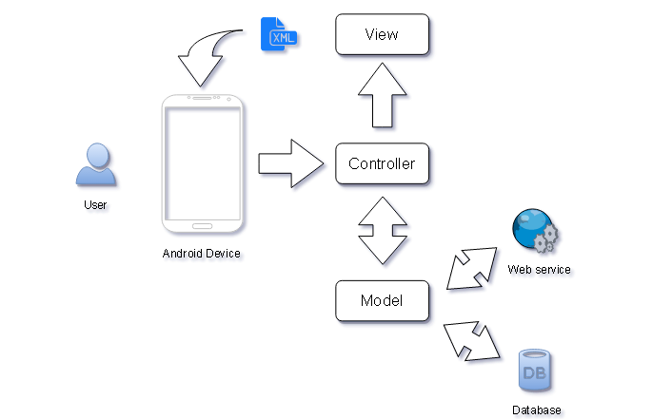
Figure 1.1 – System Architecture
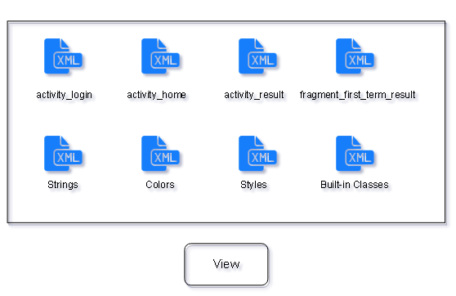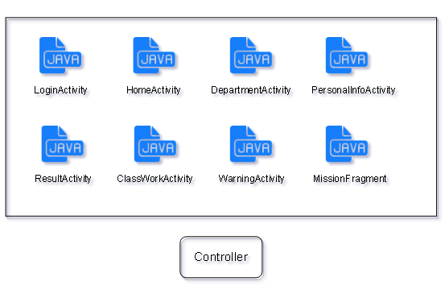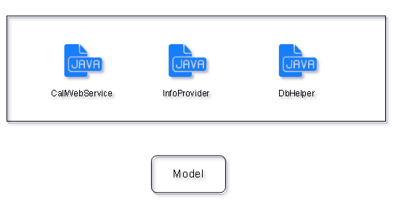

Figure 1.2 – Detailed System Architecture

The view is the xml files which displays user-interface on the android device; it includes activities layout, Strings, Colors, Styles and built-in classes like buttons... Etc.
The Controller is a set of java classes that handles the user actions; it includes activities and fragments classes.
The Model is a set of java classes that calls the web service and access the database.

Design Models

Design Patterns Description

Singleton: is a software design pattern that restricts the instantiation of a class to one object. This is useful when exactly one object is needed to coordinate actions across the system. The concept is sometimes generalized to systems that operate more efficiently when only one object exists, or that restrict the instantiation to a certain number of objects. Class Student is our Singleton, it holds the user’s data through the whole log in time.

Factory Method: Define an interface for creating an object, but let subclasses decide which class to instantiate. Factory Method lets a class defer instantiation to subclasses. Class getStudentFactory creates an object of SemesterStudent or CreditStudent based on the user’s department.

Adapter: is a software design pattern (also known as Wrapper, an alternative naming shared with the Decorator pattern) that allows the interface of an existing class to be used as another interface. It is often used to make existing classes work with others without modifying their source code. Multiple adapter classes are used to in application.

Class Diagrams
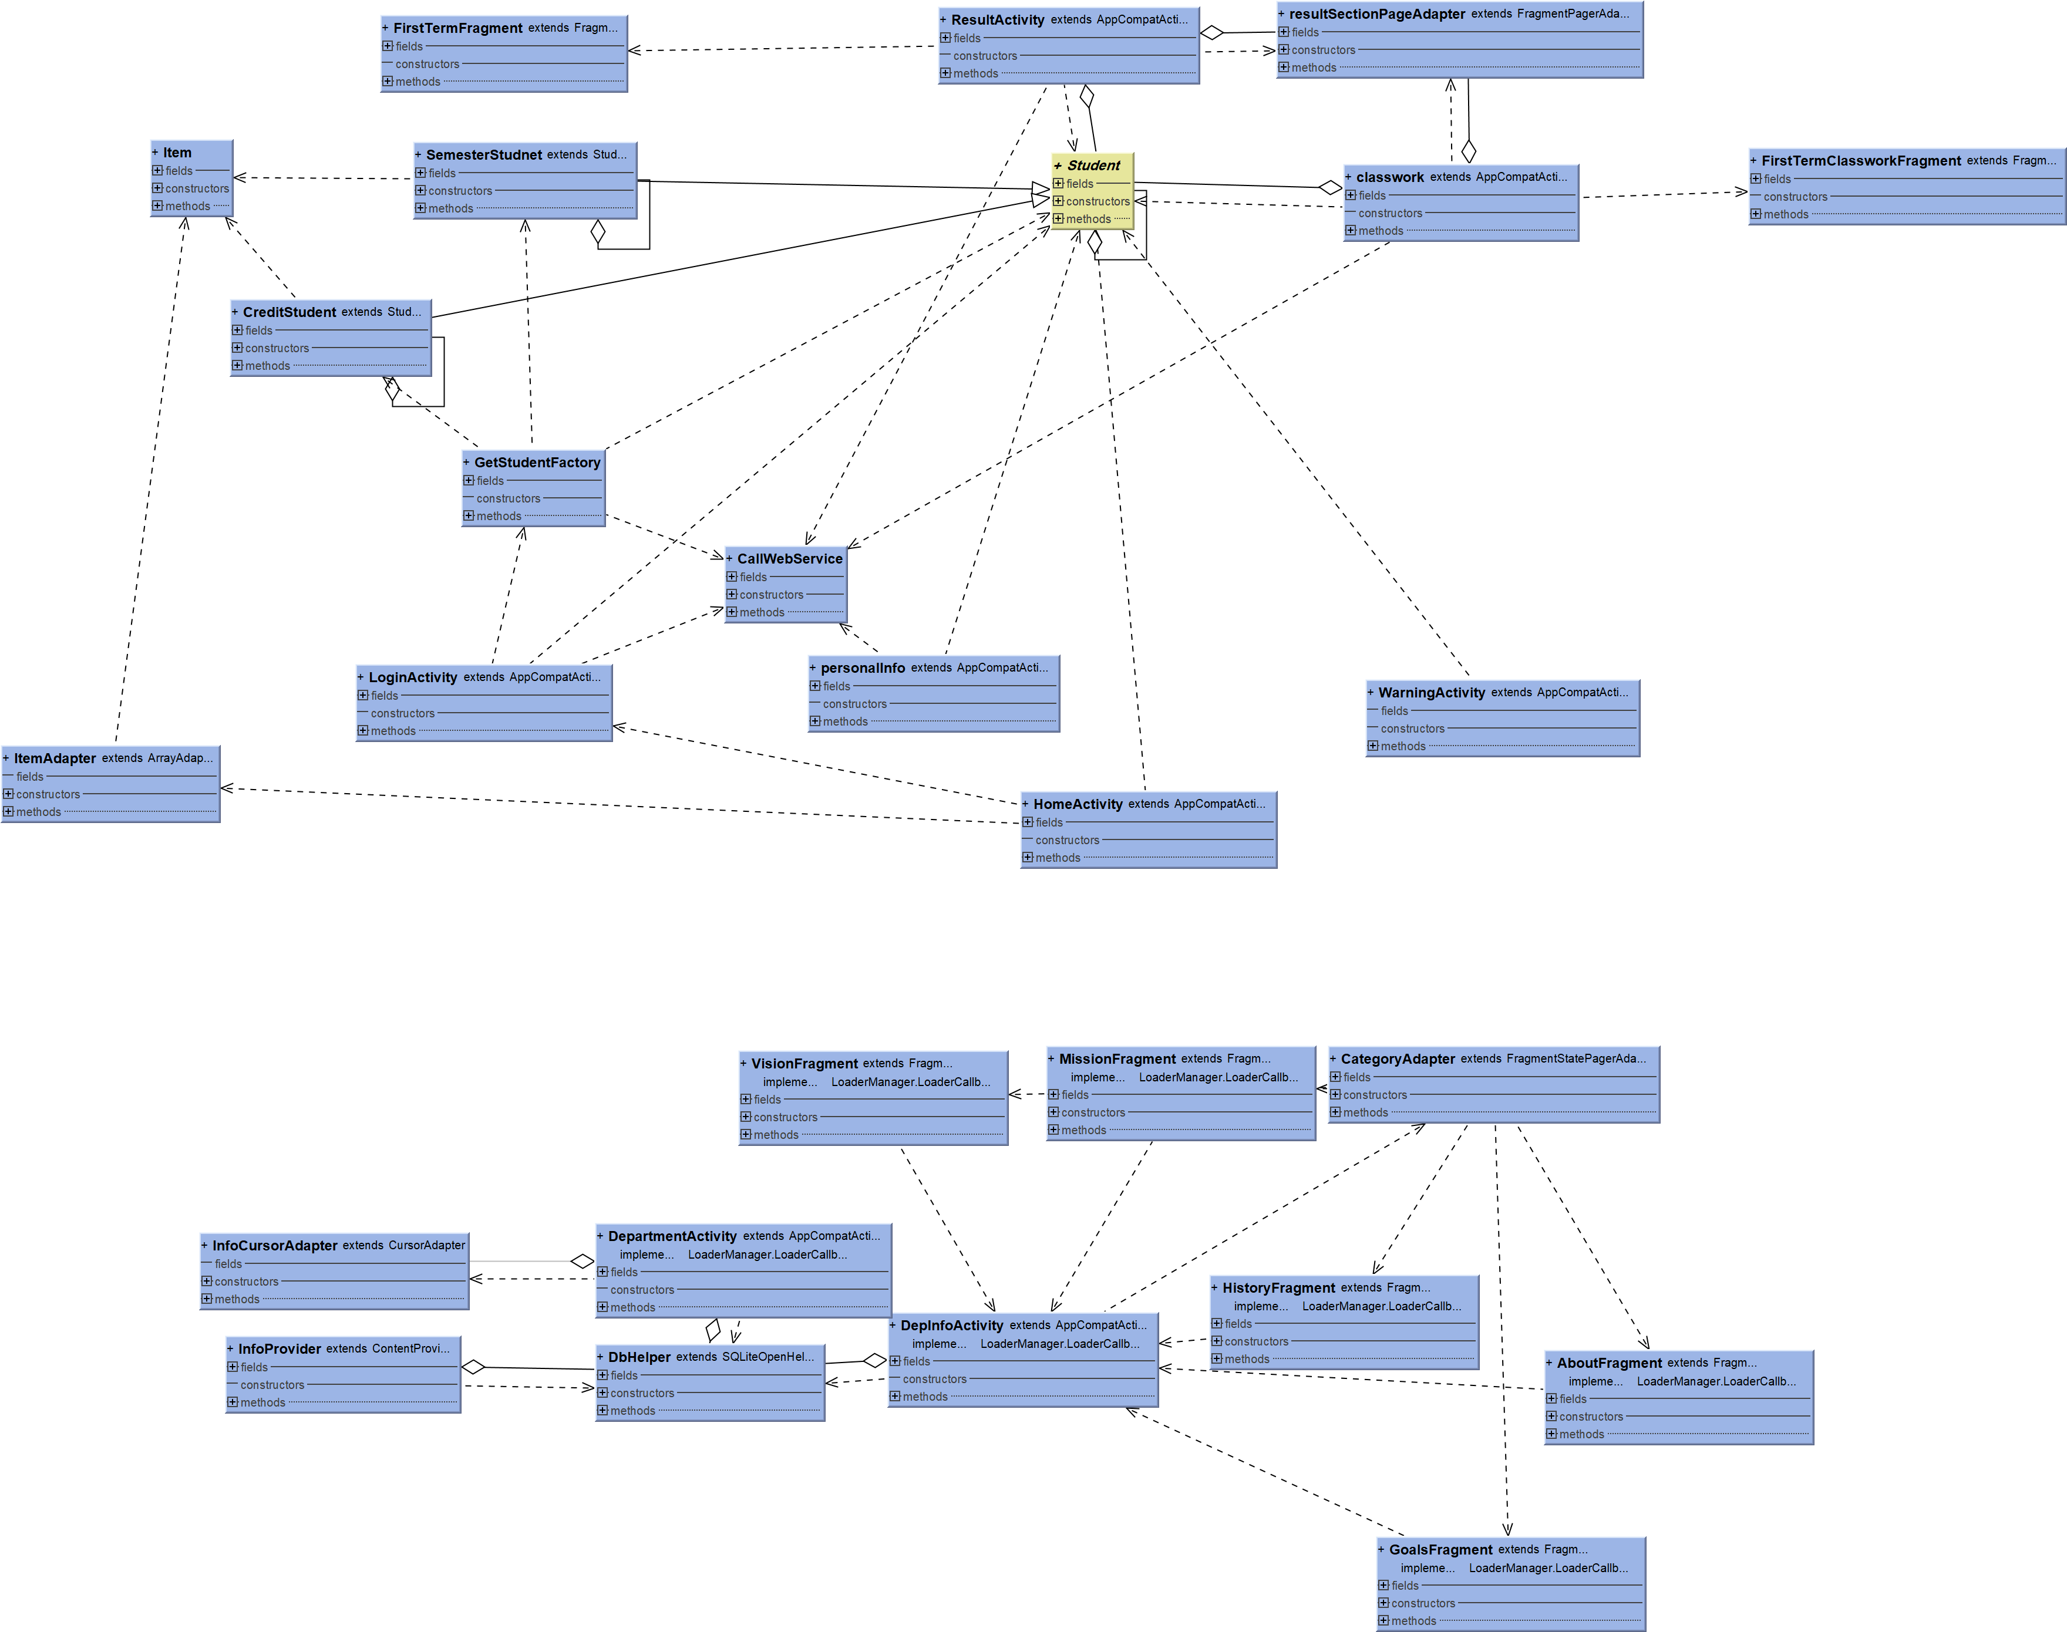
Figure 2 – Class Diagrams

Interaction Diagrams

SD1:

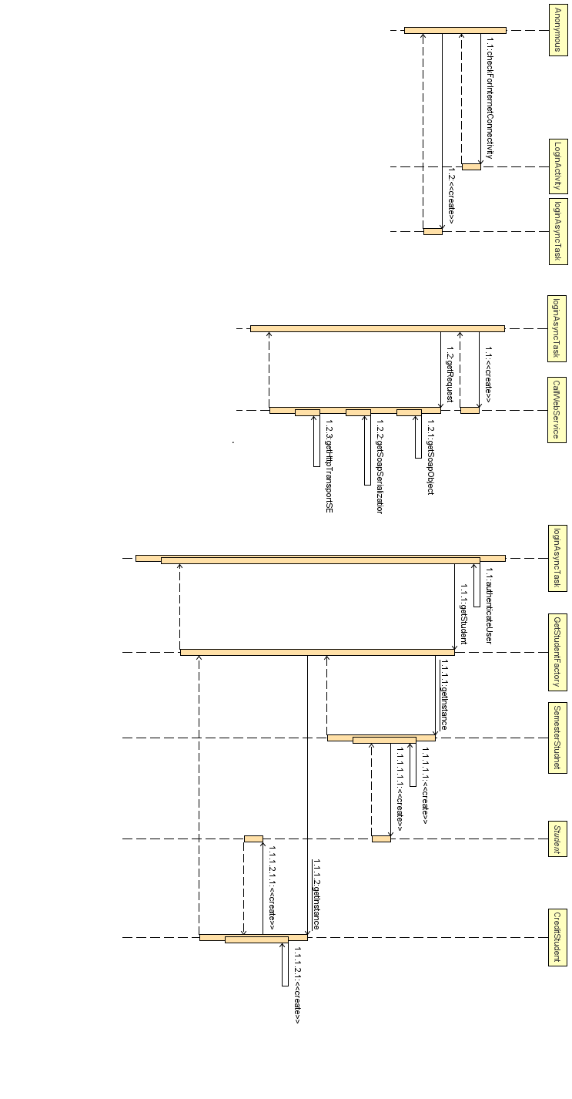
Figure 3– LoginActivity

SD2:
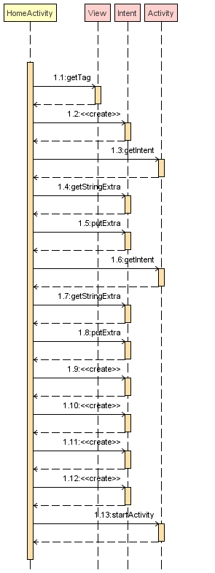
Figure 4 – HomeActivity

SD3:

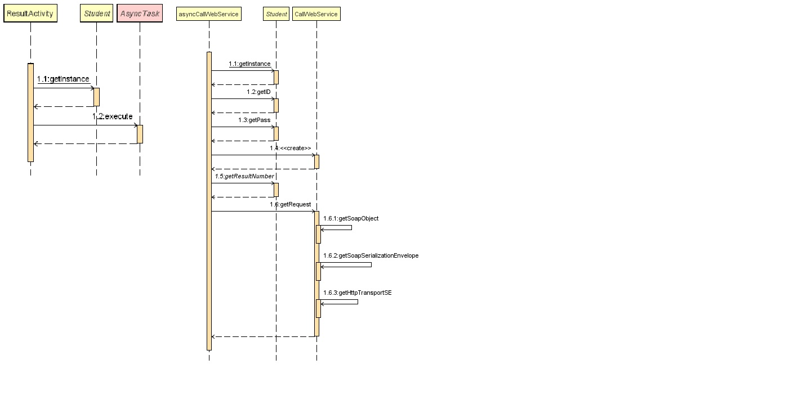
Figure 5 – ResultActivity

SD4:

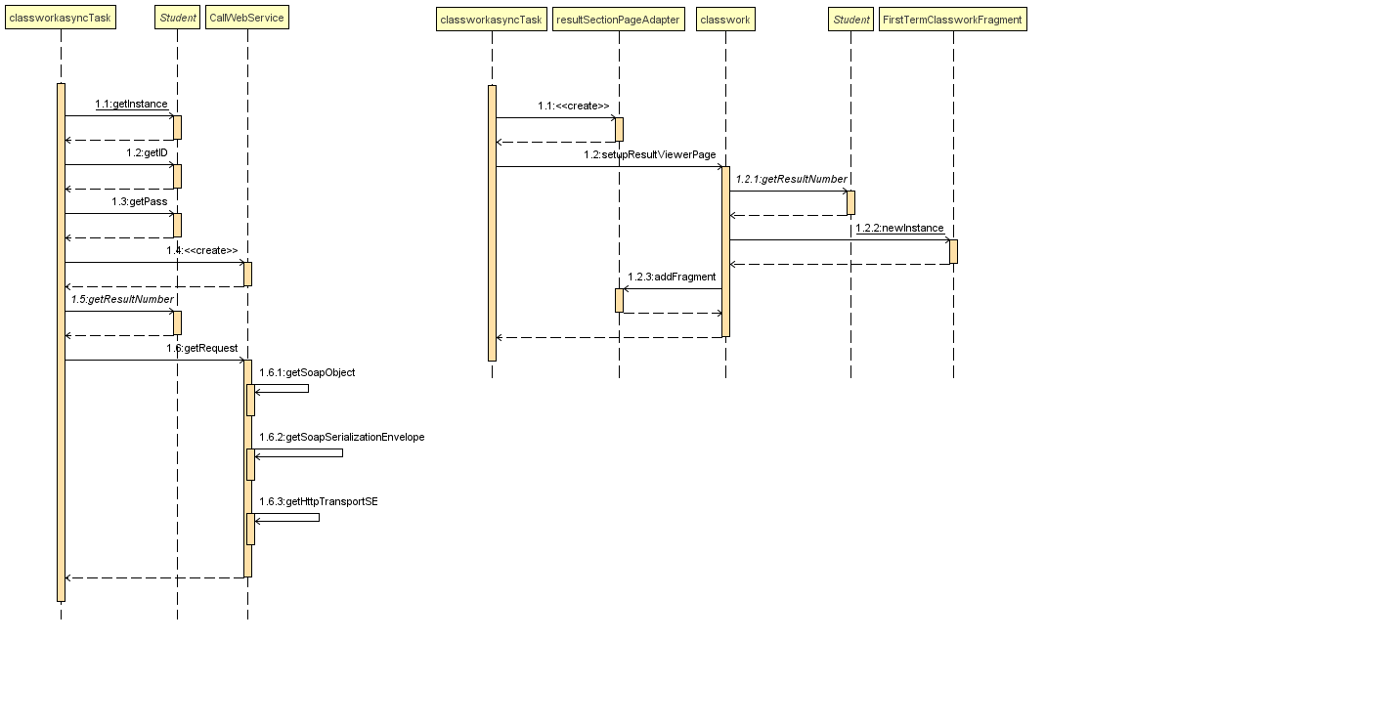
Figure 6 – classworkActivity

SD5:

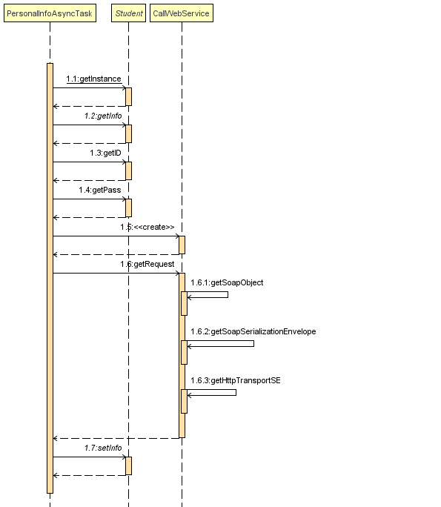
Figure 7 – PersonalInfoActivity

SD6:

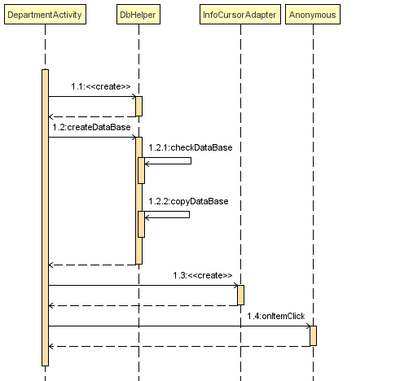
Figure 8 – DepartmentActivity

SD7:

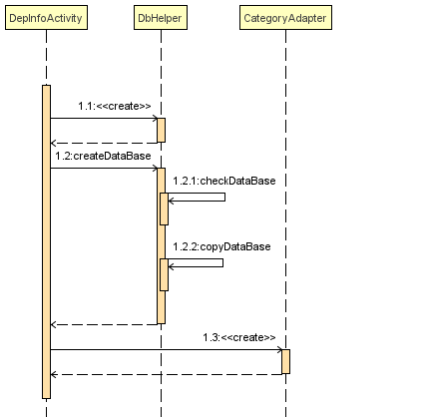
Figure 9 – DepInfoActivity

Data Models
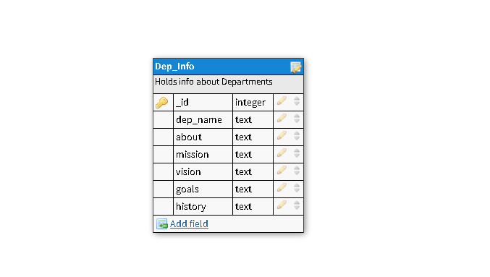
Figure 10 – Data Model

System Deployment
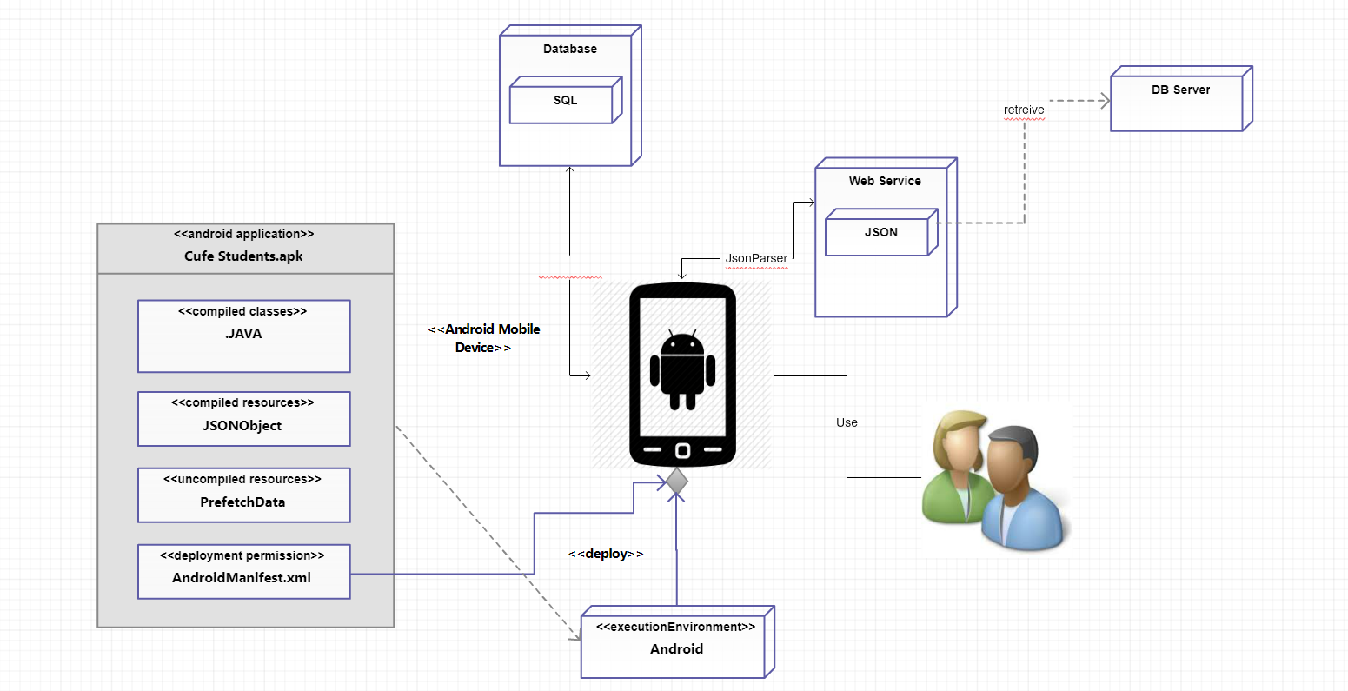
Figure 11 – System Deployment

Traceability to Requirements

SD1(LoginActivity) | UC9 (Login)
SD2(homeActivity) | -
SD3(ResultActivity) | UC1 (Result)
SD4(ClassWorkActivity) | UC1 (Result)
SD5(PersonalInfoActivity) | UC4 (PersonalInfo)
SD6(DepartmentActivity) | UC8(Departments)
SD6(DepInfoActivity) | UC8 (Departments)

Table 1 – Traceability to Requirements

