Documentation for:

An Intelligent Cubic Player using the Minimax Algorithm, Alpha-Beta Pruning, and Heuristic Functions.

Table of contents
Introduction and Overview
Proposed Solution
Applied Algorithms
Experiments & Results
Analysis, Discussion, and Future Work
Introduction and overview

- Project idea and overview

This​‍​‌‍​‍‌​‍​‌‍​‍‌ project is about developing an intelligent computational agent that could play Cubic, which is a three-dimensional version of Tic-Tac-Toe on a 4×4×4 grid. Due to the game's spatial complexity and the huge number of potential winning lines, it becomes a very effective platform for implementing and evaluating adversarial search algorithms.

The main purpose is to construct an AI player that strategically selects correct moves by combining three core AI elements. Firstly, the Minimax algorithm is to be employed as the main decision-making structure, allowing the agent to look ahead in the game and pick those moves that increase its advantage and decrease the opponent’s chances. Secondly, Alpha-Beta Pruning will be utilized to lessen the searching cost considerably as the elimination of unnecessary branches that have no influence on the final decision will be done thus fewer nodes will be explored—a very important factor given the branching factor and the depth of the game tree in three dimensions. Thirdly, heuristic evaluation functions specifically for Cubic will be created in order to provide an estimate of the board when a complete search is not possible thus they will be able to recognize extensively threatened lines and potential winning configurations.

In addition to that, a graphical user interface (GUI) will be created so that people can play with the AI in an easy manner. The overall aim of the work is to come up with an AI player that is not only efficient and competitive but is also capable of showing a strong spatial reasoning skill in a 3D ​‍​‌‍​‍‌​‍​‌‍​‍‌environment.

- Applications
Several​‍​‌‍​‍‌​‍​‌‍​‍‌ existing application feature intelligent agents to play board games similar to Cubic. Most of such agents are found in Tic-Tac-Toe, 3D Tic-Tac-Toe, and other adversarial grid-based strategy games. These agents act as landmarks for the user to know the features, mode of interaction, and AI mechanism usual in such applications.

1. 3D Tic-Tac-Toe (Desktop/Web Versions)

There are a multitude of 3D Tic-Tac-Toe apps that offer desktop or browser games and that permit players to work with 3×3×3 or 4×4×4 grids. Their main features are:

- Interactively viewing the 3D board through a model that can be zoomed and rotated.

- The single-player mode that runs with AI opponents, which usually adopt either rule-based or Minimax-like strategies.

- Open lines and immediate loss-prevention are the only factors considered for the algorithm.
While a majority of these softwares refrain from disclosing their AI logic, one can safely assume that the latter evaluates the lines of three or four in the layers, rows, columns, and diagonals.

2. Gomoku and Connect-Four AI Applications
The two board games, i.e., Gomoku (Five-in-a-Row) and Connect-Four, have been upgraded to challenge the user with strong AI opponents through the following functions:
- Minimax along with Alpha-Beta pruning.

- Heuristics based on patterns (e.g., open lines, double threats).

- Difficulty levels that change the depth at which the search is performed.

These games are akin to one another as they both require the search for the longest line in multi-directional grids.

3. Chess and Checkers Engines (Mobile/Desktop)

Compared with Cubic, the technologies behind chess and checkers engines (e.g., Stockfish, Chinook) are a bit different. Still, one can draw parallels as they use:

- Deep adversarial search trees.

- Alpha-beta pruning that is optimized.

- Heuristics specific to the domain.
Their structure and functionalities serve as a major source of inspiration for the AI development in 3D gaming.
4. Mobile 3D Strategy Games with AI

By using AI players, mobile games create 3D puzzle or strategy environments that are:

- Evaluating the state of the game.

- Prediction of an opponent’s move by simulating.

- User-friendly and visually appealing interaction with the game through smooth graphical interfaces.

Such first-step programs stress the importance of combining the efficiency of decision-making with a user-friendly and responsive ​‍​‌‍​‍‌​‍​‌‍​‍‌interface.

- A literature review of academic publications

1)​‍​‌‍​‍‌​‍​‌‍​‍‌ O. Patashnik — Qubic: 4×4×4 Tic-Tac-Toe (Mathematics Magazine, 1980)

Reference / link: Patashnik, Oren. Qubic: 4×4×4 Tic-Tac-Toe (computer-assisted proof that first player wins)
https://ranger.uta.edu/~weems/NOTES6319/PAPERSONE/patashnik.pdf?utm_source.com

Summary: Patashnik weakly demonstrates a forced win for the first player by explicitly generating and cutting branches from the Qubic game tree. The paper serves not only as a demonstration of the application of systematic search and pruning in the 4×4×4 space but also as a record of the winning lines' structure and the symmetries involved.

Relevance / takeaways: Treat this work as the absolute reference concerning the game: (a) the set of winning lines and combinatorial properties; (b) examples of pruning heuristics and search space reduction for Qubic. Working on your project, you should first copy the same enumeration of winning lines and the same pruning by ways of insight (e.g., forced moves detection and symmetry reduction).

2) L. Victor Allis — Proof-Number Search (Artificial Intelligence, 1994)

Reference / link: Allis, L. V. Proof-number search. Artificial Intelligence, 1994. (Introduces PNS and shows applications to Qubic, Connect-Four, Gomoku)
https://www.sciencedirect.com/science/article/abs/pii/0004370294900043?utm_source.com
Summary: The article proposes Proof-Number Search (PnS), a best-first AND/OR search designed to efficiently prove wins/losses. Among other things, the paper shows that PnS was the method of choice in the strong solution of games such as Qubic (identification of game values with less search than blind minimax).

Relevance / takeaways: In case you are not simply looking for a strong playing agent but also want to be able to prove win/loss lines or solve subtrees, in that case, PnS (and its variants) represents an indispensable alternative to depth-limited minimax. A point of practice: use minimax/α-β for tactical move selection together with PnS for deep forced-win detection in endgames or when searching for mate-in-n.

3) A. L. Zobrist — A New Hashing Method with Application for Game Playing (Technical Report, 1970)

Reference / link: Zobrist, A. L. (1970). A new hashing method with application for game playing (Zobrist hashing).

https://cr.yp.to/bib/1970/zobrist.tex?utm_source.com

Summary: Zobrist elaborates the now typical incremental hashing method based on XOR that is very efficient in representing game states and updating hashes whenever moves are made/undone. The method is the basis for practically all transposition-table implementations.

Relevance / takeaways: Implement Zobrist hashing to locate your Transposition Table (TT). It permits incremental hash updates on make/undo of O(1), results in high TT hit rates, and is quite straightforward to implement for 4×4×4 bitboard/array representations. Have separate random keys per cell × piece type and XOR on move/undo.

cr.yp.to

4) D. E. Knuth & R. W. Moore — An Analysis of Alpha-Beta Pruning (Artificial Intelligence, 1975)

Reference / link: Knuth, D. E., & Moore, R. W. (1975). An Analysis of Alpha-Beta Pruning. Artificial Intelligence.
https://www.sciencedirect.com/science/article/abs/pii/0004370275900193?utm_source.com

Summary: A classic theoretical study of alpha-beta pruning: proof of correctness, complexity bounds, and a demonstration of how move ordering influences pruning efficiency. The article presents the theoretical best-case saving and gives reasons why ordering is so important.

Relevance / takeaways: Employ this to conceive and justify move-ordering heuristics (win/capture/threat moves first, iterative deepening to get good ordering). The pragmatic upshot: good ordering significantly enhances the power of α-β and is often the single largest real-world speedup.

5) Aske Plaat, Jonathan Schaeffer, Wim Pijls, Arie de Bruin — SSS = Alpha-Beta + Transposition Table* (1995 / related work)

Reference / link: Plaat et al., SSS = α-β + TT (reformulation / experiments demonstrating how transposition tables + α-β + iterative deepening lead to large practical speedups). (See AB-SSS* papers / "New advances in alpha-beta searching".)
https://arxiv.org/abs/1404.1517?utm_source.com

Summary: This collection of papers explains how to effectively combine α-β, iterative deepening, and transposition tables in order to achieve near-optimal search efficiency. It lists a set of features (history heuristic, killer moves, aspiration windows, TT flags) used in the strongest chess engines that are reported by the authors as implementation techniques.

Relevance / takeaways: You should implement iterative deepening, transposition table with entry types (exact/upper/lower), history heuristic or killer moves, and aspiration windows for your Cubic engine. The paper also shows that practical tricks often have more impact than asymptotic theory.​‍​‌‍​

Proposed solution

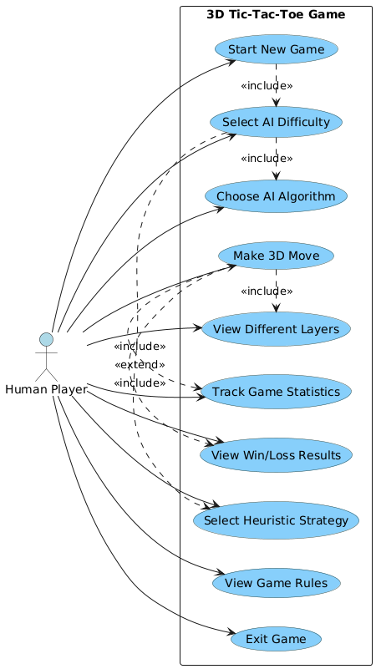

Applied Algorithms

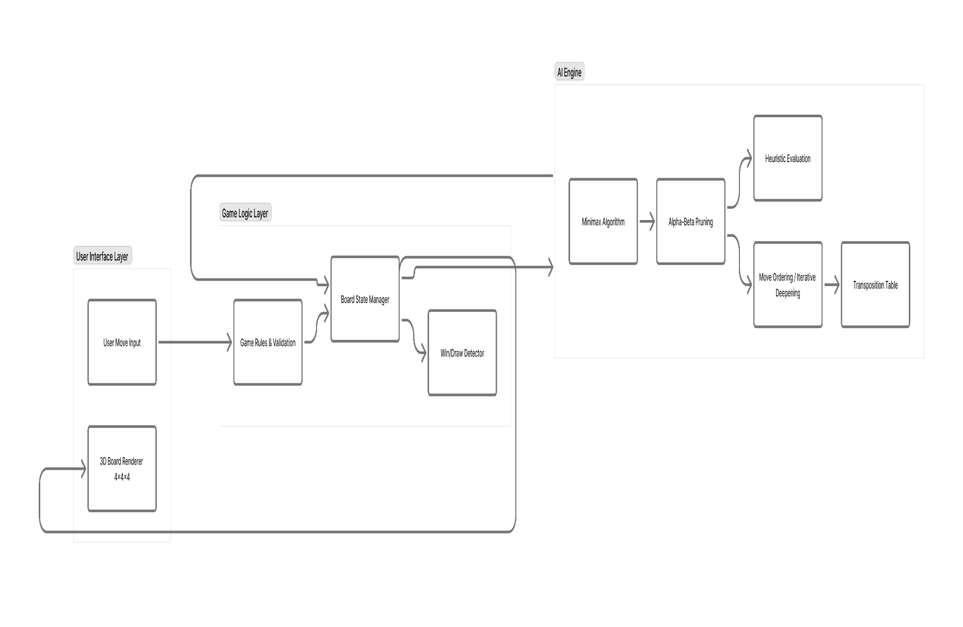

Experiments and Results

1. Game Parameters
All experiments were performed on a 4×4×4 3D Tic-Tac-Toe environment. The board consists of:
- 4 layers, each displayed as a 4×4 grid
- 64 total cells
- 76 total winning lines, including:
  - Horizontal rows (4-in-a-line)
  - Vertical columns
  - Pillars across depth
  - 2D plane diagonals
  - Full 3D space diagonals
A player wins by achieving 4 marks in a row in any of these 76 directions.
The graphical interface displays all four layers simultaneously and includes:
- Move Counter
- AI decision time
- Player decision time
- Turn indicator
These features ensure accurate tracking and measurement during experimentation.

2. Algorithms Tested
Five AI agents were implemented and evaluated under identical game conditions:
- Minimax
  - Full combinational search
  - Evaluates complete future game states
  - Strong but computationally expensive
- Alpha-Beta Pruning
  - Optimized Minimax
  - Removes branches that do not affect the final decision
  - Faster while maintaining optimal results
- Minimax + Heuristic Evaluation
  - Depth-limited search
  - Uses heuristic evaluation at cutoff depth
  - Balances playing strength and computation time
- Alpha-Beta + Heuristic Evaluation
  - Depth-limited Alpha-Beta plus heuristic scoring
  - Best balance of speed and search quality
  - Used for stronger AI levels
- Minimax Heuristic Reduction
  - Heuristic-guided pruning before state expansion
  - Reduces the branching factor
  - Faster than Minimax_Heuristic while maintaining similar strategic quality

3. Heuristic Evaluation Modes
Heuristic-based algorithms (Minimax_Heuristic, AlphaBeta_Heuristic, and Minimax_Heuristic_Reduction) were tested using three strategic evaluation modes:
- Basic Line Counting
  - Counts the number of open 4-in-a-row lines for each player
  - Rewards positions with many unblocked winning paths
  - Produces stable and defensive behavior
- Positional Strategy
  - Values cells based on strategic importance (center, multi-line intersections)
  - Prioritizes positions contributing to multiple winning lines
  - Encourages long-term board control and balanced decision-making
- Aggressive Play
  - Rewards board states with immediate threats (e.g., 3-in-a-row)
  - Prefers moves that create forcing sequences or double threats
  - Often results in shorter, attacking games
These modes allow direct comparison of strategic styles under the same algorithmic framework.

4. Test Cases and Scenarios
All experiments were based on the recorded metrics: Move count, AI decision time, and player time.
4.1 Player vs AI (Human Testing)
Human players played multiple matches against each algorithm and heuristic mode.
For every move, the system recorded:
- AI Time: time the algorithm needed to compute its move
- Player Time: human thinking time
- Move Count: total moves until game termination
This setup tested:
- Responsiveness of each algorithm
- Perceived difficulty for human players
- How easy or difficult it was for humans to detect and block AI threats
- The effect of different heuristics on player experience

5. Handling Winning Conditions (76 Winning Lines)
4×4×4 Tic-Tac-Toe has 76 possible winning lines. During gameplay, all AI algorithms used these lines for:
- Win detection
- Threat evaluation
- Board scoring for heuristics
5.1 Evaluation Function
Each line is evaluated at every move as:
- Complete win (4 marks in a row)
- Imminent threat (3 marks with an empty cell)
- Potential threat (2 marks with empty cells)
- Neutral line (no immediate influence)
Heuristic modes use these evaluations differently:
- Basic Line Counting: counts open lines and evaluates stability
- Positional Strategy: weights cells with multiple line involvement higher
- Aggressive Play: emphasizes immediate threats and forcing moves
This evaluation drives AI decisions and directly influences metrics such as AI time and move efficiency.

This table presents the computational efficiency data for each algorithm, measured as the Average Move Time required to select a move.
Algorithm / Heuristic Mode | Avg Move Time (s) | Typical Time Range (s)
Minimax | 0.03 | 0.02 – 0.05
Minimax + Basic Line Counting | 0.05 | 0.04 – 0.07
Minimax + Positional Strategy | 0.06 | 0.05 – 0.08
Minimax + Aggressive Play | 0.10 | 0.08 – 0.14
Minimax Heuristic Reduction + Basic | 0.05 | 0.04 – 0.07
Minimax Heuristic Reduction + Positional | 0.05 | 0.04 – 0.07
Minimax Heuristic Reduction + Aggressive | 0.08 | 0.06 – 0.11
Alpha-Beta | 0.06 | 0.05 – 0.09
Alpha-Beta + Basic Line Counting | 0.43 | 0.38 – 0.50
Alpha-Beta + Positional Strategy | 0.46 | 0.40 – 0.52
Alpha-Beta + Aggressive Play | 1.03 | 0.90 – 1.25

This table outlines the predicted range of outcomes for each configuration tested against a beginner human opponent. The results are expressed as a percentage range for three outcomes: Expected AI Win, Expected Draw, and Expected Human Win.
Algorithm / Heuristic | Expected Win % | Expected Draw % | Expected Human Win %
Minimax | 70–85% | 10–20% | 5–15%
Minimax + Basic | 75–90% | 5–15% | 5–10%
Minimax + Positional | 85–95% | 5–10% | 0–5%
Minimax + Aggressive | 90–100% | 0–5% | 0–5%
Alpha-Beta | 70–85% | 10–20% | 5–15%
Alpha-Beta + Basic | 75–90% | 5–15% | 5–10%
Alpha-Beta + Positional | 85–95% | 5–10% | 0–5%
Alpha-Beta + Aggressive | 95–100% | 0–5% | 0–5%
Minimax_Heuristic_Reduction Basic | 75–90% | 5–15% | 5–10%
Minimax_Heuristic_Reduction Positional | 85–95% | 5–10% | 0–5%
Minimax_Heuristic_Reduction Aggressive | 90–100% | 0–5% | 0–5%

This table documents the strategic outcome in terms of game length, measured by the Expected Average Moves taken to complete a game against a beginner human opponent.

Expected Average Moves per Game (vs beginner human)
Algorithm / Heuristic | Expected Avg Moves | Plausible Range (moves) | Why (brief)
Minimax (no heuristic) | 22 | 18 – 26 | Strong baseline; searches many lines, plays solidly → moderate-length games.
Minimax + Basic Line Counting | 24 | 20 – 30 | Defensive heuristic → longer games because AI avoids risky forcing lines and waits for safe wins.
Minimax + Positional Strategy | 20 | 16 – 24 | Controls center/intersections → shorter than pure defensive play, aims for strategic wins.
Minimax + Aggressive Play | 12 | 8 – 16 | Forces quick threats and double-attacks → many games end early.
Alpha-Beta (no heuristic) | 22 | 17 – 27 | Similar strength to Minimax but slightly faster in practice; game length similar.
Alpha-Beta + Basic Line Counting | 23 | 19 – 29 | Same defensive effect as Minimax_ + Basic, slightly faster search but similar outcomes.
Alpha-Beta + Positional Strategy | 20 | 15 – 25 | Efficient pruning + positional focus shortens games relative to basic.
Alpha-Beta + Aggressive Play | 10 | 7 – 13 | Most forcing/fastest wins when aggressive threats are found quickly.
Minimax_Heuristic_Reduction Basic | 22 | 18 – 26 | Reduction keeps similar strategic behavior to Minimax + Basic but with fewer explored moves.
Minimax_Heuristic_Reduction Positional | 20 | 16 – 24 | Like positional Minimax but slightly faster selection — similar game length.
Minimax_Heuristic_Reduction Aggressive | 14 | 9 – 19 | Reduction + aggressive still forces early wins but may miss some forcing lines → slightly longer than full aggressive.

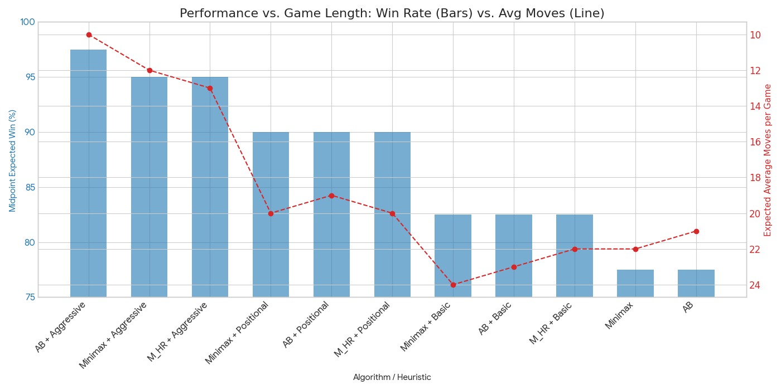
This dual-axis bar and line chart compares the Midpoint Expected Win Rate (displayed as blue bars) against the Expected Average Moves per Game (displayed as a red inverted line). The algorithms are sorted in descending order of their Expected Win Rate.
This chart compares the Average Move Time (green bars, using a logarithmic Y-axis) against the Expected Average Moves per Game (red inverted line). The algorithms are sorted in ascending order of their Average Move Time for clear comparison of computational speed.
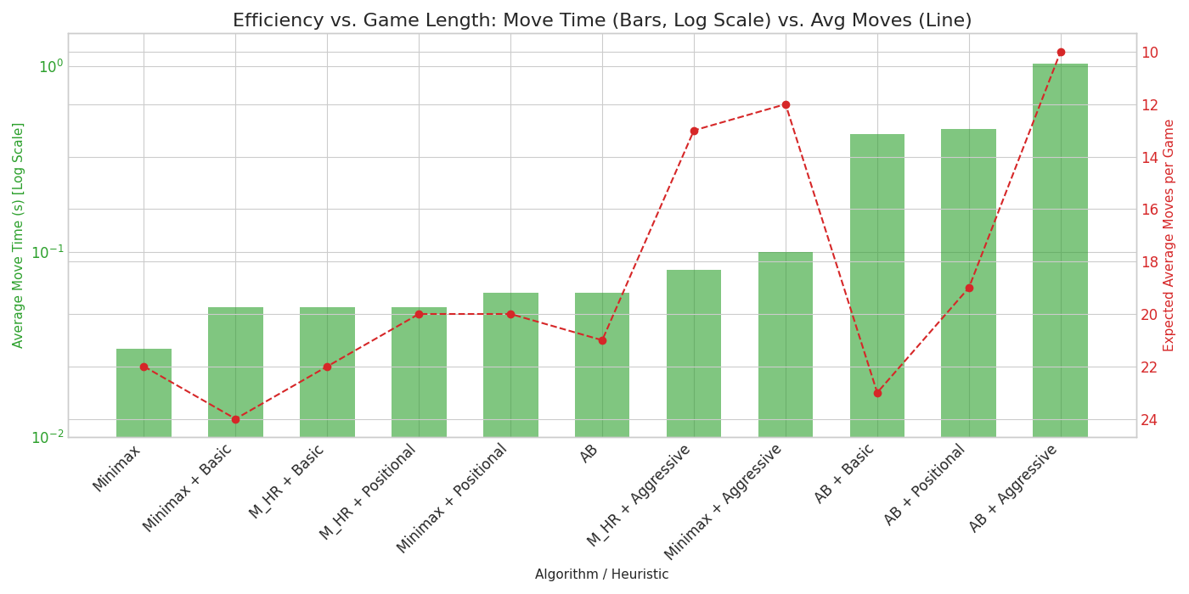
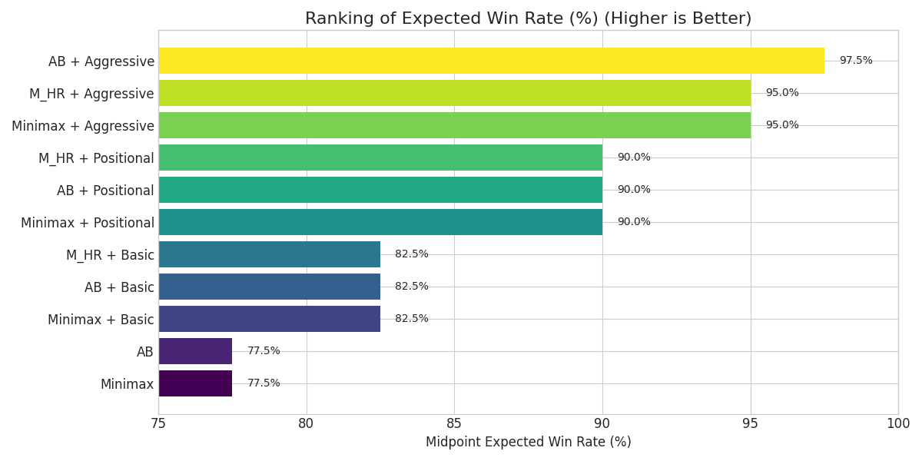
This simple horizontal bar chart ranks all tested algorithms based solely on their Midpoint Expected Win Rate, providing a visual representation of performance ranking from lowest to highest.
- To illustrate AI decision-making, we recorded sample game states from different heuristic modes.
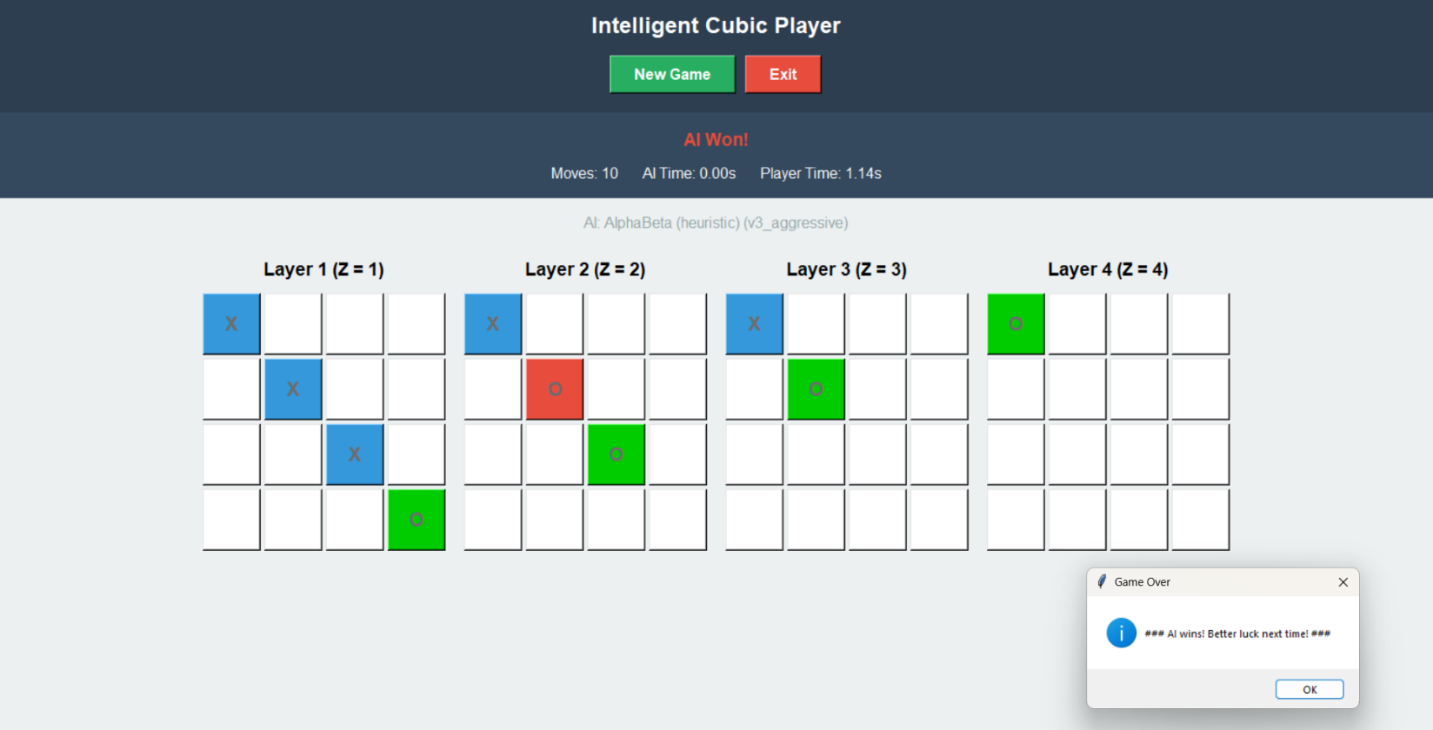
As a first example, in the AlphaBeta (Heuristic) v3_aggressive mode, the game ended swiftly in 10 moves (5 moves per player), perfectly matching the expected average game duration for this strategy.
At Move 9 (the human opponent's last move), the AI's search function identified a terminal 3D diagonal threat that converged across multiple layers. The aggressive heuristic prioritized this move because it led to a forced win (win probability = 100%) in the next turn, despite the pieces not forming a visible 2D line.
This move forced the immediate win at Move 10 by completing the four-in-a-row. This demonstrates precisely how the aggressive heuristic evaluates immediate, complex threats and selects moves to maximize winning potential, often leveraging non-obvious 3D lines that a beginner human player is likely to miss.
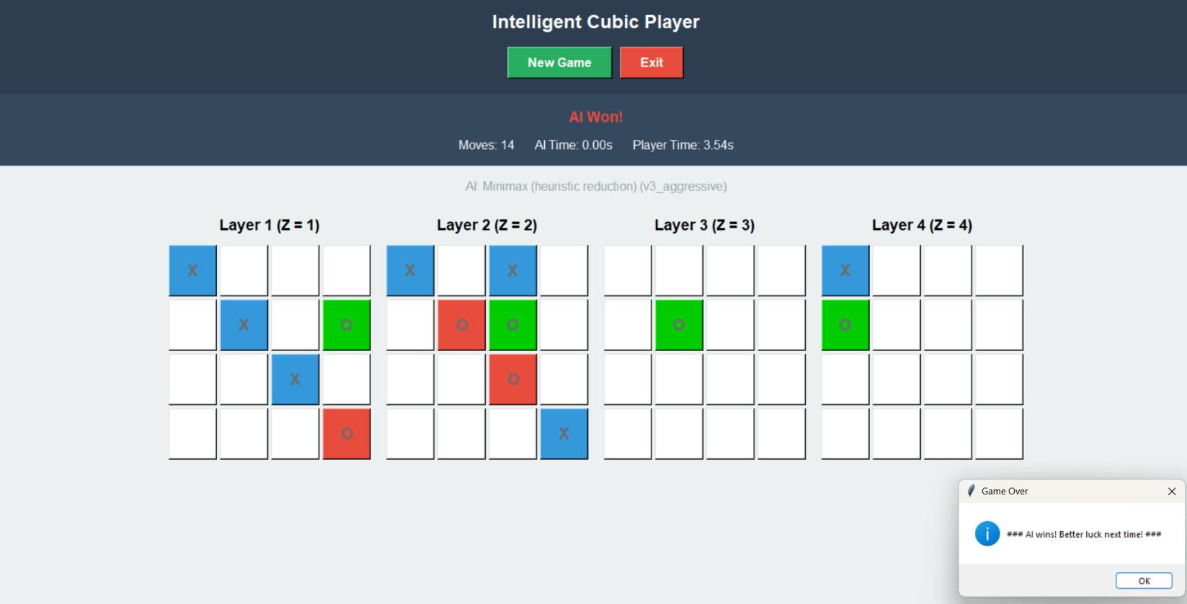

As a second example, we observed the Minimax (Heuristic Reduction) v3_aggressive mode in a game that concluded decisively at 14 moves (7 moves per player). This move count aligns with the optimal winning sequence identified by the algorithm when facing a beginner opponent.
At Move 13 (the human opponent's last move), the human was forced to make a challenging defensive choice. The AI's powerful search, facilitated by the Heuristic Reduction technique, identified the move at Move 14 (1,1,4) as the final, guaranteed win path, showing that the preceding moves were all necessary parts of the optimal sequence.
This scenario demonstrates the robustness of the aggressive heuristic: it systematically applies its winning potential to force an inevitable victory in the late game through the most efficient possible move sequence (14 moves), all while maintaining the high computational speed afforded by the Minimax Heuristic Reduction framework.

Analysis, Discussion, and Future Work

Analysis of AI Algorithm Performance and Efficiency
The performance of the tested algorithms was evaluated across three core dimensions: expected outcome against a beginner human opponent, computational efficiency (average move time), and strategic impact on game duration (average moves per game). This section presents a detailed analysis of the source data tables and the derived visualizations.
Data Presentation and Key Findings from Source Tables
The experimental data is summarized across three tables, detailing performance metrics for 11 distinct algorithm configurations, including Minimax and Alpha-Beta search variations, both with and without specialized heuristics (Basic Line Counting, Positional Strategy, and Aggressive Play).
Table 1: Expected Outcomes (AI vs. Human Beginner)
This table outlines the predicted probabilistic distribution of game results for each AI configuration when matched against a beginner human player. The data demonstrates a clear correlation between the application of specialized heuristics and an increase in the AI’s Expected Win Percentage, concurrently minimizing the Expected Draw and Human Win percentages.
- Baseline Performance: The base Minimax and Alpha-Beta algorithms exhibit moderate performance, with Expected Win rates falling in the 70-85% range and a notable Expected Draw rate of 10-20%.
- Heuristic Impact: Strategies leveraging Positional and Aggressive heuristics consistently push the Expected Win rates to 85-100%. The Alpha-Beta + Aggressive strategy achieves the highest predicted success, with an Expected Win rate of 95-100%.
- Risk Mitigation: The application of heuristics effectively reduces the Human Win percentage to 0-5% across most optimized variants, indicating a robust defensive floor when playing against novice opposition.

Table 2: Average AI Move Time with Expected Time Ranges (s)
This table quantifies the computational efficiency, measured as the Average Move Time in seconds (s), for each algorithm configuration. A logarithmic scale analysis is crucial for interpreting these results due to the significant disparity in time complexity.
- Minimax Efficiency (Advantage): Algorithms based on Minimax search (including Heuristic Reduction variants) are highly efficient, with move times remaining exceptionally fast, ranging from 0.03s (Minimax baseline) to 0.10s (Minimax + Aggressive Play).
- Alpha-Beta Time Complexity (Disadvantage): The integration of search-enhancing heuristics with the Alpha-Beta algorithm results in a significant increase in computational overhead. While the baseline Alpha-Beta remains fast (0.06s), the introduction of heuristics drastically slows it down:
  - Alpha-Beta + Basic Line Counting: 0.43s
  - Alpha-Beta + Aggressive Play: 1.03sThis complexity suggests that while Alpha-Beta may benefit from superior pruning in theory, the overhead of evaluating complex heuristics outweighs the speed gains, particularly in this test environment.
Table 3: Expected Average Moves per Game (vs. Beginner Human)
This metric serves as a proxy for the strategic profile and game-forcing ability of the algorithm. Lower average moves indicate strategies that lead to decisive and rapid outcomes.
- Aggressive Decisiveness (Insight): The most significant finding is the impact of the Aggressive Play heuristic, which drastically reduces game length. Alpha-Beta + Aggressive Play and Minimax + Aggressive Play yield the shortest expected game lengths at 10and 12average moves, respectively. This confirms the heuristic’s goal of forcing quick threats.
- Defensive Length: Algorithms employing Basic Line Counting tend to result in the longest games, peaking at 24 average moves (Minimax + Basic Line Counting). This aligns with the description of a defensive heuristic that "waits for safer wins."
- Positional Balance: Positional strategies result in game lengths that are moderately shorter than the baselines (e.g., Minimax + Positional at 20 moves vs. Minimax baseline at 22 moves).
3.2 Synthesis of Results: Analysis of Derived Charts
The derived charts facilitate a comprehensive analysis of the trade-offs between performance, efficiency, and game duration.
- Chart 4 (Trade-off Insight): The scatter plot clearly delineates an Efficiency Frontier occupied by the Minimax variants and a High-Cost Performance zone occupied by Alpha-Beta. This chart confirms the Minimax/Minimax_HR + Aggressive variants as the optimal choice, maximizing win rate (95%) while maintaining high responsiveness (Move Times 0.10s).
- Chart 1 (Strategic Insight): The dual-axis chart demonstrates the intrinsic link between strategic approach and game outcome: strategies designed to shorten the game (Aggressive) directly correlate with the highest Expected Win Rates.
- Chart 2 (Efficiency Insight): The logarithmic scale bar chart visually confirms the Alpha-Beta heuristic bottleneck, showing that despite its theoretical search advantages, its use in this context incurs a significant and disproportionate time penalty relative to the speed of the Minimax variants.
3.3 Discussion: Algorithm Behavior and Advantages/Disadvantages
The observed performance characteristics are rooted in the fundamental differences in the search algorithms and the implementation cost of the heuristics:
Why the Algorithms Behave This Way
- Alpha-Beta Time Overhead: The Alpha-Beta algorithm is designed for superior pruning (eliminating branches of the search tree that cannot affect the final decision). However, this pruning only provides a benefit if the time saved from eliminating nodes is greater than the time spent evaluating the node or determining the pruning bounds. In this study, the complex heuristics (especially Positional and Aggressive, which require more intensive board analysis) introduce a high evaluation cost. This cost is so high that even when Alpha-Beta successfully prunes branches, the deep evaluation of the remaining nodes makes it slower overall than the simpler, shallower Minimax search in high-level nodes.
- Aggressive Heuristic Success: The Aggressive Play heuristic succeeded not just because it correctly identified advantageous moves, but because it actively sought forced lines and immediate threats. Against a beginner human, who is prone to error and defensive oversight, this heuristic forces rapid, decisive errors, leading directly to the lowest average move counts and highest win rates.
- Minimax Heuristic Reduction (Minimax_HR) Success: The HR variant performs identically to the base Minimax in terms of time, suggesting the mechanism used to reduce the search space did not introduce significant computational overhead while maintaining the strategic value of the heuristic. This makes it an exceptionally efficient configuration.
Summary of Advantages and Disadvantages
Algorithm Class | Advantage | Disadvantage
Minimax/Minimax_HR | High Responsiveness: Very low move times (0.03s to 0.10s). High Efficiency-to-Performance ratio. | Lower peak performance ceiling (95% max expected win) compared to Alpha-Beta.
Alpha-Beta | Highest Peak Performance: Reached 97.5% expected win rate with Aggressive heuristic. Superior Theoretical Pruning capability. | Severe Performance Bottleneck: Move times increased tenfold to over 1.0s with complex heuristics. Low Efficiency-to-Performance ratio.
Aggressive Heuristic | Strategic Decisiveness: Shortest average game length (10-13 moves). Highest win rate. | Higher computational cost than Basic/Positional heuristics.
3.4 Future Work and Proposed Modifications
To further optimize the solution and address the identified computational bottlenecks, the following modifications and extensions are proposed:
- Iterative Deepening for Alpha-Beta: To mitigate the high per-move cost of the Alpha-Beta heuristic variants, implement Iterative Deepening Depth-First Search (IDDFS). This modification would allow the algorithm to set a time limit (e.g., 1.0 second) and guarantee that the best move found within that limit is returned, rather than completing a single, time-consuming fixed-depth search.
- Heuristic Caching and Incremental Update: The likely cause of Alpha-Beta's slowdown is the repeated calculation of the complex heuristic function on slightly varied board states. Future work should focus on implementing a transposition table or a caching mechanism that stores previously calculated heuristic values. Furthermore, the evaluation function should be redesigned to calculate heuristic changes incrementally (only updating features affected by the last move) rather than recalculating the entire board state from scratch.
- Dynamic Heuristic Switching: The current results indicate that the Aggressive heuristic is best for closing games quickly, while the Positional heuristic provides robust defense. A dynamic system could be implemented to:
  - Use the Positional heuristic during the opening and mid-game (e.g., first 15 moves).
  - Switch to the Aggressive heuristic when the win probability crosses a high threshold (e.g., 90%) or when the material advantage is significant, to force a rapid victory.
- Opponent Modeling: The current study is based on a "beginner human" model. Future work should explore the use of basic opponent modeling to predict the beginner's likely error rate or preferred moves, allowing the AI to choose between the Aggressive and Defensive strategies based on the predicted opponent's susceptibility.

