# Analysing Employee Attrition using Power BI: A Case Study

**Background:** ABC Corporation is a multinational company facing challenges with employee attrition. The company is keen on understanding the factors contributing to attrition to develop strategies for retention and talent management. To address this issue, they have decided to implement a Power BI project to analyse their attrition data comprehensively.

**Project Objectives:**

1. **Identify Key Drivers of Attrition:** Determine the primary factors influencing employee attrition within the organization.
2. **Segmentation Analysis:** Analyse attrition rates across different segments such as departments, job roles, genders, education levels, etc., to identify high-risk groups.
3. **Dashboard and Reporting:** Design an interactive dashboard to present insights and recommendations to stakeholders effectively.

**Data Sources:**

1. **Database:** Provided are 3 database tables:
   * 1. Employee_survey: Responses from employees regarding their satisfaction, work-life balance, etc.
     2. Manager_survey: Responses from managers regarding employee performance, etc.
     3. EmployeeInfo: Demographic information, job role, etc.
2. **IN/OUT Times:**
   * Provided are 2 sheets extracted from the Clock-In-Machine for year 2015, the sheets include in/out times for all employees.

**Methodology:**

1. **Data Collection:** Import the data from various sources including the database and csv files.
2. **Data Preparation:** Reshaping data for analysis, such as pivoting, aggregating, or filtering.
3. **Data Model:** Build a dimensional model to integrate your data sources and facilitate the reporting phase.
4. **Visualization and Dashboarding:** Create an interactive dashboard using Power BI to communicate your insights effectively.

* **Employees details page**

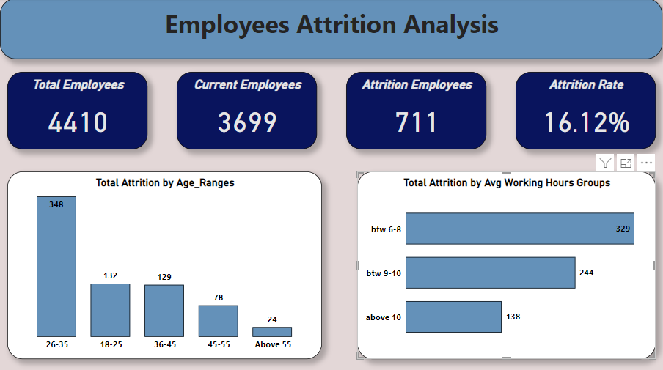

* **Insights from this page:**

1. **The total percentage of attritional employees is 16.12% of the total amount of employees which is 711 employees out of 4410 employees and the current employees count is 3699.**
2. **From the first bar chart we deduced that most of the attritional employees is between the ages of 26 years and 35 years and the least attritional employees is above the age of 55 years.**
3. **From the second bar chart we noticed that the employees that work between 6 and 8 hours are more attritional than those who work more than 10 hours**

* 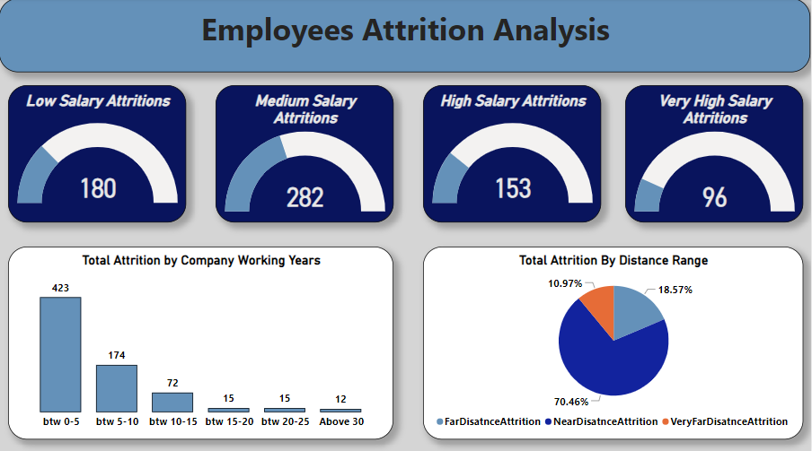 **Salary Ranges page**
* **Notes from this page:**

1. **The 4-gauge charts are representation of the relationship between the attrition of the employees and the salary ranges that the employees take. We note that the employees who have medium range of salary have high attrition and the employees with very high salaries have low attrition.**
2. **The bar chart represents that the relation between the attrition and the number of the years an employee has in a one company then we deuced that the less the number of the years the employee spend in a one company the more attritional will be**
3. **The pie chart explains that the relationship between the attrition and the distance range to the workplace.**

* **Total Attrition Categories**
* 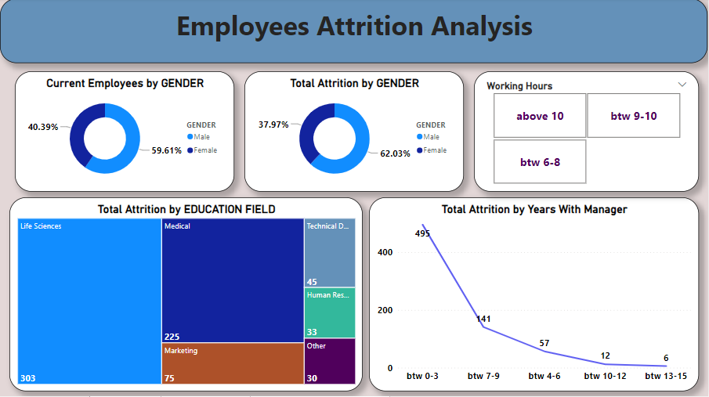 **Conclusion from this page:**

1. **The higher number of the employees is with male gender also they are highly attritional employees than female.**
2. **The more years the employee spend with his manager the less the chance to be attritional employee.**
3. **From the treemap chart we can see that the employees who have life sciences and medicine education fields have the most attrition rate.**

* 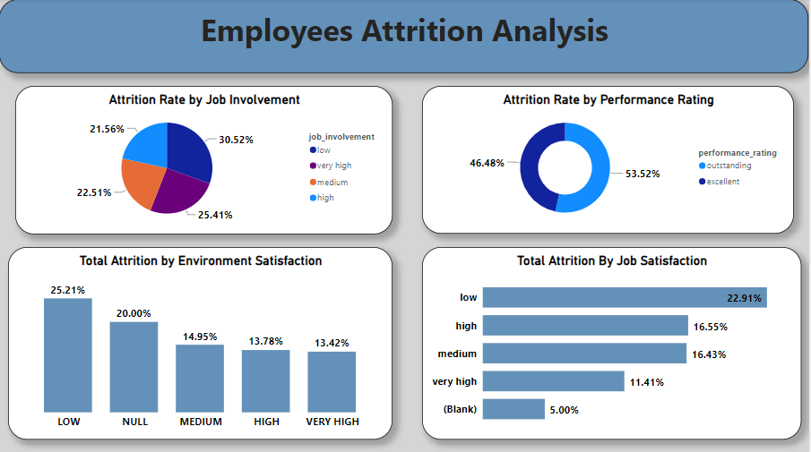 **Survey page**