Nature-Inspired Computation for Brain Tumor MRI Classification with Explainable AI

1. Introduction
This project investigates the integration of Nature-Inspired Computation (NIC) with Deep Learning (DL) and Explainable Artificial Intelligence (XAI) for the task of brain tumor classification from MRI images. A multi-stage optimization framework was designed to systematically improve model performance and interpretability.
Multiple metaheuristic algorithms were employed to optimize CNN hyperparameters, hierarchical optimizer parameters, and XAI configurations. The final outcome is a high-performance, interpretable CNN model capable of classifying brain tumor images while providing reliable visual explanations using SHAP and LIME.

2. Dataset Description and Preprocessing
2.1 Dataset Selection
- Dataset: Brain Tumor MRI Dataset
- Source: Kaggle (Masoud Nickparvar)
- Image Modality: MRI
- Classes: 4 tumor classes ['pituitary', 'no tumor', 'meningioma', 'glioma']
- Task: Multiclass image classification
2.2 Preprocessing Steps
The following preprocessing steps were applied:
- Normalization: Pixel values scaled to the range [0, 1]
- Data Augmentation:
  - Rotation
  - Width & height shifts
  - Zooming
  - Horizontal flipping
- Train / Validation Split: 80% / 20% (via ImageDataGenerator)
- Image Resizing: All images resized to 128 × 128
These steps improved generalization and reduced overfitting.

3. Baseline Model
3.1 Architecture
A custom Convolutional Neural Network (CNN) was designed consisting of:
- Multiple Conv2D + MaxPooling layers
- Dropout regularization
- Fully connected Dense layers
- Softmax output layer
3.2 Initial Hyperparameters
Parameter | Value
Learning Rate | 0.001
Dropout | 0.30
Filters | 32
Conv Layers | 2
Batch Size | 32
3.3 Baseline Performance
- Validation Accuracy: = 69.23%
- This baseline served as the reference point for all optimization phases.

4. Methodology and Algorithms
A total of three optimization stages were implemented:
Stage | Objective | Algorithms
Phase 1 | CNN Hyperparameter Optimization | GA, PSO, SA, Tabu
Phase 2 | Hierarchical Hyperparameter Optimization | Bat ⟶ Cuckoo, GWO ⟶ Firefly
Phase 2 | XAI Configuration Optimization | Bat, Firefly, Whale, PSO
Each stage progressively refined the model and explanation quality.

5. Phase 1: CNN Hyperparameter Optimization
5.1 Search Space
The following parameters were optimized:
Parameter | Range
Learning Rate | [1e-4, 1e-3]
Dropout | [0.2, 0.5]
Filters | {16, 32, 64}
Conv Layers | {1, 2, 3}
Batch Size | {16, 32, 64}
5.2 Metaheuristic Algorithms
- Genetic Algorithm (GA) – evolutionary search
- Particle Swarm Optimization (PSO) – swarm-based optimization
- Simulated Annealing (SA) – probabilistic hill-climbing
- Tabu Search – memory-based local search
5.3 Results
The best configuration across all algorithms was selected based on validation accuracy.
Best Phase 1 Configuration: Genetic Algorithm
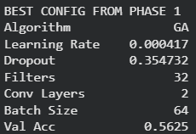
Phase 1 resulted in a consistent improvement over the baseline.

6. Phase 2: Hierarchical Metaheuristic Optimization
Phase 2 introduced hierarchical optimization, where one metaheuristic optimizes the parameters of another.
6.1 Bat Algorithm ⟶ Cuckoo Search
- Bat Algorithm optimized the α (step size) of Cuckoo Search
- Cuckoo Search optimized CNN hyperparameters:
  - Learning rate
  - Dropout
  - Filters
  - Conv layers
  - Batch size
This design enabled adaptive control of exploration and exploitation.
6.2 GWO ⟶ Firefly Algorithm
- Grey Wolf Optimization (GWO) tuned the α parameter of Firefly
- Firefly Algorithm optimized CNN hyperparameters using distance-based attraction
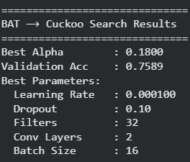
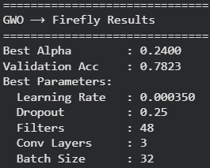

6.3 Phase 2 Results
Both hierarchies converged successfully, with Grey Wolf Algorithm ⟶ Firefly achieving the best validation accuracy.

7. Explainable AI (XAI) Optimization
7.1 SHAP & LIME Integration
The final optimized CNN was interpreted using:
- SHAP (SHapley Additive Explanations)
- LIME (Local Interpretable Model-agnostic Explanations)
7.2 XAI Optimization Search Space
Parameter | Range
SHAP background samples | [10, 100]
SHAP max evaluations | [50, 500]
7.3 Metaheuristic Optimization for XAI
The following algorithms were used to optimize SHAP parameters:
- Bat Algorithm
- Firefly Algorithm
- Whale Optimization Algorithm
- Particle Swarm Optimization
All algorithms converged to stable and comparable fitness values, indicating robustness.
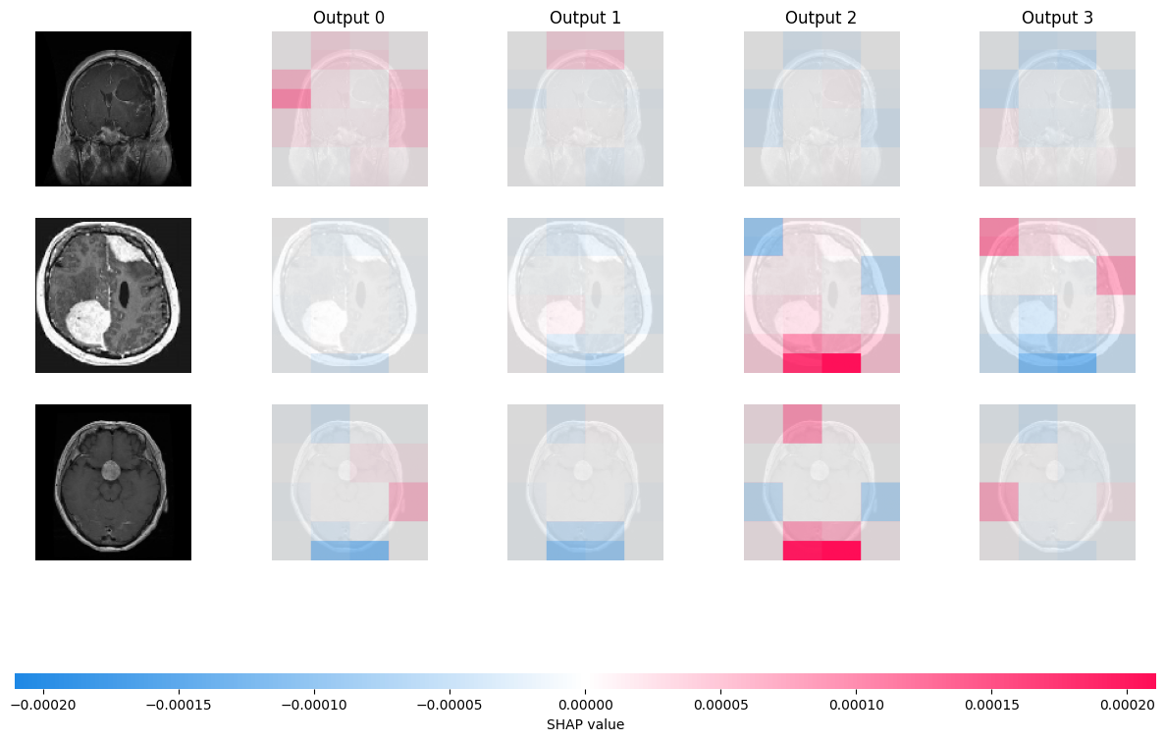

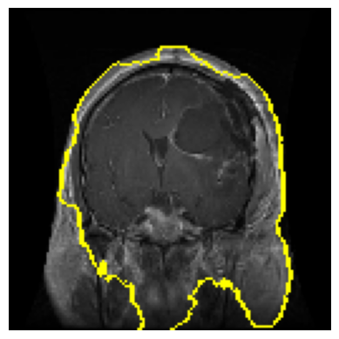

8. Discussion
8.1 Impact of NIC
- Metaheuristics consistently improved CNN performance
- Hierarchical optimization improved convergence stability
- GA and Cuckoo Search showed strong performance
8.2 XAI Insights
- SHAP highlighted tumor-relevant regions in MRI images
- LIME provided localized, human-understandable explanations
- Interpretability increased trust in model predictions
8.3 Challenges
- High computational cost
- Sensitivity to metaheuristic parameters
- Trade-off between accuracy and explainability

9. Conclusion
This project successfully demonstrated the effectiveness of Nature-Inspired Computation combined with Deep Learning and Explainable AI for brain tumor MRI classification. Through systematic optimization of CNN hyperparameters, hierarchical metaheuristics, and XAI configurations, a highly accurate and interpretable model was developed.
The results confirm that NIC techniques can significantly enhance both performance and transparency, aligning with modern requirements for trustworthy AI in medical imaging.

10. Appendix
- Dataset: Brain Tumor MRI Dataset (Kaggle)
- Frameworks: TensorFlow, Keras, SHAP, LIME
- Optimization Algorithms: GA, PSO, SA, Tabu, Bat, Cuckoo, Firefly, GWO, Whale

