**Question 1:**

**Convert English sentences into Propositional logic:**

1. If it rains, then I will stay at home.
2. If I will go to Australia, then I will earn more money.
3. He is poor but honest.
4. If a = b and b = c then a = c.
5. Neither it is hot nor cold today.
6. He goes to play a match if and only if it does not rain.
7. Birds fly if and only if sky is clear.
8. I will go only if he stays.
9. I will go if he stays.
10. It is false that he is poor but not honest.
11. It is false that he is poor or clever but not honest.
12. It is hot or else it is both cold and cloudy.
13. I will not go to class unless you come.
14. We will leave whenever he comes.
15. Either today is Sunday or Monday.
16. You will qualify GATE only if you work hard.
17. Presence of cycle in a single instance RAG is a necessary and sufficient condition for deadlock.
18. Presence of cycle in a multi instance RAG is a necessary but not sufficient condition for deadlock.
19. I will dance only if you sing.
20. Neither the red nor the green is available in size 5.

**Question 2:**

**Check the following examples whether they are satisfiable, unsatisfiable, valid, invalid, contingent:**

**Satisfiable 🡪 When any model is True.**

**Unsatisfiable 🡪 When there isn’t any model that is True.**

**Valid 🡪 When all models are True.**

**Invalid 🡪 When any model is False.**

**Contingent 🡪 When there are some models are True and others are False**

1- ⌝ (x1 ∧ x2) 🡪 (x1 ∨ x2)

2- (x1 ∨ x2) 🡪 x1

3- (x1 ∧ x2) ∧ ⌝ x1

4- (a1 ∧ a2 ∧⌝a1) ∨ (a2 ∧ a1) ∨ (a2 ∧ ⌝a3 ∧ a3)

**Question 3:**

**Check Entailment (Does the two rules sounds or not) :**

1. ⌝(P∧Q) |=⌝P∨⌝Q.
2. {A, B, C} |= A v B v C
3. A →B |= ⌝A v B
4. A →B |= ⌝ (A ∧⌝ B)
5. KB:

* Dory loves Mary
* Mary loves peter
* Peter loves every one dory loves

S: Peter loves Mary

KB |=S or not?

1. KB:

* Ahmed is peter’s father
* Juan is peter’s mother
* Omar and peter are brothers

S: Ahmed is Omar’s father

KB |=S or not?

1. KB:

* Anyone whom Mary loves is a football star.
* Any student who does not pass does not play.
* John is a student.
* Any student who does not study does not pass.
* Anyone who does not play is not a football star.

S: If John does not study, then Mary does not love John.

KB |=S or not?

**Question 4:**

**Check if they are equivalent:**

**Equivalent 🡪 If A |= B then B |= A**

1. ⌝(P∧Q) ≡⌝P∨⌝Q.
2. ⌝(P→Q) ≡P∧⌝Q.
3. P→(Q∨R) ≡ (P∧⌝Q) →R
4. [(P∧Q) →R] ≡(P→R) ∨(Q→R)
5. [(P∧Q) →(R∨S)] ≡[(P∧Q∧⌝R) →S]

**Question 5:**

**Convert following statements into CNF:**

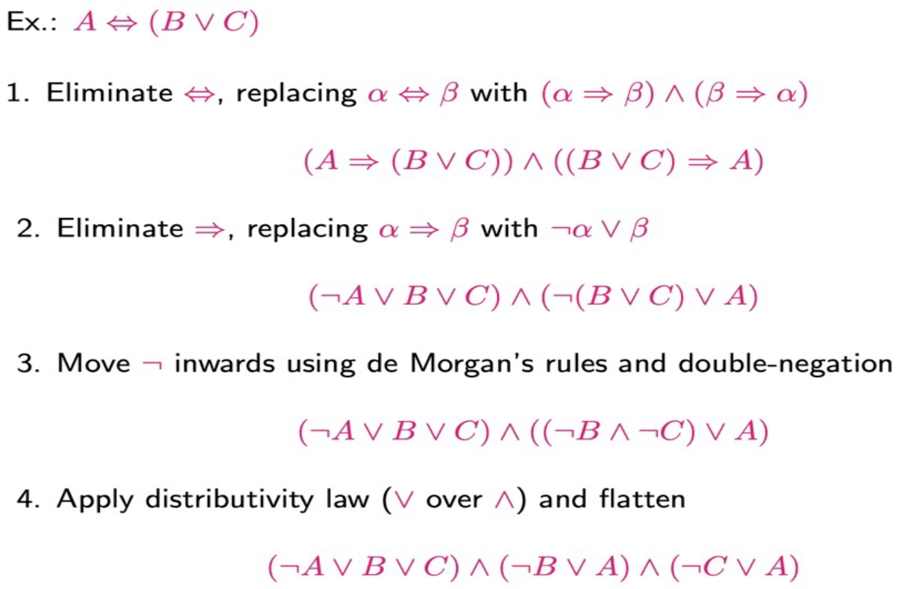

1. (taller (Y, X) ∨ wise(X) => wise(Y))

2. (P → (Q → R)) → (P → (R → Q))

3. (r (x, y) → p(x))

4. A <→ (B v C)

5. (¬P → (P → Q))

6. (P → Q) → ((Q → R) → (P → R))

7. (P → (Q → R)) → (P → (R → Q))

**Question 6:**

**Proof by resolution, by rules and by Contradiction:**

1. Given p and (p → q) and ((p → q) → (q → r)), prove r
2. KB:

* All hounds howl at night.
* Anyone who has any cats will not have any mice.
* Light sleepers do not have anything which howls at night.
* John has either a cat or a hound.
* (Conclusion) If John is a light sleeper, then John does not have any mice.

1. KB:

* Anyone whom Mary loves is a football star.
* Any student who does not pass does not play.
* John is a student.
* Any student who does not study does not pass.
* Anyone who does not play is not a football star.
* Prove that: If John does not study, then Mary does not love John.

1. KB:

* If it is sunny and warm day you will enjoy.
* If it is warm and pleasant day you will do strawberry picking
* If it is raining then no strawberry picking.
* If it is raining you will get wet.
* It is warm day
* It is raining
* It is sunny

(Goal 1) You are not doing strawberry picking.

(Goal 2) You will enjoy.