**File Upload**

**API**

**Created By**

**Mohamed Abdelmaged Mahmoud**

**Using**

**PHP | Laravel | MySQL**

**Date**

**23 – 7 – 2023**

1. **Introduction**

Multi user API that allows users to upload files online and access it only if logged in. Anyone can use the API but only must register to it then he can upload and store files to database.

1. **What is the API do**

* Upload file to database
* View all files for each authorized user
* Each user has an access only for his uploaded files
* View each single file by id

1. **How to get the API**

* From GitHub, you can go to <https://github.com/Mohamed855/fileUpload>
* Download the ZIP File or clone it to your local

1. **How To Use**
2. First Locate the Repository
3. Move to Visual Studio Code Editor
4. Clone repository
5. Select Local Directory
6. Open Cloned File
7. Setting Up Project

-- run command (npm install)

-- then run (composer install)

1. Duplicate .env.example file and rename the duplicated file to .env
2. Setup Database

-- open phpMyAdmin

-- create database with any name you want

-- open .env and change "DB_DATABASE=subnetweb" to "DB_DATABASE=$your_selected_DB_name"

-- set your DB credentials to "DB_USERNAME=" and "DB_PASSWORD="

1. Run These Comands

-- npm run dev

-- php artisan key:generate

-- php artisan migrate

-- php artisan serve

10- Finally Open "<http://127.0.0.1:8000>" and start using the App

1. **Screenshots**

* **Log in Screen**

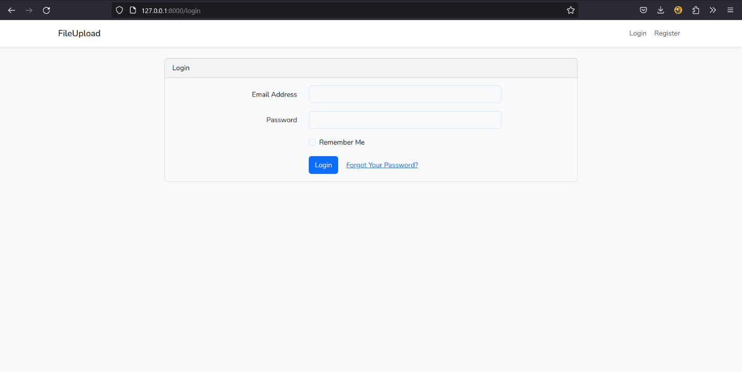

* **Register Screen**

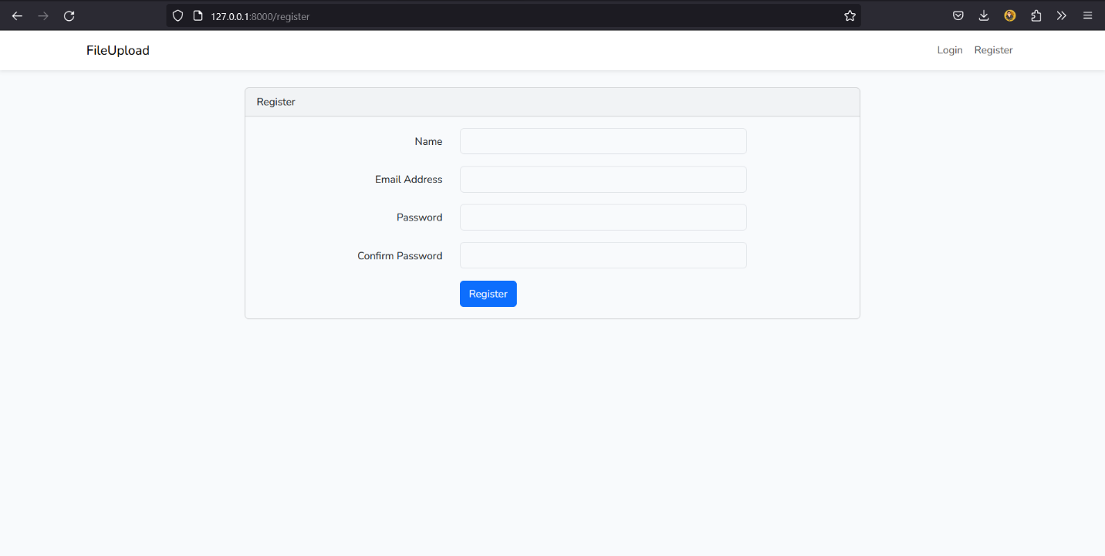

* **All user’s File Screen**

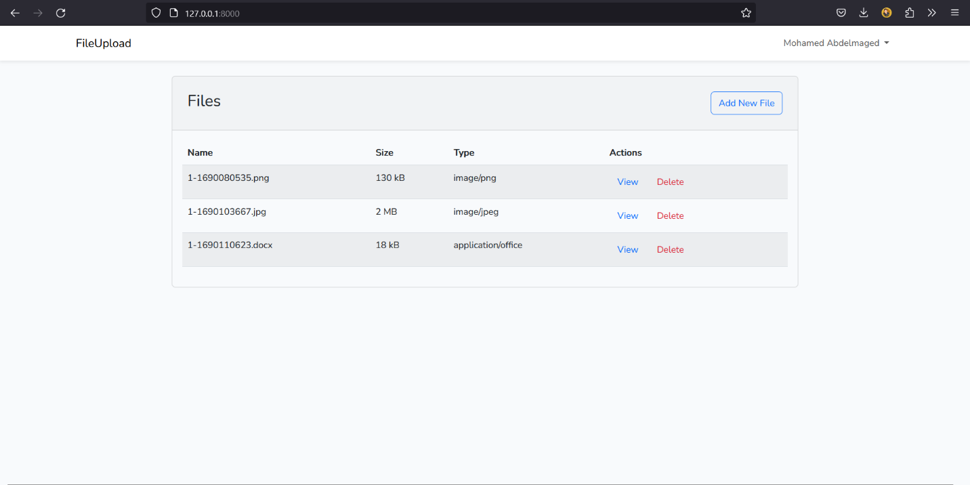

* **Add File Screen**

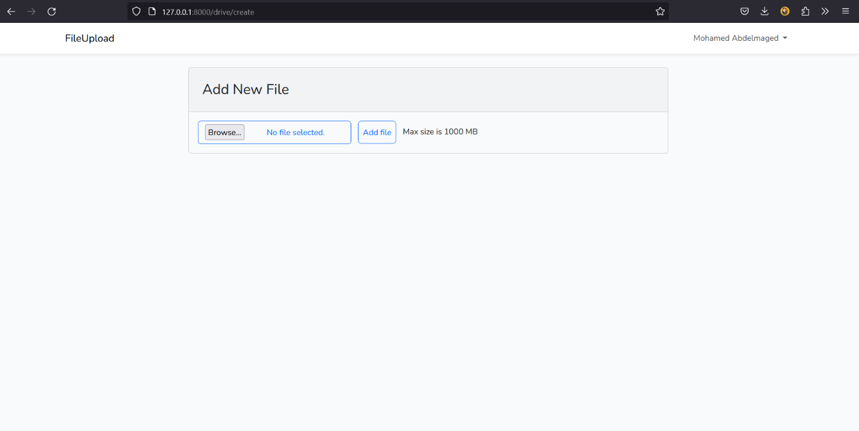

* **Uploaded Screen**

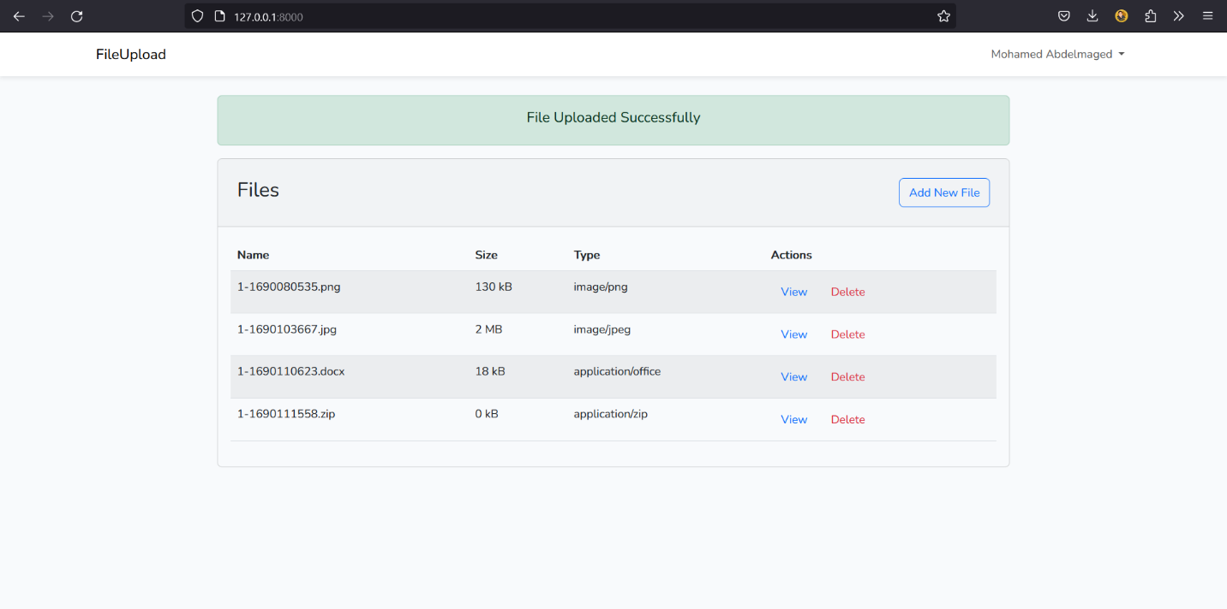

* **Deleted Screen**

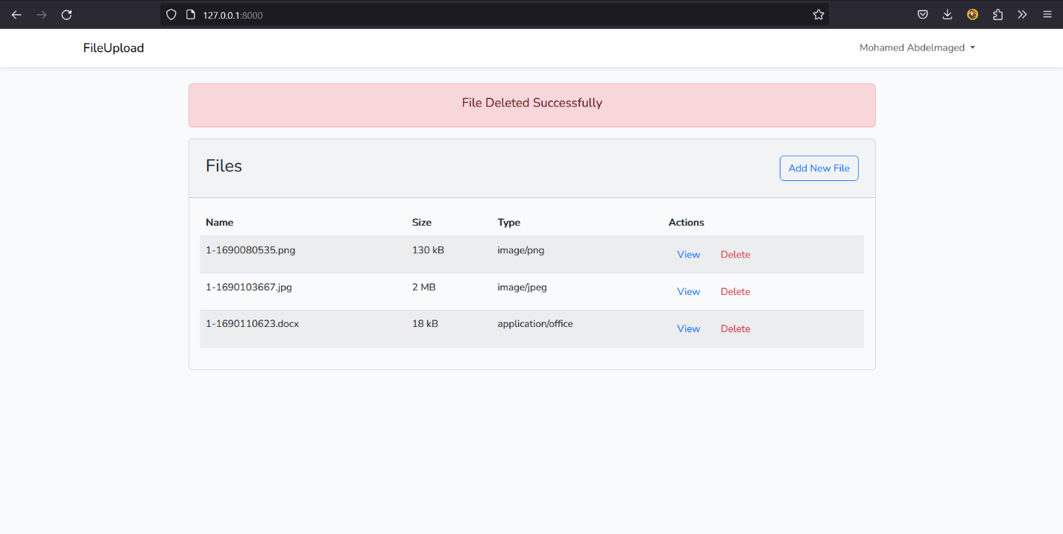

* **View File Screen**

