**Petroleum Company System Project**

**Description:Aim: To increase the efficiency of operation in the company**

**This system will be used for time scheduling and task distribution and operation management.**

**This system will not be fully involved in the production process.**

**List of team members:**

**Project Manager:**

**Ali Ehab Ali Hassan 21100800**

**Team Members:**

**Mohamed Ashraf Rabie Mohamed 21100854**

**Ramez Mohamed Fathi Ahmed 21100793**

**Youssef Khaled Abdelsalam Mohamed 21100865**

**Mohamed Ashraf Mahmoud Mohamed 21100873**

**ERD**:

**Relational Schema:**

Employee Salary (Employee ID, Accountant ID, Salary)

Hired Employee (Employee ID, Employer ID, Hire Date)

Employee Position (Employee ID, Department Number, Position)

Employee (Employee ID, FirstName, LastName, Salary, Gender, SSN, Address, Birthdate)

Contact Information (Employee ID, Contact information)

Dependent (Dependent ID, Employee ID, Birthdate, Gender, FirstName, LastName)

HR (Employee ID)

Accountant (Employee ID)

Worker (Employee ID, Engineer ID)

Worker Working in Work Site (Worker ID, Site ID)

Engineer (Employee ID)

Security (Employee ID)

Security Securing Worksite (Security ID, Site ID)

Worksite (Site ID, Address, Responsible Engineer ID)

Lab Technicians (Employee ID)

Lab Technicians Assigned Lab (Lab Technician ID, Lab ID)

Lab (Lab ID, Address, Lab Manager)

Lawyer (Employee ID)

Lawyer Suggestion (Lawyer ID, Department ID, Suggestion)

Contract Review (Lawyer ID, Contract ID)

Contract (Contract ID, Lawyer ID, Contract Date)

Contract PDF (Contract ID, Contract PDF)

Department (Department Number, Department Name, Manager)

Department Location (Department Number, Location)

Employee Request (Employee ID, Request ID, Location, Request Date)

Maintenance Request (Request ID, Employee ID, Department ID)

Defects in Maintenance Request (Request ID, Defect)

Department Contacting External Company (Company Name, Department Number)

External Company (Company Name, Address, Number, Email)

Recruitment agency (Company Name)

Specialized Tool Company (Company Name)

Insurance company (Company Name)

Transportation Company (Company Name)

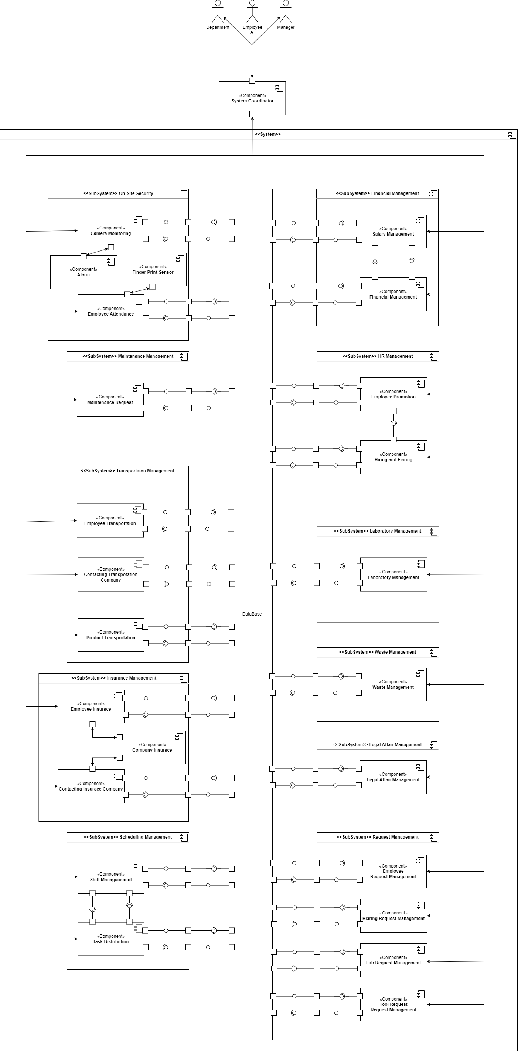Component Diagram:

Reposatory Style

With orchistraded Controle

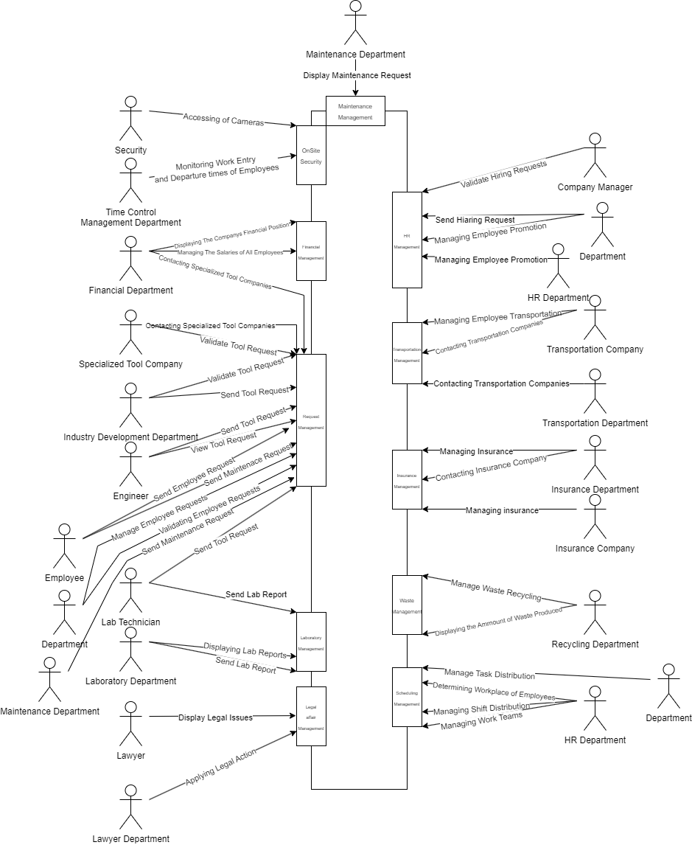ACD:

Maintenance Management:

+ DisplayMaintenanceRequests() : void  
+ ValidateMaintenanceRequest(int requestID) : void

Financial Management:

+ setEmployeeSalary(employeeID) : void  
+ getEmployeeSalary(EmployeeID) : float  
+ getCompanyFinancialReport() : void  
+ UpdateCompanyFiancialReport(Report report) : void

Request Management:

+ DisplayToolRequestPurchase() : void  
+ ValidateToolRequestPurchase(int requestID) : void

+ sendToolRequestPurchaseToCompanyManager(int requestID) : void  
+ ValidateToolRequestPurchaseRequestFromCompanyManager(int requestID) : void

+ ContactSpecializedToolCompanyCompany(String companyName, Request request) : void  
+ SendToolRequestPurchaseToFinancialDepartment(Request request) : void  
+ DisplayFinancialDepartmentValidation(int requestID) : void   
+ ValidtaeToolRequestFromExternalCompany(String companyName) : void

+ SendToolRequest(Report report) : void  
+ DisplayToolRequestValidation() : void

+ displayDepartmentRequest() : void  
+ validateDepartmentRequest(int departmentID, int requestID) : void

+ DisplayPurchaseRequest() : void  
+ ValidatePurchaseRequest(int requestID) : void  
+ DisplayToolPurchaseRequest() : void  
+ ValidateToolPurchaseRequest(int requestID) : void

+ SendEmployeeRequest(Request request, department_ID) : int  
+ SendMaintenanceRequest(Request request, department_ID) : int + displayEmployeeData() : void

Laboratory Management:

+ SendLabReport(Report report) : void  
+ DisplayLabReport() : void  
+ getLabReport(int reportID) : Report + getAllLabReports() : Report[]

Legal Affair Management:

+ fireEmployee(int EmployeeID)  
+ getAllLegalDocuments() : Report[]  
+ displayLegalDocument(int reportID) : void

Onsite Security:

+ AccessCamera() : void

+ EmployeeEntrance(int employeeID) : void  
+ EmployeeExit(int employeeID) : void

Transportation Management:

+ displayDepartmentRequest() : void  
+ validateDepartmentRequest(int departmentID, int requestID) : void

+ ContactTransportationCompany(String companyName, Request request)  : void  
+ AddTransportationTimeToEmployeeSchedual(int employeeID, String pickUpTime) : void  
+ DisplayTransportationCompanyRequestValidation(String companyName,int requestID) : void

Insurance Management:

+ displayDepartmentRequest() : void  
+ validateDepartmentRequest(int departmentID, int requestID) : void

+ setEmployeeInsurance(Report details, int employeeID) : void  
+ AddDependantsToEmployeeInsurance(Dependants[], int employeeID) : void  
+ getEmployeeInsurance(int employeeID) : void  
+ setEmployeeDependants(int employeeID, Dependant[] dependants) : void  
+ ContactInsuranceCompany(String companyName, Request request) : void  
+ DisplayInsuranceCompanyValidation(int requestID) : void

Waste Management:

+ UpdateWasteReport(Report report) : void  
+ getWasteReport() : Report  
+ DisplayWasteReport() : void  
+ getWasteReport() : Report  
+ addWasteClasificationReport(Report report) : void  
+ DisplayWasteClassificationReport() : void  
+ getWasteClassificationReport() : Report

Scheduling Management:

+ CreateTeam(Employee head, Employee[] employees, Schedual schedual) : void  
+ AddEmployeeToTeam(int teamID, int employeeID) : void  
+ RemoveEmployeeTeam(int teamID, int employeeID) : void  
+ AddTaskToEmployee(int employeeID, Task task, String date) : void  
+ ResetEmployeeSchedual(int employeeID, Schedual newSchedual) : void

HR Management:

+ setEmployeeMainWorkLocation(int employeeID, int locationID) : void  
+ getEmployeeMainWorkLocation(int employeeID) : void  
+ getTeamEmployees(int teamID) : void  
+ getEmployeeTeam(int employeeID) : void  
+ ContactRecruitmentAgencie(String companyName, Request request) : void  
+ DisplayRecruitmentAgencieRequestValidation(String companyName) : void  
+ DisplayHiringRequests() : void  
+ ValidateHiringRequest(int requestID) : void  
+ SendHiaringRequestToCompanyManager(int requestID) : void  
+ DisplayHiaringRequestValidationFromCompanyManager(int requestID) : void

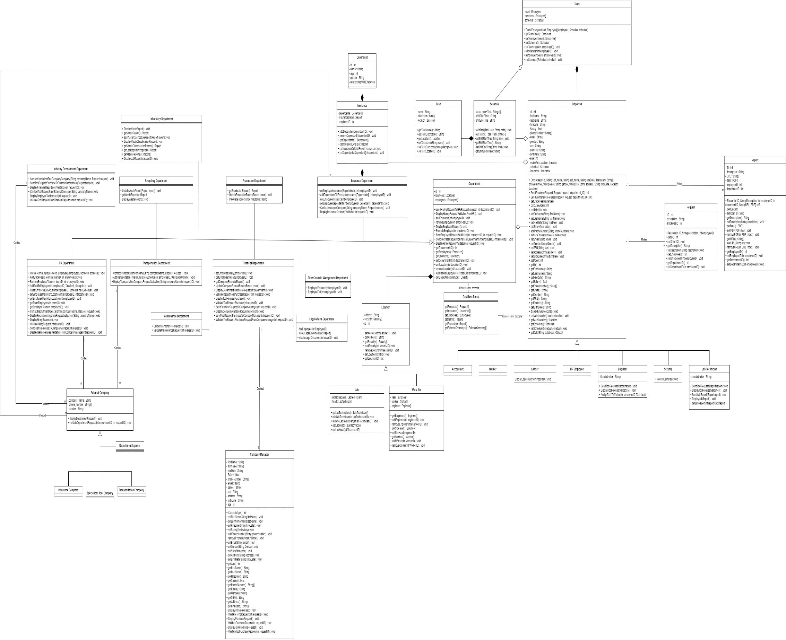

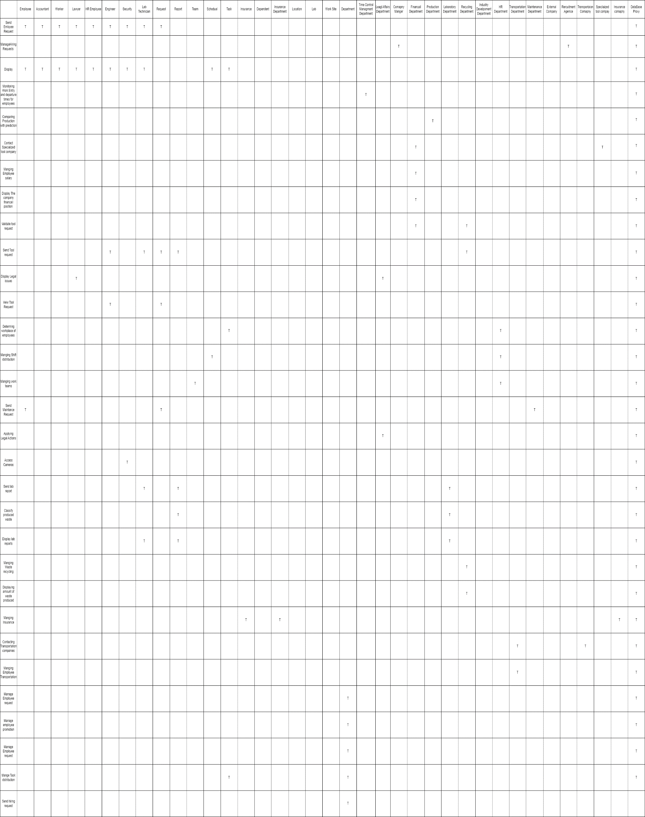

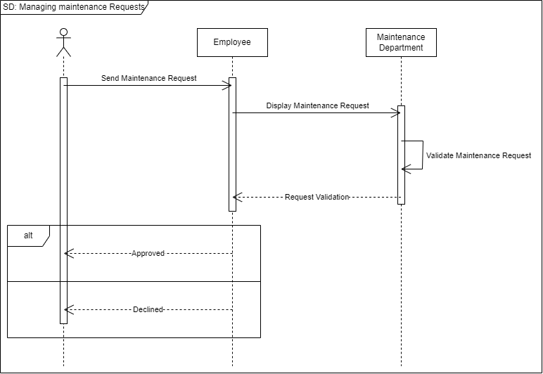

Dataflow Diagram

Level 0:

Level 1: