**Project Title: Petroleum Company Management System**

**Team Members:**

**Mohamed Ashraf Rabie:**

**ID: 21100854**

**Email:** [**mohamed.rabie.2022@aiu.edu.eg**](mailto:mohamed.rabie.2022@aiu.edu.eg)

**Ali Ehab Ali Hassan:**

**ID: 21100800**

**Email:** [**ali.hassan.2022@aiu.edu.eg**](mailto:ali.hassan.2022@aiu.edu.eg)

**Ramez Mohamed Fathi:**

**ID: 21100793**

**Email:** [**ramez.ahmed.2022@aiu.edu.eg**](mailto:ramez.ahmed.2022@aiu.edu.eg)

**Mohamed Ashraf Mahmoud:**

**ID: 21100873**

**Email:** [**mohamed.ashraf.2022@aiu.edu.eg**](mailto:mohamed.ashraf.2022@aiu.edu.eg)

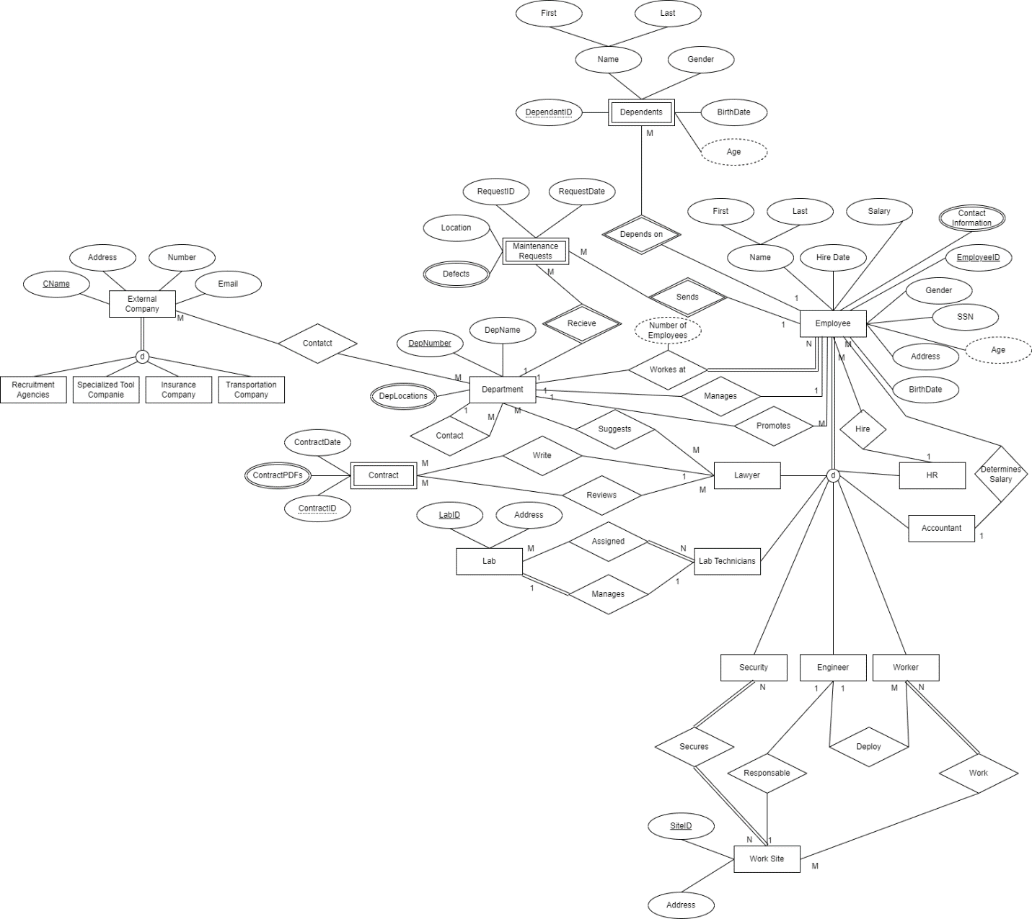

**Project Description:**

Aim: increasing the efficiency of operation in the company

This system is made with international standards and according to the company requirements in the petroleum industry to increase the efficiency of operations and monitoring it and to help employees perform tasks in a better way.

The company wants the system to save the Schedule for every employee including the task distribution and times and operation dates and employee’s info including name, id and salary and no of dependents, birthdate, contact info and hire date and the want save maintenance history and reports.

This system will not be fully involved in the production process.

**Actors:**

**Employees**:

Eng

Workers

Lab Technicians

HR

Security

Lawyer

Accountant

**Departments**:

Time Control Management Department

Production Department

Financial Department

Industry Development Department

HR Department

Department of Legal Affairs

Maintenance Department

Laboratory Department

Recycling Department

Insurance Department

Transportation Department

**External Actors**:

Recruitment Agencies

Specialized Tool Companies

Insurance Companies

Transportation Companies

**Locations:**

Labs

Work Sites

**Weak Entities:**

Dependents

Contracts

Requests

**Business Rules:**

* Dependents have (Name, Related Employee ID)
* Work Sites must have (Location ID, Address, Department name)
* Labs must have (Lab ID, Location)
* Contracts have (Contract ID, Contract Date, Contract PDF)
* Maintenance Requests have (Request ID, Request Date, location, Defect)
* All Employees must have (name, address, birth date, contact information, SSN, hire date, salary, gender, age, Dep number)
* Engs, Workers, Lab Technicians, HR Employees, Security Employees, Lawyers, Accountants are Employees.
* An Eng can Deploy many workers under him.
* Many Workers can be deployed under one Eng.
* An Eng may be responsible for a Work site.
* A Worker Can Work in Many Work Sites.
* A Work Site Can Have Many Workers.
* A Lab Technicians May Works in Many Labs.
* A Lab Has Many Lab Technicians.
* A Lab Technician May Manage only one Lab.
* A Lab can only be managed by one Lab Technician
* A Security Employee must be assigned to a location.
* An HR Employee can Hire many Employees.
* An Employee is Hired by an HR Employee.
* A Department can Request a Lawyers Suggestion.
* A Lawyer can Review Many Contracts.
* A Contract can be Reviewed by Many Lawyers.
* A Lawyer can Write Many Contracts.
* Only one Lawyer can Write a contract.
* An Accountant Assigns many Employees salary.
* An employees’ salaries is set by an Accountant.
* All Departments have (Dep number, Dep name, Dep locations, Dep manager, Dep number of employees)
* An Employee can Send Many Maintenance Requests to the Maintenance Department.
* The Maintenance Department can receive many Maintenance Requests from the Employees.
* All External Companies have (Company Name, Company Number, Company Email)
* Recruitment Agencies, Specialized Tool Companies, Insurance Companies, Transportation Companies are All External Companies.
* A Department Can Send a Request to an External Company Each request has An ID and an Attached PDF of the request.
* Employees can Have Dependents Under their insurance plan.
* All Employees belong to a department.
* One Employee manages only one department, each department can only be managed by a single employee.
* One Eng can Assign many Workers a task.
* Many Engineers can make many tool request to the Industry Development Department.
* Departments can contact each other.
* Departments can promote Employees under them.

**Potential Queries:**

* Which Employees have a salary above (Set amount)
* Which Employees Work at (Set Location)
* Which employees work in department number (enter department number)
* Which Employees have an age above (enter number)
* Who is the manager of department (enter department number)
* What are the insurance companies we are collaborating with
* What are the transportation companies we are collaborating with
* Which Employees are under (Set Department)
* Were there any Maintenance requests during (Set Date)
* Which Employees were Promoted during (Set Date)
* Which Employees were Demoted during (Set Date)
* Which Employees have Dependents
* Which Employees have more than (set amount) Dependents
* Which Employees have less than (set amount) Dependents
* Who are the Dependents of (set Employee)